University of Leicester PhD studentship
Funding Source: CENTA DTP
Proposed start date: 23rd September 2024
Closing date for applications: See our web page
Eligibility: UK/International
Department/School: Physics
Supervisors: PI: Josh Vande Hey (jvh7@leicester.ac.uk)
Co-I: Harj Sembhi
Co-I: Emma Ferranti (University of Birmingham)
Project Title: Mission to Understand Emissions: How can we assess air pollutant and greenhouse gas emissions from space today to shape the science and policies of tomorrow?.

Project Description:
Project Highlights:
- Develop new understanding of anthropogenic emissions from point sources
- Generate evidence for joined up climate and air quality policy
- Drive the development of the next generation of satellite remote sensing techniques
Overview (including 1 high quality image or figure):
As we move toward stricter air quality guidelines and more ambitious climate targets, it is imperative that we understand emissions from key point and small area sources such as power stations, mines, landfills, and other industrial facilities, in order to best target our efforts. We additionally need to monitor changes over time to evaluate the effectiveness of reduction measures. To do this on a global scale we must utilise current and future satellite technologies and high-resolution atmospheric models.
This project will utilise current satellite data and the cutting-edge model WRF-Chem to understand greenhouse gas and air pollutant emissions from important point sources including power stations, mines, and landfills. Evaluation of performance of satellite data will be conducted, and evidence for policy pathways explored. Data from Sentinel 5P TROPOMI will be used in the first instance, with a focus on nitrogen dioxide and methane emission quantification. This will be coupled with the WRF-Chem model. Requirements for future data streams will be defined, with a view to satisfying the needs of policy decisionmakers of the future.
A key element of this PhD will be understanding how environmental data products and analysis can be generated to best meet the needs of policy stakeholders. The supervisory team have strong links with local, national and international policy stakeholders in both air pollution and greenhouse gas contexts.
In addition to providing evidence for policy, this PhD will also develop advice on what future satellite observations are needed, and feed into building the case for future missions for air quality and greenhouse gas remote sensing, to ensure that future generations have a high quality long term record of point source emissions as policies and technologies evolve.

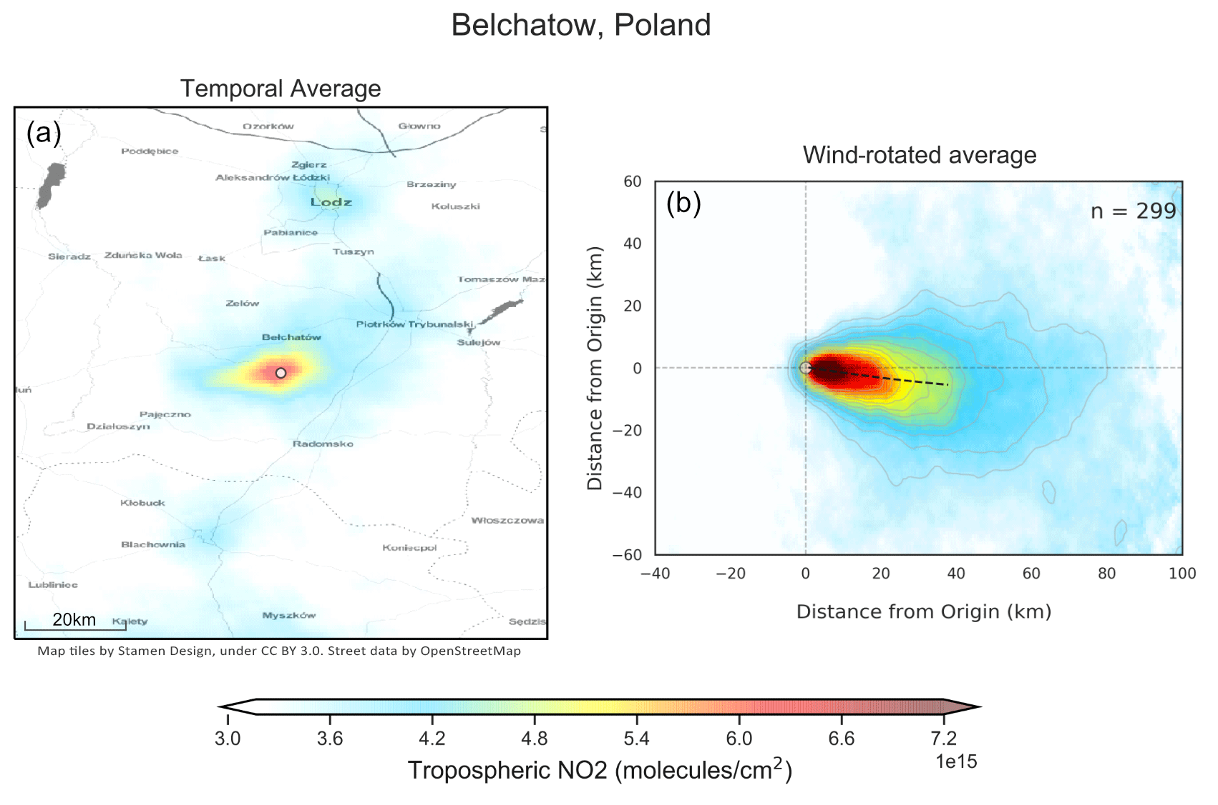
Figure 1: An example of resolving industrial emissions by combining satellite data with models. Here nitrogen dioxide emissions from a power station in Belchatow, Poland observed from TROPOMI are averaged (a) compared to wind-rotated and averaged (b) through application of ECMWF ERA5 data to illustrate how emissions can be resolved. Reproduced from Potts et al., 2023.

Methodology:
Data from Sentinel 5P TROPOMI will be used in the first instance, with a focus on nitrogen dioxide and methane emission quantification from important point sources. This will be coupled with the WRF-Chem model. You will first apply existing methodologies to quantifying emissions of these two gases, and relate those to other emissions. You will then build upon these methods to develop new techniques and expand to additional atmospheric species. Following this, you will generate a novel point source emissions catalogue for greenhouse gas and air pollutant emissions, compare these to bottom-up estimates calculated for the facilities, and put this information into a format actionable by policy stakeholders and site operators. You will then utilise these data to conduct joined up analysis for targeted emission reduction measures in the context of joined up air quality and climate change policy development.
References:

Potts, D. A., Timmis, R., Ferranti, E. J. S., and Vande Hey, J. D.(2023): Identifying and accounting for the Coriolis effect in satellite NO2 observations and emission estimates, Atmos. Chem. Phys., 23, 4577–4593, https://doi.org/10.5194/acp-23-4577-2023.
European Space Agency (2022) https://www.esa.int/Applications/Observing_the_Earth/Copernicus/Sentinel-5P/Methane_detected_over_Poland_s_coal_mines (Accessed 14 September, 2023)

Funding details:
NERC CENTA studentships are for 3.5 years and are funded by NERC. In addition to the full payment of your tuition fees, you will receive the following financial support:
- Annual stipend, currently set at £18,622 (2023/4 – new figures to be confirmed spring 2024)
- Research training support grant £8,000 (RTSG)
If you are not eligible for UK Fees the University of Leicester will fund the difference between UK and International fees for the duration of your studies
For more details of the CENTA consortium please see the CENTA website: www.centa.org.uk.
Entry requirements:
Applicants are required to hold/or expect to obtain a UK Bachelor Degree 2:1 or better in a relevant subject.
The University of Leicester English language requirements apply where applicable.

Application advice:
To apply please refer to our web page for further information and read carefully the How to Apply section before submitting your application
https://le.ac.uk/study/research-degrees/funded-opportunities/centa-phd-studentships

In the funding section please specify that you wish to be considered for Ref CENTA2-PHYS6-VAND

In the proposal section please provide the name of the supervisors and project title (a proposal is not required)

Project / Funding Enquiries to: CENTA@le.ac.uk or jvh7@leicester.ac.uk
Application enquiries to pgradmissions@le.ac.uk

