University of Leicester PhD studentship
Funding Source: CENTA DTP
Proposed start date: 23rd September 2024
Closing date for applications: See our web page
Eligibility: UK/International
Department/School: Chemistry
Supervisors: PI: Dr Stephen Ball (sb263@leicester.ac.uk), School of Chemistry, University of Leicester.
Co-I: Prof Paul Monks (psm7@leicester.ac.uk) School of Chemistry, University of Leicester.
Co-I: Prof Bill Bloss (w.j.bloss@bham.ac.uk), School of Geography Earth and Environmental Sciences, University of Birmingham.
Project Title: Oxidised nitrogen compounds and their role in the chemistry of air pollution.

Project Description:
Project Highlights:
- Build a better understanding of nitrogen compounds’ atmospheric chemistry and their roles in determining air quality
- Conduct collaborative fieldwork at one of the UK’s air quality supersites
- Gain expertise in using highly sensitive instrumentation to record air pollutants
Overview:
Air pollution is responsible for around 350,000 premature deaths per year in Europe [1] and 7 million globally [2]. In the UK and in Europe, the three most toxic air pollutants are NO2 (nitrogen dioxide), tropospheric O3 (ozone) and PM (particulate matter). NO2 and PM are emitted directly from various human-made sources and a few natural sources, but the majority of NO2 comes from road vehicles. Substantial decreases in NO2 concentrations were observed during COVID lockdown restrictions when people’s activity was severely reduced [1,3]. Contrastingly, tropospheric ozone is not emitted directly but rather it is produced within the atmosphere itself from the photochemical oxidation of volatile organic compounds in the presence of nitrogen oxides (NOx = NO+NO2). Some types of PM are also generated and/or chemically transformed in the atmosphere. Controlling these secondary air pollutants is challenging because it requires control of their precursors, and such efforts must be informed by a thorough understanding of the chemical pathways.
Observations of air pollutants are vital. The UK’s main monitoring is done by the Automated Urban and Rural Network (AURN) which runs 150 air monitoring sites [4]. Additionally, three “air quality supersites” have been established that contain more extensive instrumentation for conducting detailed studies of atmospheric composition and variability. One supersite is on Birmingham University’s campus [5], where this project will deploy additional research instruments from our group to quantify oxidised nitrogen compounds.
To further complicate the picture, air pollutant concentrations are highly dynamic, especially close to pollution sources. As an example, Figure 1 shows measurements of NO2 and aerosol optical depth (related to PM concentrations) made close to a roadside over a brief 10 minute interval. Concentrations can change by a factor of 3 in just a few seconds with the passing traffic. Notice also how some vehicles were strong emitters of both NO2 and aerosol (peaks at 15:21:40 and 15:22:27); others emitted aerosol but only small amounts of NO2 (15:15:55 and 15:17:12); and others strongly emitted NO2 but very little aerosol (15:19:47).
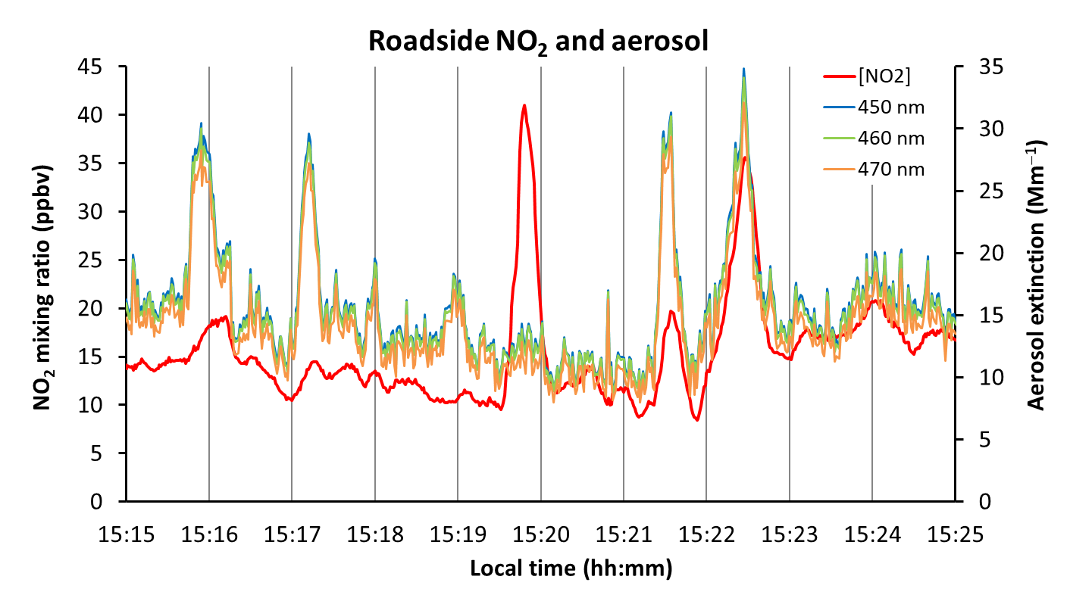
Figure 1: A time series of emissions from road vehicles. NO2 mixing ratios are in red, overlaid by wavelength-resolved aerosol extinctions (coloured as stated in the legend). The BBCEAS instrument sampled from a second-storey window of a university building overlooking a public road.

Methodology:
The CENTA student will use a broadband cavity enhanced absorption spectrometer (BBCEAS) built at Leicester University. This instrument acquired the data shown in Figure 1. A light beam is reflected many times through ambient air samples, thereby producing a highly sensitive measurement. The instrument is configurable for different nitrogen-containing trace gases: (i) simultaneous measurements of HONO and NO2 (HONO is a source of OH radicals) [6], (ii) fast time-resolution NO2 observations [Figure 1], (iii) quantifying the night-time NO3 radical and its reservoir compound N2O5 [7]. It is anticipated that the student will measure different oxidised nitrogen species at different stages of the project to complement the ongoing “core” observations at the Birmingham supersite, plus a more intensive measurement period to study the formation of aerosol nitrate from the deposition of N2O5 and HNO3.

References:

[1] “Air quality in Europe – 2021 report”, European Environment Agency (2021), https://www.eea.europa.eu/publications/air-quality-in-europe-2021/health-impacts-of-air-pollution
[2] The Lancet Commission on pollution and health, P.J. Landrigan et al., (2018) vol 391, issue 10119, 462-512, http://dx.doi.org/10.1016/S0140-6736(17)32345-0
[3] Changes in ambient air quality and atmospheric composition and reactivity in the South East of the UK as a result of the COVID-19 lockdown, K.P. Wyche , M. Nichols, H. Parfitt, P. Beckett, D.J. Gregg, K.L. Smallbone, and P.S. Monks, Science of the Total Environment 755, 142526, (2021), https://doi.org/10.1016/j.scitotenv.2020.142526
[4] Automatic Urban and Rural Network (AURN), https://uk-air.defra.gov.uk/networks/network-info?view=aurn
[5] Air quality supersites, https://clean-air-research.org.uk/projects/aqst/
[6] Nitrous acid (HONO) emissions under real-world driving conditions from vehicles in a UK road tunnel, L.J. Kramer, L.R. Crilley, T.J. Adams, S.M. Ball, F.D. Pope, and W.J. Bloss, Atmos. Chem. Phys., 20, 5231–5248, (2020), https://doi.org/10.5194/acp-20-5231-2020
[7] Atmospheric chemistry at night, S.M. Ball, (2014), http://www.rsc.org/images/environmental-brief-no-3-2014_tcm18-237724.pdf.

Funding details:
NERC CENTA studentships are for 3.5 years and are funded by NERC. In addition to the full payment of your tuition fees, you will receive the following financial support:
- Annual stipend, currently set at £18,622 (2023/4 – new figures to be confirmed spring 2024)
- Research training support grant £8,000 (RTSG)
If you are not eligible for UK Fees the University of Leicester will fund the difference between UK and International fees for the duration of your studies
For more details of the CENTA consortium please see the CENTA website: www.centa.org.uk.
Entry requirements:
Applicants are required to hold/or expect to obtain a UK Bachelor Degree 2:1 or better in a relevant subject.
The University of Leicester English language requirements apply where applicable.

Application advice:
To apply please refer to our web page for further information and read carefully the How to Apply section before submitting your application
https://le.ac.uk/study/research-degrees/funded-opportunities/centa-phd-studentships

In the funding section please specify that you wish to be considered for Ref CENTA2-CHEM1-BALL

In the proposal section please provide the name of the supervisors and project title (a proposal is not required)

Project / Funding Enquiries to: CENTA@le.ac.uk or sb263@leicester.ac.uk
Application enquiries to pgradmissions@le.ac.uk

