University of Leicester
Future 50 PhD Scholarship

Project Reference | MCB Markaki

First Supervisor | Dr. Yolanda Markaki
School/Department | Molecular and Cell Biology
Email | gm365@leicester.ac.uk | Telephone Ext

Second Supervisor | Dr. Sue Shackleton
School/Department | Molecular and Cell Biology
Email | ss115@leicester.ac.uk | Telephone Ext

Additional Supervisor | Dr. Gareth Miles/Leicester Cancer Research Centre

Section 2 – Project Information
Project Title | Identifying pathways to cancer and ageing therapies through studies of nucleus-lamina interactions in epigenome maintenance
Project Highlights: | 1. | Developmental epigenetics studies using embryonic stem cells
 | 2. | Quantitative super-resolution imaging to decipher the role of the nuclear lamina in epigenome maintenance
 | 3. | Forefront research to elucidate sex-specific susceptibilities to cancer and ageing
Project Summary
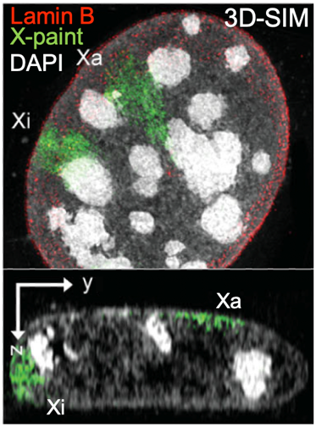
A major hallmark of epigenetic instability in cancer or aged cells is the reduction of heterochromatin. XX female mammals silence one of their two X chromosomes to equalize X-linked gene expression with XY males. The heterochromatic X (Xi) is determined in the blastocyst and persists as heritable epigenetic memory, playing a crucial role in cell physiology. Notably, Xi reactivation is manifested in ageing and cancer, as many oncogenes are encoded on the X and persistently silenced by XCI.

Figure 1 Tight association of Xa and Xi with the NL revealed by 3D-SIM (Markaki et al., 2012)

During cellular differentiation, changes in cell-cell contacts, cellular morphology or the extracellular matrix are transmitted through the cytoskeleton to the nuclear lamina (NL) and alter gene expression. Genes within Lamina-Associated Domains (LADs) become subject to silencing. Lamins are required to induce and sustain developmentally regulated gene repression. Genetic mutations in the LMNA gene (laminopathies) or abnormal NL distribution in cancer are linked to mechanosensing defects and gene reactivation. Both X chromosomes (Xa, Xi) are associated with the NL (Figure 1). NL defects in aged hematopoietic stem cells result in attrition of XCI, while loss of Xi heterochromatic marks is observed in laminopathies. The impact of NL-contact in the formation and regulation of the epigenetic stability of the Xi is unclear.
In this project the student will explore functional mechanisms of the NL in maintenance of XCI during cellular differentiation and its role in inducing epigenetic instabilities using LMNA or cancer patient cell lines. We will investigate NL-chromatin links and generate density maps of NE proteins and epigenetic factors employing super-resolution imaging and image data analysis. We will monitor LADs organization relative to X-chromosome configuration using multispectral DNA FISH and changes in gene expression by transcriptomics and single-molecule FISH. We will explore mechanoregulation through molecules that increase mechanotransduction in LMNA patient lines, mechanical forces or hydrogels. Next, we will generate live-cell imaging tools to track Xi-LADs contact frequencies and explore how the NL-contact ‘memory’ regulates gene repression. This research is critically important because it will provide insights into the fundamental process of XCI, reveal general mechanisms of heterochromatin formation and how abnormalities in the NE regulation mechanistically drive cancer.

