PhD studentship Project information
Funding Source: CENTA DTP
Proposed start date: 25th September 2023
Closing date for applications: 11th January 2023
Eligibility: UK/International
Department/School: SGGE
Supervisors: PI: Dr. Juan Carlos Berrio, jcb34@leicester.ac.uk
CI: Dr. Arnoud Boom, ab269@leicester.ac.uk

Project Title: Holocene Savannah Rainforest dynamics of the Northern Amazon.

Project Description :

Project Highlights:
1. | To work on the first ever paleo-ecological study of this important yet poorly understood part of the Amazon basin.
2. | Opportunity to participate or organise optional field work in the Amazon basin.
3. | Opportunity to expand the work into a multidisciplinary project with access to additional cutting edge technologies, expertise and benefitting from a strong network of local and international collaborators.

Overview
Savannahs are important ecosystems accounting for 20% of the global land-surface and account for an equal percentage in global net carbon uptake. However, emphasis on the role of grasslands in terms of carbon storage is often overshadowed by that of forests, which have received much more attention. The Northern Amazon basin is rich in Amazonian savannahs and while these ecosystems are highly biodiverse and offer important ecosystem services to locals, they are also poorly understood and understudied. Interestingly, in contrast to savannah ecosystems elsewhere, Amazonian savannahs are almost entirely devoid of grasses, their place being taken by endemic ancient Guyana-shield (grass-like) monocotyledon taxa which make up the bulk of the vegetation. These savannahs form characteristic mosaics with rainforest occupying large areas of the Rio Negro in the Amazon basin, and typically are found predominantly on nutrient-poor white sand substrates. It is believed that these savannahs depend on fire as a disturbance agent to prevent forest encroachment promoting their diversity. These ecotones appear extremely sensitive to Anthropogenic disturbance. In the absence of palaeoecological records, nothing is known about Anthropogenic effects on vegetation dynamics, equally not much is known about the natural drivers either. The aim of this study is to determine how climate and humans have shaped this landscape.
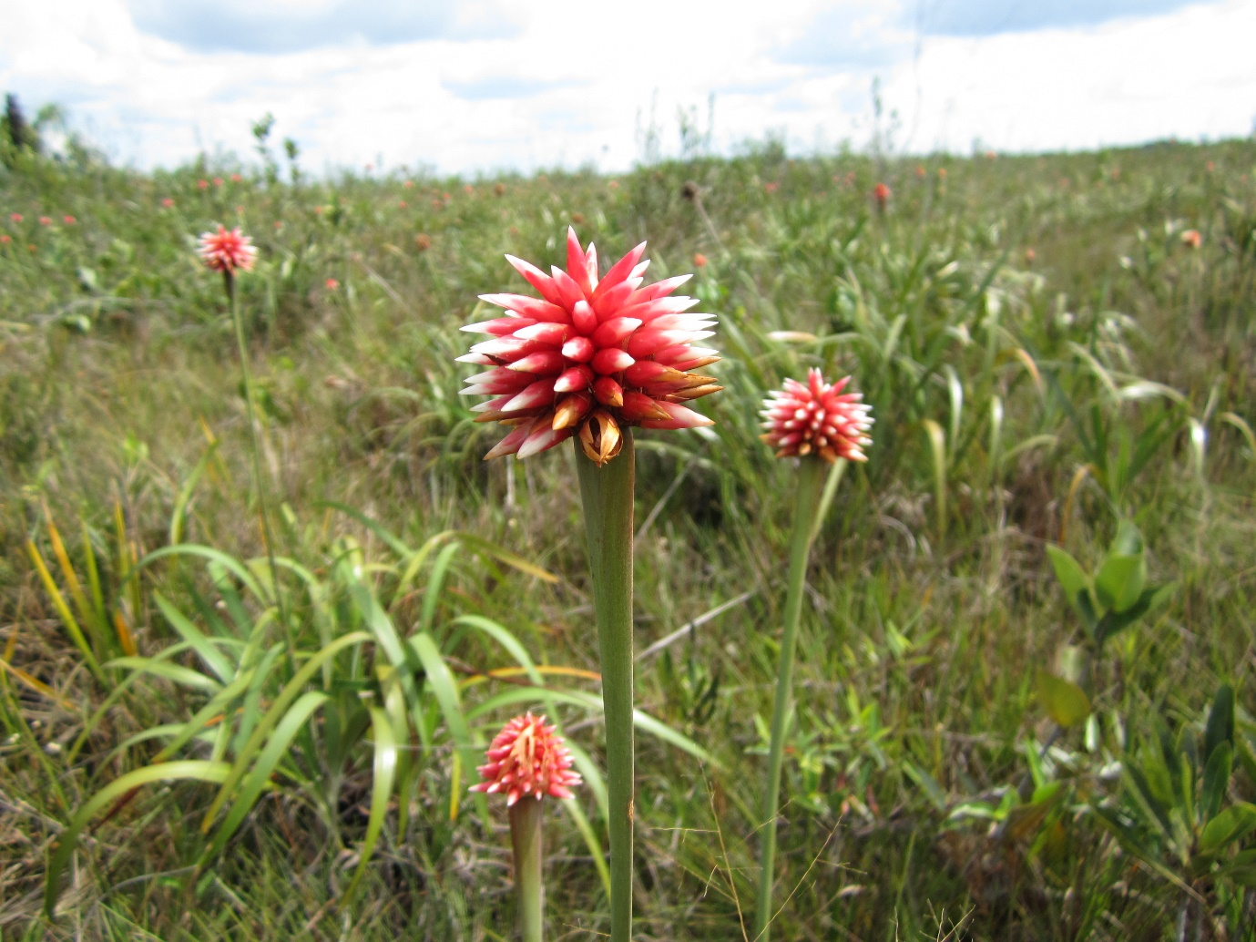
Figure 1. Guacamaya superba or Inirida flower. Endemic monocotyledons such as these replace the role of grasses in this white sand Amazonian Savannah.
We present an exciting opportunity, as we have obtained a substantial amount of peat records from the Colombian Amazon. These peatlands are close to the savannah-forest ecotones and are thousands of years old, and provide us with a unique archive that will allow us to study the palaeoecological history of these ecosystems. Because of the complete lack of comparable data, there is no evidence of how fire, humans and climate have affected these ancient Amazonian forest-savannah ecotones. This study will produce the first Holocene environmental reconstruction of the entire region. We anticipate that our peat records will provide important evidence about the evolution of the forest-ecotone dynamics over the Holocene and Anthropocene. We aim to answer the fundamental question: what are the factors that encourage for Savannahs in the Northern Amazon?

References:

Funding details:
NERC CENTA studentships are for 3.5 years and are funded by NERC. In addition to the full payment of your tuition fees, you will receive the following financial support:
- Annual stipend, currently set at £ 17,668 (2022/3 – new figures to be confirmed spring 2023)
- Research training support grant £8,000 (RTSG)
* If you do not meet the criteria for UK Fees you will need to fund the difference between UK and International fees for the duration of your studies.
* A limited number of top up studentships to fund the difference between UK and International fees may become available but are not guaranteed.
For more details of the CENTA consortium please see the CENTA website: www.centa.org.uk .
Entry requirements:
Applicants are required to hold/or expect to obtain a UK Bachelor Degree 2:1 or better in a relevant subject or overseas equivalent.
The University of Leicester English language requirements apply where applicable.

Application advice:
To apply please refer to
https://le.ac.uk/study/research-degrees/funded-opportunities/centa-phd-studentships
With your application, please include:
- CENTA Application form - available to download on the How to Apply section of the above link
- CV
- Personal statement explaining your interest in the project, your experience and why we should consider you
- Degree Certificates and Transcripts of study already completed and if possible transcript to date of study currently being undertaken
- Evidence of English language proficiency if applicable
- In the reference section please enter the contact details of your two academic referees in the boxes provided or upload letters of reference if already available.
In the funding section please specify that you wish to be considered for Ref CENTA2-SGGE-BERR

In the proposal section please provide the name of the supervisors and project title (a proposal is not required)

Project / Funding Enquiries to: CENTA@le.ac.uk or jcb34@le.ac.uk or ab269@le.ac.uk
Application enquiries to pgradmissions@le.ac.uk

