PhD studentship Project information

Funding Source: CENTA DTP
Proposed start date: 25th September 2023
Closing date for applications: 11th January 2023
Eligibility: UK/International
Department/School: SGGE (Geology)
Supervisors: PI: Prof. Kevin Tansey, University of Leicester, kjt7@le.ac.uk
Co-I: Dr Huiyu Zhou, Informatics, University of Leicester, hz143@le.ac.uk
Project Title: Integration of soil moisture and temperature data with vegetation condition temperature indices to improve drought mapping and crop yield estimation in China using Copernicus Sentinel data

Project Description:
Project Highlights:
- Time series analysis of European Copernicus radar data from Sentinel-1 will be sensitive to soil moisture changes
- Soil temperature data at high resolution is now available from satellites.
- Most of the existing methods to monitor drought impact and crop yield rely on indices from optical data. We hypothesise that integrating satellite proxies for soil and crop water derived from other Electron-magnetic wavelengths into existing models, yield estimates will improve further. We will test this theory over large agricultural plains in China and also in the UK where crop production and yield are critically important for sustainable food production.
Overview:
Drought is one of the major concerns for the sustainability and socio-economic development in rural areas in China. Monitoring of crop growth conditions is important for economic development and to avoid food production issues. The use of remotely sensed data has proved to be very important in agricultural crop growth monitoring and irrigation scheduling. The prediction of crop yields have direct impact on food management strategies [1]. The yield of a crop is influenced by many factors during its growth cycle. To better estimate yield and provide information that may help with mitigating negative factors that reduce yield, monitoring of the crop’s biophysical properties, at frequent periods if necessary. We can undertake this monitoring in situ, from a drone, or from an aircraft. However, if we want to do this at scale, over vast agricultural plains in China for example, then we need to use satellite data. Previously, we have had to rely on this monitoring using coarse-resolution instruments (minimum 500m pixel size). However, in the last 5 years, a new generation of European satellites, built as part of the Copernicus programme has provided unprecedented levels of data at high repeat frequency (6-days) and higher resolution (20m) at thermal, optical and radar wavelengths.
The aim of this PHD project is to develop methods to integrate estimates of soil moisture content, soil temperature and crop water content with existing approaches that includes the Vegetation Temperature Condition Index (VTCI), a drought monitoring index developed using Normalized-Difference-Vegetation-Index (NDVI) and Land-Surface-Temperature (LST) values. These modelled estimates will come primarily from the Sentinel-1 C-band radar mission and integrated into water balance/soil wetness models. We have started to integrate Sentinel-1 data into our models and the results are promising, but more work needs to be undertaken. We will also utilise next generation high resolution land surface temperature retrievals from thermal detectors. The primary study area will be the Guanzhong Plain, located in Shaanxi Province, China and covering an area of ~12,000 km², but sites within the UK will also be selected. The student will be expecting to spend 6 months in China, working primarily with the group of Prof. Wang at China Agricultural University. Here she/he will undertake field work and also develop further training on the nature of agricultural systems, field and crop patterns and current machine learning approaches. The costs associated with visits to China are fully covered.

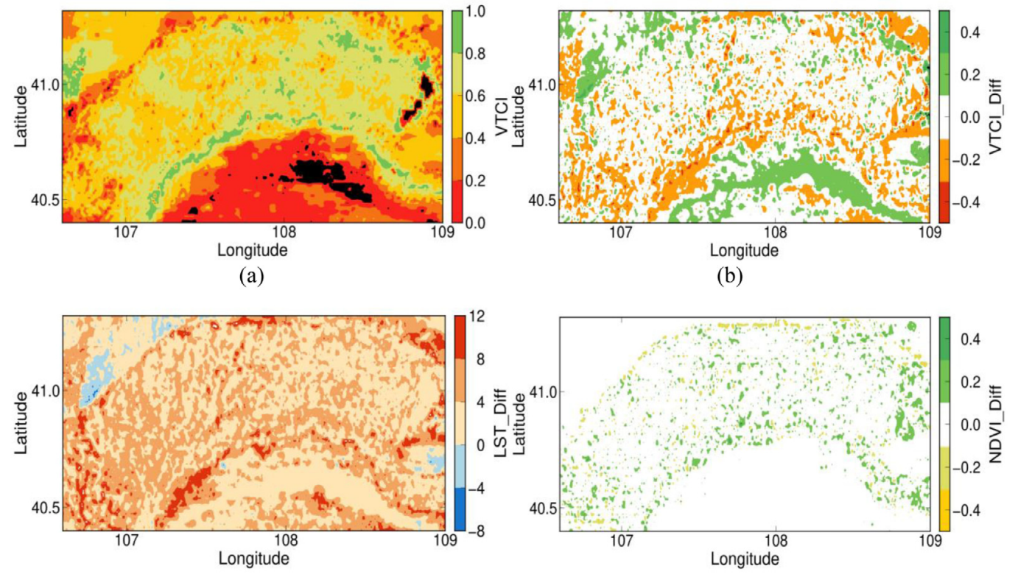
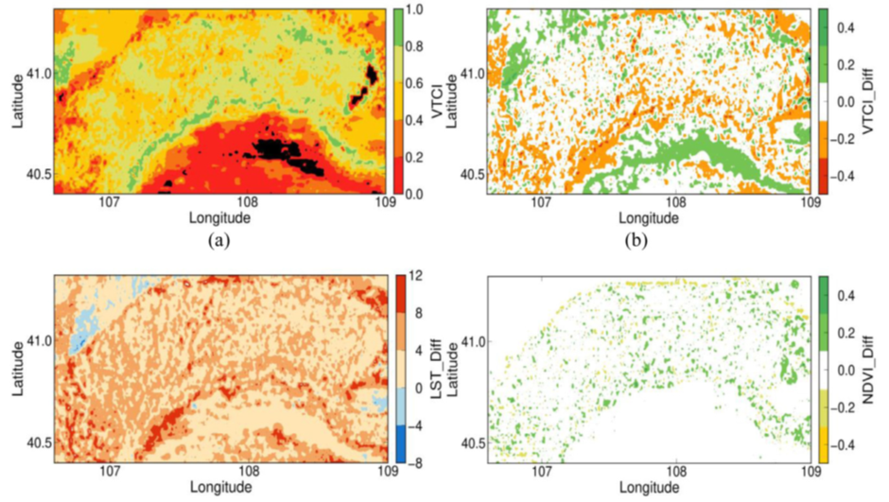
Figure 1: This figure shows (a) VTCI images of Hetao Plain, China captured on August 12 2017 by MODIS observations, and the differences of (b) VTCIs, (c) LSTs, and (d) NDVIs between Sentinel-3A SLSTR and MODIS (i.e., SLSTR minus MODIS). Taken from Hu et al. (2019).

Methodology:
In research funded by the UKRI-STFC and the Royal Society in collaboration with CAU and Peking University-PKU, we have adapted existing models to utilise Copernicus products. Our focus to date has been on using Sentinel-3 for Land Surface Temperature retrieval [2] and Normalized Difference Vegetation Index [3]. From these indicators derived from Sentinel-3, we derive the VTCI that has been shown to be sensitive to drought and crop yield. Recently, we have investigated the fusion of high-resolution, multi-spectral data from Sentinel-2 into models [4-5]. These results show unprecedented levels of detail in the ability to map drought impacts. In the work funded by ESA-CCI, we built an automated, large-area Sentinel-1 backscatter/coherence processor. Work recently undertaken have explored the use of deep learning within agricultural yield estimation and soil characterization. These approaches will be further developed in the project [6-9]. We will bring these observing systems and methods together in this PhD project as well as observations from high resolution thermal imagery. We will also deploy our results on a data processing platform for stakeholders to engage with and explore.

References:

Journal:
[1] Prasad, A. K. , Chai, L. , Singh, R. P., and Kafatos, M. (2006) ‘Crop yield estimation model for Iowa using remote sensing and surface parameters’, International Journal of Applied Earth Observation and Geoinformation, 8, 26-33, https://doi.org/10.1016/j.jag.2005.06.002
[2] Zheng, Y., Ren, H., Guo, J., Ghent, D., Tansey, K., Hu, X., Nie, J., and Chen, S. (2019) ‘Land surface temperature retrieval from Sentinel-3A Sea and Land Surface Temperature Radiometer, using a split-window algorithm’, Remote Sensing, 11, 650, https://doi.org/10.3390/rs11060650
[3] Hu, X., Ren, H., Tansey, K., Zheng, Y., Ghent, D., Liu, X., and Yan, L., 2019, Agricultural drought monitoring using European Space Agency Sentinel 3A land surface temperature and normalized difference vegetation index imageries. Agricultural and Forest Meteorology, 279, 107707. https://doi.org/10.1016/j.agrformet.2019.107707
[4] Zhou, X., Wang, P., Tansey, K., Zhang, S., Li, H., and Wang, L., 2020, Developing a fused vegetation temperature condition index for drought monitoring at ﬁeld scales using Sentinel-2 and MODIS imagery. Computers and Electronics in Agriculture, 168, 105144. https://doi.org/10.1016/j.compag.2019.105144
[5] Zhou, X., Wang, P., Tansey, K., Zhang, S., Li, H., Tian, H., 2020, Reconstruction of time series leaf area index for improving wheat yield estimates at field scales by fusion of Sentinel-2, -3 and MODIS imagery. Computers and Electronics in Agriculture, 177, 105692, https://doi.org/10.1016/j.compag.2020.105692
[6] Periasamy, S., Ravi, K.P., and Tansey, K., 2022, Identification of saline landscapes from an integrated SVM approach from a novel 3-D classification schema using Sentinel-1 dual-polarized SAR data. Remote Sensing of Environment, 279, 113144, https://doi.org/10.1016/j.rse.2022.113144
[7] Zhang, J., Tian, H., Wang, P., Tansey, K., Zhang, S., and Li, H., 2022, Improving wheat yield estimates using data augmentation models and remotely sensed biophysical indices within deep neural networks in the Guanzhong Plain, PR China. Computers and Electronics in Agriculture, 192, 106616, https://doi.org/10.1016/j.compag.2021.106616
[8] Han, D., Wang, P., Tansey, K., Liu, J., Zhang, Y., Tian, H., and Zhang, S., 2022, Integrating an attention-based deep learning framework and the SAFY-V model for winter wheat yield estimation using time series SAR and optical data. Computers and Electronics in Agriculture, 201, 107334, https://doi.org/10.1016/j.compag.2022.107334
[9] Han, D., Wang, P., Tansey, K., Liu, J., Zhang, Y., Zhang, S., and Li, H., 2022, Combining Sentinel-1 and -3 imagery for retrievals of regional multitemporal biophysical parameters under a deep learning framework. IEEE Journal of Selected Topics in Applied Earth Observations and Remote Sensing, 15, 6985-6998, https://doi.org/10.1109/JSTARS.2022.3200735

Funding details:
NERC CENTA studentships are for 3.5 years and are funded by NERC. In addition to the full payment of your tuition fees, you will receive the following financial support:
- Annual stipend, currently set at £ 17,668 (2022/3 – new figures to be confirmed spring 2023)
- Research training support grant £8,000 (RTSG)
* If you do not meet the criteria for UK Fees you will need to fund the difference between UK and International fees for the duration of your studies.
* A limited number of top up studentships to fund the difference between UK and International fees may become available but are not guaranteed.
For more details of the CENTA consortium please see the CENTA website: www.centa.org.uk .
Entry requirements:
Applicants are required to hold/or expect to obtain a UK Bachelor Degree 2:1 or better in a relevant subject or overseas equivalent.
The University of Leicester English language requirements apply where applicable.

Application advice:
To apply please refer to
https://le.ac.uk/study/research-degrees/funded-opportunities/centa-phd-studentships
With your application, please include:
- CENTA Application form - available to download on the How to Apply section of the above link
- CV
- Personal statement explaining your interest in the project, your experience and why we should consider you
- Degree Certificates and Transcripts of study already completed and if possible transcript to date of study currently being undertaken
- Evidence of English language proficiency if applicable
- In the reference section please enter the contact details of your two academic referees in the boxes provided or upload letters of reference if already available.
In the funding section please specify that you wish to be considered for Ref CENTA2-SGGE3-TANS

In the proposal section please provide the name of the supervisors and project title (a proposal is not required)

Project / Funding Enquiries to: CENTA@le.ac.uk or Kevin Tansey kjt7@le.ac.uk
Application enquiries to pgradmissions@le.ac.uk

