PhD studentship Project information
Funding Source: CENTA DTP
Proposed start date: 25th September 2023
Closing date for applications: 11th January 2023
Eligibility: UK/International
Department/School: SGGE (Geography)
Supervisors: PI: Andrew Carr, University of Leicester, asc18@le.ac.uk
Co-I: Dr Hayley Cawthra, Chief Scientist - marine geology. Council for Geoscience, South Africa and African Centre for Coastal Palaeoscience, Nelson Mandela University, South Africa cawthra.h@gmail.com
Co-I Dr Mark Powell, University of Leicester dmp6@le.ac.uk
Project Title: Luminescence dating a tool to interrogate multi-scale coastal landscape response, Cape south coast, South Africa.

Project Description:
Project Highlights:
- Develop new approaches for understanding coastal landscape change across multiple timescales along the spectacular coastline of South Africa
- Application and training in diverse set of geochronological and geophysical methods
- Co-supervision from an international interdisciplinary research group
Overview
The South African coast is a key region for Neogene and Pleistocene sea level studies (Hearty et al. 2020). Along the Western and Eastern Cape Provinces, thick sequences of cemented coastal deposits (dunes and near-shore deposits) form an archive of climatic and landscape change, as well as preserving numerous trace fossils (Helm et al., 2020) and evidence of human occupation (Helm et al., 2018). This project will interrogate these coastal sedimentary archives at two scales:
- The long-term timing of onshore dune and shoreline emplacement broadly equates to high interglacial sea-levels (Bateman et al., 2011), with coastal dune formation on the continental shelf during low-stands (Cawthra et al 2018). However, variability in the peri-coastal stratigraphic record is imparted by the interplay of (inherited) sediment supply and offshore topography (Carr et al., 2019) and we predict more complex scenarios exist, particularly in areas with a narrower coastal shelf. This is exciting as it offers scope to drill into far broader questions of diverse coastal landscape evolution(s) via, high-density geochronological sampling closely accompanied by targeted geophysical surveying.
- Today parts of the coastline are rapidly eroding due to sea level rise and relatively soft Pleistocene coastal sediments. This occurs in the face of burgeoning coastal development. This project will investigate the potential of luminescence rock surface dating methods to estimate the timing and rates coastal cliff erosion and to test the potential to date the displacement of large blocks from cliffs and shore platforms; the latter include potential storm surge and tsunami deposits (e.g. Brill et al., 2021). The potential of surface exposure luminescence dating methods is still being realised, but this approach - in a region rich in quartz with suitable luminescence properties – may offer entirely new insights into shorter-term coastal landscape change, and contribute to better-defining regional coastal hazards.
This project will primarily employ luminescence dating methods, in conjunction with other surveying techniques, to interrogate coastal landscape processes over multiple spatial-temporal scales. The student will focus on the development of the new luminescence dating chronologies at Leicester, in collaboration with researchers from the Council for Geoscience, South Africa.
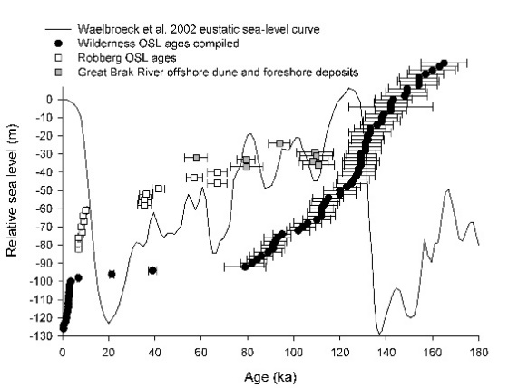 | 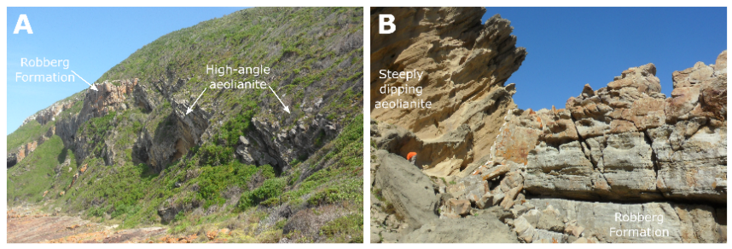
Figure 1: Left: Compilations of dune luminescence ages from the South African south coast, showing interglacial-focused dune formation at the well-studied Wilderness embayment (black circles) accompanied by offshore Marine Isotope Stage (MIS) 4 dune formation at Groot Brak (grey squares). These contrast with a potentially new scenario for MIS 3 dune formation at Robberg (white squares). The photos on the right show the “pockets” of MIS 3 dunes (“aeolianite”) at Robberg, preserved within more ancient bedrock structure (from Carr et al., 2019)

Methodology:
The student will work closely with South African collaborators to identify new locales preserving ancient dune deposits, particularly in the less-studied Cape St. Francis and Algoa Bay, Eastern Cape. These will be sampled for luminescence dating in conjunction with targeted geophysical surveys, allowing onshore chronologies and stratigraphic data to be integrated with offshore geophysical data. To consider a first attempt at quantifying coastal erosion and boulder emplacement, the student will apply remote sensing and terrestrial laser scanning to (respectively) locate and characterise boulder deposits and block fall sites. From this, known age samples will be identified for testing of surface exposure luminescence dating. Following this, first attempts at dating unknown aged deposits will be made. These ages will be considered in light of block size/dimensions, location and climatic data to evaluate likely rates/timescales/mechanisms of block detachment and the role (or otherwise) of major storm events.

References:

Bateman, M.D., Carr, A.S., Holmes, P.J., Dunajko, A., McLaren, S.J., Marker, M.E., Roberts, D.L., Murray-Wallace, C.V., and Bryant, R.G., 2011. ‘The evolution of barrier dune systems: a case study of the Middle-Late Pleistocene Wilderness barrier dunes, South Africa’. Quaternary Science Reviews, 30, pp63–81.
Brill, D., May, S.M., Mhammdi, N., King, G., Lehmann, B., Burow, C., Wolf, D., Zander, A. and Brückner, H., 2021. ‘Evaluating optically stimulated luminescence rock surface exposure dating as a novel approach for reconstructing coastal boulder movement on decadal to centennial timescales’. Earth Surface Dynamics 9, pp.205-234.
Carr, A.S., Bateman, M.D., Cawthra, H.C. and Sealy, J., 2019. First evidence for onshore marine isotope stage 3 aeolianite formation on the southern Cape coastline of South Africa. Marine Geology, 407, pp1-15.
Cawthra, H.C., Jacobs, Z., Compton, J.S., Fisher, E.C., Karkanas, P., and Marean, C.W., 2018. ‘Depositional and sea-level history from MIS 6 (termination II) to MIS3 on the southern continental shelf of South Africa’. Quaternary Science Reviews, 181, pp156–172.
Hearty, P.J., Rovere, A., Sandstrom, M.R., O'Leary, M.J., Roberts, D. and Raymo, M.E. 2020. ‘Pliocene‐Pleistocene stratigraphy and sea‐level estimates, Republic of South Africa with implications for a 400 ppmv CO₂ world’. Paleoceanography and Paleoclimatology, 35(7), p.e2019PA003835. https://doi.org/10.1029/2019PA003835
Helm, C.W., Cawthra, H.C., Cowling, R.M., De Vynck, J.C., Lockley, M.G., Marean, C.W., Thesen, G.H. and Venter, J.A. 2020. ‘Pleistocene vertebrate tracksites on the Cape south coast of South Africa and their potential palaeoecological implications’. Quaternary Science Reviews, 235, 105857.
Helm, C.W., McCrea, R.T., Cawthra, H.C., Lockley, M.G., Cowling, R.M., Marean, C.W., Thesen, G.H., Pigeon, T.S. and Hattingh, S., 2018. ‘A new Pleistocene hominin tracksite from the Cape south coast, South Africa’. Scientific Reports 8, pp.1-13.

Funding details:
NERC CENTA studentships are for 3.5 years and are funded by NERC. In addition to the full payment of your tuition fees, you will receive the following financial support:
- Annual stipend, currently set at £ 17,668 (2022/3 – new figures to be confirmed spring 2023)
- Research training support grant £8,000 (RTSG)
* If you do not meet the criteria for UK Fees you will need to fund the difference between UK and International fees for the duration of your studies.
* A limited number of top up studentships to fund the difference between UK and International fees may become available but are not guaranteed.
For more details of the CENTA consortium please see the CENTA website: www.centa.org.uk .
Entry requirements:
Applicants are required to hold/or expect to obtain a UK Bachelor Degree 2:1 or better in a relevant subject or overseas equivalent.
The University of Leicester English language requirements apply where applicable.

Application advice:
To apply please refer to
https://le.ac.uk/study/research-degrees/funded-opportunities/centa-phd-studentships
With your application, please include:
- CENTA Application form - available to download on the How to Apply section of the above link
- CV
- Personal statement explaining your interest in the project, your experience and why we should consider you
- Degree Certificates and Transcripts of study already completed and if possible transcript to date of study currently being undertaken
- Evidence of English language proficiency if applicable
- In the reference section please enter the contact details of your two academic referees in the boxes provided or upload letters of reference if already available.
In the funding section please specify that you wish to be considered for Ref CENTA2-SGGE2-CARR

In the proposal section please provide the name of the supervisors and project title (a proposal is not required)

Project / Funding Enquiries to: CENTA@le.ac.uk or asc18@le.ac.uk

Application enquiries to pgradmissions@le.ac.uk

