PhD studentship Project information
Funding Source: CENTA DTP
Proposed start date: 25th September 2023
Closing date for applications: 11th January 2023
Eligibility: UK/EU/International
Department/School: SGGE
Supervisors: PI: Dr Marc Reichow University of Leicester (mkr6@le.ac.uk )
Co-I: Dr Andrew Miles University of Leicester (ajm131@le.ac.uk )
Co-I: Dr Nick Varley, Universidad de Colima, Mexico (nick@ucol.mx )

Project Title: Evaluation of crustal recycling and magma formation by subduction in the Trans Mexican Volcanic Belt: New insights from the Ceboruco volcano, Mexico

Project Description :
Project Highlights:
- Gain an in-depth understanding of the magma plumbing system at an active volcano
- Contribute to the understanding of the principle controls on magma evolution and enrichment at subduction zones
- Develop expertise in a variety of field and laboratory techniques pertinent to volcanology
Overview (including 1 high quality image or figure):
The Trans-Mexican Volcanic Belt (TMVB) is one of the most compositionally diverse magmatic arcs on Earth and therefore constitutes a prime location for testing emerging hypotheses on arc petrogenesis and continental evolution (Gómez-Tuena et al., 2018). Recycling of upper plate crust in subduction zones, or ‘subduction erosion’, is a major mechanism of crustal destruction at convergent margins. Assessing the impact of eroded crust on arc magmas is, however, difficult owing to the compositional similarity between the eroded crust, trench sediment and arc crustal basement that may all contribute to arc magma formation (Ferrari et al., 2011; Straub et al., 2015). Ceboruco volcano is one of a few active volcanoes in the western part of the TMVB and is compositionally diverse ranging from mafic to rhyolite magmas (Nelson, 1980; Nunez et al., 2022). It is known that Ceboruco produced three compositionally and volumetrically different magma types including two caldera-forming explosive eruptions. However, it remains unclear how these different magmas formed, what controls their composition including distinctively high-Nb magmas enriched in LILE and HFSE resembling those of enriched intraplate magmas. Volatile bearing minerals, common to other volcanoes within the TMVB, are rare at Ceboruco raising the question whether metasomatism can be held responsible for this enrichment?
This project will focus on a field-based analysis of the volcano and geochemical and petrographic study of samples collected from various domes and lavas in order to gain a better understanding leading to the formation of a range of volcanic products. The aim is to create a schematic model of the Ceboruco magma system and to see whether the basaltic to rhyolitic magmas originated from the same reservoir or whether complex processes involving partial melting of different source regions, fractional crystallisation and magma mixing and/or crustal erosion was responsible for the diverse magmatism at Ceboruco. In order to achieve this, whole rock and in-situ analyses of the mineral budget will be applied and compared to data from other subduction zone volcanoes to outline a potential magmatic system for Ceboruco. This combination provides a unique opportunity to track the eruption history of subduction-related volcanism and magma enrichment processes.
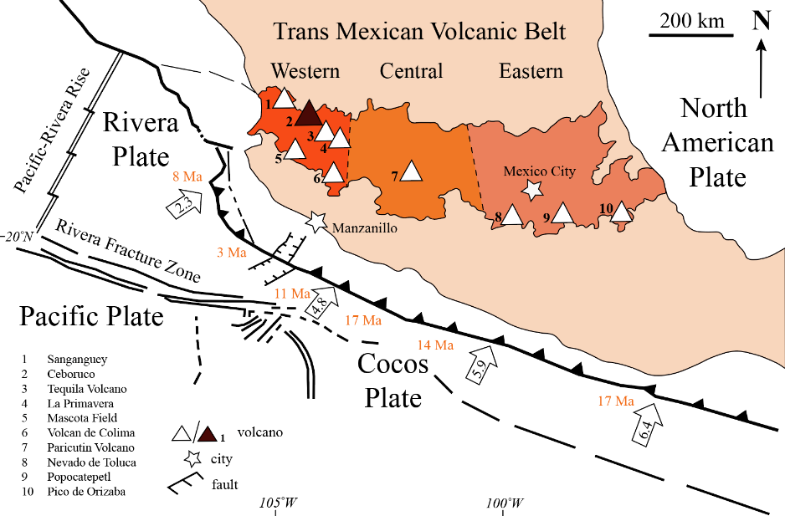
Figure 1: Simplified tectonic map of the north-eastward converging subduction zone showing the location of the Trans Mexican Volcanic Belt (TMVB) which is broadly divided into western, central and eastern regions. The location of several compositionally diverse volcanic centres, including Ceboruco, are indicated (after Frey et al., 2004; Gomez-Tuena et al., 2018).
Methodology:
Samples will be collected from Ceboruco, Mexico during a planned field season providing representative sets of samples recovered from eleven distinct volcanic episodes supplementing an existing collection gathered by the Co-PI and analysed by the PI at Leicester. Quantitative whole rock compositional characterisation will be carried out at the University of Leicester using X-ray fluorescence spectrometry (XRF) and inductive coupled plasma mass spectrometry (ICP-MS), whilst mineral compositions will be determined through scanning electron microscope (SEM) coupled with Zeiss’ Minerlogic software, laser ablation mass spectrometry and supplemented by major elements determined by electron microprobe. Textural relationships will be analysed from thin section. A range of radiogenic isotope characterisation (Lu-Hf, U-Pb, Rb-Sr, Sm-Nd) will be carried out by ICP-MS at the NERC isotope facility, Keyworth following a grant application to the National Environmental Isotope Facility (NEIF).

References:
Ferrari, L., Orozco-Esquivel, T., Manea, V., and Manea, M. (2011) ‘The dynamic history of the Trans-Mexican Volcanic Belt and the Mexico subduction zone’, Tectonophysics, 522-523, pp. 122–149, doi: 10.1016/j.tecto.2011.09.018
Frey, H.M., Lange, R.A., Hall, C.M., and Delgado-Granados, H. (2004) ‘Magma eruption rates constrained by 40Ar/39Ar chronology and GIS for the Ceboruco–San Pedro volcanic field, western Mexico’, Geological Society of America Bulletin, 116, pp. 259, doi:10.1130/b25321.1.
Gómez-Tuena, A., Mori, L., and Straub, S.M. (2018) ‘Geochemical and petrological insights into the tectonic origin of the Trans Mexican Volcanic Belt’, Earth-Science Reviews, 183, pp. 153–181, doi: 10.1016/j.earscirev.2016.12.006.
Nelson, S.A. (1980) ‘Geology and Petrology of Volcán Ceboruco, Nayarit, Mexico’, Geological Society of America Bulletin, 91, pp. 2290–2431
Núñez, D., Núñez-Cornúa, F.J., Rowe, C.A. (2022) ‘Recent seismicity at Ceboruco Volcano (Mexico)’, Journal of Volcanology and Geothermal Research, 421.
Straub, S.M., Gómez-Tuena, A., Bindeman, I.N., Bolge, L.L., Brandl, P.A., Espinasa-Perena, R., Solari, L., Stuart, F.M., Vannucchi, P., Zellmer, G.F. (2015) ‘Crustal recycling by subduction erosion in the central Mexican Volcanic Belt’, Geochimica et Cosmochimica Acta, 166, pp. 29–52. http://dx.doi.org/10.1016/j.gca.2015.06.001.

Funding details:
NERC CENTA studentships are for 3.5 years and are funded by NERC. In addition to the full payment of your tuition fees, you will receive the following financial support:
- Annual stipend, currently set at £ 17,668 (2022/3 – new figures to be confirmed spring 2023)
- Research training support grant £8,000 (RTSG)
* If you do not meet the criteria for UK Fees you will need to fund the difference between UK and International fees for the duration of your studies.
* A limited number of top up studentships to fund the difference between UK and International fees may become available but are not guaranteed.
For more details of the CENTA consortium please see the CENTA website: www.centa.org.uk.
Entry requirements:
Applicants are required to hold/or expect to obtain a UK Bachelor Degree 2:1 or better in a relevant subject or overseas equivalent.
The University of Leicester English language requirements apply where applicable.

Application advice:
To apply please refer to
https://le.ac.uk/study/research-degrees/funded-opportunities/centa-phd-studentships
With your application, please include:
- CENTA Application form - available to download on the How to Apply section of the above link
- CV
- Personal statement explaining your interest in the project, your experience and why we should consider you
- Degree Certificates and Transcripts of study already completed and if possible transcript to date of study currently being undertaken
- Evidence of English language proficiency if applicable
- In the reference section please enter the contact details of your two academic referees in the boxes provided or upload letters of reference if already available.
In the funding section please specify that you wish to be considered for Ref CENTA2-SGGE14-REIC

In the proposal section please provide the name of the supervisors and project title (a proposal is not required)

Project / Funding Enquiries to: CENTA@le.ac.uk or jh592@leicester.ac.uk
Application enquiries to pgradmissions@le.ac.uk

