PhD studentship Project information

Funding Source: CENTA DTP
Proposed start date: 25th September 2023
Closing date for applications: 11th January 2023
Eligibility: UK/International
Department/School: SGGE
Supervisors: PI: Dr Eric Guiry, University of Leicester, ejg26@leicester.ac.uk
Co-I: Prof. Mark Purnell, University of Leicester, mark.purnell@le.ac.uk,
Dr Ryan Kennedy, Indiana University, jonrkenn@iu.edu
Project Title: Developing deep-time perspectives on fish behaviour to improve conservation: historical ecology of sheepshead in the Gulf of Mexico

Project Description :
Project Highlights:
- Exploit the outstanding archaeological fish fossil record to characterize behavioural patterns over the past 2500 years for key fish species in the Gulf of Mexico.
- Use cutting edge approaches to identify habitat and spawning mobility traits that are essential for developing better ecosystem-oriented conservation strategies to protect the world’s largest sheepshead (Archosargus probatocephalus) fishery
- Opportunities to travel to collect data from fossil collections in New Orleans and elsewhere in the USA.
Overview
Understanding diet and spawning behaviour is critical for developing ecosystem-oriented conservation strategies for saving vulnerable fish species. It allows authorities to target key times and locations for protection, thus helping to balance the economic needs of fisheries with those of ecosystem health in order to achieve long-term, sustainable food security. However, scientific observation of aquatic ecosystems has only been established in recent decades, often resulting in conservation decisions that lack key details of how aquatic ecosystems respond to long-term changes in fisheries exploitation and environmental conditions. Ancient fish bones and teeth offer a solution to this problem: their physical and chemical characteristics reflect specific behaviours and ecosystem dynamics and can thus serve as a record for investigating long-term patterns in order to anticipate how future fish stocks can be sustainably managed.
While sheepshead have always been part of Gulf of Mexico fisheries, they were often overlooked in favour of more profitable species. However, as more commercially desirable fish become scarcer, sheepshead populations are under increasing pressure – a scenario emblematic of the global crises of ‘fishing down food chains’.
Approaches refined by project supervisors demonstrate that fish bone isotopic compositions (Guiry et al. 2016, 2020ab) as well as wear and surface damage on teeth (Purnell and Darras 2015) can provide robust markers for reconstructing feeding habitats and migratory patterns (Guiry et al. 2021). This project will apply these techniques to sheepshead and other fish bones and teeth, which are abundant in the archaeological and historical archives spanning the last 2500 years (de France and Kennedy 2020), to reveal key behavioural characteristics for conservation management priorities (Vanderkooy 2006) including: (1) identifying sub populations in order to better protect spawning aggregations during critical times of the year, and (2) assessing the importance of increasingly vulnerable areas of aquatic vegetation (sea grass beds) in order to quantify the impact their loss would have on sheepshead life history stages.
More broadly, despite growing calls for a better understanding of past environments to inform rehabilitation of degraded ecosystems, it is still uncommon for researchers of the past (archaeology) and present (ecology) to directly integrate perspectives between disciplinary ‘silos’ (Guiry and Hunt 2020). This is a key obstacle as archaeological evidence may offer the only source of data for addressing longer-term aspects of ecosystem change. In this context, this project will serve as an important model for future research.

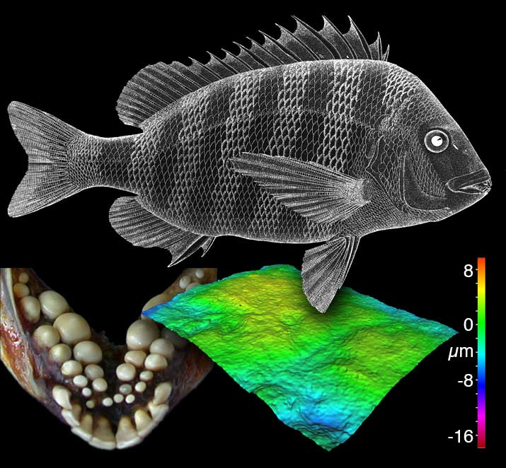
Figure 1: An example of tooth microwear in Sheepshead (from Purnell and Darras 2015).

Methodology:
Dietary analysis will be based on two proxies: stable carbon, nitrogen, and sulfur isotope analyses of bone, scale, and tooth protein using approaches developed by Guiry (Guiry and Szpak 2020; Guiry and Hunt 2020, Guiry et al. 2016, 2021); and quantitative analysis of dental microwear texture using approaches developed by Purnell (Purnell and Darras 2015). Spawning and habitat use patterns will be linked directly with diet and ‘ground truthed’ using modern and historical specimens to build a framework for millennium-scale retrospectives on fish behaviour. The project will also explore new methods for taxonomic identification, based on zooarchaeological techniques. New approaches to taphonomic analysis of postmortem wear in fish elements (pre- and post-burial) will also be developed.

References:

DeFrance, SD, Kennedy, JR. 2020. The Finny Tribe: How coastal, cosmopolitan New Orleans satisfied an appetite for fish. International Journal of Historical Archaeology 24.2: 367-397
Guiry, E. 2019. Complexities of stable carbon and nitrogen isotope biogeochemistry in ancient freshwater ecosystems: Implications for the study of past subsistence and environmental change." Frontiers in Ecology and Evolution 7 (2019): 313.
Guiry, E, Buckley, M, Orchard, T, et al. 2020. Deforestation caused abrupt shift in Great Lakes ecosystem. Limnology and Oceanography, 65.8: 1921-1935.
Guiry, E, Hunt, B. 2020. Integrating fish scale and bone isotopic compositions for ‘deep time’ retrospective studies. Marine Environmental Research 160: 104982.
Guiry, E.J., Kennedy, J.R., O’Connell, M.T., Gray, D.R., Grant, C. and Szpak, P., 2021. Early evidence for historical overfishing in the Gulf of Mexico. Science Advances, 7(32), p.eabh2525.
Guiry, E, Needs-Howarth, S, Friedland, et al. 2016. Lake Ontario salmon (Salmo salar) were not migratory: a long-standing historical debate solved through stable isotope analysis. Scientific Reports 6.1: 1-7.
Guiry, E, Royle, TCA, Matson, RG, et al. 2020. Differentiating salmonid migratory ecotypes through stable isotope analysis of collagen: Archaeological and ecological applications. PloS one 15.4: e0232180.
Guiry, E, Szpak, P. 2020. Quality control for modern bone collagen stable carbon and nitrogen isotope measurements. Methods in Ecology and Evolution 11.9: 1049-1060.
Guiry, E, Szpak, P, Richards, MP. 2016. Effects of lipid extraction and ultrafiltration on stable carbon and nitrogen isotopic compositions of fish bone collagen. Rapid Communications in Mass Spectrometry 30.13: 1591-1600.
Purnell, MA, Darras, LPG. 2015. 3D tooth microwear texture analysis in fishes as a test of dietary hypotheses of durophagy. Surface Topography: Metrology and Properties 4.1: 014006.
Vanderkooy, SJ. 2006. The sheepshead fishery of the Gulf of Mexico, United States: a fisheries profile Ocean Springs, Mississippi: Gulf States Marine Fisheries Commission. Fishery Profile Publication 143

Funding details:
NERC CENTA studentships are for 3.5 years and are funded by NERC. In addition to the full payment of your tuition fees, you will receive the following financial support:
- Annual stipend, currently set at £ 17,668 (2022/3 – new figures to be confirmed spring 2023)
- Research training support grant £8,000 (RTSG)
* If you do not meet the criteria for UK Fees you will need to fund the difference between UK and International fees for the duration of your studies.
* A limited number of top up studentships to fund the difference between UK and International fees may become available but are not guaranteed.
For more details of the CENTA consortium please see the CENTA website: www.centa.org.uk .
Entry requirements:
Applicants are required to hold/or expect to obtain a UK Bachelor Degree 2:1 or better in a relevant subject or overseas equivalent.
The University of Leicester English language requirements apply where applicable.
Application advice:
To apply please refer to
https://le.ac.uk/study/research-degrees/funded-opportunities/centa-phd-studentships
With your application, please include:
- CENTA Application form - available to download on the How to Apply section of the above link
- CV
- Personal statement explaining your interest in the project, your experience and why we should consider you
- Degree Certificates and Transcripts of study already completed and if possible transcript to date of study currently being undertaken
- Evidence of English language proficiency if applicable
- In the reference section please enter the contact details of your two academic referees in the boxes provided or upload letters of reference if already available.
In the funding section please specify that you wish to be considered for Ref CENTA2-SGGE14-GUIR

In the proposal section please provide the name of the supervisors and project title (a proposal is not required)

Project / Funding Enquiries to: CENTA@le.ac.uk or ejg26@le.ac.uk
Application enquiries to pgradmissions@le.ac.uk

