PhD studentship Project information

Funding Source: CENTA DTP
Proposed start date: 25th September 2023
Closing date for applications: 11th January 2023
Eligibility: UK/International
Department/School: SGGE
Supervisors: PI: Professor Michel J Branney UoL mjb26@le.ac.uk
Co-I: Dr Tiffany Barry UoL tlb2@le.ac.uk
Project Title: What happens during an explosive super-eruption?

Project Description :
Project Highlights:
- Fieldwork in the Yellowstone hotspot track in southern Idaho and Nevada, USA
- Physical volcanology of a super-eruption
- Variations in glass chemistry used to track what happens during a catastrophic event
- Training in modern fieldwork and micro-analytic techniques within a dynamic research team.
Overview:
Much attention has been given to identifying giant explosive volcanic eruptions in the geological record, and estimating their size and frequency. Less attention has been given to what actually happens during one of these eruptions; e.g. what are the physical processes, how long do they last, and how does a single eruption evolve with time? It is becoming apparent that the style of giant eruptions may differ fundamentally from the largest (e.g. Plinian) historic eruptions^{1,2} (Fig. 1). Resolving these issues is important if we are to understand the wider effects of major events¹.

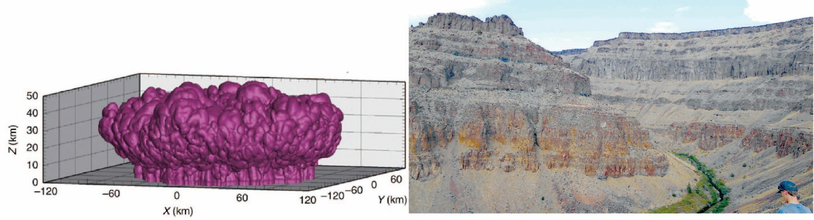
Fig. 1: Are plumes of super-eruptions really doughnut-shaped? (simulation from ²).
The evidence lies in vast pyroclastic sheet-like deposits; Snake River ignimbrites, USA¹ (right).

This PhD project aims to develop new understanding about what happens during a super-eruption. It focusses on an eruption in Idaho, USA, with a volume of ≤ 2800 km³ (magnitude 8.8) – the largest and hottest eruption from the Yellowstone hotspot yet documented³. The single welded ignimbrite covers ≥23,000 km² – an area larger than Wales. It is well-exposed⁴ allowing field access to ashfall layers and associated ignimbrite, both proximally and distally. The student will document the internal stratigraphy of the deposit in the field, followed by micro-analysis of the glassy ash textures and compositions at different heights, to track how physical processes evolved with time, during the eruption. Results will be used to develop a new model of how the largest eruptions on Earth begin, wax to a peak and then wane, and how the ash from them is more widely dispersed. The project will draw from the latest advances in understanding of large explosive eruptions², and should improve our understanding of some of the largest events on Earth.

Methodology:
The deposits of a single rhyolitic eruption will be logged and sampled in detail at numerous locations, in Idaho and neighbouring states. Geochemical analysis of individual glass shards⁵ at different levels in the deposit will be used to define time-lines (‘entrachrons’ ⁵) that can then be used to correlate with ultra-high precision across 100's of km. This approach will allow us to distinguish between successive time-slices (windows of just a few minutes) during an evolving, protracted volcanic eruption. Where conventional sieving is precluded by welding, new robust techniques developed by the research group will then be employed to quantify the different grainsizes and sorting characteristics of the deposit and used to deduce how each time-slice within it was deposited. The project will, for the first time, produce a time-series of data through a geographic spread of sites, both near to, and far from, the supervolcano. This will provide a unique basis on which to reconstruct how successive events unfolded at different locations as the eruption began, waxed and waned, and as the various types of atmospheric plume and density currents developed and shifted geographically during the eruption. Such detailed reconstruction has not been attempted before on eruptions of this scale.

References:

¹Branney, M.J., Bonnichsen, B., Andrews, G.D.M., Ellis, B., Barry, T.L., McCurry, M. 2008. ‘Snake River (SR)–type’ volcanism at the Yellowstone hotspot track: distinctive products from unusual high-temperature silicic super-eruptions’. In: Leeman, B., and McCurry (eds). 2008. Volcanism and petrogenesis of the anorogenic rhyolites, Bulletin of Volcanology 70: pp. 293-314.
² Costa, A., Suzuki, Y.J. and Koyaguchi, T., 2018. 'Understanding the plume dynamics of Explosive super-eruptions'. Nature Communications 9:654 doi: 10.1038/s41467-018-02901-0
³Knott, T.R., Branney, M.J., Reichow, M.K., Finn, D.R., Tapster, S., Coe, R.S. 2020. ‘Discovery of two new superuptions from the Yellowstone hotspot: Is Yellowstone hotspot waning?’ Geology 48. https://doi.org/10.1130/G47384.1
⁴Andrews, G.D. M., Branney, M.J. 2011. Emplacement and rheomorphic deformation of a large rhyolitic ignimbrite: Grey’s Landing, southern Idaho. Geological Society of America, Bulletin 123: 725-743. doi: 10.1130/B30167.
⁵Branney, M.J. and Kokelaar, B.P., 2002. ‘Pyroclastic density currents and the sedimentation of ignimbrites’. Geological Society of London, Memoirs 27. pp. 152.

⁶Pearce, N.J.G. Westgate, J.A., Perkins, W.T., Preece, S.J. 2003. The application of ICP-MS methods to tephrochronological problems. Applied Geochemistry 19: pp. 289-322.

Funding details:
NERC CENTA studentships are for 3.5 years and are funded by NERC. In addition to the full payment of your tuition fees, you will receive the following financial support:
- Annual stipend, currently set at £ 17,668 (2022/3 – new figures to be confirmed spring 2023)
- Research training support grant £8,000 (RTSG)
* If you do not meet the criteria for UK Fees you will need to fund the difference between UK and International fees for the duration of your studies.
* A limited number of top up studentships to fund the difference between UK and International fees may become available but are not guaranteed.
For more details of the CENTA consortium please see the CENTA website: www.centa.org.uk .
Entry requirements:
Applicants are required to hold/or expect to obtain a UK Bachelor Degree 2:1 or better in a relevant subject or overseas equivalent.
The University of Leicester English language requirements apply where applicable.

Application advice:
To apply please refer to
https://le.ac.uk/study/research-degrees/funded-opportunities/centa-phd-studentships
With your application, please include:
- CENTA Application form - available to download on the How to Apply section of the above link
- CV
- Personal statement explaining your interest in the project, your experience and why we should consider you
- Degree Certificates and Transcripts of study already completed and if possible transcript to date of study currently being undertaken
- Evidence of English language proficiency if applicable
- In the reference section please enter the contact details of your two academic referees in the boxes provided or upload letters of reference if already available.
In the funding section please specify that you wish to be considered for Ref CENTA2-SGGE10-BRAN

In the proposal section please provide the name of the supervisors and project title (a proposal is not required)

Project / Funding Enquiries to: CENTA@le.ac.uk or mjb26@le.ac.uk
Application enquiries to pgradmissions@le.ac.uk

