PhD studentship Project information
Funding Source: CENTA DTP
Proposed start date: 25th September 2023
Closing date for applications: 11th January 2023
Eligibility: UK/International
Department/School: Physics
Supervisors: PI: Dr Darren Wright, Darren.Wright@le.ac.uk , University of Leicester
Co-I: Prof Steve Milan, Steve.Milan@le.ac.uk , University of Leicester
Project Title: Investigating the Earth’s Upper Atmosphere with the EISCAT_3D radar

Project Description:
Project Highlights:
- Exploiting the first data from the new NERC EISCAT_3D radar facility to examine the coupled solar wind-magnetosphere-ionosphere-neutral atmosphere system
- Investigating the impact of high-latitude extreme space weather events on the upper and lower atmosphere by combining radar measurements with other ground- and space-based instruments.
- Providing a greater understanding of effects of solar variability on climate
Overview:
EISCAT_3D is a new, eagerly anticipated, multi-national all-sky incoherent scatter radar programme which is scheduled to start operating in Autumn 2023, following many years of development. Building on existing expertise within the Planetary Science Group the student will exploit the new radar data set in conjunction with measurements from other ground-based instruments (including our own new HF coherent radar) and satellites. They will investigate the impact of Space Weather events on the high-latitude upper and lower atmosphere and the energy flow from the solar wind into the Earth’s environment on a variety of time and spatial scales. This will involve the student working on international research programmes in conjunction with other researchers in other countries and presenting their findings at international meetings.

Following on from over 40 years of EISCAT auroral science, EISCAT_3D represents a step-change in our ability to make measurements in the Earth’s atmosphere and investigate processes of huge societal importance. A number of phenomena will be studied including geomagnetic storms, substorms and MHD waves, all of which are dynamic processes which transfer energy and momentum from near-Earth space into the Earth’s atmosphere. During these processes energetic particle precipitation (EPP) are observed to occur which drive associated aurorae and cause lower atmospheric changes (e.g. to the local chemistry). EPP are now considered to have influence on the existence of chemical species (including ‘odd’ nitrogen, NOx) which have impact on the destruction of atmospheric ozone. The project will explore links between solar variability, atmospheric chemistry and climate.

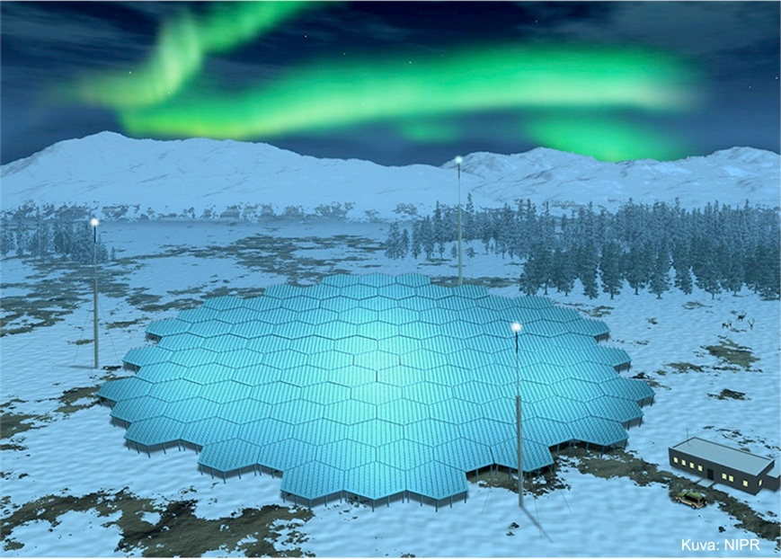
Figure 1: An artist’s impression of the new radar EISCAT_3D based at Skibotn, near Tromsø in Norway, making measurements of the aurora.

Methodology:
Initially, the student will become familiar with the operations of the EISCAT_3D radar and the processing and interpretation of data sets from relevant ground-based instruments (e.g. radars and magnetometers) and spacecraft. This may also involve training in the use of the radar systems and some arctic fieldwork. The student will employ existing complex data analysis methods and write code to extend this as required.
Subsequently, the student will undertake conjunctive multi-instrument case studies, followed by a statistical analysis of more extended data sets, assess existing models for NOx and ozone generation and create collaborative links with relevant modellers and create a coupled model between upper atmospheric EPP and lower atmospheric NOx.
The student will develop transferable skills in coding, data analysis, undertaking fieldwork, working independently and also as part of a team. They will also be required to publish their work in peer-reviewed journals and present it at national and international conferences.
Funding details:
NERC CENTA studentships are for 3.5 years and are funded by NERC. In addition to the full payment of your tuition fees, you will receive the following financial support:
- Annual stipend, currently set at £ 17,668 (2022/3 – new figures to be confirmed spring 2023)
- Research training support grant £8,000 (RTSG)
* If you do not meet the criteria for UK Fees you will need to fund the difference between UK and International fees for the duration of your studies.
* A limited number of top up studentships to fund the difference between UK and International fees may become available but are not guaranteed.
For more details of the CENTA consortium please see the CENTA website: www.centa.org.uk .
Entry requirements:
Applicants are required to hold/or expect to obtain a UK Bachelor Degree 2:1 or better in a relevant subject or overseas equivalent.
The University of Leicester English language requirements apply where applicable.

Application advice:
To apply please refer to
https://le.ac.uk/study/research-degrees/funded-opportunities/centa-phd-studentships
With your application, please include:
- CENTA Application form - available to download on the How to Apply section of the above link
- CV
- Personal statement explaining your interest in the project, your experience and why we should consider you
- Degree Certificates and Transcripts of study already completed and if possible transcript to date of study currently being undertaken
- Evidence of English language proficiency if applicable
- In the reference section please enter the contact details of your two academic referees in the boxes provided or upload letters of reference if already available.
In the funding section please specify that you wish to be considered for Ref CENTA2-PHYS2-WRIG

In the proposal section please provide the name of the supervisors and project title (a proposal is not required)

Project / Funding Enquiries to: CENTA@le.ac.uk or Darren.Wright@le.ac.uk
Application enquiries to pgradmissions@le.ac.uk

