PhD studentship Project information
Funding Source: CENTA DTP
Proposed start date: 25th September 2023
Closing date for applications: 11th January 2023
Eligibility: UK/International
Department/School: Chemistry
Supervisors: P-I: Dr Shengfu Yang, School of Chemistry, University of Leicester; sfy1@le.ac.uk.
Co-I: Dr Ruth Saunders, Department of Respiratory Sciences, University Hospitals of Leicester NHS Trust; rms4@leicester.ac.uk.
Co-I: Prof. Julie Morrissey, Department of Genetics and Genome Biology, University of Leicester; jam26@leicester.ac.uk.
Project Title: Environment and Health: Influence of Microplastic and Nanoplastics on Lung Cells

Project Description:
Project Highlights:
- Exploratory research on how microplastics and nanoplastics (MNPLs) impact on human health
- Study of how MNPLs affect long diseases by assessing their influence on smooth muscle and epithelial bacterial cells
- A multidisciplinary supervisory team to facilitate the student with wide-ranging skills
Overview:
Macroscale plastic waste polluting the earth is now a well-known issue, triggering policies that aim to limit the production and use of plastic bags and bottles, and increase of recycling. However, plastics at much smaller scale, namely, microplastics (particles < 5 mm) and nanoplastics (particles < 1 μm), can have insidious effects, which raise growing awareness and concern. These particles are produced from a variety of sources, such as breakdown of larger plastic debris into smaller pieces, synthetic clothing fibres, dust from tyres, and even from chewing gums and toothpastes. MNPLs are ubiquitous in the marine environment, which are now found inside living organisms, and can have diverse impact on marine ecosystems and humans through physical damage and chemical transfer of toxicants.
Humans are extensively and inevitably exposed to environmental MNPLs, mainly through inhalation and ingestion.¹⁻³ MNPLs are now ubiquitous in our daily life; for example, a recent analysis of tap water samples from around the world found that a high proportion (>80%) of drinking water is contaminated with MNPLs. MNPLs can cause oxidative stress, inflammatory lesions, increased internalization or translocation through tissues. Once internalized, MNPLs can release toxic compounds added during manufacture to enhance the polymers’ performance. Additionally, MNPLs can adsorb and facilitate the transport of other environmental contaminants and pathogens into living organisms, in the way of a Trojan horse. Microplastics have recently been detected in human lungs, phlegm and bloodstream; and studies suggest that exposure to MNPLs contributes to respiratory problems in certain groups of workers.⁴⁻⁶ Experiments in rodents support a detrimental role of MNPLs in lung health, e.g., via changes in the epithelial cells that line the airways, increased inflammation, and airway tissue thickening (termed “fibrosis”).^{7,8}
This project will study the effects of MNPLs on airway smooth muscle (ASM) and epithelial cells that surround the airways in fibres/bundles, which are important as they help maintain the airway calibre in health and can become dysfunctional in respiratory disease that contributes to breathing difficulties. The lung microbial community also plays a major role in respiratory health and disease, which will be influenced by MNPLs and will be explored.
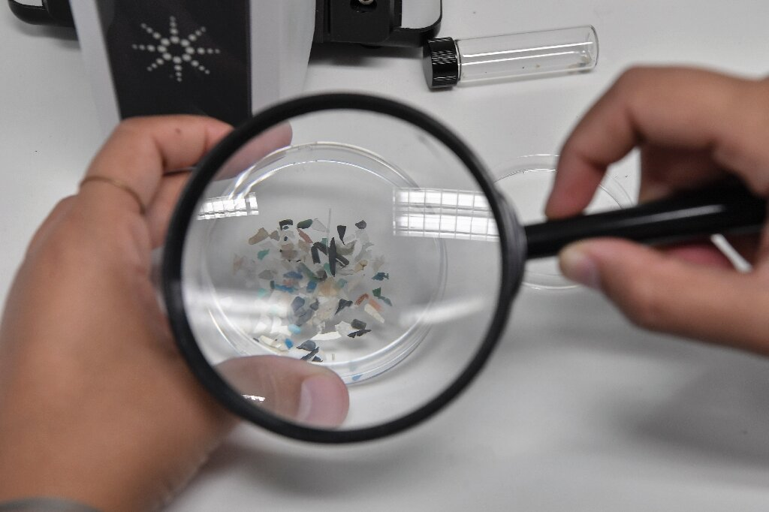
Figure 1: Microplastics had already been spotted in oceans, air and food – now researchers have found it in human blood [Source: Phys.org/News].

Methodology:
MNPLs ranging between 50 nm to 100 μm will be investigated. We will also embed photoluminescent nanoparticles into MNPLs to track MNPLs in cells. Whether MNPLs can adhere to and/or be internalised by ASM and epithelial cells will be studied by optical microscopy and atomic force microscopy. Key changes in response to the dysfunction of ASM and epithelial cells, such as contraction, production of inflammatory substances, and the number or size of cells surrounding the airway, will be assessed using various in vitro ASM and epithelial cell-based assays routinely available in the laboratory. This will include assays to measure levels of contraction-related proteins, contraction per se, migration, proliferation, viability, size and production of inflammation-causing substances. We will also study how the concentration, size, and type of MNPLs affect the bacterial interaction with epithelial and ASM cells by assessing cell viability and structure using microbiology and advanced imaging technologies.

References:

- Vethaak, A. D., Legler, J. (2021) Microplastics and human health Knowledge gaps should be addressed to ascertain the health risks of microplastics, Science, Feb. 12; 371:6530. doi: 10.1126/science.abe5041.
- Prata, J.C., da Costa, J.P, Lopes, I., Duarte, A.C., Rocha-Santos, T. (2020) Environmental exposure to microplastics: An overview on possible human health effects, Sci Total Environ, Feb 1;702:134455. doi: 10.1016/j.scitotenv.2019.134455
- Liang, B., Zhong, Y., Huang, Y., Lin, X., Liu, J., Lin, L., et al. (2021) Underestimated health risks: polystyrene micro- and nanoplastics jointly induce intestinal barrier dysfunction by ROS-mediated epithelial cell apoptosis, Part Fibre Toxicol, Jun 7;18(1):20. doi: 10.1186/s12989-021-00414-1.
- Amato-Lourenço, L.F., Carvalho-Oliveira, R., Júnior, G.R., Dos Santos Galvão, L., Ando, R.A., Mauad, T. (2021) Presence of airborne microplastics in human lung tissue, J Hazard Mater, Aug 15;416:126124. doi: 10.1016/j.jhazmat.2021.126124.
- Huang, S., Huan, X., Bi, R., Guo, Q., Yu, X., Zeng, Q., et al. (2022) Detection and Analysis of Microplastics in Human Sputum, Environ Sci Technol, Feb 15;56(4):2476-2486. doi: 10.1021/acs.est.1c03859.
- Leslie, H.A., van Velzen, M.J.M., Brandsma, S.H., Vethaak, A.D., Garcia-Vallejo, J.J., Lamoree, M.H.
(2022) Discovery and quantification of plastic particle pollution in human blood, Environ Int, May;163:107199. doi: 10.1016/j.envint.2022.107199.
- Lu, K., Lai, K.P., Stoeger, T., Ji, S., Lin, Z., Lin, X., et al. (2021) Detrimental effects of microplastic exposure on normal and asthmatic pulmonary physiology, J Hazard Mater, Aug 15;416:126069. doi: 10.1016/j.jhazmat.2021.126069.
- Xu, M., Halimu, G., Zhang, Q., Song, Y., Fu, X., Li, Y., et al. (2019) Internalization and toxicity: A preliminary study of effects of nanoplastic particles on human lung epithelial cell, Sci Total Environ, Dec 1;694:133794. doi: 10.1016/j.scitotenv.2019.133794.

Funding details:
NERC CENTA studentships are for 3.5 years and are funded by NERC. In addition to the full payment of your tuition fees, you will receive the following financial support:
- Annual stipend, currently set at £ 17,668 (2022/3 – new figures to be confirmed spring 2023)
- Research training support grant £8,000 (RTSG)
* If you do not meet the criteria for UK Fees you will need to fund the difference between UK and International fees for the duration of your studies.
* A limited number of top up studentships to fund the difference between UK and International fees may become available but are not guaranteed.
For more details of the CENTA consortium please see the CENTA website: www.centa.org.uk .
Entry requirements:
Applicants are required to hold/or expect to obtain a UK Bachelor Degree 2:1 or better in a relevant subject or overseas equivalent.
The University of Leicester English language requirements apply where applicable.

Application advice:
To apply please refer to
https://le.ac.uk/study/research-degrees/funded-opportunities/centa-phd-studentships
With your application, please include:
- CENTA Application form - available to download on the How to Apply section of the above link

- Degree Certificates and Transcripts of study already completed and if possible transcript to date of study currently being undertaken
- Evidence of English language proficiency if applicable
- In the reference section please enter the contact details of your two academic referees in the boxes provided or upload letters of reference if already available.
In the funding section please specify that you wish to be considered for Ref CENTA2-CHEM2-YANG

In the proposal section please provide the name of the supervisors and project title (a proposal is not required)

Project / Funding Enquiries to: CENTA@le.ac.uk or sfy1@le.ac.uk.
Application enquiries to pgradmissions@le.ac.uk

