PhD studentship Project information
Funding Source: CENTA DTP
Proposed start date: 25th September 2023
Closing date for applications: 11th January 2023
Eligibility: UK/International
Department/School: Chemistry
Supervisors: PI: Dr Stephen Ball (sb263@leicester.ac.uk), School of Chemistry, University of Leicester.
Co-I: Prof Paul Monks (psm7@leicester.ac.uk) School of Chemistry, University of Leicester.
Co-I: Prof Bill Bloss (w.j.bloss@bham.ac.uk), School of Geography Earth and Environmental Sciences, University of Birmingham.
Project Title: Oxidised nitrogen compounds and their role in the chemistry of air pollution.

Project Description:
Project Highlights:
- Contribute towards a better understanding of nitrogen compounds’ atmospheric chemistry and their roles in determining air quality
- Gain expertise in using highly sensitive instrumentation to record air pollutants
- Conduct collaborative field work at one of the UK’s three air quality supersites

Overview:
Air pollution is responsible for around 350,000 premature deaths per year in Europe [1] and 7 million globally [2]. In the UK and in Europe, the three most toxic air pollutants are NO2 (nitrogen dioxide), tropospheric O3 (ozone) and PM (particulate matter). NO2 and PM are emitted directly from various human-made sources and a few natural sources. But the majority of NO2 comes from road vehicles: substantial decreases in NO2 concentrations were observed in many UK and European cities during COVID lockdown restrictions when people’s activity was much reduced [1]. In contrast, tropospheric ozone is not emitted directly but rather it is produced within the atmosphere itself from the photochemical oxidation of volatile organic compounds in the presence of NOx (NO+NO2). Some types of PM are also formed and/or chemically transformed in the atmosphere. Controlling these secondary air pollutants is challenging because it requires control of their precursors (such as NO2 for tropospheric ozone), and such efforts must be informed by a thorough understanding of the chemical pathways.
Observations of air pollutants are vital. The Automated Urban and Rural Network (AURN) has 150 air monitoring sites located around the UK [3]. Additionally, three “air quality supersites” have been established that contain more extensive instrumentation for monitoring atmospheric composition than is available at regular AURN sites. One supersite is on Birmingham University’s campus [4], where this project will deploy additional research instruments to quantify oxidised nitrogen compounds (collectively termed “NOy”).
To further complicate the picture, air pollutant concentrations are highly dynamic, especially close to pollution sources. For example, Figure 1 shows measurements of NO2 and aerosol optical depth (related to PM concentrations) measured close to a roadside over a brief 10 minute interval. Concentrations can change by a factor of 3 in just a few seconds with the passing traffic. Notice also how some vehicles were strong emitters of both NO2 and aerosol (peaks at 15:21:40 and 15:22:27); others emitted aerosol but only small amounts of NO2 (15:15:55 and 15:17:12); and others strongly emitted NO2 but very little aerosol (15:19:47).
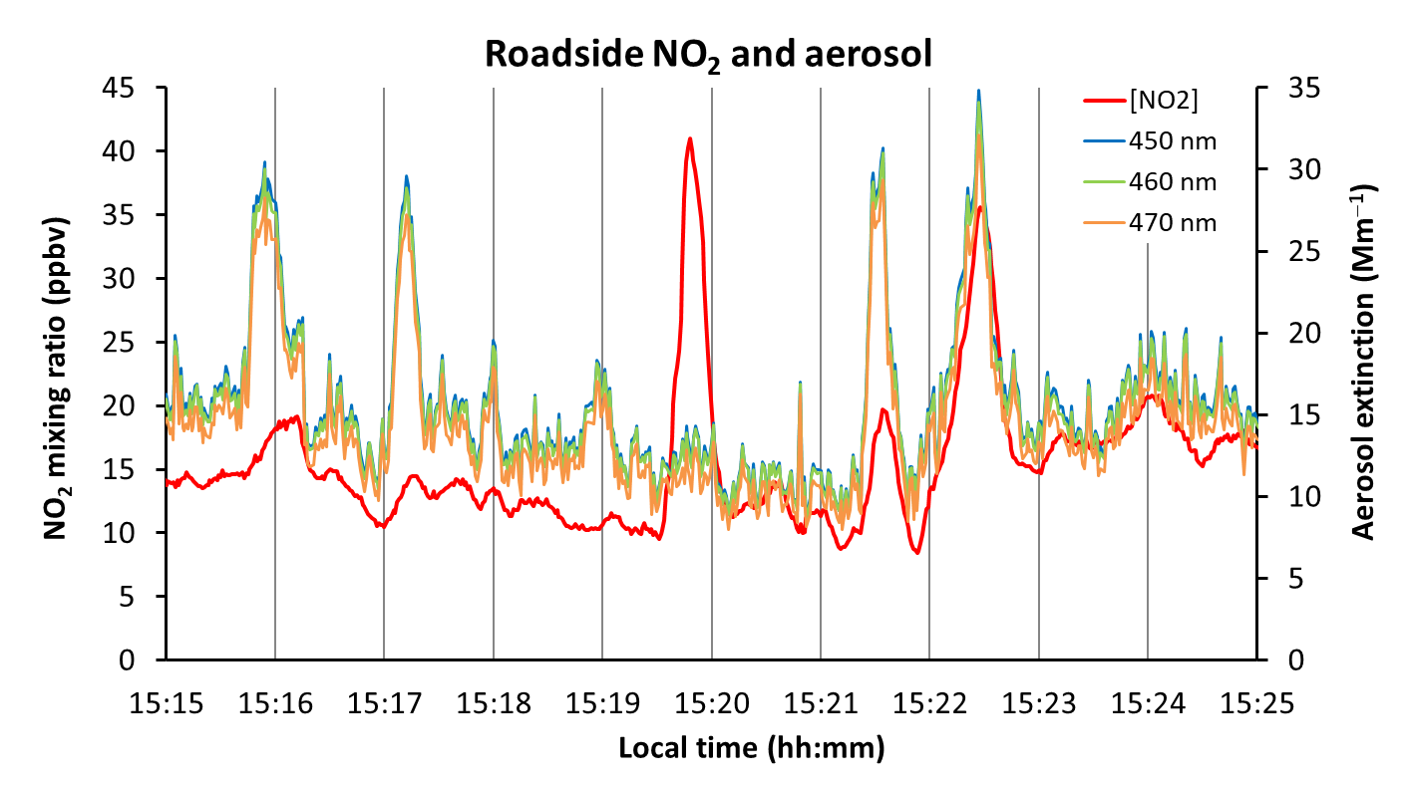
Figure 1: A time series of emissions from road vehicles. NO2 mixing ratios are in red, overlaid by wavelength-resolved aerosol extinctions (coloured as stated in the legend). The BBCEAS instrument sampled at 1 second time resolution from the second-storey window of a building at Leicester University that overlooks a public road approximately 10 metres away.

Methodology:
The CENTA student will use a broadband cavity enhanced absorption spectrometer (BBCEAS) built at Leicester University. This instrument acquired the data shown in Figure 1. Multiple reflections of light between the instrument’s mirrors generates the “cavity enhancement” – photons typically travel 5 km through the gas sample, thereby producing the instrument’s high sensitivity. The instrument is configurable at different wavelength regions: (i) near-UV to measure HONO and NO2 [5] (HONO is a source of the daytime oxidant OH radicals), (ii) blue wavelengths for fast NO2 measurements like in Figure 1, or (iii) red wavelengths to quantify the night-time reservoir compound N2O5 [6]. It is anticipated the student will measure different NOy species at different stages of the project to complement the ongoing “core” observations at the supersite, plus a more intense measurement period targeting the formation of aerosol nitrate from the deposition of N2O5 and HNO3.

References:

[1] “Air quality in Europe – 2021 report”, European Environment Agency (2021), https://www.eea.europa.eu/publications/air-quality-in-europe-2021/health-impacts-of-air-pollution
[2] The Lancet Commission on pollution and health, P.J. Landrigan et al., (2018) vol 391, issue 10119, pages 462-512, http://dx.doi.org/10.1016/S0140-6736(17)32345-0
[3] Automatic Urban and Rural Network (AURN), https://uk-air.defra.gov.uk/networks/network-info?view=aurn
[4] Air quality supersites, https://clean-air-research.org.uk/projects/aqst/ and https://www.strath.ac.uk/workwithus/cop26/innovationshowcase/behindthescience/measuringtheairwebreathe/
[5] Nitrous acid (HONO) emissions under real-world driving conditions from vehicles in a UK road tunnel, L.J. Kramer, L.R. Crilley, T.J. Adams, S.M. Ball, F.D. Pope, and W.J. Bloss, Atmos. Chem. Phys., 20, 5231–5248, (2020), https://doi.org/10.5194/acp-20-5231-2020
[6] Atmospheric chemistry at night, S.M. Ball, (2014), http://www.rsc.org/images/environmental-brief-no-3-2014_tcm18-237724.pdf.

Funding details:
NERC CENTA studentships are for 3.5 years and are funded by NERC. In addition to the full payment of your UK tuition fees, you will receive the following financial support:
- Annual stipend, currently set at £ 17,668 (2022/3 – new figures to be confirmed spring 2023)
- Research training support grant £8,000 (RTSG)
* If you do not meet the criteria for UK Fees you will need to fund the difference between UK and International fees for the duration of your studies.
* A limited number of top up studentships to fund the difference between UK and International fees may become available but are not guaranteed.
For more details of the CENTA consortium please see the CENTA website: www.centa.org.uk .
Entry requirements:
Applicants are required to hold/or expect to obtain a UK Bachelor Degree 2:1 or better in a relevant subject or overseas equivalent.
The University of Leicester English language requirements apply where applicable.

Application advice:
To apply please refer to
https://le.ac.uk/study/research-degrees/funded-opportunities/centa-phd-studentships
With your application, please include:
- CENTA Application form - available to download on the How to Apply section of the above link
- CV
- Degree Certificates and Transcripts of study already completed and if possible transcript to date of study currently being undertaken
- Evidence of English language proficiency if applicable
- In the reference section please enter the contact details of your two academic referees in the boxes provided or upload letters of reference if already available.
In the funding section please specify that you wish to be considered for Ref CENTA2-CHEM1-BALL

In the proposal section please provide the name of the supervisors and project title (a proposal is not required)

Project / Funding Enquiries to: CENTA@le.ac.uk or sb263@leicester.ac.uk
Application enquiries to pgradmissions@le.ac.uk

