University of Leicester

Project Reference | BRC Studentships

First Supervisor | ​Professor Gavin Murphy​
School/Department | ​Cardiovascular Sciences
Email | ​gjm19@le.ac.uk

Second Supervisor | Dr Marcin Wozniak
School/Department | ​Cardiovascular Sciences
Email | ​mw299@le.ac.uk

Additional Supervisor | ​Adewale Adebayo​
School/Department | Cardiovascular Sciences
Email | asa50@le.ac.uk

Section 2 – Project Information
Project Title | ​Epigenetic regulation of myocardial cell signaling in multiple long-term conditions and frailty​
Project Highlights: | 1. Epigenetics in cardiovascular disease and frailty
 | 2. Integration of transcriptomics and chromatin organisation
 | 3. Bioinformatics and coding skills
Project Summary
Background: ​Multiple long-term conditions (MLTC) are associated with the development of the frailty phenotype, a condition characterized by increased susceptibility to injury or metabolic insults. Improved understanding of the mechanisms underlying these changes could identify new therapeutic targets or strategies to improve clinical outcomes and quality of life in this high-risk population. We have shown that MLTC are associated with specific cellular changes in human myocardium that are consistent with biological ageing; a constellation of processes including immunosenescence, DNA damage, metabolic switching, mitochondrial dysfunction, epigenetic dysregulation, and cell senescence. Also, our previous work altering these processes changes the susceptibility of human cardiomyocytes to metabolic stress in vitro, representing a potential mechanistic link between MLTC and clinical frailty. Many of the effects of MLTC on biological ageing are thought to be mediated via epigenetic mechanisms, although these are poorly defined. We have performed combined single nuclei RNA seq and ATAC seq in mouse hearts, but not yet in human hearts. This three-year PhD project aims to achieve this in human myocardial biopsies and to use established and novel systems biology techniques to explore underlying cellular processes, cell-cell interactions, and modifiable targets for intervention development.

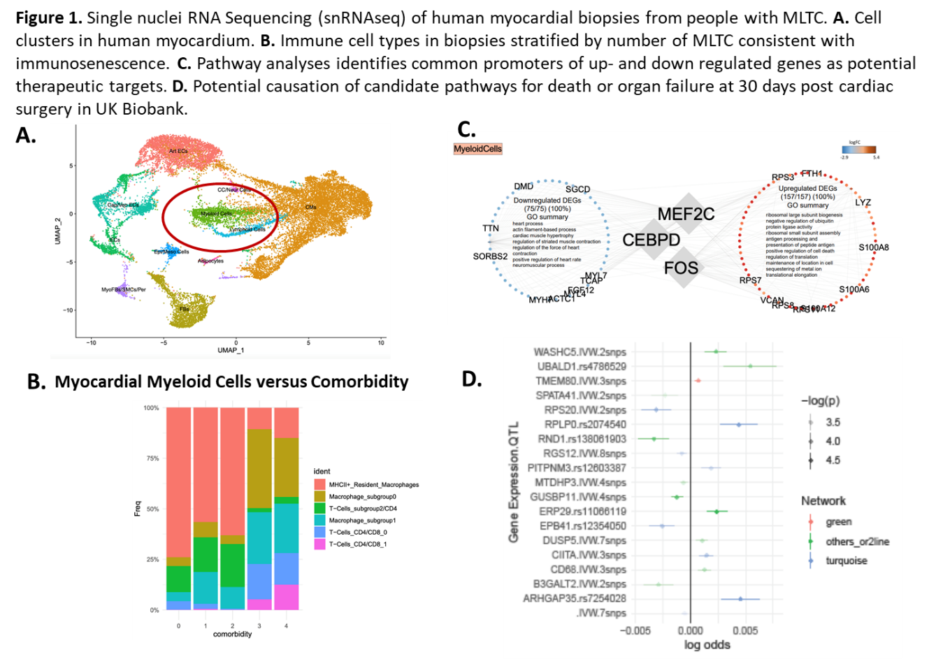
Aim: ​To identify the genetic and epigenetic endotype of biological ageing in myocardial biopsies of people with biological ageing/ frailty.​

Research Plan: ​
- Study 1: A systematic review of single cell/ nuclei ATAC sequencing in cardiovascular disease.
- Study 2: Combined single nuclei RNA and ATAC sequencing in human myocardial biopsies using refinement of protocols established in mice. Biopsies have already been collected as part of the ongoing ObCARD study.
- Study 3. Bioinformatics analysis of combined RNA/ ATAC sequencing data in people with/ without MLTC, and people with/ without Frailty.
- Study 4. External validation of findings using targeted analysis of human myocardial biopsies from the VAL-CARD trial, the human cell atlas, and published GEO datasets. Training and development will focus on wet-lab techniques including DNA library construction and single nuclei RNA/ ATAC sequencing as well as targeted validation using FACS and QT PCR. Informatics skills development will focus on bioinformatics, systems biology, and machine learning. ​

Expected outcomes and impact: ​Single cell resolution has provided important new knowledge as to the cellular heterogeneity of common disease processes. We believe that this combined RNA/ ATAC approach to the study of human myocardium in people with MLTC will be unique and will confer key, modern research skills to the successful applicant. ​

References

