University of Leicester

Project Reference | BRC Studentships

First Supervisor | Dr Hannah Young
School/Department | Diabetes Research Centre
Email | hy162@leicester.ac.uk

Second Supervisor | Dr Louisa Herring
School/Department | Diabetes Research Centre
Email | louisa.herring@uhl-tr.nhs.uk

Additional Supervisor | Prof Melanie Davies

Section 2 – Project Information
Project Title | Supporting people with long term conditions from underserved groups to improve their 24-hour physical behaviours: a mixed-methods study.
Project Highlights: | 1. | Opportunity to learn a variety of research methodologies
 | 2. | Strong focus on engaging and working with diverse stakeholders
 | 3. | An exciting opportunity to help ensure international guidance is closer to being implemented within practice
Project Summary
Background: Recent guidance recognises that people with long-term conditions (LTCs) require support to address 24-hour health behaviours, also known as “the 5S’s”; sleeping, sitting, stepping, sweating and strengthening, which can significantly impact their health¹.

This support should consider important intersectional social determinants of health (e.g. ethnicity, socioeconomic status), in addition to health and digital literacy. However, these factors are rarely considered, potentially worsening health inequalities. This is exacerbated by limited clinic time, and lack of skills/confidence to discuss 24-hour health behaviours amongst healthcare professionals (HCPs).

The Leicester Diabetes Centre has developed tools to facilitate clinical conversations around the 24-hour physical behaviours and provide tailored support, including an online physical activity and health metrics dashboard, and a web application to provide personalised guidance and support (see figure). This project will:
- adapt and refine these tools for people with LTCs from underserved groups
- integrate them into current hospital systems (e.g. SystmOne),
- develop a training package to facilitate their use by HCPs.

Research plan
The project will include three stages, encompassing quantitative, qualitative, and digital health methodologies, underpinned by diverse PPI/E and informed by NIHR INCLUDE guidance:
- A review of existing interventions targeting any of the 24-hour physical behaviours in underserved populations, to identify which adaptations may be effective

- Using the ADAPT guidance:
  - Undertake ‘think aloud’ interviews with people from underserved populations, to further elucidate the adaptations required
  - Refine and adapt existing tools, and co-produce associated training materials for HCPs using a series of workshops
- Conduct a mixed-methods acceptability study, to explore the extent to which the adapted tools and training meet the needs of underserved populations and HCPs. Measures will include (but are not limited to):
  - Feasibility (eligibility, recruitment, retention, uptake and engagement with the tools/training)
  - Change in the 5S’s in people living with LTCs
  - Attitudes, beliefs, and knowledge and confidence relating to 24-hour health behaviour support in HCPs.
Observation and semi-structured interviews will explore acceptability, fidelity, dose, and reach. Quantitative data will be analysed descriptively, and qualitative data using a reflexive thematic approach. Both sets will be then integrated.

Expected outcomes and impact: This project will reach a wide group of people, including those most at risk of adverse outcomes. The refined tools and training can be embedded within a variety of clinical and research contexts.

Figure 1: A visual of the Steps4Health web application

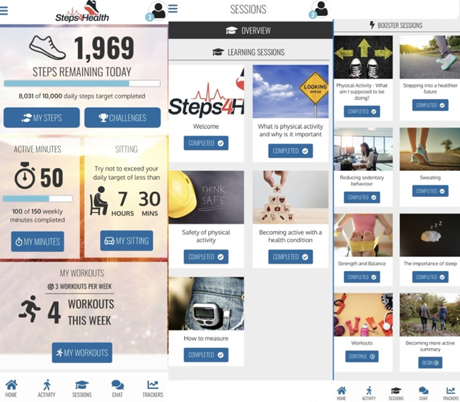

References

1. Davies MJ, Aroda VR, Collins BS, Gabbay RA, Green J, Maruthur NM, Rosas SE, Del Prato S, Mathieu C, Mingrone G, Rossing P. Management of hyperglycemia in type 2 diabetes, 2022. A consensus report by the American Diabetes Association (ADA) and the European Association for the Study of Diabetes (EASD). Diabetes Care. 2022 Nov;45(11):2753-86.

