University of Leicester Future 100 PhD Scholarship
Project Reference: RI-SPACE-Sembhi

Section 1 – Supervisor Information
First Supervisor | Dr Harjinder Sembhi
School/Department | Physics and Astronomy
Email | hs32@le.ac.uk

Proposed Second Supervisor | Prof Hartmut Boesch
Additional Supervisor | Professor Rajiv Sinha

Section 2 – Project Information
Project Title | Decoding plant fluorescence signatures in intensive agricultural regions with space sensors
Project Highlights: | 1. | Opportunity to work with innovative new satellite data on plant fluorescence
 | 2. | Collaborate with leading international institutions in India and the UK
 | 3. | Contribute to a body of research focussed on mitigating future climate risks to food security
Project Overview
A growing world population is placing huge demands on natural resources (such as water and soil) for the production of food. One region where environmental pressures related to agricultural intensification have become increasingly frequent is the breadbasket region of India, the Indo-Gangetic Plain (IGP), home to hundreds of millions inhabitants. The Agrarian population faces substantial challenges caused by largescale groundwater depletion and crop yield losses due to drought and extreme weather, issues that pose a risk to the future of food and water security.

Natural and human-induced environmental change can be captured in near real-time at high spatial resolution using satellite-based Earth Observation (EO). A host of state-of-the-art satellite sensors are currently providing innovative information such as land surface temperature and indicators of vegetation productivity. In particular, space-based solar induced fluorescence (SIF) measurements, a parameter that captures the “glowing” signatures of plants when they photosynthesize, have great potential for diagnosing environmental stress on vegetation which could be very useful for the early detection of water or nutrient stress on plants.

Current research to understand the variability of SIF signatures is fairly limited, especially when crops are undergoing heat-stress or are impacted by drought, and understanding its relationship to water stress in climate sensitive zones needs investigation. Understanding cropland signatures can be challenging because the landscape holds a manifestation of human behaviour, agricultural management and land-use policies.
In this project, the student will develop new methodologies that combine different sources of information from satellite observations to gain an understanding of plant health and stress (particularly in key food production areas) in the Indo-Gangetic Plain. This is of relevance for agricultural management across the region and can help develop intervention methods that mitigate threats to food security.

The proposed work is important because it links to key European Space Agency (ESA) activities such as the future launch of the 330 million Euro FLEX satellite mission, which will offer a new frontier in mapping high resolution vegetation stress globally (https://earth.esa.int/eogateway/missions/flex).

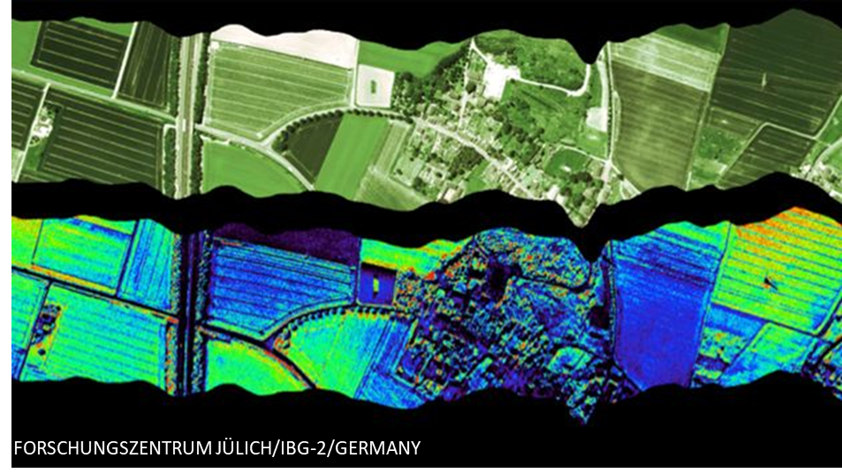
Figure shows the variation of SIF over fields from an aircraft sensor. Credit: https://www.bbc.co.uk/news/science-environment-34868153.

Methodology
In this project, the student will use an innovative multi-sensor approach, combining novel observations of vegetation from space and from the ground. The student will work with satellite SIF observations and land surface temperature (LST) information (which capture the imprint of plant stress and indicate when plants are suffering due to drought conditions) to understand its variability across the Indo-Gangetic Plain.

The student will develop methods to determine the baseline conditions, timescales and relationship between coincident SIF and LST, and verify the success of these methods in detecting regional crop stress using data from an agricultural observatory located the Ganges Basin. The student will map the variations of SIF when crops are under prolonged water stress in key agricultural regions. There will be an opportunity to travel and work with in-country partners and develop pathways to link into modelling to crop yield and water management.

References:
Sembhi, H., Ghent, D., Dodd, E., Sinha, R., Dash, S., Singh, T., Mor, S., Khaiwal, R., Evaluating Sentinel 3 SLSTR and INSAT-3D land surface temperature with in situ sensors over intensive agriculture regions in North India, Remote Sens Environ, (In preparation), 2021

Majumder, A., Setia, R., Kingra, PK., Sembhi, H., Singh SP, Pateriya, B., Estimation of land surface temperature using different retrieval methods to study the spatio-temporal variations of surface urban heat and cold islands in Indian Punjab, Environ Dev Sustain, 2021

Ghent, D., Veal, K., Trent, T., Dodd, E., Sembhi, H., Remedios, J., A New Approach to Defining Uncertainties for MODIS Land Surface Temperature. Remote Sens. 2019, 11, 1021, 2019
Gupta, S., S. H. Karumanchi, S. K. Dash, S. Adla, S. Tripathi, R. Sinha, D. Paul, and I. S. Sen (2019), Monitoring ecosystem health in India's food basket, Eos, 100, https://doi.org/10.1029/2019EO117683

