# **Risk Assessment Form**

|  |  |
| --- | --- |
| Persons Designated (PD): |  |
| Departmental name: |  |
| Date Assessment conducted: |  |
| Department Head: |  |
| Date of previous risk Assessment: |  |
| Designated Individual (DI): |  |

Risk Assessment Process

The risk assessment process consists of identifying, analysing, evaluating risks on a continual basis. It can be seen as a 5-step continual process:-

1. Identify risk –

Physical: Suitability of premises i.e. lifting, awkward postures, slips and trips, noise, dust, machinery etc.

Biological: including tuberculosis, hepatitis and other infectious diseases faced by healthcare workers, home care staff and other healthcare professionals.

1. Identify the risks– what, why and how events can happen.

* Equipment not fit for purpose;
* Loss of relevant material;
* Tissue is collected, stored or used without consent;
* Storing or using human tissue after consent withdrawal;
* Loss or mix up of material due to inadequate labelling and tracking system;
* Storage failure or other damage affecting human tissue quality for useful research;;
* Risk of Infection when handling samples of tissue, blood, urine etc;
* Loss of material due to inadequate packaging during transport;
* Transport of specimens to other buildings of the establishment;
* Material transferred without NRES approval, appropriate consent or to an unlicensed site;
* Material disposed of by an inappropriate method/route;
* Disposal records not retained for audit;
* Material disposed of in error.
* Security arrangements

1. Determine the likelihood of a hazard occurring– determine the existing controls and analyse the risk in terms of the potential consequences for the University and its likelihood in the context of the existing controls.
2. Evaluate the risks– Evaluate and rank the risks.
3. Treat the risks– Options to minimise the risk must be identified, treatment action plans must be developed and solutions implemented.

|  |  |  |  |  |  |  |  |  |  |  |
| --- | --- | --- | --- | --- | --- | --- | --- | --- | --- | --- |
| Reference e.g., lab/Freezer | Description of Risk – describe the potential problem. | Existing risk assessments– physical controls and/or systems currently in place to reduce the risk of adverse incidents? | | Risk Assessments | | | |  | | |
| Severity  (S) | | Likelihood  (L) | | Risk Rating  (SxL) | | Risk ranking |
|  | Consent.   1. Tissue is collected, stored or used without consent. 2. Storing or using human tissue after consent withdrawal. 3. Material Transferred without NRES approval, appropriate consent or to an unlicenced building. | 1. All Research requires approval by UEIC or NHS RECs. Consent forms and processes are reviewed by Sponsor / ethics committee members. 2. Relevant Material is stored for future research, undergo an end of study audit by the HTA Monitor.   Linkage is maintained to enable withdrawal at a later date.   1. All human sample related contracts undergo due diligence checks undertaken via the HTA Monitor.   Copies of consent forms are requested, if unable to obtain copies, temples of PIS/ICF and IRAS documents are requested are requested for due diligence. | | 4  1  2 | | 1  1  3 | | 4  2  6 | | Very Low  Very Low  Low |
|  | Handling and Storage   1. Risk of Infection when handling samples of tissue, blood, urine etc. 2. Loss or mix up of material due to inadequate labelling and tracking system; 3. Storage failure or other damage affecting human tissue quality for research 4. Loss of material 5. Equipment not fit for purpose 6. Security Arrangements | 1. HBA risk assessments are reviewed by safety service. Training provided and Hep B immunity established for lab operators. 2. Individual studies set-up sample handling. Documentation and spreadsheets used to manage study samples. HTA_A1012_UoL for tracking samples 3. Online monitoring system in place to alert users when fridges/freezers are set outside temperature range. Hospital generator to back up power. Local contingency plan with emergency storage space.   Processing equipment maintained and inspected, provide alternative equipment where possible in event of breakdown.   1. Sample logs / sample maps for storage area are available to enable safe storage of valuable samples 2. Fridges / freezers and cryogenic freezers are serviced annually to ensure equipment issues are picked up and addressed. 3. Access to lab and offices requires pin code door entry. Further pin code required to access the freezer storage area | | 4  4  5  2  2  1 | | 1  2  1  2  2  1 | | 4  8  5  4  4  2 | | Very Low  Low  Very Low  Very Low  Very Low  Very Low |
| Reference e.g., lab/Freezer | Description of Risk – describe the potential problem. | Existing risk assessments– physical controls and/or systems currently in place to reduce the risk of adverse incidents? | Risk Assessments | | | |  | | | |
| Severity  (S) | | Likelihood  (L) | | Risk Rating  (SxL) | | Risk ranking | |
|  | Transfer   1. Transport of specimens to other buildings of the Establishment 2. Loss of material due to inadequate packing during transport | 1. Across site – via university post vehicle. Samples packaged in accordance with road transport regulations, receiver informed of transit. 2. Offsite - recognised courier used, samples packaged according to IATA regulations. MTA in place to establish ownership. | 4  4 | | 1  2 | | 4  8 | | Very Low  Low | |
| Reference e.g. lab/Freezer | Description of Risk – describe the potential problem. | Existing risk assessments– physical controls and/or systems currently in place to reduce the risk of adverse incidents? | Risk Assessments | | | |  | | | |
| Severity  (S) | | Likelihood  (L) | | Risk Rating  (SxL) | | Risk ranking | |
|  | Disposal:   1. Material disposed of by an inappropriate method / route 2. Disposal records not maintained for audit 3. Material disposed of in error | 1. Disposal of all material is via the clinical waste route. Additional traceability is undertaken for HTA material. 2. Waste records are held in PD Masterfile for 5 years after the disposal of the last item. 3. Disposal monitored by PD and RGO office. Would also trigger HTA-A1022-UoL Adverse Events. | 3  3  3 | | 2  2  3 | | 6  6  9 | | Low  Low  Medium | |

Risk Ranking Matrix

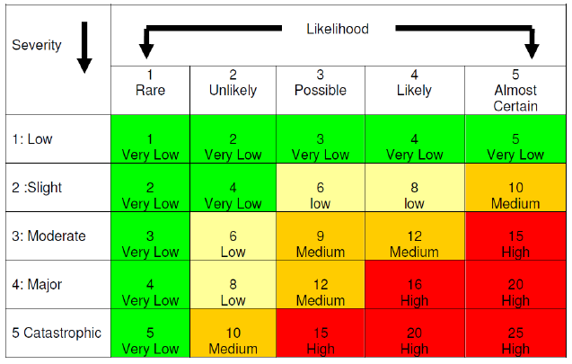

|  |  |  |
| --- | --- | --- |
| **Risk Ranking Grade** | **Score** | **Responsibility** |
| Very low | <5 | Laboratory Level |
| Low | 6-8 | Laboratory Level |
| Medium | 9-12 | DI/RGO/PD |
| High | 15-25 | Designated Individual & Licence Holder |

Likelihood Matrix

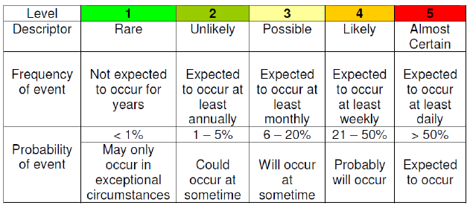Send copy of completed risk assessment to Designated Individual (DI) and Research Governance Office (RGO).