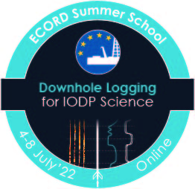
ECORD Summer
School: Downhole
Logging for IODP
Science 2022

Applications will be accepted until April 19, 2022 11:59 pm GMT, after which they will be evaluated by a panel selected from the organizers and lecturer pool. We anticipate to invite 30 participants to join the online summer school. Applicants will be notified of the outcome of their application in by May 31, 2022.

Application Procedure: To apply to this year’s online summer school please
email epc@leicester.ac.uk with the following items:

- this application form,
- a letter of motivation (2 pages maximum including letterhead), highlighting:
- your current project and how you plan to use downhole-logging and
- physical properties data in your future research,
- how your interests and expertise connect to IODP,
- your 1-page CV,
- letter of support from your supervisor (should you be an undergraduate, graduate
- or PhD student).

Please ensure, that your application is complete and strictly follows the guidelines outlined above.

Payment for the ECORD Summer School "Downhole-logging for IODP Science" will only be due upon acceptance. The fee (£95) will entitle you to join the synchronous and asynchronous sessions during the week, as well as an electronic version of the summer school materials and other online resources.

Application Form
ECORD Summer School:
Downhole logging for IODP Science
2022

First Name: |  | Last Name:
Nationality: |  | Pronouns:
Affiliation: |  | Pronouns:
Street:
City: |  | Country:
Email: |  | Time Zone:

How did you hear about the 2022 Summer School?

Do you have any concerns/ additional needs with the class being held online?

Attachments:
☐ 1-Page Resume
☐ 2-Page Letter of Motivation
☐ Supervisor Letter

