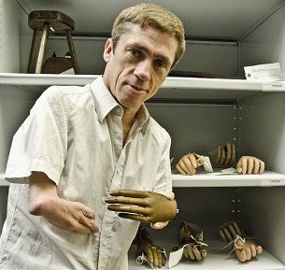
Report by Emma Shepley
Research impact report

Spring 2020

Advancing disability equality through cultural institutions

Research Centre for Museums and Galleries at the University of Leicester

Table of Contents
Executive Summary 2
Findings 2
Introduction 6
Report Overview 7
Key Research Outputs 9
Methodology 10
Interviews 10
Online Survey 10
Sector Views: RCMG 12
Reach 19
UK Museum And Heritage Sector 20
International Museum Sector 22
UK Disability Arts 25
Significance: UK Museum And Heritage Sector 29
Enabling Change: Individuals (Project Partners) 30
Enabling Change: Individuals (Non-Project Partners) 33
Enabling Change: Policy And Practice 35
Exhibitions And Interpretation 38
Hr And Recruitment 40
Collections And Documentation 41
Impact Case Studies 43
Case Study 1. Museums Association 43
Case Study 2. Medicine: The Wellcome Galleries, Science Museum London 45
Case Study 3. Thackray Medical Museum, Leeds 48
Case Study 4. Being Human, Wellcome Collection, London 51
Case Study 5. Royal College Of Surgeons Of England, Hunterian Museum 55
Case Study 6: National Trust, Everybody Welcome, 2019 56
Report Author 59
Acknowledgements 59
APPENDIX 1. Names and institutions of interviewees 60
APPENDIX 2. Questions and consent forms 62
APPENDIX 3. Organisations and job titles provided by survey respondents 65

Executive Summary

“RCMG’s work has blown open the conversation in a way that would not be happening otherwise.”
Dr Heather Smith, Equality Specialist, National Trust

Since its inception in 2000, the Research Centre for Museum and Galleries (RCMG) at the University of Leicester has carried out a series of research projects around disability and the roles that cultural institutions can play in tackling contemporary prejudice and discrimination towards disabled people.
By collaborating with museums and heritage organisations, in the UK and internationally, RCMG has conducted evidence-based research and delivered real-world impact around this theme.
This report investigates the impact of RCMG’s disability-related research since 1 August 2013 through material gathered from fourteen in-depth interviews and quantitative and qualitative data from an online survey of over 100 museum, heritage and cultural sector professionals that was carried out in February 2020.

Findings
RCMG’s disability research is highly acclaimed and widely considered unique across the sector, creating specific, broad and long-lasting impact in a range of areas. Report participants describe RCMG as ‘gold-standard’, ‘trailblazers’ and ‘mind- and horizon-changing people to be around’. The online survey of museum, heritage and cultural sector professionals in February 2020 revealed:
- 96% of respondents have developed their thinking or activity around disability over the past seven years.
- 94% of respondents agreed that RCMG had a positive impact on the museum and heritage sector’s perception of disability.
- 88% of respondents confirmed that RCMG had influenced them, their organisation and their practice.
RCMG research underpins and directly creates impact through factors including:
- The production and dissemination of high quality research outputs;
- The expertise, experience and commitment of Professor Richard Sandell, Professor Jocelyn Dodd and colleagues;
- A reputation for producing a long-standing and accessible academic body of work.
- The creation of a consistent values-led, ethical research practice encompassing the wider inclusion and diversity agenda;
- Successful and skilful management of collaborative teams with lived experience of disability, working in partnership within museums and heritage organisations;
- The translation of research outputs into the production of emotionally engaging, critically acclaimed and high-quality creative programming;
- The process of producing and hosting creative projects, which uses the social model of disability and delivers training, enhances awareness, builds confidence and changes practice for partner staff and organisation;
- Sustained engagement disseminating the research in order to mobilise, inspire and enrich thinking and practice in the wider sector.

“RCMG’s impact is cumulative. Because their projects have happened – I am conscious of a growing number of people and organisations being more observant of best museum practices, and rightly so, holding those of us working in the sector to account and having higher expectations.”
Dawn Kemp, Director of Museums, Royal College of Surgeons of England

Interview and survey data show a near-unanimous perception of RCMG as a highly influential sector leader who has successfully raised the profile of disability and substantially impacted sector policy and practice:
“[Without the work of RCMG] we would not be as far ahead in our practice. We would not have had those rigorous conversations about disability representation, inclusion and access…What the [RCMG] has done for the sector is open-up that conversation about representation and intellectual access.”
Sharon Heal, Director, Museums Association

RCMG has a significant and enduring impact on sector professionals who engage with their work:
“After engaging with RCMG – it is a complete change… Having opened your eyes, you cannot shut them again. If you are running a museum and working on access and disability… It is a totally different mindset.”
Victoria Northwood, Head of Archives & Museum (2011–2016), Bethlem Museum of the Mind

RCMG is cited as an impact on major UK museum and heritage sector developments and displays including Medicine: the Wellcome Galleries at the Science Museum and the Thackray Museum, Leeds:
“The Medicine Galleries would not be so human-centred, so diverse, so enriched by lived experience or designed in such an inclusive way without RCMG… that is absolutely driven by RCMG’s research and inspiring approach.”
Katie Dabin, Curator of Medicine, Science Museum

RCMG has had a significant influence on a wide range of smaller scale projects, policies, practices and initiatives, for example:
“RCMG's work … has directly led to a collecting theme in the Exploring Childhoods/Collecting Cultures project at Sudbury Hall and the Museum of Childhood.”
Liz Johnson, Consultancy Manager, National Trust

The impact of RCMG’s work is recognised and valued by other inclusion and disability specialists working in the arts and cultural sector:
“Thanks to their work, we can all aim higher…RCMG has given us a greater awareness and understanding of the way in which museums and galleries can genuinely take this work on and make it compelling, high-quality and critically-engaged.”
Jo Verrent, Senior Producer, Unlimited

RCMG has few parallels for sector professionals who are aware of their work in the UK and internationally:
“If I was asked to talk about anyone else working in museology on disability – I cannot think of anyone. We do a lot [of work] here but there is no one else who has the resources, the base and the reach that [RCMG] do.”
Dr Katherine Ott, Curator, Medicine and Science, National Museum of American History, Smithsonian, Washington

A majority of participants expressed their appreciation of RCMG and called for their work to continue addressing entrenched inequalities within society and the sector:
“While discussions of diversity and inclusion are becoming much more prominent in certain aspects of museum work…disability remains pretty much invisible even in this context. When disability does come up, it is invariably about accessibility, with no acknowledgement or recognition of disability culture and identity or of disability art, and no understanding of the concept of ableism. This makes initiatives…challenging, since curators, educators and other creators of content must first understand what’s missing and acknowledge that longstanding narratives might need to be reconsidered. RCMG’s work plays a vital role in demonstrating the academic and cultural validity of disability-related research, collecting, and interpretation.”
Rebecca McGinnis, Senior Managing Educator, Accessibility, Metropolitan Museum of Art, New York

Introduction
This report investigates the impact of the University of Leicester’s Research Centre for Museum and Galleries (RCMG) disability projects in the museums and heritage sector led by Professor Richard Sandell and Professor Jocelyn Dodd, from 1 August 2013 to 2020. It explores the influence of this research and its impact on thought and action in the field.
RCMG disability projects are: “A suite of collaborative research projects which build on and extend insights and innovation around societal attitudes towards disability and difference. For more than two decades, RCMG has sought to investigate how disability and the lives of disabled people are represented in museums, galleries and heritage institutions of all kinds and to foster new ethical and rights-based approaches to the topic. The lives of disabled people remain underrepresented, sometimes entirely invisible, within most museums’ exhibitions, displays and public programmes. Where they do appear, they are often portrayed in ways that reflect deeply held negative attitudes towards physical and mental difference; that sit uncomfortably with 21st-century approaches to disability rights, equality and respect” (Research Centre for Museum and Galleries website, April 2020).
This report presents evidence of impact on the museum and heritage sector as a result of engagement with RCMG’s work and gives evidence of the reach and significance of that impact.
- IMPACT: an effect on, change or benefit to society, culture, public policy or services, health, the environment or quality of life, beyond academia.
- REACH: the extent or diversity of the beneficiaries of the impact and the extent to which the potential beneficiaries have been reached.
- SIGNIFICANCE: the degree to which the impact has enabled, enriched, influenced, informed or changed the performance, policies, practices, products, services, understanding, awareness or wellbeing of the beneficiaries.
This study revealed impact for a range of beneficiaries including museum visitors, community groups and organisations campaigning for disability equality. The focus of this report, however, is on the impact of RCMG research on the museum and heritage workforce, cultural institutions and policy making bodies.

Report overview
The report starts with three overarching and recurrent themes described by participants when reflecting on RCMG’s work. This is followed by a review of its reach: firstly in the UK, secondly internationally, and thirdly to disability specialists working in the cultural sector. There is then a review of the extent to which RCMG has enabled change through increased awareness, understanding and confidence within the sector, and a review of reported change in policy and practice. The report concludes with six case studies in which interviewees and survey respondents share reflections on the impact of RCMG’s research on their own work and organisation.

2013–2020 disability collaborative research outputs:
In this report, the ‘RCMG’s work’ refers primarily to the projects, publications and associated research activity from 1 August 2013 to 2020 on disability, and not to the wider work of RCMG. This is worth noting because many of the participants mentioned RCMG’s pre-2013 disability research, but this study focuses on the impact of outputs and related activity from the following RCMG projects:

Title: Stories of a Different Kind: New Perspectives on Disability and Medicine
Sponsors: Wellcome Trust & Arts Council England
Output: Mat Fraser’s The Cabinet of Curiosities: How disability was kept in a box. First performed January 2014
Project partners: Royal College of Surgeons; Science Museum; Royal College of Physicians
https://le.ac.uk/rcmg/research-archive/cabinet-of-curiosities

Title: Exceptional & Extraordinary: unruly bodies and minds in the medical museum
Sponsors: Wellcome Trust & Arts Council England
Output: Unruly Bodies performances by David Hevey, Julie McNamara, Francesca Martinez and Deaf Men Dancing, performances from June 2016
Project partners: Royal College of Surgeons; Science Museum; Royal College of Physicians, Thackray Museum, Leeds; Royal London Hospital Museum and Archives; Surgeons’ Hall, Royal College of Surgeons of Edinburgh; Museum of the Mind; Langdon Down Museum of Learning Disability
https://www.unrulybodies.le.ac.uk/

Title: Disorder, dissent and disruption: making new narratives of disability in the Wellcome Collection
Sponsor: Wellcome Collection
Output: Being Human, permanent gallery, Wellcome Collection, London,
opened September 2019
https://le.ac.uk/rcmg/research-archive/disorder-dissent-disruption

Title: Isolation and loneliness: opening up new stories and interpretive experiences at Calke Abbey
Sponsor: National Trust
Output: HumanKind at Calke Abbey, opened March 2019
https://humankind.le.ac.uk/

Title: Everyone Welcome
Sponsor: National Trust
Output: Everyone Welcome initiative, 2019–2020

Title: Hidden, Revealed: A Collaborative Doctoral Partnership with the British Museum
Sponsor: AHRC
Period of grant: 2019–2022
Output: Isabelle Lawrence, PHD supervisor Stuart Frost/Sarah Saunders

Key research outputs
Sandell, R. (2018) Museums and our understandings of difference in S. Knell (ed) The Contemporary Museum, London and New York: Routledge.
Dodd, J., Jones, C. and Sandell, R. (2017) Trading Zones: collaborative ventures in disability history in J. Gardner and P, Hamilton (eds.) The Oxford Handbook of Public History, Oxford University Press.
Sandell, R. and Nightingale, E. (2012) Museums, Equality and Social Justice, Routledge: London and New York.
Sandell, R., Dodd, J. and Garland Thomson, R. (eds) (2010) Re-Presenting Disability: activism and agency in the museum, Routledge: London and New York.
Sandell, R. (2007) Museums, Prejudice and the Reframing of Difference, Routledge: London & New York.
Sandell, R. (ed) (2002) Museums, Society, Inequality, Routledge: London and New York.

Methodology
A mixed-methods approach, generating quantitative and qualitative data, was used to build an understanding of research impact and to gather robust evidence. Themes and individual comments have been drawn out to illustrate trends across all responses. The fieldwork included:
- individual, semi-structured, in-depth interviews;
- online survey.

Interviews
In February 2020, fourteen semi-structured interviews were conducted with museum and heritage sector professionals who had engaged with RCMG’s work as project partners, as access and inclusion specialists or in national sector leadership roles since 2013. All interviewees who were approached agreed to participate in the study.

In order to collect a representative sample of responses, interviewees were selected from national museums, large and small independent museums; UK and internationally based professionals; and roles spanning senior leadership, consultancy, curatorial, access and learning specialisms.

Data was gathered through face-to-face and telephone interviews lasting between 30 to 60 minutes. Interview questions were emailed in advance to participants and participant responses were transcribed and emailed for approval.

Interviewees are listed alongside their role and organisation at the time of writing in spring 2020, unless otherwise dated – in which case it is the role associated with RCMG’s engagement and primarily discussed at interview.

Online survey
In February, an online survey gathered data from museum and heritage sector professionals who were aware of RCMG’s work through engagement with projects or through other publications, lectures, events, social media, studying or by word of mouth. The survey was open to all and used social media and professional networks to encourage participation by people working in this field.
Survey data is not a representative sample of the museum and heritage sector. Instead, it shows the breadth and depth of engagement with RCMG’s disability work from people who were aware of RCMG research.
The survey aimed to:
- Capture data and comments from current and former RCMG project partners and associates who were not able to be interviewed due to time and resource constraints.
- Identify examples of new or broader impact of RCMG’s work on individuals, institutions and the sector.
The survey asked all respondents:
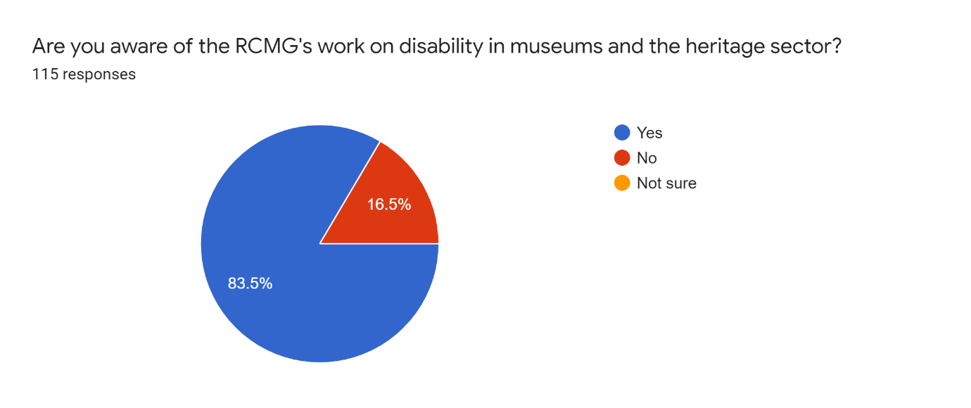
This question ensured that the survey collected responses only from individuals who were aware of RCMG and were able to comment on its impact. Of those, 96 respondents (84%) were aware of RCMG’s work and went on to take all survey questions.
19 respondents stated that they were not aware of RCMG’s work and were directed to the final survey question: ‘Any further reflections or comments on disability work in the sector?’; they were given the option to add free text responses.

Report terms:
- Report participants: Data from interviewees and survey combined
- Interviewees: Data from interviewees only
- Survey respondents: Data from survey respondents only. ‘Anonymous’ quotes are from survey respondents who did not give permission for their name to be published or who did not provide this information.

Sector views: RCMG
The survey and interviews collected information from 129 individuals working across the museums, heritage and cultural sector. Many participants spoke or wrote at length, describing the ways in which RCMG’s work has supported, enabled, transformed or enriched their professional thinking and practice.
Three themes consistently ran through participants’ statements when describing RCMG:
- RCMG’s work is extremely highly regarded and widely considered unique within the sector
Joanne Bartholomew, CEO, 2012–2018, Thackray Medical Museum, reflected this view in her interview:
“Nobody else is doing this work – not in this way...RCMG know museums, but they also know research, audiences, staff and artists as well. I’ve done other research collaborations and that’s unusual – that awareness of all the elements that museums are trying to hold in balance.”
Many of those who participated in the report described their experience of RCMG’s work as outstanding, unique or particularly impactful:
“We wanted things we felt RCMG would uniquely add – one was depth of knowledge, across the sector, we wanted something that reflected thinking that had been refined across a long period of time…There is no one else working in precisely this way.”
Dr Clare Barlow, Project Curator, 2017-2019, Wellcome Collection

“It is the variety. It is the dedicated staff time, it's the international connections, it’s the way they are integrated with the University Museum Studies department. I have not experienced that elsewhere and that sets them apart…RCMG don’t just commit to the project – it is about systemic and cultural change. You are always going back to their work. If you did not look at it – you’d be missing something very significant.”
Dr Heather Smith, Equality Specialist, National Trust

“If I was asked to talk about anyone else working in museology on disability – I cannot think of anyone! We do a lot here, but there is no one else who has the resources, the base and the reach that [RCMG] do…One of the reasons I like working with [RCMG] is that they model how to do it. Unless someone has the resources and the expertise, then people flounder, but because RCMG has been doing it so long – they are a gold standard.”
Dr Katherine Ott, Curator, Medicine and Science, National Museum of American History, Smithsonian, Washington

“There is a permanency with RCMG’s work – it is published, shared, freely available, downloadable. A lot of the work I have encountered is project-based so the legacy is much more dispersed. RCMG have been trailblazers and their work is valued beyond this country.”
Elen Phillips, Keeper of History and Archaeology, National Museums Wales

“[RCMG]’s work is distinct because it is values-led. For academic institutions it is much easier to chase the money, whereas with the Research Centre they work to a set of values, which includes social justice and that influences everything that they do.”
Sharon Heal, Director, Museums Association

“Great leadership is – not just by telling but by doing. RCMG’s creation, sharing and supporting of best practice case studies gives great tangible examples of methods and benefits.”
Dr Emily Scott-Dearing, Public Engagement Consultant

- Navigating challenge
RCMG’s work is highly valued for enabling and supporting the sector in navigating the challenges of embedding equalities practice. This work is described by report participants as challenging for a wide variety of systemic, financial and attitudinal reasons. Becki Morris, Director, Disability Collaborative Network, summarises these issues and RCMG’s impact in her comments:
“The key thing with activism is when you have to fight for something that is a basic human right. You did not want to fight for it in the first place, but you have to because it will alter your way of living if you don’t. The emotional stress, the fear in having to fight for something that others get no questions asked...What I like about RCMG is that they ask those questions. They take the time to say ‘but what does that mean?’ to someone who has been through the system in terms of their narrative and their story. And that is of critical importance because of the power of museums as symbols of authority and their ability to change people’s lives.”
Many report participants described the impact of RCMG work on people with lived experience of disability and on museum professionals who are working on disability projects without this lived experience. The following statements represent these views:
“RCMG’s collaboration had an impact on every aspect of what we were doing…the importance of casual insights like moving the bench – it is free, any museum could do it, but no museum has. The reason we don't do it is because we don't have people in the room who are able to say, ‘well from my lived experience. this’ That made me realise as a sector, how far we are falling short This kind of work is challenging. It is always challenging to be confronted with errors you have made in the past and being told that they are errors…The people we are engaging with have been let down by institutions and can bring their exhaustion and their pain in having to constantly batter at the door but never being allowed in…Richard and Jocelyn created a very safe space for these difficult conversations to happen.”
Dr Clare Barlow, Project Curator, 2017-2019, Wellcome Collection

“One of the biggest difficulties in working in this area is ignorance, prejudice, disinterest and that can be from colleagues, stakeholders and audiences sometimes. RCMG brings a collective strength that helps to leverage support. Here in the States, ableism and the language of ableism is still barely understood. So, the more [RCMG] do to hit a broader audience the better – their work has a long tail. They were among the first [museologists] to do community engagement – ‘nothing about us without us’. They have been doing that since the beginning and that’s now almost mainstream and they were way out in front on that – leaders.”
Dr Katherine Ott, Curator, Medicine and Science, National Museum of American History, Smithsonian, Washington

“I have followed [RCMG] work, read reports, and found solace in the fact that there is a body of serious work on disability in museums. Because working on disability and accessibility in museum is sometimes a very lonely job, and nothing that boards and management ask for unless they are convinced by arguments and heavy work.”
Dr Hanna Mellemsether, Senior Advisor, Museums of South Trondelag, Trondheim, Norway

“The most difficult element of access and inclusion work is ensuring this isn't just ‘if you build it, they will come’, but making sure from the ground up, you are working with individuals from those communities...And I think that is the hardest thing, and you don't see enough of it in the museum world…That is very hard for individual museums to do because there's so much day-to-day running going on. Having an organisation like [RCMG] that has the reach and wherewithal to gain funding is very important. They did amazing work to create that opportunity for us.”
Hayley Kruger, Acting Head of Access and Learning, Royal College of Surgeons of England

- Call to continue
A significant majority of report participants expressed their thanks and appreciation for RCMG’s work and called for their contribution to continue to address entrenched inequalities within society and the sector.

Dr Heather Smith, Equality Specialist, National Trust, reflected on the need to continue to build on RCMG’s and others’ work in the field in her interview:
“We cannot continue to exclude disabled people from the heritage we have. I can see so many items in our properties connected to disability history and we just do not tell anyone about them yet. Sometimes these narratives are unpalatable to the history of the organisation and then nervousness comes in – and that’s where you really need a trusted partner like RCMG to help you through that – I’ve had to wait a long time for the organisation to be in a place where they are ready.”

Many report participants described why RCMG’ projects were impactful in addressing entrenched inequalities and why they wanted the work to continue. The following statements reflect these views:
“The [heritage] sector can be hyper-focused on specific areas of work and these are often not joined up. So, disability and inclusion are highlighted and then pushed back, and this has happened continually over the 22 years that I've worked in the sector. Inclusion has never had a push to the forefront and stayed there. And that's where RCMG comes in – their projects keep inclusion constantly in focus and this is absolutely critical work.”
Becki Morris, Director, Disability Collaborative Network

“There is a big challenge for the sector around genuine co-production and meaningful participatory practice that we haven't cracked yet. Evidence shows that it has not happened thoroughly even at the best institutions. The reason is the structure and hierarchy in the profession. People are called ‘keepers’ for a reason...We have spent 200 years telling people that museums are just about looking after collections and that makes it difficult to change practice. It is a challenge for an institution to do what the National Museum of Wales and the others did with Mat Fraser.”
Sharon Heal, Director, Museums Association

“While discussions of diversity and inclusion are becoming much more prominent in certain aspects of museum work in the US, disability remains pretty much invisible even in this context. RCMG’s work plays a vital role in demonstrating the academic and cultural validity of disability-related research, collecting, and interpretation.”
Rebecca McGinnis, Senior Managing Educator, Accessibility, Metropolitan Museum of Art, New York

Several report participants reflected more broadly on inclusion work in the sector. The following statements represent these comments:
“I campaign as a SEND parent who is also a museum professional, there is still an uphill battle to get disability noticed in the same way as other protected characteristics are in the sector. 20% of the UK population are disabled, yet only 4% of the museum sector employees are. 8% of children in UK are SEND but so few museums cater for their needs or do so in a tokenistic way. This has to change.”
Sam Bowen, Museum Development Officer, South East Museum Development Programme

“I have seen an increase in events and special openings to bring in more people who identify as disabled and more effort in physical access to buildings…but not the interpretation methods or communication. More needs to be done on making museums and galleries truly inclusive where people do not need special openings, do not need to book or have to identify themselves to access the stories objects and collections can tell.”
Rebecca Ealy, Consultant, PalaeoSTEAM

“I took part in surveying 70 museum websites to see what accessibility information they provide. This made me aware that museums still have a lot of work just to show on their website that they are welcoming and accessible to disabled people.”
Anonymous

“I think there is a greater emphasis on disability within museology – however this has not effectively influenced our approach to disability within the workforce – there is still too much prejudice and bias. If we genuinely want to reflect our communities in our museology work that requires us to embed diversity within our workforce.”
Tamsin Russell, Workforce Development Officer, Museums Association

Reach
This section of the report examines the reach of RCMG’s work – the extent/numbers or diversity of the beneficiaries of the research. Reach was demonstrated through the online survey and comments from all report participants.
Survey respondents were asked:
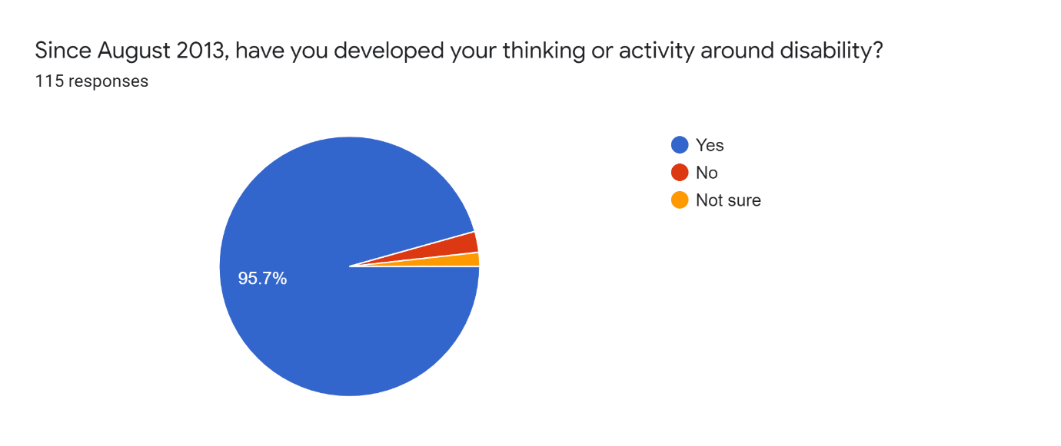
As the survey targeted individuals with experience or interest in disability access and representation, nearly 96% (110 respondents) agreement is unsurprising, but does provide confirmation of sector engagement with disability during the period of this report’s focus.
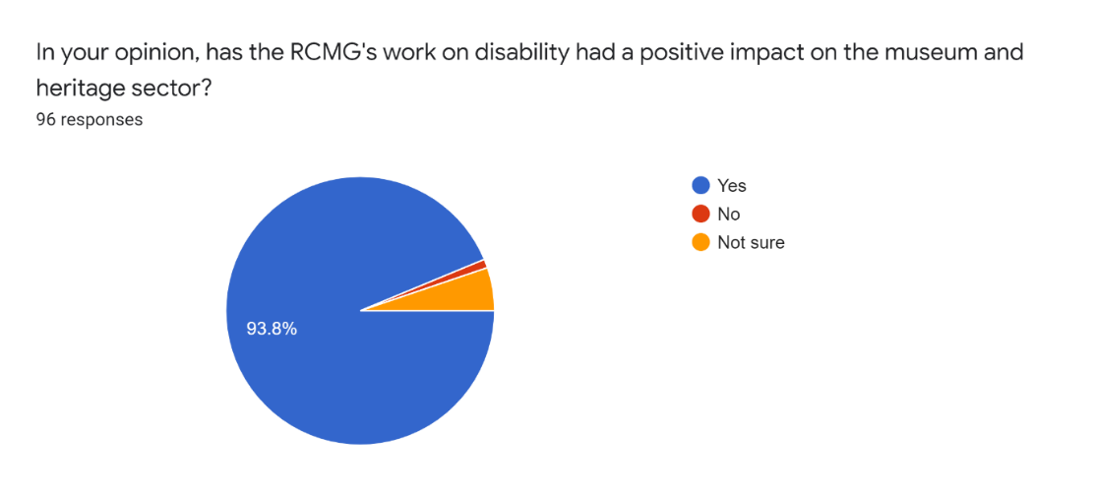
Nearly 94% of survey respondents agreed that RCMG’s work has had a positive impact on the sector overall.
The extent and diversity of RCMG’s impact is assessed in this section through three categories of beneficiary. Firstly, the UK museum and heritage sector. Secondly, international museum sector views. Thirdly, disability specialists and activists in museums and the wider cultural sector.

UK museum and heritage sector
UK museum and heritage sector professionals surveyed reported that sector awareness of disability had increased and credit RCMG’s work as a factor in heightened profile and interest. Liz Johnson, Consultancy Manager, National Trust, reflects this view:
“The sector is a different place now from ten years ago in relation to disability…RCMG’s work has put the issue and the opportunity firmly on the map.”
The following statements show the views on sectoral change over the past decade and reflect on the impact of RCMG:
“RCMG’s work around disability is sector leading. The sector as a whole would look very different without their contribution.”
Stuart Frost, Head of Interpretation and Volunteers, British Museum

“RCMG’s work has blown open the conversation [on disability and inclusion] in a way that would not be happening otherwise. They have consolidated years of experience, consistency of methodology, working with different partners, they have a very clear vision. They have provided the information, they have provided the credibility and it is sustained and passionately delivered whenever they talk about it…Overall without [RCMG] there would not have been so much sustained work in the sector, because they are a hub to go back to. They have enabled some of the research by their very existence because people have had a reference point.”
Dr Heather Smith, Equality Specialist, National Trust

“RCMG’s work has raised the conversation around disability and museum collections to a national level.”
Claire Madge, Founder, Autism in Museum

“[The distinctiveness of RCMG] is in building a coherent body of work. And over time, that has a massive impact on the sector, so their influence extends far beyond the organisations that they have actually worked with. They are very alive to the experience of visitors in a space. That I would say would be their USP. The sector needs [RCMG’s] coherence, that scholarship, that direct impact. Otherwise it would be very sporadic and un-joined up.”
Kate Forde, Head of Exhibitions, Wellcome Collection

“From a sector body perspective – RCMG’s work has helped inform several of our outputs (specifically events/conferences) and has helped staff understand and adopt a social model of disability. It has changed the language we use and made us more aware of privilege and ableist behaviour. It has introduced us to individuals, ways of working and contributed to wider work around inclusion and diversity…in terms of raising awareness of the importance of this work it has been very influential.”
Anonymous

Survey respondents
The make-up of survey respondents also helps build up a picture of RCMG’s reach:
- Job titles listed by survey respondents cover a broad span of roles. One third of roles listed included the term ‘CEO’, senior’, ‘director’, ‘head’ or similar indicator of seniority; and an additional 10% included the term ‘manager’.
- Over 50 individual organisations are named by survey respondents as ‘Your Organisation’.
- The geographic spread of UK survey respondents. Although nearly half of survey respondents were based in the south and south east of England; views from the rest of the UK were represented.
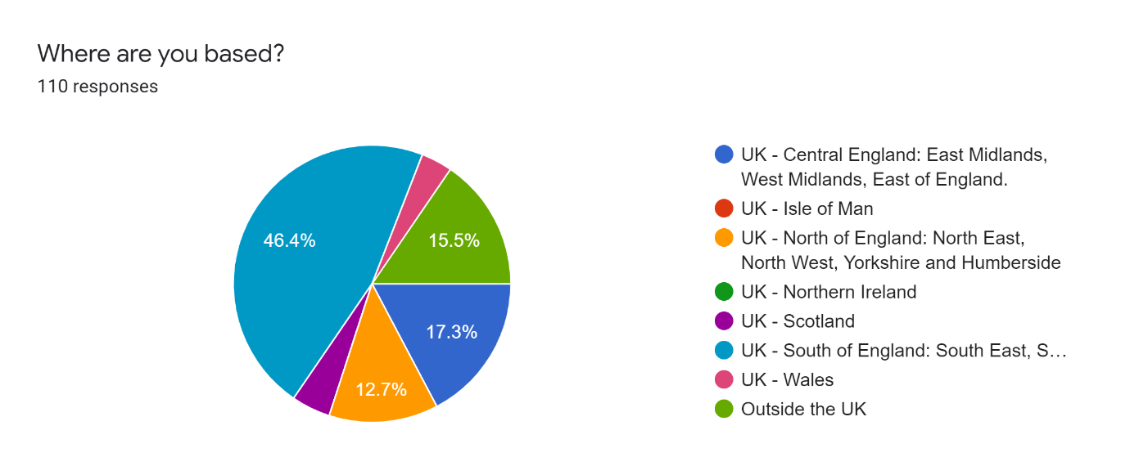

International museum sector
The international reach of RCMG’s work is shown by two interviews with museum specialists working in the field of disability history and inclusion in the US and by comments from survey respondents outside the UK.

All international report participants cite RCMG as influential to their work. Dr Katherine Ott, Curator, Medicine and Science, National Museum of American History, Smithsonian, Washington reflects this in her comments:
“I’ve spent most of my career looking at bodily difference and the history of disability. I’ve been involved with RCMG since I first met Richard in 2004 when he was a fellow here at the Smithsonian and we shared an interest in disability. It’s my nature to work with the social model of health in my work – but I’ve certainly got better at it because of working with them!
RCMG publications on disability and museums are widely read and respected here in the States – people who work on disability all know their names and have read their work…Because of the collaborations we have had – the value of history of disability has been raised here, in the institution that I work in and in the States….There has been definite cultural change in the sector over the last decade around disability – partly generational change but partly museums doing this work – RCMG publications are good ‘missionaries’. Without RCMG’s work cultural change, certainly in this country, would be even slower.
Important qualities of their work are not just depth of expertise, knowledge and creativity, but the overarching impact for me is their openness to international collaboration. They always promote growth, intellectually and creativity in all of the parties they work with. Their insight comes from the work they do – they notice things in my work – that synergy that’s created around international collaborations – that is the main impact.
Some impact is not tangible – it’s the importance of having colleagues and allies and confederates as a sounding board. I’ve asked their opinions, pooling knowledge, brainstorming and the sense of a shared intellectual burden – that has enriched my work. Because of the collaborations we’ve had – the value of history of disability has been raised here, in the institution that I work in and in the States.
One of the things that [RCMG] really brought into my consciousness in a way that I hadn’t understood previously was the importance of the arts in interpreting difficult topics and using the arts as a vehicle. Visual engagement, performance, poetry, theatre – that’s one of the things about RCMG’s work that is unique and that’s really been driven home for me. We just did an exhibition for the Stone Wall anniversary here called ‘Illegal to be you’ which is very poetic and visually-led in carrying content in exactly that way.”

Rebecca McGinnis, Senior Managing Educator, Accessibility, Metropolitan Museum of Art, New York, cites a current project as one example of RCMG’s reach:
“My colleagues and I are currently in the midst of an initiative called Crip The Met, funded by the New York City Department of Cultural Affairs Disability Forward Fund for the second year, which aims to make disability more visible through the Museum’s collection and interpretation. RCMG’s research and collaborations with museums has certainly been an important seed and a catalyst for this current project.
Involving and partnering with museums, disabled artists, and others from the cultural sector is crucial to the sustainability of inclusion. This practice isn’t unique, but RCMG has demonstrated a commitment to this way of working.”
Seventeen international survey respondents described the impact on their practice and organisations as a result of engagement with RCMG’s work. Their experience echoes views of the UK museum sector in describing increases in confidence, awareness and support. They particularly value RCMG’s research publications in their own academic research, policy and programme creation as these selected statements show:
“Work from RCMG encouraged me to question our representivity as an overall strategy, and not only for disability…RCMG has provided me with arguments, examples and references that I have used when developing strategies and applying for funding. I pick examples from RCMG’s research when I make our internal annual course on accessibility and in our handbooks. I am proud to say that this constant ‘nagging’ now means that accessibility is no longer an option in our museums, it is a must.”
Dr Hanna Mellemsether, Senior Advisor, Museums of South Trondelag (MiST), Trondheim, Norway

“RCMG’s work helped me develop a better understanding of disability and its relationship with museums practice…[and] develop a strategy in terms of academic research. I am currently researching…museum collections representing disability…Some of those findings were published in Representing Disability, 2019, co-edited by me – the first publication in Portugal related to this subject.”
Patricia Roque Martins, post-doctoral researcher, University of Porto

“RCMG's research has informed our research and inspired us to do more to strengthen disability-related work within the cultural sector.”
Laura-Edythe Coleman, Programme Director, Drexel University, US

“[RCMG has influenced my work] training museum professionals & research on collections and representation: awareness of / change of perceptions of disability issues & nature of collaborative work.”
Professor Alice Semedo, University of Porto

“My awareness of the topic has changed dramatically over the last years thanks to [RCMG] publications/projects.”
Dr Ariane Karbe, Freelance Curator

“I have used RCMG’s initiatives in my teaching and for primary examples of what is happening in the field when I address museum boards, conferences and other gatherings of museum professionals…RCMG’s research has supplied data indicative of success through disability programming and has given me the confidence to push forward in my quest to make all museum, arts, and daily living activities accessible, inclusive, and meaningful to people of all disabilities.”
Dr Susan Davis Baldino, Program Coordinator, Arts4All Florida and Florida State University

UK disability arts
Survey and interview data show evidence of significant RCMG reach to individuals and organisations who work in the disability arts field. This group include both museum professionals and practitioners from the wider cultural sector.
These report participants primarily see RCMG as an ally who, through high quality research, creates sustainable links and who makes an impact through high-profile projects that benefit wider inclusivity in the cultural sector. Jo Verrent, Senior Producer, Unlimited, summarises this view:
“Thanks to [RCMG] work, we can all aim higher. It shows that inclusive practice, at the very highest level is not only achievable but interesting; it provides a compelling future narrative. there is no going back. [RCMG should] keep going and keep the quality threshold high. I can see the shift over time and it’s so welcomed…RCMG has given us more a greater awareness and understanding of the way in which museums and galleries can genuinely take this work on and make it compelling, high quality and critically engaged.”

Selected statements on RCMG’s impact from individuals working in cultural sector disability organisations:
“[RCMG’s work] has certainly helped me as an individual (and therefore impacted our organisation) in taking a holistic view of disability, i.e. disabled people in collections, on stages, in the workforce, as leaders, curators, artists and audiences and how there is a virtuous circle of representation between them.”
Matthew Cock, Chief Executive, Vocaleyes

“As a practitioner working in the field with museums, galleries and other cultural institutions, the work of RCMG has become a vital resource to me. My research, its arguments and debates are grounded in their work and I have, as a result, a more assured practice…When I ask for inclusion of the disability narrative in our culture beyond my own demands, I look to the work of RCMG. I am supported by their research personally and professionally. Disability is cultural – and I need to see my stories and that of the 15–20% of the population reflected in our galleries and museums…RCMG’s work in this [area] helps to push the boundaries and lay new foundations.”
Dr Simon McKeown, MIMA School of Art and Design, Teesside University

“[RCMG have impacted us through] awareness, like-minded fellow travellers, commissions, advice and by being the leading thinkers around disability and museum interpretation.”
David Hevey, CEO/Artistic Director, Shape Arts

Disability specialists working within the museum sector report RCMG’s impact on their practice in a number of ways. The most direct example of RCMG’s reach came from Becki Morris, Director, Disability Collaborative Network, who described watching an RCMG’s performance as a key impetus for her work:
“I saw Mat Fraser [in Cabinet of Curiosities] in Leicester. What had been in my own head – Mat Fraser was saying on stage, and I literally thought ‘this is it! If I am going to do something about this, now is the time to do it because of the profile, but also in terms of the readiness of the sector.
Champions like RCMG create what I call a ‘sensible steer’ of actually looking at the real issues that we need to concentrate on, and not the natural frustration. Mat Fraser, Being Human, all enable us to put inclusion at the forefront of everything we do. The heritage sector needs places like RCMG to create projects while background structural work is going on and their project work impacts on that structural work too.”

The following statements reflect RCMG’s impact on museum and heritage specialists in this field:
“For me – RCMG’s very existence has influenced all of my 17-year career with the National Trust. They have always been there with a project, articles, moral support, a connection or a contact I can ask for…One of the things I was told when I got this job was: ‘keep your external networks live because you'll need them’ and [RCMG] have been crucial to that. You can’t be a lone wolf on your own doing these things, but bringing people [like RCMG] who have got strong voices, who will listen to you, and you'll listen to them and they will speak to your colleagues in a way that means they listen and don’t feel threatened – that has made a big difference.”
Dr Heather Smith, Equality Specialist, National Trust

“As a person with lived experience of invisible disabilities working towards a Masters in Interpretation…RCMG’s disability research has been helpful in reinforcing my belief in the work I want to do to improve inclusive practice in interpretation for museums and galleries.”
Rebecca Ealy, Consultant, PalaeoSTEAM

“I am a disability advocate and the work that RCMG undertakes is critical when I discuss disability rights, inclusion, and social justice with legislators and policy makers. Thousands are impacted by my work through public exhibitions, interpretive programming, art shows, dance performances, music, and advocacy.”
Dr Susan Davis Baldino, Program Coordinator, Arts4All Florida and Florida State University
“RCMG's work has raised the conversation around disability and museum collections to a national level, particularly with keynote speeches at the MA conference. Their recent work at the Wellcome Collection and how well they have shared that work has shown how museums and galleries can work with groups and individuals traditionally seen as ‘outsiders’ to make sure the whole spectrum of voices and experiences are heard.”
Claire Madge, Founder, Autism in Museums

Significance: UK museum and heritage sector
This section of the report examines evidence of the significance of RCMG’s work – the degree to which RCMG disability research has enabled, enriched, influenced, informed or changed the performance, policies, practices, products, services, understanding, awareness or wellbeing of the beneficiaries.
RCMG’s significance is assessed in this section in two categories. Firstly, by presenting descriptions of influence and change on the development of individual sector professionals. Secondly, by looking at impact on policy and practice.

The online survey and the comments from report participants give clear evidence of enrichment, enablement and practice change across the sector as a result of engaging with RCMG’s work.
Survey respondents were asked:
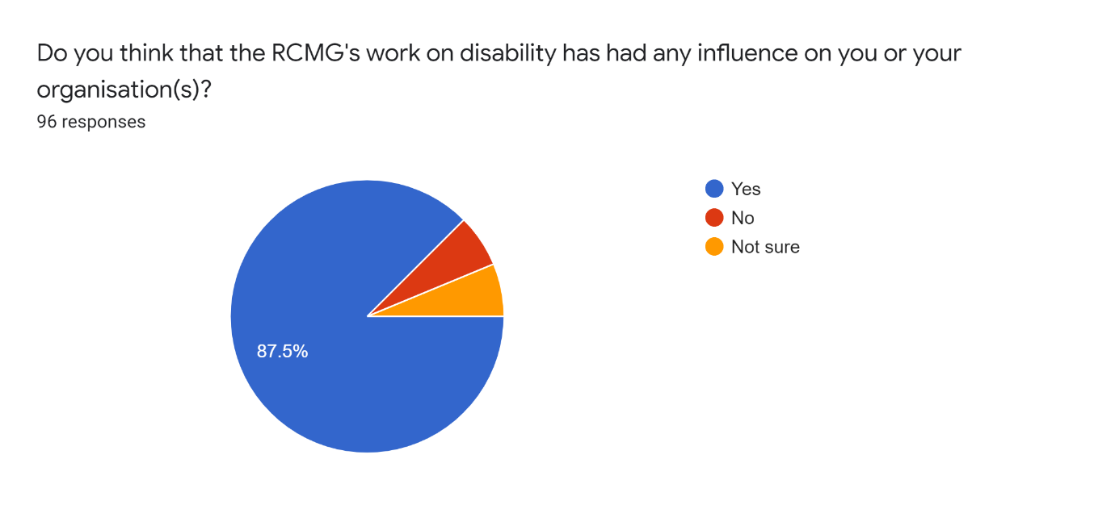
Nearly 88% of survey respondents agreed that RCMG had influenced themselves or their organisation.
Survey respondents were asked: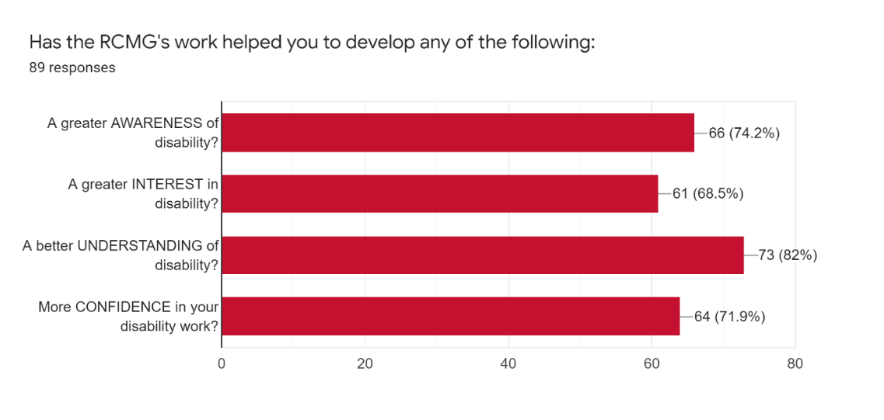
89 survey respondents (93%) responded to this question by selecting at least one of the four choices listed above. 82% of respondents selected ‘understanding’, 74% selected ‘awareness’ and 65% of respondents selected three or all four of the words.

Enabling change: individuals (project partners)
Katie Dabin, Curator of Medicine, Science Museum, commented on the depth and scale of RCMG’s impact for many individual project participants:
“[RCMG] are mind- and horizon-changing people to be around. They have changed how I see the world and how I understand our collections. Their projects transformed my thinking from a personal and professional point of view.”

The statements below reflect the development of awareness, interest, understanding and confidence created in RCMG project partners:
“The biggest ongoing impact [of RCMG] is always going to be when someone says to you ‘What experience do you have of working with these audiences?’. I can turn around and say, Well, actually – this!’…It has given us confidence and insights that continue to occur to us.”
Hayley Kruger, Acting Head of Access and Learning, Royal College of Surgeons of England
“The pair-writing activity [creating object label text] was a real wake-up moment for me…The pair was between a disabled activist/artist and a member of Wellcome staff. It revealed how problematic some of our current interpretation was (and still is!).”
Rosie Stanbury, Head of Public Programmes, Wellcome Collection

“Involvement in [RCMG] projects enabled me to better understand both historic and current attitudes to disability from a number of points of view. My awareness has been increased particularly with regards to history and culture and how we ought to represent a greater variety of voices.”
Richard Meunier, Head of Archives and Local Studies, Bath & North East Somerset Council

“[Without RCMG] I would not be aware of the social model of disability. I would have thought about accessibility in narrow way – ‘can a wheelchair move through this doorway?’. I hadn't met many disabled people in my life and talking with amazing people like Mat Fraser and Francesca Martinez and understanding their stories – it was tremendous. Working with Richard and Jocelyn, going to the project meetings, taking the artists round our collections – opened up my thinking and made me conscious of accessibility across every aspect of our service. This is something which I hadn’t thought about before and it’s something that’s ingrained in me now.”
Peter Basham, Curator, Royal College of Obstetricians and Gynaecologists

“RCMG’s work informed the interpretation delivered in HumanKind for National Trust Calke Abbey. This work gave the team the confidence to present an experience of disability ethically, delivering a positive experience for visitors. The approach developed by RCMG had an important influence on the way we presented disability and life changing injuries within HumanKind.”
Anonymous
“What we do tend to do now [after working with RCMG] is bring [out] multiple perspectives from themes – academics, artists, curators, story tellers, everybody in one space – and we wouldn’t have had the confidence to think we could do that before.”
Sioned Williams, National Museums Wales

“[Working with RCMG] has made me more confident in thinking about what my goals for inclusion are for every [new] project…[and] in thinking about what makes a genuine consultation and how to build accountability in consultation.”
Dr Clare Barlow, Wellcome Collection

Over half of interviewees reported no significant disability awareness or training before engagement with RCMG’s work. As Jo Bartholomew, CEO, 2012-18, Thackray Museum, commented:
“I was familiar with the social model of disability from a physical access point of view, but I don’t think I’d ever experienced it being used from a patient perspective within museum narratives in that way.”
The impact on individual museum professionals engaging with or working as a project partner with RCMG is also lasting. Survey respondents and interviewees consistently reported long-term attitudinal change. Once they have worked with the social model of disability in creating narratives and interpretation around collections and events, they continue to use it. Victoria Northwood, Head of Archives and Museum, 2011–16, Bethlem Museum of the Mind, reflected this in her interview:
“After engaging with RCMG – it is a complete change…Having opened your eyes, you cannot shut them again. If you are running a museum and working on access and disability…It is a totally different mindset.”
Lauren Ryall Waite’s survey comments summarises this point and describes the process of development she and her museum gained:
“Through working with RCMG at Thackray Medical Museum I became more aware of the lack of representation in our collections of disabled voices, and of the bias of the medical model of disability. Work with RCMG has led to a personal change in how I approach medical collections as a curator.”

Enabling change: individuals (non-project partners)
The survey provides evidence that RCMG’s work has similarly enabled positive change in individuals who have not worked directly with the organisation. Selected comments from the survey provide more detail on how this happens:
“I saw two of the [Exceptional & Extraordinary] artists’ responses at Derby Silk Mill and the Hunterian. Both gave me greater understanding of…disability history. I was also sent reports to read and advice when developing a small display about our site’s disability history. All helped to support and give me confidence in developing this work.”
Susan Eskdale, Community Engagement, Royal Pavilion & Museums, Brighton & Hove

“I have a greater understanding of the social model of disability and how we can change our approach to make our spaces and exhibitions more inclusive.”
Sam Jenkins, Collections Officer People's History Museum

“The work’s existence…has hugely informed my work in advocating for better disability representation, and in evidencing how change can come about.”
Christopher Olive, Cultural Intern, Birmingham Museums Trust

“RCMG’s work has been a huge inspiration and provided a lot of framework for my own practice.”
Corinne Ball, Curator, Migration Museum

“The work of RCMG…challenged my thinking around disability in terms not only of access to installations, exhibitions and cultural institutions, but more fundamentally representation within them.”
Tom Butler, Associate Lecturer, Central Saint Martins

“I came across RCMG’s work on disability during my MA...It became a key resource I constantly went back to as I entered my job at GEM (Group for Education in Museums). It was great reference material to share and also inspired me to put SEND inclusion on GEM’s agenda, driving new partnerships. I had not considered the scope and impact of SEND inclusion work before coming across RCMG and now I would say it is one of my key personal aims in my career.”
Holly Bee, PhD student, University of Leicester

A selection of anonymous comments from the survey confirm RCMG’s wider impact:
“Their work sparked my interest and made me want to do more.”
“[RCMG] work is extremely influential. Personally, it really helped me develop a much deeper understanding of disability, the disability rights movement and disabled artists.”
“RCMG’s work has encouraged me to view disability as something with a story worthy of recognition and sharing.”
“RCMG’s work helped me to understand how the medical model of disability had been the dominant lens through which disabled people’s histories had been told at my museum.”
“I have been interested in inclusive practice for the past 20 years…but your work with Mat Fraser…gave me more understanding about representation and the social model. I sought out other likeminded projects and have attended conferences and related events over the past seven years. All of which have informed my practice.”

Enabling change: Policy and practice
Participants were asked through interview or the online survey to list any specific changes to policy and practice that occurred as a result of engagement with RCMG; and if RCMG’s work had enabled any projects that might not otherwise have happened (or happened in the same way).
Survey respondents were asked:
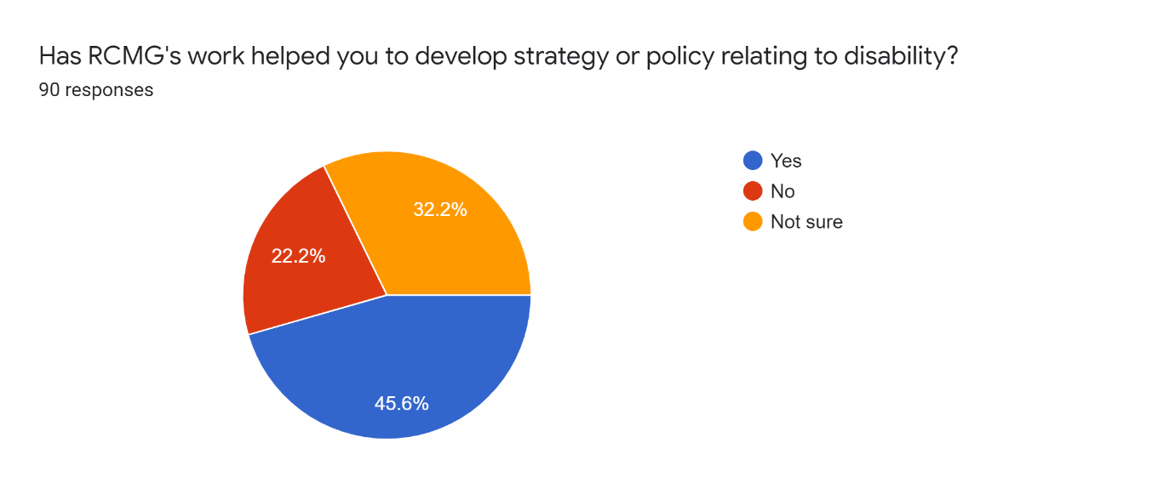
Nearly half of respondents said that RCMG’s work had helped them to develop strategy or policy relating to disability.
Amongst the third of survey respondents who answered ‘no’ or ‘not sure’, many stated that this was because policy and strategy was not currently part of their role.

Policy and strategy cited as being impacted by RCMG’s work include:
“RCMG played a major role in altering the whole perspective of [Thackray’s] strategy. We went through a process of transforming what the museum could be and the purpose it would serve for those under-represented audiences. [RCMG] was an absolutely vital step in that.”
Joanne Bartholomew, CEO, 2011–18, Thackray Medical Museum
“The work of RCMG … informed how we as a team developed a new audience development policy and plan which had a strong focus on building disabled audiences – mainly through improving physical access and a greater representation of disabled people in our interpretation.”
Beth Wilkey, Curator, Royal College of Physicians Museum

“We are being more proactive in considering disability and access as part of our strategic approach to galleries, exhibitions etc. This is based on a range of factors, but keynotes/sessions at MA conferences have played a part.”
Gabrielle Heffernan, Curatorial Manager, Tullie House Museum and Art Gallery Trust

“[RCMG’s work] raised our awareness of disability issues at the museum. Helped us to plan an access strategy.”
Rachel Bairstow, Head of Museum Services, British Dental Association Museum

“RCMG’s work gave us the impetus to consult on the Thackray’s new collections development policy. We knew that we had to rewrite this policy, which was out of date, so we included staff, trustees, stakeholder groups and the general public.”
Sue Mackay, Head of Collections and Programmes, Thackray Museum

Survey respondents were asked: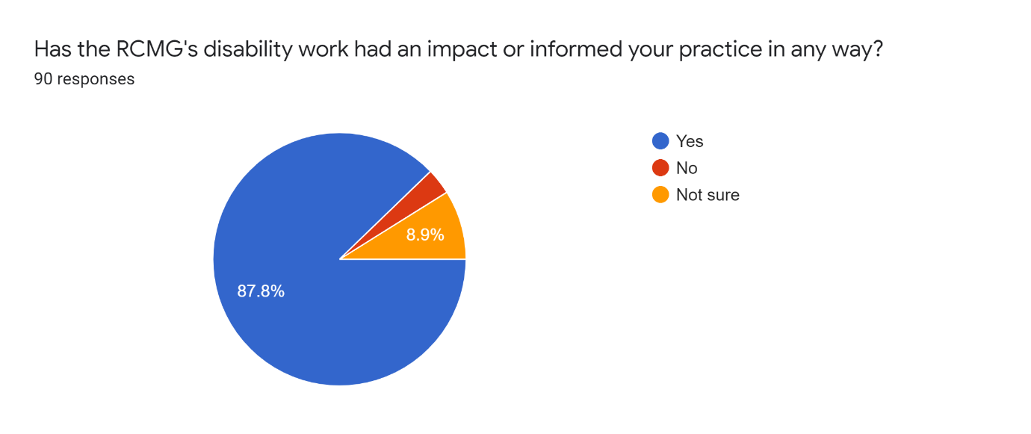
Nearly 88% of respondents agreed that RCMG’s work had impacted or informed their own practice. This question was followed up with a request for information about activities they had developed as a result:

Survey respondents were asked:
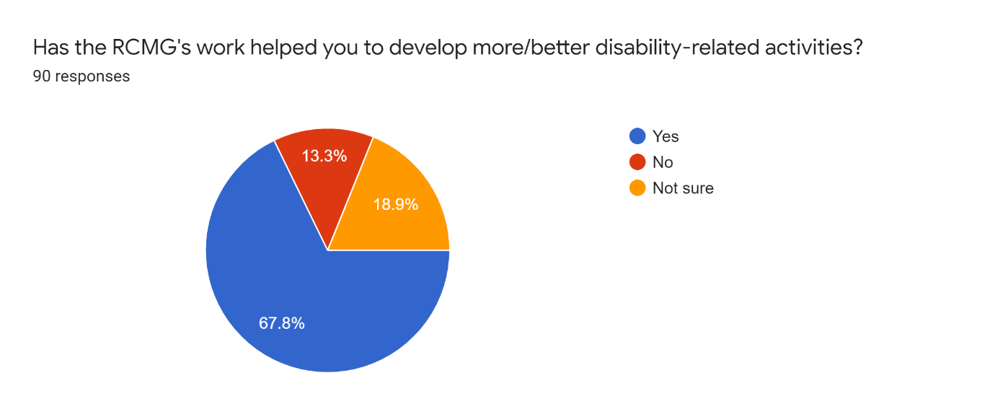
Nearly 70% of survey respondents agreed that they had developed more/better disability-related activities. They were asked to say more about these activities with four free text questions:
- Tell us what you did? What happened? Any highlights?’
- How much engagement was there?
- Any other positive consequences?
- Can you describe how RCMG’s research impacted, supported or informed these activities?

Participants described a range of large- and small-scale activity. They describe RCMG’s impact in terms of providing impetus, inspiration, confidence, mentoring support, encouragement, training or practical models. The following statements can be read as a snapshot of RCMG’s impact on exhibitions and interpretation, recruitment, collections and documentation, learning and outreach – all linked to RCMG’s work by the respondent:

Exhibitions and interpretation
“[After] Mat Fraser's keynote at MA…I investigated three objects in our collection with direct connections. Being Human at Wellcome has also been a big influence on me. I am about to display a permanent gallery about an individual who was disabled and Being Human has shown…how best to interpret this.”
Anonymous

“I am working on a Body exhibition as part of a new children-focused STE(A)M attraction developed by Eureka! The National Children's Museum in Merseyside and we are very conscious of and interested in representations of the body.”
Lucy Harland, consultant, Lucidity Media

“We have included disabled stories to a greater extent in our museum, identified more disability-related objects in our collection and are now working with the local Deaf community to present an exhibition.”
Corinne Ball, Curator, Migration Museum

“An exhibition called Nothing About Us Without Us, which acted as a catalyst for further work in 2021, which will include a whole year of programming themed on disabled persons rights and activism.”
Michael Powell, People’s History Museum

“I shared Exceptional & Extraordinary information with the Access Advisory Group at the Horniman Museum whilst working on their World Gallery exhibition. Discussing the exhibition allowed us to think about medical and social models of disability, how to work with groups who have a lived experience of disability to influence exhibition design, object choice and interpretation. This all helped the process of displaying ‘We were always part of the story’.”
Claire Madge, Founder, Autism in Museums

“Influence and awareness that helped focus disability in the interpretation for our new permanent galleries and our outreach/RAF Stories programme.”
Maggie Appleton, CEO, RAF Museum

“We have started using NFC tags to provide oral versions of written labels. It’s still a work in progress but we have worked with groups with visual impairments and they’re telling us the information they want to hear, not just the text.”
Sarah Keeling, Curator of Collections, St Albans Museum

“I particularly worked on improving accessibility changes to displays, interpretation and information e.g. embedding large print caption provision into exhibition plans and creating these for permanent displays. I also lobbied to improve disabled access...I made our website clearer with best practice access guidance.”
Beth Wilkey, Curator, Royal College of Physicians Museum

“Developing interventions with specific museums such as the Museum of Liverpool, Beamish and Preston Park, challenging their day to day operations, and providing new materials and activities as a result during 2018–2020.”
Dr Simon McKeown, Mima School of Art and Design, Teeside University

“I included a discussion wall relating to disability now…it gave us some real insights into how the display was received and the impact it had. We were approached by a local rehabilitation unit to host a talk and visit for their amputees [and] we are now developing a smaller version of the display to go to the unit.”
Susan Eskdale, Community Engagement, Royal Pavilion & Museums, Brighton & Hove

“We have just moved building and are currently setting up new museum displays from scratch. I am very conscious of our narratives – historically we haven’t pulled out the voices of patients and we want to bring out different experiences of obstetrics and gynaecology. That voice is currently missing from our displays but over the next twelve months we are building it in.”
Peter Basham, Curator, Royal College of Obstetricians and Gynaecologists

HR and recruitment
“We have changed the criteria by which our staff and people we contract are recruited and managed and have introduced structures to projects to ensure that we think about how we are working and who we consult and represent. It is everyone’s responsibility to work in an inclusive way. This has developed alongside change in the sector which is certainly informed and inspired in part by work by RCMG.”
Anonymous

Collections and documentation
“RCMG’s work was the catalyst for a review of our disability-related collections. As a result, we began to find objects and archives which had a disability story to tell, but those stories had been undocumented or not explicitly explored. This led to us adding keywords/tags to our collection management system to bring these wide-ranging collections together.”
Anonymous

“RCMG’s work (specifically Mat Fraser's keynote at MA conference) has directly led to a collecting theme in the Exploring Childhoods/Collecting Cultures project at Sudbury Hall and the Museum of Childhood. I have included RCMG in a conference which I helped to convene; speaking to the Visitor Experience teams at National Trust. I have included content from RCMG in training sessions.”
Liz Johnson, Consultancy Manager, National Trust Learning and outreach

“I created programmes that were multisensory or designed with specific audiences or needs in mind, trialled some programmes that were part of mainstream programming but inclusive, created ‘relaxed’ versions of some of our art workshops, embedded inclusive practice into every job description in a large education team.”
Gill Hart, Head of Devonshire Educational Trust

“Whilst working at a sports museum, we displayed objects from wheelchair tennis in the museum. Also, at an event where we had a handling collection table, we had equipment used by blind tennis players.”
Anonymous

“Organised a full culture night event in collaboration with local centre for deaf people. Included incorporating Irish Sign Language tours into our standard calendar of events and generally enhancing our offering of ISL services at all conferences and talks.”
Holly Furlong, National Museum of Ireland

Impact case studies
In this final section, interviews and survey comments have been used to create six case studies exploring the sustained and specific impact of RCMG’s work as described by professionals in the museum and heritage sector.

Case study 1 describes developments in the Museums Association as an example of RCMG’s reach across the sector. Case studies 2–6 explore RCMG’s impact on recent or current museum projects and new galleries as examples of significant influence, enrichment and tangible change to professional practice, public programming and exhibitions.

Case Study 1. Museums Association
This interview with Sharon Heal, Director, Museums Association (MA), highlights how RCMG has impacted the UK’s leading professional membership body for museum, gallery and heritage professionals and organisations.

MA annual conferences have featured RCMG project performances as key-note speakers (Mat Fraser’s Cabinet of Curiosity, 2014, and Francesca Martinez, Exceptional & Extraordinary, 2016).

The MA’s principal policy - Museums Change Lives – has featured RCMG work since 2017. The MA’s Museums Change Lives campaign included RCMG’s Exceptional & Extraordinary as a case study representing the theme of ‘Inspiring engagement, debate and reflection: Museums promoting learning and contemporary thought’.
https://www.museumsassociation.org/download?id=1218885 (2020)

Sharon Heal: “There are lots of valuable resources out there, but we do pick and choose. If you are talking to students or people who work in the sector, you want to be certain that what you’re referring to is useful and usable. I always use [RCMG] materials, because I know they do in-depth academic research and also practical applied resources as well.

[Without the work of RCMG] as a sector, we wouldn’t be as far ahead in our practice. We would not have had those rigorous conversations about disability representation, inclusion and access. What the [RCMG] has done for the sector is open up that conversation about representation and intellectual access.

I was aware of [RCMG’s early work] when I was working on Museums Journal. It had a big impact on me and my thinking about what was the purpose of a museum and how we connect communities. And [it had] a really powerful impact on the Museums Association and colleagues who wanted to work with those broader issues of representation in the sector.

Over the past five years, the Museum Association has become much more of a campaigning organisation. My role is to make sure we represent the interests of our members and deliver membership services, but more than that, to take a leadership role in the sector. We are the only museum body that represents all four nations of the UK and all types of workers and institutions. That is why we've become a more ‘activist’ organisation under our campaign ‘Museums Change Lives’, and through our code of ethics and across all our areas of work as well.

We've got a responsibility to provide challenge through our platforms, to find people who shock, surprise and make us laugh. Mat’s performance [at the Museums Association annual conference in 2016] was absolutely amazing – a complete knockout showstopper. People really remember it and refer to it as a legacy. We have it on our website, so we know that there’s a lot of traffic now because people are intrigued and want to understand what that performance meant for the museum’.

I’ve spent years using Francesca and Mat’s performances at conferences – particularly when talking internationally. I spoke in Copenhagen last year at the European Science Centres network and used Mat and Francesca as examples of bringing activism into the museum space, and again in Rio when I spoke at a British Council convened conference.

In terms of supporting our thinking more widely about inclusion beyond physical access – the – [RCMG’s] work has really influenced us – particularly about intellectual and emotional access as well as the support that people might need to be included in events.

Case Study 2. Medicine: the Wellcome Galleries, Science Museum London
RCMG project partner, Cabinet of Curiosities, 2014, and Exceptional & Extraordinary, 2016

This interview with Katie Dabin, Curator of Medicine, Science Museum, and survey comments from Science Museum staff Emily Scott-Dearing, Vandana Patel and Selina Hurley demonstrate RCMG’s direct impact on the new permanent display – Medicine: the Wellcome Galleries (referred to as the Medicine Galleries). Opened in November 2019, the five new galleries cover 3,000 square metres, display over 3,000 historical and contemporary medical artefacts with commissioned artworks, interactive games and experiences. In the first three months of opening, there have been 150,513 visitors (according to a survey response by Selina Hurley, Curator). The galleries are predicted to attract a million visitors annually over their 25-year life (Sarah Bond, Curator, survey respondent). The budget to develop and fit-out the gallery was £24 million.

Katie Dabin: “The Medicine Galleries wouldn’t be so human-centred, so diverse, so enriched by lived experience or designed in such an inclusive way without RCMG. [They are] absolutely driven by RCMG’s research and inspiring approach.

[What is distinctive about RCMG] is that they offer practical insights that are research- and evidence-based on very simple but innovative practice. The work has been hugely important for the London medical museums network in terms of aligning ourselves with best practice and a value system about how we approach our collections. RCMG have been a lynchpin connecting our organisations together.

For Exceptional & Extraordinary, Mark Smith, director of Deaf Men Dancing, was invited to see our audiology collection. Audiology was an absolutely unloved collection with very little potential, nobody had explored it, and now because of [Mark’s visit] there is real emotion associated with it – we – gained these incredibly personal stories that we can continue to share. He created the most inspired and profoundly impactful dance performance. You can absolutely see the link he made from his experience of having hearing tests imposed on him.

After Exceptional & Extraordinary, I went out to read more, to do the research on how medicine defines disability and health. I was curating the new Bodies gallery and RCMG are the key influence – you can see it in the floor space alone – it is huge in comparison to other collection-led galleries. Without [RCMG’s impact], I probably would have displayed a mass of objects that only speak to what a normal body is, or I may have taken a very medicalised perspective on bodies or health. But having had that experience, I saw that we needed to counterpoint that, to push back and incorporate different perspectives. [RCMG] influence isn’t just about selecting individual objects, it’s in the whole concept of what we were trying to display, not a museum ‘top-down’ voice.

All of our curatorial team [at the Science Museum] had experience of working with RCMG – either – directly or by benefiting from the output of the events and the research. RCMG’s thinking shaped all the different participation projects. It permeated the whole team and drove a real commitment.

With the Bodies gallery, we were exploring themes such as studying the dead and anatomy through imaging the body. It was so important to include voices of different people with lived experiences of disabilities to respond to the themes and to be visible. We had never done that before [at the Science Museum] – people – aren’t quite so visible in many of our other galleries and the approach is working for our visitors – early feedback has been really positive.

Because of [RCMG] work, we created the What is Normality? project as part of the medicine galleries development. That was [an example of] incremental relationship building that changed our values and ways of looking at the collections. We already had many stories of illness and health in the collections and we could have just selected them ourselves, but one of the legacies [of RCMG] was to make it a participatory project where we worked with a panel to create a more robust representation of responses to health, ‘normality’, and how medicine defines them – and not the museum deciding. That shaped the output of the project in terms of photography, audio, scripting questions and contributors.”

Emily Scott-Dering, Lead Curator, Medicine Galleries, 2014-16: “RCMG influenced our Wounded: Conflict, Casualties and Care exhibition [2016] and Medicine Galleries. They gave us a focus to invest resources to prioritise this work, to learn/grow our confidence and understand the benefits first-hand. Outputs on gallery include the film made with people recovering from brain injury, content developed with mental health service users, portraiture and audio content weaving lived experience of people [who] medicine classifies as different. We have benefited hugely from the input of specialist facilitators to ensure we look after, respect and appropriately represent potentially vulnerable partners. That reduces risk, builds confidence and through multiple projects we've built our own confidence within the curatorial team too – enabling – curators to do more without specialist support.”

Vandana Patel, Interpretation Manager: “I was lucky to join the Science Museum at a point when they had already set out to explore disability in a more inclusive and nuanced way for the new Medicine Galleries, which I know was influenced by RCMG’s work. We worked closely with an access panel throughout the gallery development (consisting of people with a range of physical disabilities and those living with mental health issues), and they provided regular feedback on a broad range of matters that included the content of specific displays, to the use of language across the galleries. They assisted with the development of various guides and resources.”

Selina Hurley, Curator of Medicine: ”RCMG’s work has given me the confidence to tackle displays which include disability and how to ensure that different voices and stories are represented. Medicine: The Wellcome Galleries was a major project which included five new gallery spaces, online content, two books, a learning offer for KS3 and an ongoing programme of events. We were keen to ensure that people’s stories were a visible thread throughout the suite of galleries – including – where possible their words and their faces – this – includes narratives about disability. Working with the Thalidomide Society was a highlight and built on the Mat Fraser’s Cabinet of Curiosities.”

Case Study 3. Thackray Medical Museum, Leeds
RCMG project partner, Exceptional & Extraordinary, 2016

Interviews with Joanne Bartholomew, Curator and CEO, 2003-2018, and Sue Mackay, Head of Collections and Programmes, provide examples of direct RCMG impact on the Thackray Museum’s major capital redevelopment project, which is creating new and updated exhibitions and visitor facilities, and restoring the Grade II listed building. The project cost is £4.9 million and is currently in development. It was due to open in late 2020 before closures due to the global pandemic caused by Covid-19. The museum website reports pre-closure annual visitor figures of 82,445 (2018).

Joanne Bartholomew: ‘‘[Imagining life without RCMG’s research] is a horrifying thought! We would still be struggling to get to grips with those collections and to find ways of engaging with users and groups. It kickstarted our work and acted as an accelerator to propel us forwards. It has shown what is possible.
Exceptional & Extraordinary raised our profile and literally took us down that path of using other art forms – dance, theatre, comedy – to develop the museum. It demonstrated that we could approach controversial collections from an alternative perspective – and not that of the medical professional. It brought us into contact with leading advocates for disability equality and challenged internal thinking, supporting and enabling the curatorial team to look at the collections differently.

I was aware of [RCMG] research from early projects and when an opportunity came up to show Mat Fraser’s Cabinet of Curiosities at [Thackray] I jumped on it...For the museum, it was a very challenging time. We had lost substantial sources of income for a variety of reasons and were casting around for new ways to work. [RCMG’s project] was a great opportunity to do something different. We had all these collections relating to disability, we needed to display them from a more contemporary perspective and that was written into the vision for the museum – and ultimately became the justification for the major work happening now. The current capital project was driven by those collections and the potential we now saw for audiences to engage with them.

RCMG’s work supported key funding applications to Wellcome Trust [2016] and to Arts Council England [2017] to become a National Portfolio Organisation. This is having a transformational impact on the museum’s future. We could demonstrate the strength of the collections in relation to Creative Case for Diversity, which was substantially grounded in [RCMG] thinking and tied to the re-working and relevance of the collections. The key premise of the argument for our major capital funding programme from Heritage Lottery with a £4 million development programme was from Exceptional & Extraordinary. Linked to this, we argued that the museum should be fully accessible given the importance of the collections to disabled people. So, major work on securing full access to the building and including a Changing Places toilet is being implemented on this basis.

For me [Exceptional & Extraordinary] was a very positive collaboration. It really did show me that people’s individual training and perspective carries them down a particular path, and only in really effective inter-disciplinary collaboration can you breakthrough – that’s one of the real strengths of RCMG.”

Sue Mackay: “RCMG has had a massive influence on our museum. If Exceptional & Extraordinary had not given us the courage and confidence to work with groups and to challenge, we would have been a lot poorer in our interpretation and in our whole approach to the development.

RCMG’s work has influenced many different things – we set up an access panel in the interpretation development phase which was in our early plans. It’s been very important to our approach and we consulted them about our content as well as access.

The new galleries have been heavily influenced by the [RCMG] research work to push boundaries and challenge people’s perceptions. We start from the perspective of centuries of correcting bodies to medical norms but in [new gallery Normal and Me], we celebrate difference. Using Exceptional & Extraordinary’s example we included a ‘fun house’ element which explores our abilities to challenge our view of ourselves and others with large mirrors that make you see your body in different ways. Then we incorporated perception challenges: How many colours can you see in this? What sounds can you hear? As we all experience colour and sound differently. And we’ve also added simple tests – things like rolling your tongue, which some bodies can do and some can’t. These are prompts to get people thinking about physical similarities and differences.

The final [RCMG] influence here was that we have created a debate space. This is central to our vision – we’re here to inspire people with medical capital and to inspire agency, both for people's own health, but also taking part in the wider world of health, wellbeing and medicine. That sense of challenge, disruption and debate is absolutely in line with the example of Exceptional & Extraordinary.

I don't know whether anybody else is doing the work that RCMG does to raise the profile of the representation of disability and, at the same time, challenge current representation and explore how to do it better. They are the go-to team as far as I'm concerned.”

Case Study 4. Being Human, Wellcome Collection, London
RCMG project partner

Interviews with Kate Forde, Head of Exhibitions, Dr Clare Barlow, Project Curator, and survey comments from Wellcome staff Dr Simon Chaplin, James Peto and Kate Moores show direct RCMG’s impact on Being Human – the Wellcome Collection’s permanent gallery which opened in September 2019. Displaying fifty artworks and objects exploring genetics, minds and bodies, infection and environmental breakdown with interactive and sensory experiences, the gallery cost £2 million. In the six months from September 2019 – February 2020, estimated visitor figures are 178,000 (Source: Wellcome Trust, staff member, April 2020).

Kate Forde: ”[RCMG] convened a number of workshops and conversations with activists and disabled artists who really helped us to think very deeply about the social model of health. This kind of terminology was not entirely new to us, but they [RCMG] really embedded this principle at the heart of everything. It is still early days in assessing the impact of Being Human – but – [RCMG] affected the process of putting that gallery together on every level, – from consulting over the content to the interpretation to design, to shaping the curatorial narrative and approach. That has very deep roots and a big impact.

We will be announcing a sector day designed to hold up Being Human as an example of best practice to kickstart our dialogue with the sector. There are a lot of organisations out there doing really pioneering work and we want to use [Being Human] as a way to increase our network and start an ongoing conversation with others.

When I say ‘best practice’ some of it is very subtle, it's to do with opening up the windows and letting natural light into the space. It is to do with having clear sightlines through the gallery and having places where you can sit down. What we were really trying to do with the space was to create somewhere that felt welcoming and encouraged new visitors to have a sense of ownership or entitlement to the space.

I would say [Being Human] is also best practice in terms of the fact that it was created in dialogue: – ‘nothing about us without us’ with people with lived experience. For me, as someone with a long history here at Welcome, it’s hard not to walk through [Being Human] and see the ghost of the previous gallery in my mind, which was a very different place. It was a starkly lit space which was uncomfortable for some people we talked to, who felt the gallery reinforced ideas about the pre-eminence of science and the medical model. I feel hugely delighted that it has materialised into something more accessible, and hopefully more welcoming.’

‘Working with [the RCMG] gave us tools so Wellcome Collection could initiate useful discussions with its sponsor and parent organisation [Wellcome Trust] because it has this direct interface with the public. [RCMG] are external specialists who provided this open door to the rest of the organisation. It is all very well us talking about it, but if you have this external team with an incredible track record, then it [success] lands.”

Dr Clare Barlow: “The impact RCMG had on the Wellcome was huge. Wellcome had a new vision [for inclusion and disability] and a lot of internal knowledge that was very inspiring, but that vision and experience wasn’t yet coming through in a public way. [Being Human] was key in showing Wellcome a way of working with lived experience that didn't diminish the curatorial voice.
When I started, there seemed to be an assumption that an accessible gallery would be an ugly gallery. That it was impossible to do something with high-design values, that would also work for a wide range of different visitors. It was really heartening to see that was not the case. But that's not somewhere we would have got to – had we not had this depth of engagement.

I had seen Mat Fraser’s Cabinet of Curiosities, which had a really profound effect on me It is a good starting point for rethinking everything you thought you knew. Curatorship can depend on false empathy, – this idea that we can put ourselves into other people’s shoes and have a stab at guessing what they are feeling. And that is helpful up to a point, but it breaks down very quickly. And I was becoming aware of the importance of taking a different perspective.

[At the Wellcome] I was aware that there was a problem I needed to solve, but I was also aware that this was not a problem I could solve by myself. I did not have the experience of engaging with issues around disability politics. I needed a guide to help me have the right conversations and how we could set up a framework that would shape the entire gallery. Museums want to bring the voices of activists in, but they tend to ghettoise them off in temporary programmes. So, I thought, – well, I’ve got this project and it’s a permanent gallery. What does it mean to bring in activism and make that part of the conversation from the start? What's gained and lost by the museum and by the activists, and is there a way that we can do it that is ethical to ensure that these voices are heard and respectfully integrated alongside other perspectives in the space?

RCMG’s collaboration had an impact on every aspect of what we were doing. And that was partly through the sustained engagement with the activists, like off-setting the seating in front of the videos because Tony [Heaton] had said ‘you’ve got loads of videos on here. – I hate videos in exhibitions because I can never see them’. That opened our eyes to the fact that there were lots of free solutions that weren’t a huge neon sign saying, ‘for disabled people’, but were instead simple, subtle considerations in the design.

I had thought that it could end up as an adversarial process: – the different groups we were consulting, disabled activists, research scientists, lots of people in tandem with different groups. Actually, what really stuck with me was that everybody liked the final result. It was not a question of trading off. I had started with the question ‘what is gained and what has lost?’. But actually, everything had been gained. The things that had been lost were things that were not helpful anyway. More of our sector is beginning to realise that they're missing out on people in terms of visitors, staff and audiences. I think, RCMG is the go-to-place to find out what other people are doing and what problems other people are addressing.”

Simon Chaplin, Director, Culture and Society: “RCMG played an important role supporting the curatorial development of our Being Human gallery, resulting in changes to the way we work which have impact beyond the gallery itself.”

James Peto, Project Director, Collections Gallery: “I am acutely aware of the impact of RCMG’s work. I am working on a new project for the Wellcome Collection, which will ultimately deliver a new gallery for our permanent exhibitions built on new research. I have a much clearer understanding of when and how disabled people should be involved in the development of this project. Many people have approached the Wellcome Collection to ask about the principles and methods behind Being Human, – particularly those relating to the accessibility of the gallery and the strong presence in the exhibition of the voices of disabled people. This suggests that the exhibition has had, and will continue to have, a significant influence.”

Kate Moores, Lead Media Manager: “We already had a strategic direction for our access, diversity and inclusion work but RCMG has added depth and meaning to it and helped us make our vision a reality. The project has yet to be fully evaluated, but the feedback so far has been overwhelmingly positive from our visitors, from the sector and beyond in the press.

Some, I think, were surprised at the focus we put on disability within the campaign…there was certainly a risk that we would not be able to live up to it. There were and are mistakes in the communications but I am convinced it was the right thing to do to make sure that the voices of disabled artists, visitors and activists were heard, and at scale, – in the same way that we would do for any major campaign. I also had not considered how much fun it would be, and how lucky I am to work somewhere where we are able to do things like this and learn along the way.”

Case Study 5. Royal College of Surgeons of England, Hunterian Museum
RCMG project partner, Cabinet of Curiosities, 2014 and Exceptional & Extraordinary, 2016

Interviews with Dawn Kemp, Director of Museums, and Hayley Kruger, Acting Head of Access and Learning, provide an example of RCMG’s impact on the redevelopment of the Hunterian Museum, including a new temporary exhibition space, public learning centre, café and shop. The museum is currently closed and due to reopen in 2021. Pre-closure annual visitor figures were 90,000.

Dawn Kemp: “When I first started at the Royal College of Surgeons (RCSEng) in London in 2016 – I saw the final event of Exceptional & Extraordinary – that evening was inspirational: very rich, affective and provocative, in a good way. At RCSEng, we continue to draw on themes that came out of Exceptional & Extraordinary (and similar RCSEng projects before that) especially patient experience, for example, how we interpret contemporary surgery.

I first became aware of RCMG in 2005. I found it really helpful in considering best practice and how we could bring in more stories of the patients and their experience. All the work we did following that, whether exhibitions or events, tried to incorporate these principles in some way.

RCMG has international standing making it hugely influential. Richard and Jocelyn have inspired a lot of people through their personal commitment and passion for their field of work. It is really good to know that they are there. RCMG’s research not only informs the development plans, but gives academic standing to museum practice. Evidence-based decision-making, as you would expect, is well favoured within a medical institution, which is invaluable in giving confidence to many of our key stakeholders.”

Hayley Kruger: “RCMG’s publications are very important when you’re doing any kind of planning – they have fed into our plans for a much more inclusive design of the new museum. We had an early consultation with Jocelyn and Richard to discuss how best we could bring accessibility into the new spaces, and they gave us valuable advice which we took on board. For example, the importance of paying people for their time. It should not be seen as ‘oh, give your time for free because it’s so nice of us to consult you!’ This might seem like a no-brainer. But when we told our inclusivity group that we were going to pay them, they expressed pleased surprise because they were not used to being recompensed for their work. That was something that RCMG was very, very clear on.

[RCMG is] so museum-focused, that it becomes a touchstone within the museum community. And the fact RCMG also work across multiple disabilities and access issues, so they are not just covering visual or hearing impairments, for example. Other organisations tend to be specialised towards a particular impairment. They are constantly pushing us to be better. I think RCMG does a great job pulling everything together, encouraging best practice, creating hugely important joint partnerships with the museum community and actually showing people how they can incorporate best practice within a museum setting.”

Case Study 6: National Trust, Everybody Welcome, 2019
RCMG project partner

This interview with Dr Heather Smith, Equality Specialist, and survey comments from Liz Girling, Assistant Director, Inclusion, provide evidence of RCMG’s impact on the National Trust (NT) through the Everybody Welcome access initiative.

Liz Girling: ”We are working on a collaborative research partnership with RCMG on our Everyone Welcome test programme. Two of our tests are specifically relevant to this theme and RCMG have provided huge integrity and a much-needed, research-led approach. Their experience in this field is hugely admired and they have secured additional expertise to challenge our thinking. RCMG’s ethics-led approach is also influencing and contributing to our Everyone Welcome commitment as a whole.

Dr Heather Smith: “I’d been trying to get [RCMG] directly involved in the NT for a while, but the organisation wasn’t ready until recently when RCMG were appointed as partners for the Everyone Welcome access initiative [in 2019]. That programme has several test-hypothesis running, one is the question: If we remove barriers by involving disabled people, will we be more successful in improving accessibility?

I connected with [RCMG] work very early on – perhaps 20 years ago while I was doing my PhD. Two early reports [Buried in the Footnotes, 2004, and Rethinking Disability Representation in Museums, 2006] on disability were integral to my thinking. I use their content in my training, as reference points for our visitor experience colleagues about the collections we have, and the connections we can make with disabled people’.

Particularly for the NT – if you want to experience our places, there is often a physical barrier that gets in the way. What is inspirational is the commitment of RCMG to the narrative aspect of the test studies – to moving physical barriers and telling stories. For us it was linear – if you couldn’t get in somewhere – you couldn’t tell the story.

We wouldn't be able to do [Everybody Welcome] in this way if it weren’t for the body of evidence from RCMG. Without [the work of RCMG] NT progress in this area would be much more sporadic, we may have taken a different approach, or I may still be banging my head against a brick wall!

We are on a journey ourselves as an organisation and we’ve still got a lot of core access work to do but because we are engaging with organisations like RCMG we are getting closer to our goals. We’ve just changed our values and one of them is ‘Welcome Everyone’ – you can’t get much more inclusive than that – everyone – means everyone!

There is a realisation that people aren’t going to be grateful for just parking their car and having a cup of tea. They want space. The expectation of different generations is changing. Younger disabled people expect more – and say – that’s not enough!

The main impact [of RCMG] is around the academic rigour of their work – they have shown us how it can be done. The voice of disabled people is central to their work and leads their work – that, in itself, is inspirational. It opens up mindsets of the people in the organisations they work with’.

Overall, without [RCMG] there would not have been so much sustained work in the sector, because they are a hub to go back to. They have enabled some of the research by their very existence because people have had a reference point.

Report author
Emma Shepley is an independent museum consultant. She established and directed the Royal College of Physicians Museum, London as Senior Curator, 2005-2016, chaired the London Museums of Health and Medicine group, 2014-2017, and is the Arts Council England Accreditation Mentor for St Bartholomew’s and the Royal London Hospital Museums. Since 2016, she has worked for Historic Royal Palaces, Florence Nightingale Museum, Science Museum Group and Museums Journal.
Email: shepleyemma@gmail.com

Acknowledgements
Thanks to Catherine Mailhac and Cesare Cuzzola for survey development, Emma Maund for editing and all interviewees and survey respondents for their time and reflections.

Appendix 1. Names and institutions of interviewees
Name | Role | Institution
Sharon Heal | Director | Museums Association
Dr Heather Smith | Equality Specialist | National Trust
Becki Morris | Director | Disability Collaborative Network
Katie Dabin | Curator of Medicine and Chair, London Museums of Health and Medicine group | Science Museum Group
Elen Phillips & Sioned Williams | Keeper of History and Archaeology / Principal Curator Contemporary and Community History | National Museums Wales
Kate Forde | Head of Exhibitions | Wellcome Collection, London
Dr Clare Barlow | Project Curator (2017–2019) | Wellcome Collection, London
Joanne Bartholomew | CEO (2012–2018) | Thackray Medical Museum, Leeds
Sue Mackay | Head of Collections and Programmes | Thackray  Medical Museum, Leeds
Dawn Kemp | Director of Museums | Royal College of Surgeons, England
Hayley Kruger | Acting Head of Learning and Access | Royal College of Surgeons, England
Victoria Northwood | Head of Archives and Museum (2011–2016) | Bethlem – Museum of the Mind, London
Rebecca McGinnis | Senior Managing Educator, Accessibility | Metropolitan Museum of Art, New York, USA
Dr Katherine Ott | Curator, Medicine and Science | National Museum of American History, Smithsonian, Washington, USA

Appendix 2. Questions and consent forms
Questions emailed to interviewees in advance:
- Can you outline your own background and career briefly and your experiences of working with inclusion and/or disability in museums?
- Can you describe how you have engaged with RCMG and its research on disability?
- What would you say have been the main benefits/impact of your engagement with RCMG's research? Can you give any specific examples?
- What are the challenges you face when doing disability-related work and how did the work of RCMG support you in this?
- Have you made any changes to your working practice which have been influenced by RCMG’s research in any way? Can you give specific examples?
- From your perspective – what do you think RCMG brings to the field of disability equality research that is different / distinctive?
- What ideas from RCMG have stayed with you? What was most memorable / useful for you?
- Why does it matter today that you are supported to develop work in this area?
- How would you sum up the impact that RCMG has had on you / your organisation / the sector?

Consent form signed by interviewees:
Consent – RCMG Research Impact 2020. I have had the research project explained to me, been given the opportunity to ask questions about it and I have read the information about the project which I may keep for my records.
Taking Part | Yes | No
I have read and understood the information about the project outlined in an email.
I agree to take part in the project. Taking part in the project will include being interviewed and recorded.
I understand that my taking part is voluntary; I can withdraw from the research and I do not have to give any reasons for why I no longer want to take part. I understand that I should inform Emma Shepley (shepleyemma@gmail.com) if I wish to withdraw by Friday 28 February 2020.
Use of the information I provide for this project only | Yes | No
I agree that any words I have said or information I have passed on may be used or quoted as part of the research project, unless withdrawn.
I understand that my words may be quoted in publications, reports, web pages, and other research outputs.
I agree that my real name may be used in connection with any words I have said or information I have passed on.
Material I provide as part of this study will be securely stored in accordance with the Data Protection Act 1998 and the GDPR (General Data Protection Regulations) and disposed of 7 years after the project.

Appendix 3. Survey respondent organisations and job titles
Survey respondents were asked for their role and organisation. These may be current or previous roles/organisations associated with the respondent’s primary RCMG experience. The tables give an indication of range and multiple references to job titles and organisations have been removed.
Your organisation(s)
Aerospace Bristol | Arts4All Florida and Florida State University
Autism in Museums | Bath & North East Somerset Council
British Dental Association Museum | Birmingham Museums Trust
British Museum | Central Saint Martins
Chatsworth House | Cynon Valley Museum Trust
Devonshire Educational Trust | Drexel University
Freud Museum London | Fu Jen Catholic University
GAMeC Galleria d'Arte Moderna e Contemporanea di Bergamo | Graduate Institute of Museum Studies,  Langdon Down Museum / Down's Syndrome Association
Lucidity Media | Migration Museum
MIMA School of Art and Design. | Museum of London
Museums Association | Museums of South Trandelag (MiST)
Narrative Threads | National Museum of Ireland
National Museums Scotland | National Trust
Oklahoma Railway Museum | PalaeoSTEAM
People's History Museum | PLB Projects Ltd
RAF Museum | Royal College of Obstetrics and Gynaecology Museum
Royal College of Physicians Museum | Royal Pavilion & Museums
Science Museum | Shape Arts
South East Museum Development Programme | St Albans Museums
StageText | Teesside University
The Foundling Museum | The Mary Rose
The Norwegian Museum, Library and Archive Council, Arts Council Norway | The Pathology Museum, Queen Mary University London
The Skylark IX Recovery Trust (Dunkirk Little Ship) | Tullie House Museum and Art Gallery Trust
University of Cambridge Museums | University of Porto
University of Roehampton | Unlimited
Villa Freischtz | VocalEyes
Wellcome Collection

Your job title(s)
Access Lead | Archivist
Artistic Director | Assistant Director
Assistant Professor | Associate Lecturer
Audience Development Officer | CEO
Collections Management Assistant | Collections Manager
Collections Officer | Community Engagement
Community Partnerships Coordinator | Consultancy Manager
Consultant | Cultural Intern (Curatorial & Exhibitions)
Curator | Curator of Collections
Curator of Medicine | Curator of Modern and Contemporary Art
Curatorial Manager | Custodian
Digital Trainee | Director
Education Assistant | Events Programmer
Programme Officer | Exhibitions Officer
Founder | Freelancer
Head of Studies | Head of Trust
Head of Interpretation and Volunteers | Head of Learning & Engagement
Head of Live Programmes | Head of Museum Services
Head of Public Programmes | Head of Education
House Steward | Inclusive Practice Lead
Interpretation Manager | Interpretive Consultant
Keeper of Medicine | Keeper of Science & Technology
Lead Curator | Lead Media Manager
Learning Associate: Young People | Learning Officer
Manager | Museum Administrator
Museum Co-ordinator | Museum Development Officer
PhD Candidate | Post-doctoral researcher
Professional Development Officer | Professor
Program Coordinator | Program Director, Arts Administration & Museum Leadership
Programme Officer | Programme Manager
Project Director | Project Manager
Public Engagement Consultant | Reader, University
Researcher | Senior Advisor
Senior Exhibitions Project Manager | Senior Producer
Supervisor | Visitor Experience Manager

See Appendix 1 for more information about interviewees and their institutions and Appendix 2 for interview questions and interviewee consent forms.

