Travel Plan Addendum
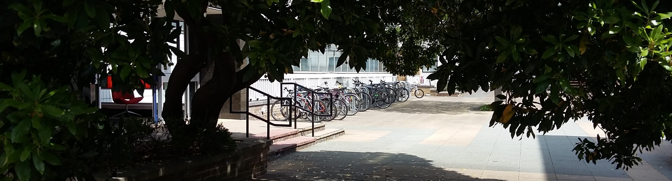2018-2020

Contents
Executive Summary 12
Introduction 13
Leicester Transport Links 14
University Travel Plan Progress 15
Sites Covered by Existing Travel Plans 16
Planned Developments 19
Principles of Transport Provision for New Developments 21
Appendix 1: Travel Survey Modal Splits 22
Appendix 2: Maps 23

Executive Summary
As a part of the Masterplan Development Programme, the University of Leicester is making changes to its campuses.
Since 2010 The University has operated a multiple-campus Travel Plan to encourage more sustainable travel choices by its staff, students and visitors. However, as the campuses have increased and developed since the original Travel Plan was introduced, it has been necessary to add to that first document, first with the Phase 2 Plan (2015 – 2020) but also with a set of separate transport statements; one for each new site.
This Addendum highlights the aims of the Phase 2 Travel Plan that are core to all of the University sites and consolidates them with the additional initiatives that are specific to the named individual sites – both established and currently under development. A set of best-practice guidelines is included for future, as yet unconfirmed, developments that may also evolve from the Masterplan Development Programme.
In addition, the progress enabled by the University Travel Plan since 2010 is described and placed into context within the transport schemes available in Leicester.
The purpose of this Addendum is to show how the University is reducing the impact of its past and future developments on the local road infrastructure and surrounding environment & air quality by providing practical ideas and support to reduce the need for single occupancy vehicle travel.

This report has been created by Go Travel Solutions Limited; August 2018.

Introduction
As a part of the Masterplan Development Programme, the University of Leicester is making changes to various sites within its campus portfolio.
Since 2010 The University has operated a multiple-campus Travel Plan with the stated aim of tackling car parking problems and the transport challenges and opportunities that arise as a consequence of the University’s growth.
As the campuses have increased and developed since the original Travel Plan, it has been necessary to add to that first document, first with the Phase 2 Plan (2015 – 2020) but also with a set of separate statements each pertaining to an individual campus or site additional to the Central Campus. These statements can be seen as addenda within the Travel Plan Appendices document.
In light of the expected rapid growth of the next few years, including a new multi-storey staff car park on Freemans Common as a replacement for other ‘satellite’ parking areas, this document has been prepared as a statement for how the new developments will conform to the current Travel Plan and help to make sure that future growth will not impact negatively on local traffic levels.
The creation of this Addendum will negate the need to create further individual Site Statements each time the University makes a new capital investment for the duration of the current Travel Plan.
The Addendum has been written with reference and in addition to the following documents:
The Final Travel Plan (2010)
Travel Plan Phase 2 2015 – 2020
Brookfield Travel Plan Statement (2017)
Freemen’s Common and Nixon Court Travel Plan Addendum (2018)

“The University is in the midst of a long term, multi-million-pound development plan to accommodate growth in student numbers, expansion of degree course provision and increased research activity.”
UoL Travel Plan (2010)

Leicester Transport Links
Leicester and Leicestershire have a mix of transport initiatives to help travellers move to and within the area some of which are described below.

Local Transport Plan
The third Leicester Local Transport Plan (LTP3) was adopted in 2011. LTP3 sets out Leicester City Council’s (LCC) plans for traffic and transport during the period from 2011 to 2026.
The objectives of LTP3 are:
- Reduce congestion and improve journey times
- Improve connectivity and access
- Improve safety, security and health
- Improve air quality and reduce noise
- Reduce carbon emissions
- Manage to better maintain transport assets
- Improve quality of life.

Connecting Leicester
Sir Peter Soulsby’s plan to create and provide a connected, safe and family friendly city centre by reducing the dominance of roads and creating an attractive, pedestrian-friendly, environment.

Access Programme (Choose How You Move)
£3.2million to support a three-year programme (2016 – 2019) of sustainable transport schemes on the west of the city and neighbouring areas of the county. Funded from the Government’s £60million Sustainable Transport Access Fund to support active travel.

Public Transport Services
Leicester has an extensive network of bus routes; the two largest operators being Arriva Midlands and First Leicester. In addition to the standard service-buses, the Hospital Hopper service commissioned by UHL operates East-West across the city and there are three Park & Ride services into the city centre.
The rail station is less than one mile from the Central Campus.

Cycle Support
Leicester and Leicestershire are covered by a series of six cycling maps which link together, with the Leicester map at the centre:
One-off £300 grants are available for city-based groups to promote initiatives that help increase numbers of local cyclists:

University Travel Plan Progress
In 2009 a baseline Travel Survey was used to assess the modal split of staff and students commuting habits to the University. Approximately 70% of the staff and 8% of the students took part in that survey. An additional survey was carried out in 2015 at the launch of the Phase 2 Travel Plan. To assess progress since 2015, a third survey was carried out this year (2018); headline results can be seen below. For Further details see Appendix 1.

Headline Findings
- An increase in the percentage of staff who walk or run to campus.
- A decrease in the percentage of single-occupancy-vehicle (SoV) staff commuters.
- An increase in the percentage of staff public transport commuters.
- A static, but high, percentage of students who walk or run to the University.
- Falling levels of car sharing to the campus by both staff and students.

For comparison, data from the Transport Statistics Great Britain 2017 show:
- From 2009 – 2017 Great Britain bus passenger numbers reduced from 6% - 4%.
- In 2017, 80% of commuting journeys in the East Midlands were by car, 3% were by bike, 7% were by public transport and 11% were by walking.

In Leicester from 2009 – 2017 there have been increases in the numbers of cyclists and car users but a large reduction in the number of bus users.

“The Travel Plan…is essential to ensure that the University can continue to expand and that its staff and students can carry out their work conveniently and effectively”
UoL Travel Plan (2010)

Sites Covered by Existing Travel Plans
The following is a list of University operated sites that are currently covered by the Phase 2 Travel Plan or an additional Site Statement:
- Central Campus (Phase 2 Travel Plan)
- South Campus (Site Statement)
- North Campus (Site Statement)
- University Hospitals Leicester (Site Statements)
  - Royal Infirmary
  - Glenfield
  - General Hospital
- Oadby Halls of Residence (Site Statement)
- Vaughan College (Site Statement)
See Appendix 2 for a map of the sites (Map 1).

Principles
A Travel Plan is a strategy for managing all travel and transport within an organisation that seeks to maximise access to a site by sustainable modes of transport.
With a multi-site organisation such as the University, each specific Site Statement added to the Travel Plan needs to be tailored to the characteristics of the site location, the organisation and its operations.
Therefore, the Travel Plan has a set of common measures that are applied to the individual sites (see Table 1) plus each site has several recommended site-specific travel plan measures (see Table 2).

Aims
The Travel Plan and Site Statements aim, where practical, to increase the percentages of staff, students and visitors using sustainable travel methods to commute to and between the campuses. The provision of infrastructure, encouragement and education will help to promote lower impact forms of travel in place of the current reliance on single occupancy vehicles and other unsustainable travel methods.

Objectives
- To capture commuter and business travel data for carbon footprinting;
- To improve the choice of transport options and facilities available to staff, students and visitors travelling to, from, and between University sites;
- To implement travel initiatives through behaviour change that reduce transport-related emissions;
- To reduce the use of single occupancy vehicles by staff travelling to and from and between, University sites and increase the use of cycling, walking and public transport use;
- To promote more sustainable ways of working;
- To improve the health and fitness of staff and students through the promotion of walking and cycling;
- To make changes to University vehicles to reduce their environmental impact.

Targets
Targets for the modal split of commuting journeys are shown in Appendix 1. These are the targets that were set in the 2010 – 2015 Travel Plan.
Table 1 University Travel Plan Measures
Implementation Area | Measures
Communication | - Website  - Staff and student travel options booklets  - Online journey planning  - Notice boards  - Press releases  - Events  - Social marketing campaign
Cycling & walking | - Walking and cycling “wish list”  - New showers  - New cycle storage facilities  - Recycled bike scheme  - Staff cycle to work scheme  - Stakeholder engagement  - Walking and cycling maps  - Annual events  - Cycle registration scheme  - Walking/cycling buddy scheme
Public Transport | - Consultation with local service providers  - Stakeholder engagement  - Real time bus information  - (Potential) shuttle bus service
Smarter Working | - IT developments including expansion of teleconferencing and video conferencing facilities  - User guides and training facilities
Managing demand | - Redevelop car parking layouts and numbers  - Development of car sharing scheme  - Car park permit management and visitor parking

“[The aim of the Policy is] to encourage walking, cycling and the use of public transport as principal means of commuting to university for work, study and for travel by staff on University Business”
UoL Travel Plan (2010)

Table 2 Site-specific travel plan measures
Campus | Individual Measures
South Campus | - Signage to cycle parking  - The provision of a basic toolkit kept in one of the bike sheds for use by all for bicycle repairs  - Online travel information  - Stricter car park management
North Campus | - Online travel information  - Site specific travel information, including local recommended walking and cycling routes and journey times to key destinations  - Promoting of alternative options, e.g. walking, cycling and bus or a combination of these modes  - Staff season ticket loans and salary sacrifice schemes
Royal Infirmary | - Improved online travel information – including linking to the LCC UHL bus leaflet and information on cycle routes and cycle safety  - Promotion of alternative options, e.g. walking, cycling and bus or a combination of these modes, and making available travel information on these modes  - Promotion of car sharing for those staff who do not live in a location from which they can walk, cycle or use public transport  - Staff season ticket loans and salary sacrifice schemes  - Looking into setting up a hospital-wide Bicycle Users Group, linking to wider LUH and UoL groups, to help identify and tackle barriers to cycling to the site  - Establishment of a lunchtime walking group, taking leisure walks for health, for getting to know the local area and to demonstrate proximity to the station, town centre, University Central Campus etc.  - Linking in with wider NHS Active Living campaigns to ensure they include travel to and from work
Glenfield Hospital | - Signage to cycle parking  - Travel information available from the hospital website providing maps and covering bus timetables, routes and information on the Hospital Hopper Service.  - Travel information specifically for CVRC on the CVRC website (part of the wider UoL website)
General Hospital | - Online travel information  - Stricter car parking management  - Site specific travel information  - Promoting of alternative options, i.e. walking and bus or a combination of the two  - Staff season ticket leans and salary sacrifice schemes
Oadby Halls | - Improved online travel information – including linking to bus leaflets and information on cycle routes and cycle safety  - Promotion of alternative options, e.g. walking, cycling and bus or a combination of these modes, and making available travel information on these modes  - Promotion of car sharing for those staff who do not live in a location from which they can walk, cycle or use public transport  - Staff season ticket loans and salary sacrifice schemes  - Looking into setting up a campus-wide Bicycle Users Group, linking to wider UoL groups, to help identify and tackle barriers to cycling to the site  - Establishment of a lunchtime walking group, taking leisure walks for health, for getting to know the local area and to demonstrate proximity to the station, town centre, University Central Campus etc.
Vaughan College | - Signage to cycle parking  - Online travel information  - Stricter car parking management  - Site specific travel information  - Promoting of alternative options, i.e. walking and bus or a combination of the two  - Working with other organisations on site to target non UoL travellers with travel information

Planned Developments
See Appendix 2 for a map of the planned sites (Map 2).
As with the previous campus developments described earlier, each new site will adhere to the main University Travel Plan (Table 1) whilst adding location-specific elements of its own (see Table 3).

Brookfield
Brookfield campus was purchased by UoL in 2013. The principal building on the site is Brookfield House, the former home of Thomas Fielding Johnson who donated land to the University. Brookfield House fronts on to London Road, with a garden between the building and the street.
The site is currently in use primarily as the Postgraduate Teaching Centre, which is housed in Brookfield House and a large annexe to the south. This dates back to when the site was used as residential college of nursing.
The buildings to the rear of the site, adjacent to the car park, are used as administration blocks.
The University plans to establish a Business School at Brookfield, which will be a merger of two existing University departments currently based on the main campus.

Freemen’s Common and Nixon Court
This is a redevelopment of existing low-density student accommodation, a surface car park, a public house and library stores to provide high density student accommodation, additional teaching space and a Multi-Storey Car Park (MSCP).
The provision of parking will be expanded from 340 to 555 spaces within the new MSCP and dedicated blue badge parking area. This additional parking will, in part, replace existing spaces in other campus areas that will be closed.

Space Park Leicester
Space Park Leicester is an ambitious initiative that will develop a global hub and collaborative community for businesses, researchers and academia based on space and space-enabled technologies. Offering high-tech facilities and capabilities, it will be a brand-new hub for the analysis and commercialisation of space-enabled data and space mission development.
Based near the National Space Centre the Space Park is a partnership between the University of Leicester, the City and the Leicester and Leicestershire Enterprise Partnership (LLEP). Space Park Leicester will also be home to the Leicester Institute for Space and Earth Observation - one of the University of Leicester's flagship research institutes, along with first class teaching and laboratory facilities. It will also be home to a wide range of commercial partners, both large and small which will provide exceptional business partnering and collaborative opportunities.

Table 3 shows the site-specific Travel Plan measures that are planned for the three currently confirmed developments.
Campus | Individual Measures
Brookfield | - A new shared use pedestrian/cycle access directly from the building entrance to the pedestrian crossing of London Road  - An amended walk map directing users from the main campus to the Brookfield site to use the new shared use path  - Cycle parking provision within the car park  - Additional showers provided in several buildings across the site
Freemen’s Common & Nixon Court | - New cycle and footway routes plus improvements to existing facilities including additional toucan crossings  - Improved and increased provision of secure cycle parking across the development sites including visitor cycle parking  - An Induction Pack and Travel Plan summary distributed to all students within the facility  - Increased Bicycle User Group awareness  - Free high visibility clothing and on-site cycle repair kit for staff and visitors  - Season ticket loans to be made available for staff where a monthly deduction is made from their pay  - Provision of the details of relevant buses to all staff, students and visitors  - Provision of designated car share spaces  - Customised walking route maps  - Transport Newsletter detailing all the relevant transport information to employees  - A single sheet detailing the sustainable transport opportunities available to visitors  - Ensure that all Student ID cards are OneCard enabled to allowance bus journeys to be paid for on ID cards
Space Park Leicester | Transport Statement is still in production.

“The redevelopment of this key University site provides additional opportunities to promote sustainable travel choices amongst staff, students and visitors.”
Freemen’s Common and Nixon Court Travel Plan Addendum (2018)

Principles of Transport Provision for New Developments
For new capital developments a set of principles will be carried out that follow the patterns set by the previous Site Statements:

Checklist
1 | Carry out a regular Travel Survey to evaluate the current commuting habits of site users. | ☑
2 | Evaluate the local sustainable transport network and promote to all users. | □
3 | Assess the onsite provision of active travel facilities and develop further if needed e.g. cycle storage, showers, changing. | □
4 | Publish clear targets for transport modal split expectations. | □
5 | Ensure that the site is compliant with the existing UoL Travel Plan measures. | □
6 | Assess the potential for additional site-specific sustainable transport measures. | □
7 | Plan for the implementation of any additional measures if appropriate. | □
8 | Ensure that a representative of the site is included as a member of the Sustainable Travel Implementation Group (STIG) | □

Other commitments
The University’s Sustainable Construction Principles state the following:
“The University’s aspiration for all projects is to consider a holistic design approach that does not follow one design principle and instead, utilises the most appropriate from selected standards. The Passivhaus and BREEAM design philosophies will be used in conjunction with Leicester’s own self-assessment methodology and will apply to both new builds and refurbishments.”
These standards help to ensure, for example, that all refurbishments target at least a ‘Good’ BREEAM rating and all new builds at least a ‘Very Good’.
In addition, the Leicester for Life Policy aspires to develop a campus comprised of Interesting, Immersive and Interactive Sites (IIIS) that are open and accessible to students, staff, the local community and other species. The IIIS standard is a self-assessment method developed by the Social Impact Team, which picks up on the weaknesses and gaps not covered by other standards.
Vehicle and cycle parking standards are informed by the Leicester City Council guidelines:
https://www.leicester.gov.uk/media/179303/vehicle-parking-standards.pdf
The University has made additional commitments to reducing its impact on the local transport infrastructure:
- Main Campus car parking is also under review e.g. the introduction of ‘drop-off’ spaces at the QE College site
- The University is signed up to SmartGo membership until 31 May 2020
- Working in partnership with – University Hospitals Leicester NHS Trust, De Montfort University, Arriva, and Leicester City Council
- Membership of Leicestershare.com

 | Students |  |  |  | Staff
MAIN Travel Choice | 2009 | 2015 | 2018 | Travel Plan Target | 2009 | 2015 | 2018 | Travel Plan Target
Walk / run | 56% | 62% | 59% | 61% | 16% | 21% | 22% | 22%
Cycle | 11% | 7% | 7% | 20% | 11% | 7% | 10% | 14%
Motorbike/scooter | 0% | 0% | 0% | N/A | 0% | 0% | <1% | N/A
Private car (alone – single driver) | 9% | 5% | 9% | 3% | 49% | 37% | 41% | 34%
Private car (as a driver with passengers) | 3% | 2% | 1% | 2% | 9% | 8% | 6% | 15%
Private car (as a passenger) | 1% | 2% | 1% |  | 3% | 4% | 3%
Bus or coach | 16% | 18% | 16% | 35% | 5% | 8% | 8% | 15%
Train | 3% | 3% | 5% |  | 7% | 10% | 9%
Taxi | 3% | 3% | <1% | N/A | <1% | <1% | 3% | N/A

Appendix 1: Travel Survey Modal Splits

Appendix 2: Maps

Map 1 Sites covered by the Travel Plan or Site Statements
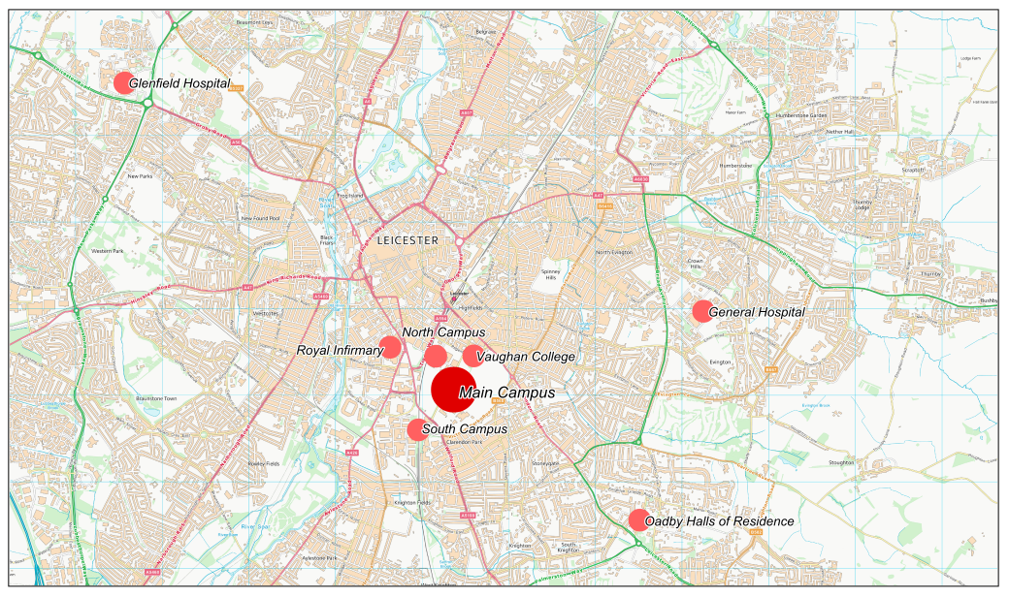
Contains OS data © Crown copyright and database right (2017)
Contains Royal Mail data © Royal Mail copyright and Database right (2018)
Contains National Statistics data © Crown copyright and database right (2018)
Map 2 Confirmed capital developments
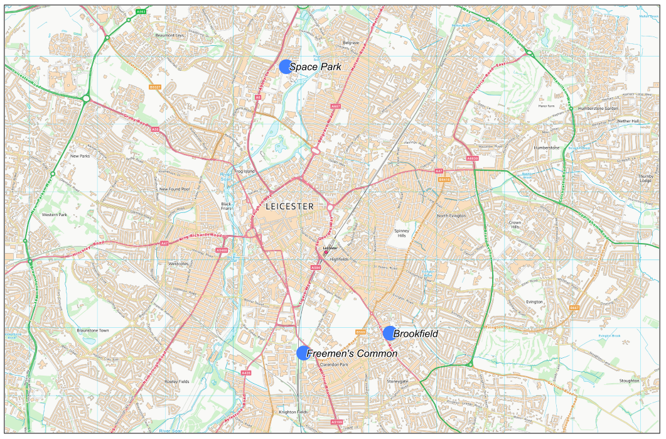
Contains OS data © Crown copyright and database right (2017)
Contains Royal Mail data © Royal Mail copyright and Database right (2018)
Contains National Statistics data © Crown copyright and database right (2018)

https://www.gov.uk/government/statistics/transport-statistics-great-britain-2017
https://www.dft.gov.uk/traffic-counts/area.php?region=East+Midlands&la=Leicester

