Leaf I-Spy

Look around the arboretum part of the Garden and see if you can find these leaves

Oak | Ash | Horse Chestnut
Silver Birch | Walnut | Alder
Lime | 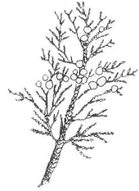  Cedar | Sycamore
Pine | Holly | Beech

Remember!
Please don’t pick any leaves off trees or bushes, just look at them and record them, leaving them there for the tree and others to enjoy

Bingo

Find as many of these as you can in the Garden.

Remember please don’t pick

something yellow | a green leaf | something pink or purple | a stone
a piece of litter | something thin | something long | something surprising
a brown leaf | a feather | a seed | a piece of bark
something red | something with a jagged edge | a twig | something curly
something an animal has eaten | a yellow leaf | Something with two colours on | a cone

Can you find where these photographs were taken in the Botanic Garden?
(Note some of these scenes may look different in different seasons)
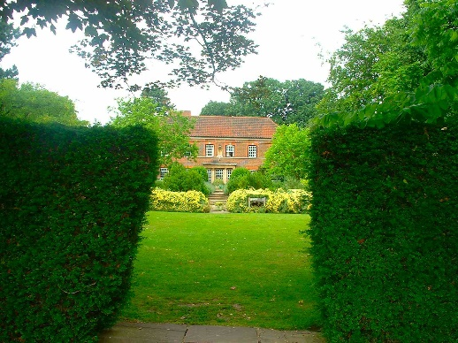
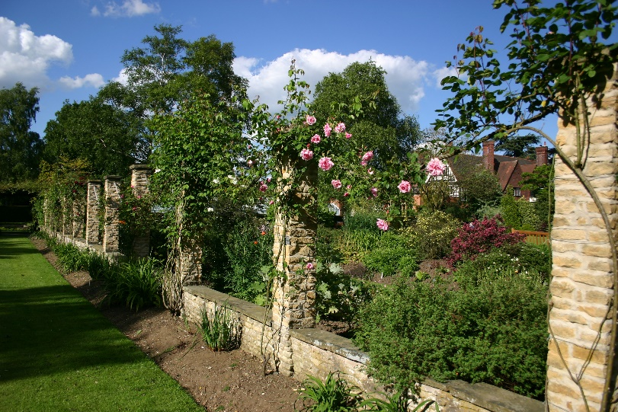
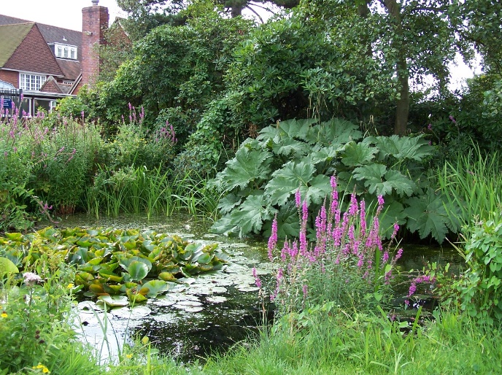
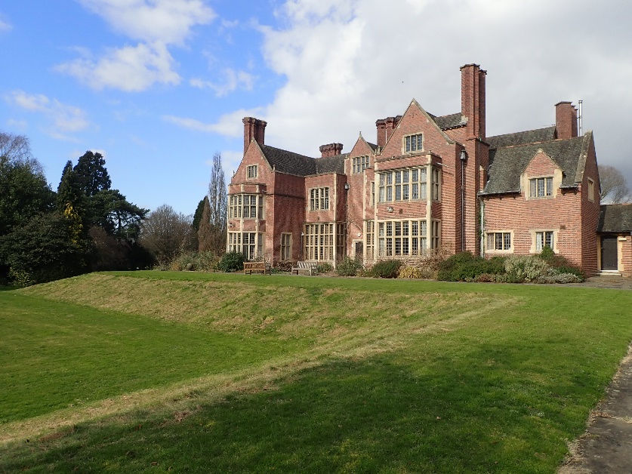
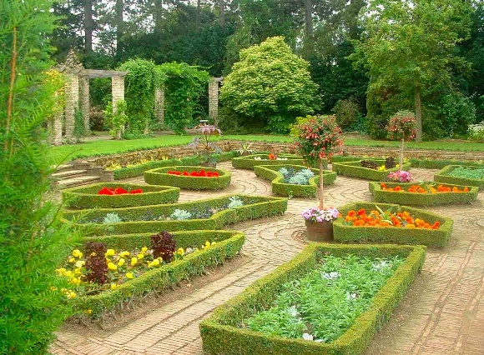
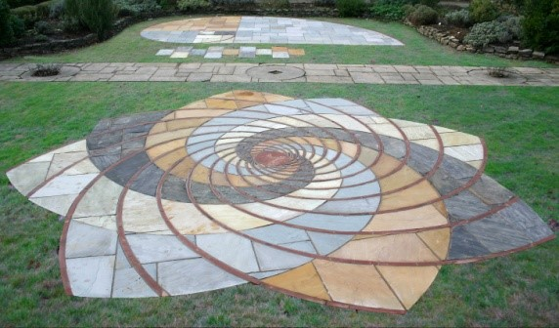
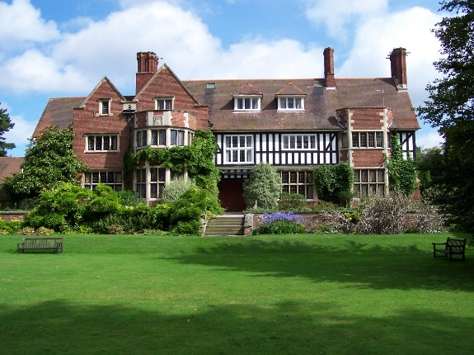
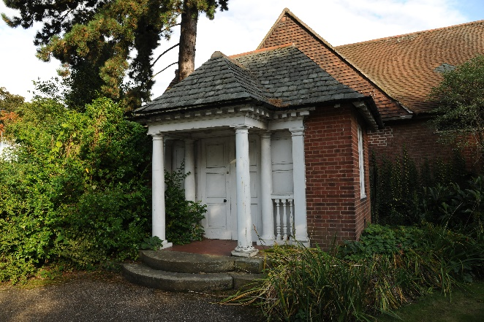
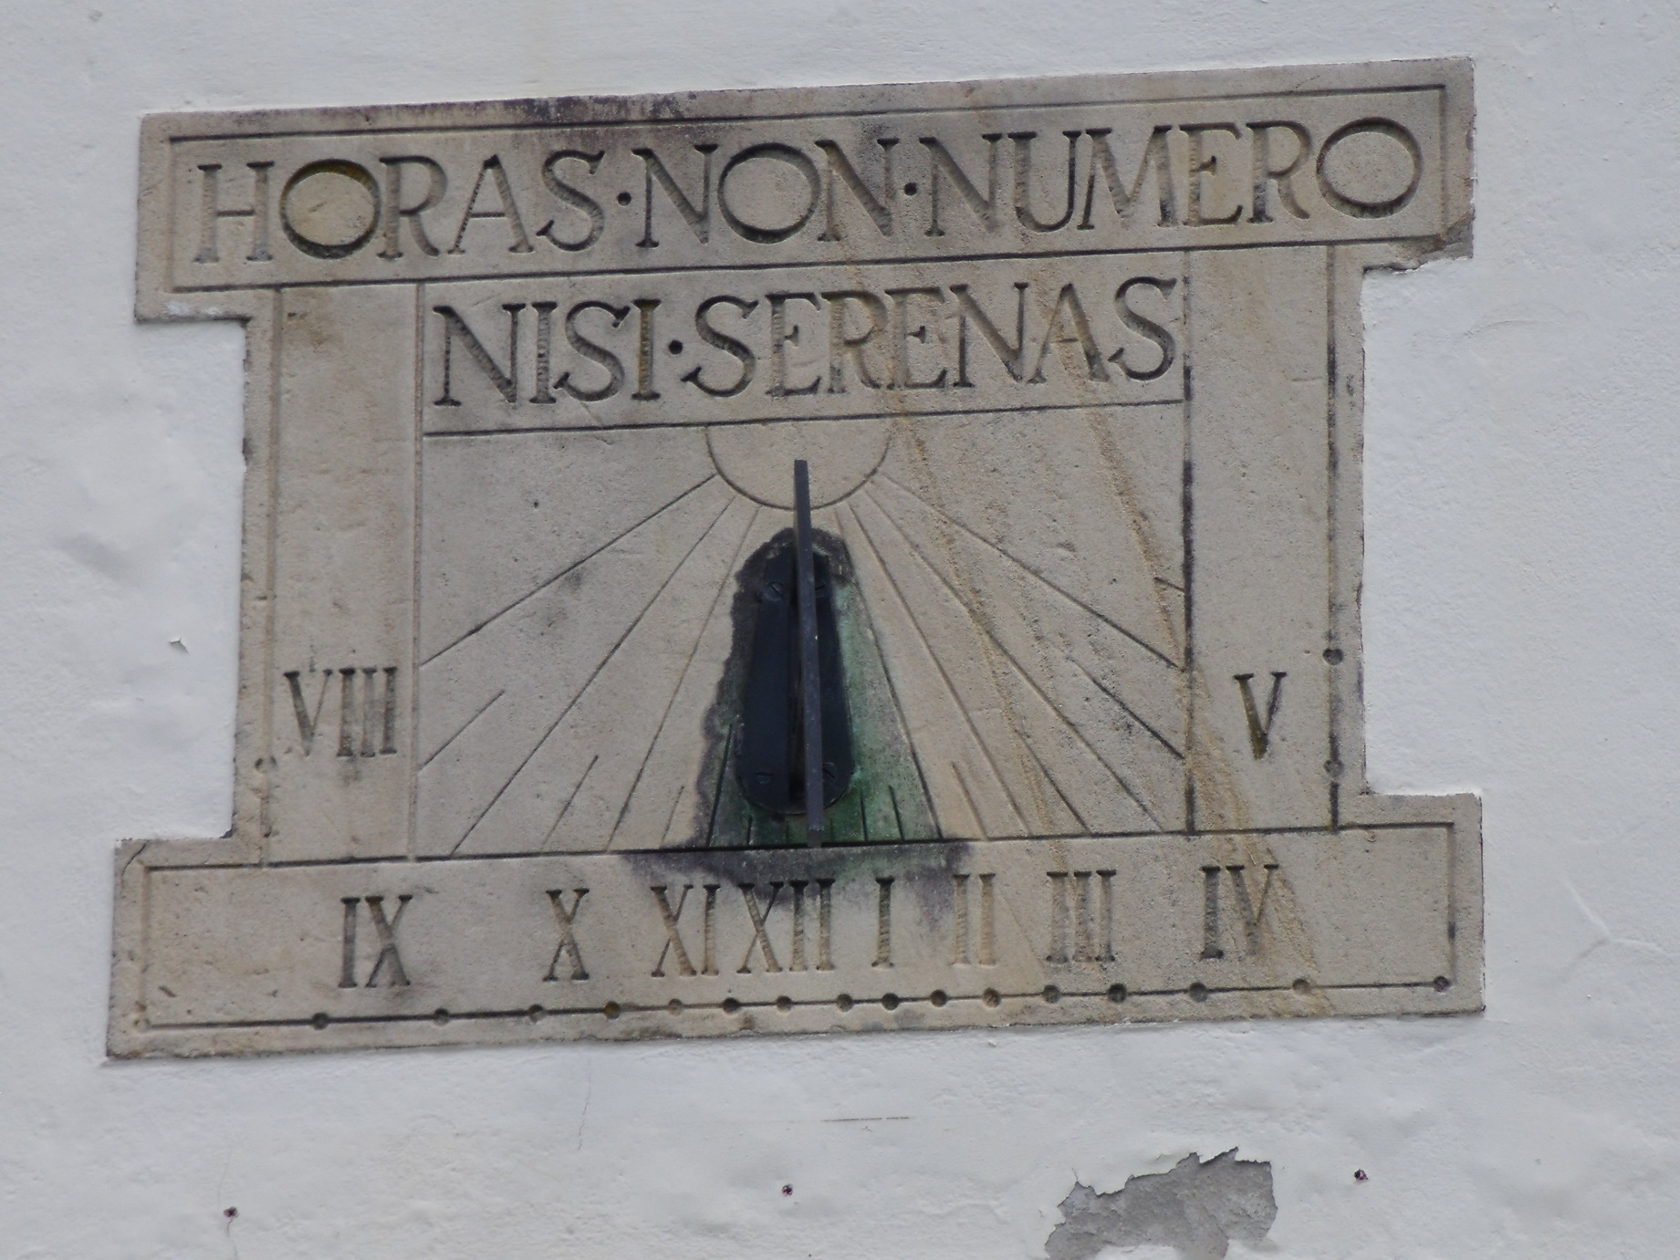
How many different leaves can you find?
(Remember only take leaves from the ground not from plants)

A leaf with one point | A leaf with many points | A leaf with toothed edges | A rough, knobbly leaf
A smooth, shiny leaf | A hairy leaf | A leaf with several colours on | A sharp spiky leaf
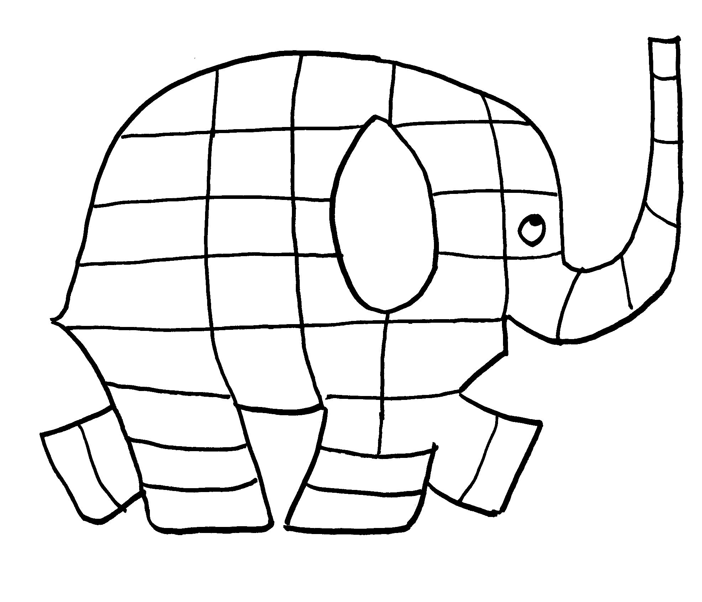
Colour in Elmer with the colours you see in the Garden

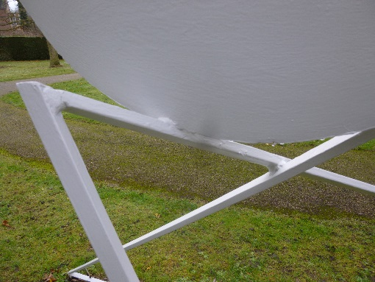
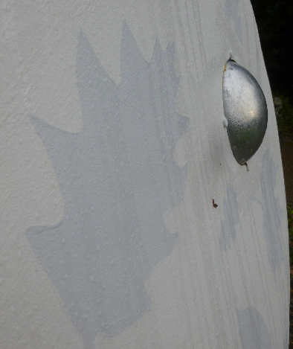
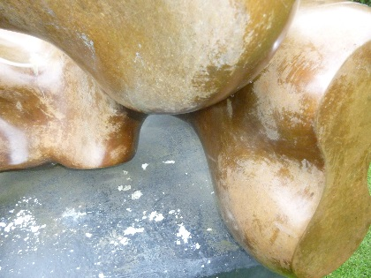
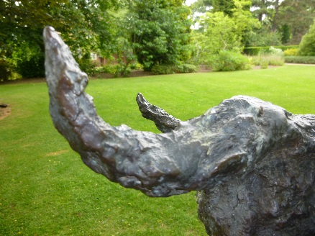
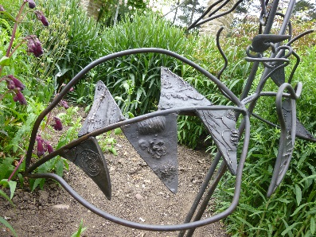
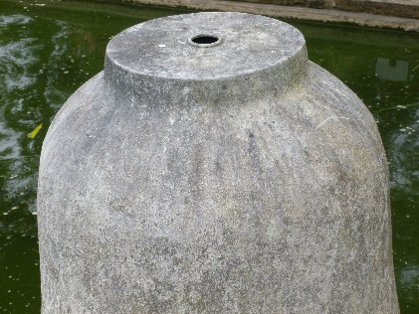
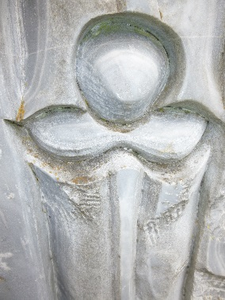
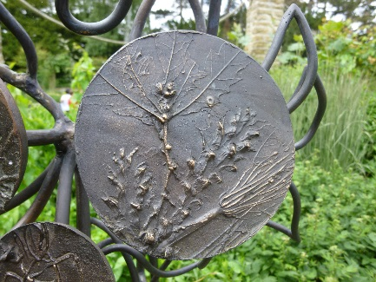
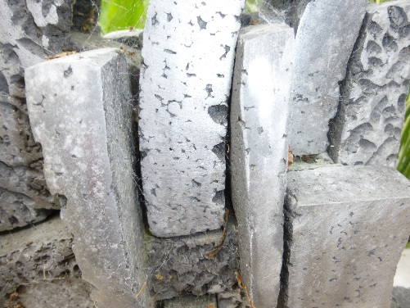
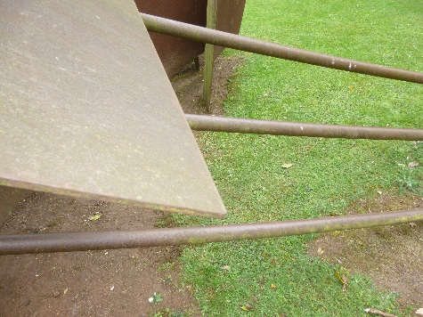
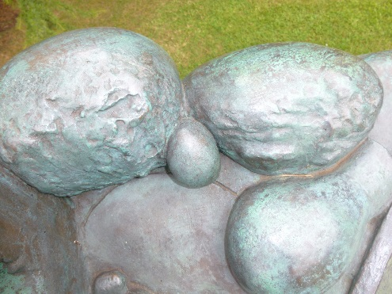
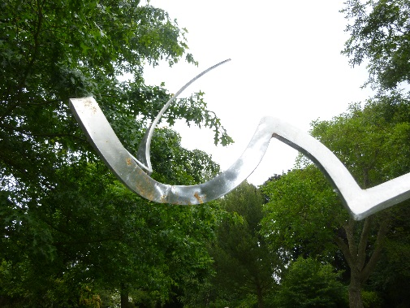
Can you find where these sculpture pictures were taken?

