Acts who have performed at the University over the decades include:

1964
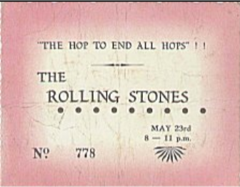
The Rolling Stones (23 May)
Brian Poole and the Tremeloes + The Mojos (19 June)

1965
John Mayall and the Bluesbreakers (20 November)
The Small Faces (10 December)

1966
The Animals (4 March)
The Small Faces (17 June)

1967
The Zombies (14 October)
Kaleidoscope (25 November)
Traffic + Bonzo Dog Doo Dah Band (8 December)

1968
Family + Cream + The Crazy World of Arthur Brown + Wynder K. Frogg + The Freddie Mack Show (9 February)
The Scaffold + The Incredible String Band + Ron Geesin (13 February)
The Move (23 February)
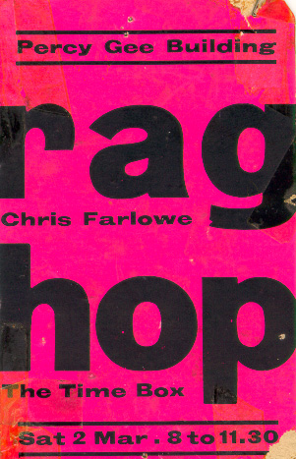
Chris Farlowe + Timebox (2 March)
Manfred Mann (4 May)
The Who + PP Arnold (14 June)
The Move (2 November)
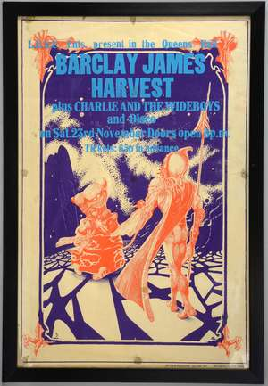
Barclay James Harvest + Charlie and the Wideboys (22 November)

1969
The Web (8 February)
Ben E King + Chris Shakespeare’s Globe Show (28 February)
Led Zeppelin (12 March)
Spooky Tooth + Yes + East of Eden (13 June)
East of Eden + Juicy Lucy (7 November)
Graham Bond (22 November)
Percy Sledge (5 December)

1970
Deep Purple (7 February)
Genesis + Nick Drake (14 February)
Bob Kerr’s Whoopee Band + Hard Meat (28 February)
The Faces (14 March)
The Who (18 April)
Atomic Rooster (2 May)
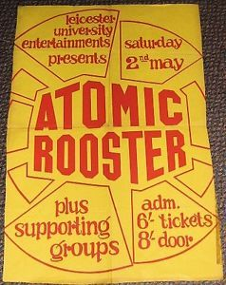
Principal Edwards Magic Theatre (9 May)
Colosseum (16 May)
Manfred Mann Chapter III + Taste (19 May)
The Faces (19 June)
Fotheringay (24 October)
The Strawbs (31 October)
Uriah Heep (14 November)
The Faces (28 November)

1971
Elton John (6 March)
Lindisfarne + Philip Goodhand-Tait (15 May)
Humble Pie + Hookfoot (18 June)
Procol Harum + Barclay James Harvest (9 October)
Cat Stevens + Sutherland Brothers Band (9 October)
Steeleye Span + Andy Roberts (16 October)
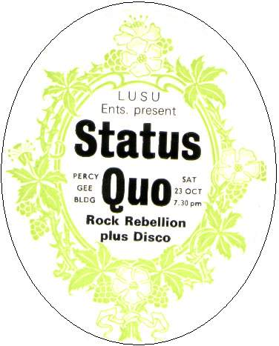
Status Quo (23 October)
Bell + Arc (30 October)
Mott the Hoople (13 November)
Mick Abrahams (20 November)
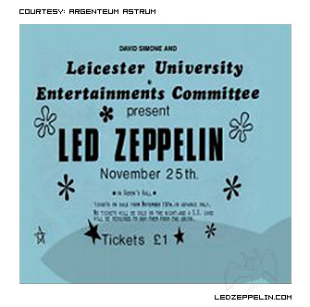
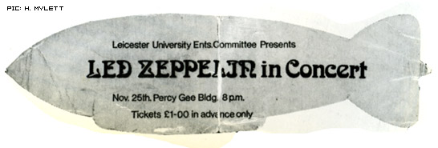
Led Zeppelin (25 November)
Redbone (11 December)

1972
Slade (15 January)
Barclay James Harvest (22 January)
Ten Years After (29 January)
Stud (12 February)
Roy Harper + Flash (19 February)
Roxy Music (19 February)
The Moody Blues (1 March)
Gypsy + Morgan (29 April)
Edgar Broughton Band (6 May)
Vinegar Joe (27 June)
Hawkwind (7 Oct)
Lou Reed (14 October)
John Martyn (21 October)
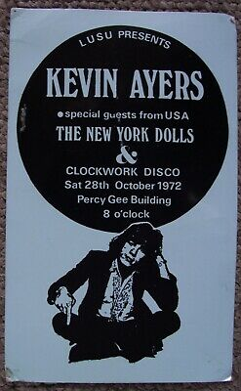
Kevin Ayers + The New York Dolls (28 October)
Argent (4 November)
Roxy Music (18 November)
Holy Mackerel (25 November)
Genesis (1 December)

1973
Captain Beefheart (5 January)
Richard and Linda Thompson (28 January)
The Groundhogs (3 February)
Chris Spedding + Sharks (24 February)
Atlantis (3 March)
Wizzard (10 March)
Captain Beefheart and the Magic Band (1 May)
Help Yourself + Flying Aces (5 May)
Good Habit (26 June)
Michael Chapman + Prelude (10 October)
Ralph McTell + Paul Brett (13 October)
Sharks (20 October)
King Crimson (25 October)
Cockney Rebel (27 October)
Cockney Rebel (2 November)
Steeleye Span + Horslips (3 November)
Spooky Tooth (17 November)
Sensational Alex Harvey Band + Beckett (1 December)
Cockney Rebel (8 December)
Queen (15 December)

1974
Barclay James Harvest (12 January)
Rab Noakes (19 January)
Nucleus (9 February)
Incredible String Band (12 February)
Al Stewart (28 February)
Stackridge (2 March)
The Kinks (7 March)
Snafu (12 March)
Chick Corea (14 March)
Medicine Head (20 April)
Geordie (15 June)
Strawbs (11 October)
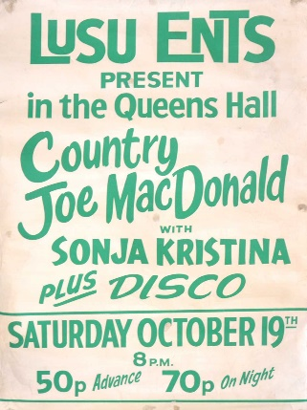
Country Joe MacDonald + Sonja Kristina (19 October)
Barclay James Harvest (23 October)
Hudson Ford (26 October)
Lindisfarne + Wally (2 November)
Queen (9 November)
Babe Ruth (14 November)
Fairport Convention + Bryn Haworth (16 November)
The Sweet (30 November)
Starry Eyed and Laughing (3 December)

1975
John Martyn (23 January)
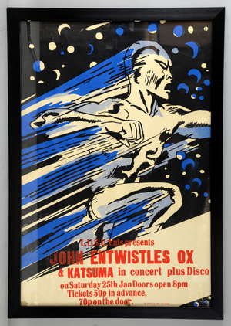
Jon Entwhistle’s Ox + Katsuma (25 January)
Isotope (31 January)
Babe Ruth (7 February)
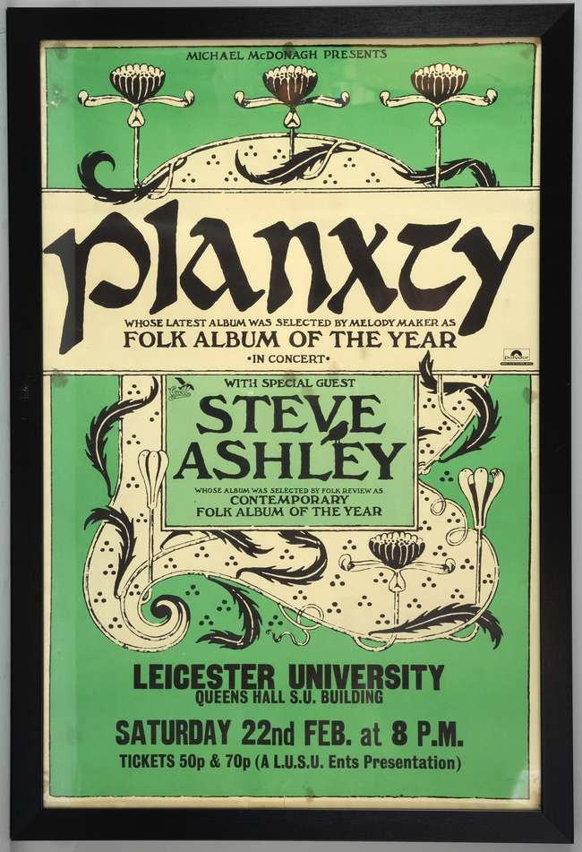
Planxty + Steve Ashley (22 February)
Caravan (8 March)
Curved Air (13 March)
Love (17 May)
John Mayall (3 October)
Argent (11 October)
The Baker Gurvitz Army (18 October)
Fairport Convention + Dave Lewis (1 November)
Desmond Dekker + Heinz + JohnJames + Kelly (Medical Ball) (21 November)
Procol Harum (29 November)
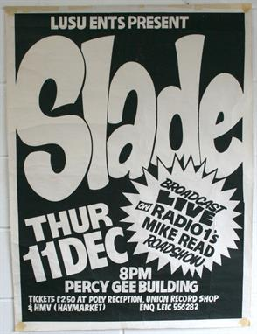
Slade (11 December) – Broadcast live on Radio 1, Mike Read’s Roadshow

1976
Nucleus (31 January)
Freshers Ball: Sassafras + Alkatraz + Roger Ruskin Spear’s Giant Kinetic Wardrobe (9 October)
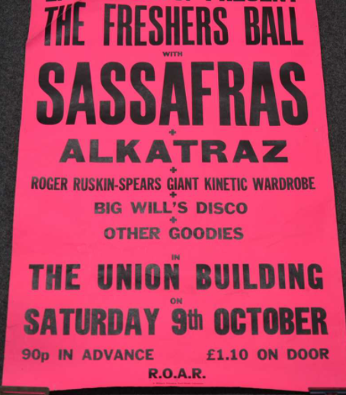
Renaissance + Gordon Giltrap Band (23 October)
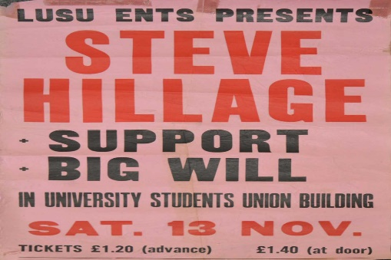
Steve Hillage + Nova (13 November)
Curved Air (4 December)

1977
Roy Harper (22 February)
Generation X + The Boys (11 March) – gig abandoned when someone smashed a glass in the GenX bassist’s face
Little River Band (11 October)
801 (15 October)
Elvis Costello + Ian Dury and the Blockheads + Nick Lowe + Larry Wallis + Wreckless Eric (22 October)
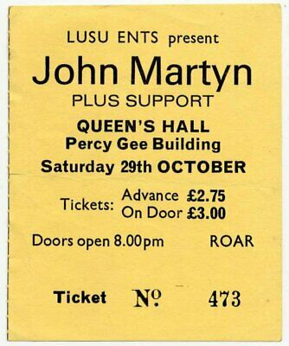
John Martyn (29 October)
Radio Stars (4 November)
Radiator (19 November)
The Jam + The New Hearts (24 November)
Split Enz (3 December)

1978
Talking Heads + Dire Straits (26 January)
Alberto Y Lost Trios Paranoias + The Smirks (4 March)
Graham Parker and the Rumour + Strangeways (26 April)
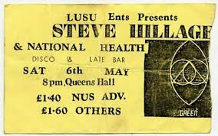
Steve Hillage + National Health (6 May)
Flamin’ Groovies + Radio Birdman (16 May)
Dire Straits + John Mellencamp (15 June)
Here and Now + Supercharge (15 June)
Wilko Johnson (14 October)
The Radio Stars (17 October)
Wire (24 October)
999 (27 October)
The Soft Boys (11 November)
Dire Straits (14 November)
The Rezillos + The Undertones (15 November)
Pere Ubu + The Soft Boys (21 November)
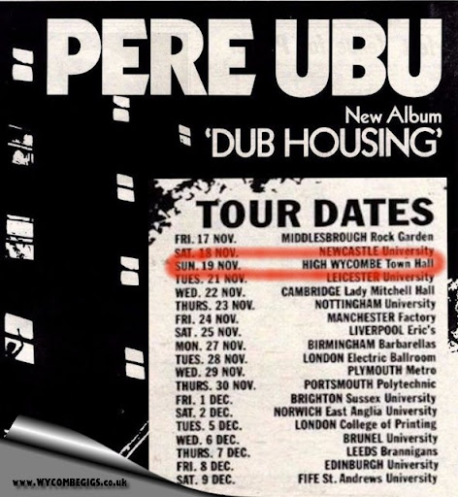
The Rubinoos (7 December)

1979
Generation X + Bernie Torme (10 February) – gig abandoned when the GenX drummer’s head was cut open by a flying beer can
Iron Maiden (23 February)
Magazine + pragVec (27 February)
The Smirks + John Dowie (12 March)
Pierre Moerlen’s Gong (13 March)
Iggy Pop (28 April)
John Otway (5 May)
John Cooper Clarke + Essential Logic + Wendy Tunes + The Chords (14 June)
The Damned + The Ruts + The Spiders + Auntie Pus (16 June)
Steve Hackett (23 June)
The Undertones (14 July)
Def Leppard (28 September)
Stiff Little Fingers (13 October)
The Ruts + The Flys (16 October)
The Lambrettas + Black Slate (20 October)
Penetration (27 October)
John Martyn (5 November)
The Tours (9 November)
Motorhead (17 November)
Secret Affair (27 November)
XTC (29 November)

1980
Angelic Upstarts (15 January)
Robin Trower + Samson (29 January)
999 (2 February)
Def Leppard +Magnum + Witchfynde (5 February)
Gang of Four + The Mekons (9 February)
The Pretenders (12 February)
Iron Maiden (23 February)
Squeeze + Wreckless Eric (1 March)
Diamond Head (7 March)
Toyah (8 March)
Stiff Little Fingers + Another Pretty Face (11 March)
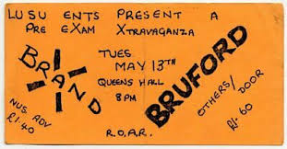
Brand X + Bill Bruford (13 March)
Dexy’s Midnight Runners + The Nips (15 March)
Roy Harper (2 June)
Adam and the Ants + Martian Dance (7 June)
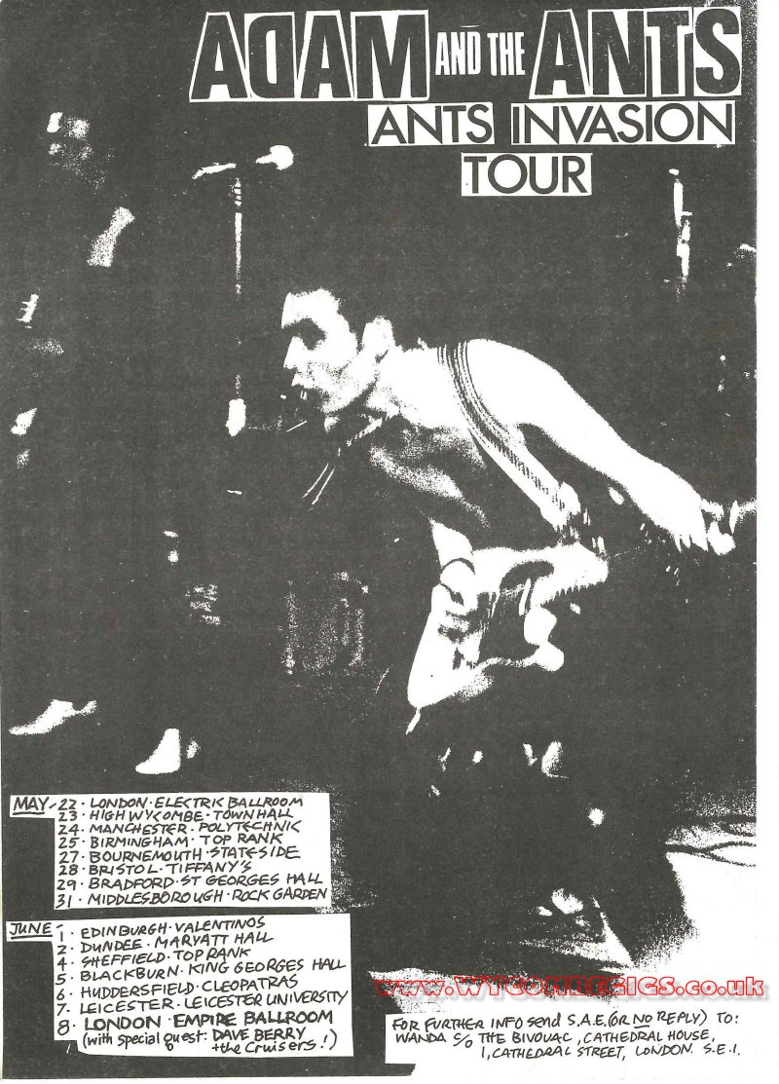
The Beat (14 June)
Diamond Head (27 June)
The Chords + The Gas (25 October)
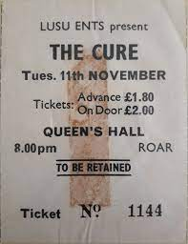
The Cure + Chris Lavelle (11 November)
The Skids + On the Air (29 November)
The Pretenders (2 December)
Slade (11 December)

1981
Durutti Column (14 January)
Toyah (27 January)
The Fall (31 January)
Wilko Johnson (17 February)
Squeeze (19 February)
Pere Ubu + Delta Five + Gang of Four (16 March)
Gang of Four (16 March)
Stiff Little Fingers + The Wall (25 April)
Diamond Head (16 May)
The Revillos (27 June)
John Cooper Clarke (13 October)
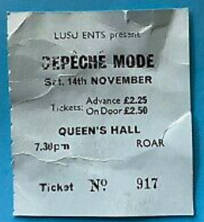
Depeche Mode + Blancmange (14 November)
Dr Feelgood (1 December)
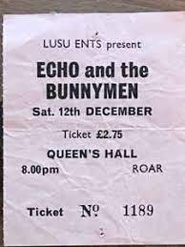
Echo and the Bunnymen + The Wild Swans (12 December)

1982
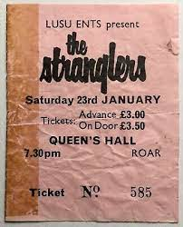
The Stranglers (23 January)
Killing Joke + The Sinatras (20 February)
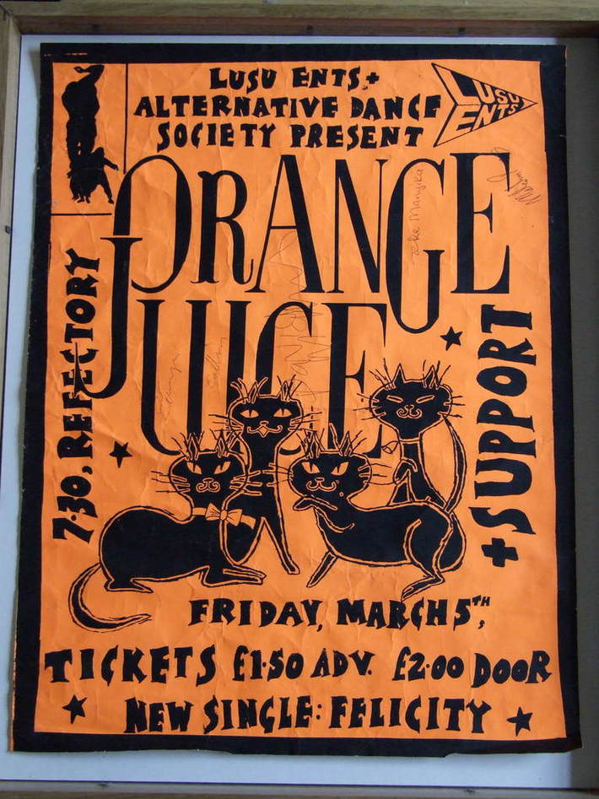
Orange Juice (5 March)
Judie Tzuke (13 March)
Bauhaus (24 April)
The Cure (30 April)
Cabaret Voltaire + A Certain Ratio (19 June)
The Teardrop Explodes (9 October)
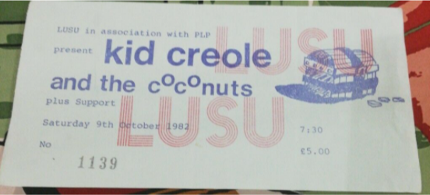
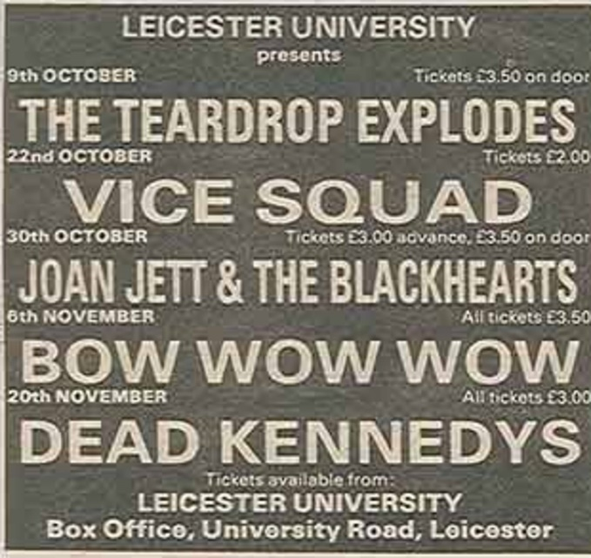
Kid Creole and the Coconuts (9 October)
Vice Squad (22 October)
Joan Jett and the Blackhearts (30 October)
Bow Wow Wow (6 November)
The Dead Kennedys + MDC (20 November) – DKs set abandoned during first song when gang of skinheads climbed on stage and tried to stab the drummer!
Dr Feelgood (9 December)

1983
Hawkwind (11 February)
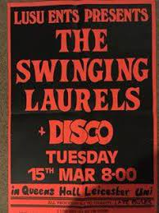
The Swinging Laurels (15 March)
Big Country + The Lotus Eaters (17 June)
Level 42 (7 October)
The Comsat Angels (13 October)
The Danse Society (5 November)
Billy Bragg + Richard Thompson (11 November)
The Enid (26 November)
Solstice (3 December)
Killing Joke (9 December)
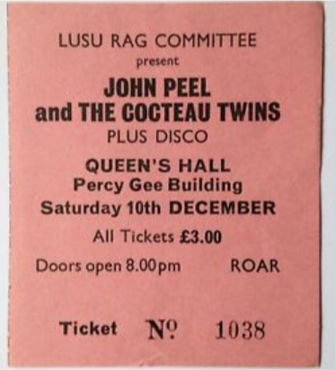
Cocteau Twins [+ John Peel!] (10 December)

1984
The Alarm (27 January)
The Boomtown Rats (14 February)
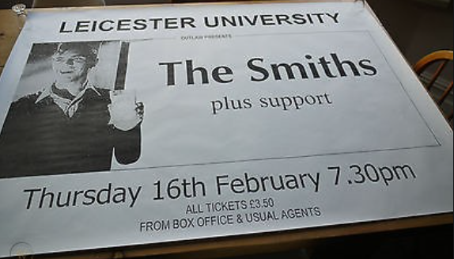
The Smiths + The Red Guitars + Telephone Boxes (16 February)
Diamond Head (17 February)
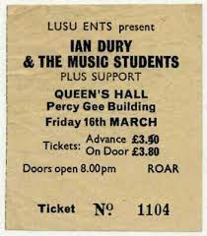
Ian Dury and the Music Students (16 March)
Haze (2 May)
The Psychedelic Furs (3 May)
The Lotus Eaters (5 May)
Billy Bragg + The Redskins (15 May)
Tones on Tail (2 June)
Everything But the Girl (13 October)
The Sisters of Mercy + Skeletal Family (18 October)
The Babysitters (21 October)
Pallas (13 November)
REM (27 November)

1985
Killing Joke (21 January)
Boomtown Rats (2 February)
Uli John Roth + Robin George (6 March)
China Crisis (9 May)
The Redskins (17 June)
Johnny Osbourne + Instigators (23 June)
Squeeze (26 June)
The Pogues (5 October)
The Icicle Works + The Rage + Huge Big Massive (16 October)
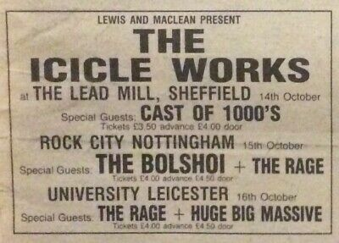
The Fall (17 October)
The Sisters of Mercy + Skeletal Family (18 October)
Prefab Sprout (24 October)
Pallas (5 November)
The Larks (5 December)

1986
The Colourfield (22 February)
Yeah Yeah Noh (27 February)
Half Man Half Biscuit + Gone to Earth (11 March)
The Waterboys (6 May)
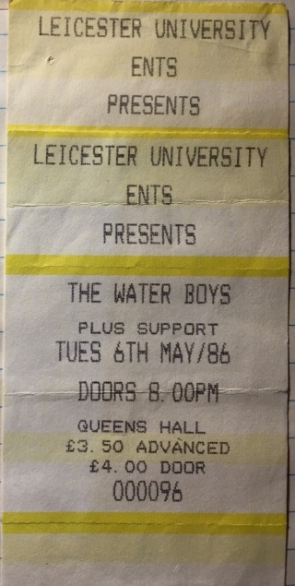
Cherry Bombz + The Babysitters + The Queerboys (22 May)
The Larks (12 June)
The Damned (7 October)
Smiley Culture (11 October)
The Larks (4 December)
Frank Sidebottom (31 December)

1987
Julian Cope + Biff Bang Pow (21 January)
The Godfathers (16 March)
The Alarm + Wire Train (2 May)
The Larks (8 October)
Doctor and the Medics (10 October)
The Bolshoi (14 October)
Bhundu Boys (15 October)
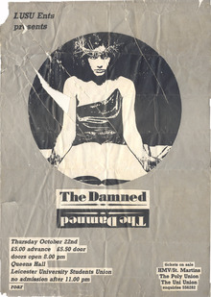
The Damned (22 October)
10,000 Maniacs (9 November)
Ghost Dance + Salvation (2 December)
Big Country + The Wonder Stuff (12 December)
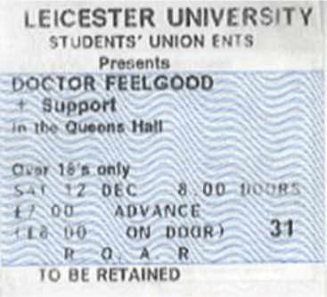
Dr Feelgood (12 December)
Skin Games (16 December)

1988
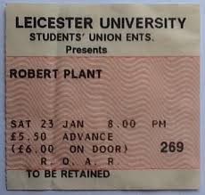
Robert Plant (23 January)
Faith No More (25 January)
The Rose of Avalanche (1 February)
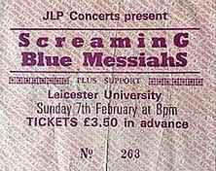
The Screaming Blue Messiahs (7 February)
The Mighty Lemon Drops (9 February)
The Mission + Salvation (12 February)
All About Eve (22 February)
Zodiac Mindwarp and the Love Reaction + The Wonder Stuff (27 February)
Big Country + The Wonder Stuff (1 March)
Stiff Little Fingers (13 March)
The Larks (14 March)
The Fall (17 March)
The Hothouse Flowers + Salvation (20 March)
Something Happens (27 April)
The Primitives (4 May)
It Bites (8 May)
The Sugarcubes (11 May)
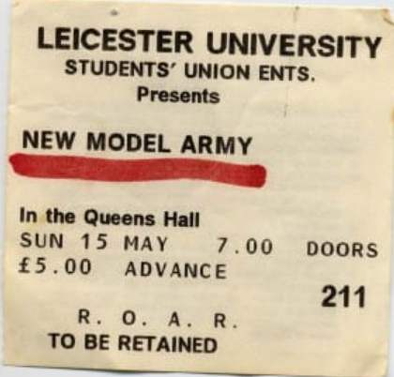
New Model Army (15 May)
Little Angels (16 September)
Tanita Tikaram + Rod Argent (6 October)
Julian Cope (12 October)
The Godfathers (13 December)
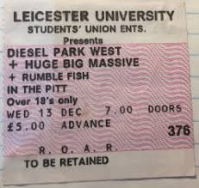
Diesel Park West + Huge Big Massive + Rumble Fish (13 October)
Deacon Blue (16 October)
James + The Happy Mondays (18 October)
The House of Love (20 October)
Balaam and the Angel + Dawn After Dark (25 October)
The Three Johns (2 November)
Spear of Destiny (8 November)
The Godfathers (13 November)
Dr Feelgood (19 November)
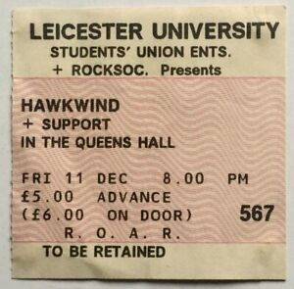
Hawkwind (11 December)
Julian Cope (12 December)

1989
Throwing Muses + The Sundays (22 February)
Stray Cats (28 February)
New Model Army (1 March)
Motorhead + Miss Daisy (5 March)
The Georgia Satellites (? March)
The Pixies + Wolfgang Press (7 May)
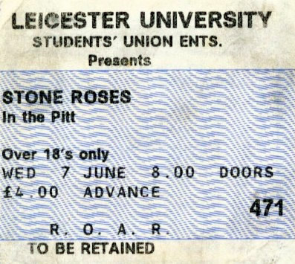
The Stone Roses + The Sandkings (7 June) – gig paused when lighting rig collapsed
Spacemen3 (13 June)
James + The Band of Holy Joy (20 June)
Birdland (12 July)
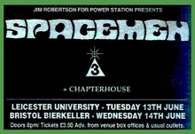
Gaye Bykers on Acid (22 September)
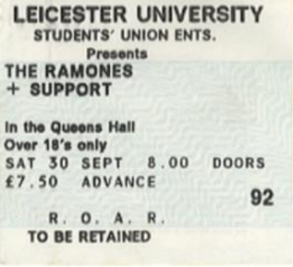
The Ramones (30 September)
The Mighty Lemon Drops + The Family Cat (11 October)
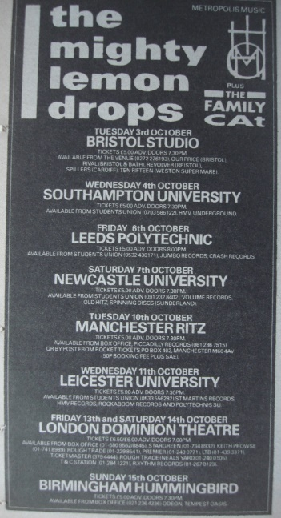
Squeeze (12 October)
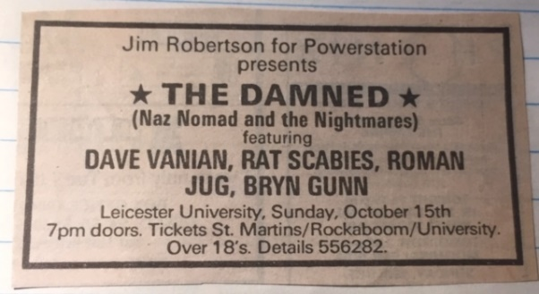
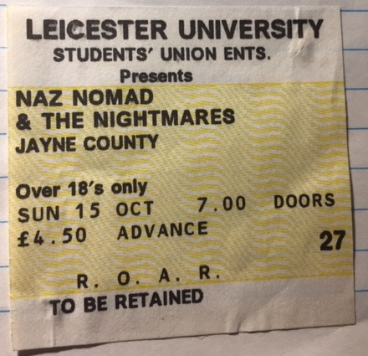
Naz Nomad and the Nightmares (ie . The Damned) + Jayne County and the Electric Chairs (15 October)
Jesus Jones (17 October)
Roy Harper (26 October)
The Darling Buds + Lush (29 October)
Maria McKee (1 November)
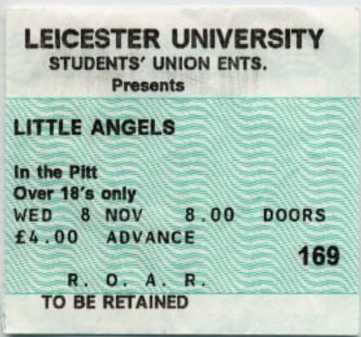
The Little Angels (8 November)
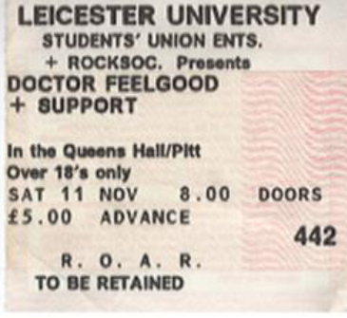
Dr Feelgood (11 November)
Green on Red (16 November)
FM (19 November)
Mega City Four (27 November)
James + The Band of Holy Joy (6 December)

1990
The Sundays + Galaxie 500 (6 February)
Birdland (7 February)
Gun + Slide (13 February)
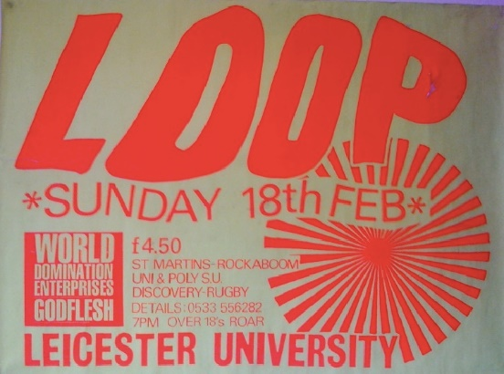
Loop + World Domination Enterprises + Godflesh (18 February)
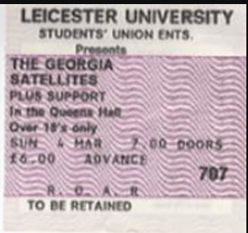
The Georgia Satellites (4 March)
The Quireboys (11 March)
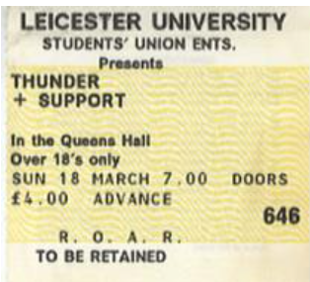
Thunder (18 March)
Saxon (24 March)
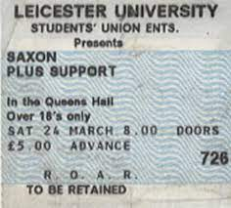
Gaye Bykers on Acid (20 April)
Acid Reign (28 April)
My Bloody Valentine + Something Pretty Beautiful (1 May)
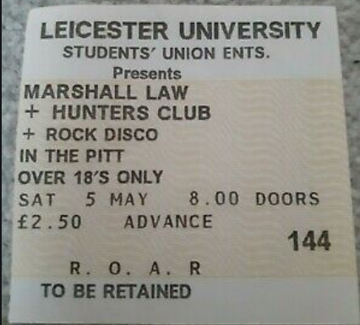
Marshall Law + Hunters Club (5 May)
Claytown Troupe (1 June)
The Charlatans (2 June)
They Might be Giants (21 June)
Lush + Easy (27 June)
River City People (6 July)
Cerebral Fix (11 September)
That Petrol Emotion (10 October)
The Blue Aeroplanes (16 October)
Ned’s Atomic Dustbin + Scorpio Rising (28 October)
Roy Harper (4 November)
Galaxie 500 (7 November)
The Shamen (11 November)
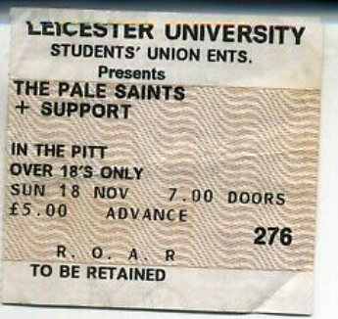
Pale Saints + Edsel Auctioneer (18 November)
Sam Brown (2 December)
The Paul Weller Movement (4 December)
Dr Feelgood (6 December)
The Ancestry (11 December)
Mega City Four + Joy Riders (18 December)

1991
Jesus Jones + Soho (24 February)
Uriah Heap (3 March)
The La’s (4 March)
The High (30 April)
Curve (9 May)
Julian Cope (11+12 May)
The Orb (16 May)
Spiritualized (23 May)
John Martyn (28 May)
The Almighty + Cheap’n’Nasty (4 July)
RPLA (7 September)
Voice of the Beehive (13 September)
Slowdive (18 September)
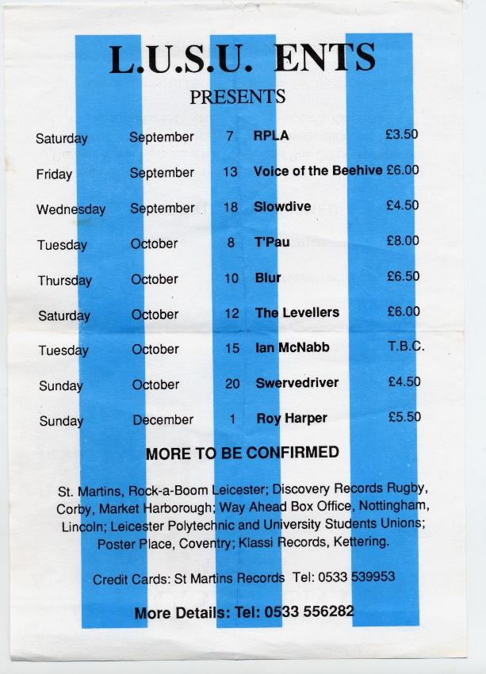
T’Pau (8 October)
Blur + Spitfire (10 October)
The Levellers (12 October)
Ian McNabb (15 October)
Swervedriver (20 October)
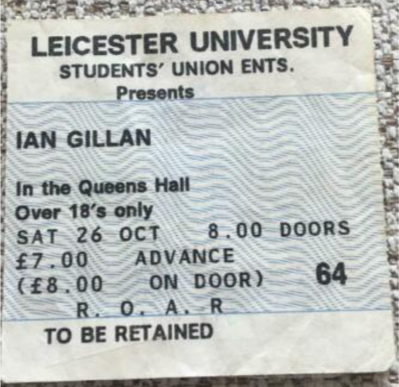
Ian Gillan (26 October)
Pigface (10 November)
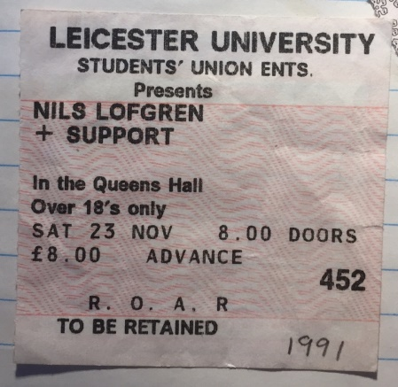
Nils Lofgren (23 November)
Roy Harper (1 December)

1992
Kingmaker + Blab Happy (15) January)
Manic Street Preachers (30 January)
Zodiac Mindwarp + Terrorvision + Beki Bondage (9 February)
Planet Gong + Here and Now (15 February)
Diesel Park West (18 Feb)
Thousand Yard Stare (20 Feb)
River City People (23 Feb)
Curve (17 March)
Shakespear’s Sister (18 March)
Milltown Brothers + The Wonder Stuff + Crazyhead (19 March)
Nitzer Ebb (30 March)
Gun (5 May)
Ozric Tentacles + Dodgy (10 May)
Michelle Shocked (17 May)
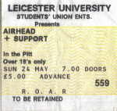
Airhead (24 May)
PJ Harvey (2 June)
Kraftwerk (16? 18? June)
Murder Inc (28 June)
Throwing Muses (4 September)
CUD + The Family Cat (12 October)
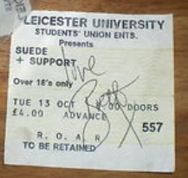
Suede (13 October)
Manic Street Preachers (14 October)
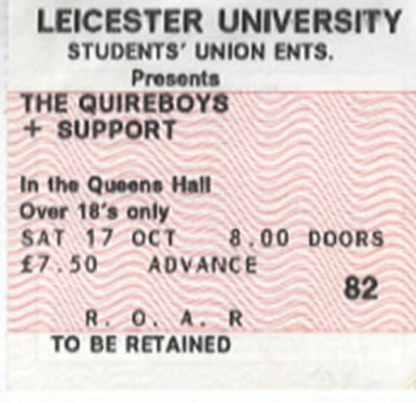
The Quireboys (17 October)
The Verve (20 October)
Pele (2 November)
Kingmaker + Radiohead (7 November)
Spear of Destiny (11 November)
Therapy? (22 November)
The Sundays (3 December)
The Wedding Present (5 December)
Roy Harper (13 December)

1993
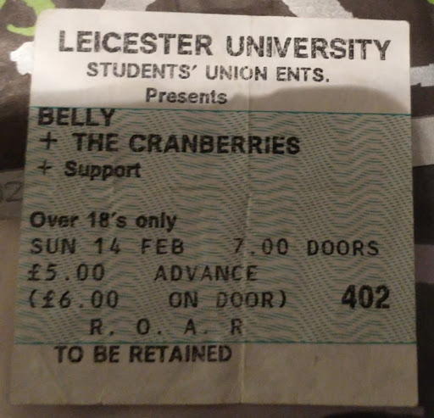
Belly + The Cranberries (14 February)
Fairport Convention (16 February)
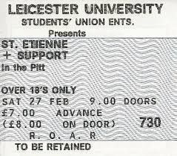
Saint Etienne + Pulp (27 February)
Radiohead + Strangelove (6 May)
Blur + Darkingheart (26 May)
Pele (? May)
Mega City Four (4 June)
Spiritualized (25 June)
Blur + Salad (10 October)
Teenage Fanclub + Superchunk (14 Octobeer)
Swervedriver (26 October)
Buffalo Tom (13 November)
Texas (14 November)
Pulp + Elastica (18 November)
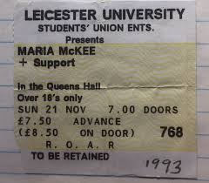
Maria McKee (21 November)
The Orb (25 November)
The Damned (2 December)
Moby (3 December)
The Sundays + Butterfly Child (3 December)

1994
Bark Psychosis (30 January)
Underworld (18 February)
Therapy? + Kerbdog + Credit to the Nation (24 February)
The Wildhearts (12 March)
Terrorvision (27 April)
Pulp + Pram (3 May)
Henry Rollins Band (4 May)
Lena Fiagbe (25 May)
Big Country (15 June)
Radiohead + The Julie Dophin (2 October)
The Wedding Present (8 October)
Underworld + The Drum Club (14 October)
Elastica + Ash + Blubber (16 October)
Orbital (20 October)
Die Toten Hosen + Terrorvision (29 October)
Sparks (12 November)
Ned’s Atomic Dustbin (13 November)
Roy Harper (19 November)
New Model Army (14 December)

1995
L7 + Wool (8 February)
Radiohead (17 February)
Senseless Thing + Minxus + AC Acoustics (5 March)
Del Amitri (12 March)
Carter the Unstoppable Sex Machine (15 March)
Kingmaker (11 May)
The Young Gods (15 June)
The Ramones (29 June)
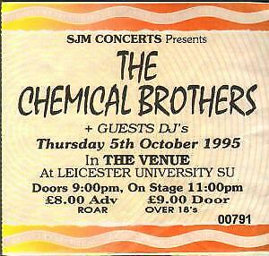
The Chemical Brothers (5 October)
Cast + Ocean Colour Scene (5 October)
Carter the Unstoppable Sex Machine (13 October)
Mike Scott (20 October)
Motorhead (29 October)
The Chemical Brothers (5 November)
The Saw Doctors (29 November)
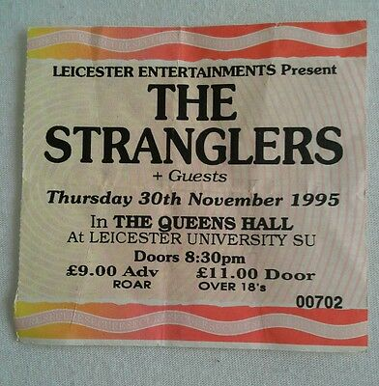
The Stranglers (30 November)

1996
Sunscreen (13 March)
Misfits + English Dogs + Sardonica (14 March)
Manic Street Preachers + Catatonia (2 June)
808 State (31 October)
Ben Folds Five + The Diggers (19 November)
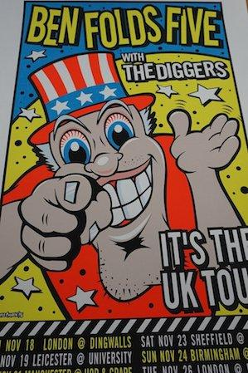
Billy Bragg (1 December)

1997
Babybird (14 March)
John Martyn (26 April)
The Supernaturals + Grass-Show (10 May)
The Longpigs + Embrace (24 October)
Sparks (12 November)
My Life Story + Imogen Heap + Ether (10 December)

1998
Sleeper + Rialto + Libido (17 February)
Space (19 March)
Catatonia (24 April)
Lo Fidelity Allstars (1 June)
Lighting Seeds + Honeyz [+ Tony Blackburn!] (17 June)
Shed Seven (17 July)

1999
Idlewild (22 January)
Terrorvision + Leafeater (6 February)
Roni Size (1 May)
Ben Folds Five + Furslide (11 May)
The Longpigs + Black Star Liner + Dawn of the Replicants (24 October)

2000
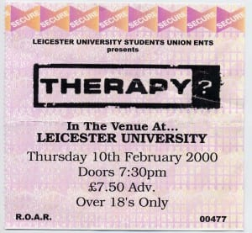
Therapy? + Yo-Yos + Clutch (10 February)
Eels + Lori Carson (8 March)
Pitchshifter + Sona Fariq + The Workhorse Movement (28 September)
Idlewild + Turn + Hundred Reasons (15 October)
Terrorvision (5 December)

2001
Amen (30 January)
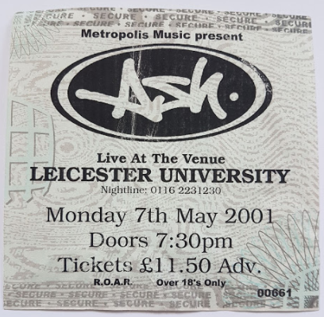
Ash + Snow Patrol (7 May)
Sparklehorse (30 October)
Wheatus (2 December)

2002
Dropkick Murphys (31 January)
Pet Shop Boys (13 February)
Super Furry Animals + Killa Kela (10 April)
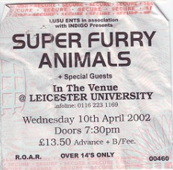
Sophie Ellis-Bexter (30 April)
New Found Glory + The Starting Line + Finch (7 May)
The Wildhearts + Sugarcoma (24 September)
Hanoi Rocks + Diamond Dogs (10 November)

2003
Shed Seven (11 December)

2004
Kasabian + Trap2 (11 September)

2006
The Go! Team (6 Maerch)
Graham Coxon (27 March)
Dirty Pretty Things + Young Knives + Metro Riots (28 April)
Boy Kill Boy + The Automatic + Forward Russia! + The Long Blondes (15 May)
Zero 7 (27 May)
Kasabian (4 September)
Aiden + Bayside + The Aufution + The Sleeping (15 September)
Mogwai (21 September)

2007
The Arctic Monkeys (13 February)
The Automatic + Bjorn Again + Killa Kela + East Seventeen 16 June)
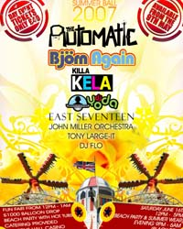
Kosheen (23 September)
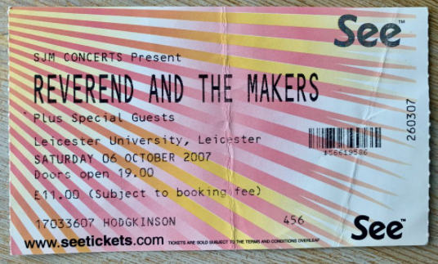
Reverend and the Makers (6 October)
Idlewild + The Twilight Sad (11 October)
We Are Scientists + The Cinematics + Kid Harpoon (11 November)
Kula Shaker (24 November)
Cloned Spirit (11 December)

2008
Athlete + Boy Kill Boy (22 January)
Biffy Clyro + Lovvers + Twin Atlantic (7 February)
The Twang (12 February)
Hot Chip (14 February)
The Cribs + Emma Townshend (16 February)
The Ting Tings + Does It Offend You, Yeah? + Joe Lean and the Jing Jang Jong (16 February)
The Moderators + El Pussy Cat Ska (27 February)
Amy McDonald (? May)
The Subways (30 May)
Right Said Fred (? June)
The Ting Tings + Fight Like PES (30 September)
Hot Chip + Max Tundra (3 November)

2009
Jersey Budd (11 May)
Pendulum (20 June)
J Mascis and The Fog + Dead Confederate (10 December)

2010
The Heroes (2 March)
Wild Beasts (13 March)
O2 Academy opens…
Shadows Chasing Ghosts + Surrender the Coast + Amherst (19 September)
Get Cape, Wear Cape, Fly + David Lyre (21 September)
Philadelphia Journey (21 September)
Professor Green + Ironik + Maverick Sabre (23 September) – official launch night
The Union (24 September)
The Furious Five (25 September)
The Jim Jones Revue (29 September)
The Magic Numbers (4 October)
Sound of Guns (6 October)
Fancy (7 October)
Aynsley Lister (8 October)
The Screening + Charlie Coombs and the New Breed + The Heroes (9 October)
General Fiasco (10 October)
Drag the River + Austin Lucas + Cory Branan (14 October)
Miss Dynamite (14 October)
Dan Le Sac vs Scroobius Pip + Misty’s Big Adventure + Kid A (15 October)
Little Night Terrors + Kyte + Joy-Machine (16 October)
Chess-Club + The Chairman + Autohype (16 October)
Fozzy (17 October)
The Birthday Massacre (18 October)
Corinne Bailey Rae (19 October)
Mr Scruff (21 October)
Attack! Attack! + Straight Lines + Forever Living Dead + That Sunday Feeling (23 October)
Plan B (24 October)
Southside Johnny and the Asbury Jukes + The Billy Walton Band (28 October)
Midlake + John Grant and Jason Lyttle (6 November)
The Doors Alive (14 November)
Goo Goo Dolls + Lostboy! aka Jim Kerr (17 November)
The Complete Stone Roses + Kings of Lyon (18 November)
Chase and Status (18 November)
The Twang (21 November)
The Wedding Present + The View (22 November)
65daysofstatic + Kong (23 November)
Pulled Apart by Horses + Gay for Johnny Depp (29 November)
Young Legionnaire (29 November)
The Courteeners (4 December)
Jesse Malin + The St Mark’s Social (7 December)
The Bluetones (8 December)
Jody has a Hitlist (8 December)
China Crisis (9 December)
Frank Turner + Ed Harcourt (10 December)
Lissie + The Pierces (11 December)

2011
The Molotov Solution + The Tony Danza Tap Dance Extravaganza + The Red Shore + Martyr Defiled (16 January)
Andy McKee (5 February)
John Cooper Clarke (6 February)
The Joy Formidable + The Chapman Family + Airship (13 February)
Ben Montague + Leddra Chapman (22 February)
The Go! Team (26 February)
Beardyman (27 February)
Example (8 March)
Small Fakers (12 March)
The Stranglers (13 March)
Primal Scream (24 March)
Scouting for Girls (5 April)
Bowling for Soup + People on Vacation + Erik Chandler and the Mulberry St Socialites + Linus of Hollywood (12 April)
Bring Me the Horizon + Parkway Drive + Architects + The Devil Wears Prada (2 May)
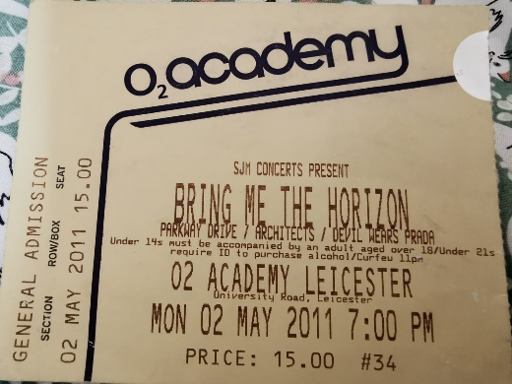
Pete Doherty (4 May)
You Slut! + Maybeshewill (6 May)
The Levellers (12 May)
Jimmy Eat World + Twin Atlantic (23 August)
Wilko Johnson + Ian Siegal (25 September)
The Answer (10 October)
Gentlemans Pistols (10 October)
Scott Matthews + Lotte Mullan (11 October)
The Jamm (15 October)
Noah and the Whale (17 October)
Hawklords (18 October)
Wretch 32 (22 October)
Kasabian (26 October)
Duff McKagan’s Loaded + Dear Superstar + Riot:Noise (6 November)
Imelda May (7 November)
The Complete Stone Roses (12 November)
Turin Brakes (14 November)
Devin Townsend + Dave McPherson (17 November)
The Smiths Indeed (19 November)
Billy Bragg + Akala + Sound of Rum (24 November)
Ocean Colour Scene (2 December)
Jersey Budd (10 December)
David Wyatt + Guano + Lonesome Party Heroes + Martha Bean (11 December)
The Saw Doctors (13 December)
Saxon + Hammerfall (14 December)
The Levellers (16 December)

2012
Relentless (7 February)
CASH (8 February)
Alestorm (13 February)
Andy Wright + The Boobytraps + Theo Miller (18 February)
Dog is Dead (23 February)
Band of Skulls (27 February)
Nero + Killsonik (15 March)
You Me at Six + Kids in Glass Houses + Mayday Parade + The Skints (17 March)
KAV (21 April)
Professor Green (24 April)
The Quireboys + Pat McManus Band (28 April)
T.Rexstasy (3 May)
Rizzle Kicks (4 May)
Formal Warning + Amy Can Flyy (12 May)
Guns 2 Roses (18 May)
Gary Numan + Officers (22 May)
Little Night Terrors + Shelby Court (16 June)
Big Country + The Hotheads (20 June)
Neon Sarcastic (21 July)
By the Rivers (4 August)
The Chizzits + Ferris + The Tennysons + This Motion Picture (1 September)
The Rollin’ Clones (7 September)
Raptusound (8 September)
Modern Faces (22 September)
The Fratellis (24 September)
Maverick Sabre (27 September)
Missing Andy (28 September)
Funk Soul Brother (29 September)
The Selecter (4 October)
Tonight Alive + LostAlone + Blitz Kids + Centre Excuse (7 October)
Marina and the Diamonds (8 October)
Marina (8 October)
Ryan O’Shaughnessy (11 October)
Bo Ningen (14 October)
Dan Le Sac + Merz (15 October)
Newton Faulkner (16 October)
Secret Affair (19 October)
Delilah (20 October)
The Subways (20 October)
Palma Violets (22 October)
Conor Maynard (26 October)
Fossil Collective (27 October)
Bat for Lashes (28 October)
The Cribs + Mazes (1 November)
Spector (1 November)
Stiff Little Fingers + Spear of Destiny (4 November)
Lucy Rose (8 November)
Mystery Jets (10 November)
Kazabian (16 November)
The Crookes (16 November)
Arms of Atlas + I Divide + Violet + Pavilions (17 November)
Ben Howard (21 November)
Hats Off to Led Zeppelin (23 November)
The Complete Stone Roses (23 November)
Formal Warning (24 November)
Peace (24 November)
Peter Hook and the Light + The Shinies (26 November)
Orbital (4 December)
Chase and Status (6 December)
Stereosonics (7 December)
Canterbury + Peace (8 December)
Gentleman’s Dub Club (10 December)
Ryan O’Shaughnessy (11 December)
Chrome Molly (14 December)
The Heartland Roots Band + Jewellers Eye (22 December)
The Tennysons (29 December)

2013
West Park Reggae Collective (2 February)
Paradimes (8 February)
CASH (13 February)
The Atlantics (16 February)
Here Comes the Kraken + Thy Art is Murder (18 February)
Delphic (19 February)
Skam (1 March)
The Alarm (8 March)
The Modfathers (9 March)
Cockney Rejects (14 March)
Linear + Resin + Feedback Voice + Jinnwoo (23 March)
Everclear (24 March)
Jake Bugg + Hudson Taylor (28 March)
King Charles + Story Books + Giovanna (3 April)
The Tennysons + Raptusound + Titan + Led by Wolves (5 April)
The Rifles (13 April)
Feed the Rhino (13 April)
Funeral for a Friend + Polar (18 April)
Adam Ant (24 April)
I am Kloot (25 April)
To the Bones (25 April)
The Rave (26 April)
Lucy Spraggan (26 April)
Leaving Party (27 April)
While She Sleeps + Feed the Rhino (30 April)
If Looks Could Kill + Flip Luke Wilson + Internal Conflict + Honour The Past + In My Restless Dreams (4 May)
The Moulettes + Robert Vincent (4 May)
Colin Hay + Chris Tapper (8 May)
Attack! Attack! (11 May)
Recipe for Disaster (25 May)
Young Kato (28 May)
The Chapman Family (31 May)
Alexander O’Neal + Heatwave + Jazzie B (1 June)
Ghostpoet (2 June)
Jacco Gardner (6 June)
Public Image Ltd + The Wonder Stuff (10 June)
Frankie and the Heartstrings (12 June)
Lewis Watson (13 June)
MK1 (19 June)
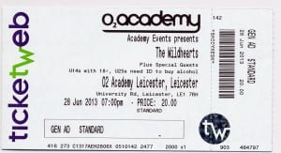
The Wildhearts + Eureka Machines + Baby Godzilla (28 June)
Burning the Day + If Looks Could Kill (29 June)
The Dead Lay Waiting (4 July)
The Hallowed People (5 July)
Neon Sarcastic (20 July)
If Looks Could Kill + Grey Goes Down + White Clouds and Gunfire + Temple Dawn (2 August)
Toots and the Maytals (2 August)
Fozzy (17 August)
Clubs (17 August)
Eels (6 September)
Janet Devlin (24 September)
The Tennysons + The Trap (28 September)
The Temperance Movement + The Graveltones (28 September)
Madina Lake + Fearless Vampire Killers (2 October)
Catfish and the Bottlemen (2 October)
Food Fighterz + This is Nirvana (5 October)
Temples (5 October)
The Starlight Beatles (12 October)
Babyshambles (15 October)
Bastille (17 October)
Goldie Lookin Chain (18 October)
Childhood (18 October)
The Cat Empire + FLAP! (19 October)
Outpatients (20 October)
Lucy Spraggan + Andreas Moe + Shannon Saunders (25 October)
The Illegal Eagles (25 October)
The Atlantics + The Moderators (26 October)
Wolf Alice + Bloody Knees (28 October)
The Feeling (29 October)
The Wedding Present (30 October)
Skam (1 November)
The Queen Extravaganza (2 November)
Hayseed Dixie + Tom Copson (3 November)
Grass House (3 November)
The Hallowed People (8 November)
Chrome Molly + Toseland (8 November)
The Small Fakers (9 November)
Absolute Bowie (9 November)
Craig Colton (10 November)
Jersey Budd (16 November)
Gnarwolves + Black Tongue + The Catharsis + Bastions (17 November)
American Head Charge + RSJ + Maple Run (18 November)
Breed 77 (20 November)
By the Rivers + Will and the People + Mysterians (23 November)
Electric Mary + Skam (26 November)
Vuvuvultures + Slaves (26 November)
Happy Mondays + The Sunshine Underground + Sulk (28 November)
My Life Story (29 November)
The Modfathers (30 November)
The Leisure Society + Alessi’s Aek (30 November)
The Damned + Ruts DC (3 December)
Dutch Uncles + Outfit + Out of Touch in the Wild Orchestra (3 December)
The South + The David Wyatt Band (7 December)
Evanstar (7 December)
Linear (14 December)
The Darkness + LostAlone + The River 68s (15 December)
Over the House (20 December)
Trio Valore + Fire and Skill (21 December)

2014
Roam (8 January)
The Smyths (25 January)
LostAlone + The Blackout + Rat Attack (29 January)
Family (30 January)
SuperEvolver (1 February)
CASH (8 February)
Young Fathers (9 February)
Mikill Pane + Rascals + Paigey Cakey (10 February)
The Red Paintings + Gestalt + Fang Trouser (14 February)
Symmetry + Flip Like Wilson (18 February)
The Answer (25 February)
Blank Onassis + SuperEvolver (26 February)
Idiom (10 March)
The Sherlocks + The Harrowbrooks (21 March)
Ferris (22 March)
Code Orange Kids + Twitching Tongues (24 March)
Miles Kane + Telegram (28 March)
Formal Warning (29 March)
Johnny and the Good Time Boys + The Atlantics (4 April)
D-A-D + ‘77 (5 April)
Patti Russo (15 April)
Public Service Broadcasting (16 April)
Hawthorne Heightrs (16 April)
Surreal Panther + The Darkness (18 April)
Blitz Kids (21 April)
The Doors Experience (25 April)
Angelic Upstarts + Crashed Out (3 May)
Tek-One + Tyler Mae (3 May)
Catfish and the Bottlemen (9 May)
Feed the Rhino + The Howling + Zoax (10 May)
Fickle Friends (13 May)
Hank Wangford and the Lost Cowboys (16 May)
Chameleons Vox (18 May)
The Pizza Underground (28 May)
Nick Oliveri (8 June)
The Dandy Warhols (3 July)
65daysofstatic + Thought Forms (3 July)
Trash Talk (8 July)
Laura Elson + Georgia Emery + The Silver Threetles + Hot City Nights + Violet Cities + Funktion Junction + Stonepark (11 July)
Chrome Molly + Black Star Riders (23 July)
Nothing But Thieves (28 July)
Blondie (20 August)
From the Jam (12 September)
The Moderators (13 September)
Wayne Hussey (23 September)
Honeyblood (25 September)
Primal Fear + Chrome Molly (27 September)
Skam (4 October)
Formal Warning + Casino Empire (4 October)
This Wild Life (4 October)
Spear of Destiny (9 October)
Bad Manners (11 October)
Festival of Psychedelic Rock: Colour Haze + Cherry Choke + The Kumari + Stubb + The Exploding Sound Machine + The Junipers (11 October)
Eliza and the Bear (15 Octiober)
Sleaford Mods (16 October)
Tapestry + Ash Mammal + Surf (18 October)
Gentleman’s Dub Club (19 October)
Half Man Half Biscuit (23 October)
Skinny Lister (24 October)
Rixton + Young Kato (24 October)
This is Nirvana + Food Fighters (25 October)
The Austrian Stones + The Atlantics (25 October)
Digital Sound Boy + Shy FX + Red Light + My Nu Leng + Dismantle + Gotsome (25 October)#
UB40 (30 October)
The Doors Experience (31 October)
The Boomtown Rats + Republica (4 November)
Flyte (5 November)
The Kooks (6 November)
The Smyths (7 November)
UK Subs (7 November)
Kazabian (8 November)
Catfish and the Bottlemen (8 November)
Example (10 November)
Alabama 3 (14 November)
The Courteeners (15 November)
Beardyman (18 November)
Too Rex (21 November)
Wishbone Ash (22 November)
LTNT (25 November)
The Darkness (28 November)
I, the Breather _+ Shoot the Girls First + Novelists (30 November)
Paul Heaton and Jacqui Abbott (2 December)
Big Sixes + Natasha North + Monmarte + Courtney Askey (4 December)
The Enemy + The Twang (5 December)
Evanstar (6 December)
Neon Waltz (7 December)
Embrace (10 December)
China Drum + Ivy Mike + The Auxiliary Unit (15 December)
Me First and the Gimme Gimmes + Capdown + The Skints (19 December)

2015
Lives (17 January)
Produkty + Sepia Sun + Jesuscarfish (23 January)
Hospitality (31 January)
Cherry Choke + Stubb + Children of Leir + Prophets of Saturn (19 February)
The Carnabys (20 February)
Trampolene + The Turning + Yak (21 February)
The Clone Roses (28 February)
Moose Blood + Creeper (5 March)
Lonely the Brave (7 March)
Bootleg Blondie (7 March)
Aaron Keylock (12 March)
Steel Panther + Skindred + The Lounge Kittens (13 March)
The Charlatans + Riding the Low (14 March)
Seafret (19 March)
The Fazed (21 March)
Sleaford Mods (23 March)
Tijuana Bibles + Dedbeats + Produkty (27 March)
The Desert Monkeys (28 March)
The Atlantics + Fire and Skuill + Ska Men UK (28 March)
Coasts (29 March)
Bipolar Sunshine (7 April)
The View (9 April)
Lee ‘Scratch’ Perry + The Paradimes + Vibronics ft. Madu Messenger (9 April)
Bars and Melody (10 April)
Swamp Delta (10 April)
Young Kato (14 April)
The Smyths (18 April)
Riding the Low (24 April)
The Interruptors (24 April)
The Sex Pissed Dolls (25 April)
Palma Violets (26 April)
Man Overboard (28 April)
Smile and Burn + Moose Blood + Roam (28 April)
The Strypes (30 April)
Handmade festival: Sam Duckworth + Thought Forms + Delta Sleep + Grace Petrie + T E Morris + Max Raptor (1 May)
Handmade festival: Nai Harvest + Luke Leighfield + Weikie (2 May)
Handmade festival: Waking Aida + Charlotte Carpenter + Buenos Aires + Speaking in Italics + Katie Malco + Theo (3 May)
Skinny Lister (9 May)
Pinkshinyultrablast (9 May)
Kid Wave + Bully + Fraser A Gorman (10 May)
H Hawkline (13 May)
All Tvvins (6 June)
Sam Bailey (19 July)
Jake Quickenden (21 July)
Sonido (30 August)
Funeral for a Friend (3 September)
Cloudbusting (12 September)
The Moderators (12 September)
The Billy Bibby Band (15 September)
The Sex Pissed Dolls (18 September)
From the Jam (18 September)
Ben Ottewell (19 September)
Chrome Molly (4 October)
Gun (4 October)
Brawlers + Allusondrugs (5 October)
Peace + Splashh + Yak (6 October)
Fever Dream (8 October)
Pinkshinyultrablast (8 October)
Mark Morriss + Lucy Ward + Refuge + Olivia Rose Deane (10 October)
Starsailor (13 October)
Bullet for My Valentine + While She Sleeps + coldrain (16 October)
The ElectriCool (17 October)
By the Rivers (17 October)
Asking Alexandria + Memphis May Fire + August Burns Red + In Hearts Wake (20 October)
August Burns Red + Memphis May Fire (20 October)
Darwin Deez (23 October)
The Sherlocks + Casino Empire + Ibisco (24 October)
Mates of State (1 November)
Food Fighterz + Novana (7 November)
The Smyths (7 November)
Seafret (9 November)
Lucy Rose (9 November)
The Mouse Outfit (14 November)
Raising Glaciers (17 November)
Saint Raymond (19 November)
Albert Hammond Jr (20 November)
Scouting for Girls (21 November)
Evil Scarecrow (21 November)
Happy Mondays (22 November)
Definitely Mightbe (27 November)
Mad 4 Brit (28 November)
Eskimo Dance (28 November)
The Courteeners (1 December)
The Rutles (4 December)
Jaws (4 December)
Theatre of Hate (5 December)
Pulse + Hazard + Mampi Swift + Sub Zero + Nicky Blackmarket + Eksman + Harry Shotta + Tonn Piper (5 December)
The Superskas (10 December)
The Wonderstuff (16 December)
Matt Henshaw (18 December)
Chrome Molly (19 December)

2016
Yonaka + Drenge (23 January)
Telegram (14 February)
Pins (15 February)
Eliza and the Bear (18 February)
Gentleman’s Dub Club (20 February)
Blossoms (26 February)
The Vryll Society (26 February)
The Clone Roses (27 February)
British Sea Power (28 February)
Tusks + Submotion Orchestra (26 March)
Trivium + As Lions + Heart of a Coward (27 March)
The View (13 April)
Cast (15 April)
The Sex Pissed Dolls (22 April)
Handmade festival: Ash Mammal + Her Name is Calla + 65daysofstatic + We are Scientists + Estrons + Vitamin + The Magic Gang + Black Honey + Pretty Vicious + French Leave + Hannah Lou Clark + Charlotte Carpenter + Elizabeth Cornish (29 April)
Handmade festival: Speaking in Italics + Cleft + Crows + Kagoule + Lonely the Brave + Deaf Havana + Happy Accidents + OhBoy! + Indoor Pets + Axes + The Xcerts + We Three and the Death Rattle + Arcades + Crosa Rosa + Clubs + She Makes War + Wise Ass + Yan (30 April)
Handmade festival: Johnny Lloyd + Big Deal + Oscar Scheller + Los Campesinos! + Swim Deep + Noyo Mathis + Bear Makes Ninja + Alpha Male Tea Party + Waking Aida + USA Nails + Three Trapped Tigers + Colour Me Wednesday + Chris T-T + Grace Petrie + Beans on Toast + Jess Green + Weikie (1 May)
Less Than Jake + Trash Boat + The Kenneths (4 May)
The Icicle Works (7 May)
Edgar ‘Summertyme’ Jones (20 May)
Space (28 May)
Norma Jean (3 June)
Coasts (6 June)
Quantic (24 June)
DMA’s (2 July)
The Bluetones (21 July)
Bill Ryder-Jones (29 July)
Fire and Skill + Stone Park (30 July)
Sticky Fingers + Will and the People + Ibisco (1 September)
The Enemy (8 September)
The Moderators (10 September)
The Sherlocks (13 September)
Mystery Jets (3 October)
The Smyths (7 October)
Ash Mammal (8 October)
Lonely the Brave (14 October)
Skinny Lister (15 October)
The UB40 Experience (15 October)
Bars and Melody + Lukas Rieger (19 October)
Steve Mason (21 October)
Slow Club (22 October)
Geko (24 October)
Lisa Hannigan (26 October)
Heartless Crew (29 October)
WSTR + Milestones (1 November)
Chas and Dave (4 November)
Ferocious Dog (5 November)
MONO + Alcest (11 November)
This is Madchester (12 November)
Vice Squad + Ricky Warwick (15 November)
Antarctic Monkeys (18 November)
Public Image Ltd + Dreadzone (19 November)
Partybaby + Vant (20 November)
Slaves (22 November)
Alabama 3 (24 November)
Definitely Mightbe (25 November)
Pearl Jam UK (26 November)
Blossoms (30 November)
Reef (10 December)
Martha Reeves and the Vandellas (14 December)
Galactic Empire (15 December)
The Twang + Cabbage (16 December)
By the Rivers + Will and the People + Ash Mammal (17 December)
Family (22 December)

2017
The Hunna (21 January)
Special Kinda Madness (21 January)
Mr Scruff (28 January)
Bry (17 February)
Sundara Karma (20 February)
Alex Horne and the Horne Section (23 February)
TRAPS (24 February)
The Clone Roses (25 February)
Jersey Budd (25 February)
White Lies (28 February)
Alex Cameron (28 February)
Nearly Noel Gallagher’s High Flyin’ Birdz + Jimmy Amnesia (11 March)
The Amy Winehouse Experience + Abandon Her (17 March)
Johnny and the Good Time Boys + The Paradimes + Captain I-Pod (17 March)
The Wailers (18 March)
The Leicester Soul Train (25 March)
The Jesus and Mary Chain (28 March)
Black Honey + Freak + Superego (29 March)
Circa Waves + The Magic Gang (1 April)
Chris Ramsey (2 April)
Stormzy (3 April)
Toseland (5 April)
Electric Six (20 April)
Shalamar (25 April)
Handmade festival: Twin Atlantic + Pulled Apart by Horses + Jaws + Tigercub + Muncie Girls + Puppy + Ash Mammal + Kermes (29 April)
Handmade festival: Frightened Rabbit + British Sea Power + Honeyblood + God Damn + Idles + DEAD! + Fizzy Blood + Little Hours (30 April)
From the Jam (6 May)
Big Narstie (7 May)
The Japanese House (12 May)
Black Honey + Royal Blood (20 May)
The Mission + Skeletal Family + Pauline Murray (27 May)
Absolute Bowie (9 June)
PYRVMIDS (17 June)
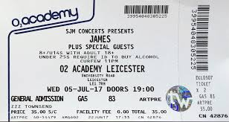
James (5 July)
We Are Scientists (23 July)
Jacek Stachursky (29 July)
Ash + Get Inuit (20 August)
Indoor Pets (20 August)
Soul II Soul (16 September)
Lucy Spraggan (8 October)
Fireball + Reel Big Fish + Anti-Flag + Mad Caddies + Sweet Little Machine (13 October)
AJ Tracey (18 October)
Elvana (20 October)
The Smyths (21 October)
Declan McKenna + Feet (21 October)
Katchafire (26 October)
J Hus (3 November)
Ghostpoet (6 November)
Milburn (10 November)
Newton Faulkner (13 November)
Black Star Riders + Tax the Heat (16 November)
Dirty Thrills + Blue Pills (16 November)
The Southmartins + Tooth and Nail + Cherry Head, Cherry Heart (17 November)
Definitely Mightbe (24 November)
Shed Seven + Cast (26 November)
Scouting for Girls (28 November)
Antarctic Monkeys (2 December)
Pearl Jam UK (8 December)
The Twang (16 December)
The Family Silver (17 December)

2018
Palaye Royale (13 January)
The Sherlocks + Neon Waltz + Oddity Road (1 February)
The Xcerts (18 February)
Alvvays (22 February)
Fickle Friends (27 February)
The Damned + Sleeper (3 March)
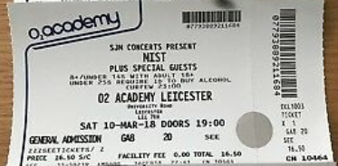
Mist (10 March)
Gary Numan + Nightmare Air (14 March)
Avalanche Party (17 March)
The Wonder Stuff + Ned’s Atomic Dustbin (1 April)
Frank Turner + The Homeless Gospel Choir (4 May)
Handmade festival: Drenge + The Wytches + Future of the Left + Protomartyr + Grace Petrie + Crosa Rosa + Eyre Llew + Her’s (5 May)
Handmade festival: Circa Waves + Little Comets + Gengahr + Findlay + The Orielles + Easy Life + Magique + Mellow Gang (6 May)
Charlie Puth (7 June)
The Psychedelic Furs + Richard Strange (12 June)
Wilkinson (22 September)
The Men They Couldn’t Hang (12 October)
Coasts + Only the Poets (18 October)
Tom Grennan (19 October)
The Smyths (20 October)
The Daniel Wakeford Experience + The Strays (28 October)
Less Than Jake + Reel Big Fish + Zebrahead + Suburban Legends + Matt Stocks (8 November)
Chrome Molly + The Dead Daisies (16 November)
Shame (17 November)
Pearl Jam UK (17 November)
The Courteeners + Zuzu (20 November)
Definitely Mightbe + Gareth Jones (23 November)
The Sex Pissed Dolls + The Mini Nukes (30 November)
Bowling for Soup + Patent Pending + Not Ur Girlfriend (2 December)
Miles Kane + Cabbage (4 December)
Bjorn Again (7 December)
Antarctic Monkeys + Echo Fire (8 December)
DMA’s + Rosborough + Neon Waltz (12 December)
Slade + Mud 2 (16 December)
Skindred + Sonic Boom Six + SKAM (22 December)

2019
Enter Shikari + Palaye Royale + Black Peaks (13 January)
The Vaccines + Jesse Jo Stark + Hatchie (5 February)
John Cooper Clarke (16 February)
TRAPS (2 March)
Fredo (8 March)
Skinny Lister + The Wood Burning Savages + Trapper Schoepp (9 March)
As It Is (14 March)
The Amy Winehouse Experience (23 March)
Easy Life (30 March)
King No-one + The Lids + Skirt (7 April)
Nilufer Yanya (8 April)
Sleaford Mods + LIINES (12 April)
Oceans Apart + We Give In + Finches of Attica (20 April)
Dave (23 April)
Teleman (26 April)
Honeyblood (2 May)
Handmade festival: Metronomy + The Sherlocks + Black Honey + Pins + Saint Agnes + Whenyoung + Arcades (5 May)
Handmade festival (stage 2): The Futureheads + Ibibio Sound Machine + C Duncan + Danny Goffey + The Snuts + Pixx + Magique (5 May)
Demons of Ruby Mae + Midnight Wire + World Without Want (10 May)
Lucy Spraggan + Emma McGrath (12 May)
Kamakaze (18 May)
Gazelle (18 May)
Psychedelic Porn Crumpets (19 May)
KSI and Randolph (25 May)
Bodega + Dry Cleaning (10 August)
Barracuda + Spacetoast + Dum Language (6 September)
Arcades (7 September)
Uprising festival: Napalm Death + Memoriam + Acid Reign + Vardis + OHHMS + Krysthla + Aluna + Resin + The Darkhorse + Seven Hells + Foul Bodu Autopsy (14 September)
New Hope Club (2 October)
Swim Deep + Phoebe Green + Jools (10 October)
Sea Girls (11 October)
The Twang (14 November)
Gary Numan + Kanga (17 October)
Kate Tempest (18 October)
The Struts + King Nun + Kyle Falconer (19 October)
The Smyths (19 October)
Antarctic Monkeys (26 October)
Earls + Jools (2 November)
Little Comets + SisterBliss + Bubblegum Hypnosis (4 November)
Boston Manor + Modern Error + Gender Roles (8 November)
Lagwagon (8 November)
Burna Boy (9 November)
Steve Mason (9 November)
Reel Big Fish + Lightyear + Spunge (13 November)
Mahalia + Hamzaa (14 November)
The Lids + Barracuda (15 November)
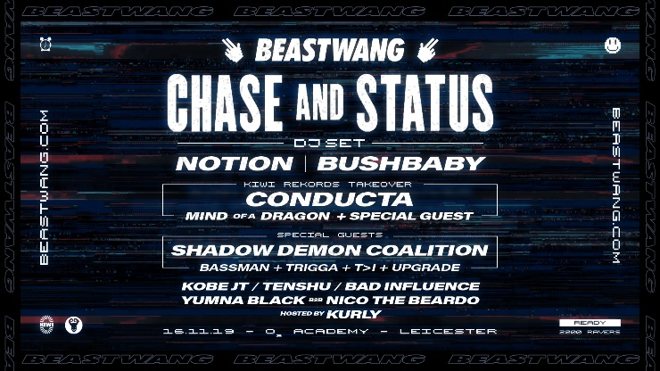
Chase and Status (16 November)
Pearl Jam UK (16 November)
Definitely Mightbe (23 November)
Electric Six + The Fazed + Prime (25 November)
The Bluetones + The K’s + Arcades (28 November)
The Darkness (2 December)
We Are Scientists + Marsicans (4 December)
Razorlight (6 December)
Norman Jay + Smoove and Turrell + Hannah Williams and the Affirmations (7 December)
Aitch (13 December)
The Clone Roses + Kazabian (14 December)
Pop Will Eat Itself + CUD (20 December)
Gazelle (21 December)

2020
Sidhu Moose Wala (15 January)
InMe + Haggard Cat (24 January)
Together (25 January)
Shy FX (1 February)
Roger Chapman + Dawson Smith (4 February)
Dreadzone (29 February)
Temples + SisterBliss + Bubblegum Hypnosis (4 March)
…And You Will Know Us by the Trail of Dead + Alex Henry Foster (7 March)
Levels (14 March)
Hayseed Dixie (17 March)
The Urban Voodoo Machine (21 March)
23 March – Coronaviryus lockdown…

2021
The Mysterines (19 February)
King No-one (28 February)
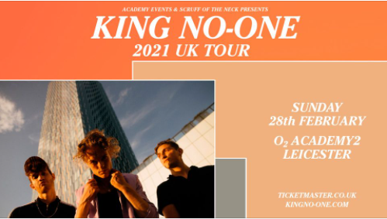
Black Foxxes (11 March)
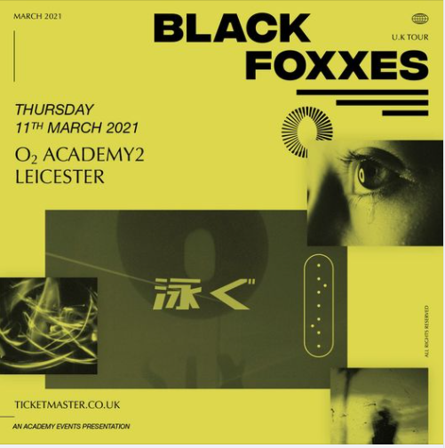
Glass Caves (26 March)
Sea Girls (26 April)
While She Sleeps (6 May)
Daytime TV (28 May)
Circa Waves + Red Rum Club (11 August)
The Bluetones + Polar States (26 August)
Tom Clarke + Conleth McGeary (3 September)
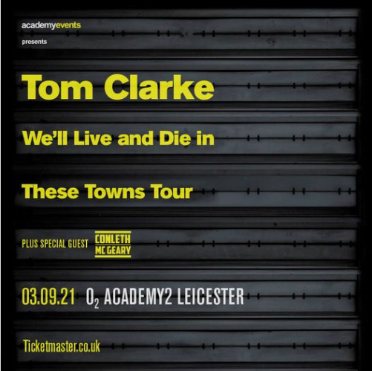
Tin Pigeons (4 September)
Twin Atlantic (4 September)
Blossoms + Fever (6 September)
The Courteeners + Zuzu (7 September)
Declan McKenna (9 September)
Beabadoobee (14 September)
Billie Marten (17 September)
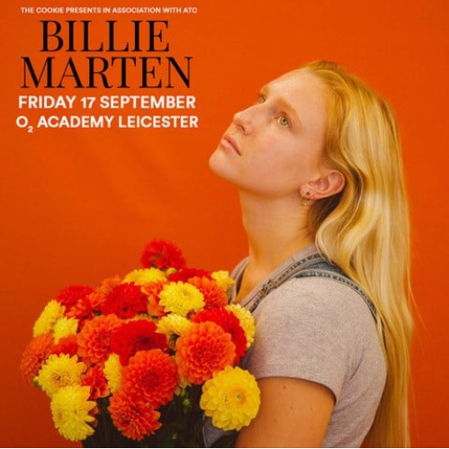
Wide Eyed festival: Beak + The Orielles + Warmduscher + Snapped Ankles + Yard Act + Do Nothing + Katy J Pearson + Lice + Sinead O’Brien + Talk Show + Chubby and the Gang + FGirls in Synthesis + John + Julia Bardo + Treeboy and Arc + Lazarus Kane + Ditz + The Lounge Society + Joe and the Shitboys + Spudge + Earls + The People Assembly + Wych Elm + Echolocation (18 September)
Fatherson (5 October)
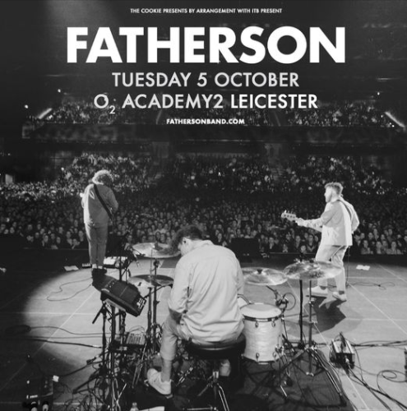
The Skints (11 October)
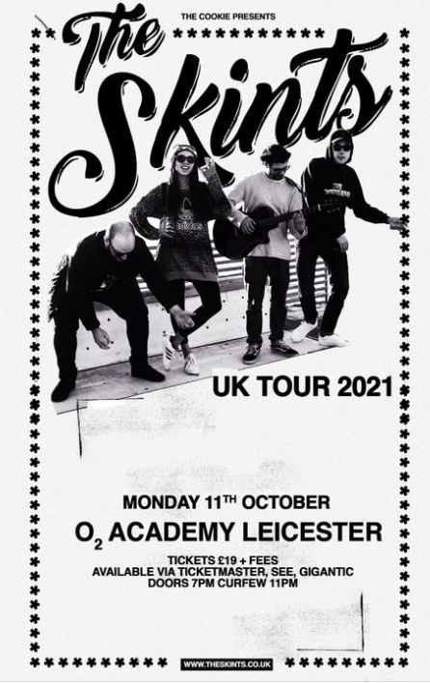
She Drew the Gun (19 October)
Submotion Orchestra (21 October)
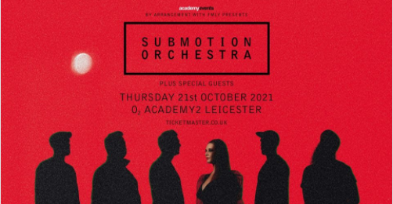
Amber Run (27 October)
Elvana + Def Ray (5 November)
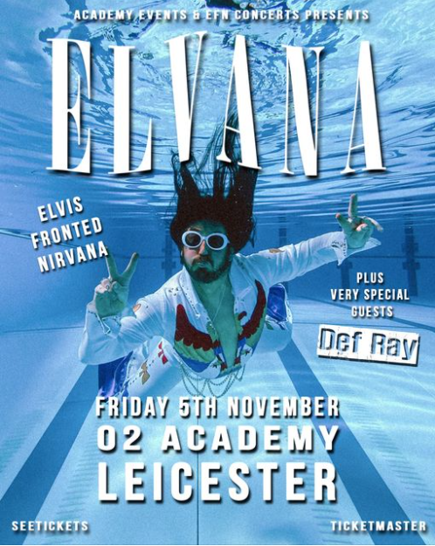
The Lathums (14 November)
Dadi Freyr (20 November)
Girli (22 November)
The Black Charade + Fell Out Boy + We Aren’t Paramore (26 November)
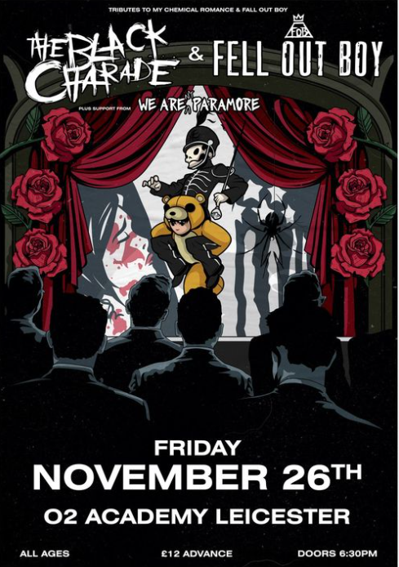
Bugzy Malone (28 November)
Deno (29 November)
Millie Manders and the Shutup + Jora the Fortune Teller (3 December)
Shed Seven + MCH (4 December)
Dreadzone (9 December)
The Dualers (11 December)
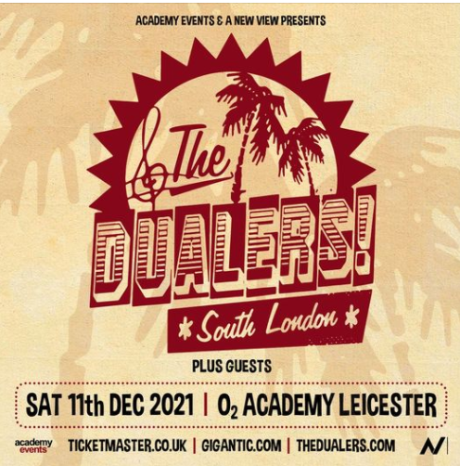

2022
The KVB (28 January)
Frank Turner and the Sleeping Souls + Pet Needs + Truck Stop Honeymoon (12 February)
The Libertines (18 February)
Gorilla Riot + Doomsday Outlaw (18 February)
Pale Waves + Hot Milk + Bitters (25 February)
Uncle Frank (12 March)
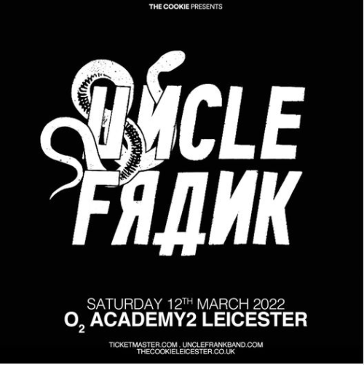
Paul Draper + Ben Sink + Steve Hewitt’s Love Amongst Ruin (17 March)
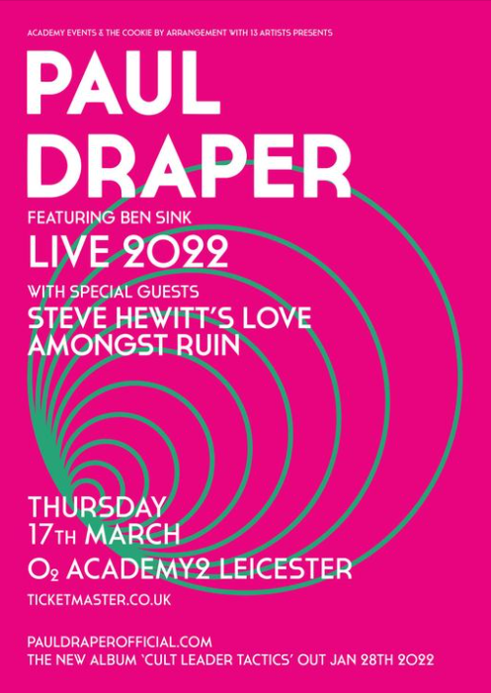
BC Camplight (24 March)
Dream Wife + Lime Garden (26 March)
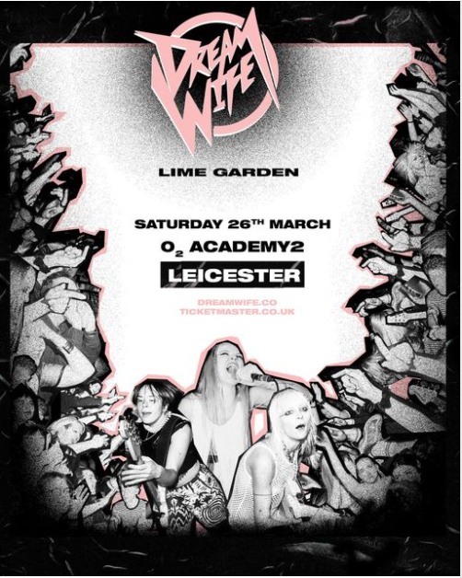
Dry Cleaning + audiobooks (30 March)
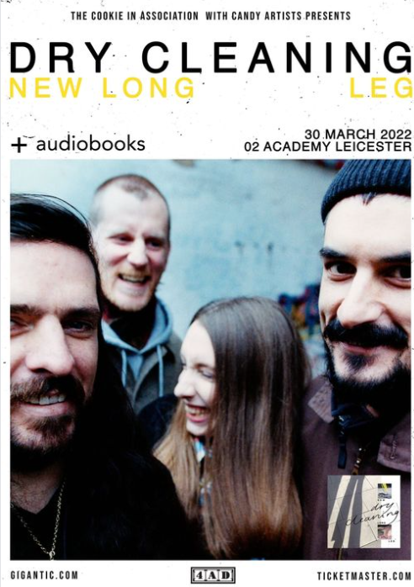
Less Than Jake + Skinny Lister + The Toasters + Millie Manders and the Shutup (5 April)
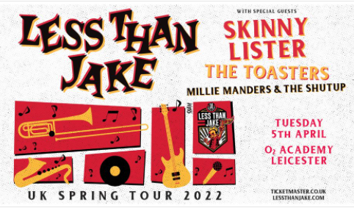
Jamie Webster (8 April)
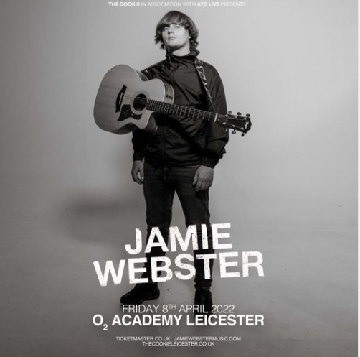
Wide Eyed festival: Gilla Band + Billy Nomates + Gwenno + Big Joanie + Blue Bendy + Courting + Drug Store Romeos + Document + Enola Gay + The Goa Express + Grandmas House + Home Counties + Honeyglaze + Jools + Lime Garden + The People Assembly + Sinead O’Brien + Snutch + TV Priest (9 April)
Mystery Jets + Fur + Jack Flanagan (20 April)
Larkins (27 April)
Tom Meighan (30 April)
JP Cooper (6 May)
James Bay + Kevin Garett (7 May)
Kae Tempest + Shungudzo (16 May)
Gary Numan + Divine Shade (19 May)
Duran Duran (21 May)
Duran Duran (22 May)
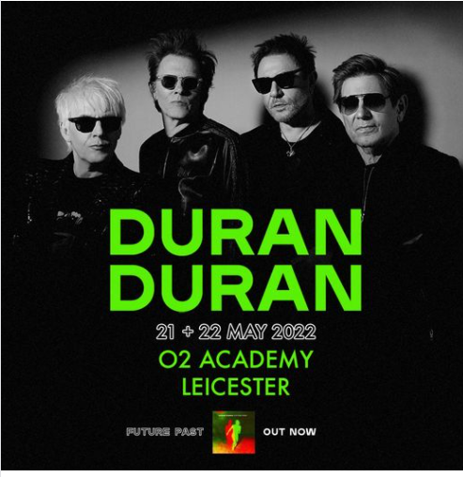
Yard Act (26 May)
Mahalia (27 May)
Uprising festival: Diamond Head + Ingested + Mage + Red Method + Twisted Illusion + Garganjua + Orange Goblin + Raging Speedhorn + Shrapnel + King Creature (25 June)
The Primitives (12 August)
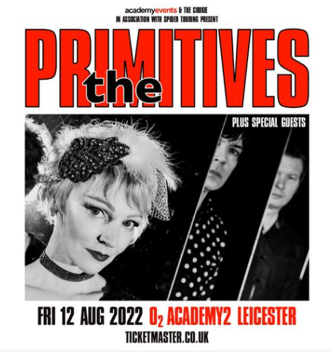
Fun Lovin’ Criminals (7 September)
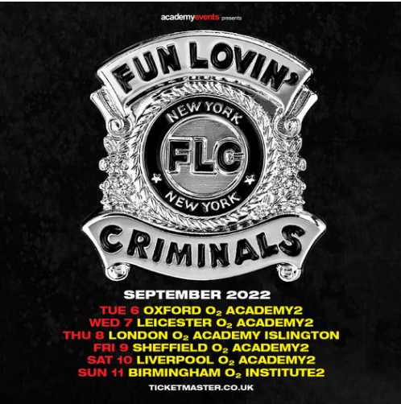
Fell Out Boy + The Black Charade (9 September)
Antarctic Monkeys (10 September)
Ian Prowse and Amsterdam (15 September)
Wide Eyed (17 September)
Public Service Broadcasting (11 October)
The Enemy + Little Man Tate + Wide Eyed Boy (13 October)
Definitely Mightbe (11 November)
Gong + Ozric Tentacles (16 November)
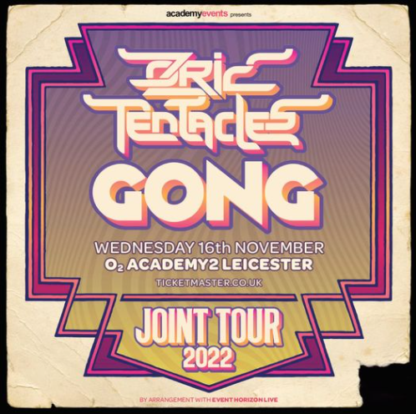
The Smyths (18 November)

