To release Examsoft quiz feedback to students so that they can see the results in their Examsoft portal (do this after the upload deadline):

Start with Assessments. Find the Assessment you want and click on it. Now click on Reporting/Scoring.

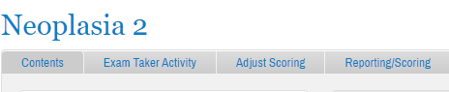

And select Release Exam Taker Results. Chill for a bit while ‘Scoring’ happens…

Tick the box to the left of StudentID so ALL students are selected, then click Next at the very bottom of the list of students. You will then see a box like the one below. I suggest ticking the boxes as shown. THEN click ‘Post to Exam Taker Portal.’ Done!
