KS3 Artefact to Art
Session 2: Art and Power in Imperial Rome

Worksheet 2: Non-Official Art

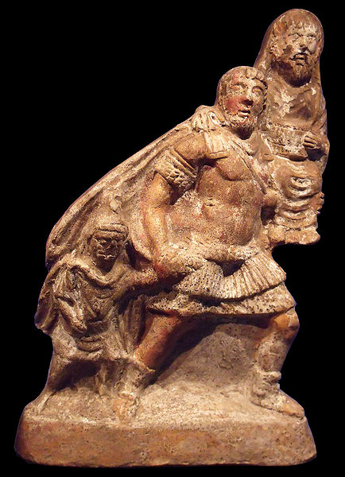

1. Terracotta figurine (about 10cm tall)

- What story is being represented by this figurine?

- What might a figurine like this have been used for?

- Why might someone choose to have a figurine representing this story in their house?

- What does this tell us about what normal people thought about official propaganda?

2. Wall painting from Pompeii

- What does this image show?

- What story is this image meant to remind people of?

- How has the image innovated on the story?

- What does this image tell us about what normal people thought about official propaganda?

