KS3 Artefact to Art
Session 2: Making Art in Classical Athens

Worksheet 2: Pheidias the famous sculptor

1. A reconstruction of the inside of the Parthenon, featuring the cult statue of Athena made by the famous sculptor Pheidias and his assistants.

- What is the statue of Athena holding in its right hand?

- The statue was made from gold and ivory. How expensive do you think it would it have been to make?

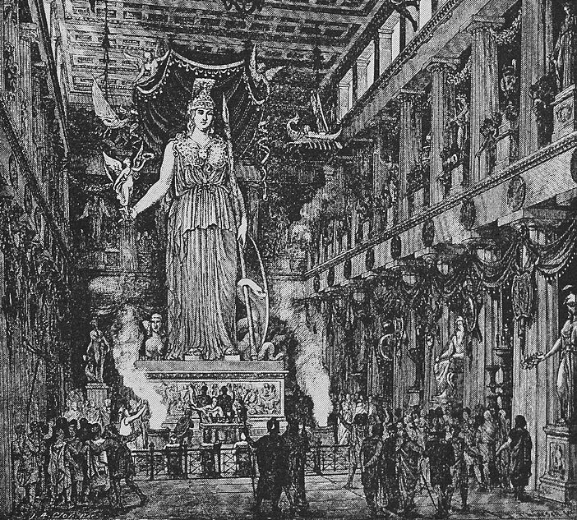
2. Pausanias 1.24.7 on the statue of Athena Parthenos

The statue is created with ivory and gold. On the middle of her helmet is likeness of the Sphinx ... and on either side of the helmet are griffins in relief. ... The statue of Athena is upright, with a tunic reaching to the feet, and on her breast the head of Medusa is worked in ivory. She holds a statue of Victory that is approximately four cubits high, and in the other hand a spear; at her feet lies a shield and near the spear is a serpent.

- Is Pausanias impressed by this statue?

- What does he tell us about its artist Pheidias?

3. An Athenian coin depicting the cult statue of Athena Parthenos on the tails side (reverse), and the head of Athena on the heads side (obverse).

- How detailed is the picture of the statue?

- What does this coin this tell us about the fame of this statue?

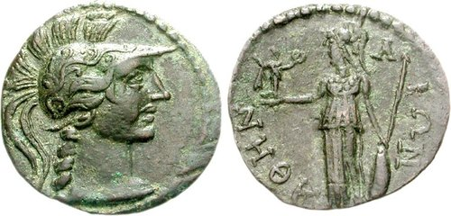

4. Imaginative exercise

- 1 cubit = 0.46cm. Using the description in Passage 2 above, work out roughly how big the statue must have been.
- Measure out the height of the statue. What would be practicalities of making this statue have involved?
- Make your own colour reconstruction of the scene inside the temple, remembering that the only light would have come from fire lamps and the sun shining through the doorway; and thinking about the material the statue was made from.

