 |  |  | Estates and Digital Services |  |  |  |  |  |  | HS2/PP-054b form
 |  |  | Specific Risk Assessments and Method Statements (RAMs) Checklist
Contractor
Work
Risk Assessment includes the following:
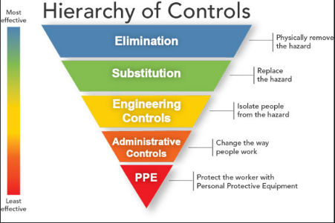
1. Dates, Job and Location Specific
2. Significant hazards (including hazards present in the University area where they will be working)
3. Who is affected by the work and how?
4. Evaluation of the risk (e.g. risk rating like high, medium, low or 1-5 or similar)
5. Control measures and precautions they will apply
6. Risks controlled by following the hierarchy of controls
7. Working during pandemic (for duration of pandemic)

Your Notes:
Method Statement includes the following:
1. Company identification
2. Specific address where the work is to be carried out
3. The date and times the work is to be carried out, especially if this is considered out of hours (estimated or specific*)
4. The names of their employees to be engaged in the work (where known*)
5. Any specialist competencies, such as PASMA, CSCS and IPAF, relevant to the work being undertaken
6. List of any equipment to be used and calibration certificates for any testing equipment
7. Any requests for permits or special permission as part of the required work e.g. laboratories, hot works, electrical works, confined space, working on roof, fire system impairment
8. Emergency arrangements, especially if working in potential confined spaces, or working at height, or fire watch after hot works
9. Any notifications to the building or ECS Helpdesk
10. Overall is the content logical, step-by-step with clear instructions.

Your Notes:

Subcontractors
1. Confirm main contractor has checked subcontractor’s RAMs

Your Notes:
Your Name: |  |  |  | Your Signature: |  |  |  | Date
Guidance:
- Use this checklist before the work starts on site when you receive a specific risk assessment and method statement from your contractor.
- *Some information may only be known at a latter stage (e.g. 3&4 in the method statement after Notification of Works)
- In notes, capture any issues you have fed-back to the contractor. Comment on technical content only if you are competent on that subject and to the extent of your competence.
- It is the contractor’s responsibility to provide suitable and sufficient RAMS, including technical content and sequence of work, and that they check the RAMs of subcontractors. Request contractor send you RAMs in a manageable format (e.g. not 10 individual assessments) and reflect your feedback in revised RAMs on the first occasion without repeated exchange.

