Degree Outcomes Statement, 2025
The University of Leicester is committed to ensuring that the value of qualifications awarded to students at the point of qualification and over time is in line with sector-recognised standards.
The University’s academic governance structure, led by Senate acts strategically to protect the value of qualifications over time. Senate monitors the effectiveness of the University’s strategies implemented to achieve this aim.
This statement has been drafted on behalf of the University’s Curriculum and Quality Sub-Committee and covers five academic years up to 2023/24. The statement includes analysis of the University’s assessment and marking processes, an outline of the academic governance structure, a summary of quality assurance practices, and an outline of awarding regulations and the institutional degree classification profile.

Assessment and Marking Practices
Assessment practices are scrutinised through the programme development and approval process. Programme teams are required to reference relevant benchmarks to ensure that assessment criteria meet relevant sector reference points. Approval Panels include relevant external academic expertise to confirm academic standards and assessment approaches. External Examiners are appointed for every programme and confirm each year the appropriateness of the University’s assessment, marking and moderation practices. The process of nominating, appointing and inducting External Examiners was reviewed and enhanced in 2022, and the University complies with sector best practice including the recent UUK and QAA guidance on the external examining system. The University has in place standard Degree Classification Descriptors for level 6 in line with the UKSCQA descriptors which are benchmarked against in programme development and approval process, and are reviewed by External Examiners for current programmes. The University seeks to continuously increase its level of staff with recognised teaching qualifications. Over 76% of staff on teaching or teaching and research contracts have an academic teaching qualification The University delivers a range of professional development activities to staff in teaching roles. These are co-ordinated within the University’s strategic Academic Professional Development Framework to provide a holistic set of resources and training that can be tailored to the needs of individual staff members. Resources range from introductory self led online courses, to a full Postgraduate Certificate in Academic and Professional Practice, and support for staff to gain accreditation via the internal PEERS route.
There is a single consistent University wide Policy and Procedure for the management of mitigating circumstances and similarly for considering academic appeals, informed by the OIA good practice framework. In line with sector best practice the University operates limited self-certification for mitigating circumstances in relation to certain assessment types to allow students to take greater ownership of their studies and align more closely with the world of work.
The University framework for marking and moderation practice is set out in Senate Regulations. The University operates a three stage process. Marking and Moderation is undertaken in line with the framework within Senate Regulations and supported by the provision of central guidance and training from the University’s Education Services. This guidance is reviewed and updated regularly under the oversight of the Curriculum and Quality Sub-Committee.
Panels of Examiners consider and approve module level outcomes and a Board of Examiners determines overall student outcomes via the application of University progression and classification algorithms. Panel of Examiners are responsible for reviewing outcomes at module level and confirming that appropriate marking and moderation practices have been applied. These are subsequently confirmed by the External Examiners for the programme both at the Board of Examiners and through the annual monitoring process. The University receives assurances on the operation of these processes via regular summary reports considered through the Education Committee and Senate. A summary report on the operation of all of the University’s academic quality assurance processes is considered annually by the Governing Body, Council.
The University has recently developed and approved a new Policy on the role of Generative AI in Learning, Teaching and Assessment. The University believes that a balanced approach to the use of AI in learning, teaching and assessment is essential. The policy outlines a supportive approach to outlining safe and responsible use of AI within the context of students’ academic discipline. Students at the University will receive the support that they need to be confident in the ethical, responsible and effective use of AI in learning, teaching and assessment. All assessments will state whether and how AI may be used within the assessment process, noting that AI must never be used to generate content that a student then presents as their own.

Academic Governance
Senate has ultimate responsibility for the setting and maintenance of academic standards. Operational responsibility is delegated to the Education Committee. Senate is informed of developments through a report to each of its meetings and considers regular reports on each of the key quality assurance procedures. The operation of the academic governance framework is set out in a University level Code of Practice on Academic Governance which is owned by Senate.
The University operates standard quality assurance processes across the lifecycle of its programmes to ensure that they remain current and offer an excellent learning experience to our students. This includes programme development, approval and modification, annual monitoring, collaborative provision and a robust system of external examining to ensure that programmes are scrutinised and benchmarked against relevant sector standards such as the OFS B conditions, the UK Quality Code, Subject Benchmark Statements, the Framework for Higher Education Qualifications (FHEQ) and relevant PSRB requirements.
Each core quality assurance processes is governed by a Code of Practice which is approved by Senate. The monitoring of the assurance activities is undertaken by the Curriculum and Quality Sub-Committee which reports to the Education Committee. This range of processes, which include external input at relevant points contribute to the University’s confidence in the academic standards of its award and their value over time.
Processes for the management of collaborative provision are set out in the Code of Practice for the Management of Higher Education with Others. Robust processes are in place for the risk assessment, business case and academic approval of new partnerships. All aspects of course design, teaching, assessment and the student experience are scrutinised through the relevant approval processes. All standard processes for the monitoring of programmes are applied to collaborative provision, and these are supplemented by additional components, which focus on the particular complexity of partnership arrangements. External Examiners have oversight across equivalent programmes delivered at the University of Leicester and in partnership.
In 2020 and 2021 the University introduced a range of policies to support students and protect their outcomes in light of the impact of the Covid-19 pandemic. The relevant policies ensured that the onset of the global pandemic and its effects on the lives our students did not negatively impact their outcomes. In each case the relevant policy was developed using appropriate reference points and data to model the potential impact, and was approved by the Education Committee and Senate.
The University analysed the outcomes of these policies, taking into account feedback from External Examiners and other stakeholders such as Professional, Statutory and Regulatory Bodies (PSRBs). This process informed the managed move back to standard regulations and processes from the 2021/22 academic year.
The University Education Committee receives an annual analysis of degree classification outcomes along with planned actions for the next academic year.

Classification Algorithms
The University’s undergraduate degree classification algorithm is set out in Senate Regulation 5. The vast majority of Students graduating in 2024 were under the scheme of classification which applied to students commencing their studies in 2018/19 or later.
The University’s degree algorithm is designed to ensure academic standards by the limitation of credit which may be compensated or failed, recognising the particular role that the final year of study plays in terms of meeting learning outcomes and ensuring that borderline regulations and rules around compensation would not contribute to grade inflation. This algorithm was also benchmarked against the Principles for Degree Algorithm when they were released by the UKSCQA in July 2020.
Students may be awarded a classification either on the basis of their credit weighted average or by a combination of their average and preponderance of credits. Students falling into a mathematically defined borderline category are reviewed by the Board of Examiners and a decision made on whether to promote to a higher classification according to set criteria. These align to level 6 programme intended learning outcomes, such as independent analysis and research, which reflect the requirements of the FHEQ and the Characteristics Statement for Bachelors Degrees.
One capped re-sit attempt is allowed for any failed module as standard. One further re-sit opportunity may be offered at the discretion of the Board of Examiners. A student achieving a mark of between 35-39% at module level may be granted compensation and credit for the module, subject to the achievement of a sufficient credit weighted average for the level and within an overall maximum amount of compensation available across the programme.
Degree classification regulations are set out to students in Senate Regulations, student handbooks and in the Digital Learning Environment. A Student Guide to Regulations and video guide are also provided. Students have access to University advice via their Schools and independent advice from the Advice Service in the Students’ Union.

3.1 Impact of Covid-19
The University recognised that students graduating in 2024 may have experienced the impact of Covid-19 in their earliest years on the programme. The University put in place many allowances over the course of 2020 and 2021 for current students and these were removed in a managed fashion along with the transition back to normal delivery. No policies or regulatory amendments in light of Covid-19 applied to the calculation of awards or classifications for the 2024 graduating cohort.
The University considered the potential impact of some of the elements of previous COVID-19 related policies on the graduating cohort of 2024. In response to feedback from external examiners and professional bodies the University undertook a strategic review of assessment approaches and determined where it may be appropriate to return certain forms of assessment to being campus based. All proposals to return to campus based assessment were reviewed by a University level panel, with specific conditions applied for the support of students through the provision of mock examination opportunities and specific preparation sessions. The outcomes of modules which had transitioned back to campus based assessment were subject to additional scrutiny to review whether there was evidence of an impact upon student performance, and to identify whether adjustments may be required for future cohorts.

3.2 Looking forwards
After 5 years of the operation of the Senate Regulations governing Undergraduate programmes the University undertook a detailed review. The review considered extensive internal and external stakeholder feedback, internal modelling sector benchmarking and best practice. Revised regulations were approved in November 2023. The revised regulations set a single, clear minimum baseline for award through the removal of condonement and the simplification of the compensation system. The removal of discretionary borderline classification rules ensures consistency of academic thresholds. A single algorithm is used to calculate a student’s credit weighted average. Students may obtain a classification on the basis of their credit weighted average or, where just below a threshold on the basis of a combination of their credit weighted average and a set number of credits in the higher band. The new regulations also limit students to two attempts at an assessment in the majority of instances.
The new regulations will come into force for students commencing in the 2025/26 academic year and are available online along with supporting resources for their implementation.

Institutional Degree Classification Profile

4.1 Overall Profile
After an increase in the 2020 and 2021 academic years the overall University rate of Good Honours reduced to pre-pandemic levels in 2023. A drop of overall good honours rates was observed in 2024.
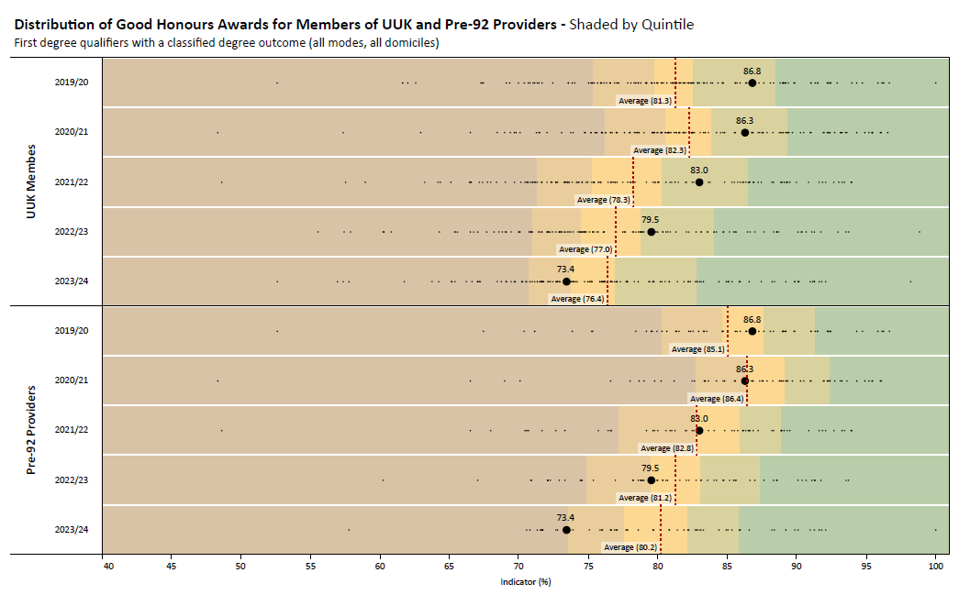
The plot shows a ﬁve-year trend in the percentage of good honours (1st and 2:1) awarded UUK and Pre-92 providers. Leicester's position is shown as the larger black dot and labelled with its percentage. The dotted red line in each year marks the 'UUKr' average. The background colour gives the quintiles with the green area showing the threshold for the top 20% highest awarding providers.
Source: HESA (Heidi database)
UoL has largely tracked the trends within the sector prior to 2024. An increase in the period 2020 – 2021 overall rates of good honours fell back to the equivalent level from 2019 by 2023. The change in good honours in 2020 and 2021 reflected the exceptional circumstances of the pandemic and the actions taken to protect student outcomes in unprecedented circumstances.
The reduction in Good Honours outcomes in 2022 and 2023 reflect a general reduction of higher awards within the wider sector post-pandemic, where there was a drop of 5.5% from the peak in 2021. Despite the extent of the challenges faced across the pandemic period and immediate aftermath the University has maintained a relatively consistent position within the sector, remaining within the same quintile for the award of Good Honours until 2023.
For 2024 the University’s overall Good Honours rate was 73.4%. For the first time in the period this dropped beneath the average for UUK members of 76.4%. Although the sector saw a slight drop in 2024 the decline at the University of Leicester is greater compared to both the UUK grouping and the pre-92 grouping.
Degree classification outcomes in 2024 identify broadly consistent levels of 2:1 awards but a drop in first class awards. The University has undertaken an analysis of the degree outcomes in 2024 to identify contributing factors and actions that might be taken in response. Actions include:
- Introduction of the Succeed@Leicester induction framework to support students at each stage of their studies.
- Launch of the Centre for Academic Achievement to support student skill development and provide targeted support to schools in enhancing their student outcomes.
- Targeted work with individual schools to review curriculum and learning, teaching and assessment practices.
- Revised processes for monitoring achievement through the year in order to target support where necessary.
- Close monitoring of end of year outcomes and the provision of targeted support to academic schools to aid student progression and achievement.
Student progression outcomes in 2024 showed a consistent improvement demonstrating that work underway earlier in programmes is impacting positively upon student achievement and an overall increase in good honours outcomes in subsequent years is anticipated.

4.2 Changes over time
The following plot compares the difference in the rate of good honours awarded in 2024 against those awarded in 2022 and 2023. UoL is designated by the dot in bold.
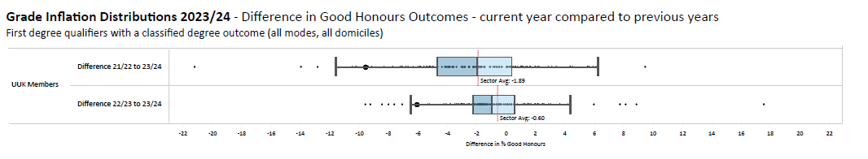
Source: HESA (Heidi database)
In 2023 and 2024 the University of Leicester saw a reduction in good honours outcomes which was greater than the average fall within the wider sector. This in part represents a re-adjustment following the atypical covid affected years but the continued fall in 2024 represents grounds for investigation and action. The actions already in place are set out in the section above.
The Office for Students (OfS) publishes an analysis of degree classifications over time. In the most recent data (2025) covering the period 2010-11 to 2023/24 the OfS reported that the ‘unexplained’ difference, between expected and actual awards for all students achieving Good Honours level for Leicester in 2024 was 5.7%. This represents a drop of 6.3% from the previous measure (2023). Overall the University is now below the sector average ‘unexplained inflation calculation’ for mainstream providers of 9.8% and ranks 74 of 98 providers (with degree awarding powers) by this metric. The OFS Unexplained analysis also demonstrates that the rate of inflation on first class degree awards for Leicester in the period is below the sector average, at 6.8%. Whilst this represents clear evidence that the University’s awards are retaining their value over time, as set out elsewhere in this document the drop in 2024 requires monitoring and action in order to ensure that the University continues to deliver the best outcomes for its students.

4.3 Closing the awarding gap
The University of Leicester is a selective institution with an embedded commitment to widening participation, diversity and equality. The University’s Access and Participation Plan details the University’s ambition and strategy to widen participation for the 2020/21 to 2024/25, and 2025/26 to 2028/29 academic years. The University remains one of the most diverse universities in the UK with 70% of its student population coming from a Black, Asian and minority ethnic background.
The University has identified where gaps in access, continuation, attainment and progression have occurred over time and compared to the sector. The institution has many initiatives already in place to reduce the gap for under-represented groups in higher education set out in an approved and published Access and Participation Plan (APP). The Plan sets out the various actions and robust targets that the University has set to address the awarding gaps between different student groups.
The rate of Good Honours achieved by students of typically underrepresented groups is consistently higher at the University of Leicester than the sector average. In 2023/24 the rate of Good Honours achieved by Black students at the University of Leicester was 7.1% higher than the sector average, and for students from the most deprived areas (Q1 IMD 2019) it was 1.8% higher than the sector average.
Gaps in outcomes between some demographic groups are narrowing. The awarding gap between students from the most deprived areas and the least deprived areas (Q1:Q5, IMD 2019) has increased by 0.5pp and is now at -11.5%. However, the awarding gap between Black students and White students has decreased from -18.6pp to -16.1pp and the awarding gap between Asian students and White students has decreased from –10.5pp to –8.4pp.
The University recognises that these gaps remain too high and, as set out above, has a range of projects in place to understand and address this issue. We were one of the very first Universities of Sanctuary and are a Quality Mark recipient for Carers and Care Leavers: these are just a few examples of our commitment to creating a welcoming, inclusive and enriching environment where all students can develop a sense of belonging and achieve success. One of our strategic priorities is our Black Student Experience Project, a project aimed at reducing inequities experienced by our Black student population, informed by student voice, and shaped around key aspects of the student experience at the University of Leicester. This project is one of a broad portfolio of targeted initiatives, across the institution, to identify and address factors which contribute to the awarding gap.

Teaching Practices and Learning Resources
The University was proud to be awarded TEF Gold status in 2023 which represents an external verification of the quality of teaching and education that we provide to our students.
In 2021 the University launched a new Research Inspired Education Strategy, a central pillar of which is to ‘provide challenging programmes that enable students to achieve their full potential regardless of background’. The implementation of the Education Strategy is supported by Education Services which works with Schools in the design, development, delivery, and continuous improvement of high-quality programmes that meet the needs and expectations of our diverse student body.
A programme of work underpins the delivery of the Education Strategy to support teaching staff to develop and enhance their practice and for the University to continuously improve its delivery, teaching and assessment processes. Examples include the completion of Racial Inclusivity Action Plans in schools, the implementation of Blackboard Ultra as a key component of the University’s digital learning environment and the launch of the University Education Academy to drive institutional transformation in learning and teaching.
The University has been working on embedding a framework for Research Inspired Education. This is a key pillar of the University’s Education Strategy and articulates how all University of Leicester programmes will be research inspired. The framework supports the University’s Schools to create inspiring research led curricula tailored to their specific subject areas and students. Students are supported to work from being receivers of research to producers over the course of their studies, developing skills which will equip them for their chosen careers.
Part of the University’s Research Inspired Education Strategy is to have an Academic Professional Development (APD) Framework and Advisory Board, both of which were implemented in 2023/24. The APD Framework provides a University of Leicester context to the Advance HE Professional Standards Framework 2023 and has introduced new ways of developing the practice of those who teach and support student learning. Through the APD Framework’s strategically aligned, holistic programme of academic professional development, we have begun to empower our staff to create consistently high-quality, inclusive, learning and teaching.
The University has recently developed a new Assessment Strategy. The strategy emphasizes the dual purpose of assessment: as a means for learning and as a measure of learning. By aligning assessments with learning outcomes, providing constructive feedback, and promoting self-reflection, the strategy aims to enhance students' learning experiences and outcomes, enabling all students to become agents of their own learning. To support the implementation of the strategy all schools have produced new Assessment maps to demonstrate how different forms of assessment are introduced and scaffolded over the course of each programme. Assessment rubrics have been reviewed across programmes to ensure that requirements are clear, and that rubrics support student assessment literacy.

Actions
Over the course of 2024/25 a significant programme of work has been undertaken to support student outcomes. Actions include:
- University-wide roll out of the Succeed@Leicester induction framework to support students at each stage of their studies.
- Launch of the Centre for Academic Achievement to support student skill development and provide targeted support to schools in enhancing their student outcomes.
- Targeted work with individual schools to review curriculum and learning, teaching and assessment practices.
- Revised processes for monitoring achievement through the year in order to target support where necessary.
- Close monitoring of module level outcomes and the provision of targeted support to academic schools to aid student progression and achievement.
2025/26 represents the first year of the implementation of the new Senate Regulations governing undergraduate programmes. This has been supported over the course of 2024/25 by an extensive programme of training, guidance and support for schools as well as a range of resources for students. Schools have reviewed and revised programme structures, delivery, assessment and marking schemes as appropriate.
Over the course of 2024/25 the University has also reviewed the operation of Panels of Examiners to ensure that they are undertaking thorough and effective reviews of module outcomes, identifying factors which may have impacted upon student performance and where actions may be necessary.
Closing the awarding gap has been identified as a central strategic theme for the University and there are a range of projects underway that seek to address this issue.

Risks and Challenges
Through the implementation of the Research Inspired Education Strategy the University is ensuring that the lessons and progress from the pandemic in areas such as digital delivery continues to feed through into teaching and assessment practice, whist maintaining high academic standards. The University will continue to review the appropriate balance between campus-based and remote assessment, especially in light of the challenge represented by the growth of generative AI.
Other challenges include the ongoing work to address the awarding gap between different student demographic groups. The University is committed to eliminating the awarding gap but recognises that this will require significant work and engagement with our student body.

https://www.qaa.ac.uk/docs/qaa/quality-code/annex-d-outcome-classification-descriptions-for-fheq-level-6-and-fqheis-level-10-degrees.pdf?sfvrsn=824c981_10
https://le.ac.uk/policies/regulations/senate-regulations/senate-regulation-5
https://www.universitiesuk.ac.uk/sites/default/files/field/downloads/2021-07/principles-effective-degree-algorithm-design.pdf
https://le.ac.uk/policies/regulations/senate-regulations/senate-regulation-5/2025-26-study
https://www.universitiesuk.ac.uk/sites/default/files/field/downloads/2021-08/degree-classification-2019-20.pdf

