Gender Equality Plan
The University of Leicester is committed to fostering a culture of inclusion, dignity and respect, where all members of our community are valued and treated in a fair and equitable way.
Our vision is to be a truly inclusive university and our strategy, ‘Shaping our Second Century’, puts Equity, Diversity and Inclusion (EDI) at the heart of all we do. EDI is one of the four guiding principles that informs our decision making, and one of our three university values is ‘Inclusive- we are diverse in our makeup and united in ambition. Our diversity is our strength and makes our community stronger’.
To support the delivery and achievement of our university strategy, we have developed an EDI strategy 2023-2028 with six inter-connected strategic aims which outlines how we will achieve our strong commitment to be a truly inclusive university.
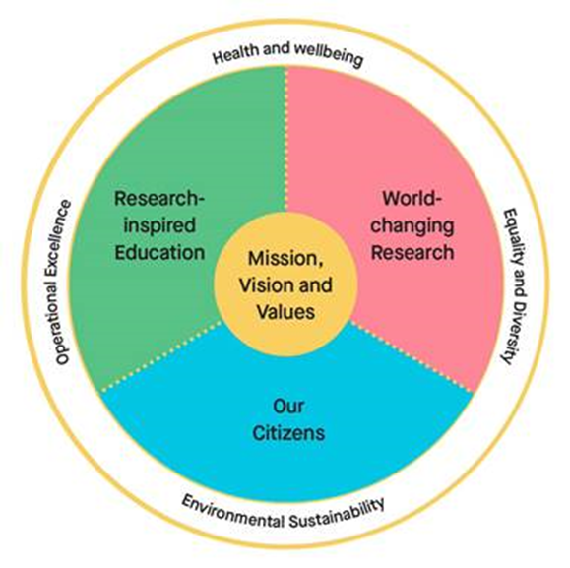
Our commitment to advance gender equity is demonstrated and embedded within a range of action plans, activities and strategies. This plan sets out key examples of our gender equity priorities through our Athena Swan and broader EDI activities.

Alignment with Horizon Europe GEP Requirements
As a higher education establishment applying to the European Commission’s Horizon Europe programme, we are required to have a gender equality plan (GEP).
Our work to advance gender equity both aligns with and fulfils Horizon Europe’s GEP requirements as follows:

Mandatory Requirements
1. Public document:
The GEP must be a formal document published on the institution’s website, signed by the top management and actively communicated within the institution. It should demonstrate a commitment to gender equality, set clear goals and detailed actions and measures to achieve them.
Our GEP is a public document published on our university webpages and is fully endorsed and signed by our President and Vice-Chancellor Professor Nishan Canagarajah. This plan has been shared widely via our main staff and student communications mechanisms.
The University of Leicester is a member of the Athena Swan Charter, and we were proud to receive our first institutional Athena Swan Bronze award in 2008. This award was successfully renewed in 2011 and 2014. In 2018, we achieved our first institutional Athena Swan Silver award to recognise a significant record of activity in addressing gender equity challenges. Our most recent Athena Swan application and action plan is available on our EDI webpages and includes a letter of endorsement signed by the President and Vice-Chancellor. The comprehensive action plan sets out the specific priorities and success measures for gender equity.
We are also extremely proud to hold several Bronze and Silver Departmental/College level Athena Swan awards.

2. Dedicated resources:
A GEP must have dedicated resources and expertise in gender equality to implement the plan. Organisations should consider what type and volume of resources are required to support an ongoing process of sustainable organisational change.
EDI Governance structure
We have a comprehensive EDI governance structure in place to support the University’s ambitious EDI commitments and to ensure that there is clear reporting and accountability in all aligned roles. The University’s EDI Committee reports through to the People, EDI and Wellbeing Committee, which is a sub-committee of Council, and is responsible for leading the direction of our EDI priorities.
The University also has four Equity Action Groups which report into the university EDI Committee (Gender, Race, Disability, LGBTQ+). The Gender Equity Action Group leads on informing strategic gender equity priorities for the University and overseeing aligned activities such as our Athena Swan applications and action plans and Gender Pay Gap action plan.
The Women’s Forum and Carers and Parents Network are supportive networks and integral components of the University Governance structure, feeding into the Gender Equity Action Group to raise awareness of gender equity issues and to inform decision making.
Staff Departmental EDI Champions and Student Curriculum Consultants support and embed gender equity and wider EDI activity in their areas and report through to College EDI Committees who, in turn, report through to the Central EDI Committee. We also have Athena Swan Self-Assessment Teams, in many of our Schools/Colleges to progress Departmental level Athena Swan applications and action plans.
Equity Action Group Chairs, Fora Chairs and EDI College/Central Professional Services Leads and Departmental EDI Champions all receive workload allocation for their involvement.
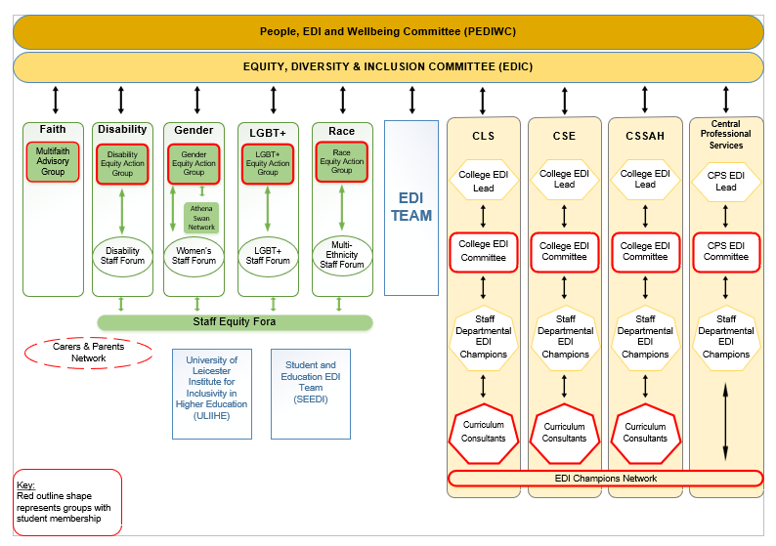
Figure 1 The University of Leicester EDI Governance Structure

Dedicated EDI Teams
We have a dedicated and experienced EDI Team, who lead and guide the University to achieve and enable our EDI ambitions. The Team oversees our institutional EDI priorities and gender equity plans and activities, as well as advising on equity related case work and embedding EDI considerations into university policy development.
The Team is led by the Associate Director for EDI, and comprises of an EDI Manager, Project Manager, Head of EDI Charters, EDI Officer and EDI Administrator. The Head of EDI Charters, is the Team’s gender equity lead and has day-to-day management of the institutional Athena Swan Silver action plan and Gender Pay Gap action plan.
The University also has a Student Education EDI (SEEDI) Team who work with colleagues to enable inclusivity in the curriculum and assessment, with the aim to have a positive impact on the awarding gap and student satisfaction. SEEDI also manage student EDI initiatives in the University’s Access and Participation Plan. The Standing Together Team in Student Support Services, are responsible for providing support to students affected by unacceptable behaviours, including discrimination. The Standing Together Team also provide training to students and provide engagement activities throughout the year to raise awareness about support and provide learning opportunities for students and staff on topics such as discrimination, sexual violence and harassment.

3. Data collection and monitoring:
Organisations must collect sex/ gender disaggregated data on personnel (and students, for the establishments concerned) with annual reporting based on indicators. Organisations should consider how to select the most relevant indicators, how to collect and analyse the data, including resources to do so, and should ensure that data is published and monitored on annual basis. This data should inform the GEP’s objectives and targets, indicators, and ongoing evaluation of progress.
Sex/gender disaggregated data is collected on staff and students as part of our diversity monitoring and wider EDI commitments. This enables us to identify and implement targeted actions to advance equity. As part of our institutional and departmental Athena Swan activities, we analyse sex/gender staff and student data across the staff and student life cycle to inform future gender equity plans and priorities.
The University publishes diversity data annually to inform our EDI priorities and to enable us to track our progress against achieving these, including:
- Gender pay gap reports and wider pay gaps reporting including ethnicity, disability and sexual orientation
- Annual staff and student Equality Information Reports
- EDI Annual Report
Reports are published and publicly available on our webpages: Diversity data | University of Leicester .

4. Training:
The GEP must also include awareness-raising and training actions on gender equality. These activities should engage the whole organisation and be an evidence-based, ongoing and long-term process. Activities should cover unconscious gender biases training aimed at staff and decision-makers and can also include communication activities and gender equality training that focuses on specific topics or addresses specific groups.
All staff at the University are required to complete mandatory online EDI training and unconscious bias training modules when they join the University, and this must be renewed every three years. In addition, we provide Recruitment and Selection training to all staff involved in recruitment processes, which covers unconscious bias in recruitment. Equality Analysis training is also available to support staff undertaking the equality analysis process to improve equity and inclusivity in all our practices, policies and services. Other related training includes Staff Bystander Intervention online training and Dignity and Respect at Leicester Workshops.
The Organisational Development Team deliver a targeted ‘Women Leading with Purpose’ Programme for Professional Services and Academic staff to support career development within the university. They also provide coaching and mentoring opportunities for all staff.

Recommended Thematic Areas

5. Work-life balance and organisational culture:
GEP’s aim to promote gender equality through the sustainable transformation of organisational culture. Organisations should implement necessary policies to ensure an open and inclusive working environment, the visibility of women in the organisation and externally, and that the contribution of women is properly valued. Inclusive work-life balance policies and practices can also be considered in a GEP, including parental leave policies, flexible working time arrangements and support for caring responsibilities.

Within our institutional Athena Swan Silver application, in sections 5.5 and 5.6 we reflect on the university culture and work-life balance and have set specific actions within our action plan to address identified gender equity prioritise in this area. These actions are outlined in our institutional Athena Swan Silver action plan under the ‘Further Embedding Athena Swan principles’ and ‘Flexible Working and Career Breaks’ themes.

6. Gender balance in leadership and decision making:
Increasing the number and share of women in leadership and decision-making positions touches upon all aspects in the GEP. Measures to ensure that women can take on and stay in leadership positions can include providing decision-makers with targeted gender training, adapting processes for selection and appointment of staff on committees, ensuring gender balance through gender quotas, and making committee membership more transparent.
In sections 5.6 iii) and iv) of our institutional Athena Swan application, we have committed to actions and targets to increase the gender balance in leadership and decision-making positions/committees. These actions are outlined in the ‘Further Embedding the Athena Swan Principles’ theme and ‘Induction, Training and Development’ Theme of the Athena Swan Silver action plan.
7. Gender Equality in recruitment and career progression:
Critically reviewing selection procedures and remedying any biases can ensure that women and men get equal chances to develop and advance their careers. Establishing recruitment codes of conduct, involving gender equality officers in recruitment and promotion committees, proactively identifying women in underrepresented fields and considering organisation-wide workload planning models can be important measures to consider in a GEP.
In sections 5.1, 5.2, 5.3 and 5.4 of our institutional Athena Swan Silver application, we examine gender equity in our recruitment and selection processes and in career progression. We have set ambitious actions outlined in the institutional Athena Swan Silver action plan under the ‘Recruitment, Selection and Retention’ theme and ‘Promotion and Career Progression’ theme.

We provide all Heads of school and Departments with an annual Diversity Data Dashboard which includes detailed information about (i) the area’s staff demographic by gender (ii) its gender pay gap data (iii) a detailed breakdown of representation by gender, at all stages of the recruitment cycle (application, shortlisting and offer), for roles advertised over the proceeding 12-month period. We have developed an Inclusive Recruitment Toolkit to be used by recruiting managers to ensure that gender equity principles and good practice are embedded throughout the recruitment process. We record and monitor the gender composition of recruitment panels and use gender decoders in our adverts.

The University has also established a Carer’s Conference and Training Fund, to support staff with caring responsibilities to fund additional childcare costs enabling them to attend work related conferences or training.
8. Consideration of gender in teaching and research:
The GEP should consider how sex and gender analysis will be included in the research or educational outputs of an organisation. It can set out the organisation’s commitment to incorporating sex and gender in its research priorities, the processes for ensuring that the gender dimension is considered in research and teaching, and the support and capacity provided for researchers to develop methodologies that incorporate sex and gender analysis. Research funding and research performing organisations both have a role to play in ensuring this.
University of Leicester research intends to contribute to reducing gender inequalities, throughout its design, implementation and impact. The Research Code of Conduct mandates University researchers to observe fairness and equity in all aspects of their research and to ensure that research undertaken complies with international and domestic laws, regulations, principles and expectations, including those concerning gender equality.
The University is a signatory of the revised national Concordat to Support the Career Development of Researchers which includes a commitment to ensuring that institutional policies and practices relevant to researchers are inclusive, equitable, transparent, and are well-communicated. It also contains a commitment to ensure that managers of researchers are effectively trained in relation to equality, diversity and inclusion. Review of progress against our Concordat Action Plan is firmly embedded within core structures and practices. The University was awarded the European Commission ‘HR Excellence in Research’ award in recognition of its commitment to its implementation of Concordat Action Plans and has held this continually since 2011.
Local equality, diversity and inclusion (EDI) champions in schools and departments share and promote best practice and provide a feedback mechanism. In addition, an EDI in Research Group has been created and meets at least 3 times a year, reporting to the University’s Research and Enterprise Committee and the Wellbeing Committee suggesting changes to training and practice to promote a more diverse and inclusive research environment.

9. Measures against gender-based violence:
Organisations establishing a GEP should consider taking steps to ensure they have clear institutional policies on sexual harassment and other forms of gender-based violence. Policies should establish and codify the expected behaviour of employees, outline how members of the organisation can report instances of gender-based violence and how any such instances will be investigated, and sanctions applied. They should also consider how information and support is provided to victims or witnesses and how the whole organisation can be mobilised to establish a culture of zero tolerance toward sexual harassment and violence.
At the University of Leicester, we promote a positive working and learning environment, free from discrimination, harassment or victimisation and where all employees, students and visitors are treated with respect. The University has a Dignity and Respect Framework and associated policies which provides clarity on what unacceptable behaviours are, and clear guidance and routes for disclosing these unacceptable behaviours, for both staff and students. Our Dignity and Respect Framework is comprised of several key policies, procedures and guidelines, including:
- Dignity and Respect at Leicester Policy
- Personal Relationships Policy (staff/student personal relationships)
- Student Sex Work Policy
- Student Sexual Violence and Misconduct Policy
All staff and students are encouraged to disclose any concerns via the online Report and Support tool either anonymously or leaving contact details, to receive support from trained members of staff. Our Together Against Harassment campaign promotes awareness, confidence and trust around supporting and disclosing incidents of harassment.
For students, the Standing Together Team, provide information and support to any students affected by inappropriate behaviours such as gender-based violence. The Team also provides training and ongoing support and deliver targeted annual campaigns including 16 Days of Activism against Gender Based Violence and Sexual Violence Week. The University has a cross university Sexual Violence Working Group to provide strategic and operational oversight for the University’s approach to harassment and sexual misconduct, ensuring alignment with sector and wider good practice and expectations.
Data on the number of disclosures and formal staff and student complaints is monitored annually by the University EDI Committee to identify themes and inform future priorities.
The University also encourages staff and students to download and use the SafeZone app, to connect users with the University Security Team 24/7 in case of an emergency or urgent assistance on campus.
Professor Nishan Canagarajah
President and Vice-Chancellor

Glossary
Glossary of Terms
Access and Participation Plan | An Access and Participation Plan sets out how higher education providers will improve equality of opportunity for students from disadvantaged backgrounds to access, succeed in, and progress from higher education.
Athena Swan Charter | The Athena Swan Charter is a framework used across the globe to support and transform gender equality within higher education and research.
Awarding Gap | The awarding gap is the difference in the proportion of students who are award a First or 2:1 classification compared to different groups of students.
College | The University offers degree programmes across three academic colleges, the College of Life sciences; the College of Science and Engineering; and the College of Social Sciences, Arts, and Humanities.
Concordat | The Researcher Development Concordat is an agreement between stakeholders to improve the employment and support for researchers and researcher careers in higher education in the UK.
EDI | Equity, Diversity and Inclusion.
Equity Action Groups | The Equity Action Groups lead on informing the setting of strategic  priorities and overseeing aligned activities to advance equity at the  University of Leicester. They promote cultural change to ensure that equity is embedded in all University functions and activities.
Gender Pay Gap | The gender pay gap is the difference between the average pay of men and women in an organisation.
Staff Equity Fora | A confidential space for staff with shared identities and experiences to come together and generate ideas and inform the University’s approach to advancing equity and developing a culture of inclusivity

