

Equity, Diversity and Inclusion
Annual Report

March 2026

UNIVERSITY OF LEICESTER
Equity, Diversity and Inclusion Annual Report
March 2026

Executive Summary

Progress and impact in advancing equity and inclusion at the University of Leicester have continued over the last 12 months and further strengthened the strategic and operational infrastructure in place to support the University’s ambitious EDI aspirations and commitments.

Key findings of the Report

Diversity: The University continues to see increased diversity of both students and staff across key diversity categories. 62.7% of our student population in 2024/25 disclosed their ethnicity as minority ethnic (a decrease from 64.2% in 2023/24) and 29.6% of staff in 2026 (a slight increase from 29.3% in 2025), these are both substantially higher than for the wider sector. For staff, this represents a very significant increase from 2022, when the proportion of minority ethnic staff was 22.6%.

The percentage of minority ethnic and female staff in some key staff groups continues to increase, including the all-staff minority ethnic group (from 22.6% in 2022, to 29.6% in 2026), the minority ethnic academic staff group (from 21.1% in 2022, to 31.6% in 2026) and the female academic staff group (from 45.8% in 2022 to 49.0% in 2026).

Diversity Data Sharing: We continue to make good progress in increasing staff diversity data sharing rates to enable intelligence-led service provision, resource allocation and policy, process and practice development. For example, the number of UoL staff sharing their ethnicity data has continued to increase over the last five years, with the proportion of ‘not declared’ reducing from 9.9% in 2021 to 5.1% in 2026. Disability non-disclosure rates reduced to 5.1%, religion or belief to 20.7%, sexual orientation to 22.1% and gender identity (‘gender same as at birth?’) to 26.8%.

Benchmarking Progress: The University’s current sector standing in terms of charter awards is very strong, enhanced by our successful 2024 submissions for an Institutional Athena Swan Silver Award (renewal) and Disability Confident Leader Award (Level 3), making us 1 of only 9 universities that hold a Silver (or higher) Institutional Athena Swan Award, a Bronze (or higher) Race Equality Charter Award, and a Disability Confident Level 3 (Leader) Award.

The University also holds 8 further College/Departmental Athena Swan awards, including a prestigious Gold College award held by the College of Life Sciences, awarded in February 2026. There is a 5-year submission programme in place, which will see all schools currently without an Athena Swan award complete a submission ahead of the next REF submission. The School of Engineering is currently working towards its first Athena Swan award, with a submission date of July 2026.

Disability Equity and Inclusion: The University’s work to advance disability equity and inclusion has continued over the last 12 months, including the implementation of the 3-year Disability Confident Leader action plan. The completion rate of Disability Confidence for Managers’ training (mandatory for managers), increased from 81.2% in 2025 to 94.2%.

Gender Equity and Inclusion: Our Athena Swan Institutional Silver Action Plan frames progress in terms of advancing gender equity, with priority action areas including representation, addressing gender based / sexual violence and ensuring fairness and transparency in workload. During 2025, the University has responded to the introduction of both the Office for Students’ Condition E6: Sexual harassment and misconduct and the Worker Protection (Amendment of Equality Act 2010) Act with comprehensive set of reviews, initiatives and actions in place, including the introduction of a new Staff and Student Personal Relationships Policy.

LGBT+ Equity and Inclusion: Our work to advance LGBT+ equity and inclusion over the last 12 months has seen a continued focus on trans and non-binary voice and visibility, with the delivery of further very well attended training to staff by the trans led organisation Gendered Intelligence. Gendered Intelligence also facilitated a listening event for trans and non-binary staff in July, to inform our future work in this area.

Like all universities, following the Supreme Court ruling in April on ‘sex’ and ‘woman’ in the Equality Act 2010, we await the publication of the EHRC Services, Public Functions and Associations: Code of Practice. This will inform the approach we take in ensuring that the University does not discriminate against protected groups in terms of accessing services and facilities, whilst at the same time continues to support our trans community.

Race Equity and Inclusion: We continue to monitor progress against the Race Equality Charter action plan and to work with key stakeholders, including the Race Equity Action Group, to ensure that race equity remains a priority across the University. Of the 77 actions, 58 are now complete, 13 are in progress and 6 are no longer relevant. The University hosted a mid-term Race Equality Charter review workshop led by Advance HE, which brought together key stakeholders from across the University to plan for the Silver Race Equality Charter Submission in 2027. A Race Equality Charter institutional self-assessment consisting of staff and students has been established and will meet regularly over the next 18 months to develop the University’s Silver submission.

Equity Pay Gaps: The University’s expanded pay gap reporting includes disaggregated pay gap data for disability, ethnicity, gender and sexual orientation, by function, grade groupings and an intersectional pay gap (ethnicity and gender). In terms of progress to close the pay gaps, the median pay gaps narrowed across all 4 reported categories, With the largest decrease being in the sexual orientation pay gap, of 6.4 percentage points, from 17.1% in 2024, to 10.7% in 2025. Overall, there was a reduction of 13.0 percentage points across the 4 main median pay gaps.

Organisational Embedding of EDI: We have continued to deliver a range of initiatives and projects to make progress on developing our infrastructure and resource base to further embed EDI good practice and principles across the working life of the University, with a focus on building organisational EDI capability to underpin our commitment to advancing equity and inclusion. A new Equity, Diversity and Inclusion Policy was launched, setting out the University’s commitments to EDI. Our equality impact analysis (EIA) process was also reviewed and revised, to include sections and prompts to consider freedom of speech in the development of our practices and policies, and to ensure any mitigations to address negative impact do not restrain freedom of speech for equity groups. Additional amendments were also made to introduce further checks where a policy or project is intended as a form of positive action.

Staff and Student EDI Related Cases: Following a significant increase in both student and staff informal disclosures in 2023-24, in 2024-25 there was a further 56% increase in informal student disclosures, with a drop in informal staff disclosures. Potential contributing factors for the increase in student disclosures may be a result of on-going awareness raising initiatives.

Freedom of Speech: A revised Code of Practice Concerning Freedom of Speech and Academic Freedom was launched, in line with the requirements of the Higher Education (Freedom of Speech) Act 2023 and a full review of the University’s EDI policies, guidance, resources and other materials was progressed.

Diverse Community Events: The University continued to celebrate and commemorate a range of key diverse community events over the last 12 months, including: Black History Month, International Day of Disabled People, World AIDS Day, Holocaust Memorial Day, LGBT+ History Month, International Women's Day, Transgender Day of Remembrance, Leicester Pride.

SEEDI: The University’s Access and Participation Plan 2025/26-2028/29 was approved by the Office for Students and the implementation, monitoring and evaluation of this plan is underway.

Students’ Union: Following changes to the SU governance structure, a full-time Communities Officer and five part-time liberation officers are now in place, supporting five specific areas (Ethnic Equity, LGBTQ+, Trans and Non-Binary, Accessibility, and Women). The newly established Liberation Council also enables regular discussions and supports the SU’s work around liberation and encourages change.

Introduction
  - This Equity, Diversity and Inclusion Annual Report 2025, details the Equity, Diversity and Inclusion (EDI) Team led activity to advance equity and inclusivity at the University since the last report in January 2025.
1.2 It details progress across all key equity areas, including in relation to the objectives and priorities identified by the University’s Equity Action Groups, in line with our Public Sector Equality Duty.
1.3 The Report is organised into the following sections:
Section 1 | Introduction
Section 2 | Student and Staff 5-year Diversity Profile
Section 3 | Advancing Equity and Inclusivity in Key Areas
Section 4 | University of Leicester Equity Pay Gaps
Section 5 | Organisational Embedding of Equity, Diversity and Inclusion
Section 6 | Student and Education Equality, Diversity and Inclusion Team Activity and Achievements
Section 7 | Students’ Union EDI Activity and Achievements
Section 8 | Summary of Progress and Impact

1.4 As is detailed throughout the Report, strong progress and impact in advancing equity and inclusion at the University of Leicester has continued over the last 12 months. This has further developed and strengthened the strategic and operational infrastructure in place to support the University’s ambitious EDI aspirations and commitments.
  - The Report includes the full student and staff diversity demographic, including benchmark data, where relevant, over the last five years.
  - It also includes information about key EDI achievements and activity from both the Student and Education EDI Team and the Students’ Union.
  - Other EDI related expertise and activity take place across the University but are not included in this report as they are reported elsewhere. This includes the work of central Student Support Services, where EDI is embedded into service delivery (and includes the Standing Together Team and AccessAbility Service). In addition, embedded EDI activity takes place at College, Division and School/Department level, including as part of the University’s EDI governance structure.
  - The Report details the University’s Pay Gaps Report for 2025 (published March 2026) and includes, for the third year, the University’s disability, ethnicity, and sexual orientation pay gaps, as well as the gender pay gap, along with details of initiatives and actions and being taken to reduce these gaps.
  - Continued strong partnership working, including with the Students’ Union, the Staff Equity Fora, Academic and Professional Services teams and other key stakeholders across the University, remain vital to the work of the EDI Team and to progressing equity and inclusivity at the University of Leicester.

Student and Staff 5-Year Diversity Demographic Profile
2.1 This section provides an overview of the diversity demographic of students and staff at the University over the last 5 years.
  - The data tables and graphs for both students and staff by equality characteristic are included in Appendix A to accompany the following narrative (see Tables 1.1-7.2 and Graphs 1.1-7.2).
  - The student population data covers the academic years 2020/21 to 2024/25. The data includes all UG, PGT and PGR students, excluding students that are suspended, dormant or withdrawn on 1st December 2024. Dalian students studying at Dalian (China) for all 4 years of their course have been excluded.
  - The staff data provided is based on a snapshot of data captured annually on 1st January (2026, 2025, 2024, 2023, and 2022).
  - Percentages provided in the report have been rounded to one decimal place.
  - Please note that where figures are given for the UK, these are for UK HEI’s (Higher Education Institutions) for the Academic Year 2022/23 which are the latest available from Heidi Plus (HESA UK HEI figures).
  - For further national staff data please see Advance HE’s 2024 statistical report on staff in higher education.
  - To view further national student data please see Advanced HE’s 2024 Equality in Higher Education: Student Data Dashboards.

All tables and graphs referenced in Sections 2.9 – 2.68 can be found in Appendix 1.

Age Profile of Students
  - In the academic year 2024/25, 68.6% of the UoL student population were classified as ≤21, an increase of 0.9 percentage points from 2023/24. This remains above the national picture in the sector for 2023/24, in which 46.7% of students studying in UK higher education were classified as ≤21 (Advance HE, 2024 Report).
  - Since 2020/21, the proportion of UoL student’s ≤21 has fluctuated each year, the vast majority of students at UoL are in the 18-21 age group (Table 1.1, Graph 1.1).

Age Profile of Staff
  - UoL has seen a decrease in staff aged 30 and under, from 12.4% in 2025 (Table 1.2, Graph 1.2) to 10.4% in 2026.
  - The proportion of staff aged 66 and over increased slightly from 2025, when it was 3.1%, to 3.3% in 2026. The proportion of staff aged 25 and under It continues to be the lowest proportion of the overall staff body at UoL, at 2.8%.

Disability Profile of Students
  - In 2024/25, 6.6% of UoL’s students disclosed a disability, this is a decrease of 3.6 percentage points from 10.2% in 2023/24 (see Table 2.1, Graph 2.1). This decrease is not unexpected, given changes to the online registration form. An action plan is being developed to address this and there is currently some research ongoing to better understand the reasons for non-disclosure. The % of students with a declared disability in year for 2025/26 has risen to 9%.

  - The proportion of students whose disability status is ‘unknown’ increased by 2.1 percentage points, from 2.8% in 2023/24 to 4.9% in 2024/25.

Disability Profile of Staff
  - Disability data sharing rates by staff working in UK HEIs have continued to increase over the last decade. In 2022/23, 7.2% of staff working in UK HEIs disclosed a disability.
  - The proportion of UoL staff disclosing a disability in 2026 has increased by 0.5 percentage points, from 8.2% in 2025 to 8.7% in 2026, 1.5 percentage points higher than the national picture (Table 2.2, Graph 2.2).
  - Of staff disclosing a disability, the disability and/or health conditions disclosed most often were: a learning difference such as dyslexia, dyspraxia and ADHD (23.7%), a long-term illness or health condition such as cancer, HIV, diabetes, chronic heart disease or epilepsy (23.0%) and a mental health condition such as depression, schizophrenia or anxiety disorder (17.6%). 8.8% of staff who disclosed a disability, disclosed more than one disability.

Ethnicity Profile of Students
  - In 2024/25, 62.7% of UoL students disclosed their ethnicity as minority ethnic, a slight decrease from 64.2% in 2023/24 (Table 3.1).
  - The percentage of students who have not declared their ethnicity increased in 2024/25 to 5.7% from 2.9% in 2023/24.
  - In 2024/25, the majority of UoL students identified as either Asian or Asian British (33.7%) or White (31.6%) (Table 3.3).
  - Of the total UoL minority ethnic students in 2024/25, the largest ethnic group were Indian, at 29.2%. This is a decrease of 1.7 percentage points, from 30.9% in 2023/24 (Table 3.5).
  - 17.9% of all UoL students in 2024/25 identified as Black or Black British, an increase from 16.9% in 2023/24 (Table 3.3). Of these students, most identified as being from a Black African background (24.1%) (Table 3.5). Black Caribbean students continue to be less represented, constituting 3.0% of minority ethnic students overall at UoL in 2024/25, which is an increase from 2.8% in 2023/24 (Table 3.5).
  - Nationally, in 2022/23, 43.0% of minority ethnic UK domiciled students were Asian, of which the majority were Pakistani (14.3%) and Indian (13.0%). 6.8% of minority ethnic students were Bangladeshi and 8.9% were from other Asian backgrounds. 29.2% were Black, most of whom were from a Black African background (22.7% of total minority ethnic UK domiciled students). Black Caribbean students were much less represented and constituted 5.0% of minority ethnic UK domiciled students overall. 16.8% of minority ethnic UK domiciled students were from a mixed background, 3.2% were Chinese, and 7.8% identified as other ethnic background (Advance HE, 2024 Report).
  - Since 2020/21, we have seen considerable growth in the proportion of UK-domiciled UoL students who disclosed their ethnicity as minority ethnic (Table 3.6). In 2024/25, 57.4% of all UK-domiciled UoL students identified as minority ethnic, a slight decrease from 58.6% in 2023/24.
  - In 2022/23, 28.2% of the UK domiciled student population identified as minority ethnic (Advance HE, 2024 Report). UoL continues to have a significantly higher proportion of UK-domiciled minority ethnic students than the sector average.
  - Since 2020/21, there has been a steady increase in the proportion of international UoL students who identified as minority ethnic (Table 3.7). In 2024/25, 78.0% all international UoL students identified as minority ethnic, a slight decrease from 78.7% in 2023/24.
  - In 2024/25, 37.3% of UK domiciled UoL students identified as White, and 29.3% as Asian or Asian British (Table 3.6).
  - Of the total UK domiciled UoL minority ethnic students in 2024/25, the largest group, at 30.4%, were Black or Black British – African, an increase from 27.3% in 2023/24 (Table 3.8).
  - 20.4% of all UK domiciled UoL students in 2024/25, identified as Black or Black British, an increase from 18.9% in 2023/24 (Table 3.6). Of these students, most identified as being from a Black African background (30.4%) (Table 3.8).
  - Black Caribbean students constituting 4.0% of minority ethnic UK domiciled students overall at UoL in 2024/25, a slight increase from 3.8% in 2023/24 (Table 3.8).
  - The majority of international UoL students identified as either Asian or Asian British (46.2% in 2024/25) or Other/Mixed (21.0%) (Table 3.7).
  - Since 2022/23, the proportion of Asian or Asian British international UoL students has decreased by 5.6 percentage points to 46.2% in 2024/25, from 51.8% in 2023/24 (Table 3.7).
  - Of the total international UoL minority ethnic students in 2024/25, the largest student group, at 31.8%, were Indian. This is a decrease from 35.3% in 2023/24 (Table 3.9).
  - 15.9% of minority ethnic international students were Chinese in 2024/25, a decrease from 19.7% in 2023/24 (Table 3.9).

Ethnicity Profile of Staff
  - In 2026, 29.6% of UoL staff identified as minority ethnic, an increase from 29.3% in 2025. Since 2022, the proportion of minority ethnic staff at UoL has increased by 7.0 percentage points (from 22.6%) and is substantially higher than the UK HEI figure of 16.2%. (Table 3.2, Graph 3.2).
  - The number of UoL staff disclosing their ethnicity has continued to increase over the last five years, with the proportion of ‘not declared’ reducing from 8.4% in 2022 to 5.1% in 2026.
  - In 2026, the proportion of Asian or Asian British (20.7%), Black or Black British (4.1%) and Other and mixed (4.8%) UoL staff remains higher than the national picture for UK HEI’s (Table 3.4).

Religion or Belief Profile of Students
  - The proportion of UoL students reporting no religion or belief continues to decrease each academic year, to 28.2% in 2024/25 from 30.1% in 2023/24 (Table 4.1).
  - The proportion of Hindu students at UoL has decreased again, from 14.6% in 2022/23, to 10.8% in 2023/24, to 9.8% in 2024/25. (Table 4.1). However, this still remains significantly higher than the national figure in 2022/23, in which the proportion of UK higher education students who reported their religion as Hindu was 5.2% (Advance HE, 2024 Report).
  - The proportion of Muslim students has increased to 19.2% in 2024/25, from 18.7% in 2023/24. Since 2020/21, the proportion of Muslim students at UoL has increased by 4.8 percentage points, from 14.4% to 19.2%.
  - The proportion of Sikh students at UoL has decreased slightly, from 4.8% in 2023/24 to 4.4% in 2024/25.
  - The proportion of Christian students increased slightly in 2024/25 to 26.9%, from 26.5% in 2023/24.
  - Nationally, Advance HE reported that the three religion or belief groups with the highest proportions of students in 2022/23, were no religion or belief (41.6%), Christian (28.9%) and Muslim (11.5%) (Advance HE, 2024 Report).

Religion or Belief Profile of Staff
  - The religion or belief groups with the highest proportion of staff in 2026 include: 36.7% no religion or belief, 23.8% Christian, 7.4% Muslim and 6.1% Hindu. 20.7% of UoL staff declared ‘prefer not to say’ (Table 4.2).
  - Over the last five years, the proportion of staff who have declared ‘prefer not to say’ has decreased by 11.1 percentage points from 31.8% in 2022 to 20.7% in 2026.

Sex/Gender Profile of Students
  - There has been a slight reduction in the proportion of female students studying at UoL in 2024/25 (52.4%) compared to 52.6% in 2023/24. Females continue to make up the majority of students studying at UoL (Table 5.1).
  - The higher proportion of female students compared to male students studying at UoL, aligns with the national picture in UK higher education. In 2022/23, 57.1% of all students studying in UK higher education were female (Advance HE, 2024 Report).

Sex/Gender Profile of Staff
  - In 2026, 55.5% of UoL staff were female and 44.5% male. Over the last five years, female staff have constituted the majority of staff at UoL (Table 5.2).

Gender Identity of Students
  - The University first began to collect gender identity data from students in the academic year 2023/24.
  - In 2023/24, 97.7% of students disclosed that their gender identity matches the sex registered at birth, with 0.7% (#112) disclosed that their gender identity does not match the sex registered at birth and 1.6% unknown/prefer not to say (Table 6.1). In 2024/25, 97.7% of students continued to disclose their gender identity as matching the sex registered at birth, with 0.9% (#194) disclosed that their gender identity does not match the sex registered at birth, an increase of 0.2 percentage points.

Gender Identity of Staff
  - In 2026, 72.2% of UoL staff disclosed that their gender identity matches their sex as registered at birth, 1.0% of staff disclosed that their gender identity differs to their sex as registered at birth, an increase from 0.9% in 2025, and 26.8% of staff chose not to disclose (Table 6.2).
  - Over the last three years, the proportion of staff who have disclosed ‘prefer not to say’ has decreased by 5 percentage points, from 31.8% in 2024 to 26.8% in 2026.
  - We will continue to monitor both students and staff gender identity data in future annual reports.

Sexual Orientation Profile of Students
  - The proportion of students at UoL identifying as LGB+ decreased slightly in 2024/25, to 8.8%, from 9.2% in 2023/24 (Table 7.1).

Sexual Orientation Profile of Staff
  - In 2026, 6.1% of UoL staff identified as LGB+ (compared to 6.2% in 2025), 71.8% as heterosexual/straight and 22.1% as not declared/prefer not to say.
  - The proportion of staff declaring ‘prefer not to say’ has decreased considerably since 2022 by 12.9 percentage points and the proportion of staff declaring their sexual orientation as LGB+ has increased by 1.5 percentage points.

Key Data Trend Reflections
  - Reflecting on both the student and staff diversity profile at the University of Leicester over the 5-year period, the proportion of UoL staff declaring a disability continues to increase, with 8.7% of staff declaring a disability in 2026, compared to 8.2% in 2025 (1.0% higher than the national picture) but decreased significantly for students from 10.2% in 2023/24, to 6.6% in 2024/25. This decrease is not unexpected, given changes to the online registration form and has increased in the current academic year.
  - The ethnic diversity of our student body slightly decreased in 2024/25, with 62.7% of UoL students identifying as minority ethnic, compared with 64.2% in 2023/24.
  - Black Caribbean students continue to be less represented, constituting 3.0% of minority ethnic students overall at UoL in 2024/25, which is an increase from 2.8% in 2023/24, compared to 24.1% Black or Black British – African students (an increase from 22.1% in 2023/25).
  - Of UK domiciled students in 2024/25, 57.4% identified as minority ethnic, a decrease from 58.6% in 2023/24. Of international students, 78.0 % identified as minority ethnic, a slight decrease from 78.7% in 2023/24.
  - Of the total UK domiciled UoL minority ethnic students in 2024/25, the largest group, at 30.4% were Black or Black British – African, an increase from 27.3% in 2023/24.
  - The percentage of minority ethnic staff continues to increase, from 29.3% in 2025 to 29.6% in 2026.
  - The proportion of Hindu students continues to decrease, from 10.8% in 2023/24, to 9.8% in 2024/25. The proportion of Muslim students continues to increase, from 18.7% in 2023/24 to 19.2% in 2024/25.
  - The proportion of staff at the University identifying as LGB+ (Bisexual, Gay man, Gay woman/Lesbian, Other) has decreased slightly to 6.1% in 2026, from 6.2% in 2025 and decreased for students from 9.2% in 2023/24 to 8.8% in 2024/25.

Key staff Groups
  - The percentage of minority ethnic and female staff in some key staff groups continues to increase (Table 7.3), including the all-staff minority ethnic group (from 22.6% in 2022, to 29.6% in 2026), minority ethnic academic staff group (from 21.1% in 2022, to 31.6% in 2026) and female academic staff group (from 45.8% in 2022 to 49.0% in 2026).
  - There is a slight increase in the percentage of minority ethnic professors (from 10.9% in 2025, to 11.3% in 2026), although there was no academic promotion round in 2025.

Table 7.3: Diversity in Key Staff Groups 2022-2026

  - There are a range of initiatives in place to support increasing the diversity of key staff groups. For example, there are annual academic promotions workshops for eligible minority ethnic and female staff, and recently promoted staff are encouraged to become mentors to future applicants. The guidance on special circumstances has also been developed to recognise systemic disadvantage that may impact academic promotion.

  - A senior member of the EDI Team is now part of the membership of each College Academic Promotion Committee, the University Promotion Ratification Committee, the Senior Staff Pay Committee and the Staff Pay Committee, as a bias observer. A bank of case studies is developed every year featuring successful promotions across a range of staff demographic and contract types.

Reducing Diversity Data Non-Disclosure Rates
  - Having an accurate picture of the diversity demographic of the University helps inform intelligence-led service provision, resource allocation and policy, process and practice development. It helps us to identify specific issues and barriers, and take targeted action to support all of our community and forms part of our statutory duty in publishing our annual statutory Equality Information Report.
  - We continue to make good progress in increasing staff diversity data sharing rates, with ethnicity and disability non-disclosure rates reducing to 5.1%, religion or belief to 20.7%, sexual orientation to 22.1% and gender identity (‘gender same as at birth?’) to 26.8%. (Table 7.4).
Table 7.4: Staff Diversity Data Non-Disclosure Rates 2021-2026
Category | January 2021 | January 2023 | January 2024 | January 2025 | January 2026
Disability | 7.7% | 5.8% | 5.2% | 5.2% | 5.1%
Ethnicity | 9.9% | 6.7% | 5.5% | 5.2% | 5.1%
Gender Identity – gender same as at birth | N/A | 39.7% | 31.8% | 28.6% | 26.8%
Religion/Belief | 35.7% | 26.1% | 22.3% | 21.7% | 20.7%
Sexual Orientation | 39.1% | 28.1% | 24.6% | 23.5% | 22.1%
  - Table 7.5 details the progress made since last year in reducing non-disclosure rates by College and Central Professional Services. Significant progress continues to be made across all areas.

Table 7.5: Staff Diversity Data Non-Disclosure Rates 2025 and 2026
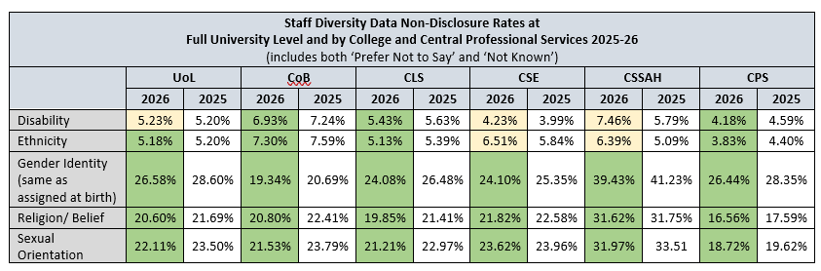

  - The University introduced socio-economic diversity data collection, monitoring and reporting for staff in 2024, recognising that staff may experience barriers or disadvantages relating to their social and economic background, as well as in relation to other aspects of their identity, such as their ethnicity, disability, sexual orientation, faith, or gender identity.
  - Staff are asked 3 questions about their household and education growing up, based on the Social Mobility Commission Framework:
(1) ‘the occupation of the main householder earner when you were aged 14’
(2) ‘the type of school you attended between the ages of 11 and 16’
(3) ‘whether you were eligible for free school meals’
  - 102 staff shared their socio-economic data in 2025 and this increased to 608 in 2026. We will encourage further data sharing of staff socio-economic data as part of our activity in this area over the coming 12 months, and continue to monitor and analyse this data for trends in relevant equality analysis.
  - The Director of EDI is a member of the UCEA Equality Pay Gaps Reference Group and the Diversity Data Task and Finish Group. In recognition of the significant progress that has been made in improving diversity data sharing rates, and the approach we have taken to this, the University will feature as a good practice case study in the sector level source material and guidance on encouraging the sharing of of diversity data to be published by UCEA. This will include our clear strategic commitment (as detailed in our EDI Strategy Deliver Plan), our targeted campaigns, different methods of collecting data (for example, supporting ECS staff diversity data disclosure through drop in and one on one meetings), our myth-busting approach around data collection (who can see it and what happens to it) and our data collection expansion to socio-economic data.

Advancing Equity and Inclusivity in Key Areas
  - Measuring and Benchmarking Progress
    - An important part of the University’s equity and inclusivity work is to continually review and assess the progress we are making, and the impact our initiatives are having, by benchmarking against relevant sector and other nationally recognised equality charters.

    - Submission to equality charters involves a comprehensive self-assessment process and the development of an evidence-based and solution focused action plan to remove barriers or inequities identified, to bring genuine organisational structure and culture transformation.
    - The equality charters that the University is affiliated to are the standard sector and national charters:
- Athena Swan Charter
- Disability Confident Scheme
- Race Equality Charter
- Stonewall Diversity Champions Network
    - It is important that our equity and inclusion work is not determined or bound by equality charters and their aligned awards but, rather, that we use them to measure and benchmark the progress we are making. Applications to charters have a very significant impact on resource but they remain a key sector marker of equity and inclusivity progress.
    - The University’s current sector standing in terms of charter awards is very strong, enhanced by our successful 2024 submissions for an Institutional Athena Swan Silver Award (renewal) and Disability Confident Leader Award (Level 3), making us 1 of only 9 universities that currently hold a Silver (or higher) Institutional Athena Swan Award, a Bronze (or higher) Race Equality Charter Award, and a Disability Confident Level 3 (Leader) Award.

Figure 1: UoL Equality Charter Awards Journey
    - In addition, the University holds 8 Departmental Athena Swan awards, including the outstanding achievement of a Gold College award by the College of Life Sciences (Table 7.6) in February 2026.

Table 7.6: University of Leicester Departmental Athena Swan Awards
School | Level of Award
College of Life Sciences | Gold
School of Chemistry | Silver
College of Business | Bronze
School of Physics & Astronomy | Silver
School of Archaeology and Ancient History (now Culture and Heritage) | Bronze
School of Computing and Mathematical Sciences | Bronze
School of History, Politics and International Relations | Bronze
School of Law | Bronze

    - The EDI Team continue to support institutional level equality charter related work and departmental level Athena Swan submissions through a framework review process, with a particular focus on culture survey administration and analysis, data collection and presentation, along with full submission review and analysis.
    - During 2026, there is 1 further planned University Athena Swan submission, a Bronze Award by the School of Engineering. Criminology, Sociology and Social Policy will begin working towards their first Athena Swan (Bronze) submission and the College of Business will be working toward a Silver College award. There is also a 5-year submission programme plan, which will see all schools currently without an Athena Swan award complete a submission ahead of the next REF submission in 2029.
    - A number of universities have withdrawn from Stonewall’s Diversity Champion programme in recent years. In discussion with the LGBT+ Equity Action Group, we have retained membership of Stonewall, recognising its continuing role in leading LGBT+ inclusion in the UK. Alignment with other LGBT+ charters will be explored by the LGBT+ Action Group in 2026.

Advancing Equity and Inclusivity in Key Areas – Disability
    - The University’s work to advance disability equity and inclusion has continued over the last 12 months, in collaboration with both the Disability Staff Forum and the Students’ Union.
    - Strategic Objectives: Initiatives and activities have focused on supporting and delivering the strategic objectives, proposed by the Disability Equity Action Group and confirmed by the EDI Committee, as detailed in Table 7.7.

Table 7.7 Disability Equity Objectives 2025-26
University of Leicester Disability Equity Objectives 2025-26
1
Identify emerging or under-recognised aspects of staff and student experience that require additional support, and develop policies, initiatives, or measures to address these needs in line with disability equity and inclusion principles.

Continue to drive and inform disability inclusive and anti-ableist policy and practice for staff and students.

2
3
Lead the University to embed disability equity principles, proactive good practice, accessibility and inclusive design into the physical and virtual environment, through policy and process.

Monitor compliance and success of policies and initiatives introduced to support disabled staff and students that were recognised as sector-leading by the Disability Confident assessment process

4
Lead and promote engagement and awareness of staff and students, to embed disability equity, inclusivity, and proactive understanding across the organisation.

5

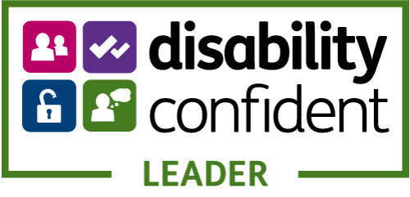

    - Disability Confident: Disability Confident is a government scheme which aims to encourage employers to think differently about disability by positively challenging attitudes, increasing understanding and removing barriers to employment for disabled people.
    - In April 2024, following a rigorous self-assessment and external validation process, the University was recognised with Disability Confident – Leader status, the highest level of the award.
    - Building on the exemplar best practice recognised within the validation process, work has continued over the last 12 months to implement a 3-year action plan, collaboratively developed, informed and monitored by the disabled staff voice.
    - As a Disability Confident Leader organisation, we have a responsibility to promote good practice in the wider sector, local area and nationally and to be a beacon of disability inclusion for other organisations. We have already provided guidance to local authorities and are working with the LCC Employment Hub, to deliver workshops to local employers, to demystify and promote the benefits of the scheme, and to provide support and guidance to local businesses on their Disability Confident Scheme journey.
    - Mandatory Disability Confidence for Managers Training: This course, originally launched in 2022, focuses on increasing understanding of disability and associated responsibilities of managers, and equips managers with the skills and confidence to proactively support disabled team members and create an inclusive environment for disabled staff to thrive.
    - Following feedback from the Disability Staff Forum (DSF) and Disability Equity Action Group (DEAG), and in recognition of its importance to ensuring disability equity, this training became mandatory for all Line Managers in 2024. The training comprises a mandatory online webinar supplemented by an optional workshop to support managers to apply their learning in the University context. Completion of the mandatory element currently stands at 94.2%, a significant increase from 81.2% in 2025.
    - Disability Diversity Data: Diversity data relating to disabled candidates’ journey from application to offer has been added to the departmental recruitment dashboards from May 2025. This data helps organisational areas to identify any disparities and measure the impact of initiatives taken to address. Historically, disability data shared by staff on SAP has only been used to statistically analyse and report on staff disclosure rates. From January 2026, this data will be analysed to understand the representation of different disabilities and health conditions within our staff body and the number of staff sharing more than one disability. This will, in turn, inform our service provision.
    - To align with good practice, DEAG approved a proposal to change the language used around disability diversity data, to move away from using the term ‘disclose a disability’, to using the term ‘share a disability’, wherever possible. ‘Disclose’ can sometimes have negative connotations, whereas ‘share’ is more positive. This has been incorporated into the Reasonable Adjustments Guide and will be gradually introduced wherever appropriate.
    - Policy Development: During the last two years, there has been a significant increase in requests from students to bring a wide range of animals onto campus and into accommodation. In light of this, a review was undertaken of the Assistance Animals on Campus Policy, together with 2 related policies: Pet Free Campus Policy and Pets and Assistance Animals Policy (owned by Student Accommodation), to create one single policy which more clearly sets out the University’s position in relation to assistance dogs, emotional support animals, therapy animals and pets.
    - The new Assistance Dogs and Other Animals on Campus Policy was informed by legal advice, good practice and reviewed by the DEAG and the DSF. Its focus is on assistance dogs, as they are protected in legislation, with provision for emotional support animals to be considered as a reasonable adjustment in exceptional circumstances. The new Policy, launched in May 2025, aims to improve clarity around animals that can be accepted onto campus, those that can’t and the criteria and associated processes for consideration.
    - The Staff Quiet Room continues to receive very positive feedback and has been used almost 250 times since its launch in 2024. There have been requests from staff for similar additional spaces in other areas on campus, which are being considered.
    - Accessible Templates: Over recent years there have been a number of requests from disabled colleagues to improve the accessibility of document templates, and in particular, PowerPoint templates. Due to branding specifications, this had not been feasible. Following a further request, members of DEAG and the EDI Team supported colleagues in Design Services (ERD) and Digital Services, in the development of a more accessible PowerPoint template. The template has become part of the brand templates and is being rolled out for use in learning and teaching, for improved accessibility for students, and for use by staff. A workshop on the new templates was delivered in November 2025 and a recording is available as a resource.
    - AccessAble Building Guides: DEAG and the DSF continue to drive and inform improvements to the accessibility of the physical estate. The Estates and Campus Services, Head of Space Management, a member of DEAG, is facilitating the review and improvement of the AccessAble Building guides. AccessAble, previously known as Disabled Go, provide information about the accessibility of buildings in thousands of organisations on their website. These can be used by prospective and current staff, students and visitors, to help them to navigate our physical estate.
    - International Day of Disabled People 2025: 3 December marks the United Nation’s sanctioned date to celebrate the achievements and contributions of disabled people, raise awareness of disability inequity and promote the rights of disabled people.
    - As with every year, the University celebrated this date with a programme of events from 17 November to the 14 December, in collaboration with the Attenborough Arts Centre, the Disability Staff Forum, Staff Health & Wellbeing and various university departments.
    - With a number of virtual and face-to-face events, the University delivered sessions addressing digital accessibility with dedicated training and awareness raising (Digital Accessibility) showcasing of the support that is available at the University (Staff Disability Adviser, IDoDP Showcase), as well as training for managers, equipping them with the skills and confidence to support and develop staff.
    - Additionally, a focus on lived experience was addressed with dedicated sessions on neurodiversity in women, Chronic Fatigue Syndrome (and the ongoing research here at Leicester on diagnosis), and mental health experiences for men.
    - Performances by local disabled artists with WORD! and Teagan Buckley were also showcased, exploring ideas around (dis)ability and imagining a present and future that is accessible for all without exception. While Dr David Wilkin (Honorary Visiting Fellow at the School of Criminology, University of Leicester) was invited to discuss hostility against disabled people.

Advancing Equity and Inclusivity in Key Areas – Gender
    - Advancing gender equity and inclusion remains a clear and visible priority across the University. This includes the commitment to implement the Institutional Silver Athena Swan action plan priorities, and a continued focus to address the University’s gender pay gap.
    - Strategic Objectives: Table 7.8 details the University’s agreed gender equity objectives for the academic year 2025-2026, proposed by the Gender Equity Action Group and confirmed by the EDI Committee.

Table 7.8: Gender Equity Objectives 2025-26
1
To oversee the successful implementation of the University of Leicester’s Athena Swan Silver Action Plan.
To support the progression of the following Athena Swan priority: ‘Enhance the support provided to staff with caring responsibilities on return from family leave’.
To support the progression of the following Athena Swan priority: ‘Enhance our current provision to raise awareness of gender-based/sexual violence and harassment and review support available to students experiencing these forms of behaviours.
2
3
University of Leicester Gender Equity Objectives 2024-25

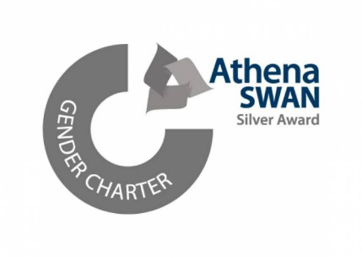
    - Athena Swan: As detailed in 3.1.5, the University currently holds an Institutional Silver Athena Swan charter mark. Initially awarded in 2018, this was successfully renewed in May 2024 and remains valid for 5 years (until July 2029). Given the comprehensive nature of the award process, including detailed self-assessment and analysis across the full student and staff lifecycles, the University’s current actions to advance gender equity are framed around the existing aligned Silver action plan.
    - The six priority areas identified through the self-assessment process are to:
Athena Swan Priority Areas 2024-29

- Increase the representation of women staff in senior academic/research roles
- Enhance provision to raise awareness of gender-based/sexual violence and better support students who experience these behaviours.
- Improve the representation of women students at Undergraduate level in the College of Science and Engineering.
- Enhance the support provided to staff with caring responsibilities on return from family leave.
- Ensure fairness and transparency in workload.
- Enable an effective and safe engagement environment to improve the experiences of trans/non-binary staff and students at the University.

    - During 2025, the University responded to both the OfS’s Condition of Registration E6: Harassment and Sexual Misconduct and the introduction of the Worker Protection (Amendment of Equality Act 2010) with a comprehensive set of reviews, initiatives and actions taken/in place.
    - Condition of Registration E6: Harassment and Sexual Misconduct: The E6 Condition came into effect on 1 August 2025 and was introduced in recognition of the prevalence of harassment and sexual misconduct in universities and colleges, and the need to take more effective steps to tackle these. The Condition requires higher education providers to take strong, effective and credible steps to prevent and respond to the harassment and sexual misconduct of students.
    - A specific requirement of the Condition relates to intimate personal relationships between staff and students, recognising the different forms of abuse of power that can take place within such relationships, including those that may result in a detriment or advantage to the student, such as unfavourable or favourable treatment in academic assessment, access to funding and career advancement.
    - A new policy Staff and Student Personal Relationships Policy has been developed, as part of the University’s commitment to ensuring a safe learning, working and research environment for all staff and students in which professional boundaries are maintained. The Policy was developed collaboratively with a wide range of stakeholders, including the Students’ Union and the three recognised trade unions.
    - Whilst the University’s existing Personal Relationship Policy had been in place since 2020, on average, only 2 disclosures of staff/student personal relationships (of any kind) are made per year across the whole University. This is likely to represent a significant level of underreporting, typical of what is reported across the sector.
    - The OfS E6 Guidance details that providers must take one or more steps which could make a significant and credible difference in protecting students from any actual or potential conflict of interest and/or abuse of power in relation to personal relationships between staff and students.
    - The Guidance specifies that:

- A ban on intimate personal relationships is deemed to be a step which could make a significant and credible difference in protecting students; and
- a statement made by the provider to the effect that it disapproves of and/or discourage intimate personal relationships between staff and students may contribute to compliance but will not individually be treated as a step which could make a significant and credible difference in protecting students.
(OfS Guidance, E6.6)

    - The Working Group gave full consideration to all requirements of the condition, took into account relevant UoL contextual information and consulted with a wide range of stakeholders.
    - From this, a new Staff and Student Personal Relationships Policy was developed that prohibits intimate personal relationships between staff and students (with exemptions in place for such relationships that were in place before the launch of the Policy or before both parties were members of the University).
    - Gender Equity Policies: A number of university family friendly policies were updated in 2025:
- Neonatal Leave – relevant policies updated to reflect the introduction of Statutory Neonatal Care Leave and Pay, with enhanced pay provision for university staff (full pay) regardless of length of service. The University upgraded to Employer with Heart 2.0 charter accreditation status with the premature baby charity The Smallest Things.
- Flexible Working Policy and Procedure – amended to reflect that staff requests for a temporary flexible working arrangement of up to 18 months in duration, with a guaranteed return to previous contracted working hours, will be considered in exceptional circumstances.
- KIT and SPLIT Day Guide – updated to ensure the guide is accessible for all staff, up to date and comprehensive in setting out how Keeping in Touch and Shared Parental Leave in Touch days operate.
- Family Leave Coaching – coaching provision to support staff before, during and after taking Maternity, Adoption or Shared Parental Leave.

    - Gender Equity Events: The University’s annual programme of gender equity events continued to take place across the University through engagement with international campaigns, such as International Women’s Day and 16 Days of Activism against Gender-Based Violence (the latter of which is led by the Standing Together Team). Between late-November and early-December 2025, numerous events were organised collaboratively with the Gender Equity Action Group, the Women’s Forum, the Students’ Union, Student Support Services and various academic departments.
    - In March, the University held a range of in-person and virtual events for International Women’s Day under the global theme of #AccelerateAction. Events included a focus on career and personal development, alongside dedicated literary exhibitions, health initiatives and the celebration of women in both the arts and STEM.
    - Literary exhibitions included 'International Women's Day Represent Display' in the David Wilson Library. This exhibition was curated via recommendations from University students through the Represent campaign, with the David Wilson Library promoting and showcasing the recommend titles to highlight the diverse range of voices in the Library's collection.
    - Health focused events took place on menopause, exercise, breast screening with the Leicester Cancer Research Centre, and urogynecology treatments and management with Dr. Aneta Obloza.
    - An afternoon of conversation, creative writing, reflection and action-setting, and the screening of a Bell Hooks documentary was organised by international PhD researchers from the School of Arts, Media & Communications. The Let's Do Leicester group organised a series of activities across the month of March including Women's Only Gym sessions, badminton, and a paint & sip session. These events provided the University's women staff and students with safe spaces for gender related discussions and support.
    - Guest speakers were also invited to the University, notably, Dr Felicity Sedgewick from the University of Bristol who discussed autism in girls and women. This talk explored the intersection between gender and disability, illuminated male bias in autism research, and showcased new findings on the presentation of autism in girls and women and new figures on the increasing proportion of girls experiencing this condition..
    - One of the most iconic and well attended IWD events was the retitling of the Archaeology and Museum Studies Building, which was renamed in honour of the prominent and influential archaeologist Dame Kathleen Kenyon (1906-1978). This is the first academic building to be dedicated to a woman and builds on the University’s commitment to recognising and celebrating the achievements and successes of women.

Advancing Equity and Inclusivity in Key Areas – LGBT+
    - Strategic Objectives: Work to advance the agreed LGBT+ strategic objectives continued over the last 12 months, in collaboration with a broad range of stakeholders, including the Students’ Union and the LGBT+ Staff Forum.
    - Table 7.9 details the University’s agreed LGBT+ equity objectives for 2025-2026, proposed by the LGBT+ Equity Action Group and confirmed by the EDI Committee.

Table 7.9: LGBT+ Equity Objectives 2025-26
1
Drive and promote cultural change whereby LGBT+ equity is further embedded in university functions, activities and ethos, including embedding LGBT+ equity, inclusivity and understanding across the organisation, effecting a cultural shift to a LGBT+ inclusive culture, aligned with the University’s commitments and the Dignity and Respect at Leicester framework.
Work with trans and non-binary staff and students to enhance the trans and non- binary voice and visibility in the University, through understanding, identifying and informing appropriate responses to related inequities experienced by both students and staff. Alongside implementing proactive measures to develop the safety of the trans and non-binary community at the University and a continued commitment towards trans/non-binary inclusion.
Identify priority areas to enhance the lives of the LGBT+ community at the University of Leicester at operational and institutional levels, additionally identifying key foci on the mental and physical wellbeing of LGBT+ staff and students and the health and wellbeing inequities the community disproportionately experiences.
2
3
University of Leicester LGBT+ Equity Objectives 2025-26

    - Our work to advance LGBT+ equity and inclusion over the last 12 months has seen a continued focus on trans and non-binary voice and visibility.
    - Trans Awareness Training: A specific tailored session was commissioned and delivered for the Senior Leadership Team in June. Delivered by Gendered Intelligence, a trans-led registered charity, the training comprised a face-to-face workshop, attended by 46 members of SLT and receiving very positive feedback.
    - Trans and Non-binary Staff Listening Event: Gendered Intelligence were also commissioned to facilitate a listening event in July. Trans staff had less favourable responses throughout the Staff Survey and, with a shifting wider societal context, this event was organised to provide a safe space for trans and non-binary staff to share their experiences, concerns and suggestions for improved trans inclusion in the workplace, to inform our future work. Like all universities, following the Supreme Court ruling in April on ‘sex’ and ‘woman’ in the Equality Act 2010, we await the publication of the EHRC Services, Public Functions and Associations: Code of Practice. The Code will inform the approach we take in ensuring that the University does not discriminate against protected groups in terms of accessing services and facilities, whilst at the same time continues to support all members of our community.
    - Once the Code has been published, the Heads of relevant service provision areas, including those relating to student accommodation, sports and lifestyle facilities, toilet and changing room facilities, will work collaboratively to review and interpret the Code, with external legal advice, where appropriate.
    - Consultation with students and staff on any changes to current university practice or provision will that place through the Equity Action Groups.
    - As part of the University’s enhanced duties in relation to freedom of speech and academic freedom, and following the OfS investigation and subsequent fine of the University of Sussex, finding that the University to uphold the freedom of speech and academic freedom public governance principles through the publication of its Trans and Non-Binary Equality Policy Statement, a review of all central university EDI policies, statements, resources and training materials is being completed. Further details can be found in Section 5.11.
    - Leicester Pride 2025: The University marked the annual celebrations for Leicester Pride on 30 August, joining thousands at Abbey Park and engaging with over 400 attendees at the University’s festival stall. 2025 saw the continued growth of Leicester Pride in terms of size and attendance; and the University’s presence at Pride is a continuation of our strong history of contributing to the ongoing work in advancing LGBT+ equity and inclusion in the region, while also celebrating the rich diversity and history of Leicester’s LGBT+ community.
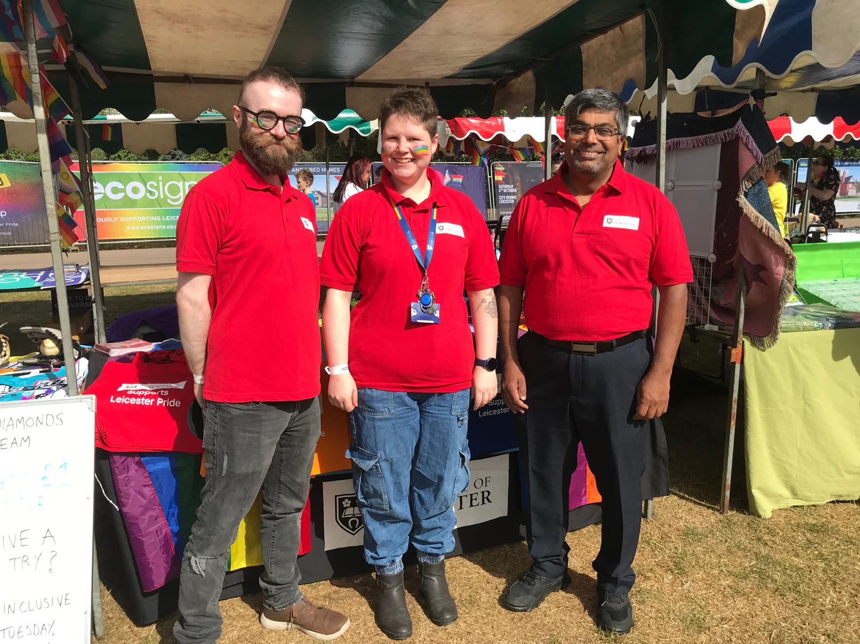
Figure 2: University of Leicester staff at Leicester Pride 2025
    - LGBT+ History Month 2025: February marked the University’s annual celebrations for LGBT+ History Month and, for 2025, the University focused on local artistic achievement, academic talks and targeted need here at Leicester.
    - With dedicated showcases of LGBT+ history by MedPRIDE, explorations of Leicester’s local LGBT+ history (Joe Orton Leicester Ride), creative writing with Appittame Arts on the theme of love, and numerous performances highlighting LGBT+ artists in Leicester and across the UK (Mo Gearing, Order of the Peaky Grindrs) as well as performances that explored the intersectionality of sexuality and disability (Queers Tales For Autistic Folk) with the Attenborough Arts Centre.
    - An academic focus was delivered via a lecture that reflected on the failures and futures of queer engagements with human rights (Human Rights and Other Catastrophes: Reflections on Queer Engagements with International Law).
    - The month of celebrations also coincided with National HIV Testing Week, and the University supported the LGBT+ Student Society and Students’ Union in hosting the local charity Trade Sexual Health on campus, to provide confidential and free rapid HIV tests, alongside information on knowing your HIV status, effective treatment, to increase opportunities for people to get tested and end the stigma of HIV.
    - Transgender Day of Remembrance 2025: In collaboration with the Students’ Union, the University joined Trade Sexual Health’s Memorial Walk in Victoria Park, carrying a memorial wreath (woven with the colours of the Trans Pride Flag) and lights in memorial of trans lives lost this year to acts of anti-trans violence, suicide, and medical complications, under the theme of “carry their light”. With over 100 attendees, the memorial walk started at Victoria Park’s Peace Walk and travelled to Leicester Cathedral, where the wreath sat over the weekend in memory of the lives lost. As part of the commemoration, alongside flying the Progress Pride Flag from the Fielding Johnson Building, the University lit up the Attenborough Tower in the colours of Trans Pride Flag, showcasing our visible commitment to the trans community and support for wider trans inclusion.

Figure 3: Trans Day of Remembrance Attenborough Tower
    - World AIDS Day: The University joined the Red Ribbon Remembrance Vigil hosted by Trade Sexual Health at the Leicester HIV and AIDS Memorial Garden, to remember, mourn and celebrate those lost to AIDS and HIV-related illnesses. As part of ongoing efforts through education, prevention and support to address sigma and health needs of those with HIV, the vigil highlighted the timeline of the HIV epidemic to celebrate how far we have come and what we need to do to help end new cases.

Advancing Equity and Inclusivity in Key Areas – Race
- The University’s work to advance race equity and inclusion has continued over the last 12 months, in collaboration with both the Race Equity Action Group, the Students’ Union and key stakeholder student and staff groups across the University.
- Strategic Objectives: The strategic objectives for 2025-26, proposed by the Race Equity Action Group and confirmed by the EDI Committee, are detailed in Table 7.10.

Table 7.10: Race Equity Objectives 2025-26

1
To act as an internal stakeholder for key workstreams of activity which have a focus on addressing evidenced racial disparities across the student and staff lifecycle, by contributing to ideas generation and by undertaking an internal review of any related strategic proposals which seek to remedy race related disparities.

To learn from and work collaboratively with other comparable Race Equality Charter Mark regional universities, and areas who are leading in race equality activity within our university, to share and implement best practice; and to generate creative, innovative and effective actions that tackle systemic and institutional racism in higher education.
2
University of Leicester Race Equity Objectives 2025-26
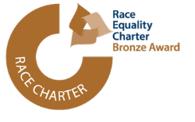

- Race Equality Charter Mark (RECM): We continue to monitor progress against the RECM action plan and to work with key stakeholders and the Race Equity Action Group to ensure that race equity remains a priority across the University.
- Considering the strong progress made against our RECM Action Plan, and after reviewing the award criteria for a Silver RECM award, the University will be applying for a Silver Race Equality Charter Award in July 2027.

- In June 2025 the EDI Team facilitated a RECM mid-term review workshop delivered by Advance HE, with 22 staff and students from across the University attending. The following themes were identified as emerging priority areas for the University in relation to race equity and inclusion;
  - Improving the representation of minority ethnic staff at certain grades and on decision-making Committees/Boards.
  - Supporting career progression for minority ethnic staff through measurable increases in engagement and participation in training and leadership development opportunities.
  - Improving the success rate of minority ethnic applications in academic promotions.
  - Improving satisfaction and academic career progression for postgraduate researchers.
  - Closing the awarding gap.
  - Closing the satisfaction gap for minority ethnic, particularly Black, students.
  - Improving the satisfaction of minority ethnic staff in relation to how the University addresses bullying and harassment.
- After a call for expressions of interest to staff and students, the University’s institutional Self-assessment Team (ISAT) was established, and is chaired by Professor Teela Sanders and Dr Nora Musyoka.
- In preparation for our institutional Silver submission and the ISAT meetings, the EDI Team have produced, and are analysing, a range of data sets across the student and staff lifecycle for the past 4 years.
- Also, to support our Silver submission, Race Equality Charter Mark student and staff surveys were launched in October 2025. There were 100 responses from staff and 16 responses from students. The outcomes of these surveys will be reviewed by the ISAT and the results will be communicated to the wider university community via The Citizen.
- As part of an annual review of the progress made in relation to the University’s Bronze Race Equality Charter action plan, the Race Equality Charter Mark Update Report 2024-2025 provides a comprehensive update of the key areas of progress and includes a summary of the race related activities and actions taking place across the University more widely, including actions led by the Student and Education EDI Team related to the ethnic disparities across the student lifecycle.
- Of the 77 actions within the University's Bronze Race Equality Charter Action Plan; 58 are completed/achieved, 13 are in progress/success measures not yet met, and 6 are no longer relevant.
- Highlights of the Race Equality Charter Mark Update Report 2024-2025, which details race equity and inclusion progress across the University, include:
- In 24/25, the University had higher offer acceptance rate for minority ethnic students than for white students. 48% of UK Black students accepted their offer compared with 25% of UK. In 25/26, 86% of the University’s clearing population are minority ethnic.
- In 24/25 there is a 2.3 percentage point reduction in the awarding gap between UK Black and UK white students (currently 14.7%). Institutional data for 2024/25 shows an awarding gap of 7.1% between minority ethnic and white students which is reduction of 4.8 percentage points since 2023/24.
- In 25/26, 52.6% of the University’s PGR cohort are from minority ethnic backgrounds and 49% are international students. Based on the PRES2024 outcomes, there are a range of initiatives in place to improve the experience and satisfaction of minority ethnic, particularly Black, PGR students. This includes a wide range of projects through I-REACCH, who have invested over £60,000 across 37 locally-led research culture improvement projects.
- The majority of gaps have narrowed on NSS 2025 compared to 2024, with the exception of “teaching on my course”, which has increased for both minority ethnic students from -4.3pp to – 5.4pp compared to white students. This is mirrored in with a similar gap of -5.5pp between Black and white students. There is still a significant gap of -3.5pp for minority ethnic students compared to white students in “student voice” however this has reduced by 1.5pp since last year.
- In 2024/25, application rates for minority ethnic applicants to staff posts were 68.1% of all applications, which is an increase from 2023/24 (65.3%). Offer rates to minority ethnic applicants were 41.2% of all offers in 2024/25, which was a slight decrease of 0.4% from the 2023/24 (41.6%). The population of staff from a minority ethnic background has increased to 29.6%.
- Advancing Race Equity and a Culture of Anti-Racism: The University continues to undertake a wide range of initiatives and actions across the University, to challenge and address race inequities, including structural, in order to create a culture of anti-racism.
- The EDI Team have delivered a series of race equity related workshops and training sessions to colleagues, detailed below in 5.2.
- The University has a range of funded opportunities to support the progression and representation of minority ethnic students. These include Cowrie Scholarships, EmbRACE award, Len Garrison Award, Missing Elements Grants Scheme, the Geology Award, the Skylark Scholarship and Economics Award, Future50 Scholarships. In addition, the University’s Advancement Team administer several donor-funded scholarships and awards and have offered scholarships and awards totaling £24k to Black or mixed heritage students, in their 2025/26 intake.
- The Centre for Hate Studies have led on a range of sector wide race inclusion projects including a short film that was part of the wider Rural Racism Project, winning the Learning on Screen Award 2024 for their short film, Revisiting the Harms of Hate and leading a study on harassment in higher education- Catalyst for Change.
- The Colleges and Professional Services Division have also led a wide range of race inclusion projects and activities including:
  - Events such as the EDI Conference in the College of Business and a five-day festival of events in the College of Life Sciences led by MedRACE bringing together students, colleagues and national partners.
  - MedRACE were awarded the Collaborative Award for Teaching Excellence (CATE) from Advance HE and the Times Higher Education Award for Excellence in Equality, Diversity and Inclusion (2025), in recognition of their outstanding and high impact work.
  - The Law School have established a co-created EDI Programme-LAWRise which includes informal and more formal activities aimed at increasing diversity and inclusivity for non-white students.
  - The International Experience Team have engaged over 3,600 from more than 90 countries through an annual programme of inclusive, social, cultural and wellbeing events.
  - The Students Union have delivered a range of events and projects including adopting the Halo Code, Uniting Leicester Campaign, International Arts and Culture Festival and Black History Month.
  - Library Services have collaborated on a range of events including a South Asian Heritage month event and exhibition, the Memories of Living Well Together project and the Sikh Museum Initiative.
  - A number of academics have been recognised nationally for their sector leading work related to race equity, including Dr Paul Ian Campbell's book, Race and Assessment in Higher Education, winning the British Educational Research Association (BERA)'s Educational Research Book of the Year, and a paper on the evaluation of the multi-institutional Decolonising Midwifery Education Toolkit, co-authored by Maxine Chapman.
  - The SEEDI Team led on a range of student facing initiatives which seek to address racial disparities and in particular seek to close the awarding gap, including the Black Student Experience Programme.
- Black History Month 2025: The University’s Black History Month programme has grown each year. Working collaboratively with the Students’ Union, and Attenborough Arts Centre, a wide range of events and activities took place around the theme of Beyond Representation: Commitment to Change across October. The theme was selected by the University’s BHM Black Experiences Steering Group (BLESG),comprising 18 student and staff members, who use their lived experiences as a reference point in ensuring authenticity and relevance in our approach in delivering an inclusive, representative and engaging programme of events and activities.
- The programme covered a variety of academic, artistic and collaborative events, including a range of events and activities hosted by Attenborough Arts, such as performances of TaylorMade Studios’ 'Infectious: Part One: Mad About The Boy', inspired by the poetry of Gwendolyn Brooks and the artistry of Allesandra Seutin, exploring the relationship between art, collectivism and therapy through Nubian aesthetic to the issue of emotional well-being in diaspora; and BAKUYARD Productions’ Whoodoo You Come From?’ which was facilitated by multi-heritage/Caribbean ancestry artist Mellow Baku and presented a transformative journey into ancestral connection, through creative expression, art, music and communal ritual.
- As part of the theme of Commitment to Change, a number of events in support of Black academic staff, researchers and students were held. With creative workshops to provide a space for Black and mixed Black heritage postgraduates to share their experiences of being a researcher at the University of Leicester and their ideas for how we can improve things going forward; PGR and ECR roundtable discussions between students and staff from across the University explored experiences of academia and how we can change culture for the better; and a research showcase highlighting the rich contributions of Black heritage students, researchers and staff across the University. Additionally, trailblazing rugby captain and educator, Floyd Steadman OBE was invited to share his remarkable journey, from Saracens RFC to shaping young minds in education, including mentoring England RFU captain Maro Itoje.
- Following from last year’s Pukaar Awards winning collaboration, the University once again worked alongside John Lewis Leicester for A Soulful Celebration, a day-long event featuring live performances from the University of Leicester Gospel Choir and the renowned EAGA Gospel Choir.
- The University was also proud to welcome the return of Chancellor Dame Maggie Aderin-Pocock DBE for an intimate conversation to hear her personal insights and reflections around this year’s theme ‘Beyond Representation: A Commitment to Change’. Additional talks were also hosted by Robert Beckford and Emma Babiri exploring colonial legacies in archives and museums.
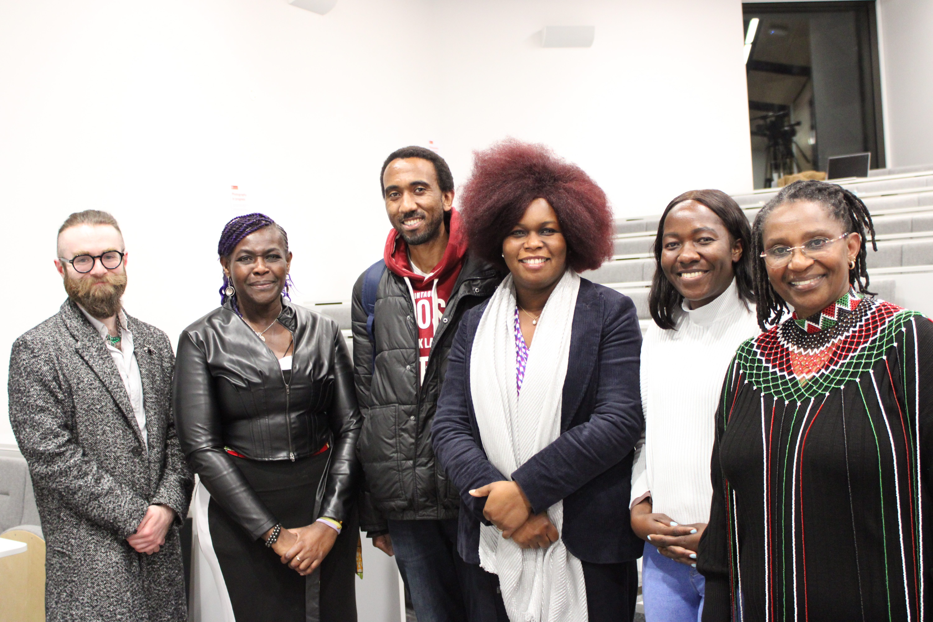
Figure 4: Chancellor Dame Maggie Aderin-Pocock DBE and staff/student attendees.

Advancing Equity and Inclusivity in Key Areas – Faith
    - The University is committed to developing its provision to support multi-faith and spiritual groups, following a review of the University’s existing provision. Faith-based support for students remains under the remit of Student Services and Belonging, with a dedicated faith@le.ac.uk inbox for queries.
    - Prayer Facilities: The EDI Team continue to work closely in an advisory capacity with the Students’ Union, Estates and Campus Services and Student Services and Belonging, regarding the provision of prayer facilities and faith-based support. We currently have satellite Muslim prayer facilities in Freemen’s Common and in the Maurice Shock building, as well as the Charles Wilson Prayer Rooms. We do not currently have dedicated on-campus faith spaces for other faith groups.
    - Multi-Faith and Spiritual Activities: Working closely with the Students’ Union, the University continues to support Student Faith Societies to host key religious festivals/events, and co-ordinates activities to celebrate Chinese Lunar Year. The University also recognises faith related celebrations through social media communications across the year. For the 2025-26 academic year, the Events Team have developed a Faith and Cultural Events Plan to ensure that faith and cultural activities are marked sensitively and consistently. The University also continues to work closely with the Christian Chaplaincy, based in the Gatehouse, which is allied to the University of Leicester.
    - Considering the current financial and estate related constraints faced by the University, and upon advice from various sources including St Phillips Centre, the University takes a signposting approach in relation to faith-based support for students.
    - In December 2025, the EDI Team Supported the Director of EDI in CSSAH to host a staff meeting for staff members who are interested in faith and interfaith. To support all staff equity groups, the University is exploring the development of a faith staff equity forum. The Director of EDI in CSSAH will review the outcomes of the initial meeting with a view to establishing whether there is enough staff interest to form a staff faith forum.
    - Holocaust Memorial Day 2025: The University continues to support the Holocaust Memorial Day commemorations held in the city of Leicester. 2025 was marked by the theme of the ‘For a Better Future’, and the key commemoration event was held collaboratively with De Montfort University. The event featured a live recital of the ceremonial Hebrew declaration of Kol Nidrei, a panel discussion from the city’s local schools, and a memorial address delivered by Professor Aubrey Newman. With attendees including members of the local Jewish community and synagogues, and representatives from the Office of the Lord Mayor of Leicester, Leicester City Council, and Leicestershire County Council.
    - Additional remembrance commemorations held by the University included the annual Stanley Burton Centre for Holocaust and Genocide Studies Holocaust Memorial Day Lecture, delivered this year collaboratively by the Centre and the Institute for the History of the German Jews in Hamburg, and the Wiener Holocaust Library London. Titled “Where is my grandfather?” A Family History of the Holocaust in Hungary.
    - The University of Leicester also lit up the Attenborough Tower between 27 and the 29 January as a symbol of the University’s commemoration on campus, complementing Leicester City Council’s own lighting up of City Hall and Town Hall between the 25 and 28 January.

University of Leicester Equity Pay Gaps 2025
  - Annual Pay Gaps Report: The University will publish its 2025 Pay Gaps Report in March 2026 (see Appendix C for the full Report). For the third time, the Report includes disability, ethnicity, and sexual orientation, in addition to the mandatory gender pay gap data.
  - This expanded pay gap reporting gives increased transparency and accountability across the four key equity groups and aligns the University’s commitments, especially its visible commitments, to advancing equity and inclusion in relation to ethnicity, disability and sexual orientation with those for gender around pay equity.
  - Pay Gap Data Methodology: As was agreed in 2023/24, all pay gap data, apart from the statutory gender pay gap, exclude atypical staff, as there is currently no SAP solution in place to calculate this. Unitemps records do not interface with SAP and have very little capability for analysis, with no Dept, Position, Job Family, Grade, Spine Point, HESA Function, Cost Centre or FTE recorded.
  - Headline Pay Gap Data:
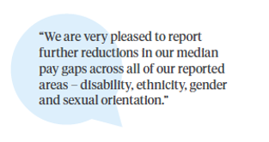

  - The headline data from the 2025 Report (see Table 7.11) includes:
Median Pay Gaps Changes:
- There has been a decrease in all four median pay gaps since 2024.
- With the largest decrease being in the sexual orientation pay gap, 6.4 percentage points, from 17.1% in 2024, to 10.7% in 2025.
- This amounts to a total movement of a reduction of 13.0 percentage points across the 4 main median pay gaps.
Mean Pay Gaps Changes:
- There are decreases in the gender (1.2 percentage points), minority ethnic gender (2.9 percentage points) and sexual orientation (2.7 percentage points) pay gaps.
- There are small increases in the disability (0.3 percentage points), ethnicity (0.9 percentage points) and white gender pay gap (0.1 percentage points).
- This amounts to a total movement of 8.1 percentage points across the 6 mean pay gaps, with 6.8 of this being favourable (decreasing pay gaps) and 1.3 being unfavorable (increasing pay gaps).

Table 7.11: UoL Pay Gaps 2025 (includes 2024-25 movement)

  - As well as the headline pay gap data for all 4 equity strands detailed in the 2024 Pay Gaps Report and mandatory gender pay gap data, we are also including disaggregated pay gap data for all 4 equity areas on both internal and external UoL EDI webpages. This data is incorporated into the following analysis.
  - Gender Pay Gap: The University’s 2025 mean gender pay gap is 17.3%, compared to 18.5% in 2024, and the median gender pay gap is 14.9%, compared to 18.1% in 2024. Both of these are higher than the higher education sector gender pay gap calculated by Advance HE, which reports a mean gender pay gap of 13.7% and a median gender pay gap of 9.0%.
Mean Gender Pay Gap Median Gender Pay Gap

17.3% 14.9%

4.7 Since 2017, the University of Leicester has seen an overall reduction of 6.8 percentage points to its mean gender pay gap and an overall reduction of 7.8 percentage points to its median gender pay gap (Table 7.12).

Table 7.12: University of Leicester Gender Pay Gap 2017-2025
  - The University’s current mean bonus gender pay gap is 85.5% (80.9% in 2024) and median bonus gender pay gap is 50.0% (the same as 2024). As the University only has a small number of bonus awards and the Clinical Excellence Awards are included in these calculations (although the cost of these is partially refunded by the NHS) the bonus gender pay gap is subject to significant fluctuation on an annual basis.
  - As for many organisations, key determinants of the University’s gender pay gap include the absence of a gender balance across job categories (horizontal occupational segregation) and through the different pay grades (vertical occupational segregation). At the University of Leicester, women continue to be overrepresented in lower and middle paid roles and underrepresented in higher paid roles.
  - Higher gender pay gaps across the sector are typically seen in HEIs that are research intensive, that have a medical school and that directly employ manual and ancillary staff. The University has all 3 of these.
  - In terms of interrogating the gender pay gap by function, both the mean and median gender pay gaps are significantly higher for academic staff (15.6% mean and 8.4% median) than for professional services staff (7.8% mean and 3.1% median) (Table 7.13).

Table 7.13: UoL Gender Pay Gaps 2025 by Function
  - When analysing by grade groupings, Grades 1-5, has no mean or median gender pay gap and the Clinical Grade has the highest (20.8% mean and 19.1% median). Grade 10 or Professor Grade also has low mean (5.1%) and median (5.8%) gaps (Table 7.14).
Table 7.14: UoL Gender Pay Gaps 2025 by Grade Groupings
  - Ethnicity Pay Gap: The University’s 2024 mean ethnicity pay gap is 9.5% (a decrease of 2.5 percentage points from 12.0% in 2023), and the median ethnicity pay gap is 14.3% (an increase of 1.0 percentage point from 13.3% in 2023) (Table 7.15).

Table 7.15: UoL Ethnicity Pay Gaps Movement 2023-25
Mean Ethnicity Pay Gap Median Gender Pay Gap

10.4% 11.6%
  - The mean ethnicity pay gap for academic staff is lower (11.0%) than for professional services staff (14.8%) but the median ethnicity pay gaps for academic staff is higher (13.6%) than for professional services staff (10.4%) (Table 7.16).

Table 7.16: UoL Ethnicity Pay Gaps 2020 by Function

  - When analysing by staff grade groupings, Grade 10 or Professor has the lowest mean ethnicity pay gap (0.4% mean) and Grades 6-9 have the lowest median ethnicity pay gap (2.9%). The Clinical Grade has the highest (13.2% mean and 11.6% median) (Table 7.17).

Table 7.17: UoL Ethnicity Pay Gaps 2024 by Grade Groupings
  - Disability Pay Gap: The University’s 2025 mean disability pay gap is 15.1% (an increase of 0.3 percentage points from 14.8% in 2024), and the median disability pay gap is 17.9% (a decrease of 1.3 percentage point from 19.52% in 2024 (Table 7.18).

Table 7.18: UoL Disability Pay Gaps Movement 2024-25
Mean Disability Pay Gap Median Disability Pay Gap
15.1% 17.9%

  - The mean disability pay gap is slightly lower for professional services staff (8.2%) than for academic staff (8.8%) and the median pay gap is slightly higher for professional services staff (6.2%) than for academic staff (4.8%) (Table 7.19).

Table 7.19: UoL Disability Pay Gaps 2025 by Function
  - When analysing by staff grade groupings, Grade 10 or Professor has the second lowest mean and median disability pay gaps (-1.8% mean and 0.2% median) (Table 7.20) (there is only 1 disabled member of staff in the Clinical Grade).

Table 7.20: UoL Disability Pay Gaps 2025 by Grade Groupings
  - Sexual Orientation Pay Gaps: The University’s 2024 mean sexual orientation pay gap is 11.8% (a decrease of 2.7 percentage points from 14.5% in 2024), and the median sexual orientation pay gap is 10.7% (a decrease of 6.4 percentage point from 17.1% in 2024) (Table 7.21).

Table 7.21: UoL Sexual Orientation Pay Gaps Movement 2024-25
 | Mean  2025 | Movement from 2024 | Mean 2024 | Median 2025 | Movement from 2024 | Median 2024
Sexual orientation | 11.8% | -2.7 | 14.5% | 10.7% | -6.4 | 17.1%
Mean Sexual Orientation Median Sexual Orientation
Pay Gap Pay Gap

11.8% 10.7%

  - The mean sexual orientation pay gap is slightly lower for lesbian, gay and bisexual (LGB+) professional services staff (8.2%) than for LGB+ academic staff (mean 8.8%) and the median sexual orientation pay gap is lower for academic staff (4.8%) than for proefssional services staff (6.2%) (Table 7.22).

Table 7.22: UoL Sexual Orientation Pay Gaps 2025 by Function

  - When analysing by staff grade groupings, the pay gaps for 2 Grade groupings, Clinical and ‘Other’, are skewed by the very low numbers of staff (3 and 1 respectively). Beyond these 2 groupings, Grades 1-5 has the lowest mean sexual orientation pay gap and no median pay gap (Table 7.23).

Table 7.23: UoL Sexual Orientation Pay Gaps by Grade Groupings
  - Intersectional Pay Gaps: The University’s intersectional pay gaps are the gender pay gaps disaggregated by broad ethnic groupings (minority ethnic and white) and illustrate the separate and combined impact of gender and ethnicity based disadvantage.
  - The University’s 2025 mean minority ethnic gender pay gap (the mean gender pay gap for minority ethnic women compared to minority ethnic men) is 21.9% (a reduction of 2.9 percentage points from 2024 when it was 24.8%) and the median minority ethnic gender pay gap is 17.9% (a decrease of 2.0 percentage points since 2024, when it was 19.9%). The mean white gender pay gap (the mean gender pay gap for white women compared to white men) is 16.5% (a slight increase from 16.4% 2024 when it was 16.4%) and the median white gender pay gap is 11.3% (a decrease of 2.4 percentage points since 2024 when it was 13.7%).

Mean Minority Ethnic Median Minority Ethnic
Gender Pay Gap Gender Pay Gap
21.9% 17.9%

Mean White Gender Median White Gender
Pay Gap Pay Gap

16.5% 11.3%

  - Actions to Close UoL Pay Gaps – As detailed in the University of Leicester 2025 Pay Gaps Report, the University is taking a wide range of actions to ensure fairness and equity across all aspects of its employment provision including in relation to

Attracting and Retaining Staff:
- offering competitive pay and setting out our approach to pay and reward in open and transparent ways;
- continually reviewing and improving our recruitment practices and processes to ensure they are equitable and inclusive including by embedding the Inclusive Recruitment Toolkit, anonymous shortlisting for professional services roles, each departments receiving annual recruitment data health checks.

Nurturing and Developing Staff:
- reinforcing our transformational approach to academic progression and promotion, created through the Leicester Academic Career Map;
- delivering our comprehensive suite of development and leadership programmes, which have equity and unconscious bias awareness embedded throughout;
- implementing mentoring and coaching to support through the academic promotion process.

Valuing Equity and Diversity:
- progressing our Institutional Athena Swan Charter Silver, Race Equality Charter Bronze and Disability Confident Leader action plan priorities;
- mandating all staff to complete both an EDI and Challenging Unconscious Bias online modules and line managers to complete Disability Confidence Training;
- offering a portfolio of resource and leaning and development opportunities to support inclusivity, including LGBT+ and Disability toolkits;
- improving disclosure rates of diversity data to enable improved understanding of barriers and disadvantage for equity groups;
- requiring all staff who sit on recruitment and selection panels to additionally complete training that specifically addresses bias in recruitment and selection processes;
- providing networking and support opportunities through our four Staff Equity Fora and Carers and Parents Network;

Celebrating and Recognising Success:
- ensuring our approach to performance, reward, recognition and promotion is transparent, understandable and fair, including offering promotion workshops for minority ethnic and women staff.
- embedding evidence-based action in promotion processes, including providing demographic data and having bias observers on professorial panels.

  - Pay Gaps Working Group: During 2025/26, further interrogation of the disaggregated pay gap data is being completed to understand patterns and trends across pay grades and organisational areas. This analysis will feed into work already started with the four Equity Action Groups, through the Pay Gaps Working Group, to identify further possible actions to close the pay gaps.

  - Findings and good practice from the UCEA Equality Pay Gaps Reference Group will also feed into this area of activity.

Organisational Embedding of Equity, Diversity and Inclusion
  - Over the last 12 months, initiatives and projects have been completed and progress made to further embed EDI good practice and principles across the working life of the University, with a focus on building organisational EDI capability to underpin our commitment to advancing equity and inclusion.
  - A number of training and development activities were delivered during 2025 to support our work in this area:

- Trans Awareness Training: A specific tailored session was commissioned and delivered for the Senior Leadership Team in June, delivered by Gendered Intelligence.
- Trans and Non-binary Staff Listening Event: Gendered Intelligence were also commissioned to facilitate a listening event in July (see 3.4.5).
- Bespoke training workshops on ‘Anti-Racism’ and ‘Dismantling Experiences of Racial Inequity’ were delivered to the Student Conduct Team, Standing Together Team and Psychology and Vision Sciences A race inclusion workshop was also delivered as part of the I-REACCH Summer school. These sessions were requested as part of improving awareness and understanding of racial inequities in higher education and at the University; to develop an understanding of key concepts related to race and to explore pro-active action that can be taken to tackle racial disparities. The EDI Team continue to deliver an annual EDI workshop to nursing and midwifery undergraduates as part of their course which aims to develop their understanding of EDI in the workplace.
  - Two EDI related staff modules continue to be mandatory for all staff:
- EDI Online Training Module: The online EDI module is mandatory for completion by all staff and currently has a completion rate of 66% (64% in 2025). The College of Business has the highest completion rate for this module at 87%, and CLS has the lowest, at 55% (see Table 7.24).
- The Challenging Unconscious Bias online training module: also continues to be mandatory for staff and has a current completion rate of 66%, (65% in 2025). Again, the College of Business has the highest completion rate for this module at 87%, and CLS has the lowest at 56% (see Table 7.24).
A further EDI related training module is mandatory for all line managers and PDD Reviewers:
- Disability Confidence for Managers Module: mandatory for line managers/PDD reviewers since 2024, as noted above, this course has a current completion rate of 94.2%, a significant increase from 81.2% in 2025.

Table 7.24: Staff Completion Rates for All-Staff Mandatory Training Modules January 2026
Module | University  (all staff) | College of Business | College of Life Sciences | College of Science and Engineering | College of Social Sciences, Arts and Humanities | Central Professional Services
Equality, Diversity and Inclusion | 66%  (64% in 2024) | 87%  (75% in 2024) | 55%  (52% in 2024) | 67%  (68% in 2024) | 64%  (69% in 2024) | 83%  (88% in 2023/24)
Challenging Unconscious Bias | 66%  (65% in 2024) | 87%  (77% in 2024) | 56%  (51% in 2024) | 66%  (69% in 2024) | 64%  (70% in 2024) | 85%  (90% in 2023/24)

  - Work is currently underway to develop a new EDI mandatory staff training module. The module will replace the existing EDI and Unconscious Bias modules with one new module that covers the essential knowledge to equip staff to meet their legislative responsibilities and expectations of the University, for launch in November 2026. Development and maintenance of the module will be brought in-house to the EDI Team, to enable tailoring to the UoL context and keep it up to date. The new module will save time for staff completing it, will have a pre-test facility, and will offer cost savings on the current two external licenses.
  - Dignity and Respect at Leicester: Workshops focused on developing a deeper understanding of the University’s Dignity and Respect framework continue to be delivered as needed, including as intervention workshops.
  - Workshops were developed and delivered in 2025, for Estates and Campus Services Staff, who did not have access to the EDI Development Week sessions (Sept 2024) due to working patterns and rotas. The workshops brought together a range of topics including dignity and respect, inclusion and inclusive practice, ways to challenge unacceptable behaviour and routes to support, in a 1-hour long briefing, organised to fit with staff working patterns.
  - A new phone service was introduced specifically for ECS staff with less regular access to computers and online support routes, together with posters and additional information in local areas for raising concerns about unacceptable behaviours.
  - In addition, a series of Dignity and Respect drop-in sessions were organised throughout 2025 for Estates and Campus Services Staff, to provide a different way for ECS staff with less access to computers to find out more about Dignity and Respect, and to access a Dignity and Respect Contact.
  - Equity, Diversity and Inclusion Policy: The University’s new EDI Policy was launched in January 2025. The Policy sets out the University’s commitment to equity, diversity and inclusion, together with its legal, ethical and moral responsibilities and the expectations it has of all members of the university community.
  - Equality Impact Assessment: Equality Impact Assessment (EIA) is a process to consider the impact of the University’s activities, policies and practices on protected equity groups, and remove barriers and disadvantages identified. It is a key way for the University to ensure it is not discriminating, is inclusive, and to demonstrate its compliance with the Equality Act 2010 Public Sector Equality Duty.
  - In 2025 our EIA process was reviewed and revised to include sections and prompts to consider Freedom of Speech in the development of our practices and policies, and to ensure any mitigations to address negative impact do not restrain freedom of speech for equality groups. Additional amendments were also made to introduce further checks and balances where a policy or project was intended as a form of positive action, informed by legal advice. The name of the process was changed back from ‘Equality Analysis’ to Equality Impact Assessments, to align with the expectation of Office for Students. The associated guidance has also been updated to reflect changes, and the EDI Team offer additional support through 1 to 1 coaching.
  - The expectation for EIA’s to be completed has been enhanced under Freedom of Speech, and further embedding will be undertaken in the coming year.
  - Freedom of Speech: A revised Code of Practice Concerning Freedom of Speech and Academic Freedom was launched, in line with the requirements of the Higher Education (Freedom of Speech) Act 2023 and a full review of the University’s EDI policies, guidance, resources and other materials was progressed during 2025.
  - A number of core EDI policies, including the Dignity and Respect Policy and EDI Policy were reviewed and amended, and these changes were approved by Council in December (they were also reviewed and approved by the EDI Committee, Executive Board, the People, EDI and Wellbeing Committee ahead of Council).
  - Staff and Student EDI Related Cases: The annual report of all EDI related staff and student disclosures/complaints/disciplinaries between 2020 –21 and 2024-25 will be considered by the EDI Committee in March 2026. This report provides trend analysis to identify any patterns around themes of behaviour such as discrimination, harassment and bullying.
  - Informal Disclosures: As detailed in the Report, bullying behaviours continue to feature significantly in staff informal disclosures (primarily via Report and Support, the University’s online disclosure platform), whilst for students disclosing via Report and Support, harassment, followed by bullying, are most often disclosed (Figure 5).
  - Following a significant increase in both student and staff informal disclosures in 2023-24, in 2024-25 there has been further 56% increase in informal student disclosures, with a drop in informal staff disclosures. Potential contributing factors for the increase in student disclosures may be a result of on-going awareness raising initiatives.
  - Diversity demographics for informal staff and student disclosures indicate that disabled staff and students continue to be disproportionately represented.

Figure 5: Staff and student informal disclosures: behaviours 2024-25
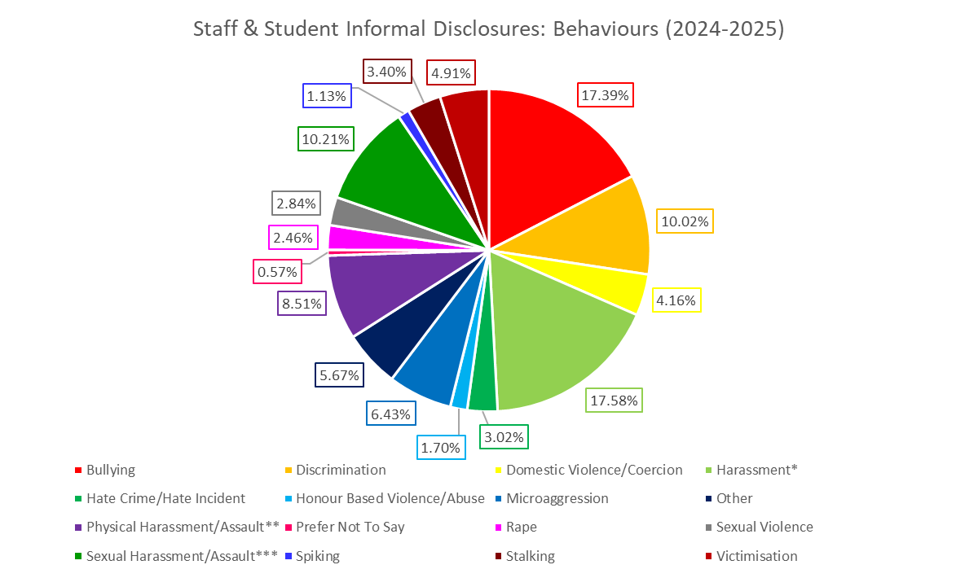
*Includes: ‘Harassment’ and ‘Verbal Harassment’.
**Includes: ‘Physical Harassment and Assault’, ‘Physical Assault’, and ‘Threatening Behaviour’.
***Includes: ‘Sexual Harassment and Assault’, ‘Sexual Harassment’ and ‘Sexual Assault’.

  - Discrimination and harassment continue to be the behaviours cited more often in formal staff and student cases. For formal staff cases, discrimination on the grounds of race was cited more often than any of the other protected equality characteristics, similar to previous years, other than 2023-24 when it was disability.
  - In 2024-25 there was a shift to sex being cited most as the grounds for student formal reports of harassment (Senate Reg 11 – behaviours between students) having previously been race. For student formal reports under Senate Reg 12, discrimination on the grounds of disability is cited significantly more than other grounds.
  - Of note, in 2024-25 there has been a marked increase in both informal and formal student disclosures, reports and complaints. This is not necessarily due to worsening behaviour or an increase in incidences, but potentially due to steps taken to raise awareness, improve policies and procedures and clearly set out the standard, which has potentially encouraged a greater level of, and confidence in, reporting.
  - For formal staff cases progressing to investigation and concluding, the proportion resulting in an outcome of ‘upheld’ or ‘partially upheld’ has increased from 17% in 2018-19 to 78% in 2024-25 Of note, during the last two years, 22% of staff engaging in a Dignity and Respect Contact meeting at the informal disclosure stage went on to make a formal complaint, indicating staff may be utilising the informal resolution options explored during the meetings rather than going on to make a formal complaint.
  - In 2024-25, 75% of formal student cases progressing to conclusion were found ‘in breach’ and resulted in sanctions.
  - For both informal and formal staff and student disclosures/cases, diversity demographics indicate women are more likely to disclose/report/make a complaint. Minoritised groups, in particular disabled staff and students, continue to be disproportionately represented as disclosers and reporters in informal and formal cases.

Figure 6: Staff and student formal disclosures: behaviours 2024-25
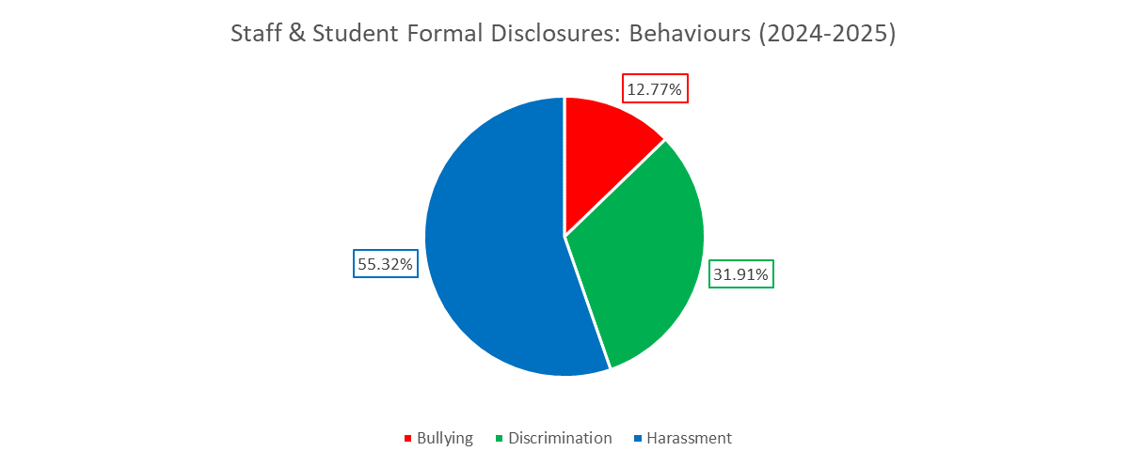

The Student and Education Equality, Diversity and Inclusion Team Activity and Achievements
  - The Student and Education Equality, Diversity and Inclusion team (SEEDI) is the focal coordinating point for EDI in relation to the student educational experience, with a particular emphasis on closing the awarding gap and satisfaction gap, and delivering our commitments to the Access and Participation Plan.
  - Our Access and Participation Plan (APP) 2025/26-2028/29 has been approved by the Office for Students (OfS) and the implementation, monitoring and evaluation of this plan is underway. Table 7.25 sets out our agreed APP targets for 2025/26-2028-29.

Table 7.25: Access and Participation Plan Targets 2025/26-2028/29

  - Throughout the year, SEEDI have worked on equity related projects and initiatives, all of which form part of our APP commitments. Key areas of work include:

- 10 students were recruited for the Curriculum Consultants programme for 2024/5 and 120 applications were received for the 2025/26 programme. The projects for 2024/25 included the following:
  - Biological Sciences: Diversify and decolonise curriculum in Biological Sciences to enhance students' experience and outcomes; working with students to identify prioritised actions and potentially implementing.
  - Clinical Sciences: Attain and act on student feedback regarding the structure and content of a Clinical Sciences BSc 3rd year module.
  - Digital & Learning Innovation Team: Investigate students' attitudes towards Generative AI in the Higher Education context, working towards developing resources.
  - Law: Produce resources to support students' transition into Law School and university.
  - Psychology: Review the challenges within a first-year module, which is perceived positively on reflection by third-year students, but does not have strong engagement from first-year students.
  - Psychology: Further developing a series of workshops to help students build their confidence in public speaking/presenting. This follows a previous Consultant project on the original workshop pilot.
- Institution-wide roll out of the Succeed at Leicester programme. This includes transition, Academic Induction and study skills elements. The team were awarding £32,000 external funding to complete a full evaluation of the programme in partnership with TASO and the National Institute of Economic and Social Research.
- Continued delivery of the Black Student Experience project. The team received £1500 funding to develop and deliver cultural competency training across the institution, and a Black Students Guide to Leicester in partnership with DMU.
- Delivery of evaluation workshops, 1-2-1 support and drop-in sessions for staff across the institution to ensure evaluation is embedded within all projects from the outset. These sessions equip colleagues with the tools to demonstrate the impact of their activities through richer evidence.
  - The ethnicity award gap and satisfaction gap represent two of the sector’s and our University’s most pressing education-related issues. In 2023/24, our awarding gap between Black and white students reduced by 1.3pp to 16.1pp.
  - In 2025, the positivity gap between Black students and White students has narrowed or closed across most sections of the NSS indicating further positive progress throughout. Notable improvements in Black positivity gaps include:
    - ‘Academic Support’, which has narrowed overall from –4.2 percentage points in NSS 2024 to -1.4 percentage points in NSS 2025.
    - The gap in the ‘Organisation and management’ question theme shifted further from +1.3 percentage points in 2024 to +2.0 in 2025, suggesting that Black students feel more positive than White students in this area.
    - The Black to White student positivity gap in the ‘Learning resources’ question theme almost closed, shifting from –2.5 percentage points in 2024 to –0.4 in 2025. our Minority Ethnic students also experienced pronounced gaps in several aspects of the National Students’ Survey (NSS) when compared to white domiciled students. These include questions relating to:
      - Teaching on my Course: -4.3% gap
      - Academic Support: -3.2% gap
      - Student Voice: -4% gap
  - During 2024/25, SEEDI met with all academic schools to develop, monitor and evaluate their Inclusion Action Plans. In 2025/26, the scope of these meetings and action plans are being widened to include student facing Professional Service teams alongside the academic schools. These meetings and action plans pick up the operational projects and planning which arise from the School’s Education meetings with the PVC Education. They will be used to support schools to reduce inequities in their student experience, and will be used as evidence towards our APP and TEF submissions.

Students’ Union EDI Activity and Achievements
  - The Students’ Union remains dedicated to celebrating Leicester’s diversity, particularly focusing this year on community building. This is done through a range of events, structural changes and campaigns.
  - Events:
- Black History Month
The Ethnic Equity Officer worked alongside the University to organise events throughout October, which included a talk with Dame Maggie Aderin-Pocock and the event Career Accelerator: Black Leadership Programme which offered students a space to discuss internships and relevant career opportunities.
- Trans Day of Remembrance
The Trans and Non-Binary Officer is in charge of organising a Trans Joy Event in February to celebrate trans-identities.
- International Day of Persons with disabilities
The Accessibility Officer organised a wide range of events, including a Sign Language workshop, a Disability Simulation event, and an Accessibility Campus Tour.
- International Arts and Culture Festival
The International Officer and Arts Officer collaborated on this event to celebrate student diversity through cultural stalls, international food and student group performances all day long.
- LGBTQ+ History Month
The LGBTQ+ Officer and Trans and Non-Binary Officer are working with a dedicated group of students selected to plan LGBTQ+ History Month in February. The group is focusing on making events relevant to queer students in Leicester specifically, but also widely relevant to sports, societies, and academics.
- Women’s History Month
The Women’s Officer is planning this month with a group of students and the SU’s councils.
  - Major Campaigns:
- Red Flags Campaign
The SU’s Safety on Campus Working Group has planned and will Launch at the end of January its Red Flags Campaign, aimed at raising awareness of unacceptable behaviours that can lead to sexual violence and abuse.
- Liberation Council Blue Booklet
The Liberation Council is working on its version of a ‘Blue Booklet’ which assesses the accessibility and sensory experience of every room on campus. This will also include information such as the location of gender-neutral toilets or baby changing stations.
- Uniting Leicester
This new group aims to involve the SU into the University’s status as a University of Sanctuary. Consisting of SU staff, University Staff and students, it is looking to campaign and make students from everywhere feel like they belong here.
  - Restructure:
- Governance: This academic year, the SU no longer has a full-time Liberation Officer. Instead, there is a full time Communities Officer and five liberation part-time officers are in charge of different specific areas (Ethnic Equity, LGBTQ+, Trans and Non-Binary, Accessibility, and Women). This allows for better, more-accurate representation work and a stronger sense of community.
- Liberation Council: This Council enables regular discussions between the Communities Officer, the liberation PTOs and selected students. This supports the SU’s work around liberation and encourages change.

8. Annual Report Summary of Progress and Impact
  - As this report sets out, the University has continued to make significant progress in advancing equity and inclusion over the last 12 months, bringing benefit to marginalised and minoritised student and staff groups, and to the full university community.
  - We have further developed the University’s EDI strategic and operational infrastructure, to ensure that the right tools and framework are in place to support our ambitious commitments to EDI, especially in a content in which the University has enhanced freedom of speech and academic freedom duties.
  - The University is seeing both a continued diversification of our student and staff populations and a continued increase in sharing rates for staff diversity data, which is helping ensure that we have an accurate picture of our community to inform targeted actions and interventions, where needed.
  - The EDI Team continue to offer an advisory service to support the University and are increasingly focussed on supporting the building of staff competency in EDI, which in turn supports the development of mature EDI capability at an organisational level.
  - We continue to help to foster a fair and inclusive culture, by providing resources to equip staff and managers with the skills and confidence to embed inclusion and equity in their everyday practice, including through the development of toolkits, training and guides.
  - The University is well positioned to drive forward equity and inclusion activity, we are currently 1 of only 9 universities that hold a Silver (or higher) Institutional Athena Swan Award, a Bronze (or higher) Race Equality Charter Award, and a Disability Confident Level 3 (Leader) Award.
  - As a university, we continue to celebrate and commemorate the contribution and experiences of our diverse community, including on International Day of Disabled People, International Women’s Day, Black History Month, Pride, LGBT+ History Month, Holocaust Memorial Day and Trans Day of Remembrance. This, in turn, enhances understanding and fosters good relations across our university community.
  - Whilst there is much more still to do, we are confident that we are well positioned, both strategically and operationally, to continue to advance equity and inclusion in all key areas and enable the University to deliver on its stretching EDI commitments and aspirations, whilst also remaining agile, given the changing world and legislative context that frames EDI.

Author:
Angie Pears, Director of Equity, Diversity and Inclusion

Contributors:
Cléophée Cornou, Students’ Union Communities Officer
Hannah Grosvenor, Student and Education Equality, Diversity and Inclusion Manager and Interim Head of AccessAbility

March 2026

Appendices

Appendix A: University of Leicester Student and Staff Diversity Data
Appendix B: University of Leicester Pay Gaps Report 2025

Appendix A

University of Leicester Staff and Student Diversity Data

Staff and Student Diversity Data

Age

Students: Table 1.1 All UoL students by age group, 2020/21 to 2024/25

Staff: Table 1.2 All UoL Staff by age group 2022 to 2026

Students: Graph 1.1 All UoL students by age group, 2020/21 to 2024/25
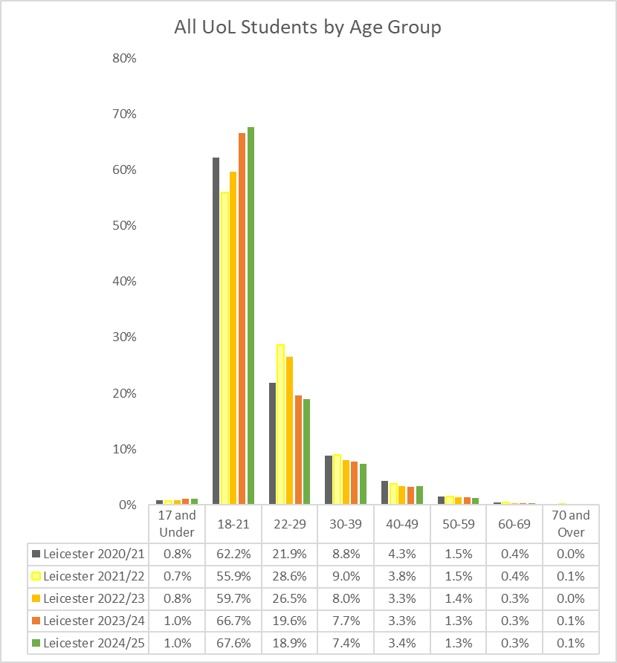
Staff: Graph 1.2 All UoL staff by age group 2021 to 2026
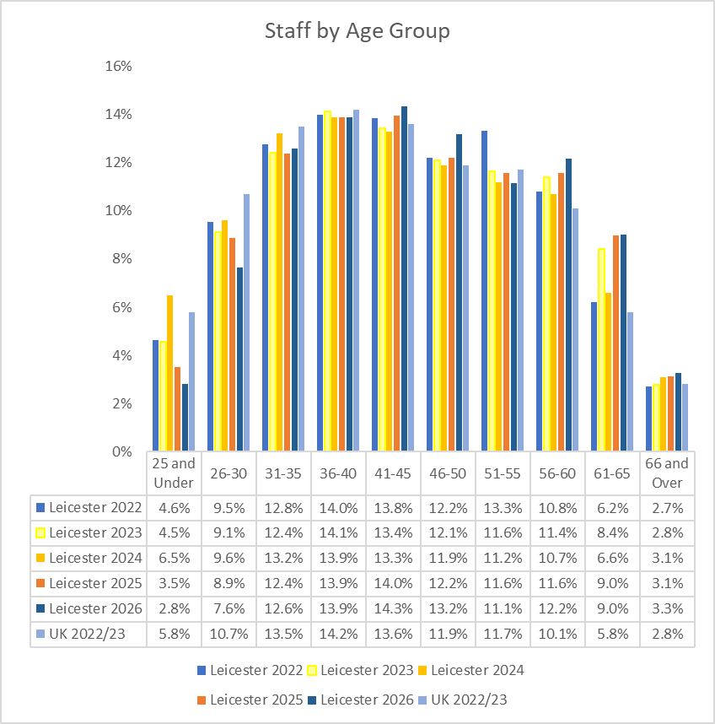

Disability

Students: Table 2.1 All UoL students by disability, 2020/21 to 2024/25

Staff: Table 2.2 UoL staff by declared disability 2022 to 2026

Students: Graph 2.1 All UoL students by disability, 2020/21 to 2024/25
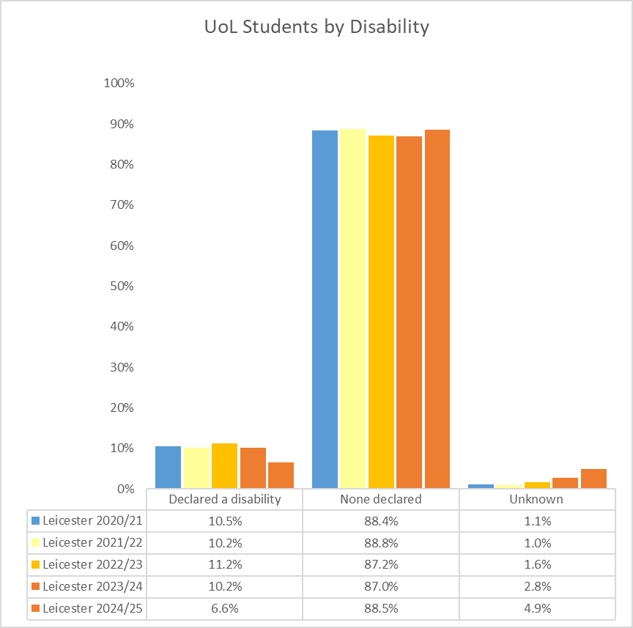

Staff: Graph 2.2 UoL staff by declared disability 2022 to 2026
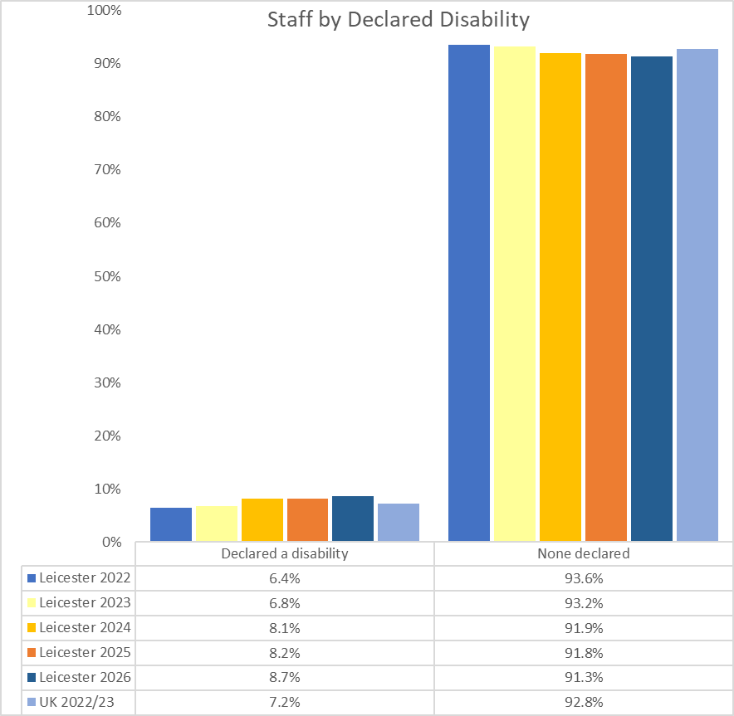

Ethnicity

Students: Table 3.1 All UoL students by ethnicity (minority ethnic, white and not declared) 2020/21 to 2024/25

Staff: Table 3.2 UoL staff by ethnicity – grouped 2022 to 2026

Students: Graph 3.1 All UoL students by ethnicity (minority ethnic, white and not declared) 2020/21 to 2024/25

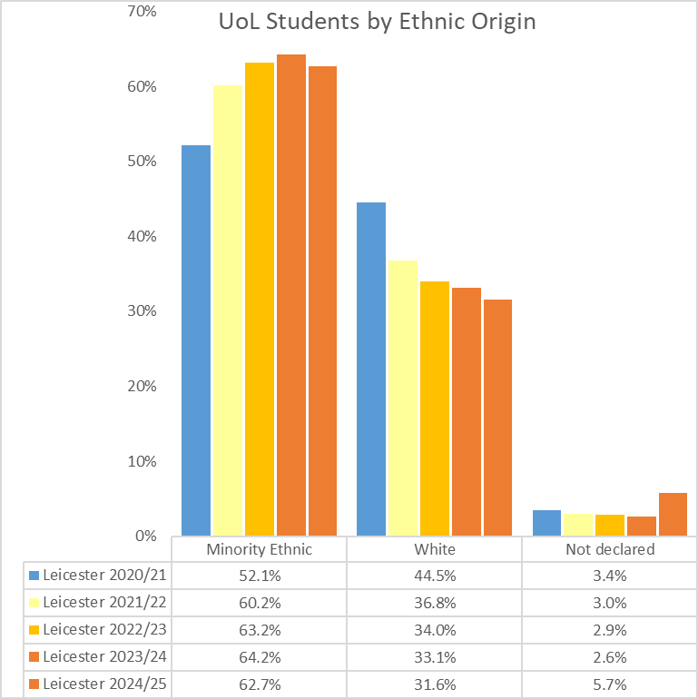

Staff: Graph 3.2 UoL staff by ethnicity – grouped 2022 to 2026
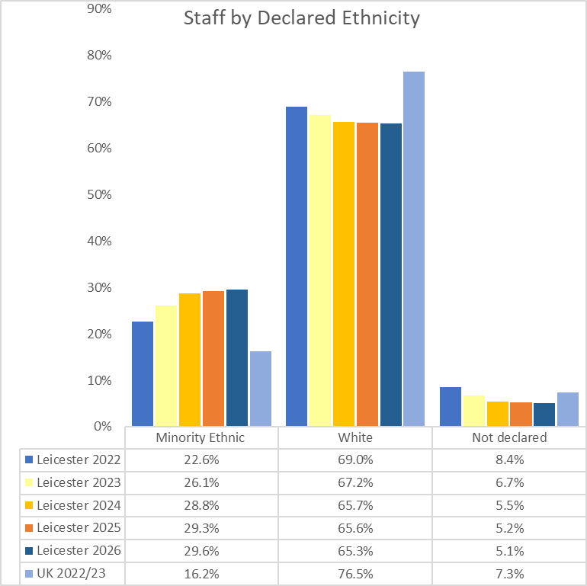
Students: Table 3.3 Breakdown of UoL Students by ethnicity 2020/21 to 2024/25

Staff: Table 3.4 UoL staff by ethnicity 2022 to 2026

Students: Graph 3.3 Breakdown of UoL Students by ethnicity 2020/21 to 2024/25

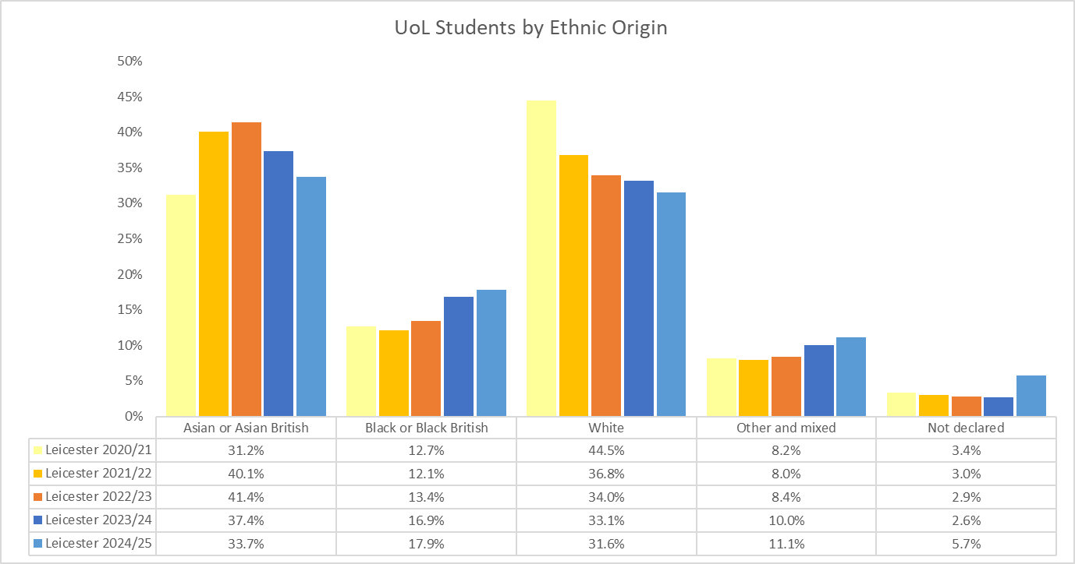

Staff: Graph 3.4 UoL staff by ethnicity 2022 to 2026
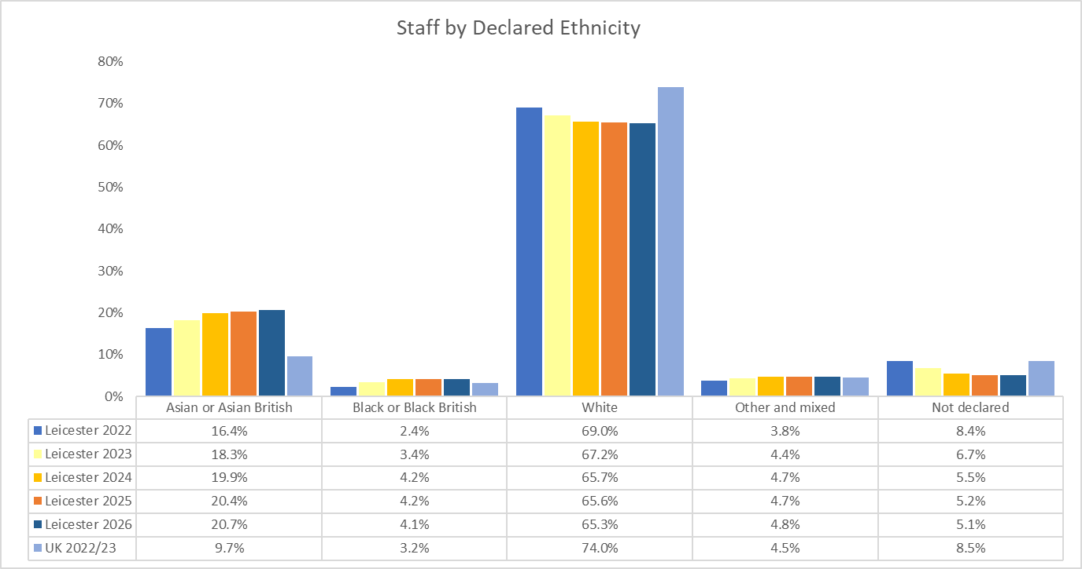

Students: Table 3.5 Detailed ethnicity breakdown of UoL Students who identify as Minority Ethnic 2020/21 to 2024/25

Students: Table 3.6 Breakdown of UK Domiciled UoL Students by ethnicity 2020/21 to 2024/25

Students: Table 3.7 Breakdown of International UoL Students by ethnicity 2020/21 to 2024/25

Students: Graph 3.5 Breakdown of UK Domiciled UoL Students by ethnicity 2020/21 to 2024/25
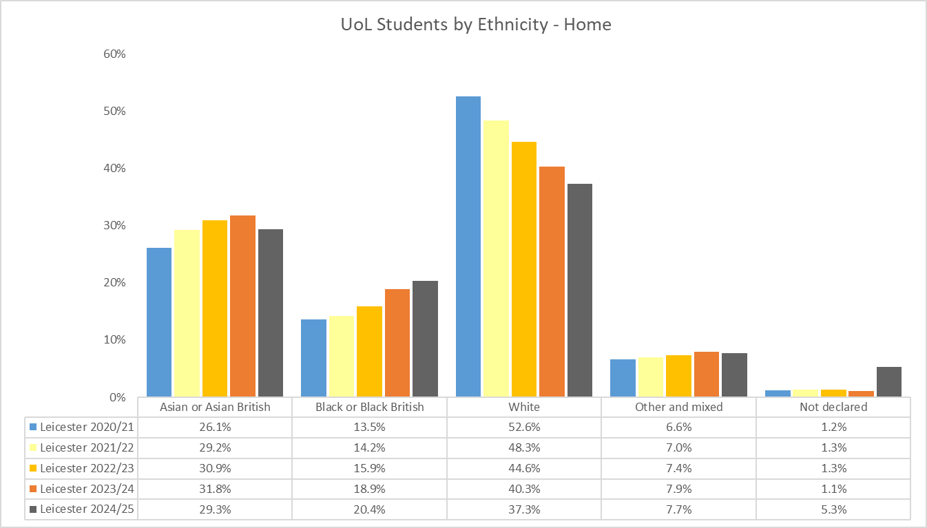

Students: Graph 3.6 Breakdown of International UoL Students by ethnicity 2020/21 to 2024/25
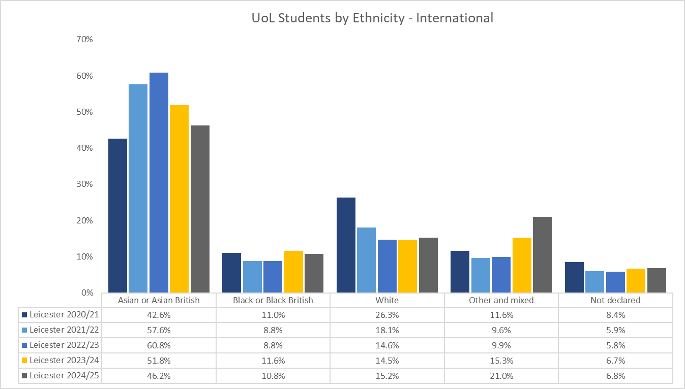

Students: Table 3.8 Detailed ethnicity breakdown of UK Domiciled UoL Students who identify as Minority Ethnic 2020/21 to 2024/25

Students: Table 3.9 Detailed ethnicity breakdown of International UoL Students who identify as Minority Ethnic 2020/21 to 2024/25

Religion or Belief

Students: Table 4.1 All UoL students by religion or belief, 2020/21 to 2024/25

Staff: Table 4.2 UoL staff by religion or belief 2022 to 2026

Students: Graph 4.1 All UoL students by religion or belief, 2020/21 to 2024/25

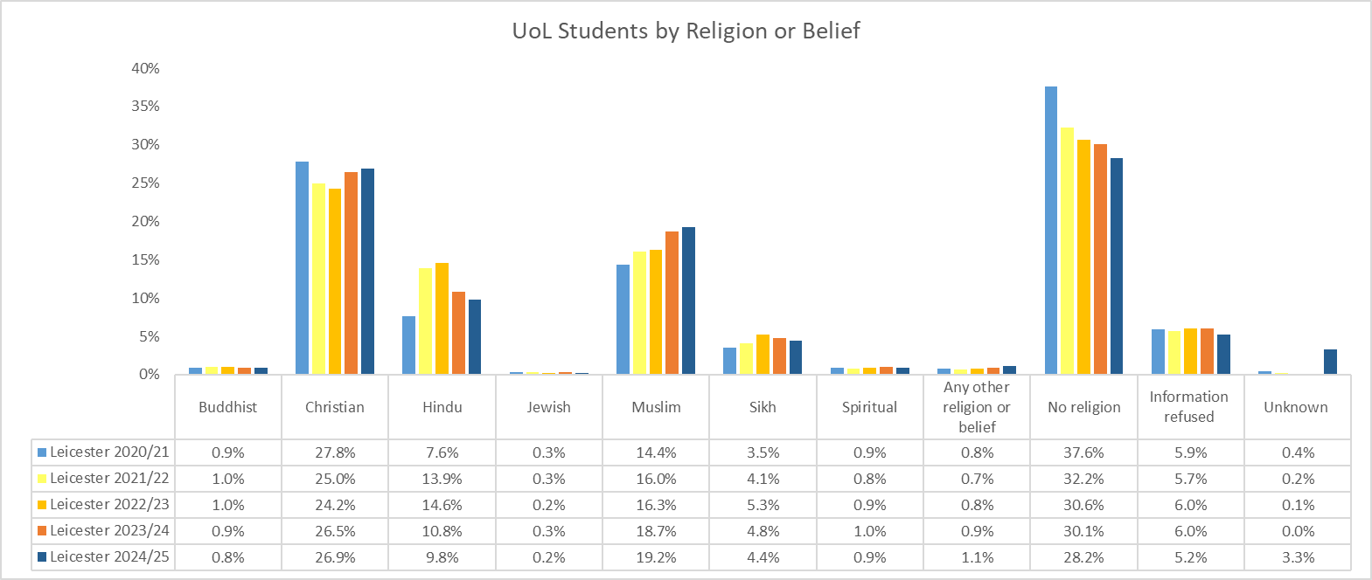

Staff: Graph 4.2 UoL staff by religion or belief 2022 to 2026

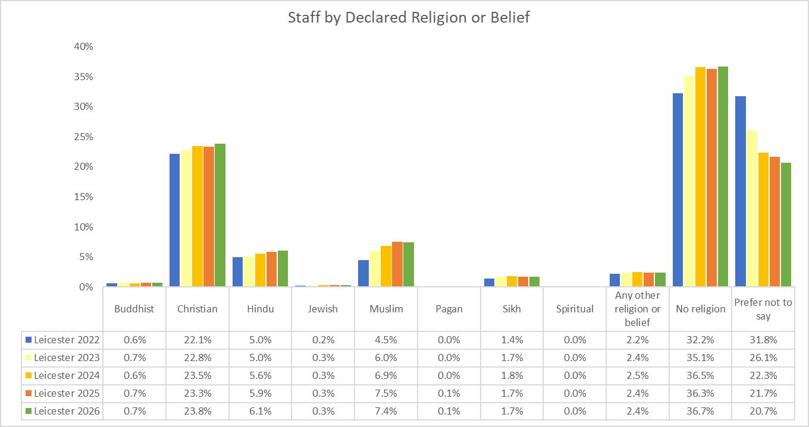

Sex

Students: Table 5.1 All UoL students by sex, 2020/21 to 2024/25

Staff: Table 5.2 UoL staff by Sex 2022 to 2026

Students: Graph 5.1 All UoL students by sex, 2020/21 to 2024/25

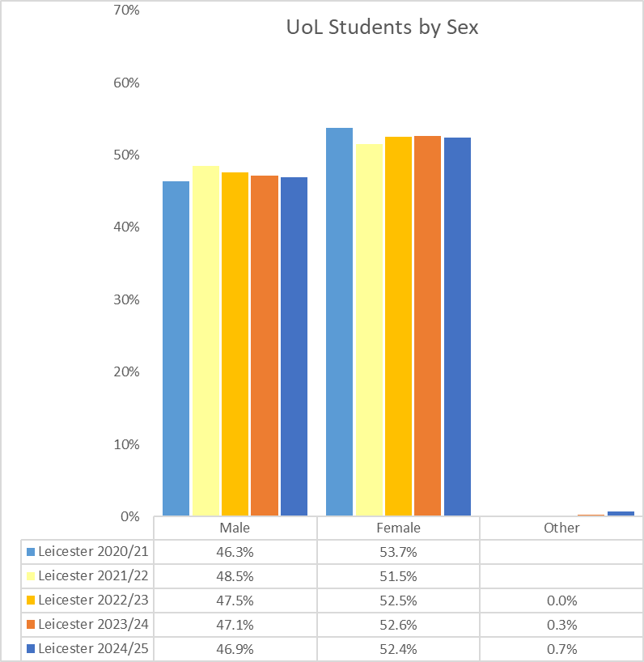

Staff: Graph 5.2 UoL staff by Sex 2022 to 2026
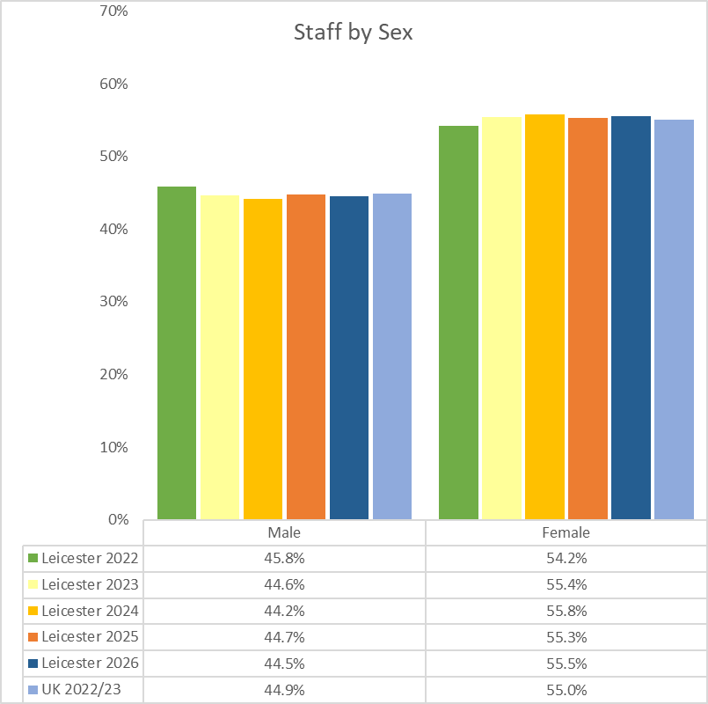

Gender Identity

Student: Table 6.1 UoL students by gender identity 2023/24 to 2024/25

Staff: Table 6.2 UoL staff by gender identity 2024 to 2026

Student: Graph 6.1 All UoL students by gender identity, 2023/24 to 2024/25

Staff: Graph 6.2 UoL staff by gender identity 2024 to 2026
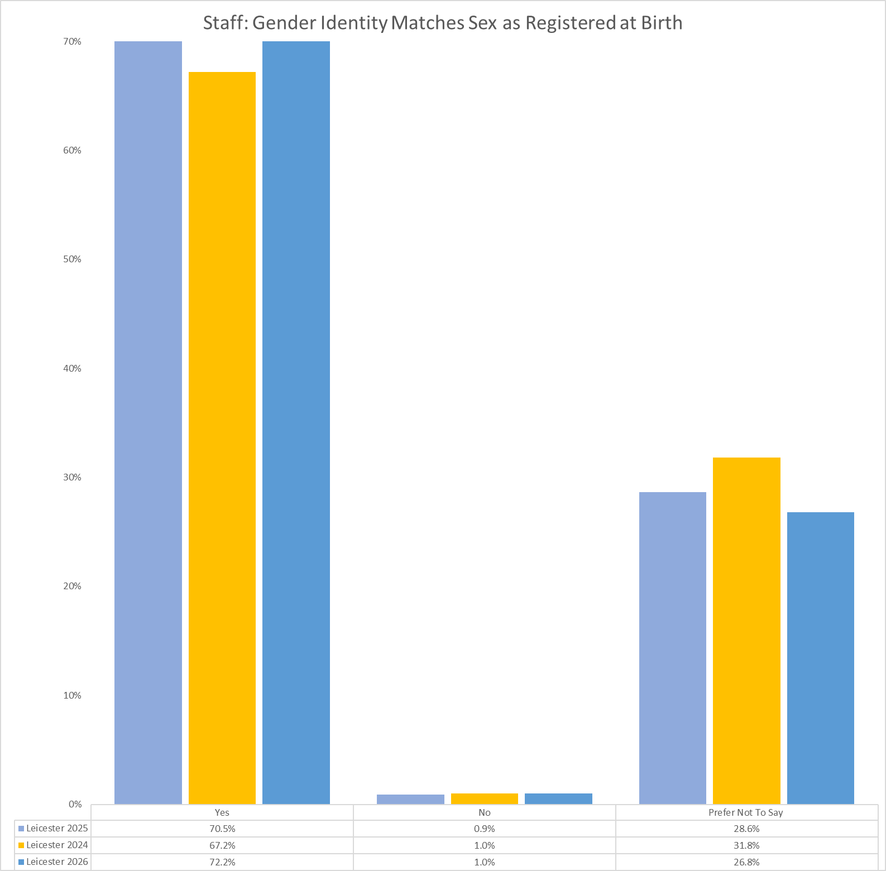

Sexual Orientation

Students: Table 7.1 All UoL students by sexual orientation, 2020/21 to 2024/25

Staff: Table 7.2 UoL staff by grouped sexual orientation 2022 to 2026

Students: Graph 7.1 All UoL students by sexual orientation, 2020/21 to 2024/25

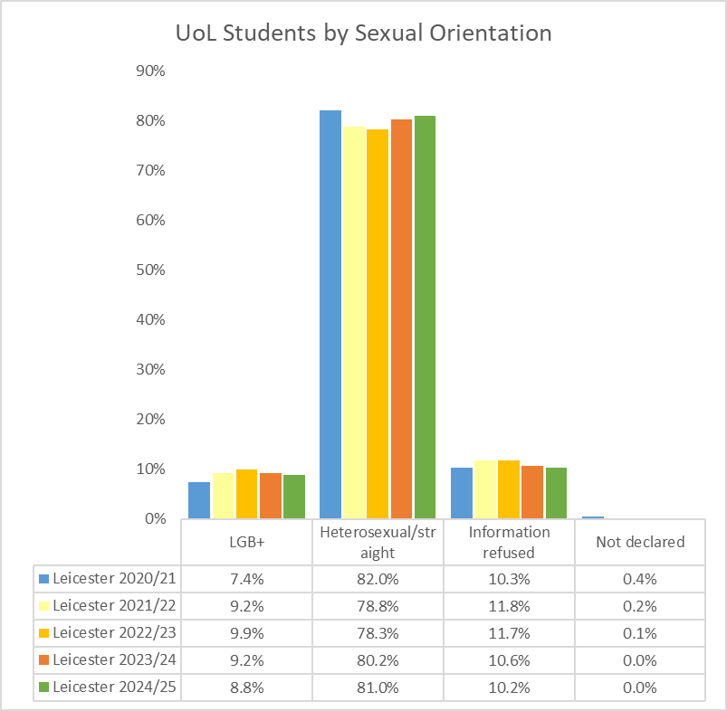

Staff: Graph 7.2 UoL staff by grouped sexual orientation 2022 to 2026

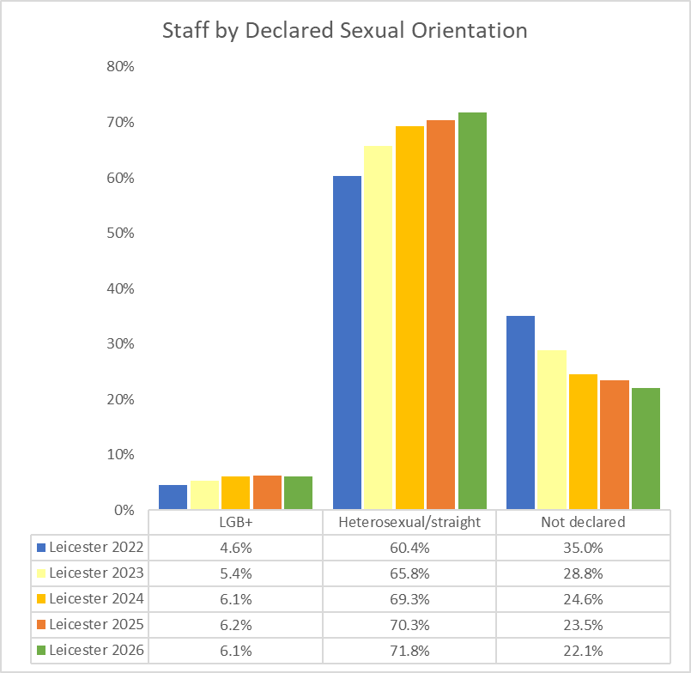

Appendix B

University of Leicester Pay Gaps Report 2025

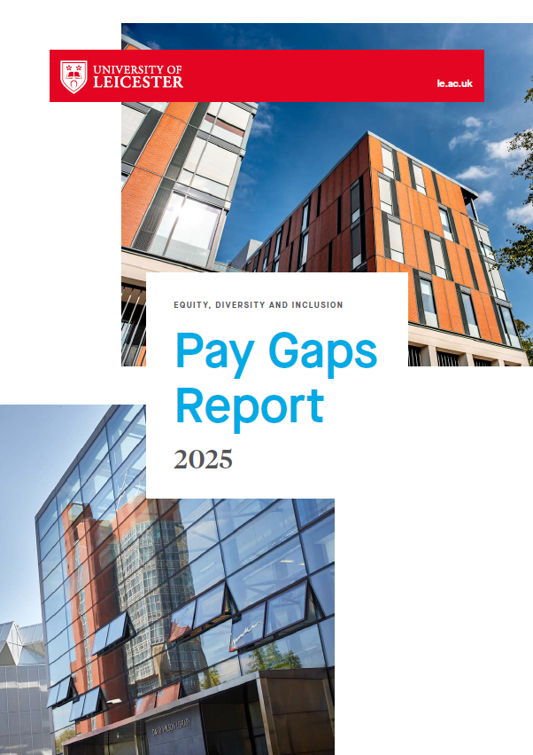

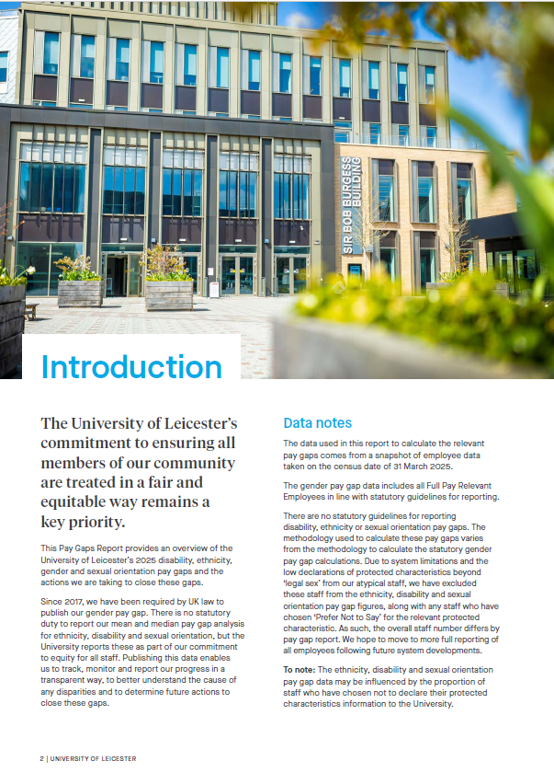

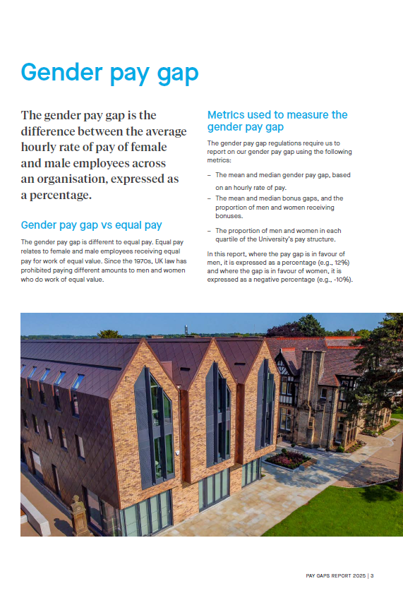
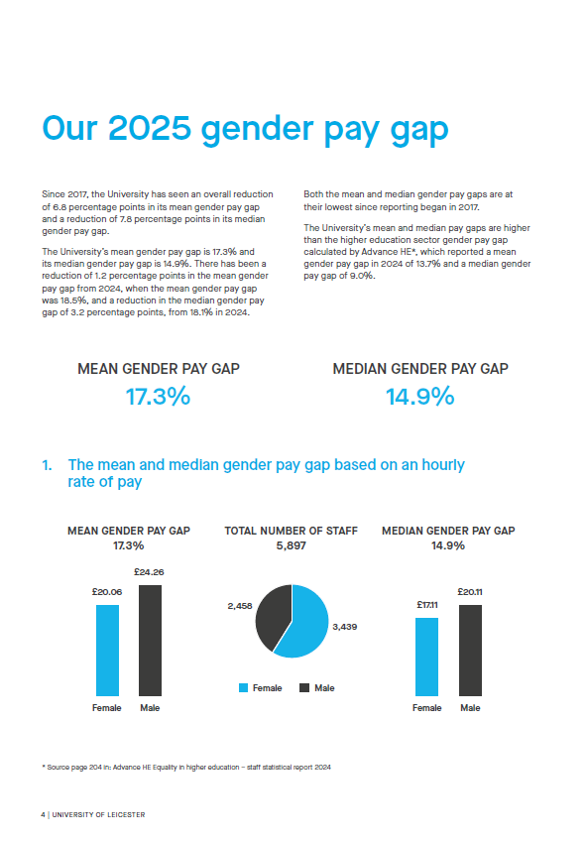

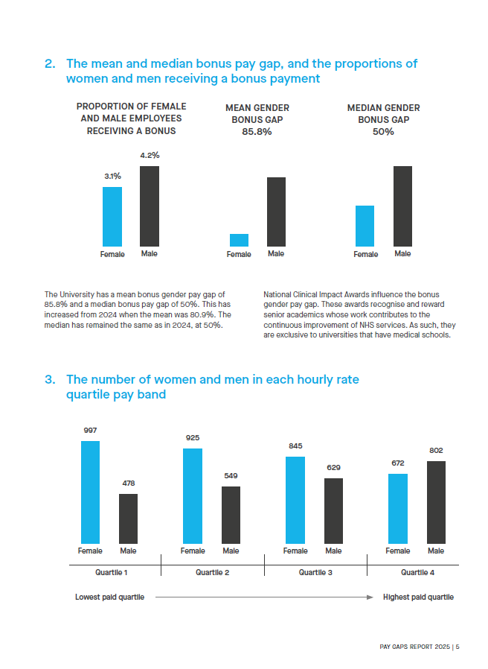

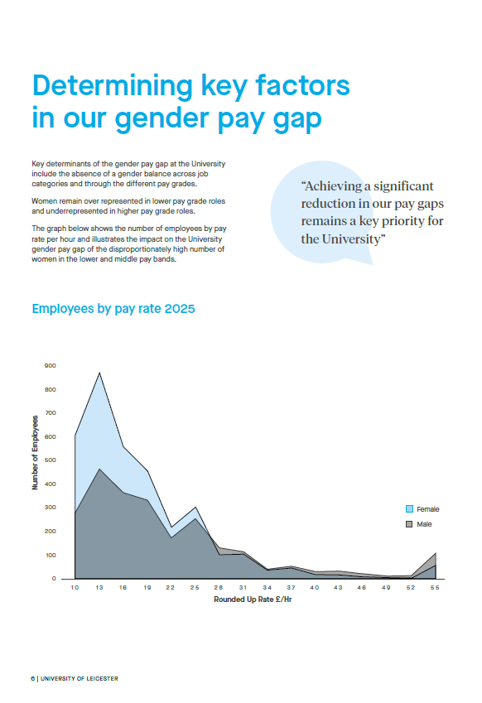

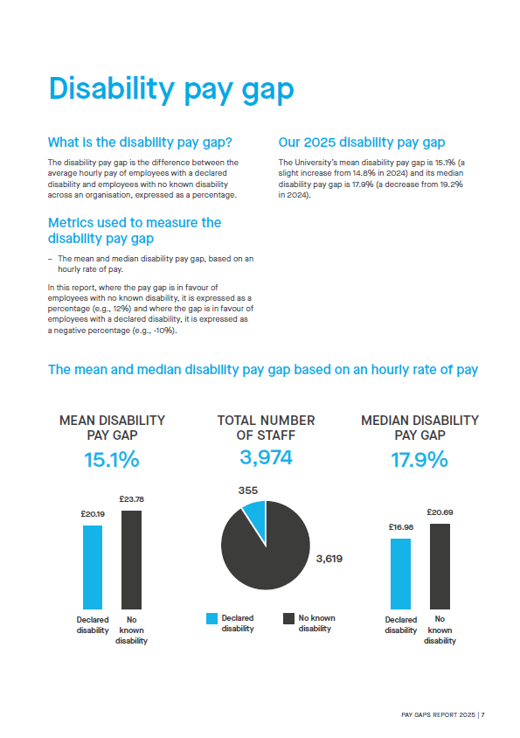

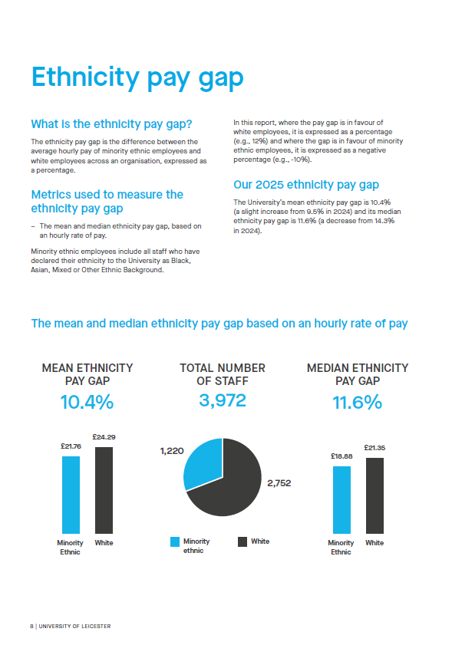

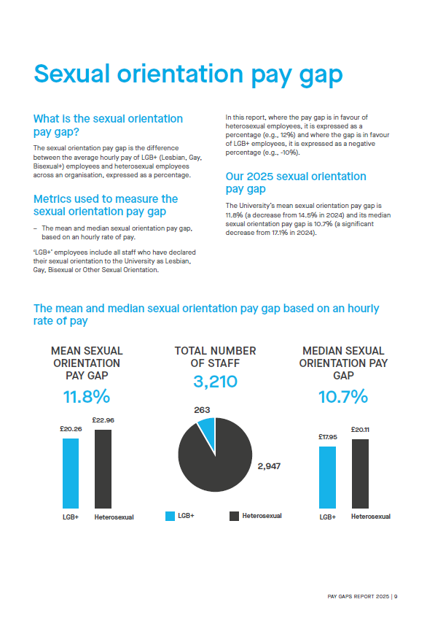

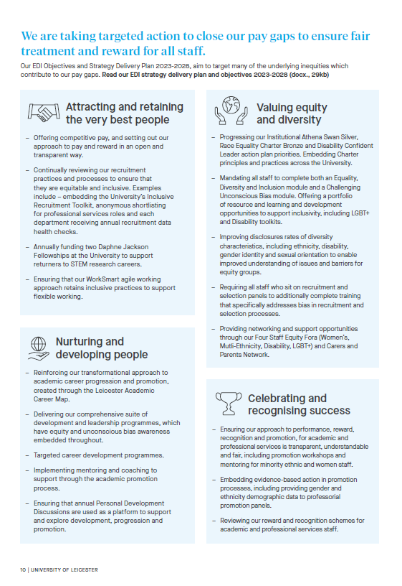

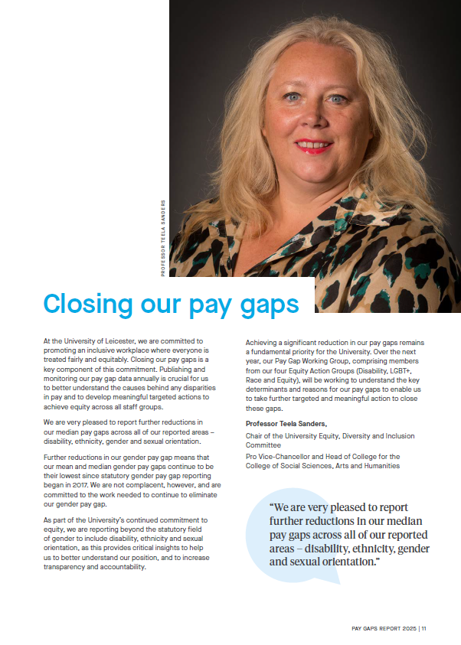

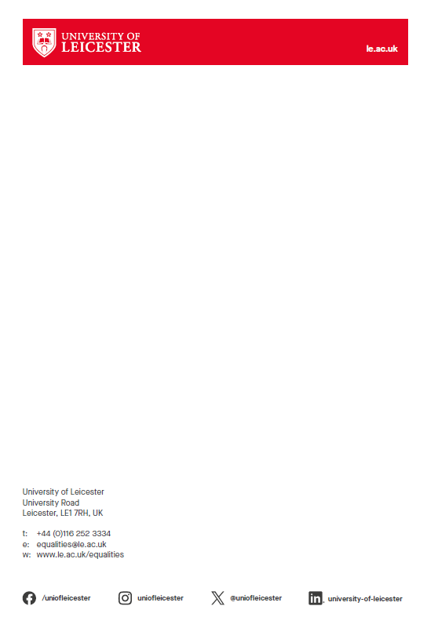

All information provided by the Student and Education EDI Team
All information provided by the SU Communities Officer

