

Equity, Diversity and Inclusion
Annual Report

January 2025

UNIVERSITY OF LEICESTER
Equity, Diversity and Inclusion Annual Report
January 2025

Executive Summary

As is detailed throughout this Annual Report, progress and impact in advancing equity and inclusion at the University of Leicester have continued over the last 12 months and further strengthened the strategic and operational infrastructure in place to support the University’s ambitious EDI aspirations and commitments.

Key findings of the Report

Diversity: The University continues to see increased diversity of both students and staff across the categories of ethnicity and religion or belief and, for staff, also across the categories of disability and sexual orientation. 64.2% of our student population are minority ethnic and 29.3% of staff, these are both substantially higher than for the wider sector. For staff, this represents a very significant increase from 2021, when the proportion of minority ethnic staff was 20.0%.

The percentage of minority ethnic and female staff in some key staff groups continues to increase, including the female professor, minority ethnic academic staff and female academic staff groups. In 2024, there was, however, continued decrease in the number of minority ethnic professors, Grade 10 professional services minority ethnic and Grade 10 female staff.

Diversity Data Disclosure: We continue to make good progress in reducing staff diversity data non-disclosure rates to enable intelligence-led service provision, resource allocation and policy, process and practice development. For example, the number of UoL staff disclosing their ethnicity has continued to increase over the last five years, with the proportion of ‘not declared’ reducing from 10.0% in 2021 to 5.2%. This is 2.1% lower than the UK HEI figure in 2022/23 (7.3%).

Benchmarking Progress: The University’s sector standing in terms of charter awards is very strong, enhanced by our successful 2024 submissions, making us currently 1 of only 5 universities that hold a Silver (or higher) Institutional Athena Swan Award, a Bronze (or higher) Race Equality Charter Award, and a Disability Confident Level 3 (Leader) Award. The University also holds 8 Departmental Athena Swan awards, including a Silver College award by the College of Life Sciences, with 2 further departmental submissions due in 2025. There is a 5-year submission programme in place, which will see all schools currently without an Athena Swan award complete a submission ahead of the next REF exercise.

Disability Equity and Inclusion: The University’s work to advance disability equity and inclusion was recognised in 2024 by the award of Disability Confident Leader, the highest award in the government scheme. Identified exemplary best practice as part of the submission review included, mandating Disability Confidence for Managers Training, the provision of a Staff Disability Advisor post, the development of new policies including Disability Leave and Assistance Animals on Campus.

Gender Equity and Inclusion: In terms of gender equity and inclusion, our Athena Swan Institutional Silver Action Plan developed as part of our charter submission in 2024, commits us to continuing to drive forward progress in this area, with priority action areas in relation to representation, addressing gender based / sexual violence and ensuring fairness and transparency in workload.

LGBT+ Equity and Inclusion: Our work to advance LGBT+ equity and inclusion over the last 12 months has seen a focus on trans and non-binary voice and visibility, with the delivery of very well attended and received training to staff by the trans led organisation Gendered Intelligence.

Race Equity and Inclusion: We have continued to drive forward progress on our Race Equality Charter Action Plan over the last 12 months. Of the 77 actions, 45 are now complete, 28 are in progress and 4 not yet progressed. The University collaborated with John Lewis, Highcross to celebrate Black History Month and this collaboration won the ‘Special Events Award’ at the Pukaar Awards.

Equity Pay Gaps: Our expansion of pay gap reporting now includes disaggregated pay gap data for disability, ethnicity, gender and sexual orientation, by function (academic/professional services), by grade groupings and an intersectional pay gap (ethnicity and gender). In terms of progress to close the pay gaps, the mean gender pay gap continues to close slowly, seeing a reduction of 0.7 percentage points (pp) to 18.5%. The mean ethnicity pay gap also reduced by 2.5pp (to 9.5%). The disability mean pay gap increased by 5.6pp (to 14.8%) and the sexual orientation by 2.1pp (to 14.5%).

Organisational Embedding of EDI: We continue to deliver a range of initiatives and projects to make progress on developing our infrastructure and resource base to further embed EDI good practice and principles across the working life of the University, with a focus on building organisational EDI capability to underpin our commitment to advancing equity and inclusion. Over the last 12 months:

- 2 new toolkits were developed and launched, on Dignity and Respect and on Inclusion, with a range of resources for staff to embed principles of dignity and respect and equity and inclusion into everyday practices and services.
- A new Equity, Diversity and Inclusion Policy was developed and will be launched in early 2025, setting out the University’s commitments to EDI.
- Equality analysis is being embedded into university activities, policies and practices to proactively consider the impact on protected equity groups, further embedding in some areas is necessary.
- Our first Staff EDI Development Week (3-13 September) and tailored Estates and Campus Services sessions (November/December) ran, with sessions on Ways to Challenge Unacceptable Behaviour, An Introduction to Systemic Racial Disparities in HE, Inclusive Practice, LGBT+ Allyship and Disability Confidence for Managers. These were attended by 299 staff.

Staff and Student EDI Related Cases: The significant increase in both student and staff informal disclosures of unacceptable behaviour seen in 2023, continued in 2024. For formal staff cases progressing to investigation and concluding, the proportion resulting in an outcome of ‘upheld’ or ‘partially upheld’ has increased from 17% in 2018-19 to 56% in 2023-24, slightly down from 2022-23.

Freedom of Speech and Protest Activity on Campus: A revised Code of Practice Concerning Freedom of Speech and Academic Freedom has been developed, in line with the requirements of the Higher Education (Freedom of Speech) Act 2023. Over the last 12 months, the University has continued to see a high level of on campus activity in relation to the Palestinian and Israeli conflict. Five organised protest/rallies with speakers and 12 targeted protests in response to events, including University open days, offer holder days, matriculation, alumni dinner, careers events, sits-ins and a number of building occupations, have taken place.

Diverse Community Events: The University continued to celebrate and commemorate a range of key diverse community events over the last 12 months, including: Black History Month, International Day of Disabled People, World AIDS Day, Holocaust Memorial Day, LGBT+ History Month, International Women's Day, Transgender Day of Remembrance, Leicester Pride.

SEEDI: The University’s Access and Participation Plan 2025/26-2028/29 has been approved by the Office for Students. Planning for the implementation, monitoring and evaluation of this plan is now underway.

Students’ Union: The Liberation Council was established in September 2024 and initiatives such as InclusiShield Project and Bridging the Gap Listening Event continue the work of the SU to drive forward equity and inclusion.

Introduction
  - This Equity, Diversity and Inclusion Annual Report 2025, details the Equity, Diversity and Inclusion (EDI) Team led activity to advance equity and inclusivity at the University since the last report in January 2024.
1.2 It details progress across all key equity areas, including in relation to the objectives and priorities identified by the University’s Equity Action Groups, in line with our Public Sector Equality Duty.
1.3 The Report is organised into the following sections:

Section 1 | Introduction
Section 2 | Student and Staff 5-year Diversity Profile
Section 3 | Advancing Equity and Inclusivity in Key Areas
Section 4 | University of Leicester Equity Pay Gaps
Section 5 | Organisational Embedding of Equity, Diversity and Inclusion
Section 6 | Student and Education Equality, Diversity and Inclusion Team Activity and Achievements
Section 7 | Students’ Union EDI Activity and Achievements
Section 8 | Summary of Progress and Impact

1.4 As is detailed throughout the Report, strong progress and impact in advancing equity and inclusion at the University of Leicester has continued over the last 12 months. This has further developed and strengthened the strategic and operational infrastructure in place to support the University’s ambitious EDI aspirations and commitments.
  - The Report includes the full student and staff diversity demographic, including benchmark data, where relevant, over the last 5 years.
  - It also includes information about the EDI achievements and activity from both the Student and Education EDI Team and the Students’ Union.
  - Other EDI related expertise and activity take place across the University but are not included in this report as they are reported elsewhere. This includes the work of central Student Support Services, where EDI is embedded into service delivery (and includes the Standing Together Team and AccessAbility Service). In addition, embedded EDI activity takes place at College, Division and School/Department level, including as part of the University’s EDI governance structure.
  - The Report details the University’s Pay Gap Report for 2024 (published March 2025) and includes, for the second year, the University’s disability, ethnicity, and sexual orientation pay gaps, as well as the gender pay gap, along with details of initiatives and actions and being taken to reduce these gaps.
  - Continued strong partnership working, including with the Students’ Union, the Staff Equity Fora, Academic and Professional Services teams and other key stakeholders across the University, remain vital to the work of the EDI Team and to progressing equity and inclusivity at the University of Leicester.

Student and Staff 5-Year Diversity Demographic Profile
2.1 This section provides an overview of the diversity demographic of students and staff at the University over the last 5 years.
  - The data tables and graphs for both students and staff by equality characteristic are included in Appendix A to accompany the following narrative (see Tables 1.1-7.2 and Graphs 1.1-7.2).
  - The student population data covers the academic years 2019/20 to 2023/2024. The data includes all UG, PGT and PGR students, excluding students that are suspended, dormant or withdrawn on 1st December 2023. Dalian students studying at Dalian (China) for all 4 years of their course have been excluded.
  - The staff data provided is based on a snapshot of data captured annually on 1st January (2025, 2024, 2023, 2022, and 2021).
  - Percentages provided in the report have been rounded to one decimal place.
  - Please note that where figures are given for the UK, these are for UK HEI’s (Higher Education Institutions) for the Academic Year 2022/23 which are the latest available from Heidi Plus (HESA UK HEI figures).
  - To view further national data please see Advance HE’s 2024 statistical report on staff in higher education. Advance HE have reported that due to a delay in receiving HESA’s 2022/23 student record, they are unable to publish the 2024 Statistical Report on Students in Higher Education, for this report the previous figures from the 2023 Report have been used in place of the missing data. To see complete data from 2021/22, please see Advance HE’s 2023 statistical report on students in Higher Education.

All tables and graphs referenced in Sections 2.8 – 2.66 can be found in Appendix 1.

Age Profile of Students
  - In the academic year 2023/24, 67.7% of the UoL student population were classified as ≤21, an increase of 6.5 percentage points from 2022/23. This remains above the national picture in the sector for 2021/22, in which 47.3% of students studying in UK higher education were classified as ≤21 (Advance HE, 2023 Report).
  - Since 2019/20, the proportion of UoL student’s ≤21 has fluctuated each year, the vast majority of students at UoL are in the 18-21 age group (Table 1.1, Graph 1.1).

Age Profile of Staff
  - In 2025, UoL has seen a slight increase in staff aged 30 and under, from 16.1% in 2024 (Table 1.1, Graph 1.1) to 16.5% in 2025.
  - The proportion of staff aged 66 and over remained the same as 2024, at 3.1%, following three years of increase in the size of this staff group. It continues to be the lowest proportion of the overall staff body at UoL. This is in line with the national picture for UK HEIs in 2022/23 (Table 1.2).

Disability Profile of Students
  - In 2023/24, 10.2% of UoL’s students declared a disability, this is a decrease of 1.1% from 11.3% in 2022/23 (see Table 2.1, Graph 2.1), this is also lower than the national picture.
  - The proportion of students whose disability status is ‘unknown’ increased by 1.2 percentage points, from 1.6% in 2022/23 to 2.8% in 2023/24.

Disability Profile of Staff
  - Disability disclosure rates among staff working in UK HEI’s have continued to increase over the last decade. In 2022/23, 7.2% of staff working in UK HEI’s declared a disability.
  - The proportion of UoL staff declaring a disability in 2025 has increased by 0.1 percentage point, from 8.1% in 2024 to 8.2% in 2025,1 .0% higher than the national picture (Table 2.2, Graph 2.2).

Ethnicity Profile of Students
  - Since 2019/20, there has been considerable growth (11.4 percentage points) in the proportion of UoL students who identify as minority ethnic (Table 3.1, Graph 3.1). In 2023/24, 64.2% of UoL students identified as minority ethnic, a substantial increase from 52.8% in 2019/20 and an increase from 63.2% in 2022/23.
  - Each academic year has seen a slight decrease in the proportion of UoL students who have not declared their ethnicity (from 3.5% in 2019/20 to 2.6% in 2023/24).
  - In 2023/24, the majority of UoL students identified as either Asian or Asian British (37.4%) or White (33.1%) (Table 3.3).
  - Since 2022/23, the proportion of Asian or Asian British UoL students has decreased by 4.0 percentage points to 37.4% in 2023/24, from 41.4% in 2022/23 (Table 3.3, Graph 3.3).
  - Of the total UoL minority ethnic students in 2023/24, the largest ethnic group were Indian, at 30.9%. This is a decrease of 8.2 percentage points, from 39.1% in 2022/23 (Table 3.5).
  - 16.9% of all UoL students in 2023/24 identified as Black or Black British, a significant increase from 13.4% in 2022/23 (Table 3.3). Of these students, most identified as being from a Black African background (22.1%) (Table 3.5). Black Caribbean students continue to be less represented, constituting 2.8% of minority ethnic students overall at UoL in 2023/24, which is an increase from 2.4% in 2022/23 (Table 3.5).
  - Nationally, in 2021/22, 42.9% of minority ethnic UK domiciled students were Asian, of which the majority were Pakistani (14.1%) and Indian (13.0%). 6.9% of minority ethnic students were Bangladeshi and 8.8% were from other Asian backgrounds. 29.6% were Black, most of whom were from a Black African background (22.8% of total minority ethnic UK domiciled students). Black Caribbean students were much less represented and constituted 5.3% of minority ethnic UK domiciled students overall. 16.7% of minority ethnic UK domiciled students were from a mixed background, 2.9% were Chinese, and 4.6% identified as other ethnic background (Advance HE, 2023 Report).
  - Since 2019/20, we have seen considerable growth (increase of 14.9 percentage points) in the proportion of UK-domiciled UoL students who identified as minority ethnic (Table 3.6). In 2023/24, 58.6% of all UK-domiciled UoL students identified as minority ethnic, a substantial increase from 43.7% in 2019/20.
  - In 2021/22, 27.0% of the UK domiciled student population identified as minority ethnic (Advance HE, 2023 Report). UoL continues to have a significantly higher proportion of minority ethnic students than the sector average.
  - In 2023/24, there has been a slight decrease in the proportion of UK-domiciled UoL students who have not declared their ethnicity (from 1.3% in 2019/20 to 1.1% in 2023/24).
  - Since 2019/20, there has been a steady consistent increase (12.2 percentage points) in the proportion of international UoL students who identified as minority ethnic (Table 3.7). In 2023/24, 78.7% of all international UoL students identified as minority ethnic, a substantial increase from 67.4% 2019/20.
  - In 2023/24, 40.3% of UK domiciled UoL students identified as White, and 31.8% as Asian or Asian British (Table 3.6).
  - Since 2022/23, the proportion of Asian or Asian British UK domiciled UoL students has increased by 0.9 percentage points to 31.8% in 2023/24 from 30.9% in 2022/23 (Table 3.6).
  - Of the total UK domiciled UoL minority ethnic students in 2023/24, the largest group, at 28.6%, were Indian. This is a decrease from 30.4% in 2022/23 (Table 3.8).
  - 18.9% of all UK domiciled UoL students in 2023/24, identified as Black or Black British, an increase from 15.9% in 2022/23 (Table 3.6). Of these students, most identified as being from a Black African background (27.3% (Table 3.8).
  - Black Caribbean students continue to be less represented, constituting 3.8% of minority ethnic UK domiciled students overall at UoL in 2023/24 (Table 3.8).
  - The majority of international UoL students identified as either Asian or Asian British (51.8% in 2023/24) or Other/Mixed (15.3%) (Table 3.7).
  - Since 2022/23, the proportion of Asian or Asian British international UoL students has decreased by 9 percentage points to 51.8% in 2023/24 from 60.8% in 2022/23 (Table 3.7).
  - Of the total international UoL minority ethnic students in 2023/24, the largest student group, at 35.3%, were Indian. This is a decrease of 15.2 percentage points from 50.5% in 2022/23 (Table 3.9).
  - 19.7% of international students were Chinese in 2023/24, an increase from 2022/23 (18.2%) but a significant decrease from 2019/20 (50.4%).
  - 11.6% of all international UoL students in 2023/24 identified as Black or Black British, an increase from 8.8% in 2022/23 (Table 3.7). Of these students, most identified as being from a Black African background (11.9%). Black Caribbean students continue to be less represented, constituting 0.9% of minority ethnic international students overall at UoL in 2023/24 (Table 3.9).

Ethnicity Profile of Staff
  - In 2025, 29.3% of UoL staff identified as minority ethnic, an increase from 28.8% in 2024. Since 2021, the proportion of minority ethnic staff at UoL has increased by 9.3 percentage points (from 20.0%) and is substantially higher than the UK HEI figure in 2022/23 (15.8%) (Table 3.1, Graph 3.1).
  - The number of UoL staff disclosing their ethnicity has continued to increase over the last five years, with the proportion of ‘not declared’ reducing from 10.0% in 2021 to 5.2%. This is 2.1% lower than the UK HEI figure in 2022/23 (7.3%).
  - In 2025, the UoL proportion of Asian or Asian British (20.4%), Black or Black British (4.2%) and Other and mixed (4.7%) UoL staff remains higher than the national picture for UK HEI’s in 2022/23 (Table 3.4).

Religion or Belief Profile of Students
  - The proportion of UoL students reporting no religion or belief has continued to decrease each academic year since 2019/20 (42.6%) to 30.1% in 2023/24 (Table 4.1).
  - The proportion of Hindu students at UoL has decreased for the first time in five years, with a decrease from 14.8% in 2022/23 to 10.8% in 2023/24. (Table 4.1). However, this still remains significantly higher than the national figure in 2021/22, in which the proportion of UK higher education students who reported their religion as Hindu was 4.2% (Advance HE, 2023 Report).
  - The proportion of Muslim students has increased to 18.7% in 2023/24, from 16.5% in 2022/23. Since 2019/20, the proportion of Muslim students at UoL has increased by 6.5 percentage points, from 12.2% to 18.7% in 2023/24.
  - The proportion of Sikh students at UoL has decreased from 5.3% in 2022/23 to 4.8% in 2023/24, this is the first decrease seen in five years. However, this still is higher than the national figure in 2021/22, in which 1.0% of students in UK higher education reported their religion as Sikh (Advance HE, 2023 2023).
  - The proportion of Christian students increased in 2023/24 to 26.5% from 24.5% in 2022/23.
  - Nationally, Advance HE reported that the three religion or belief groups with the highest proportions of students in 2020/21, were no religion or belief (43.8%), Christian (28.7%) and Muslim (10.6%) (Advance HE, 2023 Report).

Religion or Belief Profile of Staff
  - The religion or belief groups with the highest proportion of staff in 2025 include: 36.3% no religion or belief, 23.3% Christian, 7.5% Muslim and 5.9% Hindu. 21.7% of UoL staff declared ‘prefer not to say’ (Table 4.2).
  - Over the last five years, the proportion of staff who have declared ‘prefer not to say’ has decreased by 14.9 percentage points from 36.6% in 2021 to 21.7% in 2025.

Sex/Gender Profile of Students
  - There has been a 0.1 percentage point increase in the proportion of female students studying at UoL in 2023/24 (52.6%) compared to 52.5% in 2022/23. Females continue to make up the majority of students studying at UoL (Table 5.1).
  - The higher proportion of female students compared to male students studying at UoL, aligns with the national picture in UK higher education. In 2021/22, 57.3% of all students studying in UK higher education were female (Advance HE, 2023 Report).

Sex/Gender Profile of Staff
  - In 2025, 55.3% of UoL staff were female and 44.7% male. The proportion of females at UoL is slightly higher than the national UK HEI average in 2022/23 (55.0% female). Over the last five years, female staff have constituted the majority of staff at UoL (Table 5.1).

Gender Identity of Staff
  - In 2025, 70.5% of UoL staff declared that their gender identity matches their sex as registered at birth, 0.9% of staff declared that their gender identity differs to their sex as registered at birth and 28.6% of staff chose not to declare (Table 6.2).
  - Over the last two years, the proportion of staff who have declared ‘prefer not to say’ has decreased by 3.2 percentage points, from 31.8% in 2024 to 28.6% in 2025.
Gender Identity of Students
  - The University first began to collect gender identity data from students in the academic year 2023/24. In 2023/24, 97.7% of students disclosed that their gender identity matches the sex registered at birth, with 0.7% (#112) disclosed that their gender identify does not match the sex registered at birth and 1.6% unknown/prefer not to say (Table 6.1).
  - We will continue to monitor both students and staff gender identity data in future annual reports.

Sexual Orientation Profile of Students
  - The proportion of students at UoL identifying as LGB+ had increased over four years by 3.4 percentage points, from 6.5% in 2019/20 to 9.9% in 2022/23. However, in 2023/24, the proportion decreased by 0.7 percentage points from 9.9% in 2022/23 to 9.2% in 2023/24 (Table 7.1).
  - The University first started collecting student sexual orientation data in 2015/16 and the proportion of students who have ‘not declared’ their sexual orientation has continued to decrease each year.

Sexual Orientation Profile of Staff
  - In 2025, 6.2% of UoL staff identified as LGB+ (compared to 6.1% in 2024), 70.3% as heterosexual/straight and 23.5% as ‘prefer not to say’.
  - The proportion of staff declaring ‘prefer not to say’ has decreased considerably since 2021 by 16.5 percentage points and the proportion of staff declaring their sexual orientation as LGB+ has increased by 2.2 percentage points.

Key Data Trend Reflections
  - Reflecting on both the student and staff diversity profile at the University of Leicester over the 5-year period, there is continued increased diversity across the categories of ethnicity and religion or belief and, for staff only, across the categories of disability and sexual orientation.
  - The ethnic diversity of our student body, continues to increase significantly, with 64.2% of UoL students in 2022/23 identifying as minority ethnic, compared with 63.2% in 2022/23 and 52.1% in 2020/21.
  - Black or Black British Caribbean students continue to be less represented, constituting 2.8% of minority ethnic students (an increase from 2.4% in 2022/23), compared to 22.1% Black or Black British – African students (an increase from 17.3% in 2022/23) (Table 3.5).
  - Of UK domiciled students, 58.6% identify as minority ethnic, an increase from 54.2% in 2022/23 and from 43.7% in 2019/20. Of international students, 78.7% identify as minority ethnic, a substantial increase from 67.4% 2019/20.
  - The percentage of minority ethnic staff has also increased over the last five years, from 18.0% in 2020 to 29.3% in 2025 and whilst this is higher than the sector average, it is still significantly lower than the student body. Details of progress being made in inclusive recruitment can be found in Section 4.5.
  - The proportion of Hindu students has decreased for the first time in five years, from 14.8% in 2022/23 to 10.8% in 2023/24. The proportion of Muslim students continues to increase, from 16.5% in 2022/23 to 18.7% in 2023/24.
  - The proportion of staff at the University identifying as LGB+ (Bisexual, Gay man, Gay woman/Lesbian, Other) has increased, from 6.1% in 2024 to 6.2% in 2025 and decreased for students from 9.9% in 2022/23 to 9.2% in 2023/24.
  - The proportion of UoL staff declaring a disability increased by 0.1 percentage point, from 8.1% in 2024 to 8.2% in 2025 but decreased for students from 11.3% in 2022/23 to 10.2% in 2023/24.
  - The percentage of minority ethnic and female staff in some key staff groups continues to increase, including the female professor (an increase of 9.6 percentage points since 2021), minority ethnic academic staff (by 16.2 percentage points since 2021) and female academic staff groups (by 9.8 percentage points since 2021) (Table 7.3 below).
  - In 2024, there was, however, a continued decrease in the number of minority ethnic professors (by 2.9 percentage points since 2024), Grade 10 PS minority ethnic (by 6.1 percentage points since 2024) and Grade 10 female staff (by 6.1 percentage points).

Table 7.3: Diversity in Key Staff Groups
Staff Groups | March  2021 | January  2022 | January  2023 | January 2024 | January 2025
All Staff: Minority Ethnic | 19.1% | 22.6% | 26.1% | 28.8% | 29.4%
Professors: Minority Ethnic | 10.7% | 11.7% | 14.2% | 13.8% | 10.9%
Professors: Female | 23.7% | 26.1% | 28.0% | 28.9% | 33.3%
Grade 10 Professional Services Staff: Minority Ethnic | 6.1% | 8.3% | 5.6% | 4.9% | 2.3%
Grade 10 Professional Services Staff: Female | 36.4% | 41.7% | 50.0% | 56.1% | 50%
Academic Staff: Minority Ethnic | 14.6% | 21.1% | 27.4% | 30.1% | 30.8%
Academic Staff: Female | 38.9% | 45.8% | 47.4% | 48.6% | 48.7%

  - There are a range of initiatives in place to support increasing the diversity of key staff groups. For example, there are 2 annual academic promotions workshops for eligible minority ethnic staff and females and recently promoted staff are encouraged to become mentors to future applicants. The guidance on special circumstances has also been developed to recognise systemic disadvantage that may impact academic promotion.

  - A senior member of the EDI Team is now part of the membership of each College Academic Promotion Committee, the University Promotion Ratification Committee, the Senior Staff Pay Committee and the Staff Pay Committee, as a bias observer. A bank of case studies is developed every year featuring successful promotions across a range of staff demographic and contract types. Two new promotions processes for Teaching Fellows and Research Associates were launched during 2023/24.

Reducing Diversity Data Non-Disclosure Rates
  - Having an accurate picture of the diversity demographic of the University helps inform intelligence-led service provision, resource allocation and policy, process and practice development. It helps us to identify specific issues and barriers, and take targeted action to support all of our community and forms part of our statutory duty in publishing our annual Equality Information Report.
  - We are making good progress in continuing to reduce staff diversity data non-disclosure rates (including both ‘Unknown’ and ‘Prefer Not to Say’ responses) with ethnicity non-disclosure rates reducing to 5.2%, religion or belief to 21.7%, sexual orientation to 23.5% and gender identity (‘gender same as at birth?’) to 28.6%, disability remains the same at 5.2% (Table 7.4).
Table 7.4: Staff Diversity Data Non-Disclosure Rates 2020-2025
  - Table 7.5 details the progress made since 2024 in reducing non-disclosure rates by College and Central Professional Services. Progress is being made across all areas and year on year reporting will begin for the College of Business from 2026 (as no SAP comparison is currently possible).

Table 7.5: Staff Diversity Data Non-Disclosure Rates 2024-25

  - During 2024/25, an initiative focussed on increasing staff diversity disclosure rates, particularly in relation to ethnicity, disability and sexual orientation, aligned with accurate pay gap reporting will run.
  - The University introduced socio-economic diversity data collection, monitoring and reporting for staff in April 2024, recognising that staff may experience barriers or disadvantages relating to their social and economic background, as well as in relation to other aspects of their identity, such as their ethnicity, disability, sexual orientation, faith, or gender identity.
  - Staff are now asked 3 new questions about their household and education growing up, based on the Social Mobility Commission Framework:

(1) ‘the occupation of the main householder earner when you were aged 14’
(2) ‘the type of school you attended between the ages of 11 and 16’
(3) ‘whether you were eligible for free school meals’
  - Since launching the initiative in April, 102 staff have submitted their socio-economic data and work will continue over the next 12 months to increase disclosure rates in this new diversity data area.

Advancing Equity and Inclusivity in Key Areas
  - Measuring and Benchmarking Progress
    - An important part of the University’s equity and inclusivity work is to continually review and assess the progress we are making and the impact our initiatives are having, by benchmarking against relevant sector and other nationally recognised equity charters.
    - Submission to equity charters involves a comprehensive self-assessment process and the development of an evidence-based and solution focussed action plan to remove barriers or inequities identified, to bring genuine organisational structure and culture transformation.
    - The equity charters that the University is affiliated to are the standard sector and national charters:
- Athena Swan Charter
- Disability Confident Scheme
- Race Equality Charter
- Stonewall Workplace Equality Index
    - It is important that our equity and inclusion work is not determined or bound by equity charters and their aligned awards but, rather, that we use them to measure and benchmark the progress we are making. Applications to charters have a very significant impact on resource but they remain a key sector marker of equity and inclusivity progress.
    - The University’s current sector standing in terms of charter awards is very strong, enhanced by our successful 2024 submissions for an Institutional Athena Swan Silver Award (renewal) and Disability Confident Leader Award (Level 3), making us 1 of only 5 universities that hold a Silver (or higher) Athena Swan Award, a Bronze (or higher) Race Equality Charter Award, and a Disability Confident Leader Award (alongside, Imperial College London, the University of Southampton, Anglia Ruskin University and City St George’s, University of London).

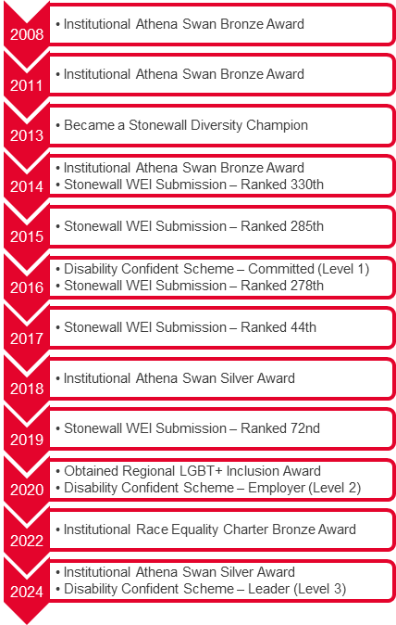
Figure 1: UoL equity charter awards journey

    - In addition, the University holds 8 Departmental Athena Swan awards, including a Silver College award by the College of Life Sciences (Table 7.6).
    - Most recently, the School of Computing and Mathematical Sciences and School of History, Politics and International Relations were both awarded Athena Swan Bronze charter awards after their applications in the May and September 2024 rounds respectively.

Table 7.6: University of Leicester Departmental Athena Swan Awards
School | Level of Award | Date of Award | Next Submission Date
College of Life Sciences | Silver | 29/04/2020 | 30/05/2025
School of Law | Bronze | 29/04/2020 | 30/05/2025
School of Chemistry | Silver | 22/12/2022 | 31/12/2027
School of Business | Bronze | 20/01/2023 | 31/01/2028
School of Physics & Astronomy | Silver | 28/03/2024 | 28/04/2029
School of Archaeology and Ancient History | Bronze | 11/07/2024 | 11/07/2029
School of Computing and Mathematical Sciences | Bronze | 23/09/2024 | 23/09/2029
School of History, Politics and International Relations | Bronze | 13/11/2024 | 31/12/2029

    - The EDI Team support institutional level equity charter related work and departmental level Athena Swan submissions through a framework review process, with a particular focus on data collection and presentation, conducting and analysing culture surveys, along with full submission review and analysis.
    - During 2025, there are 2 further planned University submissions for Athena Swan awards, the School of Law Bronze Renewal Award and the College of Life Sciences Gold Award. There is also a 5-year submission programme plan, which will see all schools currently without an Athena Swan award complete a submission ahead of the next REF exercise.
    - A number of universities have withdrawn from Stonewall’s Diversity Champion programme in recent years. In discussion with the LGBT+ Equity Action Group (including members of the Students’ Union and the LGBT+ Staff Forum), we intend to retain membership of Stonewall, recognising its continuing role in leading LGBT+ inclusion in the UK, and consideration will be given to submitting to the Workplace Equality Index in 2025/26.

Advancing Equity and Inclusivity in Key Areas - Disability
    - The University’s work to advance disability equity and inclusion has continued over the last 12 months, in collaboration with both the Disability Staff Forum and the Students’ Union.
    - Strategic Objectives: Initiatives and activities have focused on supporting and delivering the strategic objectives, proposed by the Disability Equity Action Group and confirmed by the EDI Committee, as detailed in Table 7.7.

Table 7.7: Disability Equity Objectives 2024-2025
1
Continue to drive and inform disability inclusive and anti-ableist policy and practice for staff and students
Lead the University to embed disability equity principles, proactive good practice, accessibility and inclusive design into the physical and virtual environment, through policy and process
Monitor compliance and success of policies and initiatives introduced to support disabled staff and students that were recognised as sector-leading by the Disability Confident assessment process

2
3
University of Leicester Disability Equity Objectives 2024-25
Lead and promote engagement and awareness of staff and students, to embed disability equity, inclusivity, and proactive understanding across the organisation.

4

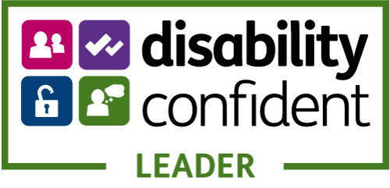
    - Disability Confident: Disability Confident is a government scheme which aims to encourage employers to think differently about disability by positively challenging attitudes, increasing understanding and removing barriers to employment for disabled people.
    - The aims of the scheme align with, and reflect, the University’s strategy to ‘be a truly inclusive University’ and it offers us a means to benchmark our disability policy and practice relating to staff. Whilst the scheme’s focus is on employment, work undertaken benefits all members of the university community including students, for example, in relation to improvements in the physical and digital estate and in students seeing the University as a disability friendly potential employer.
    - Over the past five years, an extensive programme of activities has been undertaken to progress disability equity and improve disability inclusion for staff. Following a robust self-assessment, the University was recognised with Disability Confident Employer status in 2020, re-recognised in 2023.
    - Following a further programme of work, informed by the Disability Staff Forum and in consultation with the Disability Equity Action Group, the University successfully submitted an application for Disability Confident Leader status in April 2024. Recognition came as a result of a rigorous self-assessment and thorough external validation of progress made, which included feedback of the lived experience from disabled colleagues.
    - The external validation process identified a number of areas of exemplary best practice, in particular, the excellent levels of collaboration with the Disability Staff Forum to drive change and inform disability inclusive policy and practice, including:

- mandating Disability Confidence for Managers training for line managers;
- investment in the provision of a Staff Disability Advisor role to support disabled staff and their managers;
- a central budget for some Access to Work adjustments;
- provision of a dedicated Staff Quiet Room;
- development of new policies, such as Disability Leave and Assistance Animals on Campus.
    - As with all equity charters, our disability equity work is not determined or driven by attaining Disability Confidence accreditation, rather, it is used to benchmark the progress we are making. Whilst we have achieved Leader status, we recognise there is still more we need to do to address barriers for disabled staff. A 3-year action plan, collaboratively developed and informed by the disabled staff voice, is in place to enable us to continue to advance disability equity and inclusion for the staff community, and to take us to application for re-recognition in 2027.
    - As a Disability Confident Leader organisation, we also have additional responsibilities, to promote and share best practice to drive disability inclusion in the wider sector, local area and nationally and be a beacon of best practice for other organisations.
    - New Disability Confidence for Managers Training Launched 2024: This course, originally launched in Spring 2022, focuses on increasing understanding of disability and associated responsibilities of managers, and equips managers with the skills and confidence to proactively support disabled team members and create an inclusive environment for disabled staff to thrive.
    - Following feedback from the Disability Staff Forum and Disability Equity Action Group, and in recognition of its importance to ensuring disability equity, this training became mandatory for all Line Managers in Spring 2024. The training was re-designed as a blended learning package, with a mandatory online webinar supplemented by an optional workshop to support managers to apply their learning in the University context. Completion will be monitored on-going and currently stands at 81.2%.
    - Disability Inclusive Recruitment: A new Disability Inclusive Recruitment Guide has been launched, developed by the Staff Disability Advisor, in conjunction with the EDI Team, and in consultation with the Disability Equity Action Group and Disability Staff Forum. Alongside this, disability inclusive best practice has been further woven through recruitment process, webpages and guidance, to attract disabled candidates and improve their candidate journey.
    - Collection of diversity data relating to disabled candidates’ journey from application to offer will enable us to identify any disparities and measure the impact of initiatives taken to address. This data will form part of the recruitment dashboards from May 2025.
    - Staff Policy Development: As part of the review of the Maximising Attendance Policy and following consultation with the Disability Staff Forum and Disability Equity Action Group, important changes to the way disability-related absence and disability-related sickness absence is considered and managed are now in place.
    - The new Sickness Absence Management Policy is now supplemented by, and makes provision for, disability related absence through a Disability Leave and Disability Related Sickness Absence Policy. Leave associated with disability, for example, attendance at disability related appointments, treatment etc can now be recorded and managed separately for disabled staff rather than being treated as sickness. There is also provision for disability-related sickness absence to be managed and recorded separately to sickness absence.
    - In addition, a new Disability Support Plan has been developed by HR, to enable individuals to document their agreed reasonable adjustments and disability-related absence support plan. These policies represent significant progress towards disability inclusion for disabled staff.
    - Staff Quiet Room: In response to requests and external best practice, and in collaboration with the Disability Staff Forum, a dedicated Staff Quiet Room was launched in February 2024, equipped for use by neurodivergent staff, disabled staff and those with a health condition, to rest and retreat from the busy campus. The room is also available to identified students who the AccessAbility Centre feel would benefit from access to the space. Feedback from staff using the room has been extremely positive and the room is being used by staff on a regular basis.
    - International Day of Disabled People 2024: 3 December marks the United Nation’s sanctioned date to celebrate the achievements and contributions of disabled people, raise awareness of disability inequity and promote the rights of disabled people.
    - As with every year, the University celebrated this date with a programme of events from November to the 8 December, in collaboration with the Attenborough Arts Centre, the Disability Staff Forum, Staff Health & Wellbeing and various university departments. There were a number of virtual and face-to-face events, that focused on the awareness of neurodiversity, celebration of disabled artists, training on accessibility, exploration of the lived experienced of disability and showcasing the support that is available here at the University and how to access it.
    - With performances from local disabled artists with WORD!, to webinars including PhD research on ancient disability and Creativity, Agency and Disability and the Music Biopic: Sex & Drugs & Rock & Roll (2010). Networking opportunities and showcases of the work undertaken to support disabled staff and students with demonstrations of the equipment and support available also took place.

Advancing Equity and Inclusivity in Key Areas – Gender
    - Advancing gender equity and inclusion remains a clear and visible priority across the University. This includes the commitment to implement the new Institutional Silver Athena Swan action plan priorities, and a continued focus to address the University’s gender pay gap.

    - Strategic Objectives: Table 7.8 details the University’s agreed gender equity objectives, for the academic year 2024-2025 proposed by the Gender Equity Action Group and confirmed by the EDI Committee.

Table 7.8: Gender Equity Objectives 2024-25
1
To oversee the successful implementation of the University of Leicester’s Athena Swan Silver Action Plan.
To support the progression of the following Athena Swan priority: ‘Enhance the support provided to staff with caring responsibilities on return from family leave’.
To support the progression of the following Athena Swan priority: ‘Enhance our current provision to raise awareness of gender-based/sexual violence and harassment and review support available to students experiencing these forms of behaviours.
2
3
University of Leicester Gender Equity Objectives 2024-25

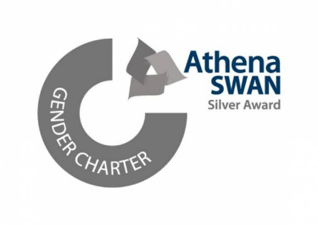
    - Athena Swan: As detailed in 3.1.5, the University currently holds an Institutional Silver Athena Swan charter mark. Initially awarded in 2018, this was successfully renewed in May 2024 and will remain valid for 5 years (until July 2029). Given the comprehensive nature of the award process, including detailed self-assessment and analysis across the full student and staff lifecycles, the University’s current actions to advance gender equity are framed around the existing aligned Silver action plan.
    - Feedback from the Advance HE Panel on the submission was extremely positive, highlighting a range of strengths including comprehensive evidenced self-assessment and acknowledgement of beacon activities identified as key for a future Gold submission, with the University’s Student Sex Work Policy and annual Pay Gap Dashboards noted as strong examples of activity.
    - The renewed application is the first institutional level application under the Transformed UK Athena Swan Charter Framework. To support this work, we established an Institutional Self-Assessment Team, chaired by the Provost and Deputy Vice-Chancellor, which included staff and student representatives from across the University. The Team undertook a full evaluation of our gender equity progress and issues to identify our future priorities for action from May 2024-29.
    - The six priority areas identified through the self-assessment process are to:
Athena Swan Priority Areas 2024-29

- Increase the representation of women staff in senior academic/research roles
- Enhance provision to raise awareness of gender-based/sexual violence and better support students who experience these behaviours.
- Improve the representation of women students at Undergraduate level in the College of Science and Engineering.
- Enhance the support provided to staff with caring responsibilities on return from family leave.
- Ensure fairness and transparency in workload.
- Enable an effective and safe engagement environment to improve the experiences of trans/non-binary staff and students at the University.

    - Gender Equality Plan (GEP): As a higher education establishment applying to the European Commission’s Horizon Europe programme, the University is required to have a gender equality plan (GEP) in place, in addition to our Athena Swan activity and accreditations. This Plan was developed and approved during 2024.
    - The GEP outlines the actions taking place within the University to drive forward gender equity and inclusivity. These include the allocation of dedicated resources and expertise to help implement the equity plan, student and staff data collection and monitoring, mandatory staff unconscious bias along with staff recruitment and selection training, and our Dignity and Respect Framework.
    - The Plan dovetails with the actions specified in our Athena Swan Action Plan and is a critical strategy that has helped the University to acquire a portion of the European Union’s €95.5 billion Horizon Europe programme budget, that aims to eliminate gender inequity.
    - Gender Equity Policies: The University’s gender equity policies have been updated to reflect the introduction of new legislation, which took effect from 6 April 2024, including changes to:
- Flexible Working Policy - right to request flexible working from Day 1 of employment.
- Paternity and Partner Leave Policy – improved flexibility around how and when paternity/partner leave can be taken.
  - Special Leave Policy: the introduction of unpaid Carer’s Leave, entitling carers to 1 week of unpaid leave per year.
    - Gender Equity Events: The University’s annual programme of gender equity events has continued to take place across the University through engagement with international campaigns, such as International Women’s Day and 16 Days of Activism against Gender-Based Violence (the latter of which is led by the Standing Together Team). Events have been organised collaboratively with the Gender Equity Action Group, the Women’s Forum, the Students’ Union, Student Support Services and various academic departments.
    - During March, the University held a number of physical and virtual International Women’s Day events under the global theme of #InspireInclusion. Events included a focus on career and personal development, alongside dedicated health initiatives and celebration of women in both the arts and STEM.
    - Artistic celebrations included ‘Emotional Capsule: Women’s Invisible Emotion’ the culmination of work carried out by two Museum Studies students during their placement with Attenborough Arts Centre, featuring artworks from the University of Leicester Art Collection. Alongside performances by the Ivor Novello Award winning musicians Tori and Alcyona, the original Punk Mum and Unglam founder Ruth Miller, and the Gallery Late showcasing local Leicester talent in music, dance, performance and crafts.
    - Health focused events on breast screening with the Leicester Cancer Research Centre, and urogynecology treatments and management with Dr. Aneta Obloza.
    - As part of the wider theme of #InspireInclusion, numerous sessions focusing on the showcasing and development of female staff were held. This included Organisational Development hosting creative coaching workshops for overcoming female imposter syndrome and speed coaching. The Space Park hosted the New Voices networking event to celebrate new and upcoming academics, and the College of Business welcomed Lorna Hinds-Sotomey to launch the College’s 2024 Career Development Exhibition.
    - As well as speaker events and Q&As with Dr. Maureen Paul on overcoming the challenges and barriers faced as a Black female, alongside her successes on her career journey to become one of the UK’s leading industrial and regulatory economists (with the School of Business); live streams of ULBC’s Head of the River Race championship, hackathon sessions, and the College of Science and Engineering’s equity for women in STEMM initiative.

Advancing Equity and Inclusivity in Key Areas – LGBT+
    - Strategic Objectives: Work to advance the agreed LGBT+ strategic objectives continued over the last 12 months, in collaboration with a broad range of stakeholders, including the Students’ Union and the LGBT+ Staff Forum.
    - Table 7.9 details the University’s agreed LGBT+ equity objectives for 2024-2025, proposed by the LGBT+ Equity Action Group and confirmed by the EDI Committee.

Table 7.9: LGBT+ Equity Objectives 2024-25
1
Drive and promote cultural change whereby LGBT+ equity is further embedded in university functions, activities and ethos, including embedding LGBT+ equity, inclusivity and understanding across the organisation, effecting a cultural shift to a LGBT+ inclusive culture, aligned with the University’s commitments and the Dignity and Respect at Leicester framework.
Work with trans and non-binary staff and students to enhance the trans and non- binary voice and visibility in the University, through understanding, identifying and informing appropriate responses to related inequities experienced by both students and staff. Alongside implementing proactive measures to develop the safety of the trans and non-binary community at the University and a continued commitment towards trans/non-binary inclusion.
Identify priority areas to enhance the lives of the LGBT+ community at the University of Leicester at operational and institutional levels, additionally identifying key foci on the mental and physical wellbeing of LGBT+ staff and students and the health and wellbeing inequities the community disproportionately experiences.
2
3
University of Leicester LGBT+ Equity Objectives 2024-25

    - Leicester Pride 2024: The University and Leicester Students’ Union marked the 16 years of Leicester Pride on 31 August, with this year seeing a record 20,000 people join in the celebrations at Abbey Park, while 2,000 marched through the city. 2024 marked the growth of Leicester Pride in terms of size and attendance, including a fly-by by the RAF with a vintage Avro Lancaster, the display of Europe’s largest 82ft long trans pride flag, and a special early performance of the Curve Theatre’s upcoming musical SuperYou. The University’s presence at Pride is a continuation of our strong history of contributing to the ongoing work in advancing LGBT+ equity and inclusion, while also celebrating the rich diversity and history of Leicester’s LGBT+ community.

Figure 3: University of Leicester staff at Leicester Pride 2024
    - LGBT+ History Month: February marked the University’s annual celebrations for LGBT+ History Month and, for 2024, the University aligned with the theme of medicine (#UnderTheScope), as well as offer a focus on local artistic achievement and targeted need here at Leicester.
    - With dedicated film screenings of cult-classic and international queer media, alongside creative workshops offer staff, students and members of the public to explore queer literature, creative writing (with Appittame Arts and WORD!) and photoshoot opportunities to showcase found family and queer history (Attenborough Arts Centre’s Pride Portraits and Family Gallery Workshops).
    - Bespoke training sessions were made available to medical students on inclusive healthcare practices (with LGBT+ Foundation) and to all University staff on increasing their understanding of gender diversity and to improve the lives of trans people, with just under 60 members of staff in attendance for the session with Gendered Intelligence; both sessions demonstrating the University’s continued commitment to trans equity and ensuring that we are being trans inclusive in our activities and services.
    - The month of celebrations also coincided with National HIV Testing Week, and the University proudly supported the LGBT+ Student Society and Students’ Union in hosting the local charity Trade Sexual Health on campus to provide confidential and free rapid HIV tests, alongside information on knowing your HIV status, effective treatment, to increase opportunities for people to get tested and end the stigma of HIV.
    - Transgender Day of Remembrance 2024: In collaboration with the Students’ Union, the University supported a vigil on campus commemorating the memory of trans, non-binary and gender non-conforming individuals whose lives have been lost to acts of anti-trans violence, suicide, and medical complications. As part of the commemoration, alongside flying the Progress Pride Flag from the Fielding Johnson Building, the University lit up the Attenborough Tower in the colours of Trans Pride Flag, showcasing our visible commitment to the trans community and support for wider trans inclusion.
    - Leicestershire LGBTQ+ Centre Relaunch: The University attended the relaunch event of the Leicestershire LGBTQ+ Centre, celebrating the Centre’s 50 year of history, alongside its evolution in reflecting the broadening scope of its mission and a response to the needs of LGBTQ+ communities across Leicester, Leicestershire, and Rutland.
    - World AIDS Day: The University joined the Red Ribbon Remembrance Walk hosted by Trade Sexual Health, this guided tour explored key sites around the city that have played a significant role in the history of HIV/AIDS in Leicester, offering members of the community the opportunity to reflect on the progress made in HIV prevention and treatment, the resilience of the city and community during the epidemic, while also honouring the lives of those lost to HIV-related illnesses over the past four decades, and the ongoing efforts through education, prevention and support to address the stigma and health needs of those with HIV.

Advancing Equity and Inclusivity in Key Areas – Race
- The University’s work to advance race equity and inclusion has continued over the last 12 months, in collaboration with both the Race Equity Action Group, the Students’ Union and key stakeholder student and staff groups across the University.
- Strategic Objectives: The strategic objectives for 2024-25, proposed by the Race Equity Action Group and confirmed by the EDI Committee, are detailed in Table 7.10.
Table 7.10: Race Equity Objectives 2024-25
1
To act as an internal stakeholder for key workstreams of activity which have a focus on addressing evidenced racial disparities across the student and staff lifecycle, by contributing to ideas generation and by undertaking an internal review of any related strategic proposals which seek to remedy race related disparities.

To learn from and work collaboratively with other comparable Race Equality Charter Mark regional universities, and areas who are leading in race equality activity within our university, to share and implement best practice; and to generate creative, innovative and effective actions that tackle systemic and institutional racism in higher education.
2
University of Leicester Race Equity Objectives 2024-25


- Race Equality Charter: We continue to monitor progress of the action plan and work with key stakeholders and the Race Equity Action Group to ensure that race equity remains a priority across the University
- As part of an annual review of the progress made in relation to the University’s Race Equality Charter action plan, the Race Equality Charter Mark Update Report 2023-2024 provides a comprehensive update of the key areas of progress and includes a summary of the race related activities and actions taking place across the University more widely, including actions led by the Student and Education EDI Team related to the ethnic disparities across the student lifecycle.
- Of the 77 actions within the University's Bronze Race Equality Charter Action Plan; 45 are completed/achieved, 28 are in progress/success measures not yet met, and 4 have not yet progressed.
- The University will be participating in a mid-term award meeting before July 2025, which will be facilitated by Advance HE, to plan for our Silver Race Equality Charter submission in 2027. This meeting will involve members of the Self-Assessment Team and key stakeholders across the University. The meeting will focus on preparing for the submission’s all staff and student survey in 2026 and identifying the key emerging themes for our Silver submission action plan
- The Race Equality Charter Mark Update Report 2023-2024 highlights include:
- In 2023/2024 the levels of applications and offer made to students from UK minority ethnic backgrounds have increased by +5% for admissions and +3% for offers.
- Whilst continuation rates for all ethnic groups have declined since 2019/2020, the University maintains higher than sector continuation rates for all ethnic groups with the largest difference in continuation rate being between Asian and Black UK students (-2.8 percentage points).
- The awarding gap data for 2022/2023 shows a 4.3pp increase between UK white and Black students, and is now 18.4%. There has also been a 6.1pp increase to the awarding gap between minority ethnic and white students and is now 12.7%.
- The results from the University's PRES2024 survey evidences that PGR student satisfaction is now high at Leicester compared to the sector. 81.6% (73.3% in 2022) of PGRs expressed overall satisfaction with their course, with the University ranked 26th in overall satisfaction, improving by 24 places. Scores from minority ethnic PGRs are higher than for white PGRs.
- The NSS 2024 results show that the positivity gap between Black students and white students has narrowed across every question section of the NSS.
- An improvement in disclosure rates in staff ethnicity, with 94.8% of staff having now disclosed their ethnicity.
- The population of staff from a minority ethnic background has increased to 29.3%.
- In 2023, the University reported on the ethnicity pay gap for the first time. The most recent 2024 ethnicity pay gap showed a mean ethnicity pay gap of 9.5% (-2.5pp movement) and a median ethnicity pay gap of 14.3% (+1.0pp movement).
- Advancing Race Equity and a Culture of Anti-Racism: The University continues to undertake a wide range of interventions and actions across the University, to challenge and address race inequities, including structural, in order to create a culture of anti-racism.
- The EDI Team have delivered a series of race equity related workshops and training sessions to colleagues, including to UoL research leaders, and as part of the EDI Development week the Team delivered a session on ‘An Introduction to Systemic Racial Disparities in HE.
- The Black Leadership Programme, which launched last autumn, saw 51 students engage in a programme of workshops and work experience, with participants reporting an increase in confidence regarding their career development post event. To enhance next year’s programme, the Service are looking to condense the experience to improve accessibility, partner with a number of employers to co-deliver the programme, and improve the range of ethnically diverse speakers and inclusive employers on campus.
- The School of History, Politics and International Relations are offering 3 studentships in 2024-2025, through the Len Garrison MA Scholarship Scheme in Black British History.
- The University was awarded c.£1m for a two-year research culture project by the Wellcome Trust (I-REACCH) to redress decreasing diversity from postgraduate researcher to professor, by co-creating interventions that rectify career progression barriers for under-represented groups.
- As part of the three-year funded research internships under the Royal Society of Chemistry’s “Missing Elements” Grant Scheme, following a competitive recruitment process, the first 3 (of 10 over 3 years) students completed their research internships. The aim of the project is to give underrepresented student groups the experience of working in a real research environment, to help inspire them to go on to do research in the future
- Following on from the Black Student Experience Working Group Report, the new Black Student Education and Experience Officer has been in post since October 2024 and will be coordinating projects and plans to reduce gaps in provision, particularly in relation to the following workstreams; Curriculum and Assessment, Employability, Accommodation & Campus Life including Sports & Active Life, Communications & Awareness and Student Wellbeing and Accessibility. A series of listening workshops are currently in progress.
- Black History Month 2024: The University’s Black History Month (BHM) programme has grown each year, with engagement at events for BHM this year exceeding 600. Working collaboratively with the Students’ Union, Attenborough Arts Centre, and John Lewis Leicester, a wide range of events and activities around the theme of Reclaiming Narratives took place across October.
- A series of month-long exhibitions which acknowledged and celebrated the contribution of Leicester’s Black community to the city’s historic and cultural development were part of the programme. Opal 22 curated an exhibition in the Students’ Union Square aimed at deepening understanding and encouraging dialogue on Leicester’s Black heritage. Sound clips of oral history interviews related to Black History Month were also played in the foyer of the Sir Bob Burgess Building as part of the Unlocking Our Sound Heritage exhibition. A series of events hosted by ResLife took place across the University’s Halls of Residences, including a movie night, a food tasting evening, and crafts afternoon.
- A range of events and activities hosted by Attenborough Arts Centre including: The Ground art exhibition by Tim Fowler, (launch event); the musical Luna Loves Library Day; Caribbean Woman presented by WORD! and Renaissance One; Black Voices in Concert: Singing in the Black Oral Tradition by Black Voices; and a creative writing workshop with Apittame Arts that explored Black Historical Figures and Afrofuturism.
- The School of History, Politics & International Relations, Centre for Regional and Local History (CRLH), and the Centre for Urban History (CUH), ran a joint series of events for BHM. The month began with a roundtable discussion of Black undergraduate and postgraduate students who talked about their experiences of learning about Black history.
- The University collaborated with the Highcross Shopping Centre’s flagship department store, John Lewis, to celebrate Black History Month. Leicester Food and Drink shared their Black Food Innovators posters which were displayed in the Café at John Lewis and the Gospel Choir also performed in store. Working closely with Library and Learning Services, the EDI Team created an exhibition which shone a spotlight on Black history makers selected from the University’s Our 100 celebrations who made a significant impact at the University and in the city. Following the conclusion of BHM, John Lewis was nominated for and won the ‘Special Events Award’ at the Pukaar Awards for Black History Month.

Figure 4: Colleagues from the University of Leicester and John Lewis receiving the Specialist Events Awards at the Pukaar Group Black History Month Awards 2024


- Lord Simon Woolley gave an up close and inspirational talk about his experience of growing up in a Leicester-based Black working-class family, the external challenges he encountered due to his racial heritage, his creation of Operation Black Vote, and subsequent achievement of a knighthood in 2019.
- The Black Heritage Post Graduate Research (PGR) Student Showcase, hosted by the College for Life Sciences, provided a forum for the presentation and celebration of academic work and achievements by Black PGR students across the University.
- To ensure authenticity and relevance in our approach to celebrating BHM we have established a BHM Black Experiences Steering Group (BLESG) who will play a crucial role in supporting the University to deliver an inclusive, representative and engaging BHM programme of events and activities by using their lived experiences as a reference point. The Group currently has 13 members.

Advancing Equity and Inclusivity in Key Areas – Faith
    - The University is committed to developing its provision to support multi-faith and spiritual groups. A review of existing provision was previously undertaken by the University, with a view to proposing recommendations to enhance its offer. This work is led by the Director of Student Services and Belonging with a new role of International Student Experience Manager reporting to them.
    - Prayer Facilities: The EDI Team continue to work closely in an advisory capacity with the Students’ Union, Estates and Campus Services and Student Services and Belonging regarding the provision of prayer facilities and faith-based support. This includes the development of a faith-based support webpage which contains information regarding the facilities and support available at the University and in the local community.
    - Multi-Faith and Spiritual Chaplaincy: Working closely with the Students’ Union the University continues to support Student Faith Societies to host key religious festivals/events, and co-ordinates activities to celebrate Chinese Lunar Year. The University also recognises faith related celebrations through social media communications across the year.
    - Considering the current financial and estate related constraints faced by the University, and upon advice from various sources including St Phillips Centre, the University has agreed to take a signposting approach in relation to faith-based support for students. A policy is being developed by Student Services and Belonging to outline this approach. This includes distinguishing the Christian Chaplaincy as being allied with the University rather than being embedded within the University.
    - Holocaust Memorial Day 2024: The University continues to support the Holocaust Memorial Day commemorations held in the city of Leicester. 2024 was marked by the theme of the Fragility of Freedom, and the key commemoration event was held collaboratively with De Montfort University. The key commemoration featured a live recital of the ceremonial Hebrew declaration of Kol Nidrei, a panel discussion from the city’s local schools, and a memorial address delivered by Professor Aubrey Newman.
    - Additional commemorations held by the University of Leicester in remembrance included lectures, art workshops and exhibitions, organized collaboratively by Leicester Museum and Art Gallery, University of Leicester Heritage Hub and the Stanley Burton Centre for Holocaust and Genocide Studies. This included the annual Stanley Burton Centre for Holocaust and Genocide Studies Holocaust Memorial Day Lecture, delivered this year by Professor Benjamin Ziemann (Professor of Modern German History, University of Sheffield) titled “Then they came for me…”. Martin Niemöller, Protestant antisemitism and the problem of Holocaust remembrance in post-war Germany, an online lecture by award-wining author/artist Barbara Yelin on the erosion of freedom by perpetrator regimes, and an exhibition comprised on a Fragility of Freedom interpretation in the German Expressionist Gallery of the Leicester Museum and Art Gallery (New Walk Museum).
    - The University of Leicester also lit up the Attenborough Tower between 27 and the 29 January as a symbol of the University’s commemoration on campus. Complimenting Leicester City Council’s own lighting up of City Hall and Town Hall between the 25 and 28 January.

University of Leicester Equity Pay Gaps 2024
  - Annual Pay Gaps Report: The University will publish its 2024 Pay Gaps Report in March 2025 (see Appendix C for the Report). For the second time, the Report includes disability, ethnicity, and sexual orientation, in addition to the mandatory gender pay gap data.
  - This expansion of pay gap reporting gives increased transparency and accountability across the 4 key equity groups and aligns the University’s commitments, especially its visible commitments, to advancing equity and inclusion in relation to ethnicity, disability and sexual orientation with those for gender around pay equity.
  - Pay Gap Data Methodology: As was agreed in 2023/24, all pay gap data, apart from the statutory gender pay gap, exclude atypical staff as there is currently no SAP solution in place to calculate this, Unitemps records do not interface with SAP and have very little capability for analysis, with no Dept, Position, Job Family, Grade, Spine Point, HESA Function, Cost Centre or FTE recorded.
  - Headline Data: The headline data from the 2024 Report (see Table 7.11) includes:
Median Pay Gaps Changes:
- A very small decrease in the median disability pay gap (of 0.3 percentage points from 19.5% to 19.2%).
- An increase in the median ethnicity pay gap (of 1.0 percentage point from 13.3% in 2023 to 14.3%), in the median gender pay gap (of 0.2 percentage points from 17.9% in 2023 to 18.1% in 2024) and in the median sexual orientation pay gap (of 0.2 percentage points from 16.9% in 2023 to 17.1% in 2024).
- This amounts to a total movement of 1.7 percentage points across the 4 median pay gaps, with 0.3 of this being favourable (decreasing pay gaps) and 1.4 being unfavorable (increasing pay gaps).
Mean Pay Gaps Changes:
- There is an increase of over 5 percentage points in the mean disability pay gap (5.6 percentage points, from 9.2 in 2023 to 14.8% in 2024).
- There is a smaller increase of 2.1 percentage points in the mean sexual orientation pay gap (from 12.4% in 2023 to 14.5% in 2024).
- Both the mean ethnicity pay gap and the gender pay gap have seen small reductions, with the mean ethnicity pay gap reducing by 2.5 percentage points (from 12.0% in 2023 to 9.5% in 2024) and the mean gender pay gap reducing by 0.7 percentage points (from 19.2% in 2023 to 18.5% in 2024).
- This amounts to a total movement of 10.9 percentage points across the 4 mean pay gaps, with 2.3 of this being favourable (decreasing pay gaps) and 7.7 being unfavorable (increasing pay gaps).

Table 7.11: UoL Pay Gaps 2024 (with 2023-24 movement)

  - As well as the headline pay gap data for all 4 equity strands detailed in the 2024 Pay Gaps Report and mandatory gender pay gap data, we are also including disaggregated pay gap data for all 4 equity areas on both internal and external UoL EDI webpages. This data is incorporated into the following analysis.
  - Gender Pay Gap: The University’s 2024 mean gender pay gap is 18.5%, and the median gender pay gap is 18.1%. Both of these are higher than the higher education sector gender pay gap calculated by Advance HE, which reports a mean gender pay gap of 13.7% and a median gender pay gap of 9.0%.
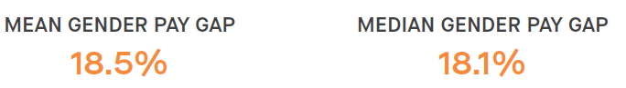
4.7 Since 2017, the University of Leicester has seen an overall reduction of 5.6 percentage points to its mean gender pay gap and an overall reduction of 4.6 percentage points to its median gender pay gap (Table 7.12).

Table 7.12: University of Leicester Gender Pay Gap 2017-2024

  - The University’s current mean bonus gender pay gap is 80.9% (75.4% in 2023) and median bonus gender pay gap is 50.0% (0% in 2023). As the University only has a small number of bonus awards and the Clinical Excellence Awards are included in these calculations (although the cost of these is partially refunded by the NHS) the bonus gender pay gap is subject to significant fluctuation on an annual basis.
  - As for many organisations, key determinants of the University’s gender pay gap include the absence of a gender balance across job categories (horizontal occupational segregation) and through the different pay grades (vertical occupational segregation). At the University of Leicester, women continue to be overrepresented in lower and middle paid roles and underrepresented in higher paid roles.
  - Higher gender pay gaps across the sector are typically seen in HEIs that are research intensive, that have a medical school and that directly employ manual and ancillary staff. The University has all 3 of these.
  - In terms of interrogating the gender pay gap by function, both the mean and median gender pay gaps are significantly higher for academic staff (16.9% mean and 8.5% median) than for professional services staff (we mean and 2.8% median) (Table 7.13).

Table 7.13: UoL Gender Pay Gaps 2024 by Function

  - When analysing by grade groupings, the grouping, Grades 1-5, has the lowest mean and median gender pay gaps (0.4% mean and 2.4% median) and the Clinical Grade has the highest (17.5% mean and 13.7% median). Grade 10 or Professor Grade also has low mean (4.4%) and median (4.6%) gaps (Table 7.14).

Table 7.14: UoL Gender Pay Gaps 2024 by Grade Groupings

  - Ethnicity Pay Gap: The University’s 2024 mean ethnicity pay gap is 9.5% (a decrease of 2.5 percentage points from 12.0% in 2023), and the median ethnicity pay gap is 14.3% (an increase of 1.0 percentage point from 13.3% in 2023).
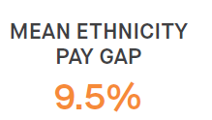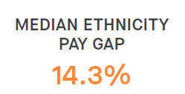
  - The mean ethnicity pay gap for academic staff is considerably lower (9.4%) than for professional services staff (15.8%) but the median ethnicity pay gaps for both staff groupings is very similar (13.6% for academic staff and 13.0% for professional services staff) (Table 7.15).

Table 7.15: UoL Ethnicity Pay Gaps by Function
  - When analysing by staff grade groupings, Grade 10 or Professor has the lowest mean and median ethnicity pay gaps (-0.9% mean and 0.5% median) and the Clinical Grade, again, has the highest (13.9% mean and 11.0% median) (Table 7.16).
Table 7.16: UoL Ethnicity Pay Gaps 2024 by Grade Groupings
  - Disability Pay Gap: The University’s 2024 mean disability pay gap is 14.8% (an increase of 5.6 percentage points from 9.2% in 2023), and the median disability pay gap is 19.2% (a decrease of 0.3 percentage point from 19.5% in 2023).
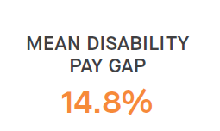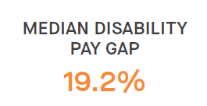
  - The mean and median disability pay gaps are lower for academic staff (mean 6.9% and median 1.8%) than for professional services staff (mean 9.1% and median 9.7%) (Table 7.17).
Table 7.17: UoL Disability Pay Gaps 2024 by Function
  - When analysing by staff grade groupings, Grade 10 or Professor has the lowest mean and median disability pay gaps (0.9% mean and 0.1% median) and the Clinical Grade has the highest (16.5% mean and 17.8% median) but the small number of disabled staff (#2) is noted in the Clinical Grade grouping (Table 7.18).

Table 7.18: UoL Disability Pay Gaps 2024 by Grade Groupings
  - Sexual Orientation Pay Gaps: The University’s 2024 mean sexual orientation pay gap is 14.5% (an increase of 2.1 percentage points from 12.4% in 2023), and the median sexual orientation pay gap is 17.1% (an increase of 0.2 percentage point from 16.9% in 2023).

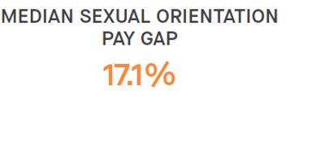
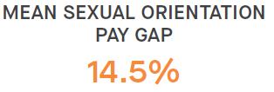

  - The mean sexual orientation pay gap is slightly lower for lesbian, gay and bisexual (LGB+) professional services staff (13.1%) than for LGB+ academic staff (14.2%) and the median sexual orientation pay gap is slightly lower for LGB+ academic staff (10.7%) than for LGB+ professional services staff (11.0%) (Table 7.19).
Table 7.19: UoL Sexual Orientation Pay Gaps 2024 by Function
  - When analysing by staff grade groupings, Grades 1-5 has the lowest mean and median sexual orientation pay gaps (2.8% mean and 3.4% median) and the Clinical Grade has the highest (18.3% mean and 36.3% median) but the very small number of LGB+ (#3) is noted in the Clinical Grade grouping (Table 7.20).

Table 7.20: UoL Sexual Orientation Pay Gaps by Grade Groupings
  - Intersectional Pay Gaps: The University’s intersectional pay gaps are the gender pay gaps disaggregated by broad ethnic groupings (minority ethnic and white) and illustrate the separate and combined impact of gender and ethnicity based disadvantage.
  - The University’s 2024 mean minority ethnic gender pay gap (the mean gender pay gap for minority ethnic women compared to minority ethnic men) is 24.8% and the median minority ethnic gender pay gap is 19.9%. The mean white gender pay gap (the mean gender pay gap for white women compared to white men) is 16.4% and the median white gender pay gap is 13.7%.

MEAN MINORITY ETHNIC MEDIAN MINORITY ETHNIC
GENDER PAY GAP GENDER PAY GAP
24.8% 19.9%

MEAN WHITE MEDIAN WHITE
GENDER PAY GAP GENDER PAY GAP
16.4% 13.7%

  - Actions to Close UoL Pay Gaps – As detailed in the University of Leicester 2024 Pay Gaps Report, the University is taking a wide range of actions to ensure fairness and equity across all aspects of its employment provision including in relation to:

Attracting and Retaining Staff:
- offering competitive pay and setting out our approach to pay and reward in open and transparent ways;
- continually reviewing and improving our recruitment practices and processes to ensure they are equitable and inclusive including by embedding the Inclusive Recruitment Toolkit, anonymous shortlisting for professional services roles, each departments receiving annual recruitment data health checks.

Nurturing and Developing Staff:
- reinforcing our transformational approach to academic progression and promotion, created through the Leicester Academic Career Map;
- delivering our comprehensive suite of development and leadership programmes, which have equity and unconscious bias awareness embedded throughout; 4.11
- implementing mentoring and coaching to support through the academic promotion process;

Valuing Equity and Diversity
- progressing our Institutional Athena Swan Charter Silver, Race Equality Charter Bronze and Disability Confident Leader action plan priorities;
- mandating all staff to complete both an EDI and Challenging Unconscious Bias online modules and line managers to complete Disability Confidence Training;
- offering a portfolio of resource and leaning and development opportunities to support inclusivity, including LGBT+ and Disability toolkits;
- improving disclosure rates of diversity data to enable improved understanding of barriers and disadvantage for equity groups;
- requiring all staff who sit on recruitment and selection panels to additionally complete training that specifically addresses bias in recruitment and selection processes;
- providing networking and support opportunities through our Four Staff Equity Fora and Carers and Parents Network;

Celebrating and Recognising Success:
- ensuring our approach to performance, reward, recognition and promotion is transparent, understandable and fair, including offering promotion workshops for minority ethnic and women staff.
- embedding evidence-based action in promotion processes, including providing demographic data and having bias observers on professorial panels.

  - Further Actions to Close UoL Pay Gaps: During 2024/25, further interrogation of the disaggregated pay gap data will be completed to understand patterns and trends across pay grades and organisational areas. This analysis will feed into work already started with the 4 Equity Action Groups to identify further possible actions to close the pay gaps.

Organisational Embedding of Equity, Diversity and Inclusion
  - Over the last 12 months, initiatives and projects have been completed and progress made on developing our infrastructure and resource base to further embed EDI good practice and principles across the working life of the University, with a focus on building organisational EDI capability to underpin our commitment to advancing equity and inclusion.
  - A number of new training and development courses and resources were developed and launched during 2024 to support our work in this area:
- Trans Awareness Training: A suite of training was commissioned and delivered for staff throughout 2024. Delivered by Gendered Intelligence, a trans-led registered charity, the training comprised online and face to face workshops, offering introductory awareness and more in-depth sessions for specific staff. A total of 137 staff attended the workshops.

- Disability Confidence for Managers: A new online module was developed and launched, aimed at providing managers with the skills and confidence to support disabled staff and promote a disability inclusive workplace. The module became mandatory for all line managers in 2024, with 83.18% of line managers now having completed the training (tracked through PDD Manager). The mandatory module is complemented by an optional follow-up workshop, where managers can explore university processes, best practice, and how to apply their learning in their own teams.
- Dignity and Respect Toolkit: A Toolkit was developed, with a range of resources to enable managers and staff to embed principles of dignity and respect into their behaviour and everyday activities. Resources include slide decks and guides on expected behaviour, creating a team behaviour charter, strategies to challenge unacceptable behaviour, responding to feedback and sources of support.
- Inclusion Toolkit: An Inclusion toolkit was also developed, with a range of resources to enable staff to create an inclusive environment, and to design and embed equity and inclusion into their everyday practice and services they provide, from the outset.
- Team Day Guide: A guide was developed, in conjunction with the Organisational Development Team, and informed by the Staff Equity Fora, to support managers and staff to consider the different requirements of staff when organising departmental/team meetings and development days, to ensure they are as inclusive as possible.
  - Two EDI related staff modules continue to be mandatory for all staff:
- EDI Online Training Module: The online EDI module is mandatory for completion by all staff and currently has a completion rate of 64% (86% in 2023/24). Central Professional Services has the highest completion rate for this module at 88%, and CLS has the lowest, at 52% (see Table 9).
- The Challenging Unconscious Bias online training module: also continues to be mandatory for staff and has a current completion rate of 65%, (84% in 2023/24). Again, Central Professional Services has the highest completion rate for this module at 90%, and CLS has the lowest at 51% (see Table 7.21).
The significantly lower completion rates (compared to 2023/24) are due to the changes in university mandatory training reporting. Just over a year ago, the University broadened the scope of those required to complete mandatory training to further mitigate risk for the University, to include temporary staff, collaborators and others who complete mandatory training via the University’s e-booklet version. The University also changed the reporting platform it uses to PowerBI, which includes the mandatory training dashboard. At this point, we cannot separate out the reporting on those who have completed the training on Blackboard and those who have completed the e-booklet. The dashboard will be rebuilt to enable this, but for now, reporting includes all those that need to complete mandatory training and this is an issue impacting all mandatory training courses, not just those related to EDI.

Table 7.21: Staff Completion Rates for Mandatory Training Modules
Module | University  (all staff) | College of Business | College of Life Sciences | College of Science and Engineering | College of Social Sciences, Arts and Humanities | Central Professional Services
Equality, Diversity and Inclusion | 64%  (86% in 2023/24) | 75%  __ | 52%  (86% in 2023/24) | 68%  (92% in 2023/24) | 69%  (94% in 2023/24) | 88%  (78% in 2023/24)
Challenging Unconscious Bias | 65%  (84% in 2023/24) | 77%  __ | 51%  (88% in 2023/24) | 69%  (90% in 2023/24) | 70%  (91% in 2023/24) | 90%  (77% in 2023/24)

  - Dignity and Respect at Leicester: Workshops focused on developing a deeper understanding of the University’s Dignity and Respect framework continue to be delivered as needed, including as intervention workshops.
  - Equity, Diversity and Inclusion Policy: The University’s new EDI Policy was developed in 2024, in consultation with staff and students, and will be launched in early 2025. The Policy sets out the University’s commitment to equity, diversity and inclusion, together with its legal, ethical and moral responsibilities and the expectations it has of all members of the university community.
  - Equality Analysis: Equality analysis (formerly called equality impact assessments) is a process to help build equity and inclusion into university activities and processes from the outset, through considering the impact of these activities, policies and practices on protected equity groups, and remove barriers and disadvantages identified. It is a key way for the University to demonstrate its compliance with the Equality Act 2010 Public Sector Equality Duty.
    - The University’s new approach to equality analysis was launched in May 2022 and continued to be embedded over the last 12 months, through a series of workshops to senior leadership teams over the past year. This has emphasised the need for equality analysis to be an integral aspect of policy, project and practice development and approval processes. Further support on completing equality analysis is also offered by the EDI Team through an online training package and 1 to 1 coaching.
    - An audit of equality analysis completed since May 2022 (launch of the new process) shows that there are strong areas of good practice but also further progress to be made in other areas to genuinely embed proactive consideration of the equality impact of the University’s decisions, policies and practices.
    - In HR, for example, equality analysis is now embedded into the annual cycles for academic promotion, senior staff pay committee, staff pay committee, citizens awards and long service awards, and considered at key committees including Executive Board, Academic Promotion Ratification Committee, Senior Staff Pay Committee and People, EDI and Wellbeing Committee.
    - Other HR equality analysis completed include:
- Disability Leave and Disability Related Sickness Absence Policy and Procedure
- Employee Study and Training Policy and Procedure
- Prevention of Psychological Trauma Policy
- Apprenticeship Policy
- Social Media Guidelines
- Occupational Health Policy.
  - EDI Staff Development Week: From 3 - 13 September 2024, the EDI Team delivered its first EDI Staff Development Week, offering a range of sessions designed to further develop understanding and give opportunities to learn key skills and practical tips that can be used by all to contribute towards a truly inclusive and fair University.
    - Designed with a variety of bite sized sessions and delivered through a mix of in person and online via Microsoft Teams or Zoom, sessions included:
- Disability Confidence for Managers
- Ways to Challenge Unacceptable Behaviour
- Student/Staff Personal Relationships Briefing
- Inclusive Practice
- LGBT+ Allyship
- An Introduction to Systemic Racial Disparities in HE
- Staff Fora Drop In and Networking Session
- Inclusive Behaviours
- Trans Equity Awareness Training
    - 185 staff attended these sessions (a 68.52% attendance rate) and 122 of these attendees were unique/single attendance. Of attendees, 70.81% were professional services and 20.19% were academic staff.
    - Slides and materials from the sessions have been made available on the EDI SharePoint pages as resources for all staff to access.
    - EDI Development for Estates and Campus Services (ECS): Recognising that a significant number of ECS staff were unable to attend the EDI Development Week due to shift patterns, a series of workshops, tailored specifically to ECS staff and covering topics explored in the September EDI Development Week, have been developed and delivered during November and December 2024 at a number of locations. 114 ECS staff attended these sessions and 2 more sessions are arranged for January/February 2025.
  - Staff and Student EDI Related Cases: The annual report of all EDI related staff and student disclosures/complaints/disciplinaries between 2019-20 and 2023-24 will be considered by the EDI Committee in January 2024. This report provides trend analysis to identify any patterns around themes of behaviour such as discrimination, harassment and bullying.
- Informal Disclosures: As detailed in the Report, bullying behaviours continue to feature significantly in staff informal disclosures (primarily via Report and Support, the University’s online disclosure platform), whilst for students disclosing via Report and Support, harassment, followed by sexual harassment/assault, are most often disclosed (Figure 5).
- Following a significant increase in both student and staff informal disclosures last year, this level has been sustained in 2023-24, with the same total number of student disclosures as last year, and a slight increase again for staff. Potential contributing factors being increased awareness of unacceptable behaviours, disclosure routes and support as a result of on-going awareness raising initiatives.
- Diversity demographics for informal staff and student disclosures indicate disabled staff and students appear to be disproportionately represented.

Figure 5: Staff and student informal disclosures: behaviours 2023-24

* Includes: ‘Harassment’ and ‘Verbal Harassment’.
**Includes: ‘Physical Harassment and Assault’, ‘Physical Assault’, and ‘Threatening Behaviour’.
***Includes: ‘Sexual Harassment and Assault’ and ‘Sexual Assault’.

    - Discrimination and harassment continue to be the behaviours cited more often in formal staff and student cases. Over the last 5 years, for both staff and student formal cases, discrimination and harassment on the grounds of race or disability have been cited significantly more often than any of the other protected equality characteristics. In 2023-24 there has been a shift to disability being cited as the grounds for both staff and student formal reports of discrimination. This may, in part, be due to an increased awareness and confidence due to a significant focus on disability inclusion over the last 3 years (Figure 6).
    - For formal staff cases progressing to investigation and concluding, the proportion resulting in an outcome of ‘upheld’ or ‘partially upheld’ has increased from 17% in 2018-19 to 56% in 2023-24, slightly down from 2022-23.
    - In 2023-24, Over half of formal student cases progressing to conclusion were found ‘in breach’ and resulted in sanctions. For both formal staff and student cases, diversity demographics indicate women are more likely to report/make a complaint.

Figure 6: Staff and student formal disclosures: behaviours 2023-24

  - Freedom of Speech and Protest Activity on Campus
    - Over the last 12 months, the Freedom of Speech Working Group, chaired by Provost and Deputy Vice-Chancellor, has considered and responded to the Higher Education (Freedom of Speech) Act 2023. The Act aims to make provision in relation to freedom of speech and academic freedom in higher education institutions and students’ unions and, in particular, imposes a duty on universities to actively promote freedom of speech.
    - As such, the Act strengthens the duties already present in HE in the UK to protect freedom of speech and academic freedom ‘on campus’, extending freedom of speech rights to explicitly include ideas and information that might be deemed by some to be controversial and even offensive. All freedoms must operate within the current legal framework
    - The Working Group has reviewed and revised the University’s existing Code of Practice Concerning Freedom of Speech and a new Code of Practice will be considered by Executive Board for approval on 10 February
    - In July 2024, the Government paused further roll out of the Act, including the requirement for every HE provider to have its own freedom of speech complaints process. Once the future of the Act is clear, the University will determine any next steps that need to be taken to ensure full alignment with its requirements.
    - Over the last 12 months the University has continued to see a high level of on campus activity in relation to the Palestinian and Israeli conflict.
    - 5 organised protest/rallies with speakers and 12 targeted protests in response to events, including University open days, offer holder days, matriculation, alumni dinner, careers events, sits-ins and a number of building occupations, have taken place.
    - A pro-Palestinian encampment was established in front of the FJB Building on 9 May and was in place until 21 June. This was one of 36 encampments in universities in the UK and the 7th largest, with 28 tents and 6 gazebos.
    - As was reported last year, the University developed Proportionate Decision-Making Guidance and aligned documentation to inform accountability in making and recording decisions which may entail making freedom of speech/academic freedom related decisions.
    - These continue to be utilised in decision making in relation to protest and broader activity, helping us to ensure that decisions made have been rigorously and systematically informed by a clear understanding and consideration of (i) the University’s legislative duties and responsibilities (including the Higher Education (Freedom of Speech) Act 2023, the Equality Act 2010 and the Prevent Duty (Counter-Terrorism and Security Act 2015)) and (ii) the University’s commitments and responsibilities in relation to inclusivity and good campus relations.
    - The Guidance and documents were cited as an exemplar of good practice by UUK in ‘Encampment: Lessons Learnt’ sector guidance, published in August 2024.
    - The University’s new Code of Practice Concerning Freedom of Speech and Academic Freedom includes a Code of Conduct on Protests. This outlines the University’s commitments to upholding the free exchange and expression of ideas and to not unduly hinder staff or students who want to undertake planned peaceful protest and orderly demonstrations, whilst ensuring that the University’s operations are not unreasonably disrupted and ensuing that it can continue to meet its veracious legal and contractual duties and that health and safety is not compromised.
    - Over the past 12 months, senior staff in the University have continued to meet with various student groups to continue dialogue around protest activity, the impact of this activity, and student concerns and demands, including boycott, divestment and sanctions (BDS) demands being made by UoL students. The BDS demands are calling on the University to end all ties with organisations with links to Israel such as Barclays Bank, Hewlett Packard and key employers who come onto campus as part of the University’s careers provision.
    - The University is working hard to balance the rights of our students and staff to engage in peaceful, lawful protests whilst also ensuring that the University’s operations are not unreasonably disrupted, so that it can continue to meet its various legal and contractual duties, and that health and safety is not compromised.
    - The University has a range of initiatives in place, many led by the Sanctuary Unit, in response to the crisis. These include work to support displaced scholars, including Gazan refugees joining the University under the University’s Gaza Sanctuary Scholarship Scheme, involvement with the British Council’s HESPAL scholarships and distance learning sanctuary awards with fee waivers.
    - The Sanctuary Unit also hosted the Moon Tell me the Truth exhibition, which showcased poetry written by children in Gaza.
    - Student and staff led activity has also taken place across the University too, including the Medical School’s pioneering project, International Medical Students at Risk, led by Shameq Sayeed, bringing displaced medical students from Gaza to Leicester and broader humanitarian fundraising and awareness raising activities.
  - Staff Survey The 2024 Pulse Survey Results continue to feed into and inform the priorities of the EDI Team.
    - Of the 3 EDI related questions identified as priority actions by the University, a number of changes were seen in terms of staff response rates from the 2022 Staff Survey and the 2024 Pulse Survey (see Table 7.22):
- The University treats people fairly: 13 percentage point increase in favourable response rates from 52% in 2022 to 65% in 2024.
- I feel I can be my true self at the University: 9 percentage point increase from 61% in 2022 to 70% in 2024.
- I have confidence in how the University addresses bullying and harassment: 3 percentage point decrease in favourable response rates from 48% in 2022 to 45% in 2024.
Table 7.22: EDI related Staff Survey questions – favourably response rates 2022 and 2024
    - Activity and initiatives in relation to all 3 priority action areas are embedded into business as usual for the EDI Team. At the start of the 2024/25 academic year, each Equality Action Group was asked to consider the staff survey priority actions as part of their setting of annual equity objectives.
    - Work around increasing awareness and understanding of the University’s approach to addressing bullying and harassment is a key ongoing focus of activity in terms of Dignity and Respect at Leicester initiatives and activity.

The Student and Education Equality, Diversity and Inclusion Team Activity and Achievements
  - Overview of Aims, Priorities and Progress to Date: The Student and Education Equality, Diversity and Inclusion team (SEEDI) was launched in August 2021 and forms part of Education Services.
  - The Team is the focal coordinating point for EDI in relation to the student educational experience, with a particular emphasis on closing the awarding gap and satisfaction gap, and delivering our commitments to the Access and Participation Plan.
  - Our Access and Participation Plan (APP) 2025/26-2028/29 has been approved by the Office for Students (OfS). Planning for the implementation, monitoring and evaluation of this plan is underway.
  - Table 7.23 sets out our agreed APP targets for 2025/26-2028-29.

Table 7.23: Access and Participation Plan Targets 2025/26-2028/29

  - Throughout the year, SEEDI have worked on equity related projects and initiatives, all of which form part of our APP commitments. Key areas of work include:
- Recruitment of 6 students onto the Curriculum Consultants programme for 2024. These students worked with academic colleagues across all four colleges on projects aimed at increasing inclusivity in the subject areas. In July 2024, Curriculum Consultants were awarded the SEDA/Jisc Student Partnership Impact Award for their contributions towards improving students' experiences.
- Leading on the organization of the RAISE conference hosted by the University Leicester. The aim of the conference was to provide the opportunity for students and staff to showcase their practice and research. The theme of the 2024 conference was Equity in Attainment and Student Success.
- Delivery of the Succeed at Leicester programme. This includes transition, Academic Induction and study skills elements. 14 schools are adopting the full Succeed programme, or supplementing their individual provision with the Succeed programme. In 2025, a review of the programme will take place, including the evaluation data collected from participants. Amends will be made as required to ensure the full programme meets the needs of our schools.
- Relaunching the Black Student Experience project with a 90-minute listening event. The purpose of this session was to provide students with an opportunity to share their thoughts and experiences in a safe environment, allowing the University to develop informed, actionable ideas aimed at enhancing experiences for current and future Black students. Out of the 23 students who registered, 14 attended the session, which included 4 taught postgraduates and 10 undergraduates. The event was insightful, and we received positive feedback from the participants.
- Development and delivery of Inclusion and evaluation workshops for staff across the institution. The aim is to embed inclusion and evaluation in all projects from the outset. These sessions highlight the inequalities across the student lifecycle between different student groups, and equip new Academic colleagues with the tools to make their curriculum, teaching and assessment as inclusive as possible. The evaluation training allows us to demonstrate the impact of our activities through richer evidence.
  - The ethnicity award gap and satisfaction gap represent two of the sector’s and our University’s most pressing and urgent education-related issues. In 2022/23, our Black students experienced the most pronounced gaps in the award for good honours (18.4%) degrees of all minority ethnic students, when compared to white domiciled students.
  - The largest school-level awarding gaps are present in Biological Sciences (-16.5pp) between Asian and White students, and Computing and Mathematical Sciences (-41.3pp), Management (-65pp) and Politics and IR (-27.8pp) between Black and White students.
  - In 2024, our Minority Ethnic students also experienced pronounced gaps in several aspects of the National Students’ Survey (NSS) when compared to white domiciled students. These include questions relating to:
    - Teaching on my Course: -4.3% gap
    - Academic Support: -3.2% gap
    - Student Voice: -4% gap
  - During 2024, SEEDI have organized Inclusion workshops in all academic schools except Accounting and Finance, and Engineering. An output of these meetings is a school-level Inclusion Action Plan.
  - These meetings pick up the operational projects and planning which arise from the School’s Education meetings with the PVC Education and support schools t. The action plans also encompass the previously created Race Inclusion Action Plans. They will be used to support schools to reduce inequities in their student experience, and will be used as evidence towards our APP and TEF submissions.
  - During 2023/24, SEEDI broadened the dissemination of the Inclusion workshops to Professional Service teams alongside academic schools. To date, twelve Professional Service teams have participated in their workshop and 2 finalised plans have been received.
  - All action plans will be submitted for approval by the Academic Registrar or PVC Education. The plans will be monitored and evaluated in partnership with SEEDI.

Students’ Union EDI Activity and Achievements
  - Throughout the year the Students’ Union has worked on equity-related projects and initiatives led by the Liberation Officer. Key areas of work include:
- Marking and Celebrating Equity-Related Events:
  - Sexual Violence Awareness Week (February 5–11, 2024): A week-long campaign raising awareness about sexual violence, fostering dialogue, and promoting available support services.
  - LGBT+ History Month (February 2024): Celebrating and amplifying the voices and contributions of the LGBT+ community through a series of events and awareness campaigns.
  - Black Excellence Gala (March 25, 2024): A prestigious evening held at the O2 Academy, celebrating Black excellence within the university community.
  - Black History Month (October 2024): A month-long celebration under the theme Reclaiming Narratives, featuring an exhibition, a keynote talk by Tara Munroe, workshops, and film screenings of Hidden Figures and Black Panther: Wakanda Forever.
  - Transgender Day of Remembrance (November 20, 2024): Honouring the memory of transgender individuals whose lives were lost to anti-transgender violence.
  - Global Fusion Fest (November 2024): A celebration of International Students Day, featuring cultural stalls, traditional performances, and a fashion show, attended by approximately 150 students.
- Major Campaigns and Initiatives:
  - InclusiShield Project: Launched during Freshers’ Week in September, this initiative educated over 250 students on recognizing and reporting harassment through activities like the Behaviour Spectrum Game and awareness campaigns on the SafeZone app and Report + Support system.
  - Bridging the Gap Listening Event: In collaboration with the Black Student Officer, this event provided a platform for Black students to share their experiences and challenges regarding the awarding gap, leading to valuable insights for actionable change.
- Ongoing Projects and Contributions:
  - Liberation Council: Established in September 2024, the council includes 9 members (5 Liberation PTOs and 4 appointed students) and serves as a platform to amplify the voices of underrepresented students. The council has met twice to identify priorities, develop campaign ideas, and plan actionable steps for inclusive initiatives.
  - Curriculum Consultants Project: Successfully completed in March 2024, this initiative empowered students to shape inclusive academic content, presenting outcomes that reflect the diverse needs of the student body.
  - South Asian Legacies Exhibition (November 2023–November 2024): A year-long exhibition highlighting South Asian heritage, fostering awareness and appreciation within the campus community.

8. Annual Report Summary of Progress and Impact
  - As this report sets out, the University has continued to make significant progress in advancing equity and inclusion over the last 10 months, bringing benefit to marginalised and minoritised student and staff groups, and to the full university community.
  - We have further developed the University’s EDI strategic and operational infrastructure, to ensure that the right tools and framework are in place to support our ambitious commitments to EDI, as we look to continue to empower and equip our community to be Inclusive Citizens of Change.
  - The University is seeing both a continued diversification of our student and staff populations and a continued reduction in non-disclosure rates for staff diversity data, which is helping ensure that we have an accurate picture of our community to inform targeted actions and interventions, where needed.
  - The EDI Team continue to offer an advisory service to support the University and are increasingly focussed on supporting the building of staff competency in EDI, which in turn supports the development of mature EDI capability at an organisational level.
  - We continue to help to foster an inclusive culture, by providing resources to equip staff and managers with the skills and confidence to embed inclusion and equity in their everyday practice, including through the development of toolkits, training and guides.
  - The University is well positioned to drive forward equity and inclusion activity, we are currently 1 of only 5 universities that hold a Silver (or higher) Institutional Athena Swan Award, a Bronze (or higher) Race Equality Charter Award, and a Disability Confident Level 3 (Leader) Award.
  - As a university, we continue to celebrate and commemorate the contribution and experiences of our diverse community, including on International Day of Disabled People, International Women’s Day, Black History Month, Pride, LGBT+ History Month, Holocaust Memorial Day and Trans Day of Remembrance. This, in turn, enhances understanding and fosters good relations across our university community.
  - Whilst there is much more still to do, we are confident that we are well positioned, both strategically and operationally, to continue to advance equity and inclusion in all key areas and enable the University to deliver on its stretching EDI commitments and aspiration.

Author:
Angie Pears, Director of Equity, Diversity and Inclusion

Contributors:
Aishwarya Kote, Students’ Union Liberation Officer
Hannah Grosvenor, Student and Education Equality, Diversity and Inclusion Manager and Interim Head of AccessAbility

January 2025

Appendices

Appendix A: University of Leicester Student and Staff Diversity Data
Appendix B: University of Leicester Pay Gaps Report 2024

Appendix A

University of Leicester Staff and Student Diversity Data

Staff and Student Diversity Data

Age

Students: Table 1.1 All UoL students by age group, 2019/20 to 2023/24

Staff: Table 1.2 All UoL Staff by age group 2021 to 2025

Students: Graph 1.1 All UoL students by age group, 2019/20 to 2023/24
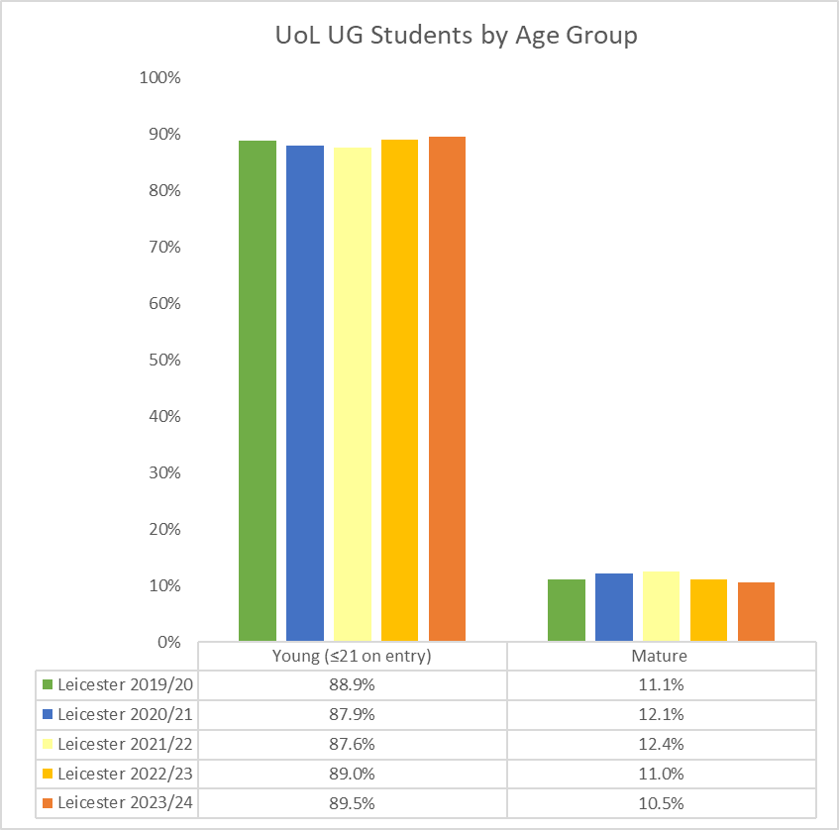

Staff: Graph 1.2 All UoL staff by age group 2020 to 2024
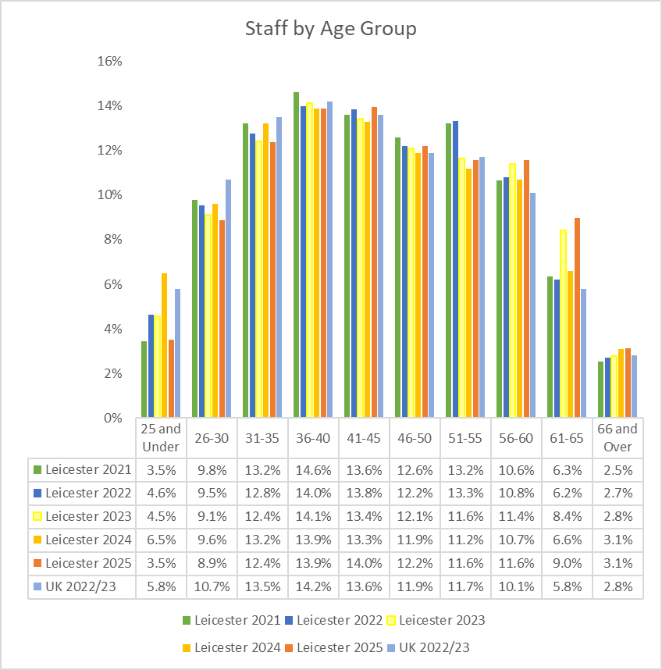

Disability

Students: Table 2.1 All UoL students by disability, 2018/19 to 2022/23

Staff: Table 2.2 UoL staff by declared disability 2020 to 2024

Students: Graph 2.1 All UoL students by disability, 2018/19 to 2022/23
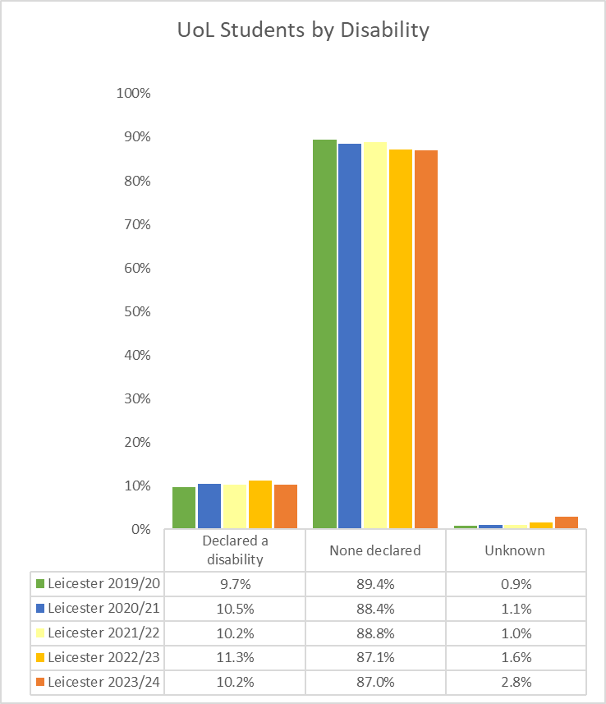

Staff: Graph 2.2 UoL staff by declared disability 2020 to 2024
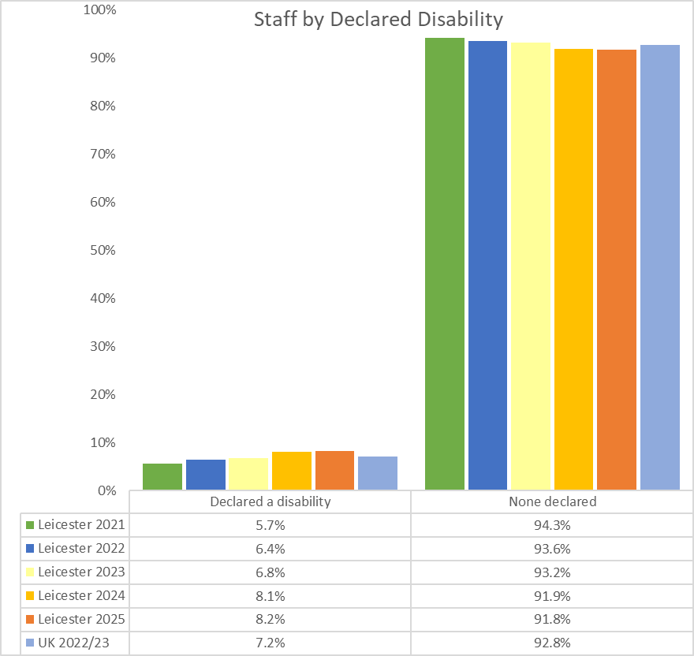

Ethnicity

Students: Table 3.1 All UoL students by ethnicity (minority ethnic, white and not declared) 2018/19 to 2022/23

Staff: Table 3.2 UoL staff by ethnicity – grouped 2020 to 2024

Students: Graph 3.1 All UoL students by ethnicity (minority ethnic, white and not declared) 2018/19 to 2022/23

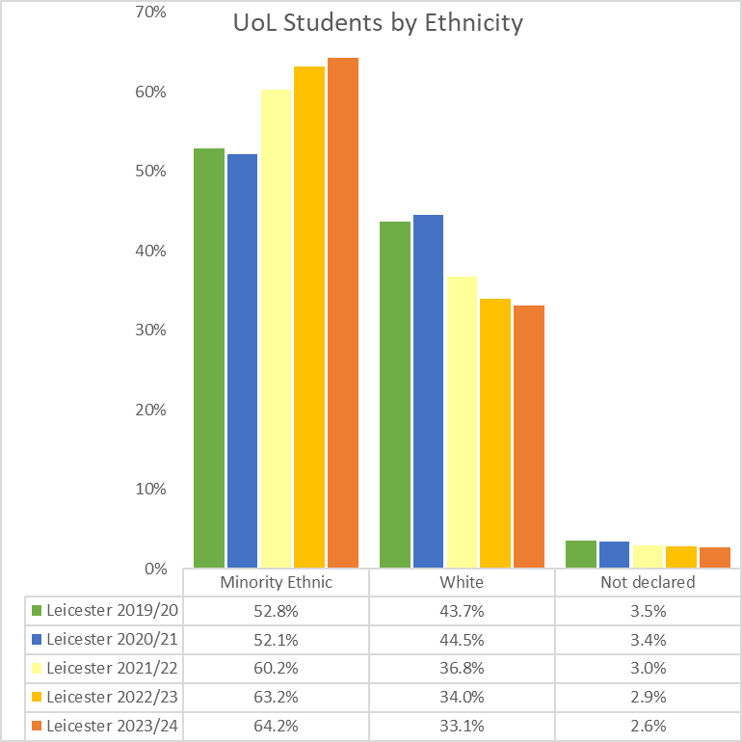

Staff: Graph 3.2 UoL staff by ethnicity – grouped 2020 to 2024
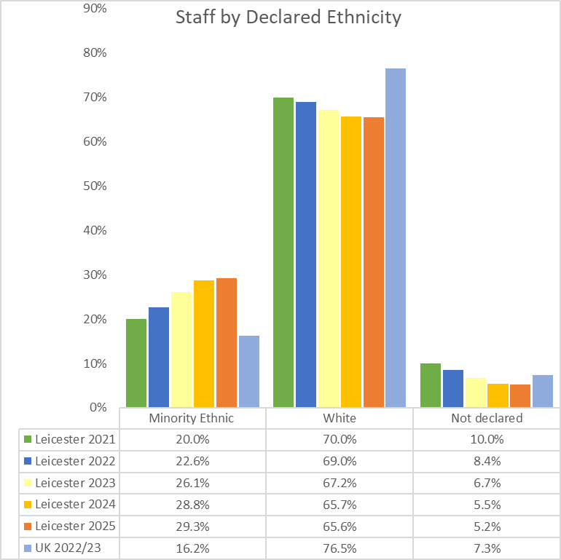

Students: Table 3.3 Breakdown of UoL Students by ethnicity 2019/20 to 2022/23

Staff: Table 3.4 UoL staff by ethnicity 2020 to 2024

Students: Graph 3.3 Breakdown of UoL Students by ethnicity 2019/20 to 2022/23
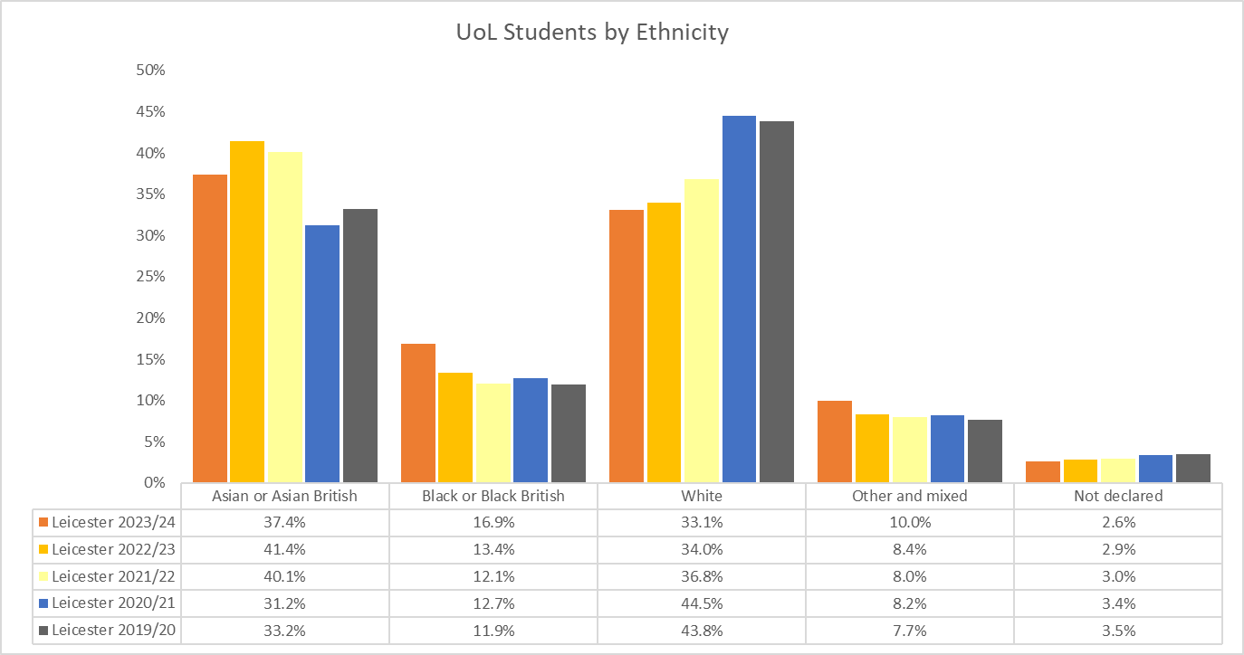

Staff: Graph 3.4 UoL staff by ethnicity 2020 to 2024
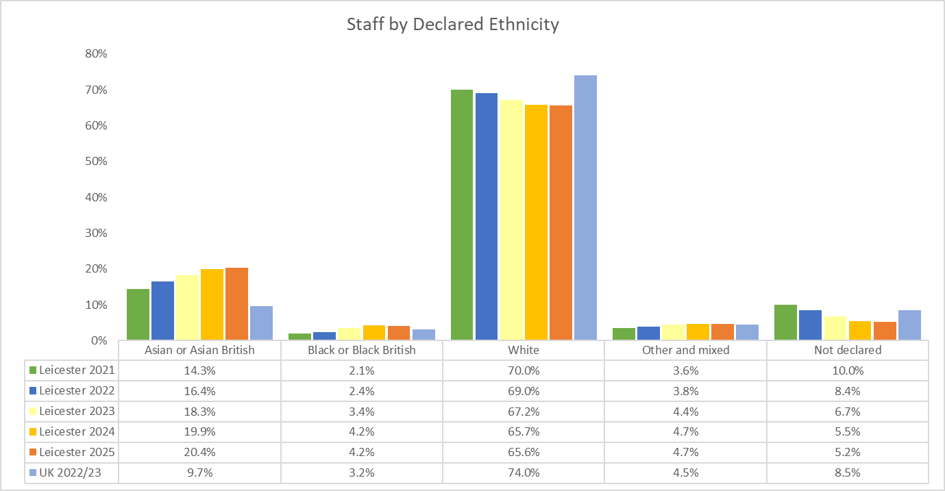

Students: Table 3.5 Detailed ethnicity breakdown of UoL Students who identify as Minority Ethnic 2019/20 to 2022/23

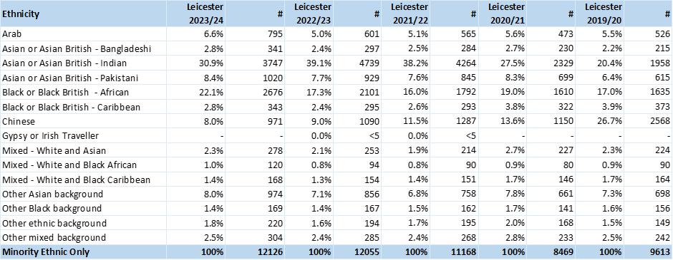
Students: Table 3.6 Breakdown of UK Domiciled UoL Students by ethnicity 2019/20 to 2023/24

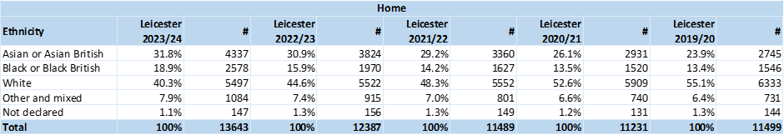
Students: Table 3.7 Breakdown of International UoL Students by ethnicity 2019/20 to 2023/24

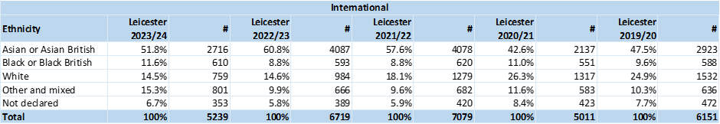

Students: Graph 3.5 Breakdown of UK Domiciled UoL Students by ethnicity 2019/20 to 2023/24

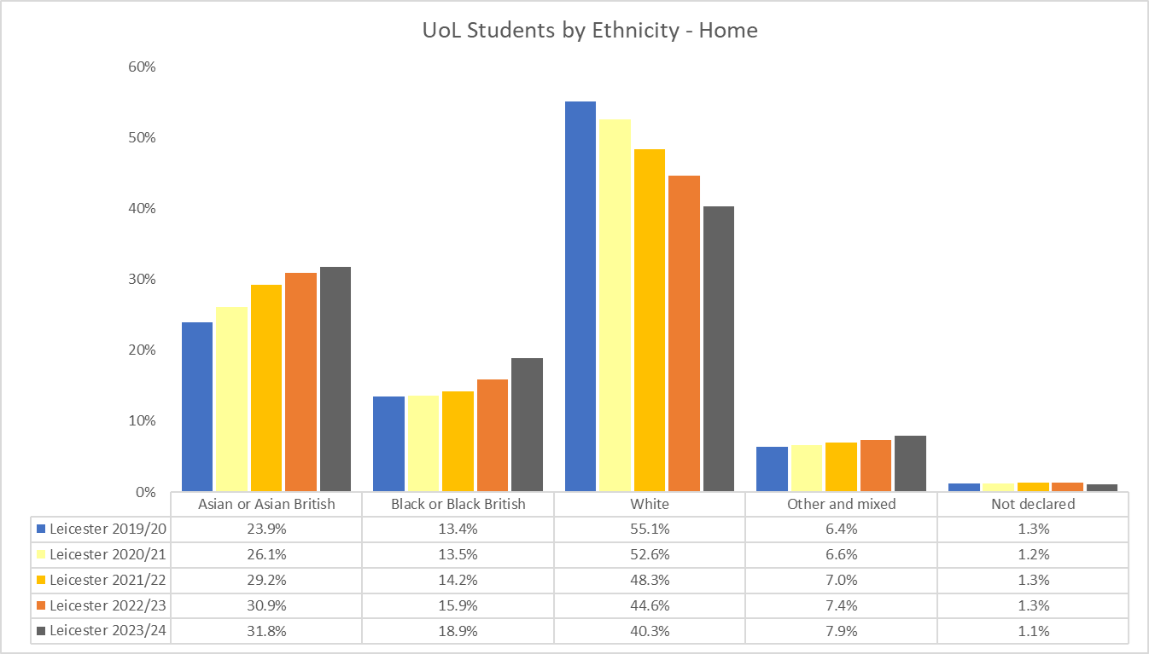

Students: Graph 3.6 Breakdown of International UoL Students by ethnicity 2019/20 to 2023/24

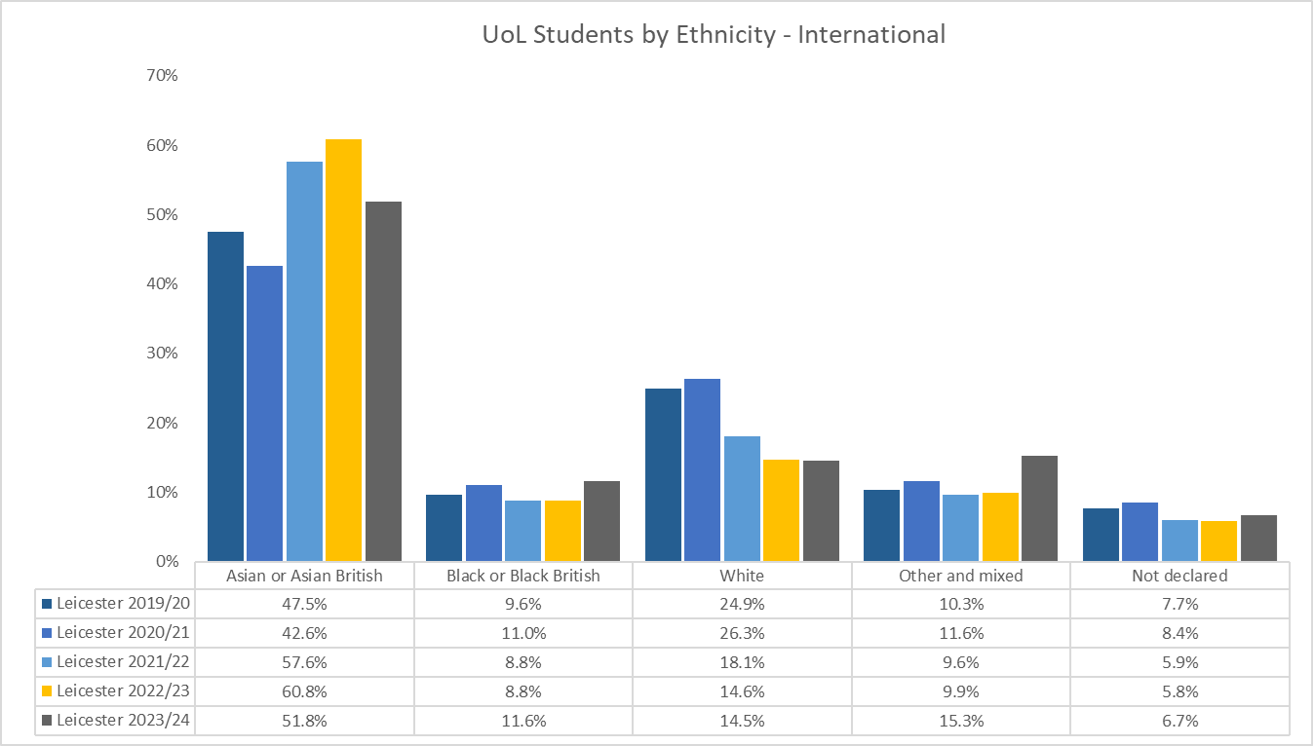

Students: Table 3.8 Detailed ethnicity breakdown of Home UoL Students who identify as Minority Ethnic 2019/20 to 2023/24

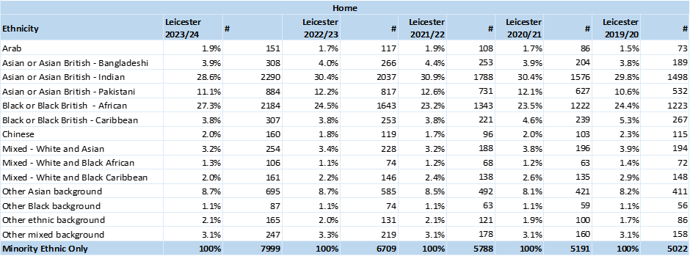

Students: Table 3.9 Detailed ethnicity breakdown of International UoL Students who identify as Minority Ethnic 2019/20 to 2023/24

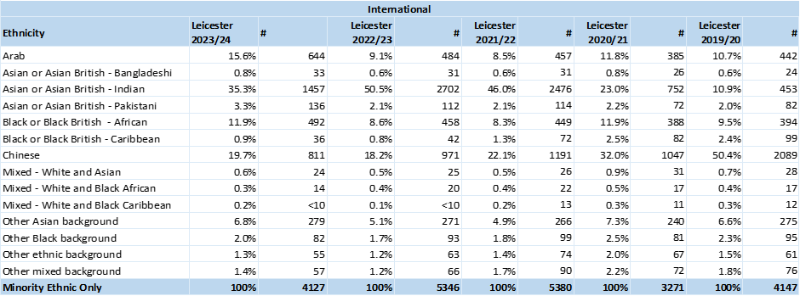

Religion or Belief

Students: Table 4.1 All UoL students by religion or belief, 2018/19 to 2022/23

Staff: Table 4.2 UoL staff by religion or belief 2020 to 2024

Students: Graph 4.1 All UoL students by religion or belief, 2018/19 to 2022/23

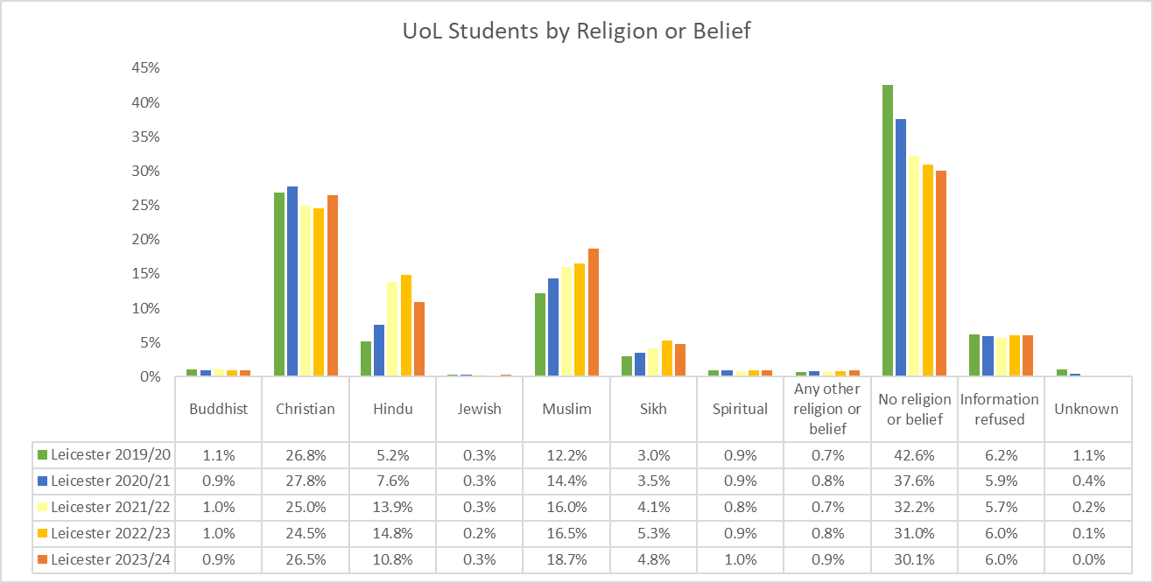

Staff: Graph 4.2 UoL staff by religion or belief 2020 to 2024

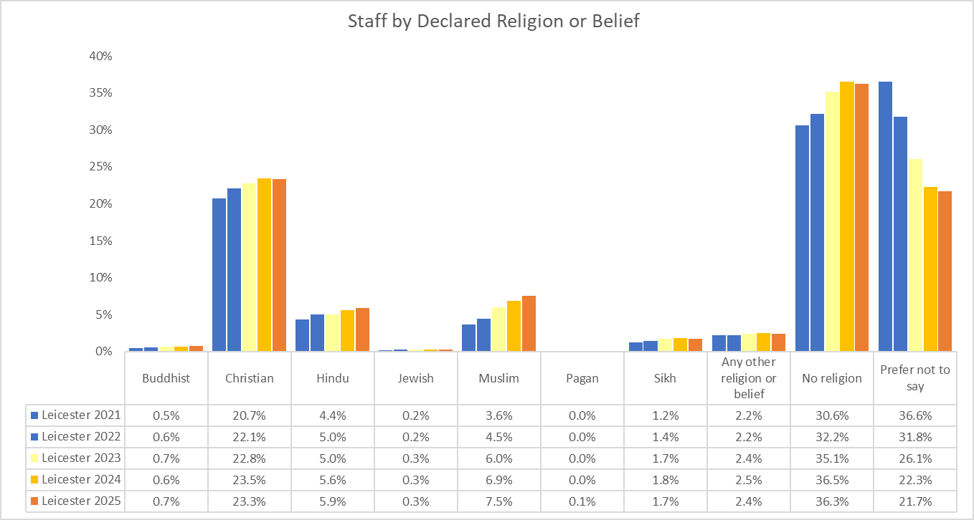

Sex

Students: Table 5.1 All UoL students by sex, 2018/19 to 2022/23

Staff: Table 5.2 UoL staff by Sex 2020 to 2024

Students: Graph 5.1 All UoL students by sex, 2018/19 to 2022/23

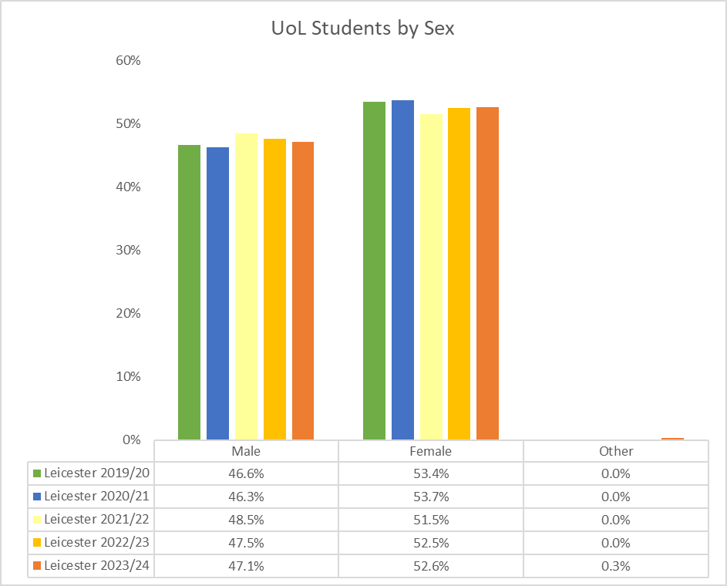

Staff: Graph 5.2 UoL staff by Sex 2020 to 2024

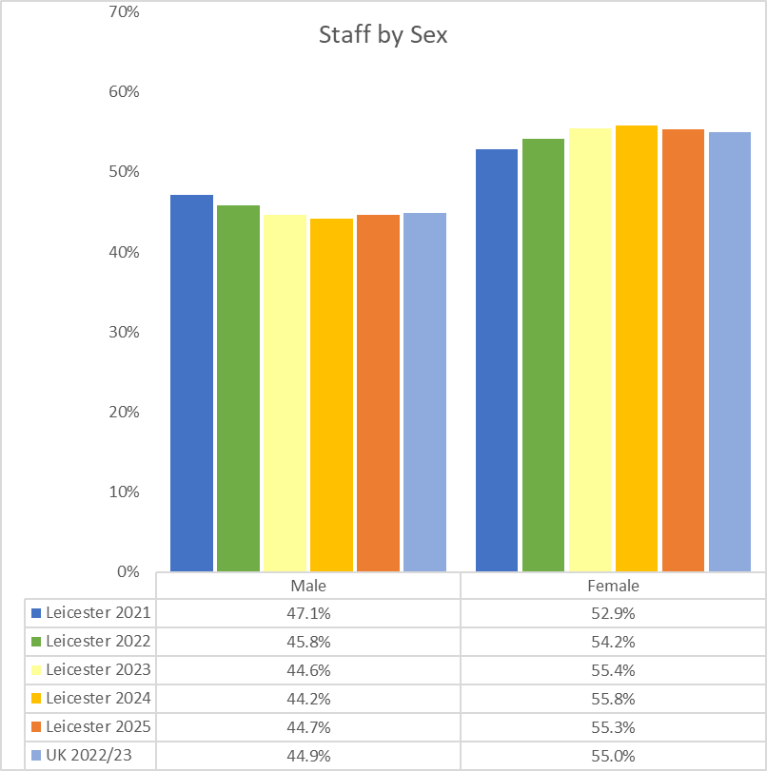

Gender Identity

Student: Table 6.1 UoL students by gender identity 2024

Staff: Table 6.2 UoL staff by gender identity 2024

Student: Graph 6.1 UoL staff: Gender Identity
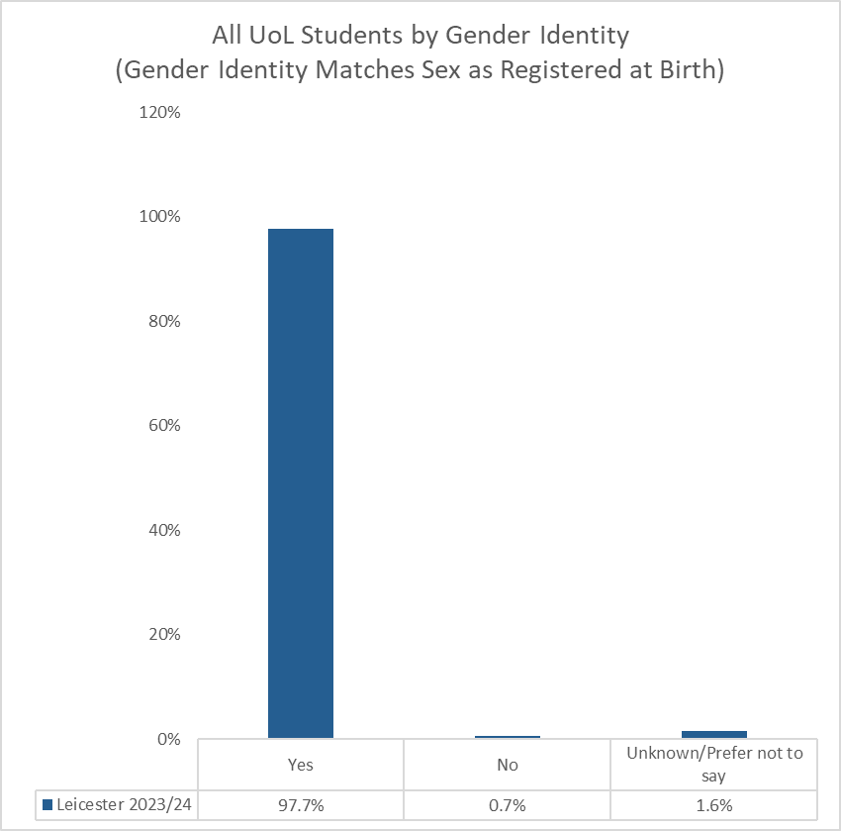
Staff: Graph 6.2 UoL staff: Gender Identity
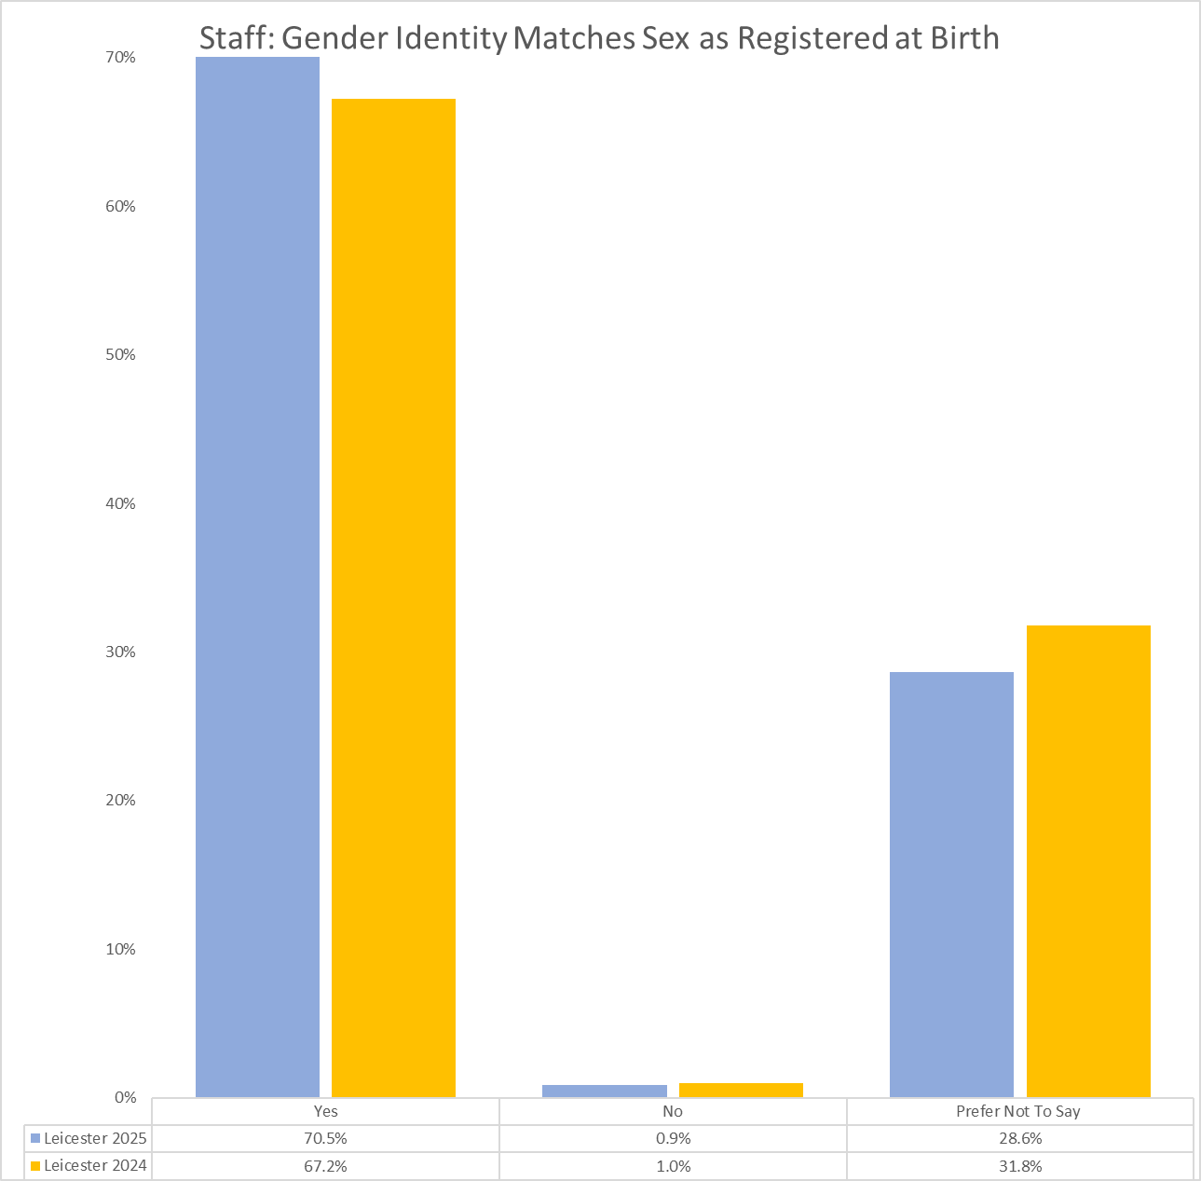

Sexual Orientation

Students: Table 7.1 All UoL students by sexual orientation, 2018/19 to 2022/23

Staff: Table 7.2 UoL staff by grouped sexual orientation 2020 to 2024

Students: Graph 7.1 All UoL students by sexual orientation, 2017/18 to 2021/22

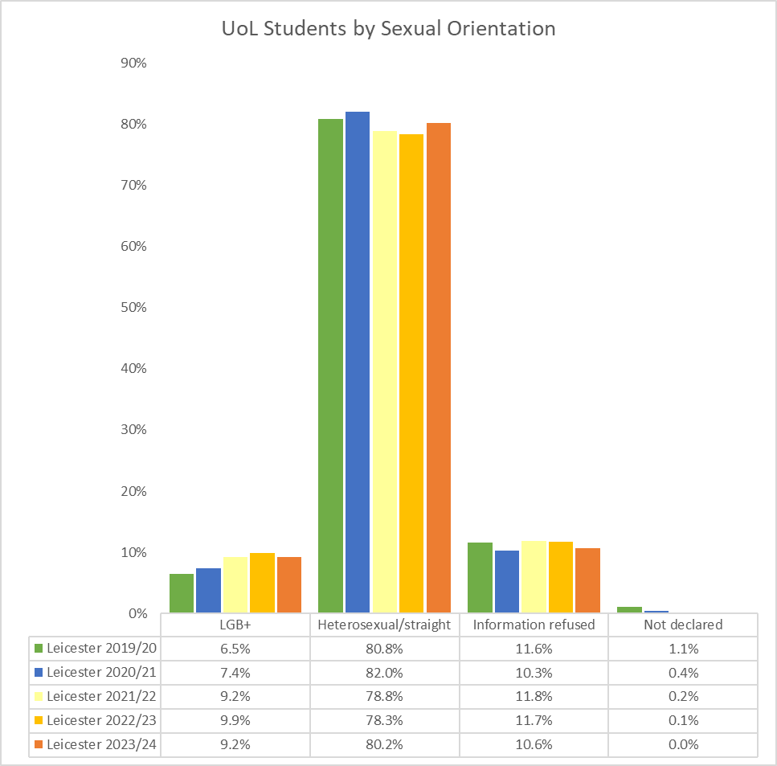

Staff: Graph 7.2 UoL staff by grouped sexual orientation 2020 to 2024

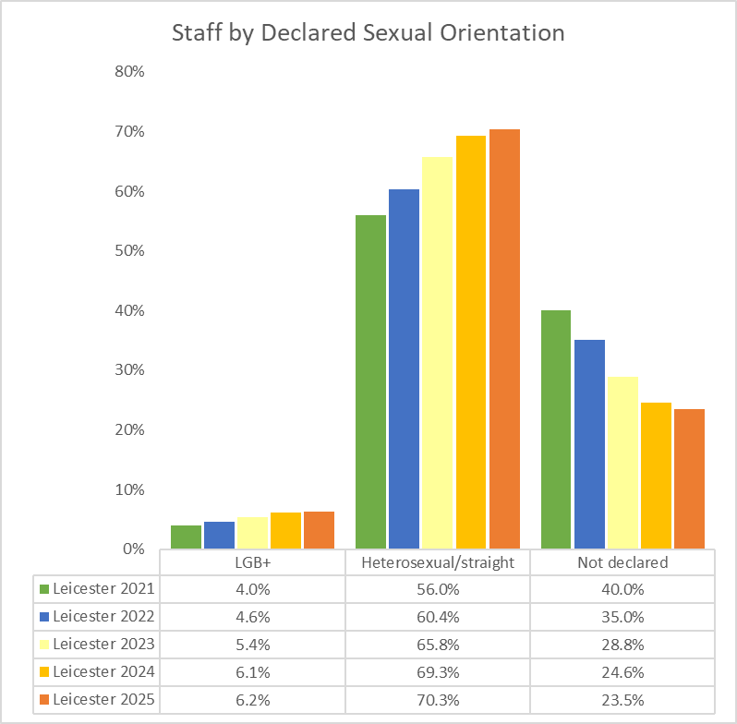

Appendix B

University of Leicester Pay Gaps Report 2024

All information provided by the Student and Education EDI Team
All information provided by the SU Liberation Officer

