University of Leicester Pay Gaps Report 2024

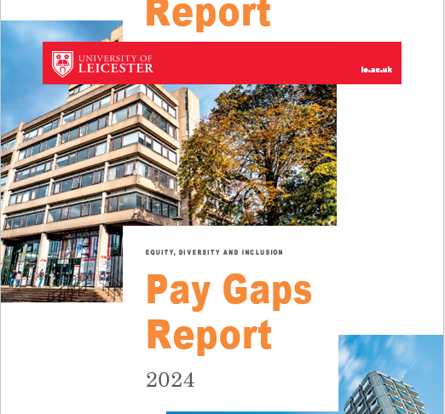

The University of Leicester’s commitment to ensuring all members of our community are treated in a fair and equitable way remains a key priority.

You can find information about the University’s 2024 disability, ethnicity, gender and sexual orientation pay gap information and the actions we are taking to close these gaps on these pages.

Whilst there is no statutory duty to report on pay gap data beyond gender, we are publishing this data as part of our commitment to equity for all staff. Publishing this will enable us to track, monitor and report our progress in a transparent way, to better understand the cause of any disparities and to determine future actions to close these gaps.

Data note

The data used to calculate the relevant pay gaps comes from a snapshot of employee data taken on the census date of 31 March 2024. The gender pay gap data includes all Full Pay Relevant Employees in line with statutory guidelines for reporting. There are no statutory guidelines for reporting ethnicity, disability and sexual orientation pay gaps. The methodology used to calculate these pay gaps varies from the methodology used to calculate the statutory gender pay gap. Due to system limitations and the low declaration rates of protected characteristics beyond ‘legal sex’ from our atypical staff, we have excluded these staff from the ethnicity, disability and sexual orientation pay gap figures, along with any staff who have chosen ‘Prefer Not to Say’ for the relevant protected characteristic. We hope to move to more full reporting of all employees following future system developments.

Headline Data

The headline data from the 2024 Report includes:

Median Pay Gaps Changes:

* A very small decrease in the median disability pay gap (of 0.3 percentage points from 19.5% to 19.2%).
* An increase in the median ethnicity pay gap (of 1.0 percentage point from 13.3% in 2023 to 14.3%), in the median gender pay gap (of 0.2 percentage points from 17.9% in 2023 to 18.1% in 2024) and in the median sexual orientation pay gap (of 0.2 percentage points from 16.9% in 2023 to 17.1% in 2024).
* This amounts to a total movement of 1.7 percentage points across the 4 median pay gaps, with 0.3 of this being favourable (decreasing pay gaps) and 1.4 being unfavorable (increasing pay gaps).

Mean Pay Gaps Changes:

* There is an increase of over 5 percentage points in the mean disability pay gap (5.6 percentage points, from 9.2 in 2023 to 14.8% in 2024).
* There is a smaller increase of 2.1 percentage points in the mean sexual orientation pay gap (from 12.4% in 2023 to 14.5% in 2024).
* Both the mean ethnicity pay gap and the gender pay gap have seen small reductions, with the mean ethnicity pay gap reducing by 2.5 percentage points (from 12.0% in 2023 to 9.5% in 2024) and the mean gender pay gap reducing by 0.7 percentage points (from 19.2% in 2023 to 18.5% in 2024).
* This amounts to a total movement of 10.9 percentage points across the 4 mean pay gaps, with 2.3 of this being favourable (decreasing pay gaps) and 7.7 being unfavorable (increasing pay gaps).

*Table 1: UoL Pay Gaps 2024 (with 2023-24 movement)*

|  |  |  |  |  |  |  |
| --- | --- | --- | --- | --- | --- | --- |
|  | Mean  2024 | Movement from 2023 | Mean 2023 | Median 2024 | Movement from 2023 | Median 2023 |
| Disability | **14.8%** | **+5.6** | 9.2% | **19.2%** | **-0.3** | 19.5% |
| Ethnicity | **9.5%** | **-2.5** | 12.0% | **14.3%** | **+1.0** | 13.3% |
| Gender (mandatory) | **18.5%** | **-0.7** | 19.2% | **18.1%** | **+0.2** | 17.9% |
| Sexual orientation | **14.5%** | **+2.1** | 12.4% | **17.1%** | **+0.2** | 16.9% |

**UoL Pay Gaps 2024 (with 2023-24 movement)**

Gender Pay Gap

The University’s 2024 mean gender pay gap is 18.5%, and the median gender pay gap is 18.1%. Both of these are higher than the higher education sector gender pay gap calculated by Advance HE, which reports a mean gender pay gap of 13.7% and a median gender pay gap of 9.0%.

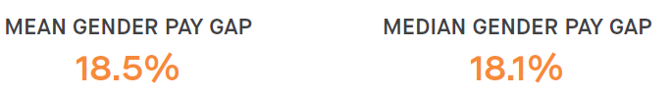

Since 2017, the University of Leicester has seen an overall reduction of 5.6 percentage points to its mean gender pay gap and an overall reduction of 4.6 percentage pointsto its median gender pay gap(Table 2).

*Table 2: University of Leicester Gender Pay Gap 2017-2024*

|  |  |  |  |  |  |  |
| --- | --- | --- | --- | --- | --- | --- |
| **Year** | **Mean Gender Pay Gap** | **+/- Movement for the Year by Percentage Points** | **+/- Movement in Total by Percentage Points** | **Median Gender Pay Gap** | **+/- Movement for the Year by Percentage Points** | **+/- Movement in Total by Percentage Points** |
| 2017 | 24.1% | --- | --- | 22.7% | --- | --- |
| 2018 | 23.1% | **- 1** | - 1 | 19.0% | **- 3.7** | - 3.7 |
| 2019 | 20.6% | **- 2.5** | - 3.5 | 18.4% | **- 0.6** | - 4.3 |
| 2020 | 20.3% | **- 0.3** | - 3.8 | 19.0% | **+ 0.6** | - 3.7 |
| 2021 | 20.0% | **- 0.3** | - 4.1 | **16.0%** | **- 3.0** | - 6.7 |
| 2022 | 21.1% | **+ 1.1** | -3.0 | 18.6% | **+ 2.6** | - 4.1 |
| 2023 | 19.2% | **-1.9** | -4.9 | 17.9% | **- 0.7** | -4.8 |
| 2024 | 18.5% | **-0.7** | -5.6 | 18.1% | **+0.2** | -4.6 |

**Gender Pay Gap Movement 2017-2024**

The University’s current mean bonus gender pay gap is 80.9% (75.4% in 2023) and median bonus gender pay gap is 50.0%(0% in 2023). As the University only has a small number of bonus awards and the Clinical Excellence Awards are included in these calculations (although the cost of these is partially refunded by the NHS) the bonus gender pay gap is subject to significant fluctuation on an annual basis.

As for many organisations, key determinants of the University’s gender pay gap include the absence of a gender balance across job categories (horizontal occupational segregation) and through the different pay grades (vertical occupational segregation). At the University of Leicester, women continue to be overrepresented in lower and middle paid roles and underrepresented in higher paid roles.

Higher gender pay gaps across the sector are typically seen in HEIs that are research intensive, that have a medical school and that directly employ manual and ancillary staff. The University has all 3 of these.

In terms of interrogating the gender pay gap by function, both the mean and median gender pay gaps are significantly higher for academic staff (16.9% mean and 8.5% median) than for professional services staff (we mean and 2.8% median) (Table 3).

*Table 3: UoL Gender Pay Gaps 2024 by Function*

**UoL Gender Pay Gaps 2024 by Function**

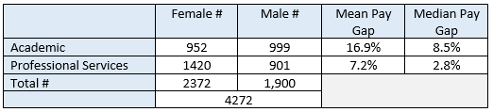

The grouping, Grades 1-5, has the lowest mean and median gender pay gaps (0.4% mean and 2.4% median) and the Clinical Grade has the highest (17.5% mean and 13.7% median). Grade 10 or Professor Grade also has low mean (4.4%) and median (4.6%) gaps (Table 4).

*Table 4: UoL Gender Pay Gaps 2024 by Grade Groupings*

**UoL Gender Pay Gaps 2024 by Grade**

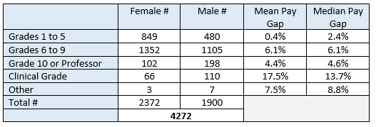

Ethnicity Pay Gap: The University’s 2024 mean ethnicity pay gap is 9.5% (a decrease of 2.5 percentage points from 12.0% in 2023), and the median ethnicity pay gap is 14.3% (an increase of 1.0 percentage point from 13.3% in 2023).

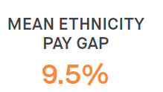 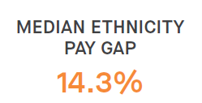

The mean ethnicity pay gap for academic staff is considerably lower (9.4%) than for professional services staff (15.8%) but the median ethnicity pay gaps for both staff groupings is very similar (13.6% for academic staff and 13.0% for professional services staff) (Table 5).

*Table 5: UoL Ethnicity Pay Gaps by Function*

**UoL Ethnicity Pay Gaps 2024 by Function**

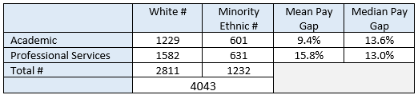

When analysing by staff grade groupings, Grade 10 or Professor has the lowest mean and median ethnicity pay gaps (-0.9% mean and 0.5% median) and the Clinical Grade, again, has the highest (13.9% mean and 11.0% median) (Table 6).

*Table 6: UoL Ethnicity Pay Gaps 2024 by Grade Groupings*

**UoL Ethnicity Pay Gaps 2024 by Grade**

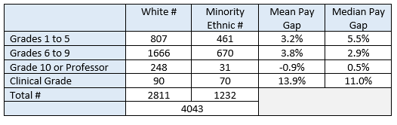

Disability Pay Gap: The University’s 2024 mean disability pay gap is 14.8% (an increase of 5.6 percentage points from 9.2% in 2023), and the median disability pay gap is 19.2% (a decrease of 0.3 percentage point from 19.5% in 2023).

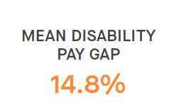 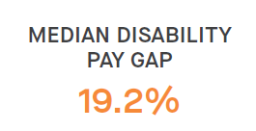

The mean and median disability pay gaps are lower for academic staff (mean 6.9% and median 1.8%) than for professional services staff (mean 9.1% and median 9.7%) (Table 7).

*Table 7: UoL Disability Pay Gaps 2024 by Function*

**UoL Disability Pay Gaps 2024 by Function**

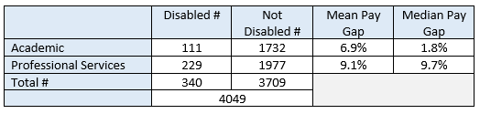

When analysing by staff grade groupings, Grade 10 or Professor has the lowest mean and median disability pay gaps (0.9% mean and 0.1% median) and the Clinical Grade has the highest (16.5% mean and 17.8% median) but the small number of disabled staff (#2) is noted in the Clinical Grade grouping (Table 8).

*Table 8: UoL Disability Pay Gaps 2024 by Grade Groupings*

**UoL Disability Pay Gaps 2024 by Grade**

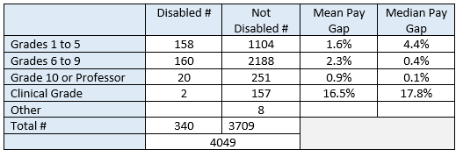

Sexual Orientation Pay Gaps: The University’s 2024 mean sexual orientation pay gap is 14.5% (an increase of 2.1 percentage points from 12.4% in 2023), and the median sexual orientation pay gap is 17.1% (an increase of 0.2 percentage point from 16.9% in 2023).

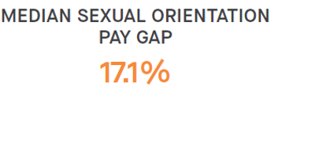

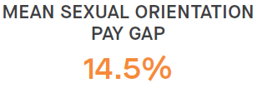

The mean sexual orientation pay gap is slightly lower for lesbian, gay and bisexualt (LGB+) professional services staff (13.1%) than for LGB+ academic staff (14.2%) and the median sexual orientation pay gap is slightly lower for LGB+ academic staff (10.7%) than for LGB+ professional services staff (11.0%) (Table 9).

*Table 9: UoL Sexual Orientation Pay Gaps 2024 by Function*

**UoL Sexual Orientation Pay Gaps 2024 by Function**

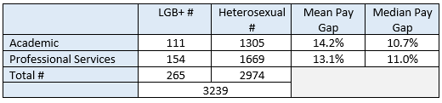

When analysing by staff grade groupings, Grades 1-5 has the lowest mean and median sexual orientation pay gaps (2.8% mean and 3.4% median) and the Clinical Grade has the highest (18.3% mean and 36.3% median) but the very small number of LGB+ (#3) is noted in the Clinical Grade grouping (Table 10).

*Table 10: UoL Sexual Orientation Pay Gaps by Grade Groupings*

**UoL Sexual Orientation Pay Gaps 2024 by Grade**

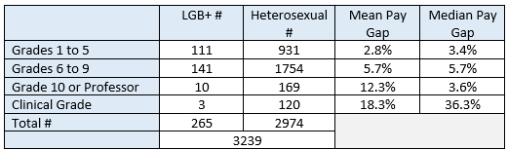

**Intersectional Pay Gaps:** The University’s intersectional pay gaps are the gender pay gaps disaggregated by broad ethnic groupings (minority ethnic and white) and illustrate the separate and combined impact of gender and ethnicity based disadvantage.

The University’s 2024 mean minority ethnic gender pay gap (the mean gender pay gap for minority ethnic women compared to minority ethnic men) is 24.8% and the median minority ethnic gender pay gap is 19.9%. The mean white gender pay gap (the mean gender pay gap for white women compared to white men) is 16.4% and the median white gender pay gap is 13.7%.

**MEAN MINORITY ETHNIC MEDIAN MINORITY ETHNIC**

**GENDER PAY GAP GENDER PAY GAP**

**24.8% 19.9%**

**MEAN WHITE MEDIAN WHITE**

**GENDER PAY GAP GENDER PAY GAP**

**16.4% 13.7%**

Actions to Close UoL Pay Gaps – As detailed in the University of Leicester 2024 Pay Gaps Report, the University is taking a wide range of actions to ensure fairness and equity across all aspects of its employment provision including in relation to:

*Attracting and Retaining Staff:*

* offering competitive pay and setting out our approach to pay and reward in open and transparent ways;
* continually reviewing and improving our recruitment practices and processes to ensure they are equitable and inclusive including by embedding the Inclusive Recruitment Toolkit, anonymous shortlisting for professional services roles, each departments receiving annual recruitment data health checks.

*Nurturing and Developing Staff:*

* reinforcing our transformational approach to academic progression and promotion, created through the Leicester Academic Career Map;
* delivering our comprehensive suite of development and leadership programmes, which have equity and unconscious bias awareness embedded throughout; 4.11
* implementing mentoring and coaching to support through the academic promotion process;

*Valuing Equity and Diversity*

* progressing our Institutional Athena Swan Charter Silver, Race Equality Charter Bronze and Disability Confident Leader action plan priorities;
* mandating all staff to complete both an EDI and Challenging Unconscious Bias online modules and line managers to complete Disability Confidence Training;
* offering a portfolio of resource and leaning and development opportunities to support inclusivity, including LGBT+ and Disability toolkits;
* improving disclosure rates of diversity data to enable improved understanding of barriers and disadvantage for equity groups;
* requiring all staff who sit on recruitment and selection panels to additionally complete training that specifically addresses bias in recruitment and selection processes;
* providing networking and support opportunities through our Four Staff Equity Fora and Carers and Parents Network;

*Celebrating and Recognising Success:*

* ensuring our approach to performance, reward, recognition and promotion is transparent, understandable and fair, including offering promotion workshops for minority ethnic and women staff.
* embedding evidence-based action in promotion processes, including providing demographic data and having bias observers on professorial panels.

Further Actions to Close UoL Pay Gaps: During 2024/25, further interrogation of the disaggregated pay gap data will be completed to understand patterns and trends across pay grades and organisational areas. This analysis will feed into work already started with the 4 Equity Action Groups to identify further possible actions to close the pay gaps.