Probing the high redshift universe with gamma-ray bursts
- Addressing fundamental questions around the formation of the first stars and galaxies.  - Exploiting existing (Swift, VLT, HST, JWST) and new facilities (SVOM, Gemini/Scorpio), for discovery and study of high-redshift GRBs and their hosts.  - Building on world-leading track record of Leicester group. | Level | PhD
 | First Supervisor | Pro Nial Tanvir  nrt3@le.ac.uk
 | Second Supervisor | Prof Paul O’Brien
 | Application Closing  Date | See web page
 | PhD Start date | September 2024

Project Details:

Long-duration gamma-ray bursts (GRBs), are exceptionally bright explosions detectable at great distances. Some GRBs occurred during the first billion years in the life of the universe, and so can be used to probe the early stars and galaxies in which they arose, and their effects on the intergalactic medium around them. This era is of great interest, and a primary target of our existing large telescope campaigns (e.g. using the ESO/VLT) and new facilities such as the James Webb Space Telescope, the new Scorpio spectrograph on Gemini etc. GRBs allow us to measure the amount of star formation taking place; pinpoint the kinds of galaxies it was occurring in; measure the build-up of heavier chemical elements; measure the amount of ionizing radiation escaping from these galaxies and hence their contribution to reionizing the universe.

In Leicester, we have a long history of discovering and studying the most distant known GRBs, and are world leaders in using them to study the era of reionization. We also are a partner institute in the Swift and new SVOM satellite (launch expected early 2024), which discover and localise the GRBs.

The main aims of the proposed PhD are to investigate the use of GRBs to explore open questions in galaxy evolution, and to use the host populations to constrain the progenitors of GRBs. This will involve triggering observations, analysing and interpreting data from the facilities outlined here. It may also involve simulating the capabilities of future facilities, such as the proposed Theseus mission.

References:

- Tanvir et al. 2009 Nature 461 1254
- Tanvir et al. 2012 ApJ 754 46
- McGuire et al. 2016 ApJ 825 135
- Tanvir et al. 2019 MNRAS 483 5380

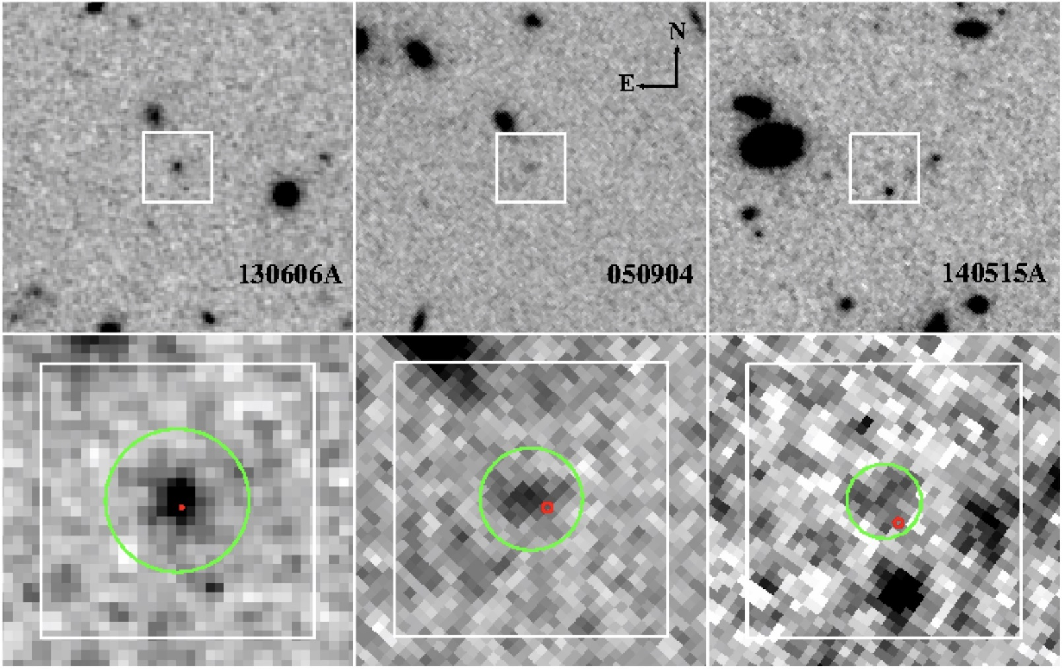

(Host_mosaic.jpg)
Three GRB hosts at redshift 6. Hubble Space Telescope (negative) images of three of the highest redshift GRB host galaxies so far discovered. Unlike other high redshift galaxies, spectroscopy of the GRB afterglows in these cases allows us to study in detail the gas in the interstellar media of these systems. (Work of a previous Leicester PhD student, Joe McGuire)

Further information on how to apply and funding can be found at
https://le.ac.uk/study/research-degrees/funded-opportunities/stfc

