Astrophysical transient searches with LOFAR
- Low frequency emission probes regions of shock acceleration and intense star formation in the Universe.  - LOFAR is providing a transformational increase in radio survey speed in the newly accessible low-frequency regime.  - The low frequency sky is revealing a transient population of astrophysical sources, many of unknown origin. | Level | PhD
 | First Supervisor | Dr Rhaana Starling  rlcs1@le.ac.uk
 | Second Supervisor | Prof Andrew Blain
 | Application Closing  Date | See web page
 | PhD Start date | September 2024

Project Details:

- The low frequency radio regime is a relatively unexplored parameter space rich in information concerning extreme astrophysical phenomena, particularly those in which magnetic fields play a key role like magnetars (highly magnetic neutron stars) and relativistic jets launched by black holes and compact object mergers. The power of the LOFAR low-frequency array to probe transient astrophysical sources is becoming evident, while for many of the transients discovered their progenitor systems and/or physics are not yet known. LOFAR is providing a transformational increase in radio survey speed in the newly accessible low-frequency regime and our international team have made significant progress in finding fast transients following the development of a dedicated detection pipeline for LOFAR images and an automated system to feed high energy transient alerts to LOFAR to initiate rapid follow-up observations. The LOFAR Surveys are continually building up images of the northern sky in which we can search for new radio bursts, to probe the populations represented among transient events. In parallel, high energy satellites are triggering on gamma-ray bursts created in shock fronts within relativistic jets. For some of these, magnetic models predict a coincident MHz radio burst, while for others radio emission is expected from spin-down of a new-born magnetar or its collapse to a black hole, and we can probe both with LOFAR in rapid-response mode.

- This PhD is well timed for the exploitation of a major upgrade to the LOFAR facility, vastly increasing the capability for transient observations in the LOFAR2.0 phase from 2025 with commissioning of the upgraded facility beginning in 2024. The PhD researcher will have an opportunity to contribute to shaping of the transients programme for LOFAR2.0, and will develop skills applicable to future big data projects such as the radio facility the Square Kilometre Array.

- The goals are to find and identify radio transients in LOFAR data. This may be survey imaging or images taken as part of follow-up of high energy events such as gamma-ray bursts and gravitational waves. Methodology includes application of analysis techniques to obtain unique radio data products, and to augment and apply our transients detection pipeline to probe LOFAR images on different timescales. The group here has access to a wide range of other facilities to collect broadband data, which may be combined with the radio information to model physical processes and origins of detected transients.

- An affinity with python or other programming language, and some familiarity with how radio interferometry works, would be beneficial.

References:
- A LOFAR prompt search for radio emission accompanying X-ray flares in GRB 210112A Hennessy, Starling et al. 2023, Monthly Notices of the Royal Astronomical Society, 526, 106 https://browse.arxiv.org/pdf/2308.16121.pdf

Constraining a neutron star merger origin for localized fast radio bursts Gourdji et al. 2020, Monthly Notices of the Royal Astronomical Society, 417, 3131 https://browse.arxiv.org/pdf/2003.02706.pdf

- Constraining coherent low frequency radio flares from compact binary mergers Rowlinson & Anderson 2019, Monthly Notices of the Royal Astronomical Society, 489, 3316 https://browse.arxiv.org/pdf/1905.02509.pdf

- www.lofar-surveys.org

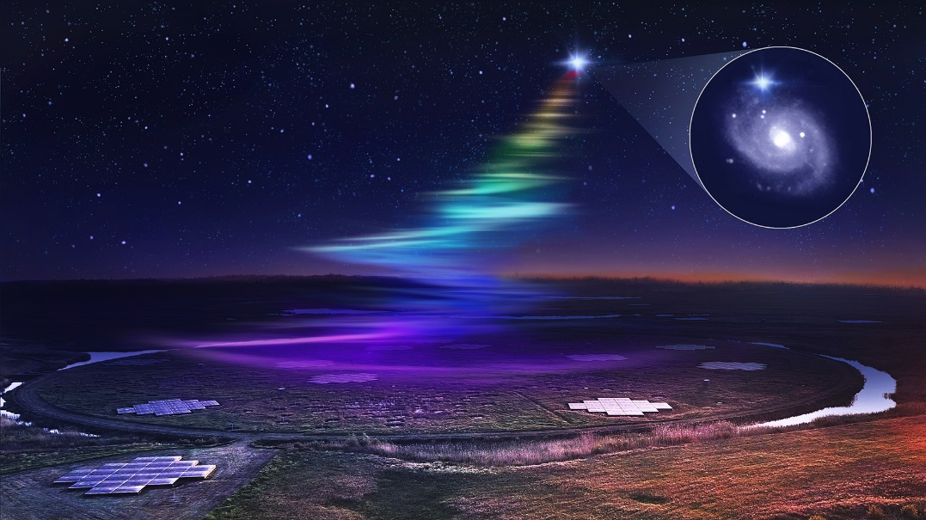

Artistic view over part of the LOFAR array as it captures low frequency radio waves from a fast radio burst. FRB20180916B is located in a spiral galaxy 500 million light years from Earth. Credit: Daniëlle Futselaar/ASTRON/HST.

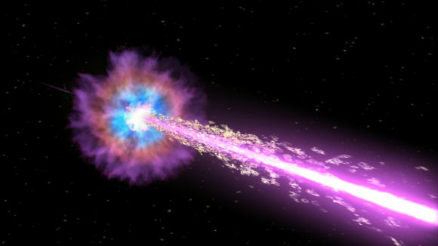
Artist’s impression of gamma-ray burst GRB 221009A, the brightest burst detected to date with the NASA Neil Gehrels Swift Observatory. Credit: NASA/Swift/Cruz deWilde.

Further information on how to apply and funding can be found at
https://le.ac.uk/study/research-degrees/funded-opportunities/stfc

