The outer bound of planet formation
- High performance numerical simulations of planet and binary star formation  - Compare simulation results with the recent exciting observational progress  - Understand protoplanetary discs and develop coding skills that will make you widely employable | Level | PhD
 | First Supervisor | Prof Sergei Nayakshin  sn85@le.ac.uk
 | Second Supervisor | Paul McMillian
 | Application Closing  Date | See web page
 | PhD Start date | September 2024

Project Details:

One of the most fundamental problems in Astronomy is how planets form. The classic paradigm for planet formation was built solely on the basis of the Solar System data of the last century. It assumes that planets grow over Millions of years by slow accumulation of matter from their local neighbourhood.

We can now observe exo-planets in ways unimaginable to our forefathers. The new data of the last 20 years are best summarised by the phrase ``no one predicted this”. The data show that planet formation is a robust process that thrives in surprisingly violent and chaotic environments nothing like the Solar System. The classic paradigm for planet formation is far from complete, and we need new ideas on how planets form.

Sophisticated numerical simulations of the last dozen years predict that planets can form much farther away from their stars than any planet in the Solar System. ``New” physical processes – gravitational instability of protoplanetary discs, planet migration, planet-planet interactions, star-planet scatterings, to name a few – can now be studied via High Performance Computing (HPC). Our group has led the way in using HPC to try and complement the classic planet formation paradigm with new pathways for planet formation [1,2]. These simulations show that planetary systems can form in a percent of the time needed by the classical picture. Furthermore, planets form by their dozens [Fig. 2], but then interactions send some into the inner regions and in fact all the way into the star, some lose mass and become small Earth-like planets, whereas yet others are completely ejected to become Freely Floating Planets (FFPs).

Two independent and very exciting observational results of 2023 made FFPs an extremely hot and important topic since they challenge the classic picture especially strongly. First, microlensing observations of the last decade culminated in detecting a surprisingly high number of small planets not bound to any star [3]. Statistical interpretation of these observations demand about 20 FFPs per each star in the Galaxy! Second, with James Webb Space Telescope (JWST) becoming operational recently, it became possible to detect very young gas giant FFPs much more robustly. JWST discovered over a hundred such planets in the nearby Orion star forming complex, and very surprisingly, many of them are wide (~100 AU separation) binary planets [Fig. 1]. Taken together, these observations suggest that planet formation at the far outskirts of planetary systems that our group advocated in the last decade is indeed far more prevalent than previously believed.

In this project we shall use HPC simulations to address planet formation via gravitational instability (GI) concurrent with stellar binary formation [Fig 2]. Past simulations focused mainly on gas giant planets formed around single stars. Such simulations show how gas giants formed by GI can be tidally disrupted to become lower mass planets. On the opposite end of the scale, some planets survive and manage to accrete so much gas as to grow into low mass stars. These (secondary) stars then eject most of the lower mass objects from the system. This model can therefore account for both low mass FFPs detected by microlensing, and the high mass FFPs detected by direct imaging. The challenge is to quantify these simulations up and to compare them with a wide array of observations.

An ideal candidate for this post will be interested in connecting theoretical/simulation work with observations. They will have background in Physics and/or Astronomy, and be keen on numerical work. The PhD student will be a part of the group and will be provided with well documented HPC codes that they will develop further. Their first goal will be to understand the conditions under which FFPs are formed in the simulations. Next they will try to compare this with the observations. Extension goals of the project include: other types of planets formed in the simulations (e.g., planets observed in binary systems); stellar multiple systems; flares on young stars occurring when they disrupt (consume) planets, and more.
References:
- Cha & Nayakshin, 2011, MNRAS, 415, 3319 https://ui.adsabs.harvard.edu/abs/2011MNRAS.415.3319C/abstract
- Nayakshin 2017, PASA, Dawes Reviews 7, https://ui.adsabs.harvard.edu/abs/2017PASA...34....2N/abstract
- Sumi et al 2023, AJ, 166, https://ui.adsabs.harvard.edu/abs/2023AJ....166..108S/abstract
- Pearson & McCaughrean 2023, preprint, https://ui.adsabs.harvard.edu/abs/2023arXiv231001231P/abstract
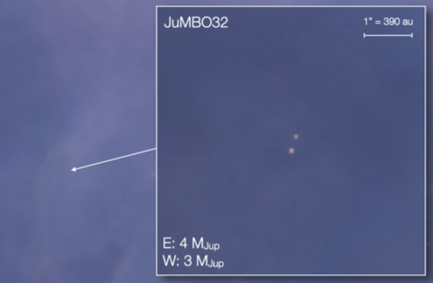
JWST NIRcam short wavelength colour composite image of the binary planet JuMBO32 in the Orion Nebula, see Fig. 1 from Pearson and McCaughrean 2023. This image is unprecedented as directly imaged planets were not yet seen to be in binaries (orbiting one another, not another star!) and in such large numbers.

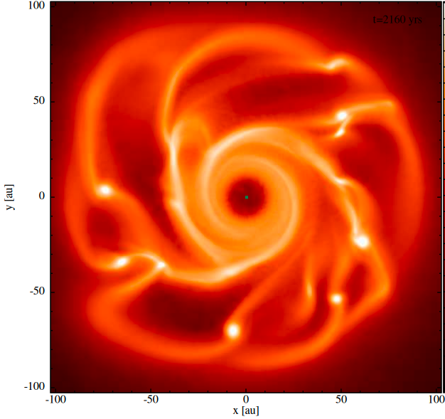

Numerical simulation of planet formation via Gravitational Instability of a protoplanetary disc performed in our group. The brighter the colour the denser the disc is at that location. The novelty of our approach is in resolving young planets internal structure rather than modelling them as ``sinks” (point masses). This allows us to predict accurately what happens with these planets (disruption, merger, inward migration or ejection).

Further information on how to apply and funding can be found at https://le.ac.uk/study/research-degrees/funded-opportunities/stfc

