The disturbances of the outer Milky Way
- The Milky Way has been disturbed. We’ll try to understand how and when.  - Modern data about the Milky Way is incredible. You will improve our models & theory to catch up!  - Perform “Galactic seismology”, understanding the galaxy through waves that are moving through it. | Level | PhD
 | First Supervisor | Dr Paul McMillan  paul.mcmillan@le.ac.uk
 | Second Supervisor | Prof Mark Wilkinson
 | Application Closing  Date | See web page
 | PhD Start date | September 2024

Project Details:
The Milky Way is the galaxy that we can study in by far the most detail. It is the best place to look if we want to understand in detail the processes that build and shape all galaxies. This approach is referred to as ‘near-field cosmology’ because we can learn about events over the full age of the universe by studying the traces that we see in the Milky Way today.

We are in a golden age of Milky Way science primarily because of the incredible data from the European Space Agency’s Gaia mission, publicly released over the last 5 years (with further releases to come). Gaia is mapping the positions and velocities of almost two billion stars in the Milky Way with ever-increasing precision, 100 times more accurately than they were ever measured before.

With this data we have seen that the Milky Way is far from calm. We can see the disc is not flat, but warps in its outer regions. This warp does not behave the way models predict that warps should – it is precessing at a high speed in the same direction that the galaxy rotates, while theory predicts that it should precess slowly in the opposite direction. More generally, the velocity distribution of the stars is just not as smooth as we would expect in a calm galaxy. Much of the current study of the Milky Way is in discovering, categorising, and trying to explain the ways in which the galaxy is disturbed.

To understand the Milky Way better, this project will build better computer models of its dynamics and compare them to what we can observe in the Milky Way. The timescales on which stars’ orbits change are millions of years, so we are inferring everything from the observed current positions and velocities of stars, which requires a model. The day-to-day work of the project will be running simulations or dynamical models of the Milky Way; analysing the data in comparison to other models, and to what we know about the Milky Way; and further developing and improving the models as we learn what they are missing. A good grasp of mechanics would be valuable, as well as some computer programming experience, but these can and will be improved during the PhD.

Existing models of the disturbance seen in-and-around the Solar neighbourhood appear to give mutually contradictory results for different regions. This raises the question: are all these disturbances in the Milky Way due to a single event, or are we seeing the consequences of multiple events? The project will try to understand if the contradictions seen are because the models deal with the galaxy’s dynamics in too simplistic a way or because they assume a single disturbance, when actually we are seeing the effect of more than one.

There are plausible candidates that could produce either a single dominant disturbance or multiple smaller disturbances. The Sagittarius dwarf galaxy is currently being torn apart by the Milky Way, but may in the past have been heavy enough to dramatically shake the disc. To date this has been the favoured theory for most of this behaviour. However, it is possible that the nearby Large Magellanic Cloud may have had an important tidal influence on the Milky Way’s disc, and even that so-called ‘dark-matter subhaloes’ (i.e., gravitationally bound structures made purely of dark matter) passing through the Galactic disc cause some of what we have seen.

Our view of the Milky Way has completely changed in the last few years, and we are in the exciting phase where our physical understanding of the galaxy is trying to catch up with our data. Just as seismologists learn about the Earth through waves that run through it, we can learn about the Milky Way from the waves seen in the motions of its stars. The work completed by the student will be an important part of better understanding the history of our own galaxy and, ultimately, the processes that shape all galaxies.
References:
- Poggio, E., et al. (2020). “Evidence of a dynamically evolving Galactic warp.” Nature Astronomy 4: 590.
- McMillan, P., et al. (2022). “The disturbed outer Milky Way disc”, Monthly Notices of the Royal Astronomical Society, 516, 4988.
- Tremaine, S., et al. (2023). “The origin and fate of the Gaia phase-space snail”, Monthly Notices of the Royal Astronomical Society, 521, 114.

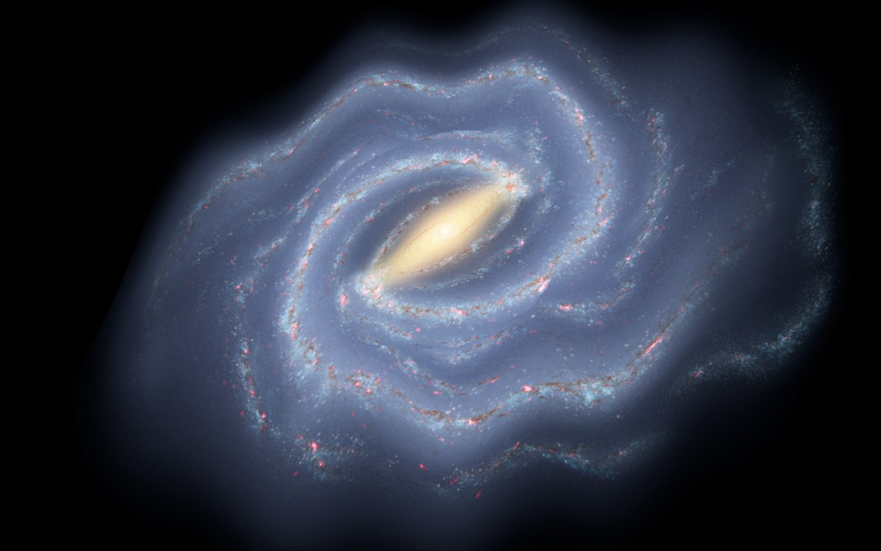

Artist’s impression of the disturbed disc of the Milky Way (Credit: McMillan, based on R. Hurt: NASA/JPL-Caltech/SSC)

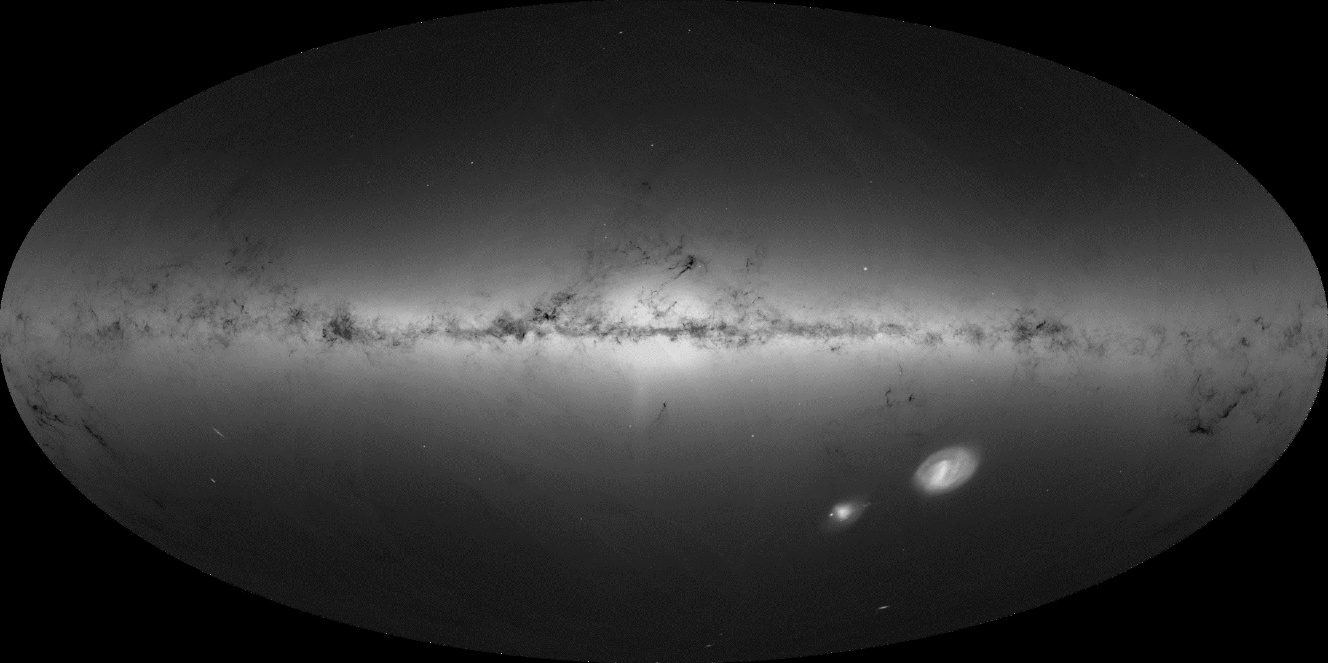

The stars of the Milky Way observed by Gaia (Credit: ESA/Gaia/DPAC; A. Moitinho and M. Barros)

Further information on how to apply and funding can be found at
https://le.ac.uk/study/research-degrees/funded-opportunities/stfc

