X-ray Interferometry: Preparing for a revolution in astronomy
- Developing technology to image an exoplanet in front of its parent star  - Modelling and experimental study of radical new technology  - Supporting a key priority research area of ESA and UKSA | Level | PhD
 | First Supervisor | Dr Adrian Martindale am136@leicester.ac.uk
 | Second Supervisor | Dr Sarah Casewell
 | Application Closing  Date | See web page
 | PhD Start date | September 2024

Project Details:
In the early 2000s the idea of an X-ray interferometer being able to transform astrophysics was born (Cash et al. 2000). Technology improvements over the intervening years now promise ways to make it happen. This project will study how to deliver an instrument that can directly image a black hole or an exoplanet in front of its parent star.

The European Space Agency recently published a science roadmap to 2050 (https://tinyurl.com/mryev7tn) which identified X-ray Interferometry (XRI) instrumentation as a key area for technology development for the coming decade - due to the enormous scope and depth of its scientific potential. XRI delivers over three orders of magnitude better angular resolution than JWST and E-ELT at optical and IR wavelengths, offering the potential to directly resolve some of the most exciting objects in astrophysics. This project will study how it can, uniquely, enable us to directly image an exoplanet transiting its parent star while monitoring the variations in intensity across the stellar disc (a key limitation of existing transit methods).

In 2021, the UK Space Agency provided us with funding for a small project to develop a roadmap for the critical technologies. This roadmap has shown the key areas that need urgent work and this PhD project will deliver critical effort to support the development of this remarkable new technology. The student’s literature review will show how interferometry can, for the first time, simultaneously image a transiting exoplanet or brown dwarf in front of its parent star and monitor the intensity of the stellar disc. They will determine the scientific justification for such measurements by assessing the limitations of unresolved photometric studies of transiting planets. For example, a white paper submitted to the recent NASA Decadal Survey (Wolk et al., 2019) discusses the possibility of X-ray observations measuring asymmetries in transit lightcurves, indicative of stellar wind induced atmospheric depletion, comet-like sublimation tails, or bow shocks around planets. Based on the literature, the student will develop a sub-set of science requirements for a future mission, showing how the next generation of X-ray instruments will go beyond what is possible with JWST and E-ELT at infra-red and optical wavelengths.

The student will investigate the most likely geometry for a practical interferometer, based on a design developed in Leicester (Willingale, 2004) as it is the only current concept that can be realised in a single spacecraft. They will build and publish a detailed instrument simulator that will enable them to model the performance of the instrument in space and during ground testing. This “digital-twin” of the hardware will be in the form of analytical and Monte-Carlo models of instrument performance. An experimental study into the readiness of the critical mirror technologies will be undertaken. These experiments will enable correlation of the model with test data to perform “hardware in the loop” testing of the performance of the interferometer.

Finally, the student will compare their simulations to the driving requirements and reveal the state of readiness of the technologies needed for XRI. By doing this, they will demonstrate the incredible opportunity to fully characterise exoplanets with XRI.

References:
- https://www.nature.com/articles/35025009
- https://arxiv.org/pdf/astro-ph/0405422.pdf
- https://arxiv.org/pdf/1904.04320.pdf

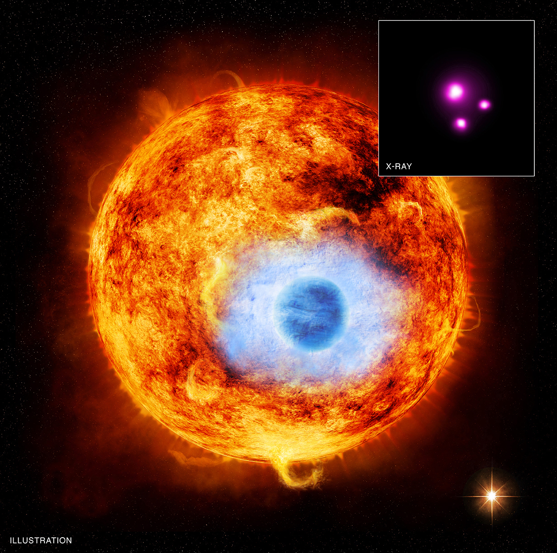

This artist’s impression of HD 189733b depicts the first exoplanet that has been found transiting in front of its parent star in X-rays - by looking for the dip in brightness of the star when the planet crosses the stellar disc. It shows a Jupiter-sized exoplanet in front of a Sun-like star. While current instruments can only resolve the stars (inset), an X-ray interferometer could in principle create an image showing the planet in front of the host star. Credit: X-ray: NASA/CXC/SAO/K.Poppenhaeger et al; Illustration: NASA/CXC/M.Weiss (https://exoplanets.nasa.gov/resources/150/exo-eclipse-in-x-ray-vision/ )

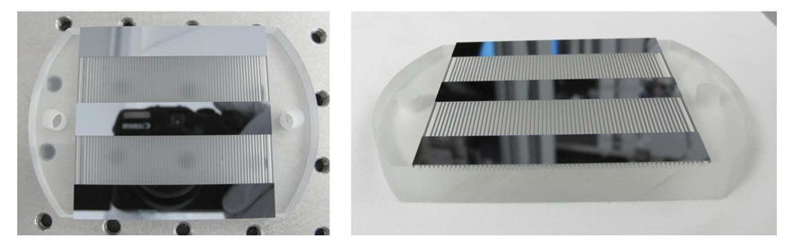
Prototype “slatted mirrors” have been machined from silicon wafers and are approaching the performance needed to create an interferometer. Credit: Willingale et al. Proceedings of the SPIE, Volume 8861, id. 88611S 6 pp. (2013).

Further information on how to apply and funding can be found at
https://le.ac.uk/study/research-degrees/funded-opportunities/stfc

