White dwarfs, planetary debris and fundamental physics

- White dwarf stars are the end points of the life cycles of most stars. They are important astrophysical laboratories.  - White dwarfs are swallowing debris from old planetary systems. Spectra can reveal the bulk composition of planets.  - The Gaia mission has provided a large sample of white dwarfs for detailed study, many of which are in binary systems. | Level | PhD
 | First Supervisor | Prof Martin Barstow  mab@leicester.ac.uk
 | Second Supervisor | Dr Matt Burleigh
 | Application Closing  Date | See web page
 | PhD Start date | September 2024

Project Details:
White dwarfs are the end products of the life cycles of more than 90% of all stars. This makes them important laboratories for studying stellar evolution and the behaviour of matter at extremes of temperature and density. We can study the population of white dwarfs to map out the history of star formation in our Milky Way galaxy. There is growing evidence that many white dwarfs are swallowing up debris from, now destroyed, planetary systems. Measuring the abundance of this material in the atmospheres of the white dwarfs can tell us about the composition of these planets. However, we first need to understand the evolution of white dwarfs, including the composition of their atmospheres. We are using data from a variety of space missions and telescopes to study the population of white dwarfs to provide this insight.

We wish to appoint an enthusiastic PhD student to contribute to the exploitation of this data, drawn from several observational programmes. The work will involve the analysis of spectroscopic and imaging data from the ESA Gaia mission, Hubble Space Telescope (HST) and ground-based telescopes. There will also be a theoretical element to the work, using the University’s supercomputer to simulate stellar atmospheres, for comparison with the data.

There are several lines of research in which the student can become involved, depending on personal interests:

We are closely involved in the European Space Agency Gaia mission. Launched in December 2013, the satellite is carrying out a detailed survey of the entire visible galaxy to measure the positions, space motion and distances of approximately 2 billion stars. Recent data releases, have yielded a sample of 100,000 white dwarfs with low resolution spectra and approximately 800,000 binary star systems, many of which will have white dwarf companions. Combine with follow-up data from other surveys and ground-based spectroscopy, the Gaia data will allow us to characterise the white dwarfs, obtain measurements of masses and radii of unprecedented accuracy, search for hidden stellar/exo-planet companions and search for the elusive progenitors of type Ia supernova explosions.

Measurement of the abundances of C and Si in a large sample of white dwarfs shows that in all cases C is depleted, indicating that the material has a rocky origin – similar to that of asteroids. A likely explanation is that this material is collected from extra-solar planetary debris and then retained in the hot white dwarf’s envelope by the force of radiation. We now need to test this by adapting the atmospheric modeling computer programme to include these physical processes.

Recently, we have shown that high spectral resolution and signal-to-noise spectra of a single hot white dwarfs can be used to measure potential changes in the value of the fundamental physical constants, such as the fine structure constant and electron/proton mass ratio, in a strong gravitational field. The accuracy of the technique is limited by how well we know the wavelengths of atomic absorption features in the spectrum. We have acquired improved atomic data and more high-quality spectra of other stars to continue this work.

A particular challenge of these projects is to handle a large quantity of data and models efficiently. This is likely to require the development of automated processing tools and application of artificial intelligence techniques. Therefore, a candidate with strong programming skills will be welcomed.

References:
M.A. Barstow, J.K. Barstow, S.L. Casewell, J.B. Holberg and I. Hubeny, 2014, “Evidence for an external origin of heavy elements in hot DA white dwarfs”, MNRAS, 440, 1607-1625. (May, 10.1093/mnras/stu216). 205.

S.R.G. Joyce, M.A. Barstow, S.L. Casewell, M.R. Burleigh, J.B. Holberg and H.E. Bond, 2018, “Testing the white dwarf mass-radius relation and comparing optical and far-UV spectroscopic results with Gaia DR2, HST, and FUSE”, MNRAS, 479, 1612-1626 (September – DOI 10.1093/mnras/sty1425).

J.C. Berengut, V.V. Flambaum, A. Ong, J.K. Webb, J.D. Barrow, M.A. Barstow, S.P. Preval and J.B. Holberg, 2013, “Limits on the dependence of the fine-structure constant on gravitational potential from white dwarf spectra”, Phys.Rev.Letters, 111. http://arxiv.org/abs/1305.1337

Gaia Collaboration; P. Montegrifo, M. Bellazzini, F. de Angeli, R. Andrae, M.A. Barstow, et al., 2022, “Gaia Data Release 3: The Galaxy in your preferred colours. Synthetic photometry from Gaia low-resolution spectra”, A&A, 674, A33. arXiv:2206.06215

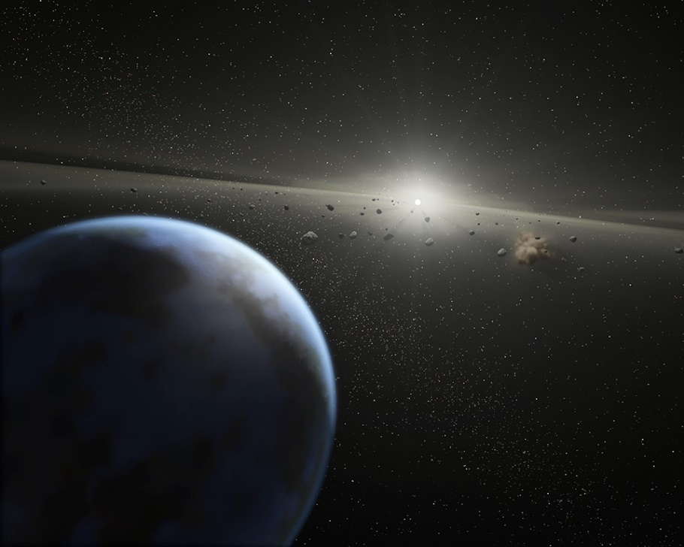

Exoplanet and debris disk around a white dwarf

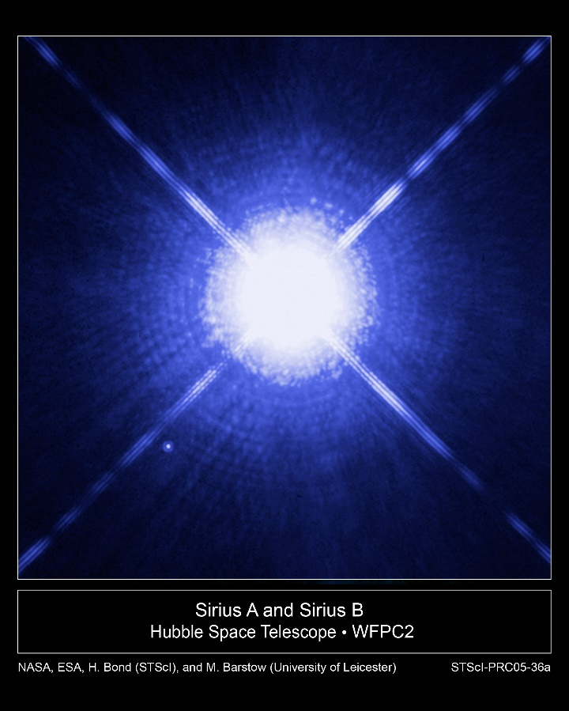

Sirius A and its white dwarf companion, Sirius B (ESA/NASA)

Further information on how to apply and funding can be found at
https://le.ac.uk/study/research-degrees/funded-opportunities/stfc

