Using Raman Spectroscopy to Assess the Habitability of Oxia Planum
- Training in the operation of Raman instruments and the interpretation of spectral data.  - Assessing the capability of the ExoMars mission Raman instrument to identify the presence of CHNOPS elements.  - Investigating the capability of the ExoMars mission Raman instrument to identify signatures of liquid. | Level | PhD
 | First Supervisor | Prof Ian Hutchinson  ibh1@le.ac.uk
 | Second Supervisor | Dr Hannah Lerman
 | Application Closing  Date | See web page
 | PhD Start date | 23 September 2024

Project Details:
The project centres around preparation/training of the student (as part of the UK RLS team) ahead of the launch of the ExoMars rover in 2028, focussing on preparations for drill site selection and the analysis/exploitation of RLS surface data, with the main goal of investigating the habitability of Oxia Planum. Correct spectral interpretation of RLS data during the mission will depend on a detailed understanding of instrument operations, the specific environmental context of samples, and sufficient pre-characterisation of analogue materials (the student will have access to flight spare instrumentation, through direct collaboration with the RLS PI group and as part of the RLS Co-PI team at Leicester). Additionally, through this activity, we seek to engage a broader network of UK planetary science students/researchers in the ExoMars programme.

Habitable environments require specific elements to build life, the minimal set being: CHNOPS (but also monovalent and divalent ions); an energy source, usually in the form of a redox couple; and liquid water. Additionally, iron is considered an essential element for life and can be used as an electron donor (Fe²⁺) or acceptor (Fe³⁺) in energy acquisition. The redox sensitive nature of Fe and the large number of Fe-bearing mineral types also means the element is a proxy for the history of water which can inform us about habitability. Consequently, the likelihood that an environment could support life processes can be determined by assessing redox conditions, the nature/existence of water-rock interaction processes, and biogenic mineralization (which can all be measured with RLS and other ALD instruments). The proposed work includes detailed laboratory characterisation of specifically targeted field specimens (some already acquired, some to be procured during the proposed field trips) in the following key areas: (i) identification / characterisation of materials containing CHNOPS elements; (ii) detection of redox couples that serve as an energy source for metabolic processes; (iii) characterisation of minerals associated with water-rock interactions. The study will address:

1) The extent to which conditions for habitability can be adequately assessed using RLS spectra acquired from Oxia Planum analogues.
2) How RLS data can be best combined with other instrument data to yield maximum knowledge about habitability.
3) How Fe minerals and their oxidation states can be used to assess availability of past liquid water, and thus habitability as part of a potential redox couple(s).

The 4–5-year period before launch (the ExoMars rover launch is now planned for 2028), provides a good opportunity to ensure PhD students are adequately trained in instrument operation, data exploitation, and surface operations (noting imminent opportunities to be included in Rover Operations Control Centre led training activities and RLS consortium training workshops). Furthermore, the UK supervisory team are involved in two additional instrument development activities that have followed on from the work completed on the ExoMars RLS programme: the design of a handheld Raman-XRF instrument for use by an astronaut on the moon (funded through the ESA PANGAEA programme), and the integration of spare RLS flight subsystems on the ispace HAKUTO-R rover mission, due for launch in 2026. The team work closely with INTA-CAB on both of programmes and a research student starting in 2024 would have the opportunity to contribute to, and learn from, both of these activities in the lead up to the launch of the ExoMars rover in 2028.

Activities in this project will include: 1st year: Training in use of Raman instruments and complementary spectroscopy techniques (including XRF and LIBS, in order to facilitate comparisons with instruments such as ChemCam on the Perseverance rover). Participation in field trips and ExoMars/PANGAEA consortium meetings (i.e., covering RLS operations and Raman/XRF instrument activities for lunar missions). Year 2: Analysis of field specimens, focusing on RLS operations and provision of inputs into drill site selection discussions. Development of dedicated laboratory facility for autonomous acquisition of spectral data. Presentation of initial results at international conference. Participation in mission simulation activities and RLS consortium surface operation planning meetings. Participation in two field trips and two visits to external collaborator laboratories. Year 3: Completion of field specimen analyses and write up of documentation (including thesis) detailing research outputs. Continued participation in mission simulations and RLS surface operation planning meetings.

References:
- J. Vago, et al., “Habitability on Early Mars and the Search for Biosignatures with the ExoMars Rover”, 2017, Astrobiology 17
- F. Rull, S. Maurice, I. Hutchinson, et al., “The Raman Laser Spectrometer for the ExoMars Rover Mission to Mars”, 2017, Astrobiology 17
- M. McHugh, J. Parnell, I. Hutchinson, et al., “Raman analysis of a shocked planetary surface analogue: Implications for habitability on Mars”, 2021, Journal of Raman Spectroscopy 51, 12

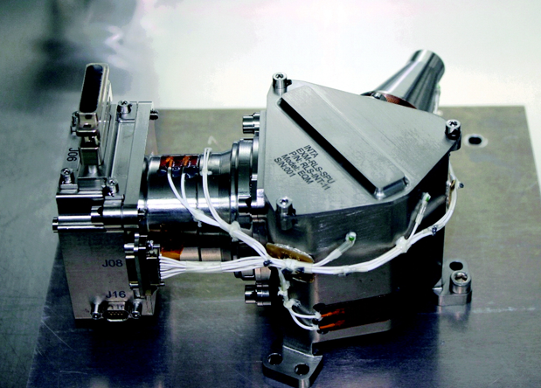

The spectrometer unit of the flight version of the ExoMars Raman Laser Spectrometer. Credit: Rull et al., 2017, Astrobiology 17

Artist’s impression of ESA’s ExoMars rover on Mars. Credit: ESA/ATG medialab

