University of Leicester PhD studentship
Funding Source: CENTA DTP
Proposed start date: 23rd September 2024
Closing date for applications: See our web page
Eligibility: UK/International
Department/School: Chemistry
Supervisors: PI: Dr. Pierre Josso (BGS) piesso@bgs.ac.uk
Co-Is: Dr. Tim van Peer (University of Leicester) tevp1@leicester.ac.uk
Dr. Matthew Horstwood (BGS) msah@bgs.ac.uk
Prof. Jens Zinke (University of Leicester) jz262@leicester.ac.uk
Dr. Hannah Grant (BGS) hgrant@bgs.ac.uk
Project Title: Reconstructing palaeo-Atlantic circulation from oceanic ferromanganese crusts at unprecedented resolution
Project Highlights:
- Development of new dating methods for deep-sea ferromanganese oxide matrices
- Paleoceanographic reconstruction of the equatorial Atlantic Ocean through Pb-Nd isotopic analysis
- Exploration of climate and oceanographic interaction on formation, alteration, and preservation of ferromanganese mineral deposits

Overview:
Constraining changes in the flow of the North Atlantic Deep Water (NADW) and Antarctic Bottom Water (AABW) currents is paramount to understanding past climate and oceanographic changes to inform future climate susceptibility. The evolution of these two water-masses remains poorly constrained in equatorial settings, despite distributing heat and nutrients globally. This project proposes to reconstruct these currents by using geochemical properties of oceanic ferromanganese (Fe-Mn) crusts. These Fe-Mn crusts form by the accumulation of Fe and Mn oxyhydroxides precipitated from ambient seawater on any indurated substrate of the ocean floor. As one of the slowest processes on Earth (a few mm/Ma) and given the high reactivity of these colloids, Fe-Mn oxides efficiently scavenge and accumulates trace metals from seawater over millions of years. Fe-Mn crusts are thus considered as reliable archives of the distribution and changes in oceanographic currents throughout the Cenozoic. The composition of Fe-Mn crusts is influenced by evolving continental weathering rates through changes in climate, oceanic gateways, and latitudinal oceanography, yet remains poorly constrained and understood.
This project uses unique samples from the Sierra Leone Rise in the equatorial eastern Atlantic Ocean (Study Area, Figure 1), aiming to produce a harmonised temporal framework of isotopic and compositional records of Fe-Mn crusts. These ultra-high-resolution records form the foundation of reconstructing the provenance, distribution, intensity, and interaction of ocean water masses in this region over the Cenozoic and also to characterise the influence of the African continent on the composition of deep-sea minerals.
With samples distributed within a 2000-5200 m depth range, this set is ideally located to characterise both intermediate and deep-water properties through the major climatic, tectonic, and oceanographic changes of the Cenozoic, something which cannot always be achieved with deep-sea sediment cores. The project aims at integrating the equatorial Atlantic basin tectonic evolution with climate change to produce a high-resolution long-term paleoceanographic record of NADW and AABW. Some samples ideally located close to the Vema equatorial fracture zone complement the set to characterise exchanges of deep-water current between the western and eastern equatorial basins.

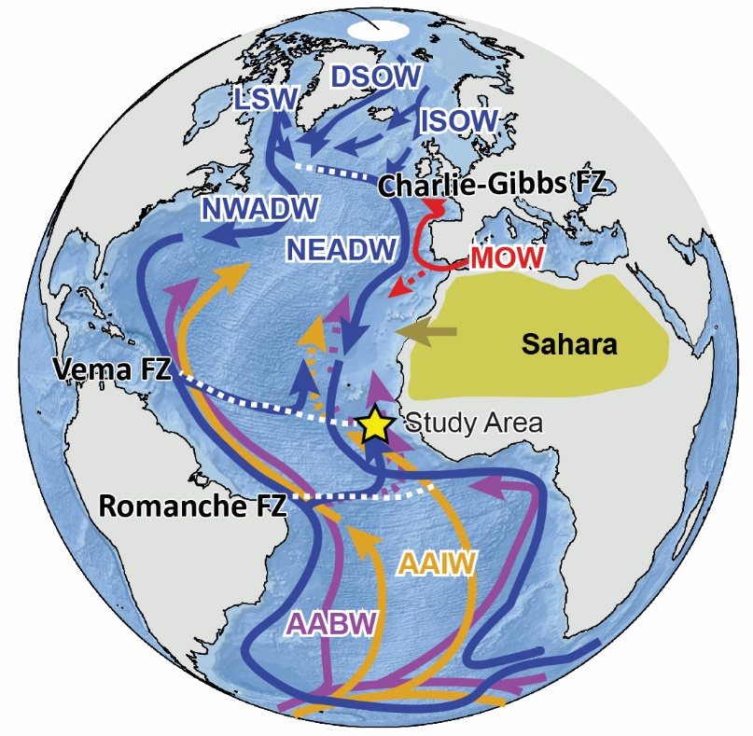
Figure 1: Modern oceanographic circulation in the Atlantic Ocean showing the main intermediate and deep-water masses with the study site indicated (yellow star): (modified from Josso et al., 2020)
Alt text: An overview of modern Atlantic oceanographic circulation, with the study site indicated off the coast of Northwest Africa.
Methodology:
This research will use existing data complemented by the latest developments in high-resolution laser-ablation inductively coupled plasma mass spectrometry (LA-ICP-MS) to establish the temporal framework of the samples focusing on lead (Pb) isotopes stratigraphic correlation (Josso et al., 2020). Age modelling will be developed through multi-proxy modelling including Osmium (Os) and Beryllium (Be) isotopes, and Pb cyclostratigraphy (Josso et al., 2019, 2021). Comparative analysis of these methods with the less robust, but widely employed Cobalt Chronometer will provide a critical review of dating methods.
Paleoceanographic reconstructions will rely on a combined approach of isotopic data using Pb and Neodymium (Nd) isotopes analysis, and geochemical and mineralogical data obtained by X-ray diffraction (XRD), scanning electron microscopy (SEM) and ICP-MS measurements.
Data analysis, processing, and modelling will be done through R and MATLAB. This will notably involve Bayesian statistical techniques and advanced time series analysis with tuning to astronomical solutions.

References:

Journal:
Josso, P. et al., 2020a. Development of a Correlated Fe-Mn Crust Stratigraphy Using Pb and Nd Isotopes and Its Application to Paleoceanographic Reconstruction in the Atlantic. Paleoceanography and Paleoclimatology, 35(10): e2020PA003928.
Josso, P. et al., 2019. Improving confidence in ferromanganese crust age models: A composite geochemical approach. Chemical Geology, 513: 108-119.
Josso, P. et al., 2020b. Late Cretaceous and Cenozoic paleoceanography from north-east Atlantic ferromanganese crust microstratigraphy. Marine Geology, 422: 106122.
Josso, P., van Peer, T., Horstwood, M.S.A., Lusty, P., Murton, B., 2021. Geochemical evidence of Milankovitch cycles in Atlantic Ocean ferromanganese crusts. Earth and Planetary Science Letters, 553: 116651.
Lusty, P., Hein, J.R., Josso, P., 2018. Formation and occurence of ferromanganese crusts: Earth's storehouse for critical metals. Elements, 14(5): 313-318.

Funding details:
NERC CENTA studentships are for 3.5 years and are funded by NERC. In addition to the full payment of your tuition fees, you will receive the following financial support:
- Annual stipend, currently set at £18,622 (2023/4 – new figures to be confirmed spring 2024)
- Research training support grant £8,000 (RTSG)
If you are not eligible for UK Fees the University of Leicester will fund the difference between UK and International fees for the duration of your studies
For more details of the CENTA consortium please see the CENTA website: www.centa.org.uk.
Entry requirements:
Applicants are required to hold/or expect to obtain a UK Bachelor Degree 2:1 or better in a relevant subject.
The University of Leicester English language requirements apply where applicable.

Application advice:
To apply please refer to our web page for further information and read carefully the How to Apply section before submitting your application
https://le.ac.uk/study/research-degrees/funded-opportunities/centa-phd-studentships

In the funding section please specify that you wish to be considered for Ref CENTA2-SGGE9-JOSS

In the proposal section please provide the name of the supervisors and project title (a proposal is not required)

Project / Funding Enquiries to: CENTA@le.ac.uk or piesso@bgs.ac.uk
Application enquiries to pgradmissions@le.ac.uk

