University of Leicester PhD studentship
Funding Source: CENTA DTP
Proposed start date: 23rd September 2024
Closing date for applications: See our web page
Eligibility: UK/International
Department/School: Geology
Supervisors: PI: David Unwin, University of Leicester (dmu1@le.ac.uk)
Co-I: Tom Harvey, University of Leicester (thph2@le.ac.uk)
Co-I: Richard Butler, University of Birmingham (R.Butler.1@bham.ac.uk)
Co-I: Stephan Lautenschlager, University of Birmingham (S.Lautenschlager.bham.ac.uk)
Project Title: The role of the hind limbs in pterosaur flight.

Project Description :
Project Highlights:
- Gain expertise in 3D digital modelling, morphometrics, photogrammetry and phylogenetics
- Data collection in key palaeontological collections in the UK, Europe, USA, China and Japan
- Generation of the first model of pterosaur flight that fully integrates the fore and hind limbs.

Overview:
The aerial ability of pterosaurs, Mesozoic flying reptiles, has been the focus of attention for more than two centuries. Efforts aimed at determining the shape and extent of the wing panels, the kinematics of the flight stroke and, ultimately, the aerodynamic performance of pterosaurs, have almost exclusively focused on the forelimb. By contrast the contribution of the hind limbs has been largely ignored, in part because of uncertainty as to the extent to which they were incorporated into the wings. Traditionally, pterosaurs were considered to be rather bat-like with extensive wing membranes that attached to the legs (Unwin, 2005). Contradicting this idea, some researchers argued for a much-reduced degree of attachment, or even complete exclusion of the hind limbs from the flight apparatus as, for example, in birds (Padian and Rayner 1991). Recent finds of exceptionally well-preserved fossils with complete wing membranes have resolved this problem, showing that the bat-like’ model is correct (Elgin et al., 2010). Despite this few, if any, recent analyses of pterosaur flight have considered the role of the hind limbs even though they are likely to have played a key role in this locomotory activity.
This project will combine a broad range of approaches to determine how pterosaurs used their hind limbs for flight including: comparative skeletal morphology with a focus on the arthrology of the hip joint; morphometric analyses of hind limb proportions and the constraints they imposed on the shape and extent of the flight membranes; reconstruction of muscles of the pelvis and hind limbs combined with biomechanical analysis to determine forces that could be generated and exerted by the hindlimbs during flight; and 3D digital modelling, based on data generated by photogrammetry, aimed at reconstruction of the kinematics of the hind limb during the flight stroke.
Data sets generated by these approaches will be synthesised into the first generalised model of pterosaur flight that incorporates both the fore and hind limbs. Several data sets, principally those relating to comparative anatomy, arthrology and morphometrics of the hind limbs, will encompass a wide range of taxa. Analysis of this data within a phylogenetic context, will be used to understand how the hind limbs contributed to the evolution of flight ability across Pterosauria, beginning with early, small, relatively short-winged forms and concluding with giants with wingspans in excess of 10 m.

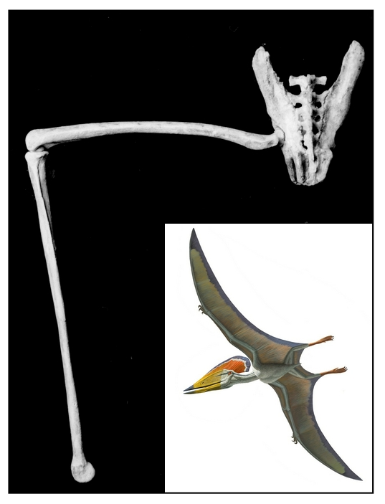
Figure 1: The exceptionally well-preserved, 3D pelvis and hind limbs of the Early Cretaceous pterosaur Tupuxuara (Iwaki Coal and Fossil Museum 1052). Inset: reconstruction of Tupuxuara in flight mode (image courtesy of the American Museum of Natural History, 2014).
Methodology:
This project will take advantage of recently developed digital approaches to analysing and reconstructing locomotion in fossil vertebrates (Benton 2020). Comparative anatomy and arthrology of the pelvis and hind limbs will be investigated using range of movement (ROM) techniques (e.g. Manafazdeh et al., 2021) based primarily on exceptionally well preserved 3D skeletal remains of pterosaurs from the Santana Formation of Brazil (Veldmeijer, 2006). Morphometrics and landmark data will be employed to analyse variation in the dimensions of the hind limb and the geometry of the flight surfaces (e.g. Webster and Sheets 2010). 3D digital techniques (Lautenschlager, 2021), will be used to develop a model simulating the kinematics of the hind limb during the flight stroke. Reconstruction of the evolutionary history of the pterosaur flight apparatus, supervised by Butler, will use quantitative approaches set within a phylogenetic framework comparable, for example, to a recent study by Yu et al. (2023).

References:

Benton, M. J. 2020. The Dinosaurs Rediscovered: How a Scientific Revolution is Rewriting History. Thames and Hudson, London 320pp.
Elgin, R. A., Hone, D. W. E. and Frey, E. 2010. The extent of the pterosaur flight membrane. Acta Pal. Polonica., 56, 91–111.

Lautenschlager, S. 2020. Multibody dynamics analysis (MDA) as a numerical modelling tool to reconstruct the function and palaeobiology of extinct organisms. Palaeontology 63, 703–715.
Manafazdeh, A. R., Kambic, R. E. and Gatesy, S. M. 2021. A new role for joint mobility in reconstructing vertebrate locomotor evolution. Proceedings of the National Academy of Sciences, 118: e2023513118.
Padian, K. and Rayner, J. M. V. 1992. The wings of pterosaurs. American Journal of Science 293-A, 91–166.
Unwin, D.M. 2005. The Pterosaurs from Deep Time. Pi Press, New York, 347pp.
Veldmeijer, A. J. 2003. Description of Coloborhynchus spielbergi sp. nov. (Pterodactyloidea) from the Albian (Lower Cretaceous) of Brazil. Scripta Geologica 125, 35–139.
Webster, W. and Sheets H. D. 2010. A practical introduction to landmark-based geometric morphometrics. In: Alroy, J. and Hunt, G., Quantitative Methods in Paleobiology, Paleontological Society Papers, 16, 163–188,
Yu, Y., Zhang, C., Xu, X. 2023. Complex macroevolution of pterosaurs. Current Biology, 33 (4), 770-779. doi: 10.1016/j.cub.2023.01.007.

Funding details:
NERC CENTA studentships are for 3.5 years and are funded by NERC. In addition to the full payment of your tuition fees, you will receive the following financial support:
- Annual stipend, currently set at £18,622 (2023/4 – new figures to be confirmed spring 2024)
- Research training support grant £8,000 (RTSG)
If you are not eligible for UK Fees the University of Leicester will fund the difference between UK and International fees for the duration of your studies
For more details of the CENTA consortium please see the CENTA website: www.centa.org.uk.
Entry requirements:
Applicants are required to hold/or expect to obtain a UK Bachelor Degree 2:1 or better in a relevant subject.
The University of Leicester English language requirements apply where applicable.

Application advice:
To apply please refer to our web page for further information and read carefully the How to Apply section before submitting your application
https://le.ac.uk/study/research-degrees/funded-opportunities/centa-phd-studentships

In the funding section please specify that you wish to be considered for Ref CENTA2-SGGE3-UNWI

In the proposal section please provide the name of the supervisors and project title (a proposal is not required)

Project / Funding Enquiries to: CENTA@le.ac.uk or dmu1@le.ac.uk
Application enquiries to pgradmissions@le.ac.uk

