University of Leicester PhD studentship
Funding Source: CENTA DTP
Proposed start date: 23rd September 2024
Closing date for applications: See our web page
Eligibility: UK/International
Department/School: Chemistry
Supervisors: PI: Prof. Jens Zinke, jz262@leicester.ac.uk
Co-I 1: Dr. Arnoud Boom, ab269@leicester.ac.uk
Project Title: Last Millennium climate change and variability in the SW Indian Ocean and their link to ecosystem and Malagasy Indigenous coastal community resilience
Project Highlights:
- Unravel Mid-Holocene to Last Millennium ocean climate history from the remote Eparses Islands (Scattered Islands) and SW Madagascar in the western Indian Ocean, with cutting edge coral core geochemistry spanning several decades per time slice
- Undertake innovative climate and geochemical proxy data analysis and develop paleoclimate reconstructions of temperature, hydroclimate and nutrient dynamics for the southern Mozambique Channel
- Bring the palaeoclimate data from past warm and cold stages into context with anthropogenic climate change and compare with SW Madagascar coral records
- Develop marine climate records to build a climate change timeline to link with coastal archaeological research on oral histories of climate responses in SW Madagascar
Overview:
Coastal communities around the world are critically vulnerable to both natural and anthropogenic climate change threats (IPCC, 2021, Teh, et al., 2013). Nearly half a billion people, especially those living in marginalized and under-resourced areas, are living with the acute impacts of climate change (Lazrus, 2012). As global climate change intensifies, the study of human adaptation and response to climate and other disturbances has become ever more critical. Therefore, understanding the role of seasonally changing ocean climate on nearshore marine and terrestrial ecosystems and coastal communities is of paramount to develop deeper insights into climate resilience of vulnerable coastal communities.

Extensive archaeological and anthropological research in southwest Madagascar and elsewhere has revealed that human memory of past spatial and temporal variations in climate and appropriate responses to these changes are collectively built through generations of empirical observation and stored as Indigenous knowledge, for instance in the form of oral histories (Fitzhugh et al., 2011). Such oral histories can extend 1000 years and have shown how communities were shaped by responses to climate shocks in the past (Edinborough et al., 2017; Douglass and Rasolondrainy, 2021).

Our study will focus on the development of climate change and variability geochemical proxy time series from coral cores for ocean climate change (temperature, hydroclimate, nutrients) in the southern Mozambique Channel spanning the Last Millennium and make use of continuous time series of the past 300+ years (Zinke eta l., 2014, 2022). Our study region is of exceptional importance as its vigorous ocean climate variability is sustaining highly productive and valuable fishing grounds off- and nearshore for coastal fishing communities in SW Madagascar (e.g. Tuna; Chassot et al., 2019; Fig. 1).

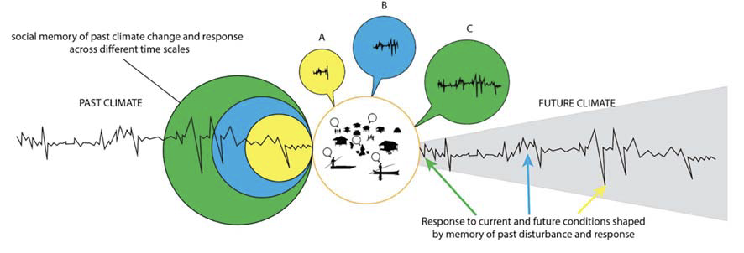
Figure 1 – Illustration of social memory of past climate change and response across short (A: around 30 years or an individual’s lifetime), medium (B: 1-2 centuries or within living memory) and long (C: over 2 centuries or beyond living memory) time scales. Response to current and future conditions is shaped by the time scale of social memory and future conditions include a range of uncertainty (gray shading. Modified after Douglass and Quintana Morales (pers. Comms.).

Methodology:
We have drilled living massive Porites corals and Last Millenium/Holocene boulders from storm deposits during a research cruise in the southern Mozambique Channel with the vessel Marion Dufresne II in April 2019. Absolute chronologies were already established for the fossil corals from U/Th dating at the University of Oxford. In 2023, we drilled several modern coral cores from Andavadoaka (SW Madagascar) where a team of coastal archaeologists is working with us on establishing a climate change timeline and oral histories of 20th century climate resilience. This project involves international collaboration with the University of La Reunion, the Natural History Museum in Paris, the University of Tulear (Madagascar) and the Morombe Archaeological Projects team of Columbia University (US) and Andavadoaka (Madagascar).
Proxies for sea surface temperature and salinity will be obtained at the University of Leicester by trace element (Sr/Ca etc., ICP-MS; Zinke et al., 2022) and isotope (δ¹⁸O, δ¹³C) analyses, while nutrient cycling (skeletal bound organic δ¹⁵N; Wang et al., 2015) will be done at Max-Planck in Mainz (Germany) and Leicester. All sampling will provide monthly-resolved reconstructions.
References:

Chassot et al. (2019) Rev Fish Biol Fisheries, doi:10.1007/s11160-019-09569-9
Douglass, K., & Rasolondrainy, T. V. R. (2021) American Journal of Human Biology, e23557.
Edinborough, K. et al. (2017) PNAS 114 (47), 12436-12441.
Fitzhugh, B. et al. (2011) In R. Whallon, W. Lovis, & R. Hitchcock (Eds.), Information and Its Role in Hunter-gatherer Band Adaptations, 85–115
IPCC report – Physical evidence for climate change (2021)
Lazrus, H. (2012Annual Review of Anthropology, 41(1), 285-301
Teh, L.S. et al. (2013) PLoS ONE, 8(6), e65397
Wang, X.T. et al. (2015) Geoch, Cosmoc. Acta, 148, 179-190
Zinke, J., et al. (2014a) Sci. Reports, 4, 4393
Zinke et al. (2019) Biogeosciences, 16, 695-712
Zinke et al. (2022) Climate of the Past 18, 1453-1474

Funding details:
NERC CENTA studentships are for 3.5 years and are funded by NERC. In addition to the full payment of your tuition fees, you will receive the following financial support:
- Annual stipend, currently set at £18,622 (2023/4 – new figures to be confirmed spring 2024)
- Research training support grant £8,000 (RTSG)
If you are not eligible for UK Fees the University of Leicester will fund the difference between UK and International fees for the duration of your studies
For more details of the CENTA consortium please see the CENTA website: www.centa.org.uk.
Entry requirements:
Applicants are required to hold/or expect to obtain a UK Bachelor Degree 2:1 or better in a relevant subject.
The University of Leicester English language requirements apply where applicable.

Application advice:
To apply please refer to our web page for further information and read carefully the How to Apply section before submitting your application
https://le.ac.uk/study/research-degrees/funded-opportunities/centa-phd-studentships

In the funding section please specify that you wish to be considered for Ref CENTA2-SGGE10-ZINK

In the proposal section please provide the name of the supervisors and project title (a proposal is not required)

Project / Funding Enquiries to: CENTA@le.ac.uk or Prof. Jens Zinke (jz262@leicester.ac.uk); Dr. Arnoud Boom (ab269@leicester.ac.uk)
Application enquiries to pgradmissions@le.ac.uk

