University of Leicester PhD studentship
Funding Source: CENTA DTP
Proposed start date: 23rd September 2024
Closing date for applications: See our web page
Eligibility: UK/International
Department/School: Physics
Supervisors: PI: Prof. T. K. Yeoman (University of Leicester, yxo@le.ac.uk)
Co-I: Prof. S. E. Milan (University of Leicester, steve.milan@le.ac.uk)
Project Title: Coordinated ground and space-based exploration of the cusp ionosphere.

Project Description :
Project Highlights:
- Explore data from the new NASA TRACERS mission
- Understand “Space Weather” and solar-planetary physics
- Run experiments on state-of-the-art ionospheric radar systems
Overview (including 1 high quality image or figure):
At near-noon local times, at locations in the high arctic near 80 degrees North and South, the magnetic fields which originate in the conducting core of our planet extend upwards and are magnetically connected to the dayside magnetopause. This subsolar magnetopause is the point where the magnetic field of the Earth first touches the highly supersonic solar wind flow, and the interplanetary magnetic field of solar origin which is embedded in it. This creates the magnetospheric cusps, which are the primary entry points for energy of solar wind origin into the regions of space controlled by the terrestrial magnetic field, and the atmospheric regions which underlie them (Figure 1(a)). This energy transfer occurs through a process called magnetic reconnection. As such, this crucial region of near-Earth space is fundamental to understanding the flow of energy, mass and momentum throughout the Earth’s magnetosphere, ionosphere and upper atmosphere, and hence in our understanding of “space weather”.

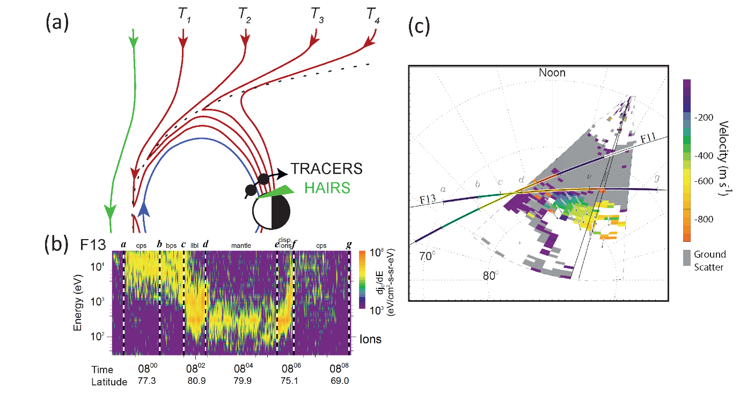
Figure 1: Panel (a) shows a schematic of the evolution of terrestrial field lines from times T1 to T4, following reconnection at the subsolar point. The motion will separate out energised ions according to their velocity (an example is shown for a single spacecraft in Panel (b)). The TRACERS twin spacecraft will take time and space separated measurements of these particles at the field line footprints. The HAIRS radar will measure the surrounding electrodynamics (an example is shown in Panel (c); data plots taken from Provan et al., 2002).
The magnetospheric cusps are longstanding areas of research interest, but their highly variable nature, in both space and time, makes them a highly challenging region to fully understand. This project is a multi-instrument research programme based around an exciting new NASA space mission, TRACERS (Tandem Reconnection & Cusp Electrodynamics Reconnaissance Satellites), due for launch in 2024. The TRACERS programme will operate in coordination with ground-based instrumentation in the Svalbard region. Around northern winter solstice Svalbard is in darkness at noon, and for ~10 days the moon is below the horizon. Such conditions offer a unique opportunity for multi-instrument cusp experiments involving cusp auroral optical observations. The project will also focus on data from the NERC-funded EISCAT Svalbard radar and the NERC-funded HAIRS (Hankasalmi Auroral Imaging Radar System) radar. HAIRS is a new state-of-the art digital imaging radar system currently under construction at the University of Leicester, which will look northwards from Finland, having a field of view centred over the Svalbard region. HAIRS will reveal the ionospheric cusp region electrodynamics at high spatial and temporal resolution over a ~1 million square kilometre region of the ionosphere.

Methodology:
In this programme, low earth orbit measurements of energetic ions precipitating from the cusp region (similar to those shown in Figure 1(b)) taken by the twin TRACERS spacecraft will provide measurements of the temporal and spatial structuring of the cusp reconnection processes. Magnetically conjugate measurements of the footprint of the reconnection line from HAIRS and associated ground-based instrumentation, (similar to those shown in Figure 1(c)) will measure the length and the location of the reconnection line. HAIRS will provide an analysis of the boundary motion, and of the convection velocities detected near the boundary, allowing a calculation of the reconnection rate mapped down to the ionosphere. Such a combination of instrumentation will provide an unprecedented opportunity to understand the temporal and spatial behaviour of cusp reconnection and its role in controlling terrestrial space weather.
References:

Amm, O., Lester, M., Wild, J. A., et al. (2005), ‘Coordinated studies of the geospace environment using Cluster, satellite and ground-based data: an interim review’, Ann. Geophys., 23, 2129–2170, https://doi.org/10.5194/angeo-23-2129-2005.

Chisham, G., S. E. Milan, M. Lester, et al. (2008), ‘Remote sensing of the spatial and temporal structure of magnetopause and magnetotail reconnection from the ionosphere’, Rev. Geophys., 46, RG1004, https://doi.org/10.1029/2007RG000223.
G. Chisham, M. Lester, S. E. Milan, M. P. Freeman, W. A. Bristow, A. Grocott, K. A. McWilliams, J. M. Ruohoniemi, T. K. Yeoman, P. L. Dyson, R. A. Greenwald, T. Kikuchi, M. Pinnock, J. P. S. Rash, N. Sato, G. J. Sofko, J.-P. Villain, and A. D. M. Walker (2007). ‘A decade of the Super Dual Auroral Radar Network (SuperDARN): scientific achievements, new techniques and future directions’. Surveys in Geophysics 28.1, pp. 33–109. https://doi.org/10.1007/s10712-007-9017-8.

McWilliams, K. A., G. J. Sofko, T. K. Yeoman, S. E. Milan, D. G. Sibeck, T. Nagai, T. Mukai, I. J. Coleman, T. Hori, and F. J. Rich (2004), ‘Simultaneous observations of magnetopause flux transfer events and of their associated signatures at ionospheric altitudes’, Annales Geophysicae 22.6, pp. 2181–2199, https://doi.org/10.5194/angeo-22-2181-2004.

Provan, G., S. E. Milan, M. Lester, T. K. Yeoman, and H. Khan (2002), ‘Simultaneous observations of the ionospheric footprint of flux transfer events and dispersed ion signatures’, Annales Geophysicae 20.2, pp. 281–287. https://doi.org/10.5194/angeo-20-281-2002.

Trattner, K. J., S. A. Fuselier, T. K. Yeoman, C. Carlson, W. K. Peterson, A. Korth, H. Reme, J. A. Sauvaud, and N. Dubouloz (2005), ‘Spatial and Temporal Cusp Structures Observed by Multiple Spacecraft and Ground Based Observations’, Surveys in Geophysics 26.1-3, pp. 281–305. https://doi.org/10.1007/s10712-005-1883-3.

Yeoman, T. K., D. M. Wright, M. J. Engebretson, M. R. Lessard, V. A. Pilipenko, and H. Kim (2012), ‘Upstream-generated Pc3 ULF wave signatures observed near the Earth's cusp’, Journal of Geophysical Research-Space Physics 117. https://doi.org/10.1029/2011JA017327.
Virginia Tech (no date) SuperDARN Available at: http://vt.superdarn.org/tiki-index.php (Accessed 15 September 2023)

EISCAT Scientific association (no date) Welcome to EISCAT Scientific Association Available at: https://eiscat.se/about/ (Accessed 15 September 2023)
University of Iowa (no date) TRACERS (Tandem Reconnection & Cusp Electrodynamics Reconnaissance Satellites). Available at: https://tracers.physics.uiowa.edu/ (Accessed 15 September 2023)
University of Leicester (no date) Planetary science at the University of Leicester. Available at: https://le.ac.uk/planetary-science (Accessed 15 September 2023)

Funding details:
NERC CENTA studentships are for 3.5 years and are funded by NERC. In addition to the full payment of your tuition fees, you will receive the following financial support:
- Annual stipend, currently set at £18,622 (2023/4 – new figures to be confirmed spring 2024)
- Research training support grant £8,000 (RTSG)
If you are not eligible for UK Fees the University of Leicester will fund the difference between UK and International fees for the duration of your studies
For more details of the CENTA consortium please see the CENTA website: www.centa.org.uk.
Entry requirements:
Applicants are required to hold/or expect to obtain a UK Bachelor Degree 2:1 or better in a relevant subject.
The University of Leicester English language requirements apply where applicable.

Application advice:
To apply please refer to our web page for further information and read carefully the How to Apply section before submitting your application
https://le.ac.uk/study/research-degrees/funded-opportunities/centa-phd-studentships

In the funding section please specify that you wish to be considered for Ref CENTA2-PHYS7-YEOM

In the proposal section please provide the name of the supervisors and project title (a proposal is not required)

Project / Funding Enquiries to: CENTA@le.ac.uk or yxo@le.ac.uk
Application enquiries to pgradmissions@le.ac.uk

