University of Leicester PhD studentship
Funding Source: CENTA DTP
Proposed start date: 23rd September 2024
Closing date for applications: See our web page
Eligibility: UK/International
Eligibility: UK/EU/International
Department/School: Physics
Supervisors: PI: Dr Tim Trent, University of Leicester, t.trent@le.ac.uk
Co-I: Dr Adam Povey, University of Leicester, adam.povey@leicester.ac.uk
Co-I: Dr Kate Willet, UK Met Office, kate.willett@metoffice.gov.uk
Co-I: Prof Richard Allen, University of Reading, r.p.allan@reading.ac.uk
Project Title: Rebalancing the scales: using data-driven approaches for advancing water cycle representation in a globally resolved energy balance climate model.

Project Description:
Project Highlights:
- This project will develop a state-of -the-art global energy balance climate model with an improved and enhanced representation of the water cycle. Particular focus will be on changes to global precipitation patterns and polar regions for past, present and future warming scenarios.
- You will combine current energy balance modelling approaches, earth observation datasets, and apply statistical and machine learning techniques to advance the current state of hydrological representation within the new model. The resulting changes to the model will be assessed through a number of experiments based on either current climate conditions and future warming scenarios.
- Provides the opportunity to join the international activities within the Global Energy and Water Exchanges (GEWEX) community and the European Space Agency Water Vapour Climate Change Initiative. Furthermore, you will collaborate with scientists from the UK Met Office and National Centre for Earth Observation with the opportunity to work on site through placements.
Overview:
Energy balance climate models are a simplified representation of the Earth's climate system and are less detailed and comprehensive than complex general circulation models (GCMs). Rather than try to attempt to resolve the dynamics of the climate system (e.g. large-scale wind and atmospheric circulation systems, ocean currents, atmosphere and ocean convective motion), they instead focus on the thermodynamics and energetics of the climate system. A key advantage of this simplicity is that their underlying assumptions and equations have greater transparency, making it easier for researchers to trace and understand the factors influencing climate change. Energy balance models can run quickly, allowing for rapid experimentation and analysis. This speed makes them helpful in exploring a wide range of climate-related questions without the computational burden of more complex models.
Energy balance models are often used to estimate the Earth's climate sensitivity, a crucial parameter in understanding how the climate system responds to changes in greenhouse gas concentrations. They provide a simple framework for studying the relationship between radiative forcing and temperature change. For example, they can assess the temperature increase associated with different levels of CO₂ emissions or perform sensitivity analyses, helping to identify the most influential factors affecting climate outcomes and guiding further research.
With globally resolved energy balance models, sensitivity to changes in the hydrological cycle significantly impacts results as the model is now sensitive to the spatial distribution of water in all its phases. For instance, sea ice extent or changes to regional rainfall will affect the model response to rising atmospheric CO₂ levels. Figure 1 presents an example of the model run for 1850-2100 using a variety of possible atmospheric CO₂ levels. The top row of plots shows that while the model agrees well with current observations at the global scale, this breaks down when we focus on the polar regions, reducing confidence in projections beyond 2030. However, the results are spatially resolved to identify areas where biases may occur. This PhD seeks to improve and enhance the representation of the water cycle in the model, making it a valuable tool for climate studies.

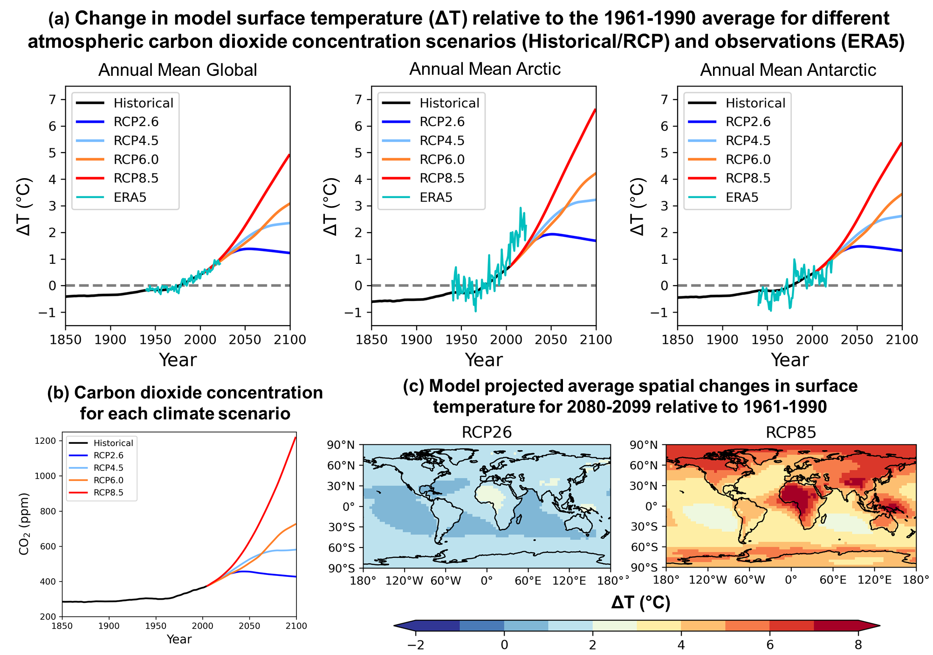
Figure 1: (a) Model results of global and polar mean changes in surface temperature relative to 1961-1990 average for historical, and future atmospheric carbon dioxide (CO₂) levels. Observed temperate changes (ERA5) between 1940-2022 are also shown. (b) Annual concentration levels of atmospheric CO₂ used to drive the globally resolved energy balance climate model. (c) Spatial pattern of average surface temperature differences for 2080-2099 relative to the reference period (1961-1990) for the lowest and highest CO₂ scenario (RCP26 and RCP85, respectively).
Alt Text: Multi-panel figure showing timeseries for global and polar results, the CO₂ concentration and maps of temperature difference.

Methodology:
Initially, the student will take advantage of freely available globally resolved energy balance climate models to investigate similarities and differences in the inclusion and parameterisation of the water cycle and the resulting model sensitivities/biases. The project's next phase will see the student working with state-of-the-art climate quality observations from satellites and ground-based measurements to develop data-driven methods to enhance and improve the water cycle representation in the Globally Resolved Energy Balance (GREB) model. These include data assimilation/Bayesian and machine learning approaches, with additional scope to bring in existing emulators for water reservoirs yet to be included in the model. Finally, the student will run multiple experiments within the current era to assess the model's improvements and further experiments that will mirror existing or upcoming model intercomparison efforts within the Coupled Model Intercomparison Project (CMIP).

References:

- Dommenget, D. and Flöter, J., 2011. Conceptual understanding of climate change with a globally resolved energy balance model. Climate dynamics, 37, pp.2143-2165. https://doi.org/10.1007/s00382-011-1026-0
- Stassen, C., Dommenget, D. and Loveday, N., 2019. A hydrological cycle model for the Globally Resolved Energy Balance (GREB) model v1. 0. Geoscientific Model Development, 12(1), pp.425-440. https://doi.org/10.5194/gmd-12-425-2019
- Watters, D., Battaglia, A. and Allan, R.P., 2021. The diurnal cycle of precipitation according to multiple decades of global satellite observations, three CMIP6 models, and the ECMWF reanalysis. Journal of Climate, 34(12), pp.5063-5080. https://doi.org/10.1175/JCLI-D-20-0966.1
- Xie, Z., Dommenget, D., McCormack, F.S. and Mackintosh, A.N., 2021. GREB-ISM v0. 3: A coupled ice sheet model for the Global Resolved Energy Balance model for global simulations on time-scales of 100 kyr. Geoscientific Model Development Discussions, 2021, pp.1-46. https://doi.org/10.5194/gmd-15-3691-2022

Funding details:
NERC CENTA studentships are for 3.5 years and are funded by NERC. In addition to the full payment of your tuition fees, you will receive the following financial support:
- Annual stipend, currently set at £18,622 (2023/4 – new figures to be confirmed spring 2024)
- Research training support grant £8,000 (RTSG)
If you are not eligible for UK Fees the University of Leicester will fund the difference between UK and International fees for the duration of your studies
For more details of the CENTA consortium please see the CENTA website: www.centa.org.uk.
Entry requirements:
Applicants are required to hold/or expect to obtain a UK Bachelor Degree 2:1 or better in a relevant subject.
The University of Leicester English language requirements apply where applicable.

Application advice:
To apply please refer to our web page for further information and read carefully the How to Apply section before submitting your application
https://le.ac.uk/study/research-degrees/funded-opportunities/centa-phd-studentships

In the funding section please specify that you wish to be considered for Ref CENTA2-PHYS5-TREN

In the proposal section please provide the name of the supervisors and project title (a proposal is not required)

Project / Funding Enquiries to: CENTA@le.ac.uk or t.trent@le.ac.uk
Application enquiries to pgradmissions@le.ac.uk

