University of Leicester PhD studentship
Funding Source: CENTA DTP
Proposed start date: 23rd September 2024
Closing date for applications: See our web page
Eligibility: UK/International
Department/School: Physics
Supervisors: PI: Adam Povey, University of Leicester, adam.povey@le.ac.uk
Co-I: Josh Vande Hey, University of Leicester, jvh7@leicester.ac.uk
Project Title: Monitoring aerosols and clouds from above and below.

Project Description :
Project Highlights:
- Reducing a major source of uncertainty in human-driven climate feedbacks
- Working with both satellite and ground-based data, including opportunities for field work
- Combines climate data analysis, algorithm development, and data collection
Overview:
Aerosols are particles suspended in the air for hours to weeks, such as grains of desert dust or droplets of acid. By scattering and absorbing light, they can alter weather by changing the atmosphere’s temperature profile. As the seeds of droplet formation, aerosols can change the properties of cloud and, thus, affect the energy budget that drives climate change. The smallest aerosols can be breathed into the lungs, and pass into blood, causing long-term illnesses and preventable deaths. Understanding where aerosols are, and how they change, is essential to predicting weather, climate, and air quality.
Aerosols are monitored in two ways: locally using particle counters, lidars, or photometers and globally using satellite imagery in the visible and infrared. Local observations can be precise but are expensive and struggle to represent regional behaviour. Global observations are comprehensive but very sensitive to their assumptions and require complex quality control. The combination of both techniques can be powerful but coincident observations can be rare (i.e. a few times a month or year).
This project will enable a more consistent source of collocated data: geostationary satellites looking at meteorological supersites. Geostationary satellites continuously monitor the same view of the Earth and, with the recent launch of Meteosat Third Generation, there are now research-grade images of the entire planet every 15 minutes suitable for aerosol-cloud retrieval. A supersite, where numerous meteorological instruments are installed alongside each other, occupies a constant position within the satellite image, simplifying data management enough that analysis can be performed by a single researcher.
The student will learn to design and implement aerosol retrievals for geostationary imagery and ground-based sensors, producing a database of collocated, synergistic observations. That will be used to address a range of scientific questions guided by the student’s interests but can include using particle counters to generate a neural network to remotely sense air quality, directly observing how aerosols alter cloud thickness and lifetime with lidar profiles, or using radar to determine the impact of aerosols on precipitation duration. Comparison against climate models is also possible.
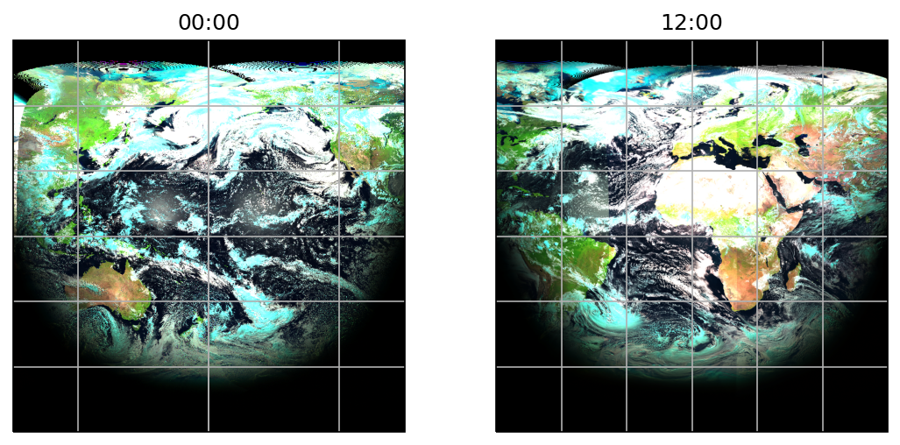
Figure 1: The Earth on 1 July 2020 as seen from geostationary orbit, using GeoRING data. In this false-colour composite, ice clouds appear light blue, liquid clouds as white, and dust as a muddy brown. Observations are continuous, so the evolution of cloud and aerosol can be monitored from both above and below.
ALT: Two satellite images of the Earth, centred on the Pacific and Atlantic Oceans, as an illustration of data to be used in this project.
Methodology:
Aerosol and cloud products will be generated with the Optimal Retrieval of Aerosol and Cloud (ORAC), a software package developed alongside the University of Oxford, RAL Space, Deutscher Wetterdienst, ESA’s Climate Change Initiative, and the Copernicus Climate Change Service. Geostationary observations will initially be taken from ISCCP’s GeoRING product as these are geo-rectified and calibrated, with the potential to use operational products later. A new implementation of surface reflectance will be necessary, making use of information available from the ground sites.
A collocation dataset will combine quality-controlled satellite, photometer, lidar, radar, and other observations at the same time and site. The relationships between these variables, alongside meteorological parameters such as humidity, will be examined using methods such as multivariate regression, singular value decomposition, and convolutional neural networks.

References:

Fan, J., Y. Wang, D. Rosenfeld, and X. Liu (2016) ‘Review of Aerosol–Cloud Interactions: Mechanisms, Significance, and Challenges’, Journal of the Atmospheric Sciences, 73, pp. 4221–4252. doi:10.1175/JAS-D-16-0037.1.
Sus, O., Stengel, M., Stapelberg, S., McGarragh, G., Poulsen, C., Povey, A. C., Schlundt, C., Thomas, G., Christensen, M., Proud, S., Jerg, M., Grainger, R., and Hollmann, R. (2018) ‘The Community Cloud retrieval for CLimate (CC4CL) – Part 1: A framework applied to multiple satellite imaging sensors’, Atmospheric Measurement Techniques, 11, pp. 3373–3396. doi:10.5194/amt-11-3373-2018.
McGarragh, G. R., Poulsen, C. A., Thomas, G. E., Povey, A. C., Sus, O., Stapelberg, S., Schlundt, C., Proud, S., Christensen, M. W., Stengel, M., Hollmann, R., and Grainger, R. G. (2018) ‘The Community Cloud retrieval for CLimate (CC4CL) – Part 2: The optimal estimation approach’, Atmospheric Measurement Techniques, 11, pp. 3397–3431. doi:10.5194/amt-11-3397-2018.
EUMETSAT (2023) Meteosat Real-Time Imagery. Available at: https://eumetview.eumetsat.int/static-images/ (Accessed 14 September 20243).

Funding details:
NERC CENTA studentships are for 3.5 years and are funded by NERC. In addition to the full payment of your tuition fees, you will receive the following financial support:
- Annual stipend, currently set at £18,622 (2023/4 – new figures to be confirmed spring 2024)
- Research training support grant £8,000 (RTSG)
If you are not eligible for UK Fees the University of Leicester will fund the difference between UK and International fees for the duration of your studies
For more details of the CENTA consortium please see the CENTA website: www.centa.org.uk.
Entry requirements:
Applicants are required to hold/or expect to obtain a UK Bachelor Degree 2:1 or better in a relevant subject.
The University of Leicester English language requirements apply where applicable.

Application advice:
To apply please refer to our web page for further information and read carefully the How to Apply section before submitting your application
https://le.ac.uk/study/research-degrees/funded-opportunities/centa-phd-studentships

In the funding section please specify that you wish to be considered for Ref CENTA2-PHYS4-POVE

In the proposal section please provide the name of the supervisors and project title (a proposal is not required)

Project / Funding Enquiries to: CENTA@le.ac.uk or adam.povey@le.ac.uk
Application enquiries to pgradmissions@le.ac.uk

