University of Leicester PhD studentship
Funding Source: CENTA DTP
Proposed start date: 23rd September 2024
Closing date for applications: See our web page
Eligibility: UK/International
Department/School: Physics
Supervisors: PI: PI: Dr Robert Parker, University of Leicester, rjp23@le.ac.uk
Co-I: Professor Kevin Tansey, University of Leicester, kjt7@le.ac.uk
Co-I: Dr Chantelle Burton, UK Met Office, chantelle.burton@metoffice.gov.uk
Co-I: Dr Doug Kelley, UK Centre for Ecology and Hydrology, doukel@ceh.ac.uk
Project Title: Developing a Wildfire Digital Twin: Attributing causes of extreme fire events.

Project Description :
Project Highlights:
- The project will identify the causes and impacts of extreme fire events, such as the recent fires in Amazonia, Western USA, Australia and the Arctic. It will inform policy and fire managers and contribute to vital information needed for NetZero financing.
- Will develop a state-of-the-art Wildfire Digital Twin, incorporating land surface modelling, earth observation data and machine learning to allow attribution of extreme fire events.
- Provides an opportunity to contribute to a large multi-disciplinary international project (https://www.isimip.org/) and collaborate very closely (including via placements) with scientists within the UK Met Office and UKCEH.

Overview:
Extreme wildfire events, like those making global headlines over the last few years, are becoming more frequent worldwide. These fires cause enormous ecosystem damage and release vast amounts of carbon, affecting society, the climate and the wider Earth System. However, how much climate change and human landscape management exacerbate these fire events is difficult to determine due to the complex and highly non-linear interactions of multiple fire drivers. Attributing direct human involvement in forest loss due to fire is particularly important, given the vital role deforestation reduction financing will have in mitigating future climate change.
Digital Twins are an emerging paradigm in environmental and climate science. They incorporate Earth System modelling, observational data (e.g. Earth Observation) and Artificial Intelligence to produce digital simulations of the Earth capable of providing advanced science-based and data-led stakeholder decision support.
We are entering a period with an unprecedented wealth of satellite observations. Alongside significant advancements in modelling within fire-enabled models such as JULES-INFERNO and ConFire, we can now start to tackle these challenges. The growth in the quantity and capability of satellite observations offers an excellent opportunity to evaluate and constrain fire processes and feedbacks on the climate, both from observations of fires themselves and many associated parameters (land surface temperature, soil moisture, biomass) that influence their behaviour.
There has also been a recent step-change in machine learning and data assimilation. This project will explore these state-of-the-art methods for bringing together large volumes of satellite observations with highly complex model output, leading to opportunities for developing novel analyses. In particular, we will explore machine learning emulation to allow additional explainability of the model outputs and a better understanding of the uncertainty associated with the model predictions.
The PhD outputs will inform deforestation and emission reduction efforts by assessing forest vulnerability to recent and future fires associated with climate change and attributing near-real-time forest loss to natural, climate change-driven, and direct human-caused burning.
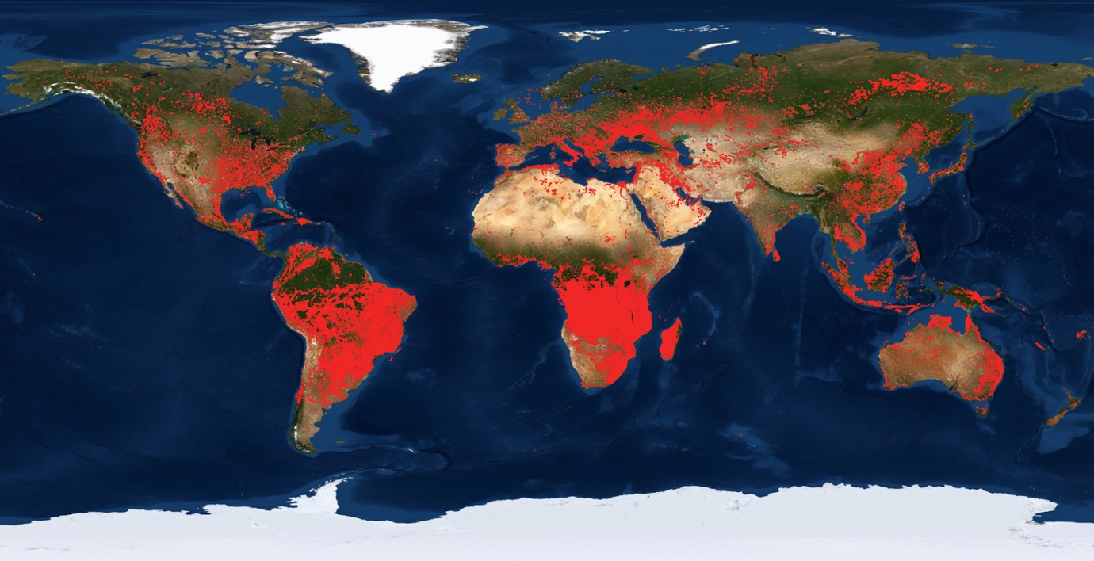
Figure 1: Much of the world is burning at any time, impacting both humans and the environment. This map shows fires detected from satellite data for August 2021 from NASA's Fire Information for Resource Management System (FIRMS) (https://earthdata.nasa.gov/firms).
Alt Text: World map showing fire locations to highlight that fire affects a large area of planet, especially South America and Africa.

Methodology:
The student will be able to take advantage of recent advances in fire modelling and novel data-model fusion techniques to investigate new methods for analysing satellite observations to evaluate and constrain present-day fire climate feedbacks.
The student will adopt modern numerical techniques such as machine learning/data assimilation to confront the model with satellite data.
The student will develop an explainable machine-learning based emulator for the JULES-INFERNO model, allowing the importance of the different driving factors to be analysed. Incorporating ConFire’s Bayesian approach will account for uncertainty in fire drivers and biases in simulated fire impacts - allowing assessment of the confidence in attributing the cause of fire events to particular drivers.
The student will perform state-of-the-art simulations with JULES carried out using the ISIMIP framework to evaluate the ability to represent fires in future climate scenarios and utilise the emulator to examine how any climate response evolves.

References:

- “Firing up ambition”, Nat. Clim. Chang. 10, 1 (2020). https://doi.org/10.1038/s41558-019-0680-9
- Phillips, N. and Nogrady, B., “The race to decipher how climate change influenced Australia’s record fires”, Nature 577, 610-612 (2020), https://doi.org/10.1038/d41586-020-00173-7
- Hantson, S. et al.: The status and challenge of global fire modelling, Biogeosciences, 13, 3359–3375, https://doi.org/10.5194/bg-13-3359-2016, 2016
- Kelley, D.I., Bistinas, I., Whitley, R. et al., How contemporary bioclimatic and human controls change global fire regimes. Nat. Clim. Chang. 9, 690–696, 2019, https://doi.org/10.1038/s41558-019-0540-7 - Accessible via https://core.ac.uk/download/pdf/226936315.pdf
- Burton, C. et al., Representation of fire, land-use change and vegetation dynamics in the Joint UK Land Environment Simulator vn4.9 (JULES), Geosci. Model Dev., 12, 179–193, 2019, https://doi.org/10.5194/gmd-12-179-2019
- UNEP (2022) “Spreading like Wildfire: The rising threat of extraordinary landscape fires” https://www.unep.org/resources/report/spreading-wildfire-rising-threat-extraordinary-landscape-fires

Funding details:
NERC CENTA studentships are for 3.5 years and are funded by NERC. In addition to the full payment of your tuition fees, you will receive the following financial support:
- Annual stipend, currently set at £18,622 (2023/4 – new figures to be confirmed spring 2024)
- Research training support grant £8,000 (RTSG)
If you are not eligible for UK Fees the University of Leicester will fund the difference between UK and International fees for the duration of your studies
For more details of the CENTA consortium please see the CENTA website: www.centa.org.uk.
Entry requirements:
Applicants are required to hold/or expect to obtain a UK Bachelor Degree 2:1 or better in a relevant subject.
The University of Leicester English language requirements apply where applicable.

Application advice:
To apply please refer to our web page for further information and read carefully the How to Apply section before submitting your application
https://le.ac.uk/study/research-degrees/funded-opportunities/centa-phd-studentships

In the funding section please specify that you wish to be considered for Ref CENTA2-PHYS3-PARK

In the proposal section please provide the name of the supervisors and project title (a proposal is not required)

Project / Funding Enquiries to: CENTA@le.ac.uk or rjp23@le.ac.uk
Application enquiries to pgradmissions@le.ac.uk

