University of Leicester PhD studentship
Funding Source: CENTA DTP
Proposed start date: 23rd September 2024
Closing date for applications: See our web page
Eligibility: UK/International
Department/School: Genetics
Supervisors: PI: Dr Robert Hammond, rh225@le.ac.uk, University of Leicester
Co-I: Dr Fabian Freund (modelling, UoL), Dr Nick Tate (GIS, UoL)
Project Title: Understanding the extinction vortex: inbreeding in haplodiploids.

Project Description :

Project Highlights:
- Your research will be high impact science geared towards the conservation of the 20% of animal species that are haplodiploid - including essential pollinators and seed dispersers.
- You will receive interdisciplinary training and gain experience in a wide variety of sought-after techniques and approaches (e.g. mathematical modelling, GIS and genomics).
- You will engage in field work in Spain and present your work in national and international conferences.
Overview:
Around 20% of all animals - including all the bees, wasps and ants that are important pollinators and seed dispersers - are haplodiploid (Heimpel and de Boer, 2008). That is, females are diploid and males are haploid. However, the mechanism underlying haplodiploidy, known as complementary sex determination (csd), means that low genetic variation and/or inbreeding can detrimentally reduce reproduction (Zayed and Packer, 2005). This is because diploid offspring erroneously develop as males rather than females (Harpur et al., 2013). Such reduced reproduction lowers population size further, exacerbating the effects in a feedback loop: the extinction vortex (Figure 1A). Given human induced habitat degradation and climate change, insect populations – including many of those with haplo-diploid sex determination - are declining and fragmenting (Sanchez-Bayo and Wyckhuys, 2019). Understanding the extinction vortex is therefore a priority.
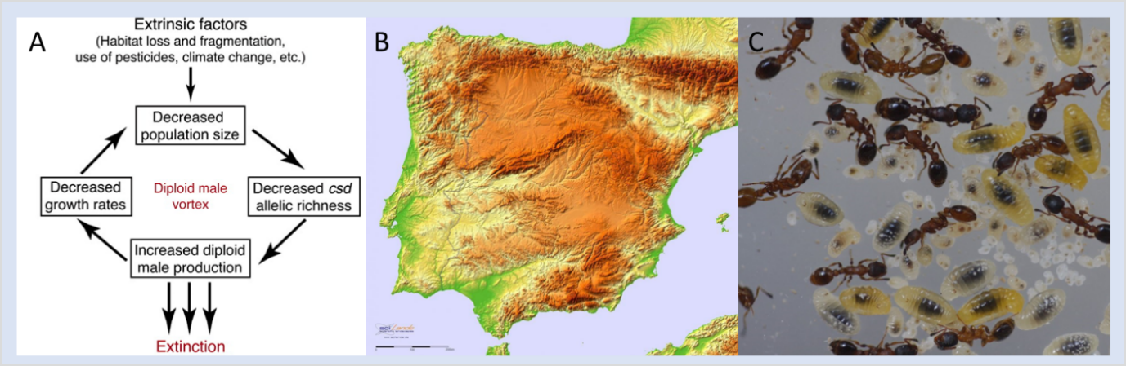
Figure 1: A: Extinction vortex caused by diploid male production (Zayed and Packer, 2005); B: relief map of the Iberian Peninsula, darker shading shows higher altitudes; C: Leptothorax acervorum colony showing a queen (yellow arrow), adults workers, developing larvae at various stages of development (gut contents clearly visible),

The objectives of the PhD project are as follows (the emphasis on each element can be tailored to your interests & how the project develops).
- Model the effects of inbreeding and diploid male production in haplodiploids. Although there is some theoretical work on the impact of inbreeding and diploid male production on population persistence, you will extend this theory to investigate how life history variation influences outcome.
- Estimate inbreeding & diploid male production in a model ant species. You will estimate diploid male production in the well-studied ant, Leptothorax acervorum (Figure 1C), and test if this correlates with effective population size (current and historical) estimated from genetic data. In the southern part of their range (Spain) this species is attitudinally limited being restricted to >1500m (Figure 1B). Populations are often small, have limited gene flow and so population isolation and inbreeding is a real issue and diploid males are regularly produced (Hammond, unpublished data)
- Model habitat patch size, occupancy and fragmentation. You will use spatial data to discover suitable habitats for L.acervorum in Spain. This will allow us to estimate patch size and connectivity and to interpret data gained from objective 2. It will also find new populations to sample for part 2.
Methodology:
- Modelling: You will develop mathematical models of diploid male production that consider: solitary vs social living, for social species the type of colony founding, mating frequency of females, colony size and female productivity, diploid male fertility and triploid female fertility.
- Inbreeding / diploid male production: You will collect samples of the ant, L.acervorum, from known locations, and locations identified by GIS modelling (see 3), in Spain. You will estimate population genetic variation using reduced representation sequencing and the proportion of diploid males will be identified genetically. This will involve molecular genetic lab work and bioinformatic analysis.
- Habitat patch size: You will develop GIS models to identify suitable habitat/altitude/aspect patches. This will be done using data derived from known populations / published records and using state of the art GIS software and modelling (e.g. ArcGIS Pro, R).

References:

Harpur, B.A., Sobhani, M., Zayed, A., 2013. A review of the consequences of complementary sex determination and diploid male production on mating failures in the Hymenoptera. Entomol. Exp. Appl. 146, 156–164. https://doi.org/10.1111/j.1570-7458.2012.01306.x
Heimpel, G.E., de Boer, J.G., 2008. Sex determination in the Hymenoptera. Annu. Rev. Entomol. 53, 209–230. https://doi.org/10.1146/annurev.ento.53.103106.093441
Sanchez-Bayo, F., Wyckhuys, K.A.G., 2019. Worldwide decline of the entomofauna: A review of its drivers. Biol. Conserv. 232, 8–27. https://doi.org/10.1016/j.biocon.2019.01.020
Zayed, A., Packer, L., 2005. Complementary sex determination substantially increases extinction proneness of haplodiploid populations. Proc. Natl. Acad. Sci. U. S. A. 102, 10742–10746. https://doi.org/10.1073/pnas.0502271102

Funding details:
NERC CENTA studentships are for 3.5 years and are funded by NERC. In addition to the full payment of your tuition fees, you will receive the following financial support:
- Annual stipend, currently set at £18,622 (2023/4 – new figures to be confirmed spring 2024)
- Research training support grant £8,000 (RTSG)
If you are not eligible for UK Fees the University of Leicester will fund the difference between UK and International fees for the duration of your studies
For more details of the CENTA consortium please see the CENTA website: www.centa.org.uk.
Entry requirements:
Applicants are required to hold/or expect to obtain a UK Bachelor Degree 2:1 or better in a relevant subject.
The University of Leicester English language requirements apply where applicable.

Application advice:
To apply please refer to our web page for further information and read carefully the How to Apply section before submitting your application
https://le.ac.uk/study/research-degrees/funded-opportunities/centa-phd-studentships

In the funding section please specify that you wish to be considered for Ref CENTA2-GENE3-HAMM

In the proposal section please provide the name of the supervisors and project title (a proposal is not required)

Project / Funding Enquiries to: CENTA@le.ac.uk or rh225@le.ac.uk
Application enquiries to pgradmissions@le.ac.uk

