University of Leicester PhD studentship
Funding Source: CENTA DTP
Proposed start date: 23rd September 2024
Closing date for applications: See our web page
Eligibility: UK/International
Department/School: Chemistry
Supervisors: PI: Dr Patricia Rodriguez Macia (prm28@leicester.ac.uk), School of Chemistry, University of Leicester
Co-I: Dr Sandy Kilpatrick (afrk1@leicester.ac.uk), School of Chemistry, University of Leicester

Project Title: Mining natural microbial diversity for optimised biohybrid scaffolds.

Project Description :
Project Highlights:
- Identify extremophile microorganisms that fix greenhouse gases from the atmosphere
- Establish biocatalytic tools for Carbon Capture and Storage
- Develop new approaches for designing biohybrid catalysts for Carbon Capture and Catalytic Hydrogenation
Overview (including 1 high quality image or figure):
Global warming caused by greenhouse gases like CO₂ is a major global concern. Understanding the complex natural cycling of greenhouse gases is crucial to address the urgent climate crisis. The cycling of key greenhouse gases, like CO₂, involves microorganisms that fix CO₂ and release methane. Some microorganisms also utilise intermediates like carbon monoxide (CO) and dihydrogen (H₂) in their metabolism. The metabolic pathways of these microorganisms involve specialised gas-processing enzymes, which are key to understand how greenhouse gases can be fixed from the atmosphere, and directly related to biogeochemical cycles, global warming, and climate change.
This project aims to develop new biohybrid catalysts by utilising biological scaffolds to host or bind synthetic catalysts. Biohybrid catalysts hold a lot of potential to fix greenhouse gases from the atmosphere and for carbon capture and storage (CCS). They are sustainable, as they are biodegradable and produced from naturally abundant materials. Biohybrid catalysts combine the advantages of synthetic chemistry with the benefits of natural enzymes (specificity/selectivity). However, biohybrid catalysts based on protein scaffolds from ‘regular’ organisms are generally restricted to ambient conditions, limiting their scope for application in biotechnology.
Extremophiles are organisms that live under extreme environments, such as under high pressures and extremes of temperature and pH. Evolution of organisms under extreme conditions has optimised their enzymes for exquisite performance under harsh conditions. This project aims to make use of the unique properties of extremophiles by mining their genomes in search of ideal scaffolds for synthetic catalysts to build biohybrid catalysts that can work under non-ambient conditions.
This project will encompass three main stages. Stage 1 will focus on searching for (i) small metalloproteins from extremophiles including enzymes active for CO₂ reduction and/or H₂ conversion and (ii) small proteins like ferredoxins and cytochromes. In Stage 2, the identified enzymes/proteins will be produced and characterised to test their stability under extreme conditions. In Stage 3, the produced enzymes will be tested as candidates for binding synthetic catalysts. Overall, this project will develop new approaches for environmental biotechnology to fix greenhouse gases from the atmosphere and for CCS by building biohybrid catalysts using biological scaffolds from extremophiles.
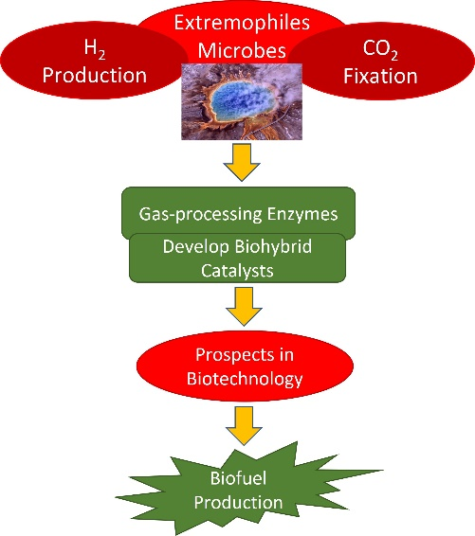
Figure 1: Extremophilic microbes have developed several physiological and molecular strategies to survive and grow in extreme environments. This figure is a graphical abstract describing the key steps of the project.
Methodology:
The research plan breaks down as follows: 1) Analysis of databases (e.g. metagenomic databases) will be done to identify homologues of well-known hydrogenases (enzyme that catalyse H₂ conversion in nature), CO dehydrogenases (enzyme that catalyse the CO₂/CO interconversion in nature), as well as ferredoxins and cytochromes that are present in extremophiles. 2) The organisms of interests will be obtained and cultured in the lab to purify the enzymes. 3) In parallel with the step 2, the enzymes will be produced heterologously (e.g. inside E. coli or other hosts). 4) The structure/function of the enzymes will be studied via an integrated approach combining electrochemical, spectroscopic, structural and computational methods. 5) The produced enzymes will be tested as candidates for binding/hosting synthetic catalysts and the reactivity of the biohybrid catalysts will be explored.
References:

Stein, LY. (2020) ‘The long-term relationship between microbial metabolism and greenhouse gases’ Trends Microbiology 28 (6), pp. 500-511.
Tiedje, JM, Bruns, MA, Casadevall, A, Criddle, CS, Eloe-Fadrosh, E, Karl, DM, Nguyen, NK, Zhou, J. (2022) ‘Microbes and climate change: a research prospectus for the future’ mBio 13 (3), e0080022.
Greening, C, Boyd, E. (2020) ‘Editorial: Microbial hydrogen metabolism’ Frontiers in Microbiology 11, pp. 56.
Diender, M, Stams, AJM, Sousa, DZ. (2015) ‘Pathways and bioenergetics of anaerobic carbon monoxide fermentation’ Frontiers in Microbiology 6, pp. 1275.

Funding details:
NERC CENTA studentships are for 3.5 years and are funded by NERC. In addition to the full payment of your tuition fees, you will receive the following financial support:
- Annual stipend, currently set at £18,622 (2023/4 – new figures to be confirmed spring 2024)
- Research training support grant £8,000 (RTSG)
If you are not eligible for UK Fees the University of Leicester will fund the difference between UK and International fees for the duration of your studies
For more details of the CENTA consortium please see the CENTA website: www.centa.org.uk.
Entry requirements:
Applicants are required to hold/or expect to obtain a UK Bachelor Degree 2:1 or better in a relevant subject.
The University of Leicester English language requirements apply where applicable.

Application advice:
To apply please refer to our web page for further information and read carefully the How to Apply section before submitting your application
https://le.ac.uk/study/research-degrees/funded-opportunities/centa-phd-studentships

In the funding section please specify that you wish to be considered for Ref CENTA2-CHEM3-RODR

In the proposal section please provide the name of the supervisors and project title (a proposal is not required)

Project / Funding Enquiries to: CENTA@le.ac.uk or prm28@leicester.ac.uk
Application enquiries to pgradmissions@le.ac.uk

