Risk Assessment Form
Persons Designated (PD):

Departmental name:

Date Assessment conducted:

Department Head:

Date of previous risk Assessment:

Designated Individual (DI):

Risk Assessment Process
The risk assessment process consists of identifying, analysing, evaluating risks on a continual basis. It can be seen as a 5-step continual process:-

- Identify risk –

Physical: Suitability of premises i.e. lifting, awkward postures, slips and trips, noise, dust, machinery etc.
Biological: including tuberculosis, hepatitis and other infectious diseases faced by healthcare workers, home care staff and other healthcare professionals.

- Identify the risks – what, why and how events can happen.

- Equipment not fit for purpose;
- Loss of relevant material;
- Tissue is collected, stored or used without consent;
- Storing or using human tissue after consent withdrawal;
- Loss or mix up of material due to inadequate labelling and tracking system;
- Storage failure or other damage affecting human tissue quality for useful research;;
- Risk of Infection when handling samples of tissue, blood, urine etc;
- Loss of material due to inadequate packaging during transport;
- Transport of specimens to other buildings of the establishment;
- Material transferred without NRES approval, appropriate consent or to an unlicensed site;
- Material disposed of by an inappropriate method/route;
- Disposal records not retained for audit;
- Material disposed of in error.
- Security arrangements

- Determine the likelihood of a hazard occurring – determine the existing controls and analyse the risk in terms of the potential consequences for the University and its likelihood in the context of the existing controls.

- Evaluate the risks – Evaluate and rank the risks.

- Treat the risks – Options to minimise the risk must be identified, treatment action plans must be developed and solutions implemented.

Reference e.g. lab/Freezer | Description of Risk – describe the potential problem. | Existing risk assessments– physical controls and/or systems currently in place to reduce the risk of adverse incidents? | Risk Assessments
 |  |  | Severity  (S) | Likelihood  (L) | Risk Rating  (SxL) | Risk ranking
Consent.
Example:
- Tissue is collected, stored or used without consent.
Handling and Storage
Examples:
•Risk of Infection when handling samples of tissue, blood, urine etc.;
•Loss of material due to inadequate labelling and tracking system;
•Loss of material due to storage equipment failure.

Reference e.g. lab/Freezer | Description of Risk – describe the potential problem. | Existing risk assessments– physical controls and/or systems currently in place to reduce the risk of adverse incidents? | Risk Assessments
 |  |  | Severity  (S) | Likelihood  (L) | Risk Rating  (SxL) | Risk ranking
Transfer – Examples:
- Risk of Infection when transferring samples of tissue, blood, urine etc.;
- Loss of material due to inadequate labelling and tracking system during transport;
- Loss of material due to inadequate packaging during transport;
- Material transferred without NRES approval, appropriate consent or to an unlicensed site.

Reference e.g. lab/Freezer | Description of Risk – describe the potential problem. | Existing risk assessments– physical controls and/or systems currently in place to reduce the risk of adverse incidents? | Risk Assessments
 |  |  | Severity  (S) | Likelihood  (L) | Risk Rating  (SxL) | Risk ranking
Disposal
Examples:
- Material disposed of by an inappropriate method/route;
- Disposal records not retained for audit;
- Material disposed of in error.

Risk Ranking Matrix
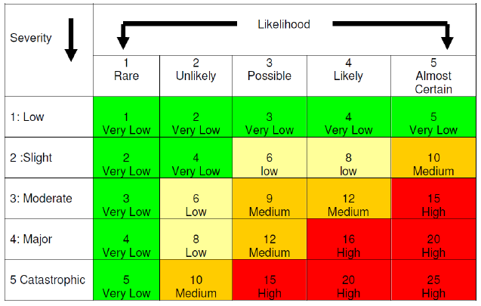

Risk Ranking Grade | Score | Responsibility
Very low | <5 | Laboratory Level
Low | 6-8 | Laboratory Level
Medium | 9-12 | DI/RGO/PD
High | 15-25 | Designated Individual & Licence Holder

Likelihood Matrix

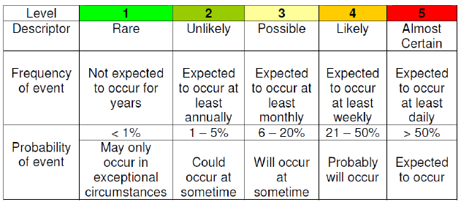
Send copy of completed risk assessment to Designated Individual (DI) and Research Ethics Governance and Integrity Office (REGI).

