

**Equity, Diversity and Inclusion**

**Annual Report**

**January 2024**

**UNIVERSITY OF LEICESTER**

**Equity, Diversity and Inclusion Annual Report**

**January 2024**

1. Introduction
   1. This report details the Equity, Diversity and Inclusion (EDI) Team led activity to advance equity and inclusivity at the University since the last report in March 2023.
   2. It reports on progress across all key equity areas, including in relation to the objectives and priorities identified by the University’s Equity Action Groups, in line with our Public Sector Equality Duty.
   3. ***In order to align with changes in reporting and committee structures, this report covers the 10-month period March 2023 to December 2023 for this year only. From 2025 onwards, the EDI annual report will span January to December.***
   4. This report is organised into the following sections:

|  |  |
| --- | --- |
| Section 1 | Introduction |
| Section 2 | Student and Staff 5-year Diversity Profile |
| Section 3 | Strategic Framing of Equity, Diversity and Inclusion |
| Section 4 | Advancing Equity and Inclusivity in Key Areas |
| Section 5 | Organisational Embedding of Equity, Diversity and Inclusion |
| Section 6 | Student and Education Equality, Diversity and Inclusion Team Activity and Achievements |
| Section 7 | Students’ Union EDI Activity and Achievements |
| Section 8 | Summary of Progress and Impact |

* 1. As is detailed throughout the report, progress and impact in advancing equity and inclusion at the University of Leicester have continued since the last annual report. This has further developed and strengthened the strategic and operational infrastructure in place to support the University’s ambitious EDI aspirations and commitments.
  2. The Report includes the full student and staff diversity demographic, including benchmark data, where relevant, over the last 5 years.
  3. It also includes information about the EDI achievements and activity from both the Student and Education EDI Team and the Students’ Union.
  4. Other EDI related expertise and activity take place across the University but are not included in this report as they are reported elsewhere. This includes the work of central Student Support Services, where EDI is embedded into service delivery (and includes the Standing Together Team and AccessAbility Service). In addition, embedded EDI activity takes place at College, Division and School/Department level, including as part of the University’s EDI governance structure.
  5. This annual report details the University’s Pay Gap Report for 2024 and includes, for the first time, the University’s disability, ethnicity, and sexual orientation pay gaps, as well as the gender pay gap, along with details of initiatives and actions and being taken to reduce these gaps.
  6. Continued strong partnership working, including with the Students’ Union, the Staff Equity Fora, Academic and Professional Services teams and other key stakeholders across the University, remain vital to the work of the EDI Team and to progressing equity and inclusivity at the University of Leicester.

1. Student and Staff 5-Year Diversity Demographic Profile
   1. This section provides an overview of the diversity demographic of students and staff at the University over the last 5 years.
   2. The data tables and graphs for both students and staff by equality characteristic are included in *Appendix A* to accompany the following narrative (see Tables 1.1-7.2 and Graphs 1.1-7.2).
   3. The student population data covers the academic years 2018/19 to 2022/2023. The data includes all UG, PGT and PGR students, excluding students that are suspended, dormant or withdrawn on 1st December 2022. Dalian students studying at Dalian (China) for all 4 years of their course have been excluded.
   4. Benchmark figures are included where appropriate, and are the latest available figures from the[*Advance HE Equality in Higher Education: Student Statistical Report 2023.*](https://advance-he.ac.uk/knowledge-hub/equality-higher-education-statistical-reports-2023)
   5. The staff population data covers 2020 to 2024, based on a snapshot of data captured annually on 1st January. Benchmark figures are for 2021/22, the latest available from Heidi Plus (HESA UK HEI Figures).

Age Profile of Students

* 1. In the academic year 2022/23, 60.5% of the student population were classified as ≤21, an increase of 3.9 percentage points in 2021/22 (See Table 1.1, Graph 1.1). This remains above the national sector picture for 2021/22, in which 47.3% of students in UK higher education were classified as ≤21 (Advance HE, 2023 Report).
  2. Since 2017/18, the proportion of students ≤21 has fluctuated each year, between 56.6% and 63.0%. The vast majority of students at Leicester are in the 18-21 age group (See Table1.1, Graph 1.1).

Age Profile of Staff

* 1. The majority of UoL staff in 2024 are between the ages of 31-60 (74.2%).
  2. In 2024, UoL has seen an increase by 2.5 percentage points, since 2023, of staff aged 30 and under, from 13.6% in 2023 to 16.1% (Table 1.2, Graph 1.2). This is 0.3 percentage points higher than the national picture of staff for UK HEI’s in 2021/22.
  3. The proportion of staff aged 66 has slightly decreased since 2023 and continues to be the lowest proportion of the overall staff body. This is in line with the national picture for UK HEI’s in 2021/22 (See Table 1.2, Graph 1.2).

Disability Profile of Students

**Disability - Students**

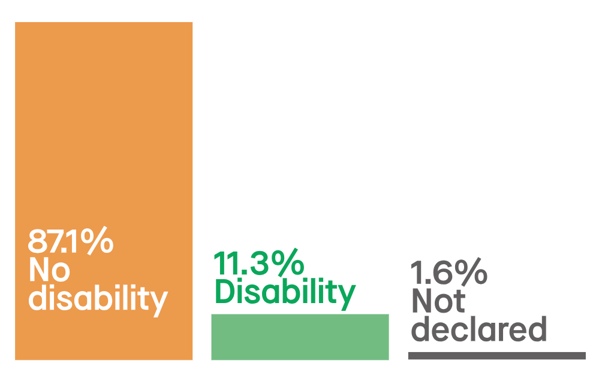

* 1. In 2022/23, 11.3% of UoL students declared a disability, this is a 1.1 percentage points increase from 2022/22. The proportion of students declaring a disability has remained above 10.0% in the last three academic years, which is an increase from 2018/19 and 2019/20 (see Table 2.1, Graph 2.1). This is still noticeably lower than the rate for the UK sector, which was 15.9% in 2021/22 (Advance HE, 2023 Report).
  2. The proportion of UoL students whose disability status is ‘unknown’ increased by 0.6% from 1.0% in 2021/22 to 1.6% in 2022/23.

**Disability – Staff**

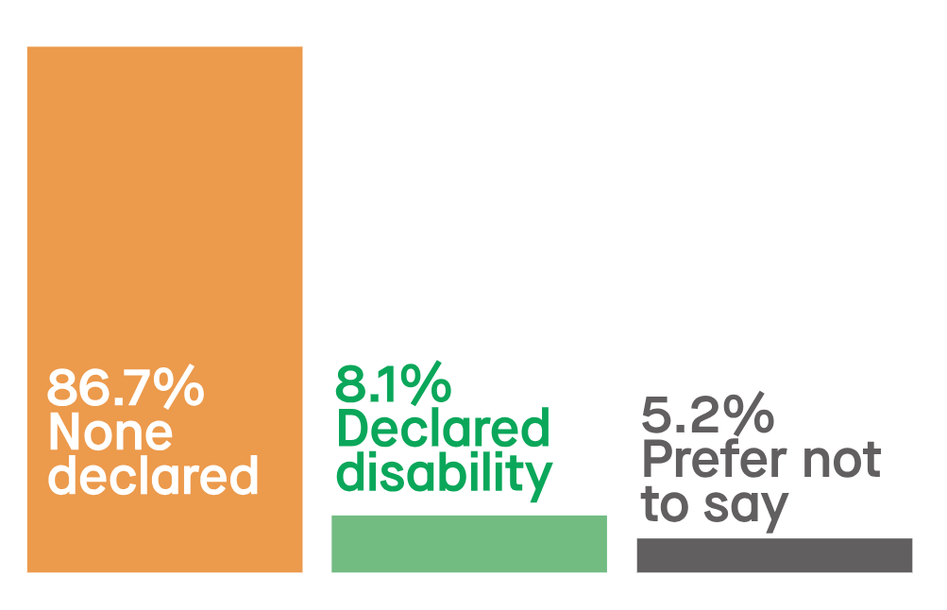

Disability Profile of Staff

* 1. Over the last five years, UoL has seen an increase in the number of staff declaring a disability. The proportion of UoL staff declaring a disability in 2024 has increased by 1.3 percentage points from 2023 to 8.1% (See Table 2.2, Graph 2.2). This is 1.1 percentage points higher than the national picture.

Ethnicity Profile of Students

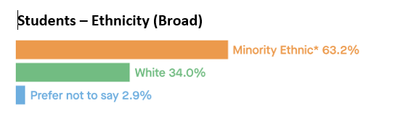

* 1. Since 2018/19, we have seen considerable growth (increase of 12.6 percentage points) in the proportion of students at the University who identified as minority ethnic (see Table 3.1, Graph 3.1). In the academic year 2022/23, 63.2% of all UoL students identified as minority ethnic, an increase from 52.1% in 2020/21.
  2. In 2021/22, 27.0% of the UK domiciled students in higher education identified as minority ethnic (Advance HE, 2023 Report). It is important to note that the population for UoL student ethnicity data includes international students. It is only compulsory to collect ethnicity data for UK domiciled students and, as such, the sector comparison only includes UK domiciled students in Higher Education.
  3. Each year we have seen a gradual decrease in the proportion of UoL students who have not declared their ethnicity (from 3.6% in 2018/19 to 2.9% in 2022/23).
  4. In 2022/23, the majority of UoL students identified as either Asian or Asian British (41.4%) or White (34.0%).
  5. The proportion of Asian or Asian British students at UoL has increased by 10.2 percentage points, from 31.2% in 2020/21 to 41.4% in 2022/23 (see Table 3.3, Graph 3.3).
  6. Of the total UoL minority ethnic students in 2022/23, the largest majority 39.3% were Indian. This is an increase of 18.9 percentage points from 20.4% in 2019/20 (Table 3.5).
  7. 13.4% of all UoL students in 2022/23 were Black or Black British, an increase from 12.7% in 2021/22 (See Table 3.3). Of these students, most identified as being from a Black African background (17.4%). Black Caribbean students continue to be less represented, constituting 2.4% of minority ethnic students overall at UoL in 2022/23 (See Table 3.5).

**Students – Ethnicity (Detailed)**

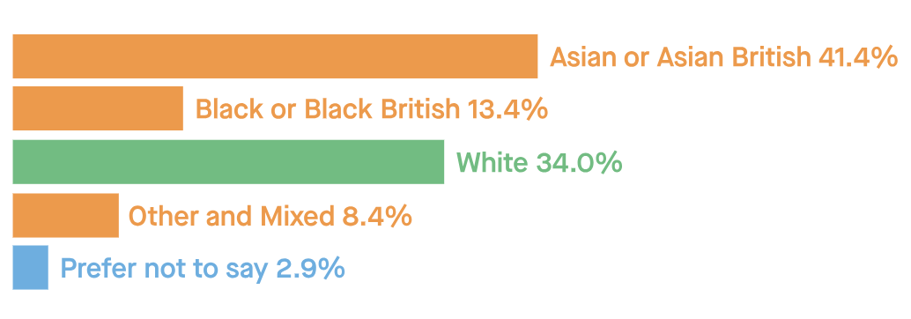

* 1. Nationally, in 2021/22, 42.9% of minority ethnic UK domiciled students were Asian, of which the majority were Pakistani (14.1%) and Indian (13.0%). 6.9% of minority ethnic students were Bangladeshi and 8.8% were from other Asian backgrounds. 29.6% were Black, most of whom were from a Black African background (22.8% of total minority ethnic UK domiciled students). Black Caribbean students were much less represented and constituted 5.3% of minority ethnic UK domiciled students overall. 16.7% of minority ethnic UK domiciled students were from a mixed background, 2.9% were Chinese, and 4.6% identified as other ethnic group (Advance HE, 2023 Report).

Ethnicity Profile of Staff

* 1. In 2024 28.8% of UoL staff identified as minority ethnic, 65.7% as white and 5.5% did not declare their ethnicity. The proportion of minority ethnic staff at UoL has increased since 2020 (18.0%) by 10.8% percentage points and is substantially higher than the UK HEI figure in 2021/22 (15.8%) (See Table 3.3, Graph 3.3).

**Staff – Ethnicity (Detailed)**

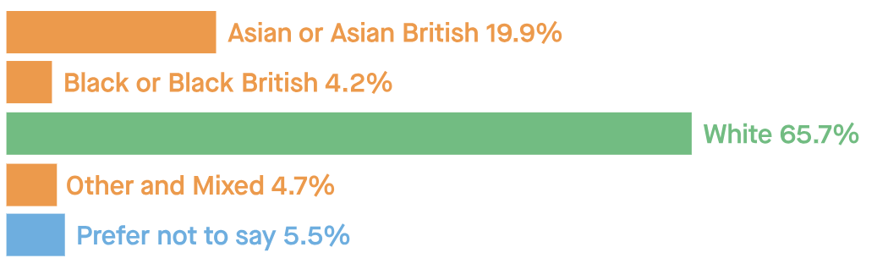

**Staff – Ethnicity (Broad)**

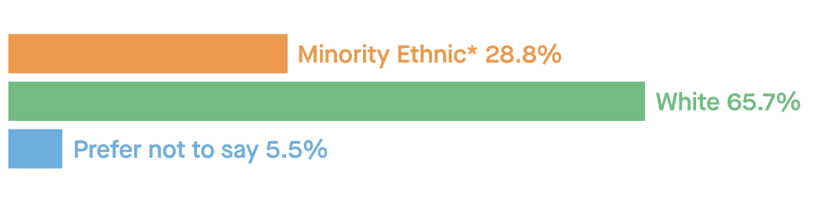

* 1. The number of UoL staff disclosing their ethnicity has continued to increase over the last five years, with the proportion of ‘prefer not to say’ reducing from 12.9% to 5.5%. This is 2.7 percentage points lower than the UK HEI figure in 2021/22 (8.2%).
  2. In 2024, the proportion of Asian or Asian British (19.9%), Black or Black British (4.2%) and Other and Mixed (4.7%) UoL staff is higher than the national picture for UK HEI’s in 2021/22 (See Table 3.4, Graph 3.4).

Religion or Belief Profile of Students

* 1. The proportion of UoL students reporting no religion or belief has continued to decrease each academic year, from 42.6% in 2019/20, to 30.6% in 2022/23 (See Table 4.1, Graph 4.1).
  2. The proportion of Hindu students at UoL has continued to increase over the last five years, with the most considerable increase from 7.6% in 2020/21 to 14.6% in 2022/23. This remains noticeably higher than the national figure in 2021/22, in which the proportion of UK higher education students who reported their religion as Hindu was 4.2% (Advance HE, Report 2023).
  3. Since 2018/19, the proportion of Muslim students at UoL has increased by 4.7 percentage points, from 11.6% to 16.3% in 2022/23.
  4. The proportion of Sikh students at UoL has increased in the last three years, from 3.0% in 2019/20 to 5.3% in 2022/23. This is higher than the national figure in 2021/22, in which 1.0% of students in UK higher education reported their religion as Sikh (Advance HE, 2023 2023).
  5. Since 2020/21, there has been a decrease in the proportion of Christian students at UoL, from 27.8% to 24.2% in 2022/23.
  6. Nationally, Advance HE reported that the religion or belief groups with the highest proportions of students in 2021/22, were no religion or belief (43.8%), Christian (28.7%) and Muslim (10.6%) (Advance HE, Report 2023).
  7. See section 6 for details of how the University is developing its provision to support student and staff faith groups.

Religion or Belief Profile of Staff

* 1. The religion or belief groups with the highest proportion of staff in 2024 include: 36.5% no religion or belief, 23.5% Christian, 5.6% Hindu and 6.9% Muslim. 22.3% of UoL staff declared ‘prefer not to say’ a reduction of 3.8 percentage points from 2023 (See Table 4.2, Graph 4.2).
  2. Over the last five years, the proportion of staff who have declared ‘prefer not to say’ has decreased by 20.9 percentage points, from 43.2% in 2020 to 22.3% in 2024.

Sex/Gender Profile of Students

**Students – Sex/Gender Profile**

**52.5% of students are female**

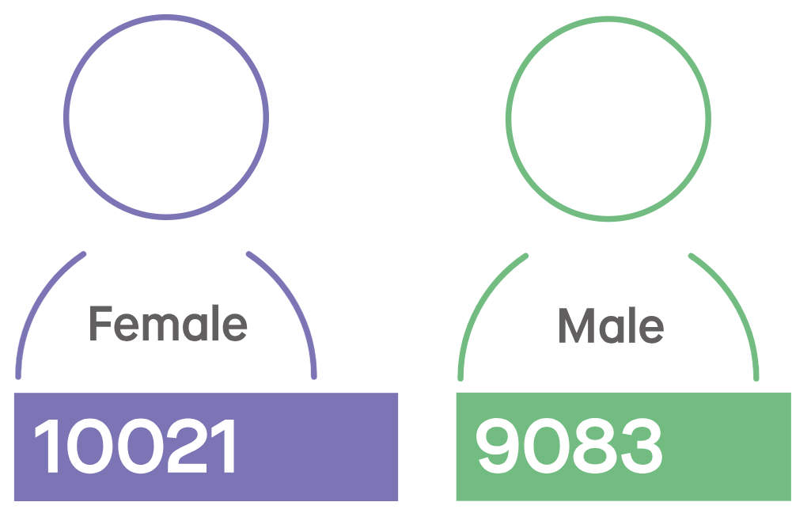

* 1. The University has seen an increase in the proportion of female students studying at UoL in 2022/23 (52.5%) compared to 51.5% in 2021/22. Female students continue to make up the majority of those studying at UoL (See Table 5.1, Graph 5.1).
  2. The higher proportion of female students studying at UoL compared to male students, aligns with the national picture in UK higher education. In 2021/22, 57.3% of all students studying in UK higher education were female (Advance HE, Report 2023).

Sex/Gender Profile of Staff

**Staff – Sex/Gender Profile**

**55.8% of staff are female**

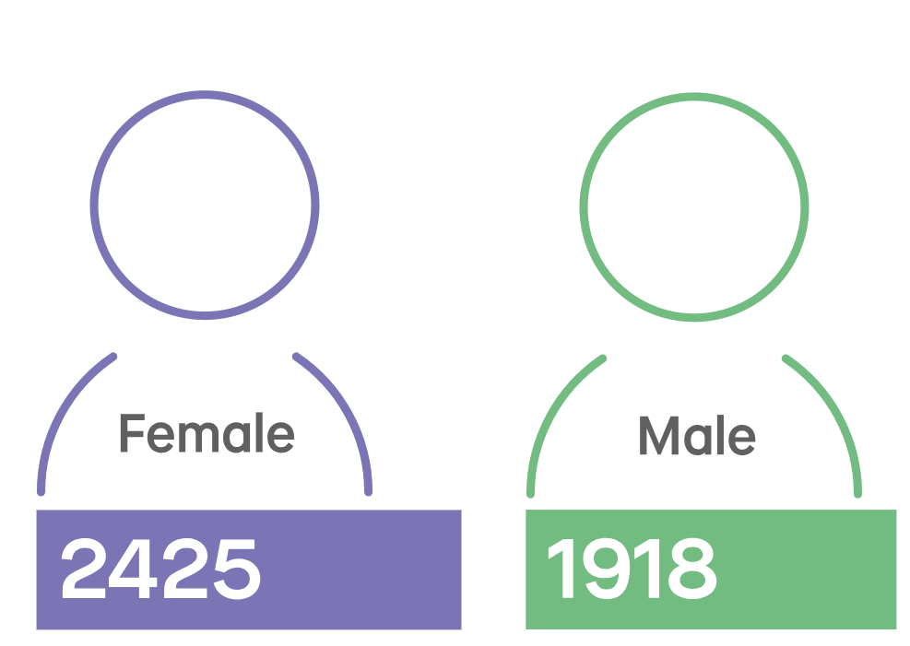

* 1. In 2024, 55.8% of UoL staff identified as female and 44.2% as male. The proportion of females at UoL is slightly higher than the national UK HEI average in 2021/22 (55.2% female). Over the last five years, female staff have remained the majority of staff at UoL (See Table 5.2, Graph 5.2).

Gender Identity of Staff

* 1. In 2024, 67.2% of UoL staff declared that their gender identity matches their ‘sex as registered at birth’, 1.0% of staff declared that their gender identity differs to their ‘sex as registered at birth’ and 31.8% of staff chose not to declare (Table 6.1, Graph 6.1). We will continue to monitor gender identity data in future annual reports.
  2. The University first began to collect gender identity data from students in the academic year 2023/24. As such, student gender identity information is not available for the academic year 2022/23. We will monitor and report on this in next year's annual report.

Sexual Orientation Profile of Students

* 1. The proportion of students at the University identifying as LGB+ (Bisexual, Gay man, Gay woman/Lesbian, Other) has increased in the last five years since 2018/19, from 5.8% to 9.9% in 2022/23 (See Table 7.1/Graph 7.1).

**Students – Sexual Orientation**

(*Bisexual, Gay Man, Gay woman/lesbian, Other)

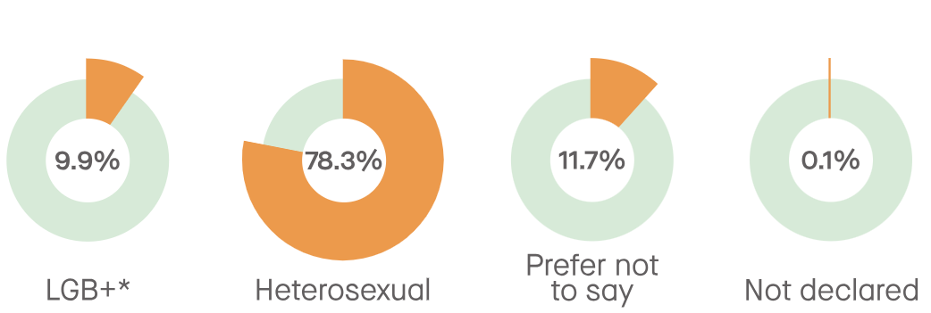

* 1. The University first started recording sexual orientation in 2015/16 and the proportion of students choosing to disclose their sexual orientation has increased each year. There have been fluctuations in the proportion of students who selected ‘information refused’ over the last five academic years.

Sexual Orientation Profile of Staff

**Staff – Sexual Orientation**

(*Bisexual, Gay Man, Gay woman/lesbian, Other)

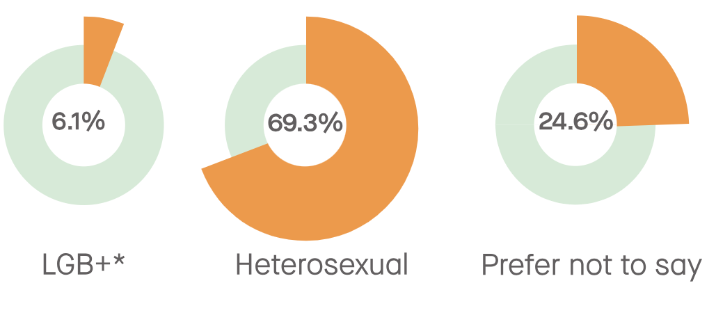

* 1. In 2024, 6.1% of UoL staff identified as LGB+ (Bisexual, Gay man, Gay woman/Lesbian, Other), 69.3% as Heterosexual/straight and 24.6% as ‘prefer not to say’ (See Table 7.2, Graph 7.2). The proportion of staff declaring ‘prefer not to say’ has steadily decreased considerably since 2020 by 22.9 percentage points, and the proportion of staff declaring their sexual orientation as LGB+ has increased by 2.4 percentage points.

Key Data Trend Reflections

* 1. Reflecting on both the student and staff diversity profile at the University of Leicester over the 5-year period, there is continued increased diversity across the categories of disability, ethnicity, religion or belief and sexual orientation.
  2. The ethnic diversity of our student body, continues to increase significantly, with 63.2% of all UoL students in 2022/23 identifying as minority ethnic, compared with 52.1% in 2020/21.
  3. Black or Black British Caribbean students continue to be less represented, constituting 2.4% of minority ethnic students, compared to 17.4% Black or Black British – African students.
  4. The proportion of Hindu students has significantly increased since 2018/19, from 4.9% to 14.6% in 2022/23, and the proportion of Muslim students has increased from 11.6% in 2018/19 to 16.3% in 2011/22. Both are considerably higher than the national sector figures.
  5. The proportion of both students and staff at the University identifying as LGB+ (Bisexual, Gay man, Gay woman/Lesbian, Other) has increased in the last five years, students from 5.8% to 9.9% and staff from 3.7% to 6.1%.
  6. The percentage of minority ethnic staff has also increased over the last five years, from 18.0% in 2020 to 28.8% in 2024and whilst this is higher than the sector average, it is still significantly lower than the student body. Details of progress being made in inclusive recruitment can be found in Section 4.5.
  7. The percentage of minority ethnic and female staff in some key staff groups continues to increase, including the female professor, Grade 10 female staff, minority ethnic Academic staff and female Academic staff groups (Table 7.5).
  8. In 2024, there was a slight decrease in the percentage of minority ethnic professors, from 14.2% to 13.8%, and in Grade 10 minority ethnic staff, from 5.6% to 4.9%.

*Table 7.5: Diversity in Key Staff Groups*

| **Staff Groups** | **March**  **2021** | **September**  **2021** | **January**  **2022** | **January**  **2023** | **January 2024** |
| --- | --- | --- | --- | --- | --- |
| All Staff: Minority Ethnic | 19.1% | 21.6% | 22.6% | 26.1% | 28.8% |
| Professors: Minority Ethnic | 10.7% | 11.7% | 11.7% | 14.2% | 13.8% |
| Professors: Female | 23.7% | 26.1% | 26.1% | 28.0% | 28.9% |
| Grade 10 Professional Services Staff: Minority Ethnic | 6.1% | 9.1% | 8.3% | 5.6% | 4.9% |
| Grade 10 Professional Services Staff: Female | 36.4% | 42.4% | 41.7% | 50.0% | 56.1% |
| Academic Staff: Minority Ethnic | 14.6% | 21.0% | 21.1% | 27.4% | 30.1% |
| Academic Staff: Female | 38.9% | 46.1% | 45.8% | 47.4% | 48.6% |

* 1. There are initiatives in place to increase the diversity of key staff groups. For example, there are 2 annual academic promotions workshops for eligible minority ethnic staff and females who are interested in applying and recently promoted staff are encouraged to become mentors to future applicants. The guidance on special circumstances has been developed to recognise systemic disadvantage that may impact academic promotion. An EDI member of staff is now included in the membership of each college Academic Promotions and Senior Staff Pay Committee. A bank of case studies is being developed every year to promote successful promotions. Two new promotions processes for Teaching Fellows and Research Associates at Grade 7 will launch in 23/24.

Reducing Diversity Data Non-Disclosure Rates:

* 1. Having an accurate picture of the diversity demographic of the University helps inform intelligence-led service provision, resource allocation and policy, process and practice development. It helps us to identify specific issues and barriers, and take targeted action to support all of our community and forms part of our statutory duty in publishing our annual [Equality Information Report.](https://le.ac.uk/about/making-a-difference/equality/equality-data)
  2. We are making good progress in reducing staff diversity data non-disclosure rates (including both ‘Unknown’ and ‘Prefer Not to Say’ responses) with disability non-disclosure rates reducing to 5.2%, ethnicity to 5.5%, religion or belief to 22.3%, sexual orientation to 24.6% and gender identity (‘gender same as at birth?’) to 31.8% (Table 7.6).

*Table 7.6: Staff Diversity Data Non-Disclosure Rates*

|  |
| --- |
| **Staff Diversity Data Non-Disclosure Rates**  (includes both ‘Prefer Not to Say’ and ‘Not Known’) |

|  |  |  |  |  |
| --- | --- | --- | --- | --- |
| **Category** | **September 2020** | **January 2021** | **January 2023** | **January 2024** |
| Disability | 9.5% | 7.7% | 5.8% | 5.2% |
| Ethnicity | 12.5% | 9.9% | 6.7% | 5.5% |
| Gender Identity – gender same as at birth | N/A | N/A | 39.7% | 31.8% |
| Religion/Belief | 57.9% | 35.7% | 26.1% | 22.3% |
| Sexual Orientation | 46.3% | 39.1% | 28.1% | 24.6% |

* 1. To accelerate progress, a number of initiatives ran during 2023 to further increase staff diversity data disclosure rates, with a particular focus on the categories of disability, ethnicity, gender identity, religion or belief and sexual orientation.
  2. The Deputy Vice-Chancellor (Professional Services) has set a shared objective for all Professional Services Division Heads/Directors to increase their staff diversity data disclosure rates, with reporting and accountability for this through the University’s planning processes. Diversity data dashboards are shared with all Division Heads every 6 months to support their progress and impact planning in relation to this objective.
  3. Table 7.7 details the percentage point change in ‘prefer not to say’ and ‘not known’ responses between February 2023 and October 2023 for Central Professional Service areas against key diversity data categories, with progress made in all Divisions.

*Table 7.7: Central Professional Services Diversity Data*

|  |  |  |  |  |  |  |  |  |  |  |  |
| --- | --- | --- | --- | --- | --- | --- | --- | --- | --- | --- | --- |
| **Diversity Disclosure Rates for PS Divisions**  **(Progress between February 2023 and October 2023)** | | | | | | | | | | | |
| **Category** | **University level** | **Digital Services** | **Estates & Campus Services** | **External Relations** | **Finance** | **Human Resources** | **Library & Learning Services** | **Planning, Legal & Governance Services** | **Research & Enterprise** | **Student & Academic Services** |
| Disability | 94.97% +0.25 | 91.67% -2.36 | 93.72% +1.67 | 96.63% - 0.92 | 94.67% -0.92 | 100% disclosure | 94.25% +0.06 | 90.32% +7.56 | 93.86% -2.14 | 98.13% +0.93 |
| Ethnicity | 94.85% +1.14 | 87.5% -1.31 | 94.4% +3.05 | 95.14% -1.20 | 93.33% --0.78 | 100% disclosure | 98.85% +1.18 | 93.55% +10.79 | 95.61% +0.41 | 97.01% +0.61 |
| Gender same as at birth? | 67.62% +-9.66 | 56.25% +6.15 | 69.27% +18.56 | 72.29% +7.39 | 58.67% +4.25 | 72.22% +2.49 | 57.47% +3.98 | 83.87% +11.46 | 66.67% +0.27 | 67.54% +5.14 |
| Religion/belief | 81.57% +3.53 | 71.53% +1.38 | 84.21% +7.36 | 80.90% +3.35 | 76.00% +2.47 | 93.06% --0.37 | 82.76% +0.20 | 83.87% +4.56 | 83.33% +1.73 | 78.73% +0.33 |
| Sexual orientation | 79.14% +4.25 | 70.83% +2.18 | 80.64% +8.38 | 77.16% +3.28 | 70.67% +0.08 | 94.44% +1.02 | 77.01% +1.43 | 77.42% +8.45 | 81.58% +3.98 | 80.22% +1.02 |

* 1. A number of successful targeted initiatives have also been implemented during 2023, with a focus on increasing staff diversity data disclosure.
  2. In the College of Science and Engineering, following a targeted initiative to increase diversity disclosure rates among Grade 10 staff, led by the PVC and Head of College, the percentage of staff who have declared their diversity data in all categories increased from 24.0% to 40.5% (Table 7.8). This initiative is now being rolled out across the College.
  3. In Estates and Campus Services, the EDI Team have provided an opportunity for staff to update their diversity data at the end of ESC team meetings, either via the completion of a paper copy of the disclosure form or the data being input into the online system with them present. This has contributed to the increase in the percentage of staff who have declared their diversity data in all categories from 46.7% to 60.4% (Table 7.8). This practice will continue throughout 2023/24.

*Table 7.8: Staff Diversity Data Disclosure in CSE and ECS*

|  |  |  |  |  |
| --- | --- | --- | --- | --- |
| **Staff Diversity Data Disclosure** | | Before the campaign (data census point 31.01.23) | After campaign (data census point (05.09.23) | Percentage point increase in disclosure rates |
| **Grade 10 Staff (70) in CSE** | Percentage of staff who have declared their diversity data in all categories | **24.0%** | **40.5%** | **16.6** |
| **ECS Staff (574)** | Percentage of staff who have declared their diversity data in all categories | **46.7%** | **60.4%** | **13.7** |

* 1. The University will also be introducing socio-economic diversity data collection, monitoring and reporting for staff in February 2024.

1. Strategic Framing of Equity, Diversity and Inclusion at the University of Leicester
   1. A key area of activity for the EDI Team over the last 10 months has been the development of the University’s new 5-year EDI Strategy with comprehensive Delivery Plan (see *Appendix B*).

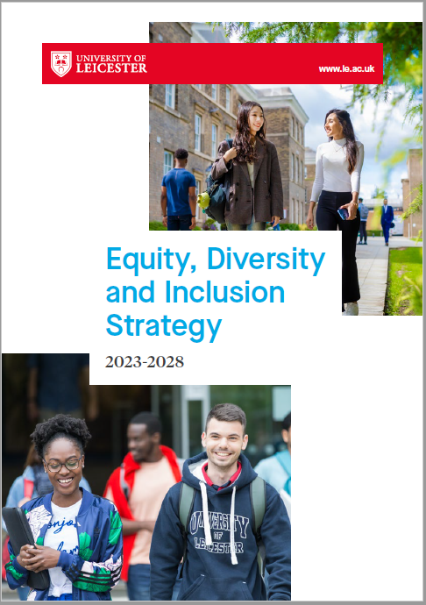

* 1. The Strategy and Delivery Plan were developed in collaboration with the university community and are closely aligned with (i) University’s Strategy, where EDI is a guiding principle and ‘Inclusive’ is 1 of the university 3 values, and with (ii) the University’s People Strategy, where ‘Inclusivity’ is 1 of 5 strategic pillars.
  2. The Strategy sets out how the University will achieve its strong commitment to be a truly inclusive university, through six interconnected strategic aims:

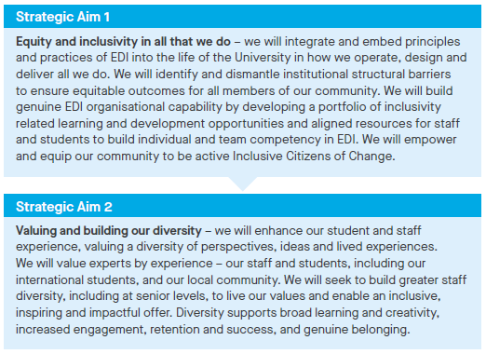

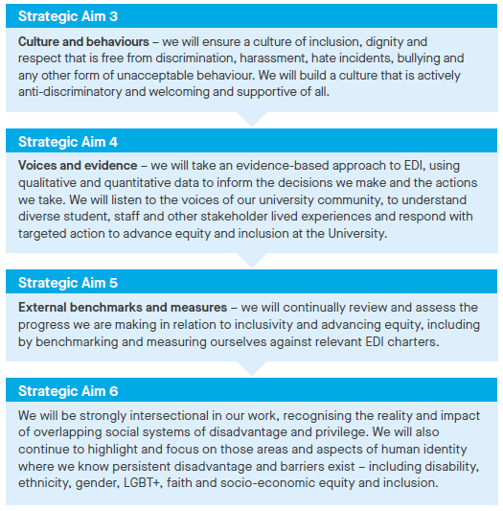

* 1. The Strategy commits us to ensuring that no member of our university community is disadvantaged, excluded or harassed on the grounds of any aspect of their identity.
  2. It also commits us to having difficult conversations, including in areas of apparent conflicting equity rights and concerns, with sensitivity and holding ourselves to account by facing challenges with integrity and accountability to build a strong, inclusive and open community.
  3. It recognises current challenges and opportunities for the University, as for the sector as a whole, in terms of freedom of speech, academic freedom and equity and inclusion.
  4. Freedom of Speech: the HE sector is working through the implications of the recent Higher Education (Freedom of Speech) Act 2023, with its aim to make provision in relation to freedom of speech and academic freedom in higher education institutions and students’ unions and, in particular, the duty it brings for both to actively promote freedom of speech.
  5. The University is well-positioned to respond to the Act and a Freedom of Speech Working Group, chaired by the Provost and Deputy Vice-Chancellor, has been established and meets monthly.
  6. The Working Group will review and revise the University’s [Code of Practice Concerning Freedom of Speech](https://le.ac.uk/policies/codes-practice/freedom-speech) and make recommendations in relation to the University’s ongoing compliance with the Act. It will also oversee the implementation of appropriate reporting mechanisms in relation to the specific requirements of the Act.
  7. The issue of freedom of speech/academic freedom and its relationship to equity, diversity and inclusion will be a significant focus for the EDI Team in the coming year, as the sector produces guidance on the impact of the enhanced duties around freedom of speech and the need to ensure that universities remain inclusive and safe for all students.
  8. We have recently developed Proportionate Decision-Making Guidance and aligned documentation to inform accountability in making and recording decisions which may entail making freedom of speech/academic freedom related decisions.
  9. The Guidance and Form have been utilised effectively in reviewing and decision making in relation to on-campus activities, such as protests, awareness raising events and posters, in the context of the current Israeli and Palestinian conflict.
  10. This has helped ensure that all decisions made have been rigorously and systematically informed by a clear understanding and consideration of (i) the University’s legislative duties and responsibilities (including the Higher Education (Freedom of Speech) Act 2023, the Equality Act 2010 and the Prevent Duty (Counter-Terrorism and Security Act 2015)) and (ii) the University’s commitments and responsibilities in relation to inclusivity and good campus relations.
  11. More broadly, the University has worked closely with the Students’ Union in its communications, support and engagement with student and staff groups impacted at such a challenging and sensitive time for the diverse university community.
  12. A number of listening events have taken place with student groups impacted by the conflict to provide a safe and supportive opportunity for students to share their perspectives, experiences and concerns with the University, including on safety, freedom of speech, university communications and the impact on student health and wellbeing and studies.

1. Advancing Equity and Inclusivity in Key Areas
   1. **Measuring and Benchmarking Progress**
      1. An important part of the University’s equity and inclusivity work, is to continually review and assess the progress we are making and the impact our initiatives are having by benchmarking against relevant sector and other nationally recognised equity charters.
      2. Submission to equity charters involves a comprehensive self-assessment process and the development of an evidence-based and solution focussed action plan to remove any barriers or inequities identified, to bring genuine organisational structure and culture transformation.
      3. The equity charters that the University is affiliated to are the standard sector and national charters:
         * Athena Swan Charter
         * Disability Confident Scheme
         * Race Equality Charter
         * Stonewall Workplace Equality Index
      4. It is important that our equity and inclusion work is not determined and bound by equity charters and their aligned awards but, rather, that we use them to measure and benchmark the progress we are making. Applications to charters have a very significant impact on resource but they remain a key sector marker of equity and inclusivity progress.
      5. Our current sector standing in terms of charter awards is strong, enhanced by our successful 2022 submission for a Bronze Race Equality Charter Award.
      6. The University of Leicester is currently 1 of 7 universities that hold a Silver (or higher) Athena Swan Award, a Bronze (or higher) Race Equality Charter Award, and a Disability Confident Level 2 (Employer) or Level 3 (Leader) Award; this is alongside Aston University, Imperial College London, the University of Brighton, the University of Cambridge, the University of Exeter, and the University of Southampton.
      7. If we are successful in our Level 3 Disability Confident Leader Award submission and the renewal of our Athena Swan Silver Institutional Award in 2024, we will be 1 of 3 universities that hold a Silver (or higher) Athena Swan Institutional Award, a Bronze (or higher) Race Equality Charter Award, and a Level 3 Disability Confident Leader Award; alongside Imperial College London and the University of Southampton.

*Diagram 1: Equity Charter Awards 2008-2023*

* + 1. In addition, the University holds 9 Departmental Athena Swan awards, including a Silver College award by the College of Life Sciences (Table 8.1).
    2. Most recently, the School of Physics and Astronomy submitted an Athena Swan Silver renewal award in the November 2023 submission round.
    3. The School of Computing and Mathematical Sciences (formally Department of Informatics and Department of Mathematics) are working on a new Bronze application as a newly merged School with an intention to submit in 2024. Archeology and Ancient History and Museum Studies have also been working on the renewal of their existing award with planned submissions in 2024.
    4. The School of History, Politics and International Relations are working towards their first Athena Swan Bronze award, with an intention to submit in late Summer/Autumn 2024.

*Table 8.1: University of Leicester Departmental Athena Swan Awards*

|  |  |  |  |
| --- | --- | --- | --- |
| **School** | **Level of Award** | **Date of Award** | **Next Submission Date** |
| School of Chemistry | Silver | 22/12/2022 | 31/12/2027 |
| School of Physics & Astronomy | Bronze | 30/04/2018 | 31/11/2023  *Submitted* |
| Department of Informatics (now School of Computing and Mathematical Sciences) | Bronze | 18/10/2018 | 29/03/2024 |
| Department of Mathematics (now School of Computing and Mathematical Sciences) | Bronze | 18/10/2018 | 29/03/2024 |
| School of Archaeology and Ancient History | Bronze | 29/04/2019 | 31/05/2024 |
| School of Museum Studies | Bronze | 30/09/2019 | 29/11/2024 |
| College of Life Sciences | Silver | 29/04/2020 | 30/05/2025 |
| Leicester Law School | Bronze | 29/04/2020 | 30/05/2025 |
| School of Business | Bronze | 20/01/2023 | 31/01/2028 |

* + 1. The EDI Team are responsible for supporting the leadership of institutional level equity charter related work and departmental level Athena Swan submissions, through a framework review process, with a particular focus on data collection and presentation, conducting and analysing culture surveys, along with full submission review and analysis.
    2. Our planned engagement with the equity charters over the next four years (Diagram 2), includes the submission for Disability Confident: Leader Status (Level 3) and a Renewed Institutional Silver Athena Swan Award in 2024, consideration of a submission to a LGBT+ Inclusion Charter (Stonewall Workplace Equality Index or a comparable award) in 2025 and a Silver Race Equality Charter Award in 2026.

*Diagram 2: Equity Charter Awards Submission Plan 2024-2026*

* + 1. A number of universities have withdrawn from Stonewall’s Diversity Champion programme in recent years. In discussion with the LGBT+ Action Group (including members of the Students’ Union and the LGBT+ Staff Forum), we intend to retain membership of Stonewall, recognising its continuing role in leading LGBT+ inclusion in the UK, and consideration will be given to submitting to the Workplace Equality Index in 2025.
  1. Advancing Equity and Inclusivity in Key Areas – Disability
     1. The University’s work to advance disability equity and inclusion has continued over the last 12 months, in collaboration with both the Disability Staff Forum and the Students’ Union.
     2. Initiatives and activities have focused on supporting and delivering the strategic objectives, proposed by the Disability Equity Action Group and confirmed by the EDI Committee, as detailed in Table 8.2.

*Table 8.2: Disability Equity Objectives 2023-2024*

1

Support the University to learn from the changes to working practices and student offer brought about by Covid-19 pandemic that positively and negatively impacted disabled staff and students.

Lead the University to embed disability equity principles, proactive good practice, accessibility and inclusive design into the physical and virtual environment.

Lead and promote engagement and awareness to embed disability equity, inclusivity and proactive understanding across the organisation, effecting a cultural shift to a disability inclusive, empathetic culture, aligned with the Dignity and Respect at Leicester Framework.

2

3

**University of Leicester Disability Equity Objectives 2023-24**



* + 1. [Disability Confident](https://uniofleicester.sharepoint.com/sites/staff/equality-diversity/SitePages/Disability-Confident.aspx): Following a comprehensive self-assessment process, the University was re-awarded Disability Confident Employer (Level 2) status in July 2023, recognising the work undertaken over the last 3 years to progress disability equity and improve disability inclusion for staff.
    2. Work is now being undertaken, in consultation with the Disability Equity Action Group and the Disability Staff Forum, and working with an external validator, to validate progress against the Disability Confident Leader (Level 3) criteria. With the intention to submit for Disability Confident Leader status by July 2024.
    3. This validation process requires us to demonstrate how we are leading disability equity and inclusion within the University, wider sector and community, our journey to date and our future aspirations to continue to improve as a disability inclusive employer.
    4. In addition to making us an employer of choice in attracting disabled staff, applying for Leader status is a way to calibrate against best practice, identifying areas for further improvement and helping us to maintain focus and momentum in effecting positive change for disabled staff.
    5. Accessibility Audit: Recommendations from the three Accessibility Audits (Digital access, Physical access and Inclusive Learning) undertaken in 2022, continue to be taken forward by the relevant University leads and their areas. The Disability Equity Action Group and Disability Staff Forum have input on the prioritisation of these actions, and are informing the annual physical estate works to improve accessibility for staff and students, based on lived experience.
    6. [Disability Confidence for Managers Training](https://uniofleicester.sharepoint.com/sites/staff/equality-diversity/SitePages/Disability-Confidence-Training-for-Managers.aspx): Since Spring 2022, 165 staff have completed this training. The course focuses on increasing understanding of disability and associated responsibilities for managers, and equips managers with the skills and confidence to proactively support disabled team members and create an inclusive environment for disabled colleagues to thrive.
    7. A disability inclusive environment and effective reasonable adjustments are critical to ensuring disabled staff are able to contribute fully in the workplace. In recognition of this, and following feedback from the Disability Staff Forum and Disability Equity Action Group, this training is to become mandatory for all PDD reviewers during 2024. The training has been re-designed to become a blended learning package, with a mandatory online webinar supplemented by an optional workshop. The new mandatory blended version of this training will be launched early in 2024.
    8. Disability Inclusive Recruitment: A new draft Disability Inclusive Recruitment Guide has been developed by the Staff Disability Advisor, in conjunction with EDI, and will be reviewed in consultation with the Disability Equity Action Group and Disability Staff Forum in January 2024. Alongside this, disability inclusive best practice has been further woven through recruitment process, webpages and guidance, to attract disabled candidates and improve their candidate journey.
    9. Collection of data relating to disabled candidates’ journey from application to offer has been introduced, enabling us to identify any disparities and measure the impact of initiatives taken to address. This data will form part of the recruitment dashboards from May 2025.
    10. Staff Policy Development: As part of the review of the Maximising Attendance Policy, the Disability Staff Forum and Disability Equity Action Group were consulted, resulting in changes to the way disability-related sickness absence is managed. A separate Disability Leave Policy for leave associated with disability, for example, attendance at appointments, is being developed.
    11. Staff Quiet Room: In response to requests and external best practice, and in collaboration with the Disability Staff Forum, a dedicated quiet room has been provided and equipped for use by neurodivergent staff, disabled staff and those with a health condition to rest and retreat from the busy campus. The room will also be available to students who the Accessibility Centre feel would benefit from access to the space. The room will be available from January 2024 and feedback and usage of the space will be monitored to assess impact and whether a further similar space would be of benefit elsewhere on campus.
    12. COVID-19 – Disability and Best Practice: The University continues to support disability related considerations and individual adjustment requirements within hybrid working and WorkSmart processes and spaces, including adjustments relating to equipment on campus and remote/home locations.
    13. International Day of Disabled People 2023: 3 December marks the United Nation’s sanctioned date to celebrate the achievements and contributions of disabled people, raise awareness of disability inequity and promote the rights of disabled people.
    14. The University celebrated this date with a programme of events from 27 November to the 8 December, in collaboration with the Attenborough Arts Centre, the Disability Staff Forum, Staff Health & Wellbeing and the University’s various departments. There were a number of virtual, face-to-face and hybrid events that focused on the awareness of neurodiversity, celebration of disabled artists, training on accessibility, exploration of the lived experienced of disability and appropriate allyship, and showcasing the support that is available here at the University and how to access it.
    15. With performances from local disabled artists with WORD!, to dedicated hybrid webinars, networking opportunities, and showcases of the work undertaken to support disabled staff and students with demonstrations of the equipment and support available.
    16. Disability Allyship Training was delivered by the Disability Staff Forum Co-Chair, focusing on the concept of disability from the perspective of those with lived experience. Considering various models of disability, including the medical, social, and ‘affirmative’ model, which is emerging from within the disabled people’s movement where disability is to be celebrated as part of the normal diversity of human existence.

* 1. Advancing Equity and Inclusivity in Key Areas – Gender
     1. Advancing gender equity remains a clear and visible priority across the University. This includes the continued commitment to implement the Institutional Silver Athena Swan action plan priorities, and a continued focus to address the University’s gender pay gap.
     2. Table 8.3 details the University’s agreed gender equity objectives, for the academic year 2023-2024 proposed by the Gender Equity Action Group and confirmed by the EDI Committee.

*Table 8.3: Gender Equity Objectives 2023-24*

1

Support the central University action plans being developed in response to the low favourable gendered response rates to the 2022 staff survey.

To monitor and progress the University of Leicester’s Athena Swan Silver Action Plan priorities, and support the work towards the renewal of the Silver Award, highlighting progress made against initial plans and endorsing future priorities.

To oversee the implementation of actions in Gender Pay Gap Action Plan and to review progress against the specific and measurable targets.

2

3

**University of Leicester Gender Equity Objectives 2023-24**

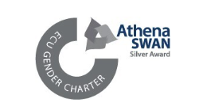

* + 1. [Athena Swan](https://uniofleicester.sharepoint.com/sites/staff/equality-diversity/SitePages/Race-Equality-Charter-(REC).aspx?web=1): As detailed in 4.1.6, the University currently holds an Institutional Silver Athena Swan award (awarded in 2018 with a renewal submission to be made in 2024). Given the comprehensive nature of the award process, including detailed self-assessment and analysis across the full student and staff lifecycles, the University’s current actions to advance gender equity are framed around the existing aligned Silver action plan.
    2. In 2023, a key priority for the University was the progression of our Institutional Athena Swan Silver award renewal, due to submitted in May 2024.
    3. The renewal application will be the first institutional level application under the [Transformed UK Athena Swan Charter Framework](https://www.advance-he.ac.uk/equality-charters/transformed-uk-athena-swan-charter). To support this work, we have established an Institutional Self-Assessment Team, chaired by the Provost and Deputy Vice-Chancellor, which includes staff and student representatives from across the University. The Team is undertaking a full evaluation of our gender equity progress and issues to identify our future priorities for action from May 2024-2029.
    4. [Annual Pay Gaps Report](https://le.ac.uk/about/making-a-difference/equality/equality-data): The University will publish its 2023 Pay Gaps Report in March 2024 (see *Appendix C* for full report). For the first time, the report detailing the University’s gender pay gap is expanded to include disability, ethnicity, gender and sexual orientation.
    5. This will give increased transparency and accountability across all key equity groups and aligns the University’s commitments, especially its visible commitments, to advancing equity and inclusion in relation to ethnicity, disability and sexual orientation with those for gender around pay equity.
    6. For the 2023 report, the data included for disability, ethnicity and sexual orientation is headline data only (see Table 8.4 for the University’s mean and median gender pay gaps by reported protected characteristic).

*Table 8.4: University of Leicester Pay Gaps 2023*

|  |  |  |  |  |  |  |  |  |  |  |
| --- | --- | --- | --- | --- | --- | --- | --- | --- | --- | --- |
| University of Leicester Pay Gaps 2023 | | | | | | | | | | |
| Gender Mean | Gender Median |  | Ethnicity  Mean | Ethnicity Median |  | Disability Mean | Disability Median |  | Sexual Orientation  Mean | Sexual Orientation  Median |
| 19.2% | 17.9% | 12.0% | 13.3% | 9.2% | 19.5% | 12.4% | 16.9% |

* + 1. From 2024, fuller pay gap reporting will include pay gap data for all 4 identified protected characteristics at (i) full university level (ii) Grades 1-5 (iii) Grade 6-9, Grade 10, Academic Staff and PS Staff, as well as the required additional statutory gender pay gap data.
    2. Gender Pay Gap: On the census date of 31 March 2023, there were 5,829 employees of the University (an increase of 760 from 5,069 in 2022). 57.8% were female (compared to 57.2% in 2022) and 42.2% male (compared to 42.8% in 2022).
    3. The University’s current mean gender pay gap is 19.2%, dropping below 20% for the first time since statutory reporting began in 2017, and the median gender pay gap is 17.9%. Both of these are higher than the higher education sector gender pay gap calculated by Advance HE, which reports a mean gender pay gap of 14.2% and a median gender pay gap of 8.5%. The median gender pay gap for all employees in the UK in 2023, based on the Annual Survey of Hours and Earnings, is calculated by the Office for National Statistics at 14.3%.
    4. Since 2017, the University of Leicester has seen an overall reduction of 4.9 percentage points to its mean gender pay gap and a reduction of 4.8 percentage points to its median gender pay gap (Table 8.5).

|  |  |  |  |  |  |  |
| --- | --- | --- | --- | --- | --- | --- |
| **Year** | **Mean Gender Pay Gap** | **+/- Movement for the Year by Percentage Points** | **+/- Movement in Total by Percentage Points** | **Median Gender Pay Gap** | **+/- Movement for the Year by Percentage Points** | **+/- Movement in Total by Percentage Points** |
| 2017 | 24.1% | --- | --- | 22.7% | --- | --- |
| 2018 | 23.1% | - 1 | - 1 | 19.0% | - 3.7 | - 3.7 |
| 2019 | 20.6% | - 2.5 | - 3.5 | 18.4% | - 0.6 | - 4.3 |
| 2020 | 20.3% | - 0.3 | - 3.8 | 19.0% | + 0.6 | - 3.7 |
| 2021 | 20.0% | - 0.3 | - 4.1 | 16.0% | - 3.0 | - 6.7 |
| 2022 | 21.1% | + 1.1 | -3.0 | 18.6% | + 2.6 | - 4.1 |
| 2023 | 19.2% | -1.9 | -4.9 | 17.9% | - 0.7 | -4.8 |

*Table 8.5: University of Leicester Gender Pay Gap 2017-2023*

* + 1. The University’s current mean bonus gender pay gap is 75.4% (29.4% in 2022) and median bonus gender pay gap is 0.0% (55.9% in 2022). As the University only has a small number of bonus awards and the Clinical Excellence Awards are included in these calculations (although the cost of these is refunded by the NHS) the bonus gender pay gap is subject to significant fluctuation on an annual basis.
    2. As for many organisations, key determinants of the University’s gender pay gap include the absence of a gender balance across job categories (horizontal occupational segregation) and through the different pay grades (vertical occupational segregation). At the University of Leicester, women continue to be overrepresented in lower and middle paid roles and underrepresented in higher paid roles.
    3. Gender Pay Gap: We are continuing to implement the SMART Action Plan that was developed by Gender Pay Gap Working Group, which was chaired by the Vice-Chancellor, to give sustained and action orientated focus to the University’s gender pay gap. The Gender Equity Action Group oversees the action plan progress.
    4. Recruitment Panel Composition: Actions underway include regular monitoring and analysis of recruitment panel composition and appointments by gender and ethnicity and mentoring for academic promotion.
    5. EDI Data Dashboards: Dashboards detailing the gender pay gap, staff demographic and recruitment data by gender and ethnicity at School/Divisions, College and University level are continuing to be produced annually for all Heads.
    6. Anonymous Shortlisting: As part of our Gender Pay Gap Action Plan commitments, the University has introduced anonymous shortlisting for all Professional Services roles at the University, provided they are not going through an executive search process.
    7. Gender Equity Events: The University’s annual programme of gender equity events has continued to take place across the University through engagement with international campaigns, such as International Women’s Day and [16 Days of Activism against Gender-Based Violence](https://uniofleicester.sharepoint.com/sites/staff/news-events/SitePages/16-Days-of-Activism-2023-%E2%80%93-Friday-24-November-%E2%80%93-Sunday-10-December.aspx). Events (the latter of which is led by the Standing Together Team) which have taken place to support these campaigns have been organised collaboratively with, the Gender Equity Action Group, the Women’s Forum, the Students’ Union, Student Support Services and various academic departments.

* + 1. [International Women’s Day 2023](https://le.ac.uk/iwd): In March 2023, the University held a number of physical and virtual International Women’s Day events under the global theme of #EmbraceEquity. Events included, a return of the award winning [Wall of Women](https://le.ac.uk/iwd/wall-of-women), focused sessions on women's health (Let’s Talk About: Periods! And Heartwize CPR Training), local artistic performances (Emma Bourke and Ildiko Rippel’s Wilding, and a special WORD! performance from Liv Torc), career development (Women in Space Showcase, and a panel session with Ane Wafula-Strike hosted by the Business School), and the history of women at the University (the Legacy of Rhoda Bennett).
    2. The University’s International Women’s Day Working Group has been meeting to plan the schedule of events for March 2024.
  1. Advancing Equity and Inclusivity in Key Areas – LGBT+
     1. Work to advance the agreed LGBT+ strategic objectives has continued in collaboration with a broad range of stakeholders, including the Students’ Union and the LGBT+ Staff Forum.
     2. Table 8.6 details the University’s agreed LGBT+ equity objectives for 2023-2024, proposed by the LGBT+ Equity Action Group and confirmed by the EDI Committee.

*Table 8.6: LGBT+ Equity Objectives 2022-23*

1

Drive and promote cultural change whereby LGBT+ equity is further embedded in the University functions, activities and ethos, including embedding LGBT+ equity, inclusivity and understanding across the organisation, effecting a cultural shift to a LGBT+ inclusive culture, aligned with the University’s commitments and the Dignity and Respect at Leicester framework.

Work with trans and non-binary staff and students to enhance the trans and non- binary voice and visibility in the University, through understanding, identifying and informing appropriate responses to related inequalities experienced by both students and staff. Alongside implementing proactive measures to develop the safety of the trans and non-binary community at the University, alongside a continued commitment towards trans/non-binary inclusion.

Identify priority areas to enhance the lives of the LGBT+ community at the University of Leicester at the operational and institutional levels, additionally identifying key focuses on the mental and physical wellbeing of LGBT+ staff and students and the health and wellbeing inequalities the community disproportionately experiences.

2

3

**University of Leicester LGBT+ Equity Objectives 2023-24**

* + 1. [Staff LGBT+ Toolkit](https://uniofleicester.sharepoint.com/sites/staff/equality-diversity/SitePages/LGBT%2B-Toolkit.aspx): Following the positive feedback on the Staff Disability Toolkit, a Staff LGBT+ focused toolkit has been developed in collaboration with LGBT+ Staff Forum and LGBT+ Equity Action Group. The Toolkit provides relevant policies, procedures and guidance, together with information about LGBT+ inclusion, training, resources and support in a central online hub.
    2. Gender Inclusive Facilities: Following a review of best practice, standard signage for university gender inclusive toilet and wash facilities has been developed. This has been added to the ECS Inclusive Design Guide and informs the University’s approach to inclusive design for new buildings and refurbishments. Information about the location of gender inclusive facilities across campus will be added to our webpages, the Staff LGBT+ Toolkit and [Supporting Trans, Gender-Fluid and Non-Binary Staff and Students Guide](https://uniofleicester.sharepoint.com/:w:/r/sites/staff/equality-diversity/edi-and-you/Shared%20Documents/Supporting%20Trans%20Gender-Fluid%20and%20Non-Binary%20Staff%20and%20Students.docx?d=wa2a2e11be0fc4b7cad7503f7f94737bf&csf=1&web=1&e=7A2X5n).
    3. World AIDS Day 2023: The University was proud to support local organisations and communities in Leicester in commemorating World AIDS Day with a dedication memorial in the city centre, and in support of the World Health Organization’s #LetCommunitiesLead initiative towards equitable HIV prevention, treatment and care.
    4. [Leicester Pride 2023](https://uniofleicester.sharepoint.com/sites/staff/news-events/SitePages/A-sea-of-colour-as-the-University-of-Leicester-join-thousands-in-celebration-of-Leicester-Pride.aspx): The University, alongside the Students’ Union, joined the city-wide celebrations at Abbey Park for the 15 years of Leicester Pride. Our presence is a continuation of our proud history of contributing to the ongoing work in advancing LGBT+ equity and inclusion.
    5. The University is preparing for its annual celebrations for LGBT+ History Month in 2024, a period for us to celebrate and recognize the recognise the achievements, history and contributions of the LGBT+ community, raise awareness of LGBT+ inequity and promote the rights of the LGBT+ community.
    6. [Trans Day of Remembrance 2023](https://twitter.com/uniofleicester/status/1726612592582705369): In collaboration with the Students’ Union, the University supported a vigil on campus commemorating the memory of trans, non-binary and gender non-conforming individuals whose lives have been lost to acts of anti-trans violence, suicide, and medical complications.
    7. [LGBT+ Allyship Training](https://uniofleicester.sharepoint.com/sites/staff/news-events/SitePages/now-available-online.aspx): Developed alongside the Students’ Union following consultation with both the LGBT+ Equity Action Group and LGBT+ Staff Forum, the training explores how to be an active LGBT+ ally, familiarising staff with key language and terminology, covering practical steps and scenarios on allyship, international statistics on LGBT+ rights, current legislative laws in the UK, and LGBT+ student’ experiences.
  1. Advancing Equity and Inclusivity in Key Areas – Race
     1. Table 8.7 details the University’s details the University’s agreed race equity objectives for the academic year 2023-2024, proposed by the Race Equity Action Group and confirmed by the EDI Committee.

*Table 8.7: Race Equity Objectives 2023-24*

1

To oversee and ensure the progress of actions as identified in the University’s Race Equality Charter Mark Action Plan, with a particular focus to:

1. Produce a visual ‘pipeline’ which indicates the representation, experiences, outcomes and opportunities of our Black UK students and act as a critical friend to identified leads across the University to develop action and support activity to address concerns relating to continuation specifically.
2. Produce a visual ‘pipeline’ which indicates the representation, experiences, outcomes and opportunities for our UK Black staff, at all grades and in both Professional Services and Academic roles; and work with the identified leads across the University to particularly develop processes and opportunities for career development, leadership roles and activities, and promotions; and specifically advocate that the promotion and retention of Black staff in the University at all levels be made a priority and a focus.

To learn from and work collaboratively with other comparable Race Equality Charter Mark regional universities, and areas who are leading in race equality activity within our university, to share and implement best practice; and to generate creative, innovative and effective actions that tackle systemic and institutional racism in higher education.

2

**University of Leicester Race Equity Objectives 2023-24**



* + 1. Race Equality Charter - The Race Equality Charter has recently been reviewed and revised by Advance HE to create a more streamlined process. The EDI Team will continue to monitor progress of the action plan and work with the Race Equity Action Group to ensure that race equity remains a priority across the University.
    2. As part of an annual review of the progress made in relation to the University’s Race Equality Charter action plan, a report was presented to the EDI Committee and the Race Equity Action Group in October 2023. The report provided an overview of the key areas of progress and includes activity and action led by the Student and Education EDI Team related to the ethnic disparities across the student lifecycle, and in relation to the staff progression and recruitment.
    3. The key areas of impact include:
* The award gap between white and Black students has improved by 3.9%, and is now 14.1%.
* An improvement in disclosure rates in staff ethnicity, now 94.5%.
* The population of staff from a minority ethnic background has increased, now 28.8%.
* A steady increase in the number of applicants and the number of employment offers made to minority ethnic applicants to staff roles in the past year (see Diagram 3).
* Annual academic promotions workshops for minority ethnic staff continue to run and the guidance on special circumstances has been developed to recognise systemic disadvantage that may impact academic promotion.

More broadly across the University, and outside of the work of the EDI Team, work on advancing race equity and inclusion continues:

* Dr Paul Campbell has led on two sector leading evaluation projects (i) a TASO funded project on the Impact of HE curriculum reform on race equality gaps. This is an Evaluation of the Race Inclusion Toolkit, to measure and evaluate the effectiveness of the Toolkit in relation to its impact on improving students’ satisfaction on our courses, the relatability of the University’s courses to students’ own lives and in relation to reducing the award gap (ii) the QAA Collaborative Enhancement Project 2021-22: Race Inclusion in Assessments, to broaden understanding of why there are outcome differences for specific assessment types for undergraduate students from different ethnic backgrounds.
* Also, carrying on from the work that Dr Paul Campbell led as part of his Directorship of the University of Leicester Institute for Inclusivity in Higher Education, the Student and Education EDI Team have delivered 16 workshops to academic schools as part of the Race Inclusion Workshops intervention which seeks to work with schools to identify actions to close the awarding gap. 5 actions plans have been submitted for approval, 8 are actively being developed and 3 are outstanding. 9 PS teams have undertaken workshops.
* A successful University of Leicester Wellcome Trust c.£1m research culture bid will look to redress decreasing diversity from post-graduate researcher to professor, by co-creating interventions that rectify career progression barriers for under-represented groups.
* The School of Chemistry have been awarded £60,000 over three years under the Royal Society of Chemistry’s “Missing Elements” Grant Scheme. The award will be used to establish and run a project which will aim to address the underrepresentation of chemists from minoritised ethnic backgrounds in academia and industry by creation of a “home-grown” network of talented chemists from minoritised ethnicities at Leicester.
* The University’s Careers & Employability Team have launched a ‘Black Leadership Development Programme’ for 23/24. The Team will incorporate activity to target minority ethnic UG and postgraduates to promote careers within HE as part of the Festival of Careers.
  + 1. Advancing Race Equity and a Culture of Anti-Racism: The University continues to undertake a wide range of interventions and actions across the University, to challenge and address race inequities, including structural, in order to create a culture of anti-racism.
    2. The University’s Race Equity Action Group have recently reviewed and updated the Guide to Race Related Terminology. Whilst the guides promote the use of a range of language which is relevant to the context in which it is being used, the guide supports the use of the term ‘minority ethnic’ to refer to those from ethnic backgrounds other than white
    3. white. [Inclusive Recruitment](https://uniofleicester.sharepoint.com/sites/staff/information-for-managers/staff-recruitment/SitePages/Recruitment-Diversity-Tool-Kit.aspx): There have been a range of initiatives that have been implemented over the past year, including recruitment roadshows at community events such as the Leicester Mela, anonymous shortlisting for Professional Services roles, improved engagement with the University’s Careers Service to recruit from our diverse student body, annual recruitment health checks provided at a Departmental level including both gender and ethnicity and developments to recruitment panelist training as well as promoting a diverse panel composition, wherever possible.
    4. There has been a steady increase to number of applicants (+0.6%) and the number of employments offers (+4.8%) (see Diagram 3) made to minority ethnic applicants in the past year. Further analysis will be undertaken to identify the outcomes at appointment stage; in relation to specific ethnic groups; and in relation to offers by role type and specific areas within Colleges and Professional Services.

*Diagram 3: Offer Rates to Minority Ethnic Applicants to Staff Roles*

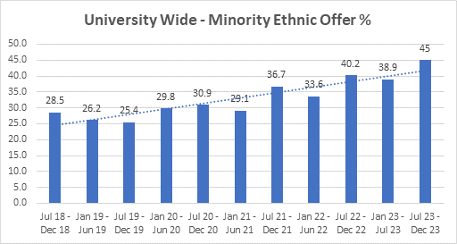

* + 1. [Black History Month 2023](https://le.ac.uk/black-history-month/events): Working collaboratively with the Students’ Union and the Attenborough Arts Centre, a wide range of events and activities took place for Black History Month, celebrating Black students, staff and changemakers further afield:

A series of exhibitions, such as those ran by the Leicester Catering Partnership, took place to celebrate Black Food Innovators, the Sound Heritage Project showcasing Black experiences through audio and the various exhibitions at Attenborough Arts. There was also a series of events hosted by ResLife that took place in Halls of Residences across Leicester.

A Health and Wellbeing Event with presentations and information stalls was held for Black staff and students, with a Coaching and Networking event for Black staff and PGRs with award winning guest speaker Sandra Pollock OBE. Both events were well received by Black staff, recognising the importance of facilitated and safe spaces for Black staff to connect and access support and information.

The headline event for the month was an [up close and personal chat with Chancellor, Dr. Maggie Aderin-Pocock](https://uniofleicester.sharepoint.com/sites/staff/news-events/SitePages/Black-History-Month-is-more-than-just-a-month.-Looking-back-on-October-and-celebrating-citizens-of-change.aspx). Sharing her own experiences in STEM as a Black woman navigating her field and sharing personal advice with students.

While throughout the month, showcases were hosted championing the voices and talents of the Black local community, with Opal22 and Attenborough Arts Centre’s collaborated to host an artistic takeover, featuring nightlong music and new exhibitions of Habib Hajallie’s latest work. Alongside [live performances by the student gospel choir the Revival](https://www.instagram.com/p/Cy1RarXtwEk/), and workshops introducing Black trailblazers in the arts, with the change to foster one’s own artistic spirit.

A number of seminars also took place, showcasing the rich history of the NHS and the generations of contributions made by Black midwives, such as the event on Black Oral Histories, and an event at the African Caribbean Centre, organised by the University’s Migration Mobility and Citizenship network to celebrate Leicester’s Caribbean community during the 75th anniversary of the passengers on Windrush.

* + 1. These events, while a part of the University’s celebrations, also continue the important ongoing conversations we have as part of our work and commitment to advance race equity and inclusion, including upcoming conversations with Lord Simon Woolley and Dr. Ngozi Emmanuel, members of our wider alumni community.

* 1. Advancing Equity and Inclusivity in Key Areas – Faith
     1. The University is committed to developing its provision to support multi-faith and spiritual groups. A review of existing provision was undertaken by the University, with a view to proposing recommendations to enhance the offer. This work is now being led by the Director of Student Services and Belonging with a new role of International Student Experience Manager reporting to them. This role has been given a set of clear objectives to deliver on the recommendations of the review report.
     2. Prayer Facilities: The EDI Team, along with the Students’ Union, Estates and Campus Services and Student Support services, are part of ongoing discussions around prayer facilities. The University is exploring alternative and additional provisions to meet the level of demand on these facilities from students and staff.
     3. The number of satellite prayer facilities has grown and the University now has one main Muslim prayer room with ablution facilities in Charles Wilson, as well as satellite prayer facilities at Brookfield, MSB and Freemans Cottages. Ablution facilities have been installed at Freemans Cottages, and plans to install ablution facilities at Brookfield and MSB are in progress.
     4. Multi-Faith and Spiritual Chaplaincy: The University will be establishing a new multi-faith and spiritual approach to provide hands-on advice and guidance on a range of faith based and spiritual matters for our staff and students.
     5. The University is also seeking to develop a programme of multi-faith and spiritual awareness raising activities which seek to celebrate the cultures and faiths of staff and students at the University.
     6. The University has a programme of events to celebrate Chinese Lunar Year, which is coordinated by Student Support Services and the Students’ Union. The University also recognises faith related celebrations through social media communications across the year.
     7. [Holocaust Memorial Day 2023](https://le.ac.uk/news/2023/january/hmd): The University continues to support the Holocaust Memorial Day commemorations held in the city of Leicester. 2023 was marked by the theme of Ordinary People, and the key commemoration event was held at the Victoria Gallery of the New Walk Museum, featuring a cello recital of the ceremonial Hebrew declaration of Kol Nidrei and a memorial address by Professor Aubrey Newman.

1. Organisational Embedding of Equity, Diversity and Inclusion
   1. Over the last 12 months, initiatives and projects have been completed and progress made on developing our infrastructure and resource base to further embed EDI good practice and principles across the working life of the University, with a focus on building organisational EDI capability to underpin our commitment to advancing equity and inclusion.
   2. Four new training and development courses launched during 2023 to support our work in this area:

* [Staff Bystander Training](https://blackboard.le.ac.uk/ultra/courses/_60278_1/cl/outline): An online training package that provides staff with the skills, tools and confidence to challenge or intervene safely and appropriately where they witness or experience unacceptable behaviour. 52 staff have completed this module since its launch in May 2023.
* [Equality Analysis Training](https://blackboard.le.ac.uk/ultra/courses/_60278_1/cl/outline): Our online Equality Analysis Training module provides staff with a clear understanding of why we need to conduct equality analysis, together with a step-by-step guide of how and when to do it. The training is supplemented by 1 to 1 coaching, as required and 21 staff have completed this training since its launch in April 2023.
* [LGBT+ Allyship Training](https://blackboard.le.ac.uk/ultra/courses/_60278_1/cl/outline): An online module that was developed in collaboration with the SU to increase awareness and understanding of the barriers and issues LGBT+ staff and students face and actions that can be taken to support our LGBT+ community as an ally. 51 staff have completed this training since its launch as an online module in July 2023.
* [Disability Allyship Training](https://blackboard.le.ac.uk/ultra/courses/_60278_1/cl/outline): Developed and delivered by the Disability Staff Forum Co-Chair, this online training looks at the concept of disability from the perspective of those with lived experience. It considers what it is to be an ally, why allyship is important and performative verses meaningful allyship. It takes a look at 7 ways to be a meaningful ally to disabled people. 10 staff have completed this training since its launch in August 2023
  1. Two EDI related staff modules continue to be mandatory:
* EDI Online Training Module: The online EDI module, launched in October 2021, is mandatory for completion by all staff and currently has a completion rate of 86% (also 86% in 2022/23). CSSAH has the highest completion rate for this module at 94%, and Central Professional Services has the lowest, at 78% (see Table 9). The training, which develops core EDI competencies and outlines what EDI means for our university community and beyond, has also been made available to all students from January 2023.
* The Unconscious Bias online training module also continues to be mandatory for staff and has a current completion rate of 84%, (a slight increase from 82% in 2022/23). Again, CSSAH has the highest completion rate, at 91% and Central Professional Services has the lowest at 78% (see Table 9).
* Activity will take place over the next 12 months to increase completion of both modules and so improve completion rates.

*Table 9: Staff Completion Rates for Mandatory Training Modules*

|  |  |  |  |  |  |
| --- | --- | --- | --- | --- | --- |
| Module | University (all staff) | College of Life Sciences | College of Science and Engineering | College of Social Sciences, Arts and Humanities | Central Professional Services |
| Equality, Diversity and Inclusion | 86% | 89% | 92% | 94% | 78% |
| Challenging Unconscious Bias | 84% | 88% | 90% | 91% | 77% |

* The EDI Team developed summary versions of the EDI and UB training for inclusion in a shorter eBooklet version of all mandatory training for specific identified groups of staff.
  1. Dignity and Respect at Leicester: Workshops focused on developing a deeper understanding of the University’s Dignity and Respect framework continue to be delivered as needed, including as intervention workshops.
  2. Student EDI Training: University students now have optional access to both the Challenging Unconscious Bias Training and the Equality, Diversity & Inclusion Training. As of July 2023, 173 students have completed the EDI Training module and 40 students have completed the Unconscious Bias module.
  3. Equity, Diversity and Inclusion Policy: A new University EDI Policy has been developed, in consultation with staff and students. The Policy sets out the University’s commitment to equity, diversity and inclusion, together with its legal, ethical and moral responsibilities and the expectations it has of all members of the university community. The Policy supports the delivery of the University’s 5-year EDI Strategy in embedding EDI in the fabric of university activities, and sits alongside the University of Leicester Dignity and Respect Framework. The Policy is planned for launch in March 2024.
  4. Equality Analysis: Equality analysis is a process to help us to build inclusion into our activities and processes from the outset, through considering the impact of our activities, policy and practice on protected equality groups, and remove any barriers and disadvantage. The University’s approach to equality analysis has continued to be embedded, through a series of workshops to senior leadership teams over the past year. This has emphasised the need for equality analysis to be an integral aspect of policy, project and practice development and approval processes. Further support on completing equality analysis is also offered by the EDI Team through the online training package and 1 to 1 coaching.
  5. EDI Staff Development Day 2024: An EDI Staff Development Day is planned for May/June 2024 to promote access and awareness of the range of learning and development opportunities and the portfolio of EDI resources available to staff. A series of workshops, bitesize learning sessions and other activities will be offered.
  6. Staff and Student EDI Related Cases: A report of all EDI related staff and student disclosures/complaints/disciplinaries between 2018-19 and 2022-23 will be taken to the EDI Committee in January 2024. This annual cases report provides trend analysis to understand any patterns around themes of behaviour such as discrimination, harassment and bullying.
  7. From the report of cases between 2018-19 and 2022-23, bullying behaviour is cited most often in informal staff disclosures, with sexual harassment/sexual assault and rape (combined) cited most often in informal student disclosures. Discrimination and harassment continue to be the behaviours cited more often in staff and student formal cases.
  8. For both staff and student formal cases, discrimination and harassment on the grounds of race is cited more often than any of the other protected equality characteristics.
  9. There has been a noticeable increase in formal staff case outcomes of upheld/partially upheld year on year, to 71% in 2022-23, and approximately half of formal student cases found ‘in breach’ and resulted in sanctions.
  10. Anti-Harassment and Antisemitism: The University’s activity and commitment to addressing antisemitism and harassment, more broadly, featured in 2 key HE sector publications in 2023.
  11. The Parliamentary Taskforce on Antisemitism in Higher Education published its report on [Understanding Jewish experience in higher education](https://eur03.safelinks.protection.outlook.com/?url=https%3A%2F%2Fantisemitism.org.uk%2Fwp-content%2Fuploads%2F2023%2F05%2FUnderstanding-Jewish-Experience-in-Higher-Education.pdf&data=05%7C01%7Cangie.pears%40leicester.ac.uk%7Ca6f26fd9af5b48237c1f08db7e32c5f4%7Caebecd6a31d44b0195ce8274afe853d9%7C0%7C0%7C638242528747773119%7CUnknown%7CTWFpbGZsb3d8eyJWIjoiMC4wLjAwMDAiLCJQIjoiV2luMzIiLCJBTiI6Ik1haWwiLCJXVCI6Mn0%3D%7C3000%7C%7C%7C&sdata=B%2FZ0zORCkP5Dob13A3PYxYpAEgmi0aaP09uuXNw%2Ffqg%3D&reserved=0) and the University features as a good practice case study in relation to our Dignity and Respect at Leicester framework and, specifically, our clear guidelines and expectations of all members of our community in relation to unacceptable behaviour, including harassment and antisemitism.
  12. UUK published its [Tackling racial harassment: progress since 2020 report](https://www.universitiesuk.ac.uk/what-we-do/policy-and-research/publications/tackling-racial-harassment-higher-0), as an update on progress made on tackling racial harassment across the sector since the 2020 and also on how many challenges still remain. The University features in the report as a case study of good practice, in relation to our Together Against Harassment Campaign, our monitoring and reporting on harassment cases, our Race Terminology Guide and wider resources.
  13. Staff Survey: The 2022 University Staff Survey results are also feeding into and informing the priorities of the EDI Team. Whilst the questions ‘The University demonstrates a commitment to EDI’ was one of the highest scoring favorable response rates in the Survey at 73%, other questions relating to ‘fairness’, how the University addresses ‘bullying and harassment’ and ‘I can be my true self at the University’ had low favourable response rates and are included in the 10 central university priority actions.
  14. Activity over the last 10 months to take forward these 3 EDI related priority action areas, began with 12 listening events with the 4 Staff Equity Fora, the trade unions and 4 Professional Services departments and academic schools to understand drivers behind the low favourable response rates.
  15. Thematic analysis from these listening events, along with analysis of the Staff Survey free text comments and overall variable response rates, are feeding into the work and priority setting of the EDI Team and the Equality Action Groups.
  16. One area of activity during the last 10 months that has supported the priority action of ‘I can be my true self at the University’ relates to promoting and further embedding the 4 Staff Equity Fora (Disability, LGBT+, Multi-Ethnicity and Women’s) plus a Carers and Parents Network.
  17. On 12 September a [Staff Equity Fora Showcase Event:](https://uniofleicester.sharepoint.com/sites/staff/news-events/SitePages/Staff-Fora-event-showcases-colleague-support-available-at-the-University.aspx) was held, introduced by the Provost and Deputy Vice-Chancellor and with talks from the Co-Chairs from each of the Staff Fora, sharing an overview of the support they could provide and success stories, followed by lunch and a networking session.
  18. Also, during November, as part of International Day of Disabled People, a [Meet the Citizens’](https://uniofleicester.sharepoint.com/sites/staff/news-events/SitePages/Meet-the-Citizens--Sharron-Sturgess-and-Charles-Wheeler.aspx) with the Chairs of the Disability Staff Forum and [Spotlight on the Disability Staff Forum](https://uniofleicester.sharepoint.com/sites/staff/news-events/SitePages/Spotlight-on-the-Disability-Staff-Forum.aspx?dm_i=I8Y,8GUXD,1G5GYQ,YZEFU,1) features highlighted and promoted the activity of the Disability Staff Forum as a key support for disabled staff.
  19. A new staff Neurodiversity Group has also been established in the last 10 months, led by the University Staff Disability Adviser.

1. The Student and Education Equality, Diversity and Inclusion Team Activity and Achievements[1]
   1. Overview of Aims, Priorities and Progress to Date: The Student and Education Equality, Diversity and Inclusion team (SEEDI) was launched in August 2021 and forms part of Education Services.
   2. The Team is the focal coordinating point for EDI in relation to the student educational experience, with a particular emphasis on closing the awarding gap and satisfaction gap, and delivering our commitments to the Access and Participation Plan.
   3. Our Access and Participation Plan (APP) 2020/21-2024/25 has been approved by the Office for Students (OfS) and in 2022, following the appointment of a new Director for Fair Access at the OfS, our APP variations were also approved. We are currently writing our APP 2024/25-2027/28 which will be submitted in May 2024.
   4. Table 10 sets out our current APP targets for 2021/22 and progress against those targets.

*Table 10: Access and Participation Plan Targets 2020/21-2021/22*

|  |  |  |  |  |  |  |
| --- | --- | --- | --- | --- | --- | --- |
|  | Description | Baseline Data | 2020/21 | 2021/22 | 2021/22  Target | |
| Access | *Increase in recruitment of mature students* | 6.8% | 8.8% | 7.6% | 8.9% |  |
| *Increase in recruitment of BAME LPN students* | 11.1% | 14.2% | 17.4% | 13% |  |
| *Increase in recruitment of Q1 students* | 9.2% | 9.8% | 11.4% | 11% |  |
| *Increased proportion of RO participants who enter RI HEI* | 42% | No new data released yet | No new data released yet | 51% |  |
| Success | *Reduction in the continuation gap between black and white students* | 1% | No new data released yet | No new data released yet | 3% |  |
| *Reduction in the continuation gap between mature and young students* | 7% | No new data released yet | No new data released yet | 5.8% |  |
| *Reduction in the attainment gap between black and white students* | 19% | 18.9% | 14% | 16% |  |
| *Reduction in the attainment gap between disabled students with a declared mental health condition and students without a disability* | 11% | -2.9% | 2.1% | 7.8% |  |
| *Reduction in the attainment gap between IMD Q1/2 and IMD Q3/4/5 students (used IMD 2019)* | 7.5% | 6% | 9% | 6% |  |
| Progression | *Reduction in the gap in progression for Q1/2 students* | 3% | No new data released yet | No new data released yet | 2.7% |  |
| *Reduction in the gap in progression for disabled students with a mental health condition* | 2% | No new data released yet | No new data released yet | 7.5% |  |

* 1. Throughout the year, SEEDI have worked on equity related projects and initiatives, all of which form part of our APP commitments. Key areas of work include:
* Recruitment of 12 students onto the Curriculum Consultants programme for 2023/24. These students are working with academic colleagues in all three colleges on projects aimed at increasing inclusivity in the subject area.
* Embedding 56 of the recommendations made by members of the 2022/23 Curriculum Consultants cohort into academic school and Professional Service practices and/or curriculum. A monitoring and evaluation framework has been devised to measure the impact of these recommendations.
* Hosting the University’s second Inclusivity Symposium. The aim of the symposium was to share student and education-focused research, projects and practices that contribute to improving inclusivity within the University. It complemented activity already underway with helping staff to develop the actions they will take to make the academic environment and curriculum more inclusive. Professor Jason Arday was our guest keynote speaker and Marva de la Coudray was a guest speaker as part of the student panel. 55 staff and student attended the event. Recordings can be accessed here: <https://uniofleicester.sharepoint.com/sites/staff/student-edi/SitePages/Inclusivity-in-HE-Conference.aspx?web=1>
* Development of the Academic Induction and HeadStart transition programmes to support staff and new entrants at Sept and January. Staff FAQ’s have been developed to better equip staff in supporting their students. The Academic Induction programme is now being reviewed for further development prior to September 2024.
* Expansion of the Study Well programme to all first-year students across five academic schools (ULSB, Psychology, Healthcare, Biosciences and the Medicine Foundation Year). The programme is being reviewed to ensure it is sustainable and fit for purpose. The revised programme will be rolled out for Sept 2024.
* Development and delivery of evaluation workshops for staff across the institution. The aim is to embed evaluation in all projects from the outset. This will allow us to demonstrate the impact of our activities through richer evidence. Also working with Professional Service and Academic colleagues to capture project information and ensure thorough evaluation plans are developed for each project.
* Development and delivery of Inclusivity workshops for both PGCAPP cohorts. The aim of these sessions is to highlight the inequalities across the student lifecycle between different student groups, and equip new Academic colleagues with the tools to make their curriculum, teaching and assessment as inclusive as possible.
  1. The ethnicity award gap and satisfaction gap represent two of the sector’s and our University’s most pressing and urgent education-related issues. The latest Education Services’ report, for example, found that in 2022, our Black students experienced the most pronounced gaps in the award for good honours (14%) degrees of all minority ethnic students, when compared to white domicile students.
  2. This institutional level gap has reduced by 4.9% since 2021, however Chemistry (49%), Engineering (30.9%), Management (28.8%), Sociology (27.3%) and Criminology (21.2%) all have much larger awarding gaps.
  3. In 2022, our Black students also experienced pronounced gaps in several aspects of the National Students’ Survey (NSS) when compared to white domicile students. These include questions relating to:
     + Teaching on my Course: -5.2% gap
     + Assessment and Feedback: -6.2% gap
  4. During 2022/23, SEEDI delivered Race Inclusion workshops in all academic schools except Sociology. The Sociology workshop will be delivered in 2024 following their move to the School of Sociology and Criminology.
  5. Following these workshops, schools created race inclusion action plans, containing at least one action which specifically focused on closing the race awarding gap in their school. Four Draft plans have been received from all schools, and final plans have been received from 6 schools.
  6. During 2022/23, SEEDI broadened the dissemination of the Race Inclusion workshops to Professional Service teams alongside academic schools. To date, nine Professional Service teams have participated in their workshop (Careers and Employability Service, UK Recruitment and Outreach Team, the Library, Sports and Active Life, Student Recruitment Marketing, Student Support Services, Student Registry Services, Education Services, Accommodation Services and Communications and Engagement). Workshops with the Doctoral College and CITE are scheduled for 2024. Currently 5 draft plans have been received.
  7. All action plans will be submitted for approval by the Academic Registrar or PVC Education. The plans will be monitored and evaluated in partnership with SEEDI.
  8. During 2023, the Inclusivity Development Fund was managed by SEEDI. The fund aims to support inclusion interventions or research that aligns with at least one of the following objectives:
     + To reduce the barriers to education equity that exist for students within UoL, *either qualitatively or quantitatively (or both)*
     + To reduce the barriers to employment equity that exist for students within UoL, *either qualitatively or quantitatively (or both)*
     + To reduce barriers or make more equitable the lived experiences and opportunities of students within the ‘communities’ within UoL, *either qualitatively or quantitatively (or both)*
  9. Five projects were awarded funding and recipients include student groups as well as Academic staff. Final reports and presentations are scheduled are available here ([https://uniofleicester.sharepoint.com/sites/staff/student-edi/SitePages/Inclusion-](https://uniofleicester.sharepoint.com/sites/staff/student-edi/SitePages/Inclusion-Development-Fund.aspx) [Development-Fund.aspx](https://uniofleicester.sharepoint.com/sites/staff/student-edi/SitePages/Inclusion-Development-Fund.aspx)).

1. Students’ Union EDI Activity and Achievements[2]
   1. Throughout the year the Students’ Union has worked on equity-related projects and initiatives led by the Liberation Officer. Key areas of work include:

* Marking and celebrating equity-related events including Black History Month, Disability History Month, LGBTQ+ History Month, Holocaust Memorial Day, and Trans Day of Remembrance.
* Launching key campaigns including the Black Student Experience project, the relaunch of LeicsDecolonise, the Black Excellence Gala, and Festival of Culture.
* Facilitating Allyship Training for over 400 student leaders, including sessions on ‘LGBTQ+ Allyship’, ‘Disability Allyship’, and ‘Intersectionality Allyship Training’.
* Changing the name of the BAME Part Time Officer to the Ethnic Equity Part Time Officer, with the use of the BAME acronym being changed to Ethnic Equity, or a more appropriate term, in both the constitution and all future communications.
* Supporting students and student groups with the ongoing Israel-Palestine conflict.
* 12 projects currently underway in 12 different courses/schools with the majority now in the stage of planning and running focus groups around their project topic.

1. Annual Report Summary of Progress and Impact
   1. As this report sets out, the University has continued to make significant progress in advancing equity and inclusion over the last 10 months, bringing benefit to marginalised and minoritised student and staff groups, and to the full university community.
   2. We have further developed the University’s EDI strategic and operational infrastructure, to ensure that the right tools and framework are in place to support our ambitious commitments to EDI, as we look to continue to empower and equip our community to be Inclusive Citizens of Change.
   3. The University is seeing both a continued diversification of our student and staff populations and a continued reduction in non-disclosure rates for staff diversity data, which is helping ensure that we have an accurate picture of our community to inform targeted actions and interventions, where needed.
   4. The EDI Team continue to offer an advisory service to support the University, and are increasingly focussed on supporting the building of staff competency in EDI, which in turn supports the development of mature EDI capability at an organisational level.
   5. We continue to help to foster an inclusive culture, by providing resources to equip staff and managers with the skills and confidence to embed inclusion and equity in their everyday practice, including through the development of toolkits, training and guides.
   6. We are promoting and supporting the early resolution of conflict through raising awareness of the Dignity and Respect at Leicester Framework, and through the use of informal dispute resolution approaches such as facilitated conversations and mediation.
   7. The University is well positioned to drive forward equity and inclusion activity, with comprehensive Athena Swan Charter, Disability Confident and Race Equality Charter action plans and LGBT+ Action Group objectives in place. Our progress in these equity and inclusion areas is evidenced by us being 1 of only 7 universities that hold a Silver (or higher) Athena Swan Award, a Bronze (or higher) Race Equality Charter Award, and a Disability Confident Level 2 (Employer) or Level 3 (Leader) Award.
   8. As a university, we continue to celebrate and commemorate the contribution and experiences of our diverse community, including on International Day of Disabled People, International Women’s Day, Black History Month, Pride, LGBT+ History Month, Holocaust Memorial Day and Trans Day of Remembrance. This, in turn, enhances understanding and fosters good relations across our university community.
   9. Whilst there is much more still to do, we are confident that we are well positioned, both strategically and operationally, to continue to advance equity and inclusion in all key areas and enable the University to deliver on its stretching EDI commitments and aspiration.

Author:

Angie Pears, Associate Director of Equity, Diversity and Inclusion

Contributors:

Jade Thomas, Students’ Union Liberation Officer

Hannah Grosvenor, EDI Manager, Student and Education Equality, Diversity and Inclusion Team

January 2024

**Appendices**

Appendix A: University of Leicester Student and Staff Diversity Data

Appendix B: Equity, Diversity and Inclusion Strategy 2023-2028

Appendix C: University of Leicester Pay Gaps Report 2023

Appendix A

University of Leicester Staff and Student Diversity Data

**Staff and Student Diversity Data**

1. Age

**Students:** Table 1.1 All UoL students by age group, 2018/19 to 2022/23

Data table of the University of Leicester student body by age group where the vast majority of students were aged 18-21 (59.7%)

**Staff:** Table 1.2 All UoL Staff by age group 2020 to 2024

Data table of the University of Leicester staff body by age where the vast majority of staff are between the ages of 31-55 which is in line with the national picture in UK higher education institutions 

**Students:** Graph 1.1 All UoL students by age group, 2018/19 to 2022/23

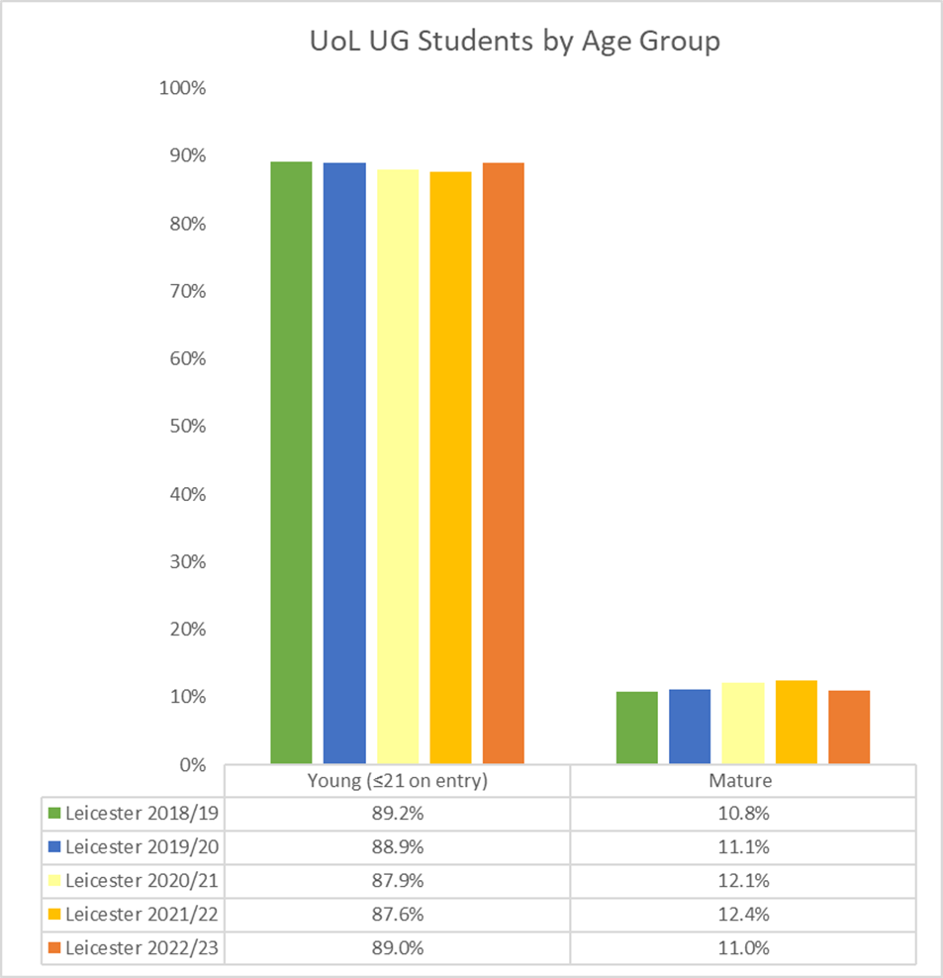

**Staff:** Graph 1.2 All UoL staff by age group 2020 to 2024

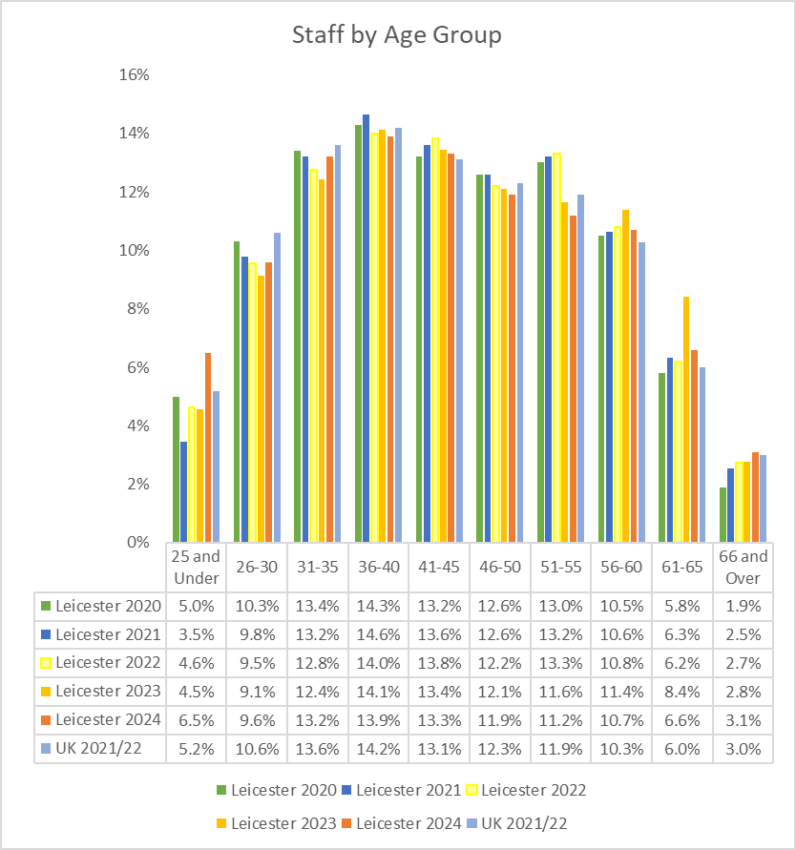

1. Disability

**Students:** Table 2.1 All UoL students by disability, 2018/19 to 2022/23

Data table of the University of Leicester student body by disability where the proportion of students declaring a disability has slightly increased over the last five years. Despite this increase, the vast majority of students have not declared a disability. 

**Staff:** Table 2.2 UoL staff by declared disability 2020 to 2024

Data table of the University of Leicester staff body by declared disability where the proportion of staff declaring a disability has continued to increase over the last five years. Despite this increase, the vast majority of staff have not declared a disability. 

**Students:** Graph 2.1 All UoL students by disability, 2018/19 to 2022/23

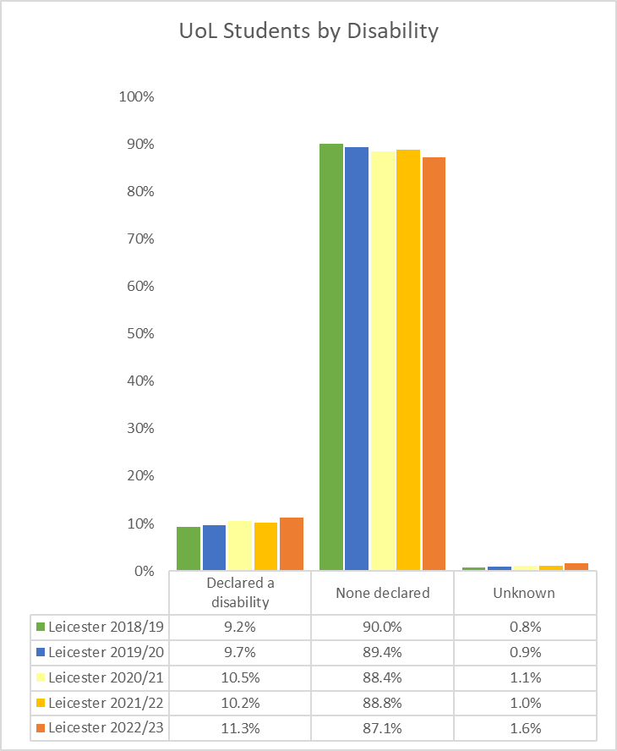

**Staff:** Graph 2.2 UoL staff by declared disability 2020 to 2024

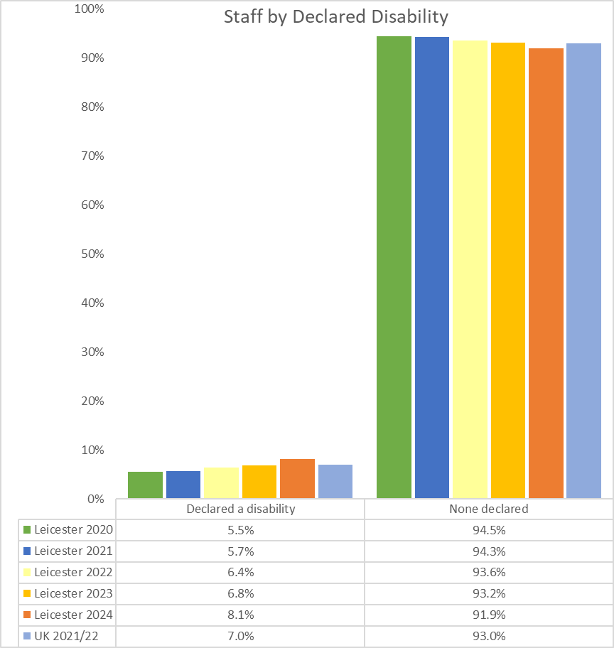

1. Ethnicity

**Students**: Table 3.1 All UoL students by ethnicity (minority ethnic, white and not declared) 2018/19 to 2022/23

Data table of the University of Leicester student body by ethnicity, where the proportion of students identifying as minority ethnic has increased considerably from 2018/19 to 2022/2023. 

**Staff:** Table 3.2 UoL staff by ethnicity – grouped 2020 to 2024

Data table of the University of Leicester staff body by ethnicity, where the proportion of staff who have declared their ethnicity has increased over the last five years. The proportion of staff identifying as minority ethnic has increased each year from 2020 to 2024.

**Students:** Graph 3.1 All UoL students by ethnicity (minority ethnic, white and not declared) 2018/19 to 2022/23

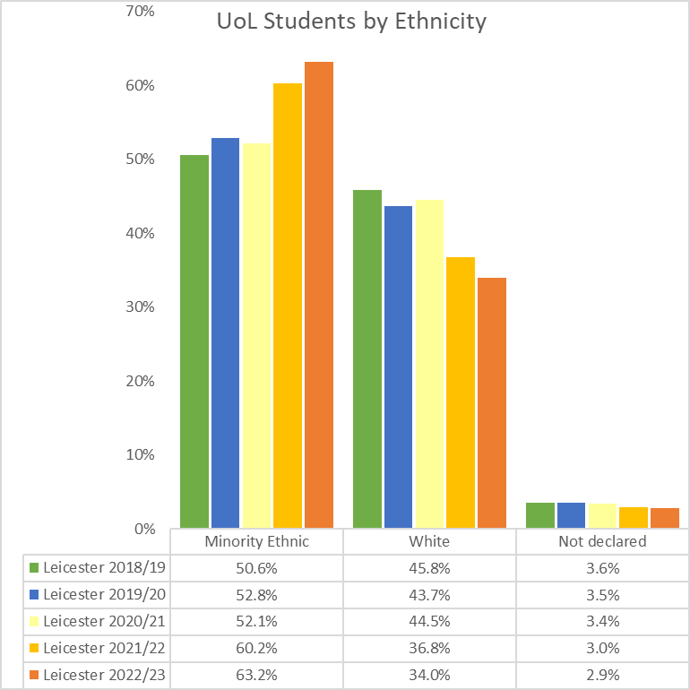

**Staff:** Graph 3.2 UoL staff by ethnicity – grouped 2020 to 2024

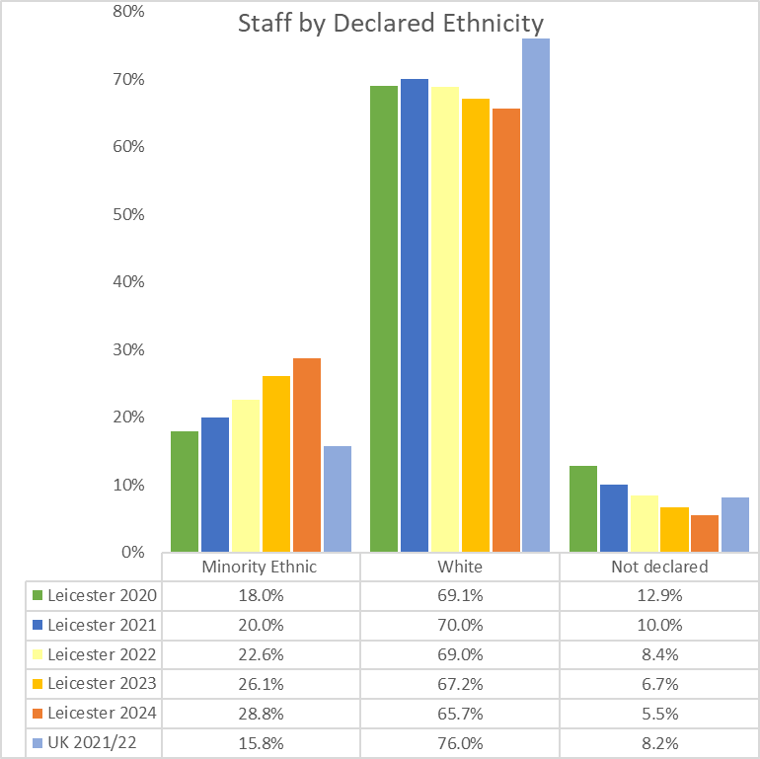

**Students:** Table 3.3 Breakdown of UoL Students by ethnicity 2019/20 to 2022/23

Data table of the University of Leicester student body by ethnicity over the last four academic years, which shows that the highest proportion of students identify as Asian or Asian British. In 2022/23 students who identified as Asian or Asian British made up 41.4% of the student body. 

**Staff:** Table 3.4 UoL staff by ethnicity 2020 to 2024

Data table of the University of Leicester staff body by ethnicity over the last five years, which shows that there has been a reduction in the number of staff who have not declared their ethnicity. Of staff who have declared, the majority of staff identified as either White followed by Asian/Asian British. 

**Students:** Graph 3.3 Breakdown of UoL Students by ethnicity 2019/20 to 2022/23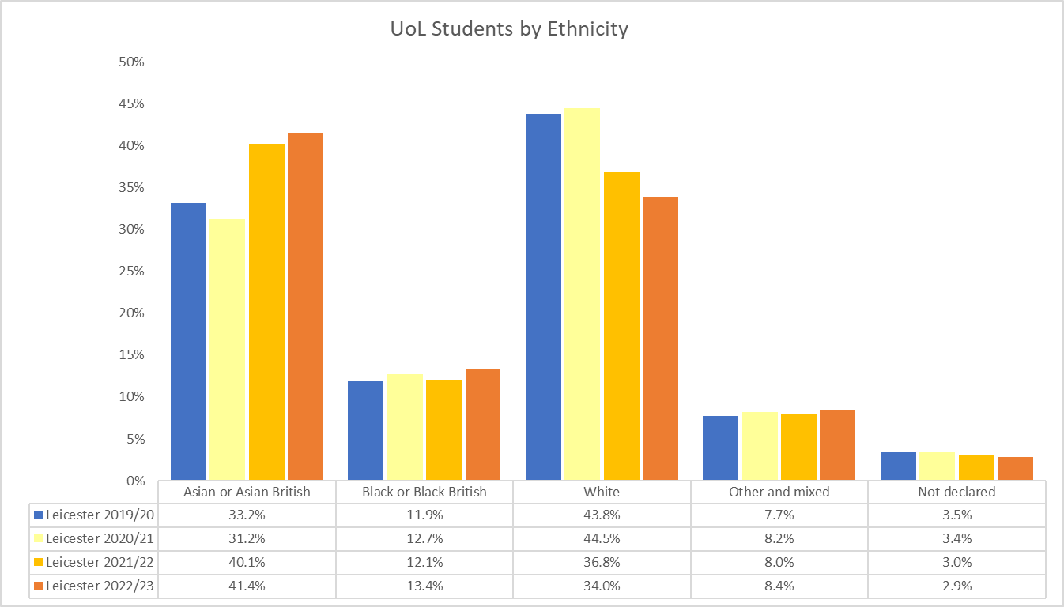

**Staff:** Graph 3.4 UoL staff by ethnicity 2020 to 2024

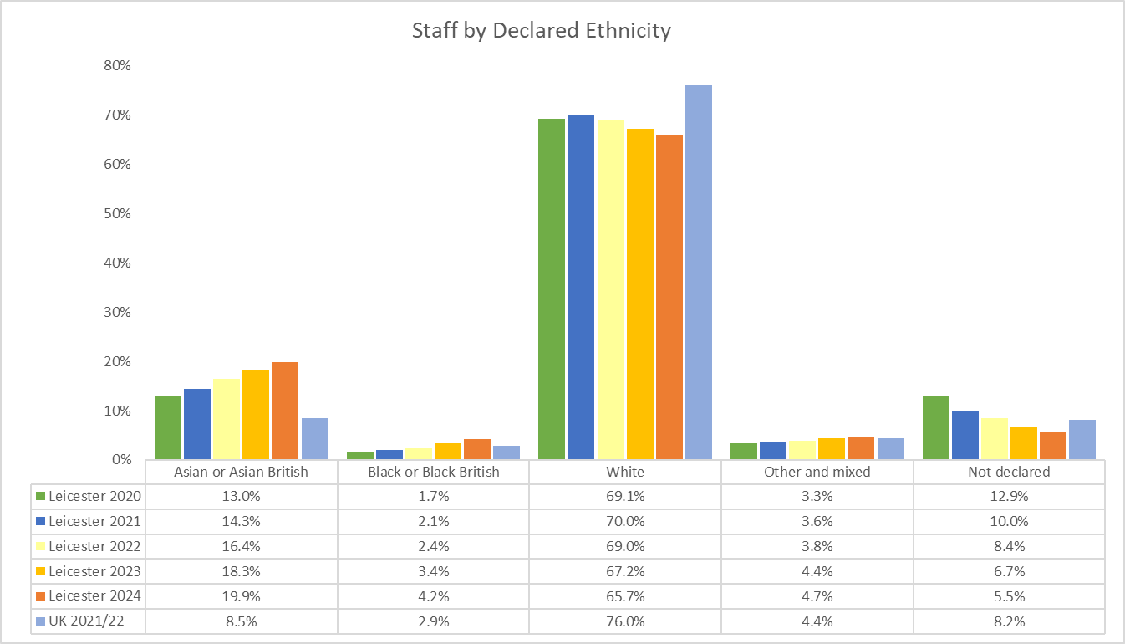

**Students:** Table 3.5 Detailed ethnicity breakdown of UoL Students who identify as Minority Ethnic 2019/20 to 2022/23

Data table of the detailed ethnicity breakdown of University of Leicester students who identify as minority ethnic over the last four academic years. Data shows that the largest proportion of students identify as Indian followed by Black African. 

1. Religion or Belief

**Students**: Table 4.1 All UoL students by religion or belief, 2018/19 to 2022/23

Data table of the University of Leicester student body by religion or belief over the last five years, which shows that the highest proportion of religion or belief groups are Christian, Muslim, Hindu and no religion. 

**Staff:** Table 4.2 UoL staff by religion or belief 2020 to 2024

Data table of the University of Leicester staff body by religion or belief over the last five years, which shows that the number of staff declaring 'prefer not to say' has decreased considerably but still remains a high proportion of reporting's from the staff body. 

**Students:** Graph 4.1 All UoL students by religion or belief, 2018/19 to 2022/23

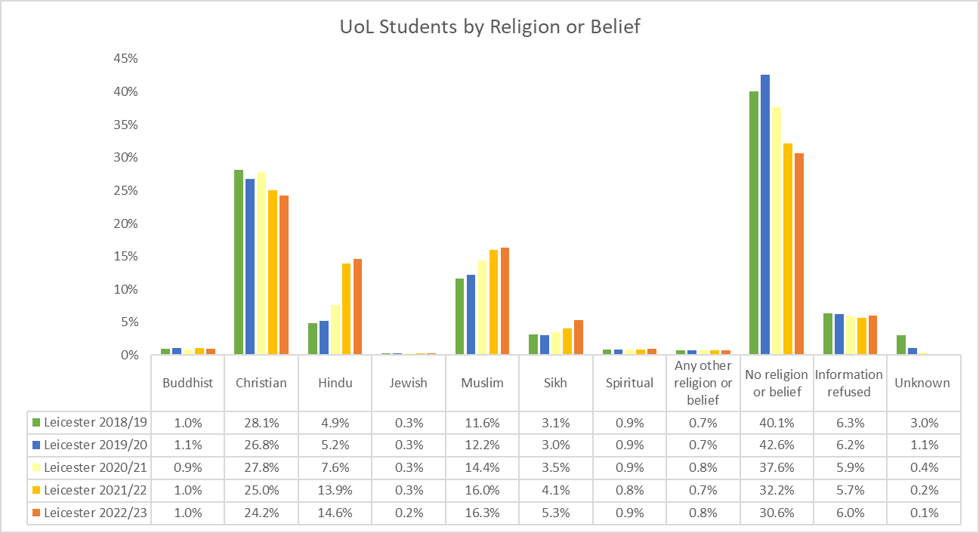

**Staff:** Graph 4.2 UoL staff by religion or belief 2020 to 2024

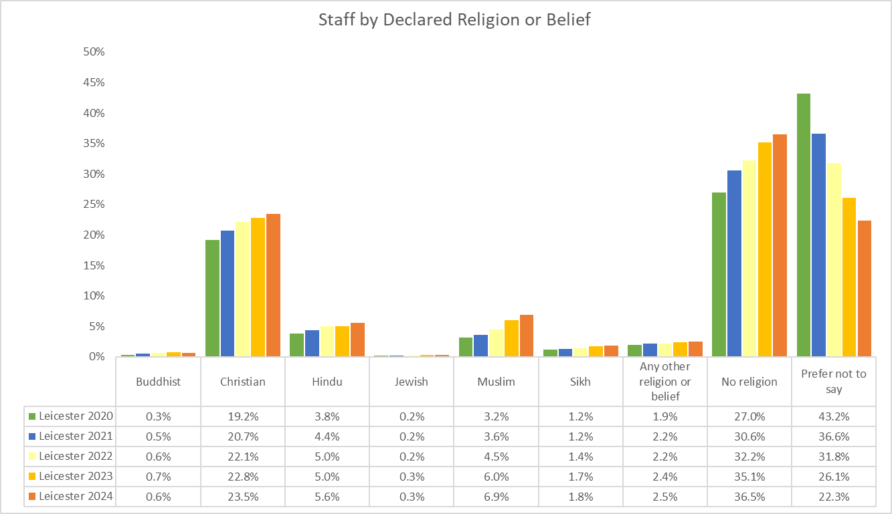

1. Sex

**Students:** Table 5.1 All UoL students by sex, 2018/19 to 2022/23

Data table of the University of Leicester student body by sex over the last five years, which shows that whilst the proportion of male and female students has remained fairly even, females make up the majority of the University of Leicester student body. 

**Staff:** Table 5.2 UoL staff by Sex 2020 to 2024

Data table to show that over the last five years, females have made up the majority of the University of Leicester staff body.

**Students:** Graph 5.1 All UoL students by sex, 2018/19 to 2022/23

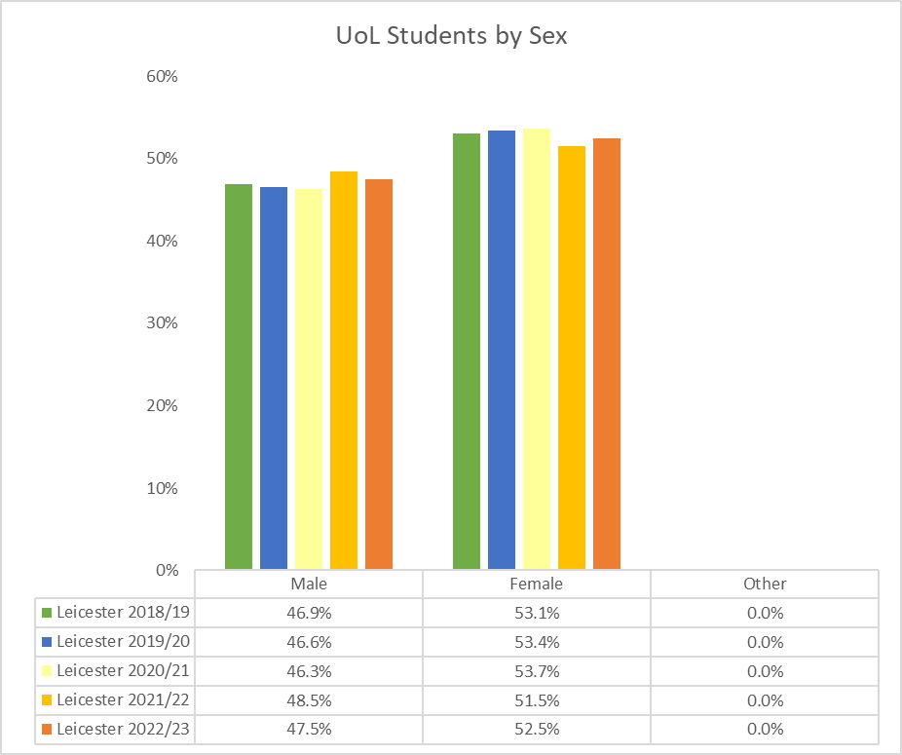

**Staff:** Graph 5.2 UoL staff by Sex 2020 to 2024

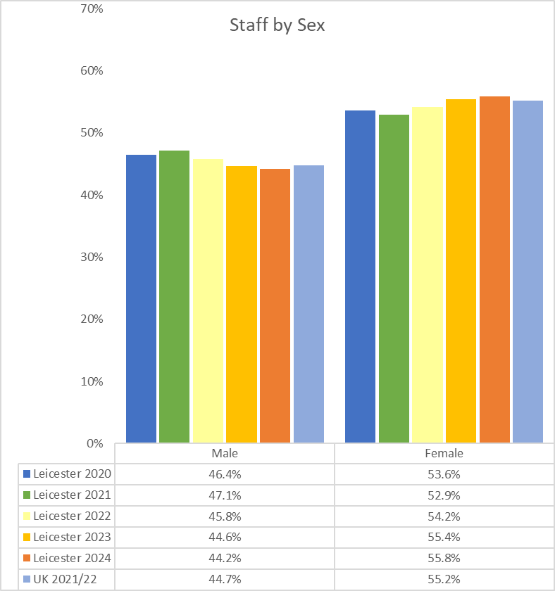

1. Gender Identity

**Staff:** Table 6.1 UoL staff by gender identity 2024

A table showing that the proportion of University of Leicester staff declaring their gender identity matching their sex registered at birth in 2024 was 67.2%. 1% of staff declared that their gender identity did not match their Sex as registered at birth and 31.8% if staff 'prefer not to say'.

**Staff:** Graph 6.1 UoL staff: Gender Identity

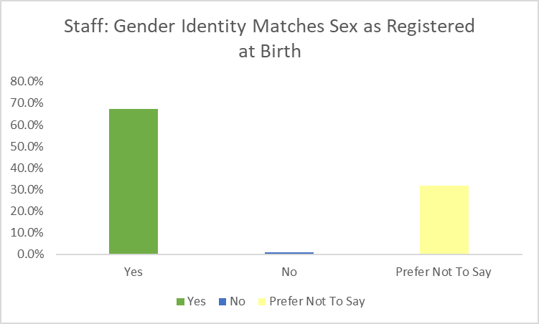

1. Sexual Orientation

**Students:** Table 7**.**1 All UoL students by sexual orientation, 2018/19 to 2022/23

Data table of the University of Leicester student body by sexual orientation over the last five years. In 2022/23, 78.3% of students identified as heterosexual/straight, 9.9% as Bisexual/Gay man/Gay woman/lesbian/Other, 11.7% Information refused and 0.1% not declared. 

**Staff:** Table 7.2 UoL staff by grouped sexual orientation 2020 to 2024

Data table of the University of Leicester staff body by sexual orientation showing that the proportion of staff who have not declined their sexual orientation has reduced in the last five years by 22.9%.

**Students:** Graph 7.1All UoL students by sexual orientation, 2017/18 to 2021/22

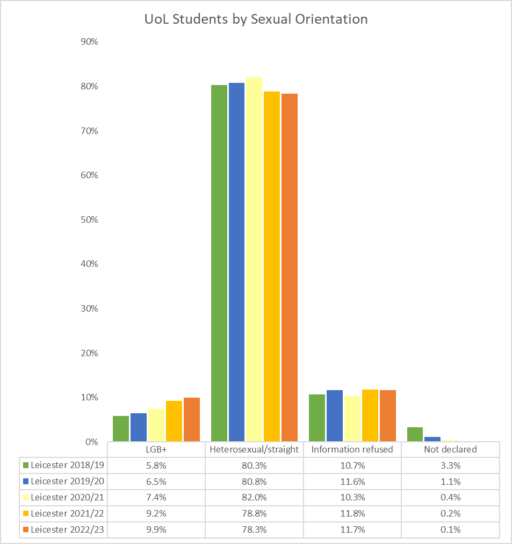

**Staff:** Graph 7.2 UoL staff by grouped sexual orientation 2020 to 2024

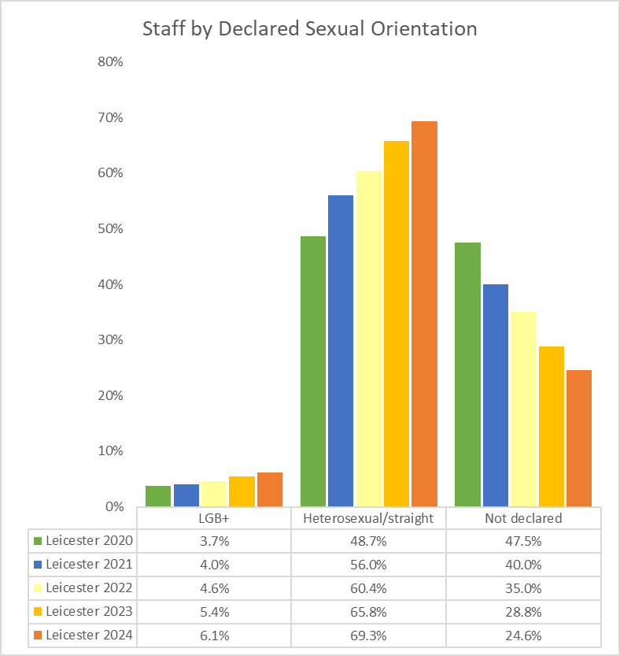

Appendix B

Equity, Diversity and Inclusion Strategy 2023-2028

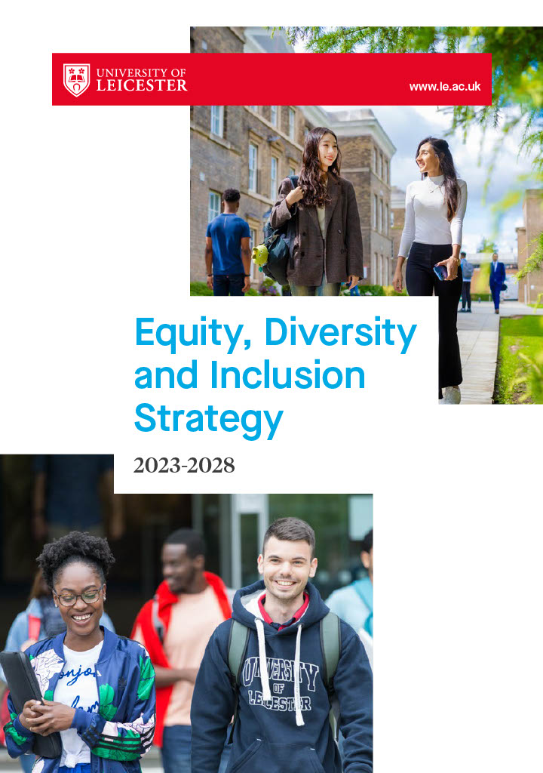

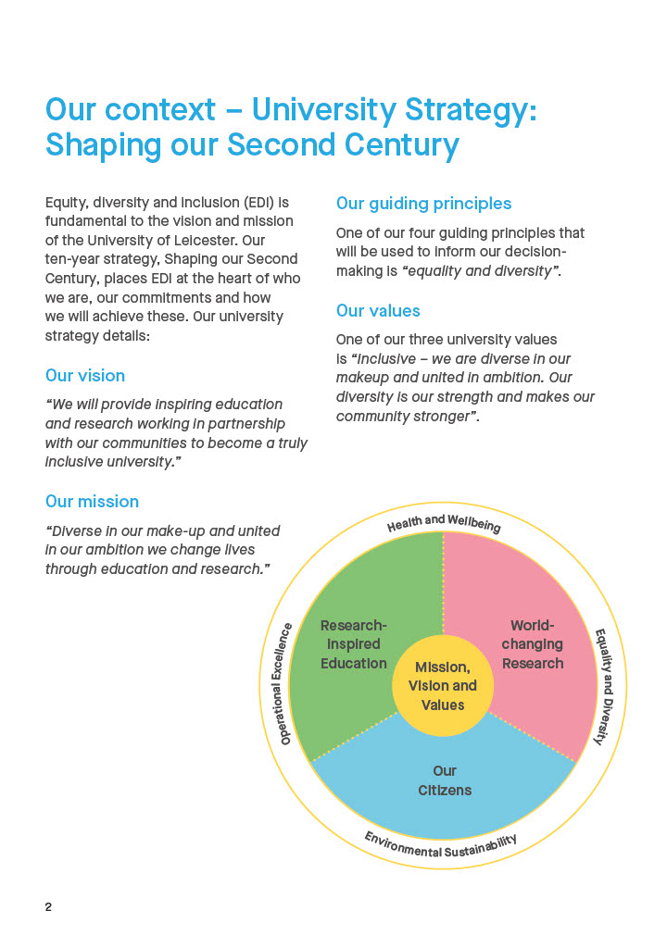

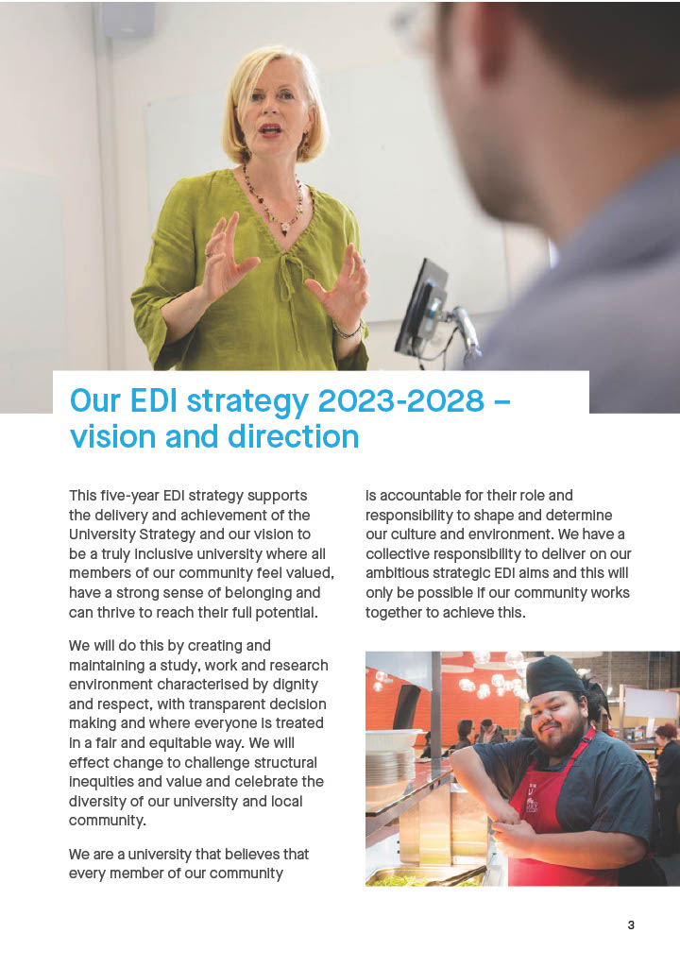

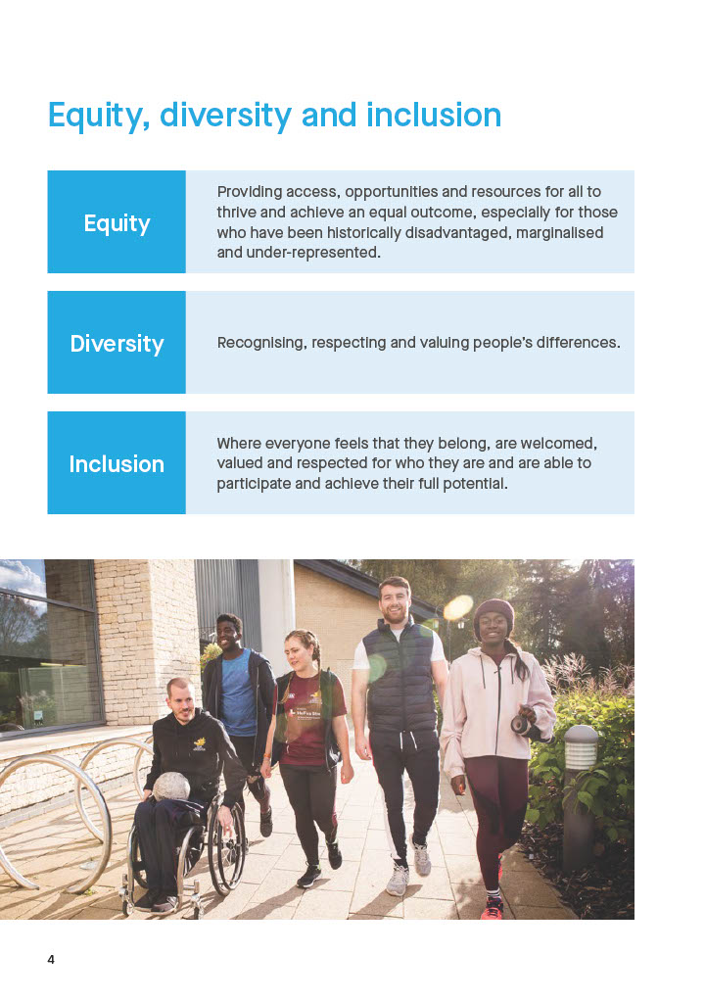

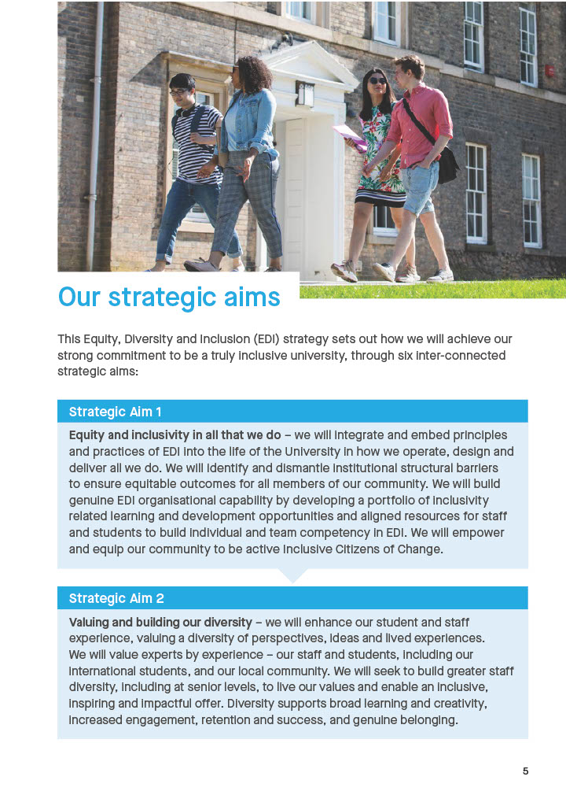

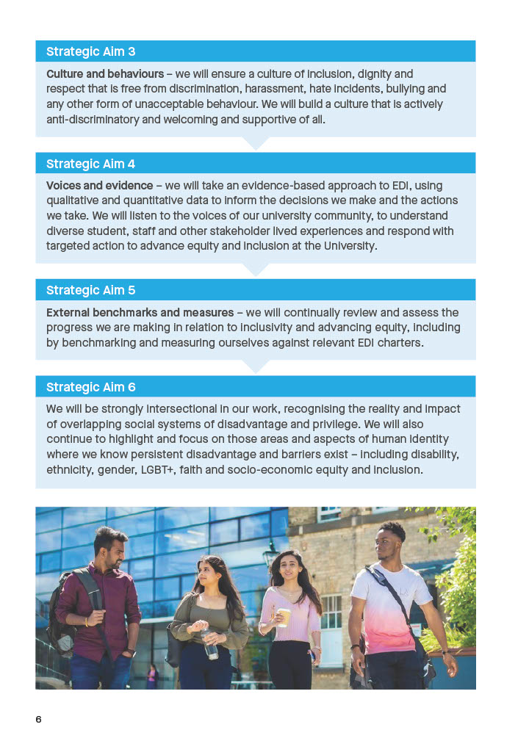

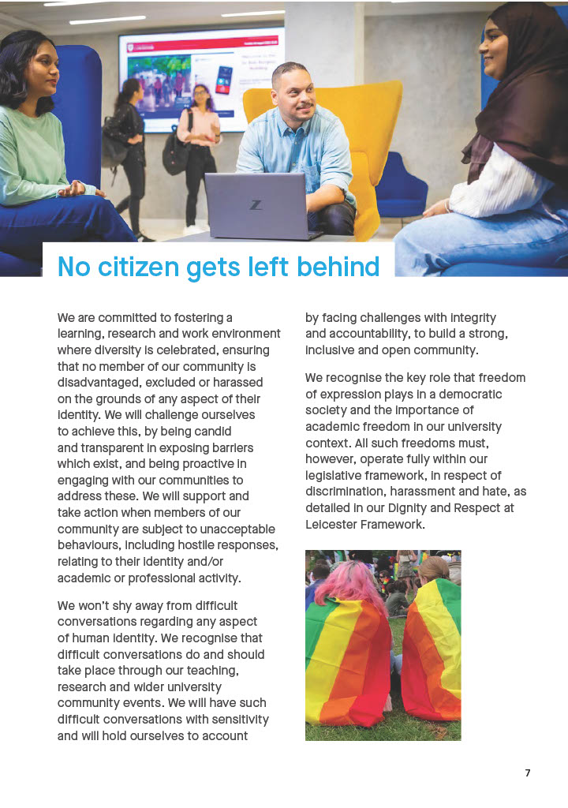



Appendix C

University of Leicester Pay Gaps Report 2023

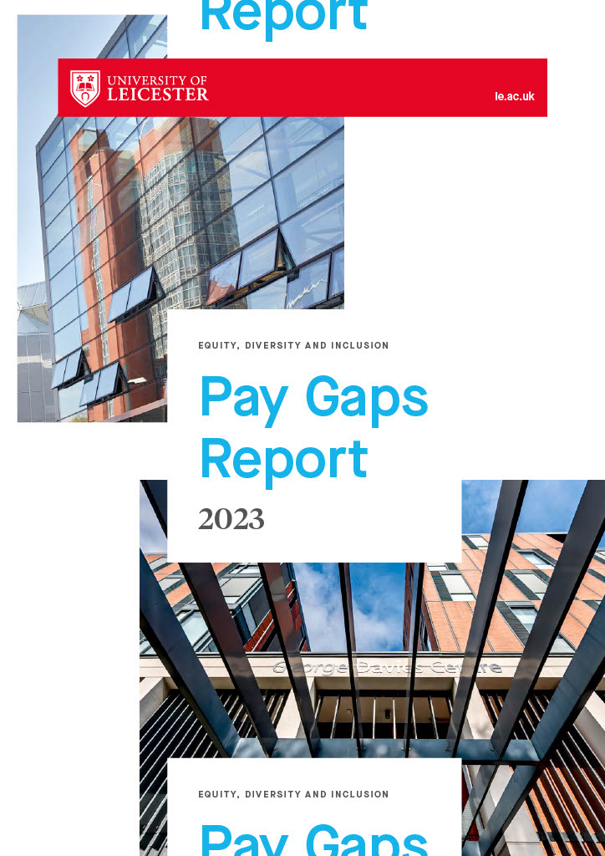

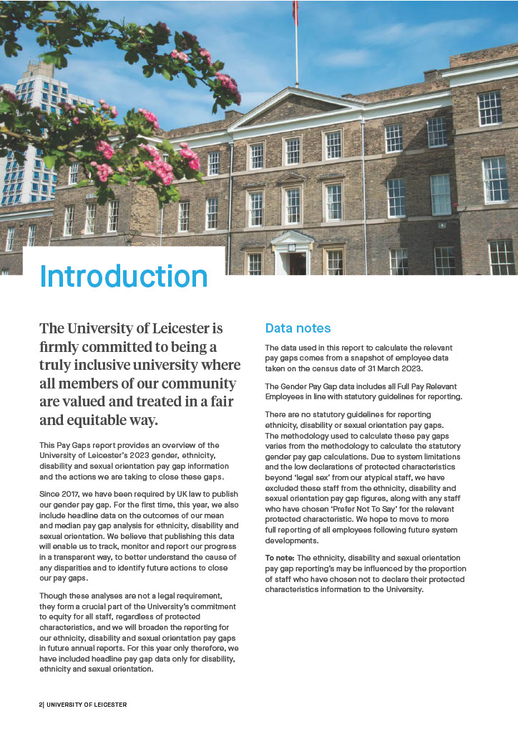

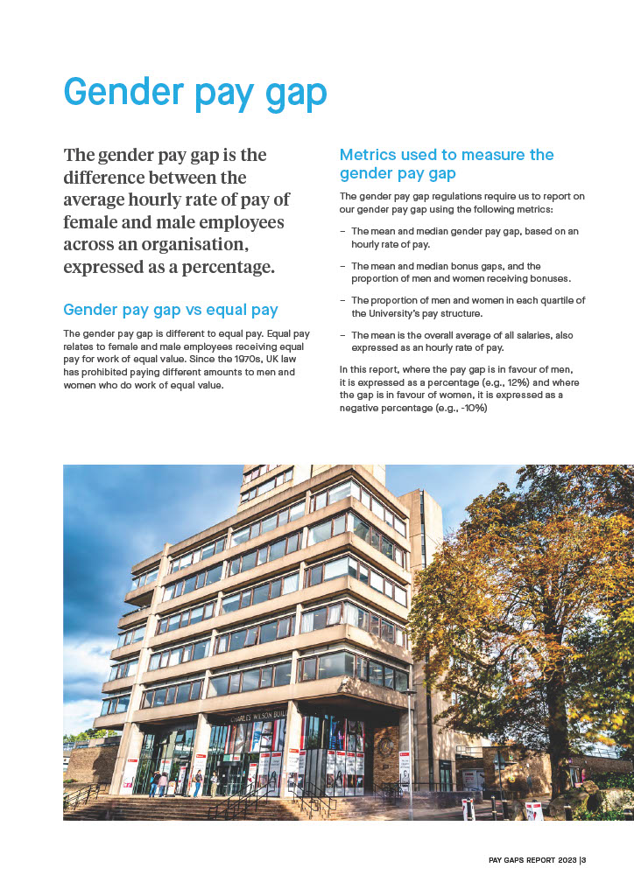

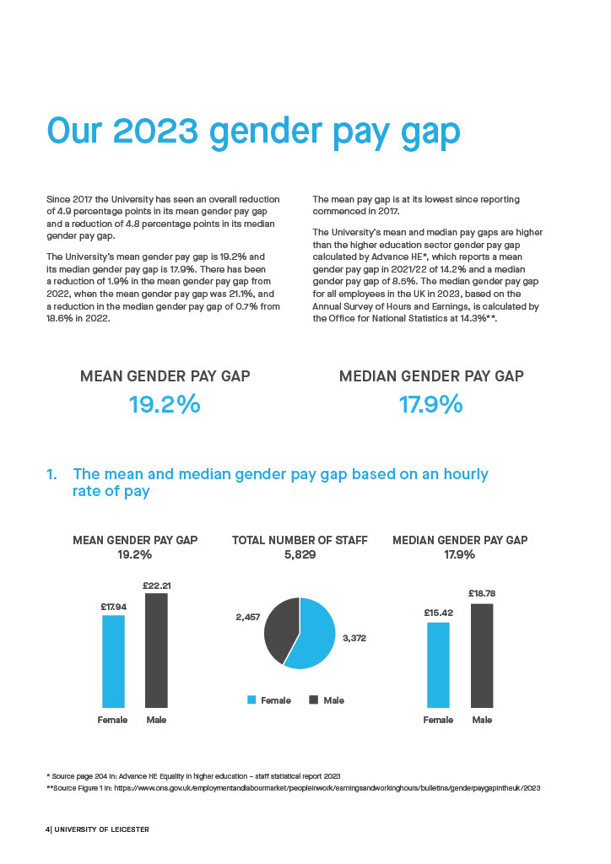

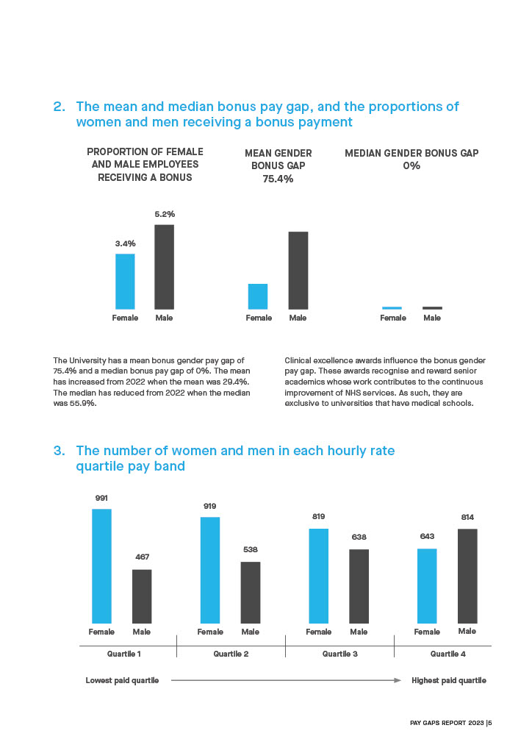

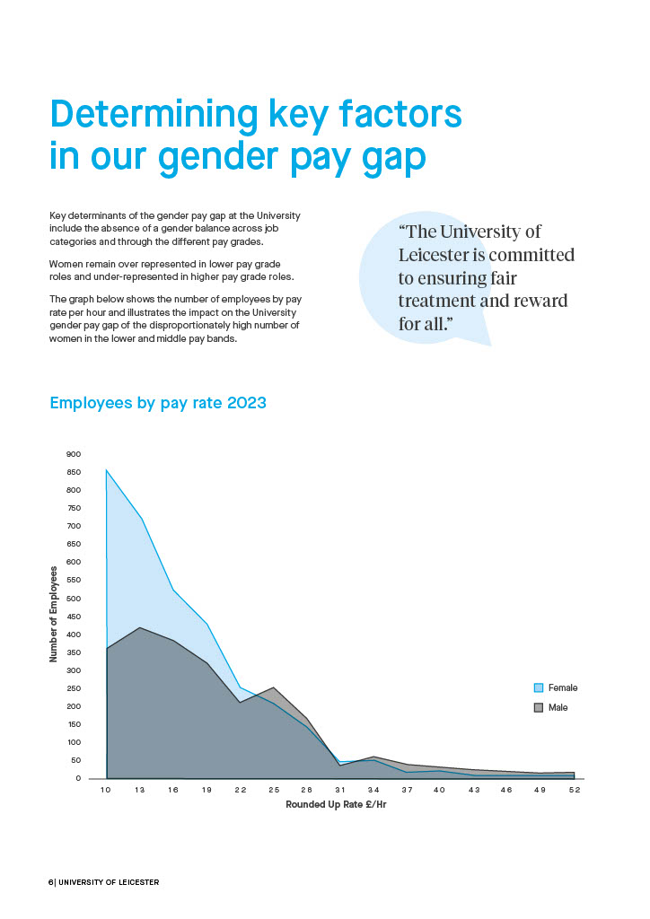

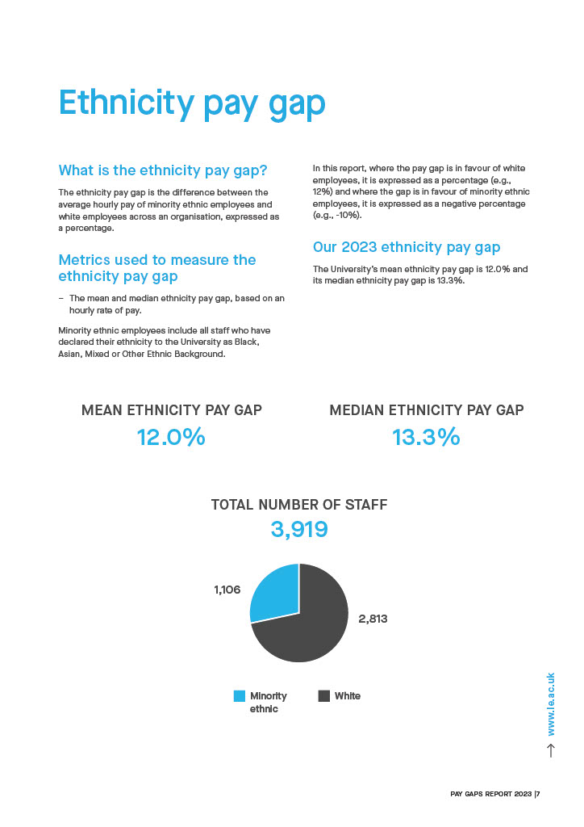

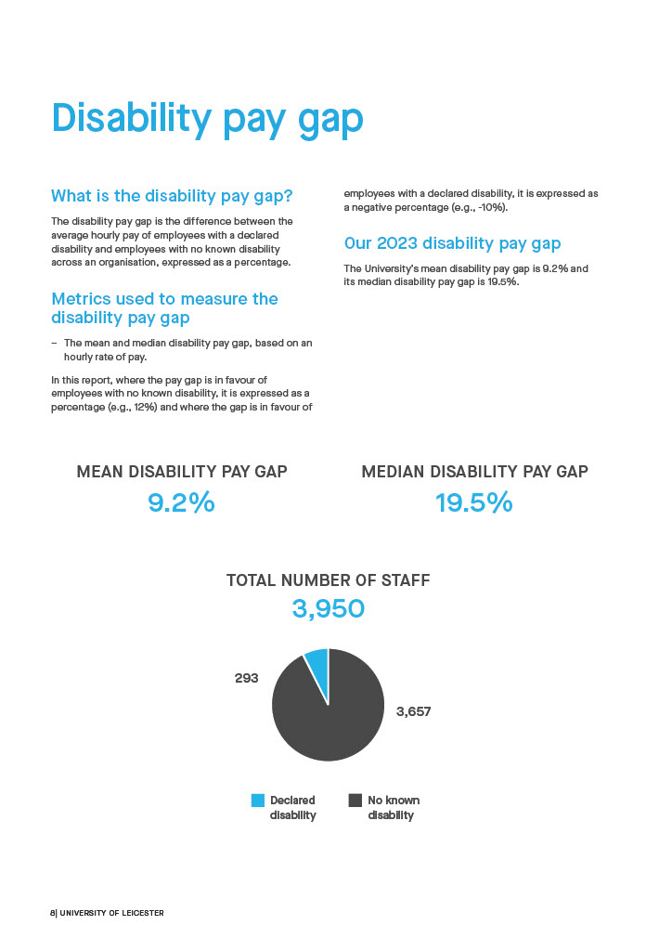

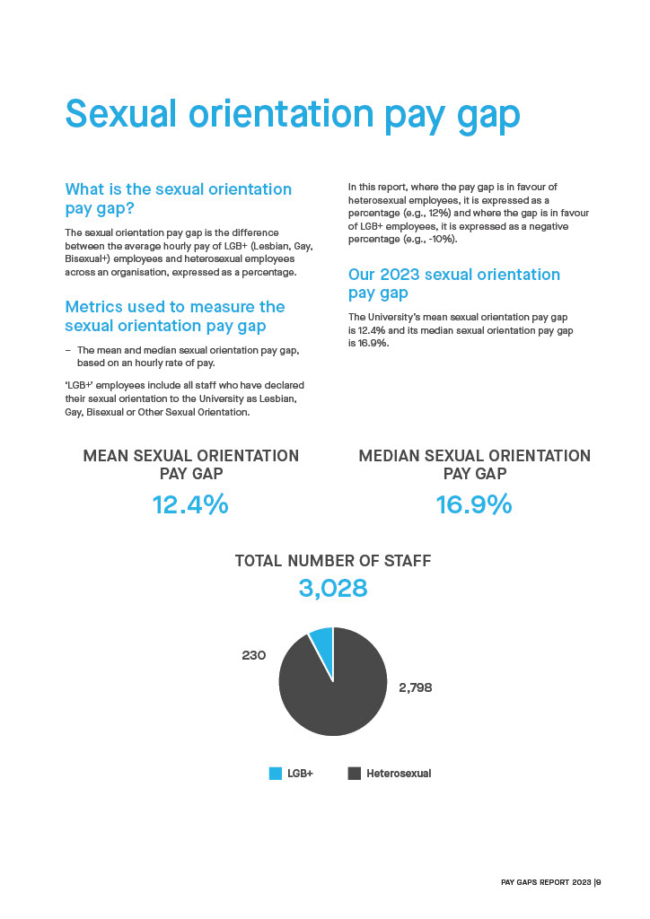

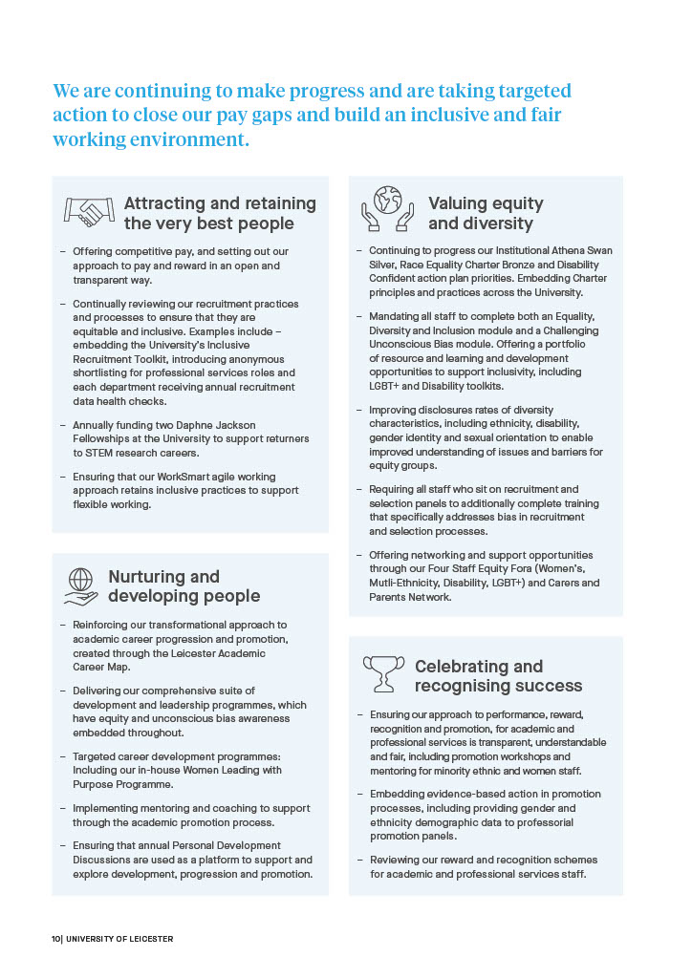



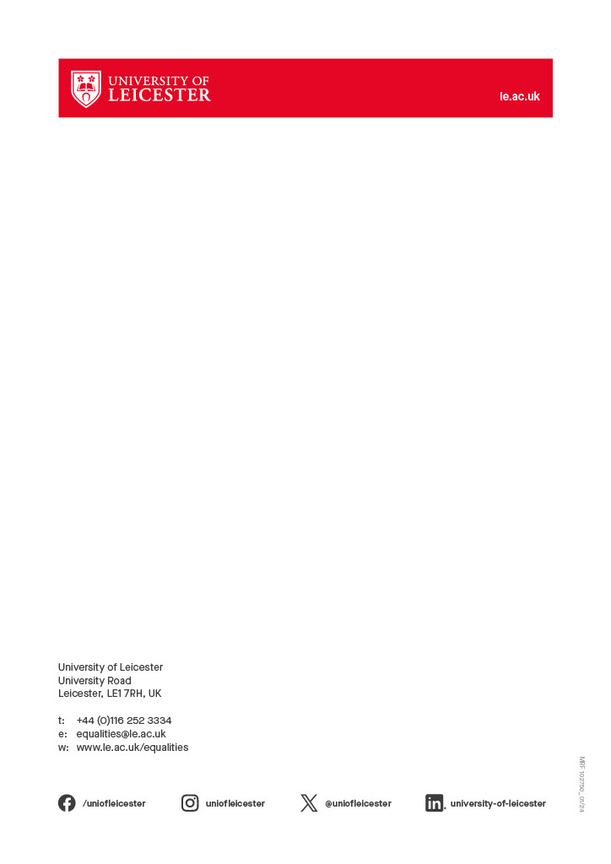

1. All information provided by the Student and Education EDI Team
2. All information provided by the SU Liberation Officer