Equality, Diversity and Inclusion

Annual Report

March 2022

UNIVERSITY OF LEICESTER
March 2022

Equality, Diversity and Inclusion Report

- Introduction

  - This report details the Equality, Diversity and Inclusion (EDI) Team led activity that has taken place to advance equality and embed inclusivity across all areas of the University during the past 12 months. It reports on progress across all key equality areas, including in relation to the priorities identified by the University’s Equality Action Groups.

  - For the first time, this report includes the full student and staff equality profile, including benchmark data where relevant, over the last five years. It reports on progress in all key equality areas, including in relation to the priorities identified by the University’s Equality Action Groups and agreed by the University’s EDI Committee.

  - It also includes information about the newly launched University of Leicester Institute for Inclusivity in Higher Education and the Students’ Union liberation campaigns and activity.

  - There is a lot of EDI related expertise and activity taking place across the University not included in this report but reported elsewhere. This includes the work of central Student Support Services, where EDI is embedded into all service delivery (and includes the Standing Together Team and AccessAbility Service) and the Student Education EDI Team. In addition, there is embedded EDI activity taking place at College, Division and School/Department level, including, for example, through the work of the College/School EDI Committees and local EDI resource, such as the College of Life Sciences EDI Team.

  - This is the fifth year of statutory gender pay gap reporting, and this report provides the University’s 2021 gender pay data, along with details of actions being taken to reduce this gender pay gap.

  - The ongoing impact of Covid-19 on the university community means that the EDI Team has continued to deliver some of its services and activities differently, but a full programme of initiatives, events and activities has again been in place over the last twelve months.

  - Strong partnership working, including with the Students ’ Union, staff equality fora, academic and professional services teams, and other key stakeholders across the University, continues to underpin, and be vital to, the work of the EDI Team.

  - This report is organised into the following sections:
    - Student and staff five-year equality profile.
    - Advancing equality in key areas.
    - Further embedding of equality, diversity and inclusion.
    - Overview of the aims, priorities and progress to date for the newly launched University of Leicester Institute for Inclusivity in Higher Education.
    - Students’ Union EDI activity and achievements.

Student and Staff Five-Year Equality Profile

  - The data in this section gives an overview of the equality profile of students and staff at the University over the last five years.

Student Equality Profile

  - The student population included within the following data includes all UG, PGT and PGR students, excluding visiting and exchange students, students with a dormant mode of attendance, students at partnership institutions, and students who have been active at the University for fewer than 14 days over the academic year.¹ Benchmark figures are from the Advance HE Equality in Higher Education: Student Statistical Report 2021.

Age Profile of Students

  - The number of students aged 30 and above has decreased over the five-year period with the number of students aged 21-29 increasing (Figure 1). There has also been a decrease in the number of students aged 20 and below.

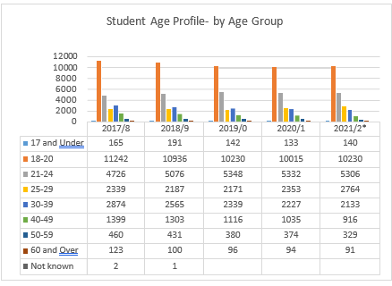
Figure 1 Age profile of students at the University of Leicester 2017 – 2022

Disability Profile of Students

  - The proportion of students who have disclosed a disability has remained constant at 10%. This is lower than the disclosure rate for the UK sector (14.6%).

¹ Navitas students have been included during their time of study at the University. Data was captured as of 28 February 2022. Data for Academic Year 2021/2 is for the period 1st August 2021 - 28th February 2022.¹.

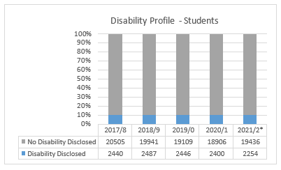
Figure 2 Disability profile of students at the University of Leicester 2017 - 2022

Ethnicity Profile of Students

  - The population for student ethnicity data includes international students, therefore, comparisons to the sector have not been made as it is only compulsory to collect ethnicity data for UK domiciled students (although these students can also choose not to disclose).

  - There has been an increase in minority ethnic students at the University over the five-year period, from 53.8% in 2017/28 to 64% in 2021/22 (all students).

  - The proportion of students who have not disclosed their ethnicity has reduced from 4.3% in 2017 to 2.9% in 2022.

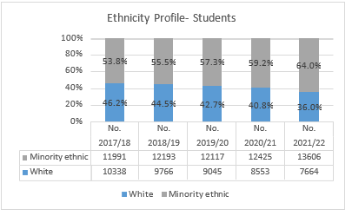
Figure 3 Ethnicity profile of students (minority ethnic and White) at the University of Leicester 2017 – 2022

There has been a large increase in the numbers of Asian students over the five-year period, 12.8% in 2017/18 to 30.4% in 2021/22 (Figure 4).

Ethnicity Profile - Students (Disclosed)
3.8%
2021/2*
30.4%
21.0%
11.4% 8.1%
3.9%
11.3% 12.8%
3.9%
36.0%
10.3%
2020/1
40.8%
10.2%
2019/0 15.9% 11.3% 15.9% 42.7%
10.3%
Asian
Black Chinese
4.1%
Mixed
2018/9 13.6% 12.2% 14.9%
44.5%
10.7%
White
4.2%
2017/8 12.8% 12.3% 13.2%
46.2%
11.3%
Other
0%
20%
40%
60%
80%
100%

Figure 4 Detailed ethnicity profile of students at the University of Leicester 2017 – 2022

Table 1 Ethnicity profile of students at the University of Leicester 2018-2022

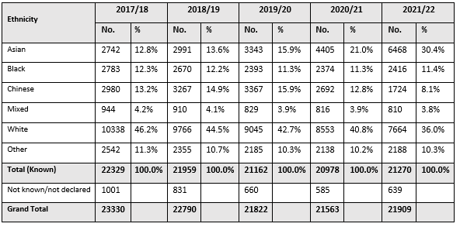

Gender Profile of Students

  - The proportion of female students registered at the University of Leicester has increased over the five-year period, from 30.1% to 45.4% (Figure 5). This is lower than for the UK, where 57% of all students studying are female.

  - Of all students, 0.6% identified their gender as being different to the sex assigned at birth.

  - The proportion of students choosing not to disclose their gender has reduced significantly over the five-year period from 35.1% to 6.5%.

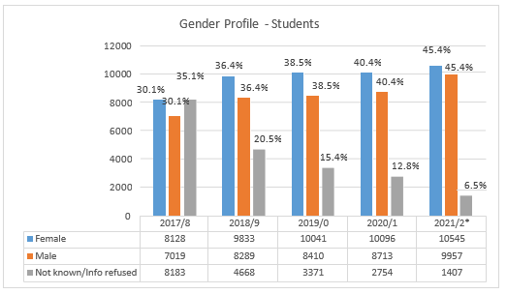
Figure 5 Gender profile of students at the University of Leicester 2017 - 2022

Religion or Belief Profile of Students

  - The proportion of students that have disclosed their religion or belief increased from 81.4% in 2017/18, to 94.2% in 2021/22.

The profile of disclosed student religion or belief is detailed in Table 2. In 2021/22, the majority of students disclosed that they had no religion (32.2%), followed by Christian (24.5%), Muslim (15.7%) and Hindu (14.6%). This broadly mirrors the UK sector, with 43.8% of students disclosing no religion or belief, 27.6% Christian, 8.7% Muslim and Hindu, 2.8%.
Religio
Religion or Belief Profile - Students
(Disclosed)
Any other religion or belief

Buddhist
2021/2*
Christian
2020/1
Hindu

Jewish
2019/0
Muslim
2018/9
No religion
2017/8
Sikh

Spiritual
0% 20% 40% 60% 80% 100%
Figure 6 Religion or Belief profile of students at the University of Leicester 2017 – 2022

Table 2 Religion or Belief profile of students at the University of Leicester 2017 - 2022

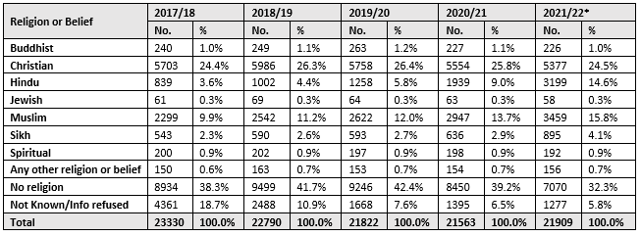

Sexual Orientation Profile of Students

  - The proportion of students who disclosed their sexual orientation increased over the five- year period from 76.8% to 87.6%. Returns on sexual orientation data are not compulsory for institutions and are therefore not included in this section.

  - 5.7% of students disclosed their sexual orientation as lesbian, gay or bisexual in 2017/18, compared to 10.1% in 2021/22.

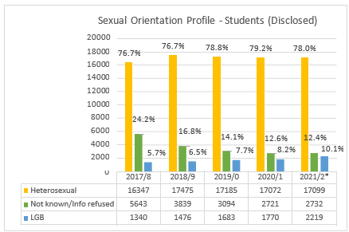

Figure 7 Sexual Orientation profile of students at University of Leicester 2018 – 2022

Staff Equality Profile

  - Detailed below, is the equality profile of staff at the University of Leicester for the last five years. University data was captured, as of January 1st each year, and compared to the HEIDI+ benchmarking data.

Age Profile of Staff

  - The majority of staff are aged 31 to 50 (Figure 8). Approximately 77% are aged between 31 and 60 years in 2022.

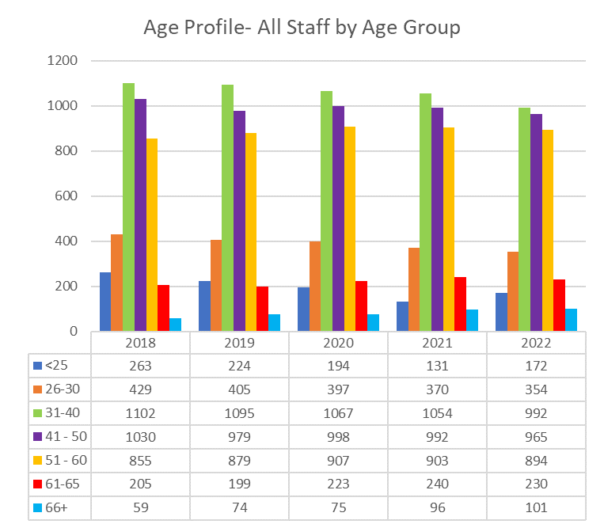

Figure 8 Age profile of staff at the University of Leicester 2018 – 2022

Disability Profile of Staff

  - The proportion of staff who have disclosed a disability has increased gradually over the five- year period, from 5.2% to 6.4%, which is higher than the sector average of 5.3% (Figure 9). In January 2022, the proportion of academic staff who disclosed a disability was 4.3%, which mirrors the sector average of 4.3%. However, for professional services staff, the proportion who disclosed a disability was 8.0%, which is much higher than the sector average of 6.1%.

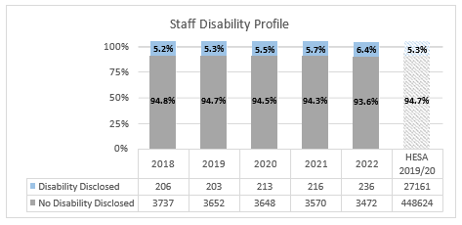
Figure 9 Disability profile of staff who have disclosed their disability at University of Leicester from 2018 - 2022

Ethnicity Profile of Staff

  - The proportion of staff who have disclosed their ethnicity has increased over the five-year period, from 87.5% in 2018 to 91.6% in 2022. Despite this positive trajectory, increasing staff ethnicity disclosure rates remains an area of focus for us during 2022.

  - SOf those who have disclosed their ethnicity, the proportion of minority ethnic staff has increased over the five-year period from 18.3% to 24.7% (22.6% minority ethnic, when including prefer not to say), which is well above the sector average of 14.5% (Figure 10). In January 2022, the proportion of minority ethnic academic staff (24.7%) and professional services staff (25.1%) were similar and are both above the sector average of 16.8% and 12.3% respectively.

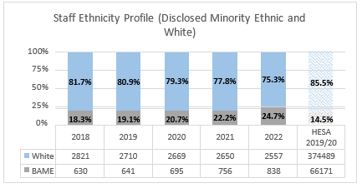
Figure 10 Ethnicity profile of staff (minority ethnic and white) at the University of Leicester 2018 – 2022

  - There has been an increase in all minority ethnic staff groups over the five-year period (Figure 11).

  - The proportion of Asian staff has seen the largest increase, from 10.1% in 2018 to 13.9% in 2022. For other ethnic groups, the proportion of Chinese staff has increased from 1.6% (2018) to 2.5% (2022) and the proportion of Black staff has increased from 1.4% (2018) to 2.4% (2022).

Staff Ethnicity Profile (Disclosed)
2022

2021

2020

2019

2018
0%
20% 40% 60%
Asian Black Chinese Mixed Other
80%
White
100%
Figure 11 Ethnicity profile of staff who have disclosed their ethnicity at University of Leicester 2018 - 2022

Table 3 Detailed ethnicity profile of staff 2018 - 2022

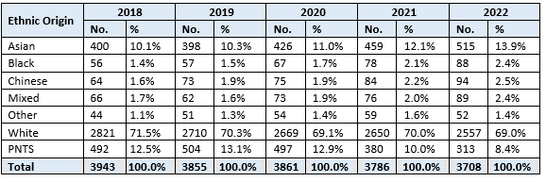
Gender Profile of Staff

  - The proportion of female staff employed at the University of Leicester has increased slightly over the five-year period, from 52.9% to 54.2%, and is very similar to the sector average of 54.6% (Figure 12).

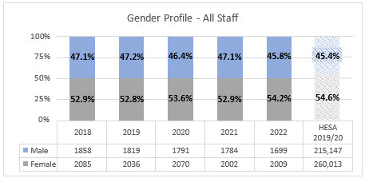
Figure 12 Gender profile of staff at the University of Leicester from 2018 – 2022

Religion or Belief Profile of Staff

  - The proportion of staff that have disclosed their religion or belief has increased over the five-year period, from 50.7% in 2018 to 68.2% in 2022. In 2022, the majority of staff disclosed that they had no religion or belief (22.1%), followed by prefer not to say (31.8%), Christian (22.1%), Hindu (5.0%) and Muslim (4.5%) (Table 4).
Religion or Belief Profile - All Staff (Disclosed)
2022
2021
2020
2019
2018
0%
10%
20%
30%
40%
50%
60%
70%
80%
90% 100%
Buddhist
Jewish Spiritual
Christian
Muslim
Any other religion or belief
Hindu
Sikh
No religion
Figure 13 Proportion of staff who have disclosed their religion or belief 2018 - 2022

Table 4 Religion or belief profile of staff at the University of Leicester 2018-2022

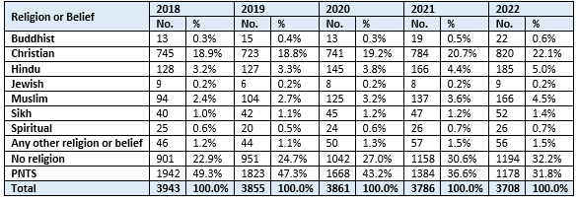

Sexual Orientation Profile of Staff

  - The proportion of staff who disclosed their sexual orientation significantly increased over the five-year period, from 45.5% to 65.0%.

  - 2.4% of staff disclosed their sexual orientation as lesbian, gay or bisexual in 2018, compared to 3.6% in 2022 (Figure 15). A full breakdown of staff disclosed sexual orientation over the five-year period is detailed in Table 5.

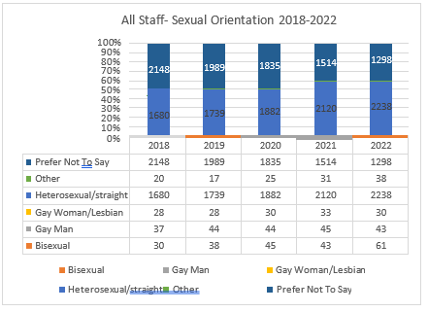
Figure 14 Staff by Sexual Orientation at University of Leicester 2018-2022

Table 5 Profile of Staff by Sexual Orientation 2018-2022

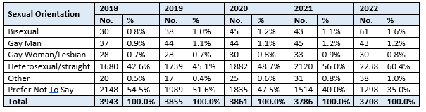

  - Reflecting on the student and staff equality profile at the University of Leicester over the five-year period, the picture is one of increasing diversity across the categories of disability, ethnicity, religion or belief and sexual orientation.

  - In terms of ethnicity, the percentage of minority ethnic students has increased significantly, from 53.8% to 64% (all students), and whilst the percentage of minority ethnic staff has also increased, it is at a much lower rate, 18.3% to 24.7% (of those who have disclosed their ethnicity). Details of how we are addressing this disparity between the ethnic diversity of our staff and that of our students and the region can be found in Section 3.4.

  - A number of initiatives will run during 2021/22 to further increase our current staff disclosure rates across the categories of disability, ethnicity, religion or belief and sexual orientation.

Advancing Equality in Key Areas

  - Advancing Equality in Key Areas – Disability

    - Work to advance disability equality has progressed significantly within the University over the last year, with continued partnership working with both the Disability Staff Forum and the Students’ Union.

    - Activities have focussed on supporting the following strategic objectives to advance disability equality, proposed by the Disability Equality Action Group and confirmed by the EDI Committee in March 2021:
      - Support the University to learn from the changes to working practices and student offer brought about by Covid-19 that positively and negatively impacted disabled staff and students.
      - Lead the University to embed disability equality principles and good practice, accessibility and inclusive design into the physical and virtual environment.
      - Lead and promote engagement and awareness to embed disability equality, inclusivity and understanding across the organisation, effecting a cultural shift to a disability inclusive, empathetic culture, aligned with the Dignity and Respect at Leicester Framework.

    - After achieving ‘Disability Confident: Employer’ status in July 2020, an Action Plan was developed and agreed with key stakeholders to continue to progress employment focussed disability equality, with a view to applying for ‘Disability Confident: Leader’ status in 2024. A significant amount of progress has been made towards completing these actions over the last 12 months.

    - Disability Toolkit - designed to serve as a ‘one stop’ resource hub to promote and support a disability inclusive workplace, a Disability toolkit has been developed which includes resources on best practice guidance, policies, information, training and sources of support, together with a section specifically for managers. The hub has been developed with, and informed by, members of the Disability Staff Forum and will develop organically over time.

    - Disability Confidence for Managers Training - A pilot of a new virtual Disability Confidence for Managers training course was delivered in December 2021 and will be rolled out from Spring 2022. The course aims to increase understanding around disability and associated responsibilities for managers, and equip managers with the skills and confidence to proactively support disabled team members and create an inclusive environment for disabled colleagues to thrive.

    - The Reasonable Adjustment Guide – this guide, for managers and staff, was reviewed and revised in collaboration with the Staff Disability Forum and Disability Equality Action Group. This provides detailed guidance on making reasonable adjustments to remove barriers that disabled staff may face in their role and ensure an inclusive workplace.

    - Embedding Disability Equality - in addition, and as part of the Disability Confident scheme action plan, disability inclusion has been further embedded into the staff recruitment processes and reasonable adjustment requirements have been embedded into the PDD conversation and process. Transcripts for all mandatory online staff training have been produced to support accessibility.

    - Staff Disability Advisor - in response to requests from the Disability Staff Forum, the University has invested in a new full-time Grade 7 Staff Disability Advisor role. A sector- leading move, this role, positioned within the Occupational Health Team, will support disabled staff and managers to implement reasonable adjustments to remove barriers and enable disabled staff to contribute fully to their role and the University.

    - Covid-19 – Disability and Best Practice - in response to the pandemic and the University’s changed ways of operating, disability considerations and individual adjustment requirements have been embedded into the development of hybrid working and WorkSmart processes and spaces, including adjustments relating to equipment on campus and remote/home locations.

    - International Day of Disabled People 2021 - (IDoDP), on 3 December, is a United Nations’ sanctioned date to celebrate the achievements and contributions of disabled people, raise awareness of disability inequality and promote the rights of disabled people. A number of well-attended events were organised for IDoDP 2021, including a talk by Sports scholar and Gold Paralympian medallist, Nick Cummins and a ‘Thinking Positively About Disability’ webinar was led by Sharron Sturgess, Co-Chair of the Disability Staff Forum.

    - Access Audit - an audit of the accessibility of the University’s physical estate, digital presence and teaching and learning is underway. The audit is being carried out by an external
disabled-led social enterprise that supports organisations to create inclusive cultures. The audit report will give us a detailed analysis of the barriers to access in the identified areas and a prioritised plan to address these.

Advancing Equality in Key Areas – Gender

    - The University’s well-established commitment to progressing gender equality has continued over the last year and remains a very visible area of activity across the organisation. This activity includes progressing the University’s Institutional Silver Athena Swan action plan, and a specific focus on addressing the University’s gender pay gap.

    - The University’s agreed gender equality objectives, proposed by the Gender Equality Action Group and confirmed by the EDI Committee in March 2021, were as follows:
      - Develop a more supportive pathway for staff returning from maternity leave which recognises and facilitates a more flexible approach to their working lives (including consideration of a reduced teaching load for academic staff).
      - Work collaboratively with other comparable Athena Swan and regional universities to share best practice and to generate creative and innovative actions to advancing gender equality.
      - Develop a gender pay gap action plan for implementation in 2022 that includes specific and measurable targets

    - The University currently holds an Institutional Silver Athena Swan award (awarded in 2018). Given the comprehensive nature of the award, including detailed analysis across the full student and staff lifecycles, many of the University’s actions to advance equality are framed around the aligned action plan.

    - In addition to an institutional Silver award, the University also currently holds 8 departmental awards - 6 Bronze and 2 Silver (Table 6), including a prestigious Silver College award in the College of Life Sciences. In 2022, the School of Chemistry will submit a Silver award application and the School of Business will submit a Bronze application.

Table 6 University of Leicester Departmental Athena Swan Awards

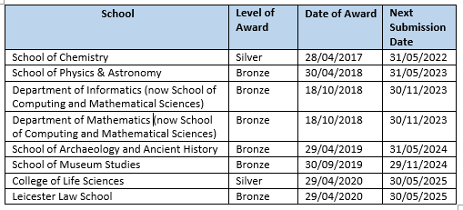

    - Work continues to embed the principles and good practice elements of the Athena Swan Charter framework and progress our ambitious Silver Athena Swan action plan. Departmental Athena Swan submissions are supported through the EDI Team, who host Athena Swan Network meetings for departmental Athena Swan leads and manage an internal panel review process to assist with applications.

    - Gender Pay Gap Report 2021 - the University published its 2021 gender pay gap report in March 2022 (see Appendix for full report). The report includes our key current gender pay gap data, along with details of initiatives and actions that the University is taking to close the gap.

    - On the census date of 31 March 2021, there were 4614 employees of the University, 54.6% female and 45.4% male. The University’s current mean gender pay gap is 20%, and its median gender pay gap is 16%. The mean gender pay gap has decreased from 20.3% in 2020 (-0.3), and the median has decreased from 19% in 2020 (-3.0).

    - Since 2017, the University of Leicester has seen an overall reduction of 4.1 percentage points to its mean gender pay gap and a reduction of 6.7 percentage points to its median gender pay gap (Table 7).

Table 7 University of Leicester GPG Movement 2017-2021

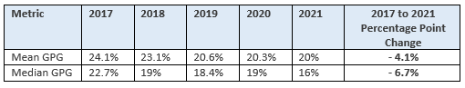

    - As for many organisations, key determinants of the University’s gender pay gap include the absence of a gender balance across job categories (horizontal occupational segregation) and through the different pay grades (vertical occupational segregation). At the University of Leicester, women continue to be overrepresented in lower and middle paid roles and underrepresented in both higher paid roles and at higher grades.

    - The University has committed to close its pay gap to the Pre-92 sector average by 2024, (the current Pre-92 mean gender pay gap is 18.9% and the median gender pay gap is 14.0%).

    - Gender Pay Gap Working Group - in order to give sustained and action orientated focus to the University’s gender pay gap, the Gender Pay Gap Working Group, chaired by the Vice- Chancellor, continued to meet throughout 2021.

    - Data dashboards detailing the gender pay gap and staff demographic data at School/Department, College and University level are now being produced for all Heads annually. In addition, during 2021, presentations were given at College Management Team meetings and workshops were held for all Heads to explore this data and identify possible actions to be taken at a School/Department level.

    - The key output for the Gender Pay Gap Working Group during 2021, was the development of a SMART Action Plan, focusing on addressing key contributory issues impacting the University’s gender pay gap, particularly relating to recruitment and academic promotion. The Gender Equality Action Group will now oversee the implementation and monitoring of this Action Plan.

    - Extension to University's Paternity Pay Provision – the University approved an extension to paternity pay provision. Staff who meet the eligibility criteria can now receive 2 weeks of Paternity Leave on their normal full pay.

    - Gender Equality Events - A full programme of gender equality events continues to take place across the University. These events are organised, many collaboratively, by various areas or groups within the University, including the Gender Equality Action Group, the Women’s Forum, the Students’ Union, Student Support Services and various academic departments.

    - During 2021, the University held virtual International Women’s Day events in collaboration with the Women’s’ Forum, Attenborough Arts Centre, and the Students’ Union. A virtual ‘Wall of Women’ was set up to celebrate women at the University. Other events included talks on diversity in medicine, discussions by Leicester Law School on the impact of COVID-19 on the progress in gender equality and the journey from academia to industry in STEM.

    - International Women’s Day 2022 celebrations aligned with the Centenary and dedicated events highlighted the impact of female staff and students throughout Leicester’s 100 years, as well as Centenary events, the digital ‘Wall of Women’ returned and alumni Esua Goldsmith hosted a book launch in collaboration with the Women’s Forum.

Advancing Equality in Key Areas - LGBT+

    - Work to advance the agreed LGBT+ strategic objectives has continued and been enhanced through collaboration with a broad range of stakeholders, including the Students’ Union and the City’s LGBT Centre.

    - The University’s agreed LGBT+ equality objectives, proposed by the LGBT+ Equality Action Group and confirmed by the EDI Committee in March 2021, were as follows:
      - Drive and promote cultural change whereby LGBT+ equality is further embedded in the University functions, activities and ethos.
      - Work with trans and non-binary staff and students to enhance the trans and non- binary voice and visibility in the University.
      - Identify priority areas to enhance the lives of LGBT+ at University of Leicester to include:
        - key communications
        - policy
        - student experience
        - staff survey results
        - role models/allies and celebratory activities and social events.

    - Supporting Trans, Gender-Fluid and Non-Binary Staff and Student Guide - in December 2021 a revised and updated Guide was published. This review was completed in collaboration with the Students’ Union, the Staff LGBT+ Forum, the LGBT+ Equality Action Group and Student and Academic Services, and focuses on ensuring a supportive environment with easily accessed information for trans, gender-fluid and non-binary students and staff, and those who are supporting them. It promotes awareness and understanding of trans, gender-fluid and non-binary identities, and the journey of transitioning unique to every individual. The Guide includes key points of contact and specialist support available, with clearly defined terminology.

    - Gender Inclusive Facilities – following a review of best practice, standard signage for university gender inclusive toilet and wash facilities was developed and agreed, in collaboration with the Student’s Union and the LGBT+ Staff Forum. This has been added to the ECS Inclusive Design Guide and informs the University’s approach to inclusive design for new buildings and refurbishments. Information about the location of gender inclusive facilities across campus will be added to our webpages, the Staff LGBT+ Toolkit and the new Trans Guide this year.

    - LGBT Centre Trans Counselling Service - following discussions with the Leicester LGBT Centre, Students’ Union and Student Support Services, a pilot of LGBT+ specialised counselling with be run by the LGBT Centre, along with a series of dedicated on-campus drop-in sessions for trans, non-binary and gender questioning students during 2022.

    - LGBT+ Toolkit Development – following the positive feedback on the Staff Disability Toolkit, a staff LGBT+ focused toolkit is now being developed. This will provide relevant policies, procedures and guidance documents together with information about LGBT+ inclusion, training, resources and support in a central online hub. Development of the toolkit will be organic, with an initial launch later in 2022.

    - Covid-19 – LGBT+ Support – The LGBT+ Equality Action Group and Staff LGBT+ Forum have facilitated conversations around the pandemic and working from home/hybrid working and overcoming associated feelings of isolation, addressed through the University’s EDI Governance Structure

    - Stonewall – the University is a Stonewall Diversity Champion and last submitted to the Workplace Equality Index in 2019, when we were placed in the Top 100 at 72nd. There are considerable challenges with the Index, in terms of methodology and its required evidence base to signify LGBT+ inclusion, and so the University of Leicester led the development of a regional LGBT+ Inclusion Award in 2020.

    - This award was developed in partnership with De Montfort University, Leicestershire Police, Leicestershire Fire and Rescue services and the Leicester LGBT Centre. The Leicester LGBT Centre now administer this award on behalf of the Group.

    - Leicester Pride 2021 - 2021 marked the return of the University’s physical celebrations for Leicester Pride, with around 2500 people returning to take part in the city-wide celebrations. The University had a stall at the Victoria Park festival venue, in a shared space with the Leicester LGBT Centre, engaging with festival goers, promoting the work and commitment of the University to equality, diversity and inclusion and as an inclusive place of study and work.

    - LGBT+ History Month 2022 - The University celebrated LGBT+ History Month in February 2022, supporting and promoting a range of workshops and talks by the University and the Student’s Union, under the theme of ‘Politics In Art’. Events included Art and Activism - Campaigning Using the Arts Workshop, In Conversation with Ben Pechey (freelance writer, fashion critic, and LGBTQ+ Activist) and the Students' Union hosted the University of St. Andrews' Institute for Gender Studies (StAIGS) - talking about how their academic work relates to queerness and decolonising.

    - Trans Day of Remembrance 2021 – as in previous years, the University recognised Transgender Day of Remembrance in November, honouring the memory of those who have lost their lives to transphobic violence and stating its continued commitment to ending such violence and supporting equal rights and justice for trans people.

Advancing Equality in Key Areas – Race

    - The University’s agreed race equality objectives, proposed by the Race Equality Action Group and confirmed by the EDI Committee in March 2021, focus on driving cultural change and addressing identified racial inequalities:
      - To advance race equality at the University of Leicester through understanding, identifying and informing appropriate responses to race related inequalities experienced by both students and staff.
      - To support the University to address the following key race equality strategic priorities:
        - To eliminate the awarding gap and satisfaction gaps for minority ethnic students.
        - To attract and retain a proportionate ethnically diverse workforce across all areas of the University and to ensure that appropriate mechanisms are in place to support the recruitment, progression and promotion of minority ethnic staff
      - To oversee the implementation of actions in the REAG Action Plan to address race equality strategic priorities, including membership of and submission to the Race Equality Charter.

    - Race Equality Charter Submission - the main area of focus this year’s activity in relation to race equality has been to complete the comprehensive analysis of our student and staff lifecycles required for a bronze submission to the Race Equality Charter.

    - The submission required us to identify and reflect on institutional and cultural barriers standing in the way of minority ethnic students and staff and, then, develop initiatives and solutions for action.

    - This analysis, together with the staff and student survey, focus groups and other evidence gives us a strong foundation to understanding how racial inequality manifest at the University. Also, the associated five-year Action Plan gives us a strong and ambitious framework to ensure that progress is made to address racial disparities at the University for both students and staff.

    - The Race Equality Charter application was submitted in February 2022 and the outcome of the application will be received in May 2022.

    - Initial feedback from the Advance HE Peer Review carried out in October 2021 of the draft submission, particularly noted the following areas as good practice:
- The development of Race Related Terminology Guide as a tool to facilitate and progress dialogue around race using agreed terminology.

- Communication and engagement with staff without regular access to IT equipment.
- Positive action in recruitment initiative and Inclusive Recruitment Toolkit.
- EDI governance structure with EDI network across the University, with strong intersectional focus.
- Detailed data analysis for - grievance and disciplinary cases, ethnicity pay gap, recruitment and selection, student admissions, awarding gap and trends in postgraduate pipeline.
- Decolonising the Curriculum Toolkit, Curriculum Consultancy initiatives and initiatives on teaching and assessments and academic confidence.

    - Guide to Race Related Terminology - Reviewed in January 2021, this guide provides an overview of the key terms used across the University when referring to race and ethnicity. The use of a common vocabulary facilitates a mutual understanding around race and clarifies what is being inferred by using certain terms. The terminology was agreed by staff and student representatives through the Race Equality Action Group and the guide will be reviewed again in April 2022 for currency in the shifting debate around terminology.

    - Inclusive Recruitment Toolkit – in order to address the significant disparity between the ethnic diversity of staff and that of students and the Leicestershire region, a comprehensive external review of our recruitment practices was completed in 2020, focused on identifying barriers experienced by minority ethnic applicants applying for and being appointed to roles at the University.

    - A Positive Action Working Group was set up to oversee the implementation of the review recommendations and has led to the development of an Inclusive Recruitment Toolkit. The toolkit was launched in March 2021 and is being embedded in our recruitment processes and training for recruiting managers.

    - The Toolkit includes guidance and good practice on inclusive practice for each stage of the recruitment cycle, including:
- Advertising and Job Summary Forms – the use of essential criteria, inclusive advertising, anonymous shortlisting.
- Shortlisting – bias awareness, transparency, making evidence-based decisions.
- Interview and Offer – mandatory training for panel members, consistency for all candidates, scoring systems.

    - Black History Month 2021 & Our 100 – the University celebrated Black history, culture and art as part of Black History Month in October, with a particular emphasis on intersectionality and identity. Events organised included a session hosted by the Students’ Union with Melz Owusu of the Free Black University exploring themes of gender, spirituality and love in traditional African cultures. Also, as part of Our 100 celebrations, the University hosted alumni Professor Emeritus Sir Geoff Palmer and students Maeva Kamtcheu and Divine Maduka in a session that explored the lived experiences of all three speakers, and how racial inequalities have been tackled, past and present through activism in the 1960s and today.

Advancing Equality in Key Areas – Faith

    - Return to Campus & Prayer Room Considerations – in collaboration of the Islamic Society, the University worked to provide dedicated prayer spaces for Friday Islamic prayer for both staff and students, ensuring that venues meet both Covid-19 health and safety requirements, meeting ventilation and spacing requirements, and the needs of students and staff using the facilities.

    - Multi-Faith Support Review – a review of the current operating model for multi-faith support across the University has begun and will be completed during 2022. This review will assess current provision and make recommendations about how student and staff faith and spirituality needs can be best supported going forward.

    - Holocaust Memorial Day 2022 – the University plays a key role in the organisation and delivery of the city of Leicester’s Holocaust Memorial Day commemoration each year. In January 2022 a virtual commemoration was held for Holocaust Memorial Day for the second year running. The University’s Professor Aubrey Newman talked on the 2022 HMD theme of ‘One Day’ and Leicester school students also shared poems about the holocaust.

Further Embedding of Equality, Diversity and Inclusion

  - Over the last 12 months, a number of initiatives and projects have been completed to further embed EDI, with a focus on building genuine organisational EDI capability and inclusivity across the University.

  - Implementing Revised EDI Governance Structure - a review of the EDI governance structure at the University took place during 2020/21. Given shifting societal drivers, changes within the sector and to the University’s own context and strategic EDI agenda, this review focussed on ensuring that the structure is strongly positioned to support the delivery of the University’s ambitions to be an inclusive university with stretching strategic EDI commitments.

  - The review took an evidence-based, diverse community informed approach to evaluate the effectiveness of the existing governance structure and, where appropriate, to identify changes that could be made to increase effectiveness.

  - The review concluded that the governance structure for EDI in place at the University of Leicester was multi-layered and complex. Whilst the devolved structure was designed to ensure that a diversity of voices and experiences feed into EDI activity at the University and to allow for informality and flexibility, at times this results in an unfocussed and ineffective provision.

  - The recommendations made focussed on implementing a more strategically informed and connected structure, whilst retaining the diverse voices and enhancing the ways in which they feed into the structure.

  - It was proposed that the University retain its 4 stranded approach to advancing equality (disability, gender, LGBT+ and race) to ensure that all 4 retain a high profile and focus but with a strong emphasis on intersectionality and that the structure remain flexible for areas of emerging focus.

  - The recommendations from the review were approved in March 2021 by the EDI Committee and the approved changes have been implemented over the last 12 months.

  - EDI Online Training Module – in consultation with a wide range of university stakeholders, including the Equality Action Groups, Staff Fora, and the Student’s Union, a new EDI online training course was developed and launched. This course, aimed at both staff and students, develops core EDI competencies and outlines what EDI means for our university community and beyond. The module includes two engaging videos that bring to life EDI at the University of Leicester and Dignity and Respect, and feature contributions from university staff and students. The videos are also being used as standalone for resources for use across university activities.

  - The course is mandatory for all staff, to be completed by 31/10/2022 and every three years thereafter and is being trialled with a number of student cohorts across all three Colleges, with a view to rollout to all students for the academic year 2022/23. The training module has received extremely positive feedback from staff and key stakeholders.

  - Inclusive Events Guide – a guide to planning and delivering inclusive events was developed and published in November 2021. This provides practical guidance and resources for planning and delivering inclusive events at the University. It includes creative suggestions about how organisers can promote greater diversity in speaker line-up, greater inclusivity in audience participation and greater accessibility in networking opportunities.

  - Negative Social Media: Practical Guidance and Support – the University encourages staff to push the boundaries with the research they undertake so that we can be truly world leading. However, we are seeing increasingly that this can sometimes lead to negative unwanted attention on social media, that can be abusive and threatening. This guidance has been developed to ensure that if negative social media occurs, staff and managers know how to get support and to disclose concerns. This includes practical support such as muting notifications, filtering direct messages, disengaging from negative social media, assessing and managing risk and escalating and seeking support as appropriate.

  - Equality Analysis – Under the Equality Act 2010, the University has a legal duty to pay ‘due regard’ to equality in the design and delivery of its policies and services. This means we have an active responsibility to consider how our activities can affect diverse groups of people in different ways, with a view to eliminating any disproportionate negative equality impact and maximising positive impact.

  - One of the most effective ways in which we can do this, is by engaging in equality analysis to ensure that inclusivity is designed into services, projects and initiatives from the outset.

  - Recognising that there is more to be done to fully embed equality impact analysis across the University, a new approach to further embed equality analysis into key University activities, including into the development of university policy, services and projects, was proposed, and approved by the University’s EDI Committee in November 2021. This new approach will be implemented during 2022 and includes building the need for equality analysis into key decision and approval making processes, supported by improved documentation, guidance and awareness training.

  - Dignity and Respect at Leicester Framework – the University’s Dignity and Respect Framework outlines the University’s expectations in terms of interpersonal behaviour, including clearly defining unacceptable behaviours, and the processes in place to address, deal with and disclose/report them. The framework is reviewed and revised on an annual basis by the Dignity and Respect Working Group, membership of the Group includes key stakeholders from across the University, including the EDI Team, Students’ Union, Trade Unions and Student Support Services.

  - Over the last 12 months, the following have also been undertaken to support and further embed the Dignity and Respect at Leicester framework:
- Anti-Harassment Campaign: the University launched a Together Against Harassment campaign in November 2021, which will run throughout the 2021/22 academic year. This campaign will promote anti-harassment, increase awareness and understanding of university expected behaviours and improve confidence and trust in disclosing of incidents of harassment, the support available and how they will be addressed.
- Report & Support: as part of its commitment to addressing all forms of unacceptable behaviour within our community the University’s online support, disclosure and reporting tool for students, ‘Report and Support’, has been extended to staff. This tool will help us to understand the prevalence of behaviours being experienced and the impact they are having, and target activity to address these. It also helps to reassure the staff and student community of the University’s ability to deal with any issues in a swift, transparent, accountable and equitable way.
- Staff Bystander Training: in collaboration with Student Support Services’ Standing Together Team, an online training package has been developed to provide staff with the skills, tools and confidence to challenge or intervene safely and appropriately where they witness or experience unacceptable behaviour. This training, based upon training already available to students, has been contextualised to the work environment and will be launched in late Spring 2022.

  - The Ongoing Impact of Covid-19 on Staff with Caring Responsibilities – in the light of many staff experiencing ongoing challenges in relation to the impact of COVID-19, the University have updated the guidance for staff with caring responsibilities and for their line managers. The guidance is designed to provide understanding of the options available to support staff in managing sudden, unexpected changes to their caring arrangements, including school or nursery closures, or longer-term reduction in care availability.

  - REF 2021 Equality Impact Assessment- the University was required to submit an equality impact assessment on the steps it took to ensure that its approach to REF 2021 was fair, transparent and inclusive. This assessment was completed and submitted in July 2021, detailing the processes it implemented to address potential and actual negative disproportionate impact of the protected staff groups.

  - The substantive analysis in the equality impact assessment focussed on how the University ensured it was inclusive and fair in terms of 3 key areas of its return:
- determining staff with significant responsibility for research;
- output selection;
- staff circumstances disclosure process.

  - This analysis concluded that in terms of the demographic of staff returned in the University’s REF 2021 submission (when analysed by research-only and teaching and research staff), the following staff groups were returned at a disproportionately lower rate:
- staff in the age category 25-29
- female staff
- minority ethnic staff
- female part-time staff
- minority ethnic female staff

  - These findings are broadly consistent with both the University of Leicester’s REF 2014 return, in terms of the highlighted disproportionate impact of staff returned in relation to age and sex, and with the full sector picture for the REF 2014 exercise.

  - Whilst these representation issues are reflective of the wider sector picture in relation to REF exercises and, indeed, the wider sector picture in general, an action plan has been developed to support the University in taking positive steps to proactively address underrepresentation (or disproportionate negative impact) of our REF and wider research activity.

The University of Leicester Institute for Inclusivity in Higher Education

  - Overview of Aims, Priorities and Progress to Date - the University of Leicester Institute for Inclusivity in Higher Education (ULIIHE) was launched in October 2021. The Institute seeks to establish itself as the lead centre for research informed best-inclusion practice and for measurable change across the sector in the UK and globally.

  - ULIIHE is different because it is focused on leading the local, national and global conversation on how inclusion translates into practice and measurable change. Consequently, ULIIHE’s mission is:

‘To be a sector leader in effecting progressive and measurable change in and around HE, in relation to all protected characteristics, for students, staff and the communities in which we are couched’.

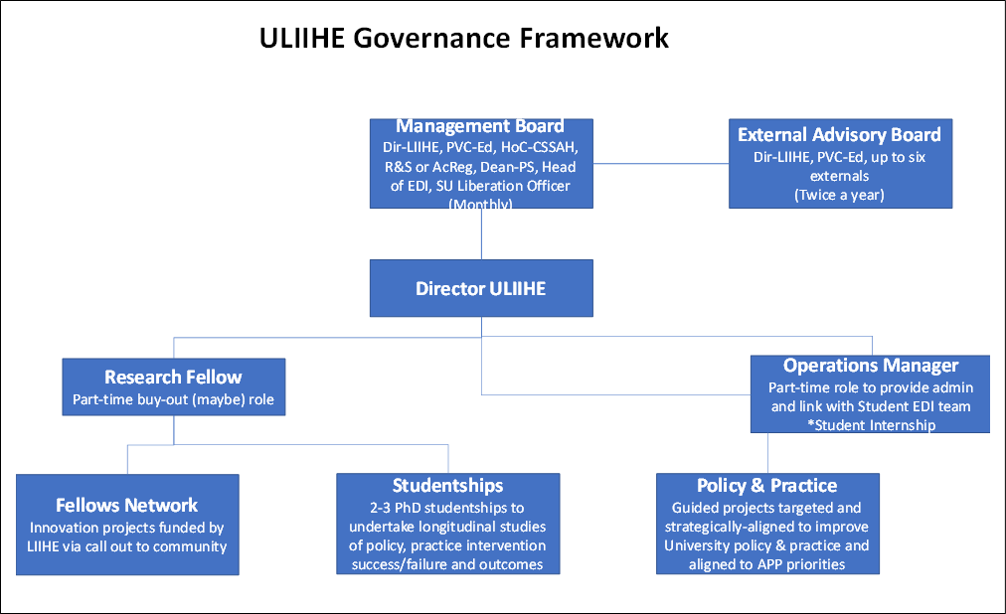

Figure 15 ULIIHE Governance Framework

  - The Management Board, Director of ULIIHE and Operations Manager (currently 0.2FTE) are now in place, with plans to recruit the Fellow and Studentships in early Autumn 2022 and other roles and External Advisory Board to be confirmed.

  - ULIIHE Objectives - the following four Objectives have been set to act as principles that steer the direction, purpose and activities of the Institute over the short, medium and long term. Each objective has a number of SMART KPIs, designed to be directly responsive to the specific inclusion challenges we may face at any one time, such as the ethnicity award gap:

- Objective One: To have reduced, in empirically measurable ways, the barriers to education equality that exist for all stakeholders within UoL.
- Objective Two: To have reduced exclusionary barriers or made more equitable, in empirically measurable ways, the lived experiences and opportunities of stakeholders within the ‘communities’ in which the University is couched.
- Objective Three: To establish ULIIHE as a sector leader for positive action and progressive change in inclusive HE practice and related community relations.

  - ULIIHE is prioritising addressing the ethnicity award and satisfaction gap during Phase 1 through a range of KPIs and associated activities. The ethnicity award gap represents one of the sector’s and our university’s most pressing and urgent education-related issue. The latest Education Services’ report, for example, found that in 2021, our Black students experienced the most pronounced gaps in the award for good honours (18.9) degrees of all minority ethnic students, when compared to white domicile students. This gap widened, and in some cases nearly doubled, in specific courses, such as, Criminology (36.6), Engineering (30.3) Management (29.4) and Law (19.5).

  - ULIIHE will lead evolving our curriculums and assessment to be racially inclusive by adopting a multi-layered approach which is focused on support at the School, College and cross- University level.

Students’ Union EDI Activity and Achievements

  - Throughout the year the Students’ Union have worked on equality related projects and initiatives led by the Liberation Officer. Key areas of work include:
- Marking and celebrating equality related events including Black History Month, Disability History Month and LGBTQ+ History Month.
- Embedding inclusivity into student committee training and launching the Be the Influence Training which includes content on Anti-Racism, Microaggressions, LGBTQ+ Allyship and Inclusivity in Sport.
- Developing policy and guidance documents to support students including a Gender Neutral Toilet Policy and a Home for the Holidays LGBT+ Guide written by LGBT+ Officer.
- Working collaboratively with the University to ensure students were able to self- certify for racial trauma for mitigating circumstances.
- Launching key campaigns including the ‘I AM’ campaign to highlight the identities of Queer, Transgender and Intersex People of Colour (QTIPOC) at the University of Leicester and ‘Me Too on Campus’, a campaign against sexual violence and harassment.

Summary

  - As this report sets out, the University has continued to make good progress in advancing equality and embedding inclusivity over the last twelve months, bringing benefit to both students and staff at all levels and in all areas of the University.

  - Reflecting on the impact of the EDI activity detailed above, whilst it is not always possible to establish a direct correlation between specific actions and identifiable impact, there are consistent good practice principles and factors in the approach we take, the actions we complete and the impact that these actions are having. These include:

    - rigorous evidence based analysis;
    - cross university partnership working (and external independent review where necessary and appropriate);
    - practical actions or tools to advance equality embed inclusivity.

  - To provide two examples of this approach:

    - In our gender pay gap work, the Gender Pay Gap Working Group analysed many different aspects of our workforce data, across roles and grades and used external pay analytics, including statistical modelling to identify key determinants our gender pay gap and inform the development of our SMART action plan. The implementation of this action plan will hopefully see further reduction to our gender pay gap, beyond the 4.1 percentage points reduction to our mean gender pay gap since 2017.

    - In relation to recruitment, workforce ethnicity data and detailed data about the profile of applicants, those shortlisted was analysed through an external review with Advance HE. The data analysis from each stage of our recruitment process led to the development of an Inclusive Recruitment Toolkit that has now been implemented across the University and we are seeing an increase in the number of minority ethnic applicants being both shortlisted and appointed. In 2022, of staff who have disclosed their ethnicity, the percentage of minority ethnic staff was 24.7%, compared to 22.2% in 2021.

7.4 Whilst there is much more still to do, we are confident that we are well positioned, both strategically and operationally, to continue to advance equality in all key areas and enable the University to deliver on its stretching EDI commitments and aspirations.

